**Phonebook user guide**

**Phonebook user guide**

Prepared for:

**London Business School**

Author:

**Julian Rawcliffe**

## **Document Information**

|  |  |
| --- | --- |
| **Title** | Phonebook user guide |
| **Subject** | Phonebook user guide |
| **Version** | 1.0 |
| **Status** | PUBLIC |

## **Revision History**

|  |  |  |
| --- | --- | --- |
| **Version** | **Date** | **Description** |
| 1.0 | 21/03/2014 | First version |
|  |  |  |
|  |  |  |
|  |  |  |

**Contents**

Document Information

Revision History

**Contents**

**1** **Phonebook usage guide**

1.1 Introduction

1.2 Key stakeholders

1.3 Usage within London Business School

1.4 Aim of this document

**2** **Unauthenticated viewing**

**3** **Authenticated access**

**4** **Editing and updating records**

4.1 Firstname

4.2 Surname

4.3 Uid

4.4 Location

4.5 Extension

4.6 Dialling right

**5** **Searching**

5.1 Search by name, room or extension

5.2 Search by sub-department

**6** **Service roadmap**

# **Phonebook usage guide**

## **Introduction**

The main purpose of the site is to enable the management of the backend data for the outsourced telephony system.

To make the most effective use of the telephony system and improve its value to customers there is a need to overhaul some of the very basic data management structures that have operated at the School for a very long time, such as an accurate list of departments and sub-departments and the shortcomings of the student records management system when applied to staff accounts.

Whilst by no means the ideal place to tackle these problems, we have decided to try and provide a central source of departmental entries for staff and faculty alongside the data required for the telephony system.

Although the phonebook means an additional system to be used as part of the staff account lifecycle it does mean that we ensure a reliable and accurate data flow of who is in which department can be established, with a consistent naming scheme throughout.

Although the data flows are initially quite complex there will be opportunities to include additional data and streamline the processing.

## **Key stakeholders**

The principle users of the phonebook website are IT support and infrastructure teams.

## **Usage within London Business School**

The phonebook website will be used as part of the staff account lifecycle process to maintain an accurate record of staff member’s department, location and telephone extension to be synchronised with external databases and directories and into the out-sourced telephony system.

## **Aim of this document**

The aim of this document is to describe the IT support user operations to maintain the extension details.

This document does not cover the administration functions that are carried out by the infrastructure team.

# **Unauthenticated viewing**

Although there is no real reason for normal users to access the phonebook site there is nothing to stop them viewing basic information with logging in.

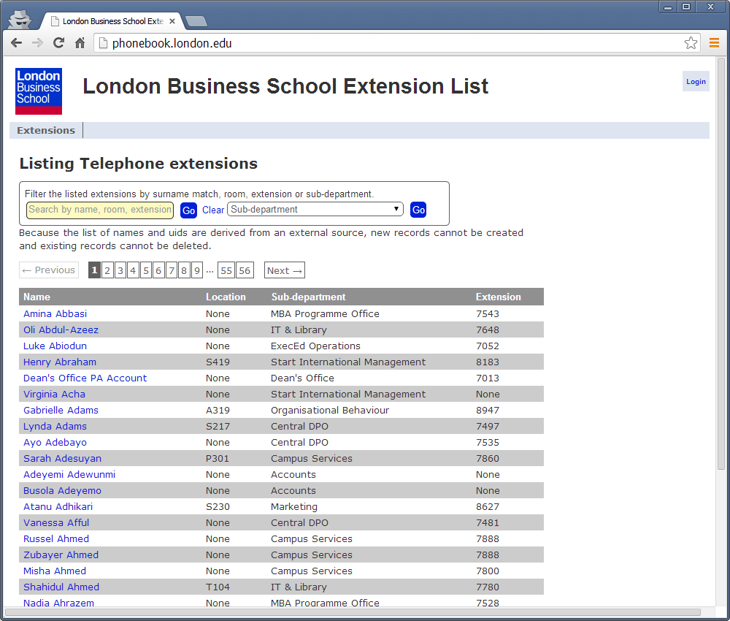

Clicking on any of the names in the left hand column will yield a popup window shown the details for that account,

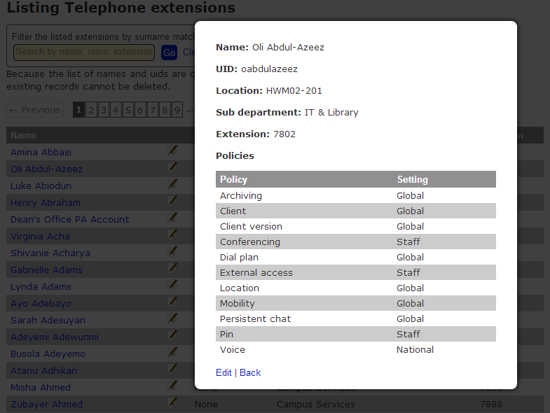

Clicking ‘Back’ or the ‘X’ in the top right will clear the popup and return to the normal page.

Clicking on the ‘Edit’ link will go to the login page.

# **Authenticated access**

Clicking ‘Login’ on the top-right corner will bring up the login page.

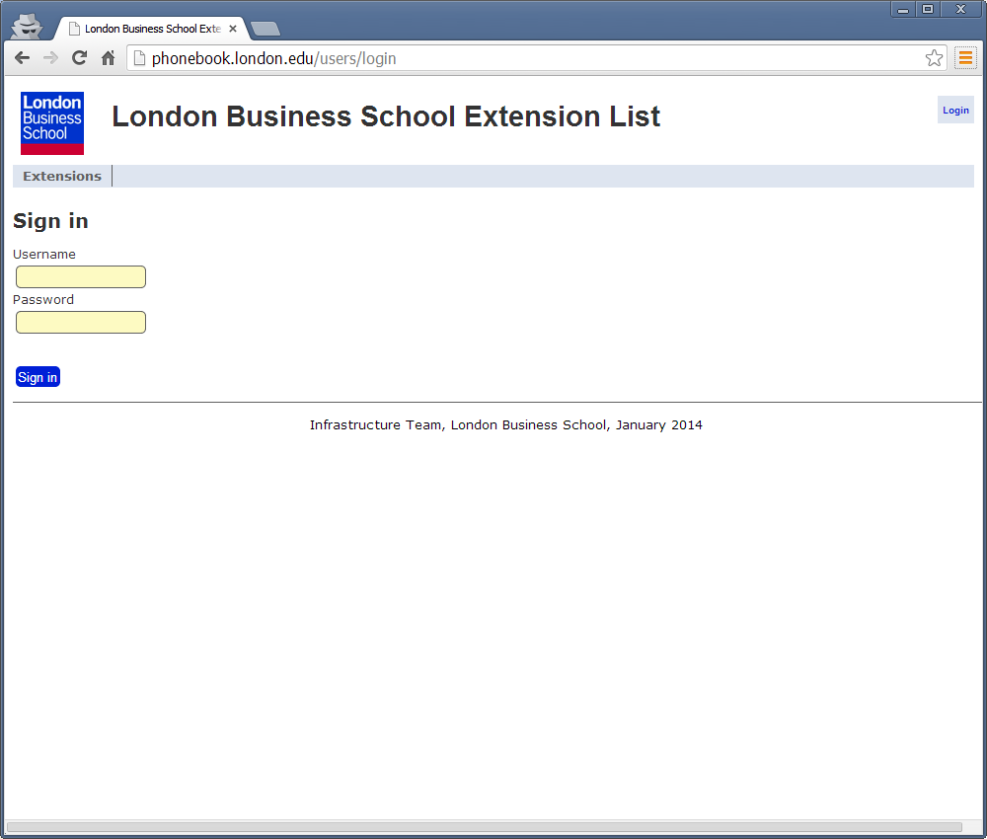

Authentication is achieved using LDAP credentials on the School’s Active Dierctory servers.

On first login, an entry is created in the users table but will require a member of the infrastructure team assign the user to the editor role. Until this is done the site will look the same as for an unauthenticated user and no updates will be possible.

After being assigned to the editor role, the main page will change to include an edit icon after the user’s name,

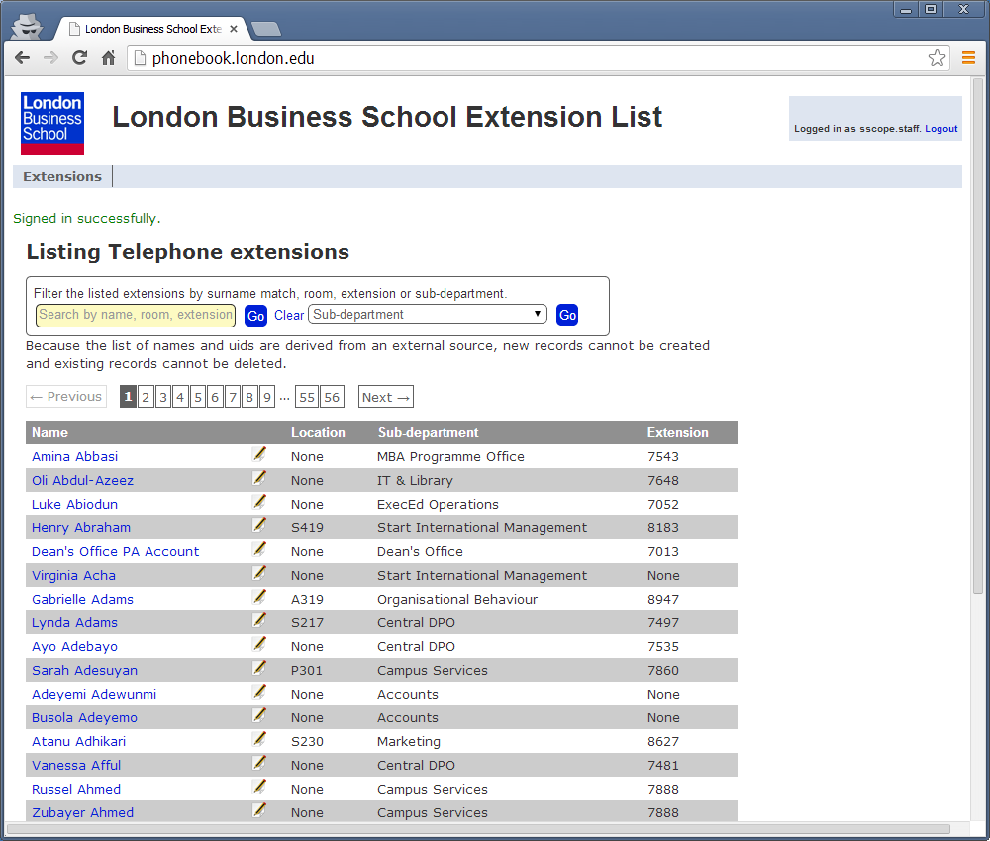

The extension records are listed in surname alphabetic order.

Above the extension list there is a pgination list showing the total number of pages of matching data,

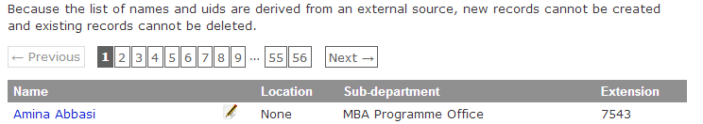

The current page is highlighted with a grey background and cannot be clicked.

Click on a page number to step through to that pages’s items,

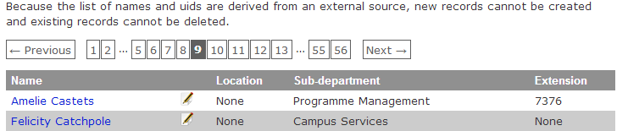

The ‘Next’ and ‘Previous’ links will progress forward and back through the pages one at a time.

The selected page can be overridden manually by changing the page value in the URL,

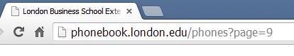

Any selected page number should be retained after editing and updating an extension value, but will be cleared when performing search operations.

The pagination list will not be displayed when the number of items on the page is less than the per page value, currently 25.

# **Editing and updating records**

Clicking the edit button (or the ‘Edit’ link on the user details modal popup) will display the following form,

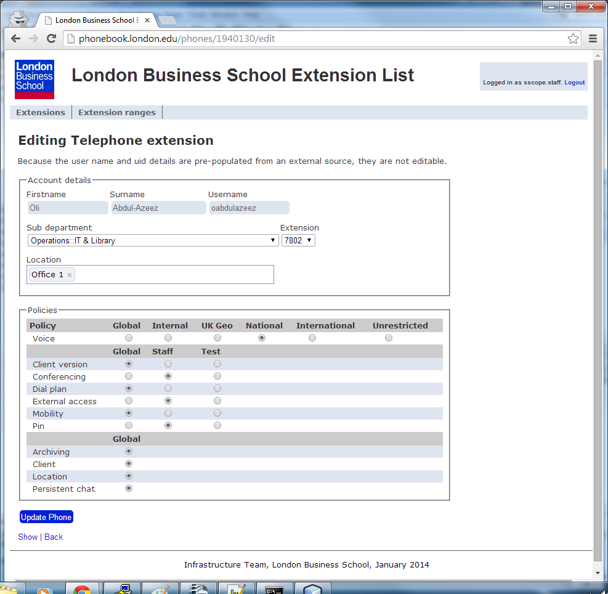

## **Firstname**

All the basic user account information is imported from EAD via a FIM management agent and cannot be edited.

## **Surname**

All the basic user account information is imported from EAD via a FIM management agent and cannot be edited.

## **Uid**

All the basic user account information is imported from EAD via a FIM management agent and cannot be edited.

## Sub-department

A list of known sub-departments prefixed with the department,

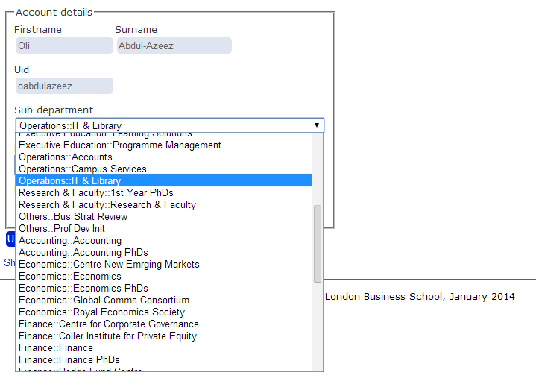

Changing the selected sub-department will dynamically update the list of available extensions and defauilt policies for the sub-department.

The selected sub-department value is synchronised back to the EAD database and will overwrite any manual updates to the SchoolDB department field.

## **Location**

A text search box that displays a list of matching rooms

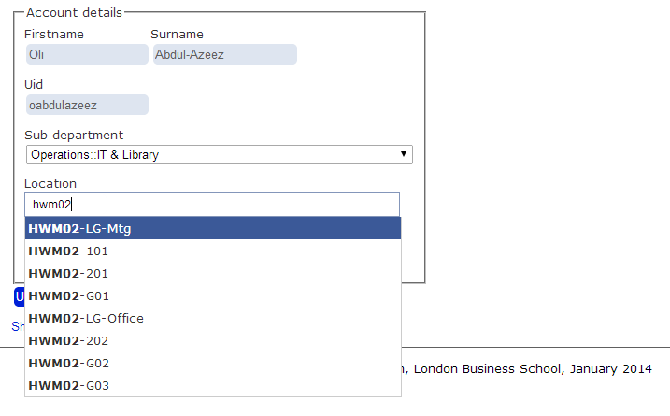

A dropdown list of matching rooms appears as you type but beware, this is quite tricky to get right as this is another area where data management is ripe for improvement.

Once a room has been selected, it can be removed from the form element by clicking the remove icon next to the name,

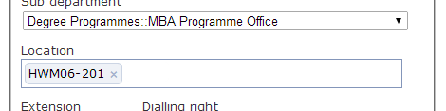

Although potentially multiple rooms could be added to the field only the first will be saved.

## **Extension**

The extension field is a list of the next 10 extensions in the range allocated to the department (or sub-department) that have not already been issued to telephones.

If the sub-department is changed, the list of available extensions will be updated automatically.

Some departments are more selective in how they allocate their extensions. For cases where the required extension for a user is outside the range available on the form, please contact the infrastructure team for an out-of-band update to the database.

## Policies

The policy section lists features and limitations on the Lync service provided to individual users, typically according to their sub-department.

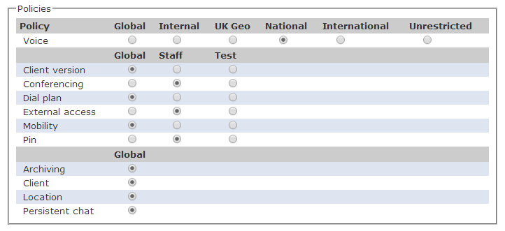

When a new user is imported into the extension system all the policies will be set to ‘Global’ which does not actually provide a usable telephony service (for voice calls and conferencing).

When a user is first added to a sub-department the selected options are dynamically changed to the sub-departments defaults but these can be subsequently modified.

If the default policies for a sub-department are changed, all of the members that had the previous policy setting will be updated to have the new. Sub-department policy changes can only be performed by a site administrator.

# **Searching**

The phonebook website allows some simple searching operations through the forms at the top of the page,

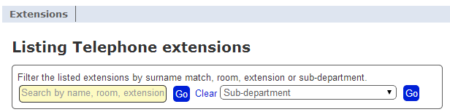

## **Search by name, room or extension**

Three types of text-based searching is supported via the txt box on the left.

Enter the text to search for in the box and press the ‘Go’ button.

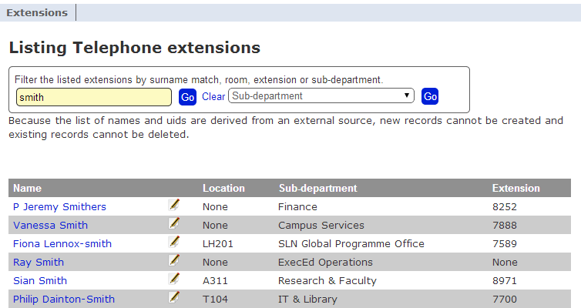

No pagination list is displayed for searches yielding less than the per-page number of items.

The search process is very simplistic and is applied in the following manner,

* Search text matches the extension number,
* If no extension matches found, then by the public name of the room, bearing in mind the limitations surrounding room naming,
* If no room matches found, then search by surname or uid.

Using the search form will clear any su-department selection as well as the page number associated with a previous listing..

The search term should persist across edit and update operations.

To clear the selection text, press the ‘Clear’ link followed by the ‘Go’ button.

## **Search by sub-department**

The second search option is by sub-department.

The search form contains a dropdown list of all known sub-departments.

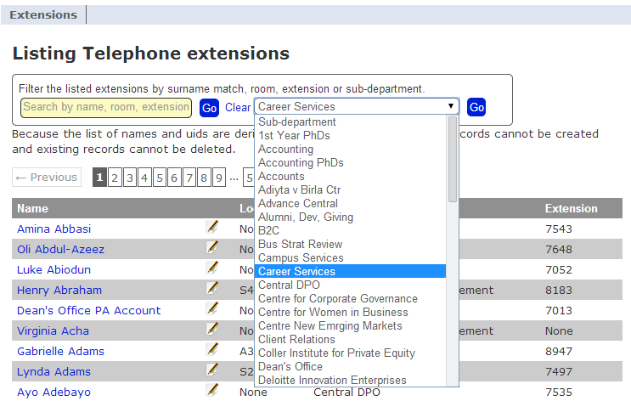

To search by sub-department, simply select one from the list and press the ‘Go’ button.

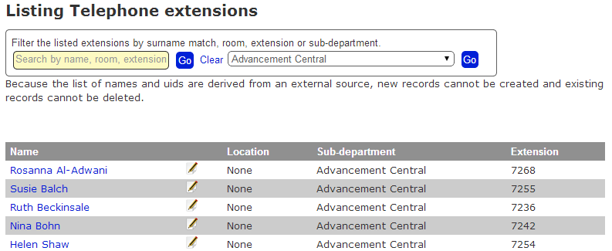

And details of the person may then be viewed,

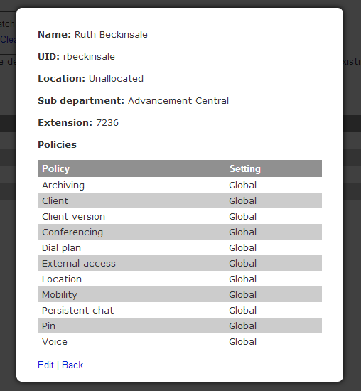

The sub-department selection should persist across edit and update operations.

Searching by sub-department will clear the search term field as well as the page number associated with a previous listing.

To clear the sub-department search field, either select ‘Sub-department’ as the search value and press the right-hand ‘Go’ button, or press the ‘Go’ button next to the name search box.

# **Service roadmap**

It is anticipated that the site will be further developed with additional features to support the ongoing needs of the IT teams.

The most obvious areas where updates will occur are:

* Location information needs to be improved and should occur as part of other Estates projects.
* Support for non-human extension records for public area rooms, hotel bedrooms and ex-directory telephone numbers,
* Better searching as the support teams identify how information can be better identified.