CS 3050 Programming Assignment # 2. Name :

Submitted to Canvas, due at 11:59pm on October 29, 2021.

In this assignment, you will develop a C program to construct a red and black tree. For a given input sequence the tree is unique by using RB-INSERT on one number at a time. Below is an example:
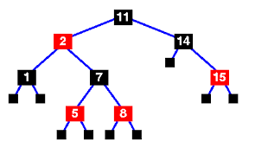

The input is a sequence of numbers separated by comma, e.g. 1,8,11,2, … You can enter the numbers using an input file and output the tree, or through a command line with one number at a time (with “X” to stop entering and printing the output). The output should reflect the above tree in the in-order traversal, by listing nodes with B and R indicating the black and red colors. In addtion, please also show the height and the black height of the red and black tree, as well as the second largest element on the tree. A sample output is:

In-order traversal of the tree:
1-B; 2-R; 5-R; 8-R, 7-B; 11-B; 14-B; 15-R;
The height of the red and black tree is 4.

The black height of the red and black tree is 2.

The second largest element of the tree is 14.

• Your program should compile using gcc on a unix/lunix machine. Using a makefile is encouraged but not required. You can also provide a readme file if needed.

• Although not encouraged, you may use g++ for a C++ code. Provide a readme file if you use C++ to explain how to compile and run the program. No other programming language will be accepted.

