Local App Deployment Steps:
- Install VS code: Download Visual Studio Code - Mac, Linux, Windows
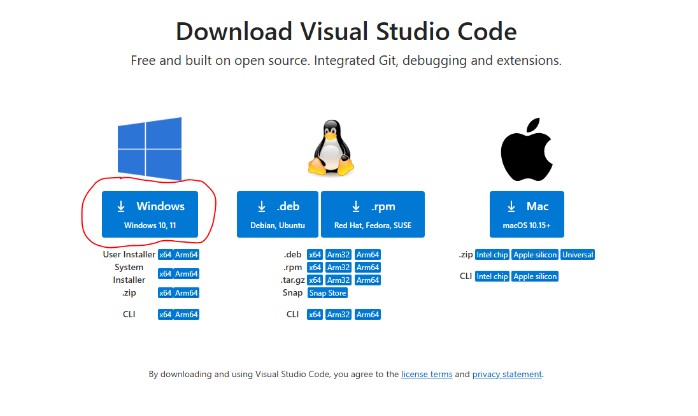
- Install Python (search for 3.12.2): Python Releases for Windows | Python.org
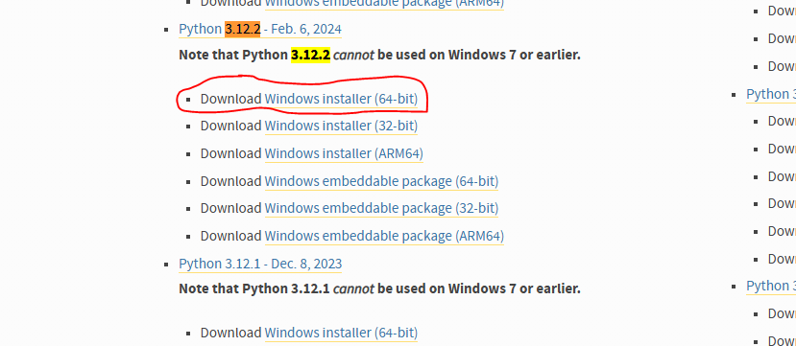
- Run python-3.12.2-amd64.exe and VS Code Installer, complete downloads
- Open VS Code
- Press Ctrl+Shift+P
- Search ‘Python: Select Interpreter’ and select it
- Select Python 3.12.2
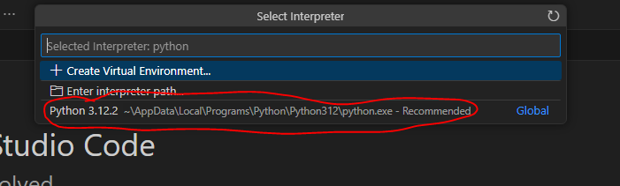
- Open SideBar folder
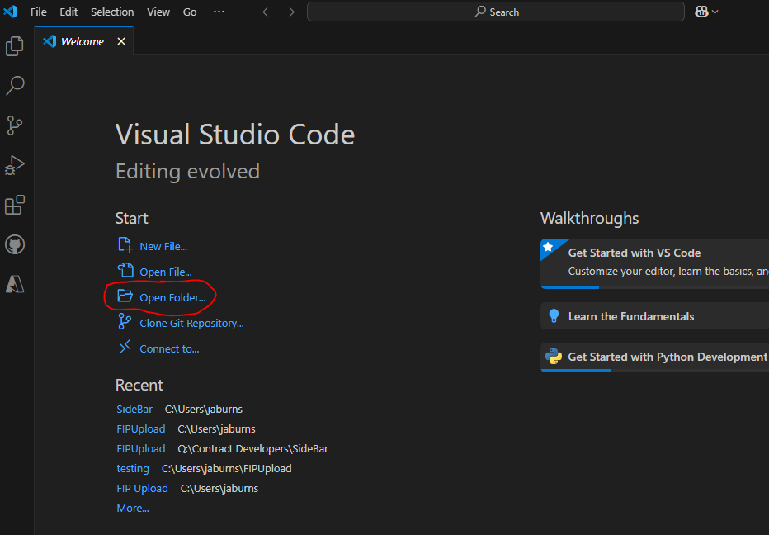

- Open Q: drive and select SideBar Folder (Q:\Contract Developers\Local\SideBar)
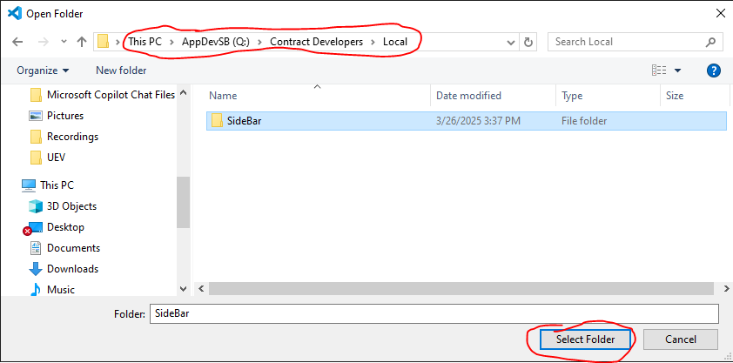
- Open a terminal
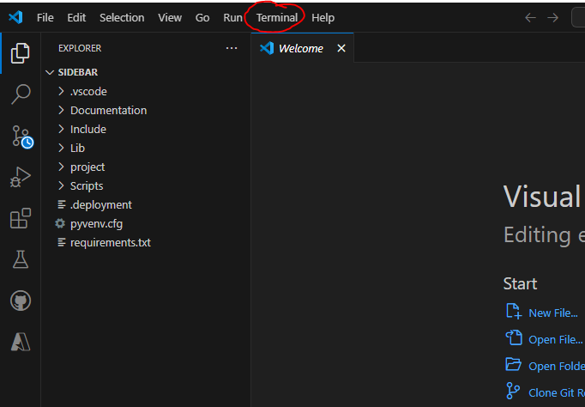
- Select ‘New Terminal’ option
- Enter the following commands:
cd project (enter)
py manage.py runserver (enter)

You should see the following output:
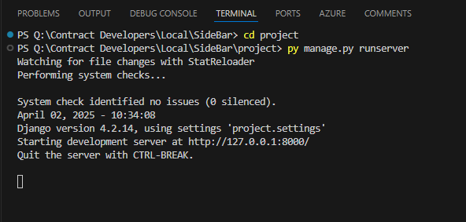
- Open a browser
- Navigate to 127.0.0.1:8000
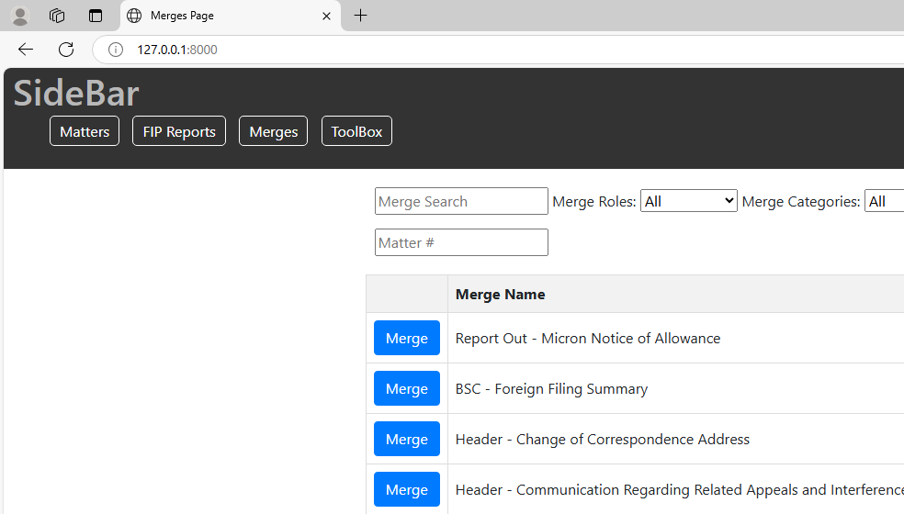

Done!

