##### **JARGONAUTS FC - OFFICIAL FOOTBALL SITE**

Submitted to the

Department of Master of Computer Applications in partial fulfilment of the requirements for the Mini Project in

**Web Programming – MCA14**

**by**

**Jason Martin D Souza**

**1MS24MCA067-T**

**Under the Guidance of**

**Guide name**

**Shreehari T M**

**RAMAIAH INSTITUTE OF TECHNOLOGY**

(Autonomous Institute, Affiliated to VTU)

Accredited by National Board of Accreditation & NAAC with ‘A+’ Grade

MSR Nagar, MSRIT Post, Bangalore-560054

[www.msrit.edu](http://www.msrit.edu/)

**2025**

**DEPARTMENT OF MASTER OF COMPUTER APPLICATIONS**

**CERTIFICATE**

This is to certify that the project entitled “ JargonautsFC – offficial football site ” is carried out by Jason M Dsouza – MCA036 student of 1st semester, in partial fulfillment for the Mini Project in Web Programming - MCA14, during the academic year 2024-2025.

Guide Name Dr. S Ajitha

Shreehari T M Head of the Department

Name of Examiners Signature with Date

**ACKNOWLEDGEMENT**

With deep sense of gratitude, I am thankful to our Respected HoD, **Dr. S Ajitha** for her pillared support and encouragement. I would like to convey my heartfelt thanks to my Project Guide **Guide name**, Department of Master of Computer Applications, for giving me an opportunity to embark upon this topic and for her/his constant encouragement.

It gives me great pleasure to acknowledge the contribution of all people who helped me directly or indirectly realize it. First I would like to acknowledge the love and tremendous sacrifices that my Parents made to ensure that I always get an excellent education. For this and much more, I am forever in their debt.

I am thankful to all my friends for their moral and material support throughout the course of my project. Finally, I would like to thank all the Teaching and Non-Teaching Staff of Department of Master of Computer Applications for their assistance during various stages of my project work.

**Jason Martin Dsouza**

**ABSTRACT**

**JargonautsFC – offficial football site**

The **Jargonauts FC** web project is a dynamic and responsive website designed to provide a seamless user experience for aspiring football players seeking admission. Built with **HTML, CSS, and JavaScript**, the website features an interactive **admissions portal, training program details, ranking information, and contact options**.

Key functionalities include a **registration form**, a structured **coaching level overview**, and an engaging **FAQ section** to address common inquiries. Additionally, the platform highlights **academy facilities**, including training grounds, tactical rooms, and boarding options, ensuring a comprehensive insight into the academy’s offerings.

The website is optimized for **mobile and desktop devices** and integrates **Google Fonts, Font Awesome icons, and external stylesheets** to enhance visual appeal and usability. A **JavaScript-powered navigation menu** and modal-based registration form improve user interaction.

This project demonstrates **modern web development practices**, focusing on **usability, responsiveness, and efficient content structuring**, making it a valuable digital platform for Jargonauts FC Academy.

**Table of Contents**

**1.** **Introduction** 1

**1.1.** **Problem Definition** 1

**2.** **Implementation** 2

**2.1.** **Code snippets** 2

**3.** **User Interface Screenshots** 24

**4.** **Conclusion and Future Enhancement** 27

# **Introduction**

## **Problem Definition**

**Jargonauts FC Academy faced challenges due to the lack of a centralized digital** platform for admissions, training details, and user engagement. The key issues included:

* No Online Registration – Manual admissions were inefficient and time-consuming.
* Limited Information Access – Difficulty in finding details about training programs, rankings, and facilities.
* Lack of Mobile Compatibility – The absence of a responsive design made navigation difficult on mobile devices.
* Weak Online Presence – No platform to showcase achievements, updates, and social media integration.

**Solution:**

To overcome these challenges, a fully responsive and interactive website was developed with the following features:

* Online Registration System – A modal-based admission form for easy and quick applications.
* Detailed Training Program Overview – Clear structure for coaching levels, from beginner to professional.
* Mobile-Friendly Design – Ensuring smooth navigation across all devices.
* Ranking & Accreditation Section – Highlighting the academy’s national and international recognition.
* Facilities Showcase – Displaying training grounds, hostels, tactical zones, and stadiums with images.

This solution provides efficient admissions, better accessibility, and a stronger online presence, making the academy more approachable to aspiring footballers.

# **Implementation**

## **Code snippets**

* **Navigation Bar (index.html & style.css)**

<nav>

          <a href="index.html">

          <img src="images/logo.png" draggable="false" class="logo-main"></a>

            <div class="nav-links" id="navLinks">

                <i class="fa fa-close" onclick="hideMenu()"></i>

                <ul>

                    <li>CONTACT US : 8861604483</li>

                </ul>

            </div>

           <i class="fa fa-bars" onclick="showMenu()"></i>

</nav>

nav {

  display: flex;

  padding: 2% 4%;

  justify-content: space-between;

  align-items: center;

}

nav img {

  width: 100px;

}

.nav-links {

  flex: 1;

  text-align: right;

}

.nav-links ul li {

  list-style: none;

  display: inline-block;

  padding: 8px 12px;

  position: relative;

  color: #fff;

  text-decoration: none;

  font-size: 20px;

  font-weight: bold;

}

.nav-links ul li::after {

  content: "";

  width: 0%;

  height: 2px;

  background: #f44336;

  display: block;

  margin: auto;

  transition: 0.5s;

}

.nav-links ul li:hover::after {

  width: 100%;

}

nav .fa {

  display: none;

}

* **Registration Box (index.html, style.css & script.js)**

<div class="modal Modal-Window ">

            <div class="modal-header">

               <button  data-close-button class="close ">&times;</button>

                   <div class="text"><h4>Apply Now</h4></div>

                </div>

                <div class="modal-body">

                   <form action="form-handler.php" method="posto0">

                       <div class="data">

                           <label>Name</label>

                           <input type="text" name="name" placeholder="Enter name">

                       </div>

                       <div class="data">

                           <span class="icon"><ion-icon name="mail"></ion-icon></span>

                           <label>Email</label>

                           <input type="email" name="email" placeholder="Enter mail" required>

                       </div>

                       <div class="data">

                           <span class="icon"><ion-icon name="call"></ion-icon></span>

                           <label>Ph-number</label>

                           <input type="tel" name="number" pattern="[0-9]{10}" placeholder="Enter 10-digit number">

                       </div>

                       <div class="data">

                           <span class="icon"><ion-icon name="location"></ion-icon></span>

                           <label>Location</label>

                           <input type="text" name="location" placeholder="Enter your location">

                       </div>

                       <div class="button">

                           <span class="icon"><ion-icon name="location"></ion-icon></span>

                           <button class="button-84" role="button">REGISTER</button>

                        </div>

                   </form>

                </div>

                   </div>

               </div>

           </div>

        </div>

        <div class="overlay"></div>

           .btnOpen {

  display: inline-block;

  text-decoration: none;

  color: #fff;

  border: 1px solid #fff;

  padding: 12px 34px;

  font-size: 13px;

  background: transparent;

  position: relative;

  cursor: pointer;

  transition: 1s;

}

.btnOpen:hover {

  border: 1px solid #f44336;

  background: #f44336;

}

.modal {

  position: fixed;

  top: 50%;

  left: 50%;

  transform: translate(-50%, -50%) scale(0);

  background: #f3f3f3;

  width: 410px;

  padding: 30px;

  border: 1px solid #000000;

  border-radius: 20px;

  box-shadow: 0 0 8px rgba(0, 0, 0, 0, 1);

}

.Modal-Window {

  transform: translate(-50%, -50%) scale(0);

}

.active {

  transform: translate(-50%, -50%) scale(1);

}

.modal-header .close {

  position: absolute;

  border: none;

  right: 20px;

  top: 15px;

  font-size: 30px;

  font-weight: 100px;

  cursor: pointer;

}

.close:hover {

  color: #3498db;

}

.modal-header .text {

  text-align: center;

  font-size: 35px;

  font-weight: 600;

}

.modal form {

  margin-top: -20px;

}

.modal form .data {

  height: 40px;

  width: 300px;

  margin: 40px 15px;

}

form .data label {

  font-size: 18px;

}

form .data input {

  height: 100%;

  width: 100%;

  padding-left: 10px;

  font-size: 17px;

  /* border: 1px solid lightgrey; */

}

const btnModal = document.querySelector(".modal-open");

const Modal = document.querySelector(".Modal-Window");

const Overlay = document.querySelector(".overlay");

const closebtn = document.querySelector(".close");

console.log(Modal);

btnModal.addEventListener("click", function () {

  Modal.classList.add("active");

  Overlay.classList.add("overlay-Active");

});

closebtn.addEventListener("click", function () {

  Modal.classList.remove("active");

  Overlay.classList.remove("overlay-Active");

});

* **Informational and Course level section (index.html & style.css)**

<section class="eduinfo">

        <div>

            <h1>Training in Jargonaut</h1>

            <p>

                At Jargonaut FC, our training structure is designed to develop players holistically, focusing on technical, tactical, physical, and mental aspects of the game. Each session begins with dynamic warm-ups, mobility drills, and conditioning exercises to enhance speed, agility, and injury prevention. Technical training emphasizes ball control, passing, shooting, and position-specific skills, while tactical development focuses on formation awareness, game intelligence, and team coordination. Small-sided games and match simulations help players apply their skills in real-game scenarios, reinforcing pressing, defending, and attacking principles. Strength and conditioning sessions build endurance, core stability, and functional strength to improve overall football fitness. Additionally, our mental training program develops confidence, resilience, and leadership, with tactical video analysis to refine decision-making. At Jargonaut FC, we ensure every player is equipped with the skills, mindset, and fitness needed to succeed at the highest level.

            </p>

        </div>

            <div class="ranking">

                <h1>Ranking and accrediaton</h1>

                <div class="row">

                    <div class="course-col1">

                        <h3>3rd</h3>

                        <p>3rd best academy across India(Officai)</p>

                    </div>

                    <div class="course-col1">

                        <h3>10th</h3>

                        <p>Ranked among the top 10 in SEA</p>

                    </div>

                    <div class="course-col1">

                        <h3>50th</h3>

                        <p>Ranked among the top 50 Academy in Asia </p>

                    </div>

                </div>

            </div>

    </section>

    <section class="course">

        <h1>Jargonaut FC Academy – Coaching Levels</h1>

        <p>level up based on performace</p>

        <div class="row">

            <div class="course-col">

                <h3>1. Grassroots (Beginner Level)</h3>

                <p></p>

            </div>

            <div class="course-col">

                <h3>

                    2. Development (Intermediate Level)<br>

                     &amp;<br>

                       Elite (Advanced Level)<br>

                </h3>

            </div>

            <div class="course-col">

                <h3>3. Pro Academy (Professional Pathway)</h3>

            </div>

        </div>

    </section>

  .eduinfo {

  width: 90%;

  margin: auto;

  text-align: center;

  padding-top: 30px;

}

.eduinfo p {

  padding: 15px;

}

.ranking {

  width: 90%;

  margin: auto;

  text-align: center;

  padding-top: 10px;

}

.ranking h1 {

  font-size: 30px;

}

.course-col1 {

  flex-basis: 31%;

  background: #fff3f3;

  border-radius: 10px;

  margin-bottom: 5%;

  padding: 20px 12px;

  box-sizing: border-box;

  transition: 0.5s;

}

.course-col1 h3 {

  font-size: 80px;

}

.course-col1 p {

  font-size: 18px;

}

.course-col1:hover {

  box-shadow: 0 0 20px 0px rgba(0, 0, 0, 0.2);

}

.course {

  width: 90%;

  margin: auto;

  text-align: center;

  padding-top: 10px;

}

h1 {

  font-size: 36px;

  font-weight: 600;

}

.p {

  color: #777;

  font-size: 18px;

  font-weight: 300;

  line-height: 25px;

  padding: 12px;

}

.row {

  margin-top: 5%;

  display: flex;

  justify-content: space-between;

}

.course-col {

  flex-basis: 31%;

  background: #fff3f3;

  border-radius: 10px;

  margin-bottom: 5%;

  padding: 20px 12px;

  box-sizing: border-box;

  transition: 0.5s;

}

h3 {

  text-align: center;

  font-weight: 600;

  margin: 10px 0;

}

.course-col:hover {

  box-shadow: 0 0 20px 0px rgba(0, 0, 0, 0.2);

}

* **Call to Action section**

<section class="cta">

       <h1>Confused about Recruitment Process?</h1>

        <p .pcta>

        Contact the number below to get a free trial to explore and understand our training system.

        </p>

        <button class="hero-btn">Call :9538285553</button>

    </section>

.cta {

  margin: 40px auto;

  width: 80%;

  background-image: linear-gradient(rgba(0, 0, 0, 0.7), rgba(0, 0, 0, 0.7)),

    url(*images/banner2.jpg*);

  background-position: center;

  background-size: cover;

  border-radius: 10px;

  text-align: center;

  padding: 100px 0;

}

.cta h1 {

  color: #fff;

  margin-bottom: 40px;

  padding: 0;

}

.cta p {

  color: #f0f0f0;

}

@media (max-width: 700px) {

  .cta h1 {

    font-size: 24px;

  }

}

* **FAQ’s section**

<section class="course">

        <h1>FREQUENTLY ASKED QUESTION</h1>

        <div class="row">

            <div class="course-col">

                <h3>What makes Jargonaut FC Academy different?</h3>

                <p>We provide top-tier coaching, structured training, and a professional environment focused on technical,tactical, physical, and mental development. Our programs cater to all levels, offering a clear pathway to competitive and professional football.</p>

            </div>

            <div class="course-col">

                <h3>

                    What training levels do you offer?

                </h3>

                <p>

                    We offer Grassroots (Beginners), Development (Intermediate), Elite (Advanced), and Pro Academy

                    (Professional Pathway) programs, ensuring players progress at the right pace with high-intensity

                     coaching and match experience.

                </p>

            </div>

            <div class="course-col">

                <h3>How can I join Jargonaut FC Academy?</h3>

                <p>

                    Players can register online or visit our facility for trials. Our coaches assess skill level and

                     fitness to place players in the right training program, with opportunities for progression to elite and professional levels.

                </p>

            </div>

        </div>

    </section>

* **Facilities section**

<section class="facility">

        <h1>Facilities</h1>

        <p>One of the best on-going facilities</p>

        <div class="row">

            <div class="facility-col">

                <img src="images/disroom.png">

                <h3>Tactical discussion zone</h3>

            </div>

            <div class="facility-col">

                <img src="images/football.png">

                <h3>Play Ground</h3>

            </div>

            <div class="facility-col">

                <img src="images/cafeteria.png">

                <h3>Cafeteria</h3>

                </div>

                <div class="facility-col">

                    <img src="images/hostel.png">

                    <h3>Boarding stay</h3>

                </div>

                <div class="facility-col">

                    <img src="images/stadium.png">

                    <h3>Stadium</h3>

                </div>

                <div class="facility-col">

                        <img src="images/changing.png">

                        <h3>Changing Room</h3>

                </div>

        </div>

    </div>

    </section>

.facility {

  width: 80%;

  margin: auto;

  text-align: center;

  padding-top: 20px;

}

.facility-col {

  flex-basis: 31%;

  border-radius: 10px;

  margin-bottom: 5%;

  text-align: left;

}

.facility-col img {

  width: 100%;

  border-radius: 10px;

}

.facility-col p {

  padding: 0;

}

.facility-col h3 {

  margin-top: 16px;

  margin-bottom: 15px;

  text-align: left;

}

* **Footer section**

  <footer class="footer">

        <div class="container">

            <div class="row">

                <div class="footer-col text-style">

                    <h4>Address</h4>

                    Head  pp. to RT

                    Nagar Post Office, Next to SBI ATM,

                    RT Nagar Main Road,

                    Bangalore - 560098

                </div>

                <div class="footer-col text-style">

                    <h4>Headquarters</h4>

                    Branch office(Delhi)

                    #537-538,5th Floor,Tower-B3,

                    Spaze ITech Park,

                    Sohna Road,Sector 49,

                    Gurugram-122018

                </div>

                <div class="footer-col text-style">

                    <h4>Contact</h4>

                    8861604483

                </div>

                <div class="footer-col">

                    <h4>Follow us</h4>

                    <div class="social-links">

                       <a href="https://www.facebook.com"><i class="fa fa-facebook"></i></a>

                       <a href="https://www.instagram.com"><i class="fa fa-instagram"></i></a>

                       <a href="https://www.youtube.com"><i class="fa fa-youtube"></i></a>

                       <a href="https://www.linkedin.com"><i class="fa fa-linkedin"></i></a>

                    </div>

                </div>

            </div>

        </div>

   </footer>

.footer {

  background-color: #24262b;

  padding: 70px 0;

}

.footer-col {

  width: 25%;

  padding: 0 15px;

}

.footer-col h4 {

  font-size: 18px;

  color: #ffffff;

  text-transform: capitalize;

  margin-bottom: 35px;

  font-weight: 500;

  position: relative;

}

.footer-col h4::before {

  content: "";

  position: absolute;

  left: 0;

  bottom: -10px;

  background-color: #e91e63;

  height: 2px;

  box-sizing: border-box;

  width: 50px;

}

.footer-col ul li:not(:last-child) {

  margin-bottom: 10px;

}

.footer-col ul li a {

  font-size: 16px;

  text-transform: capitalize;

  color: #ffffff;

  text-decoration: none;

  font-weight: 300;

  color: #ffffff;

  display: block;

  transition: all 0.3s ease;

}

.footer-col ul li a:hover {

  color: #ffffff;

  padding-left: 8px;

}

.footer-col .social-links a {

  display: inline-block;

# **User Interface Screenshots**

* 1. 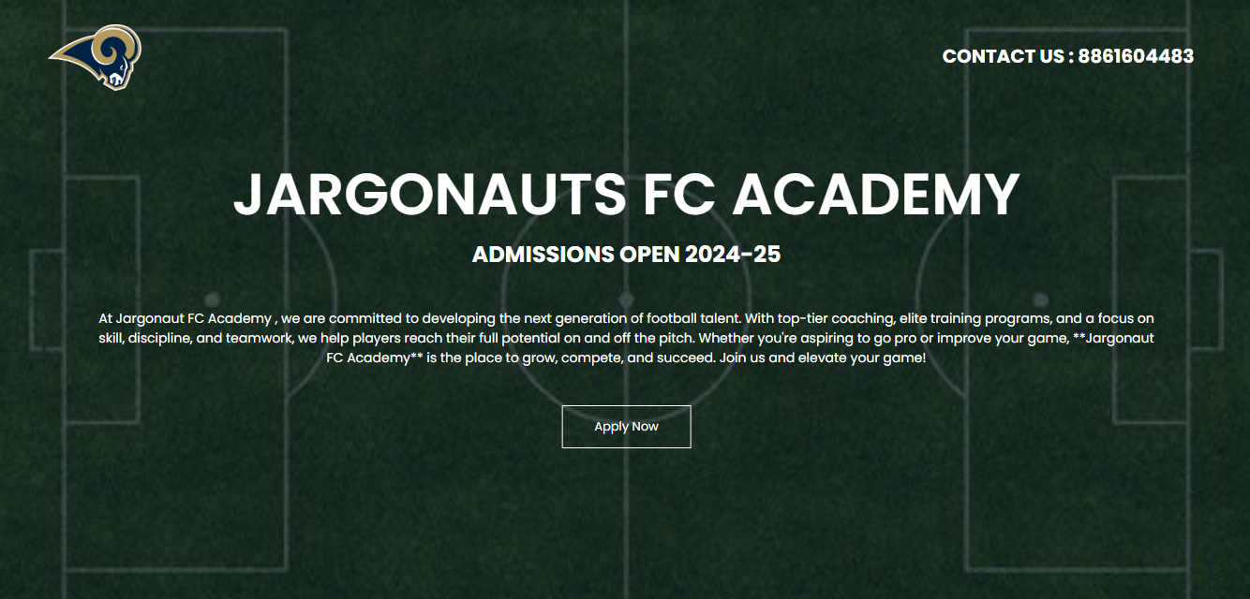**Front Page**
  2. 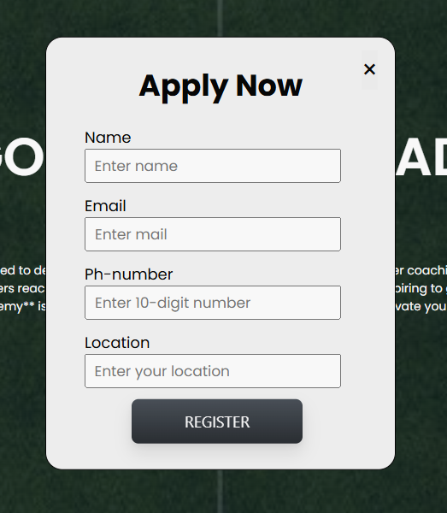**Registration Form**
  3. **Training and Ranking**

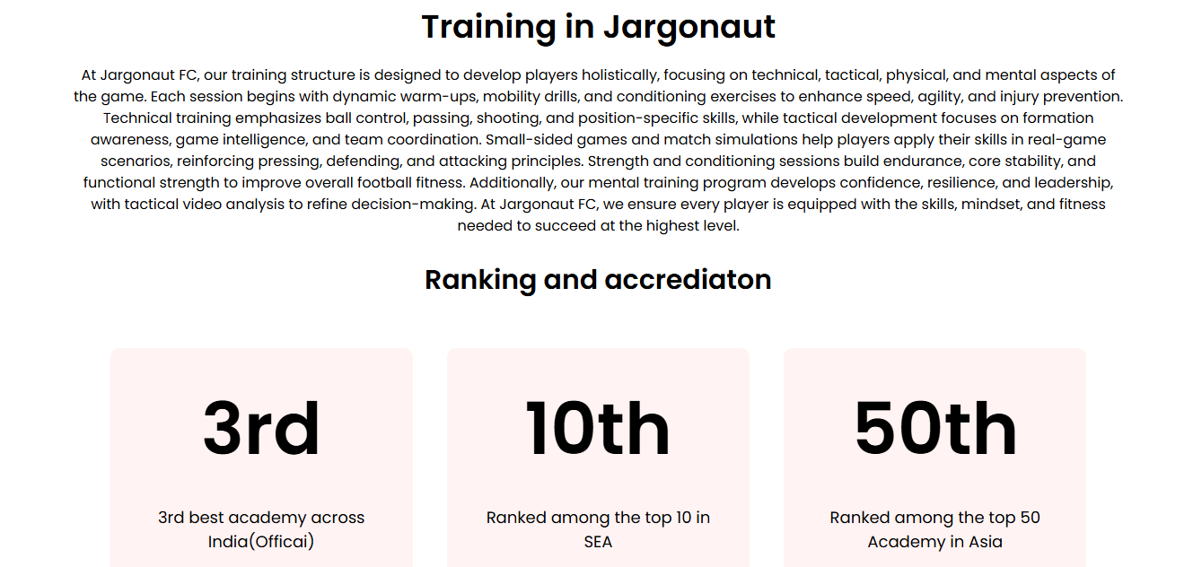

* 1. **Frequently asked questions**

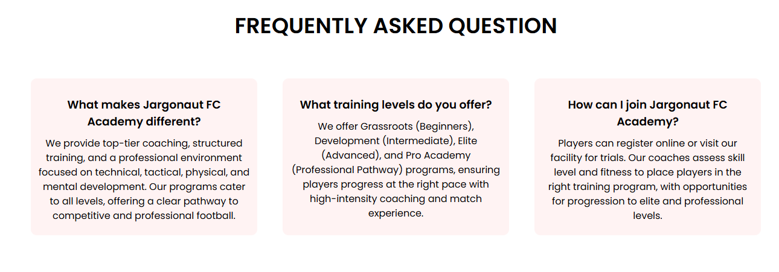

* 1. **Call to action**
  2. **Facilities**

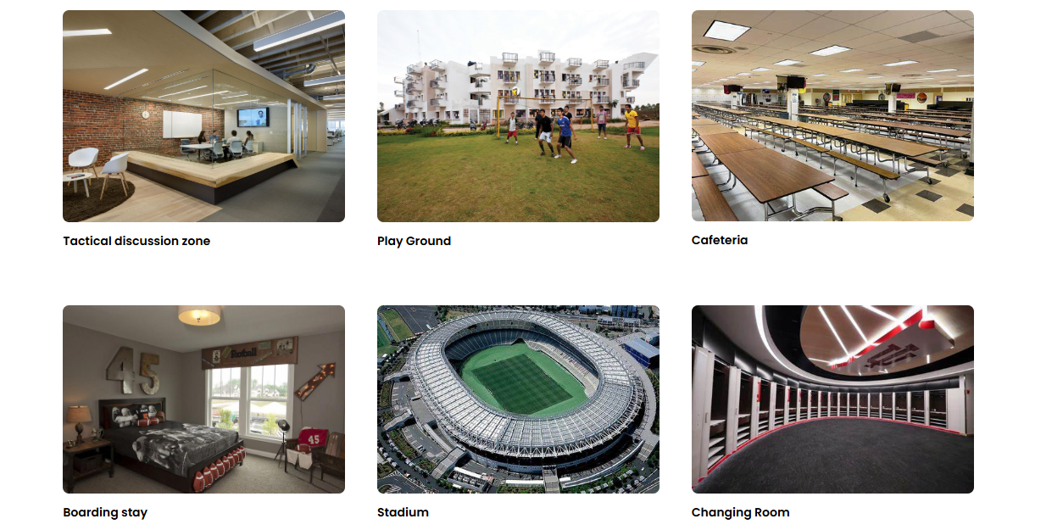

**3.7 Footer**

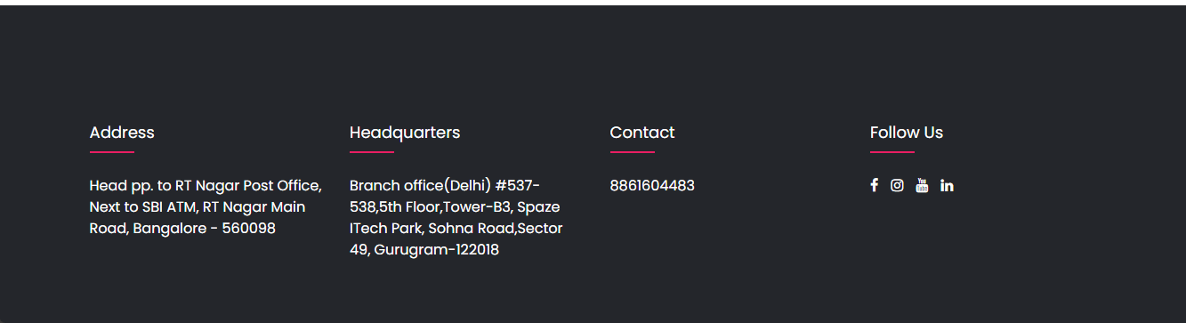

# **Conclusion and Future Enhancement**

**JargonautsFC – offficial football site**

The Jargonauts FC Website successfully addresses the challenges of manual admissions, limited information access, and weak online presence. By integrating a responsive design, online registration system, structured training details, and social media connectivity, the website enhances user experience, accessibility, and engagement. This digital platform streamlines the admissions process, improves communication, and provides a professional representation of the academy.

**Future Enhancements:**

To further improve functionality and user engagement, the following features can be added:

* Live Chat Support – Instant query resolution for aspiring players and parents.
* Player Progress Tracking – A dashboard for players to monitor their training performance.
* Online Fee Payment System – Secure transactions for admissions and training programs.
* Event & Match Updates – Live updates on academy events, trials, and tournaments.
* Video Training Library – Access to recorded coaching sessions and tactical analysis.

These enhancements will make the website more interactive, user-friendly, and efficient, ensuring Jargonauts FC Academy remains a top-tier football training institution in the digital era.