Volume

1

Binary Bits: Binary Calculator

Author: Kenneth Lamb

Binary Bits Program Manual

Table of Contents

Welcome to Binary Bits 3

Binary Addition 4

Binary Subtraction 5

Binary Multiplication 6

Binary Division 7

Binary Modulus 8

Binary Conversion 9

Decimal Conversion 10

File Processing 11

# Welcome to Binary Bits

Author: Kenneth Lamb

This program is a binary calculator that will take two values and perform mathematical calculations with them. To do this first the program will display a menu to choose which function you would like to perform. Then the program will ask the user to input two binary values. You can also convert binary numbers to decimal format and vice versa.

The user will first be presented with a menu. Of which they can choose which function of the program they would like to run.

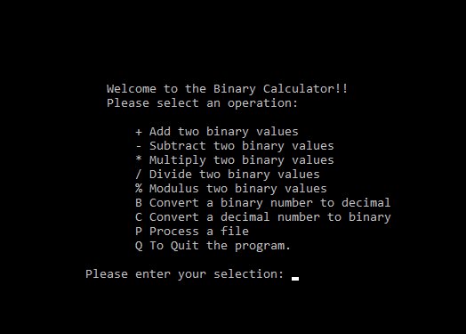



Be advised that you have only 3 attempts at entering one of the menu choices before the program will automatically close.



This is also true for any binary number that you input into the program. You will only have 3 attempts before the program shuts down.

# Binary Addition

When entering + as your menu choice you will be greeted by the binary addition screen as shown below.

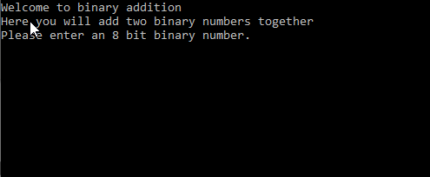

Once there you will be prompted to enter in an 8 digit binary number or a (byte). Then you will be prompted to enter in a second binary number after that.

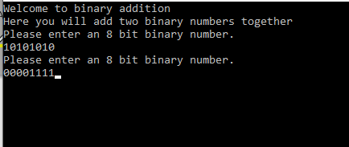

After these two operations the program will add the two binary numbers together and output the result to the user.

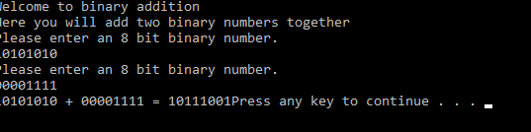

# Binary Subtraction

When entering - as your menu choice you will be greeted by the binary subtraction screen as shown below.

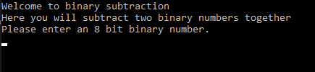

Once there you will be prompted to enter in an 8 digit binary number or a (byte). Then you will be prompted to enter in a second binary number after that.

Once these have been inputted into the system the program will subtract the second number from the first number as so.

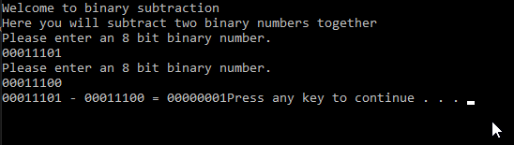

If the calculated number cannot be turned into an 8 bit binary number you will receive the following error.

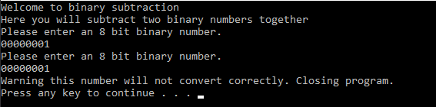

# Binary Multiplication

When entering * as your menu choice you will be greeted by the binary multiplication screen as shown below.

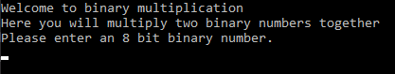

Once there you will be prompted to enter in an 8 digit binary number or a (byte). Then you will be prompted to enter in a second binary number after that.

Once these have been inputted into the system the program will multiply the numbers together and output the binary number.

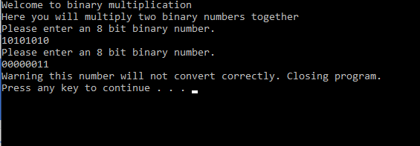

If the multiplied numbers exceed 255 it will cause an error as an 8 bit binary number can only be between 0 and 256

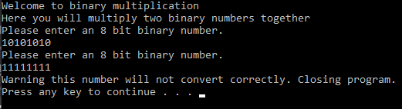

# Binary Division

When entering / as your menu choice you will be greeted by the binary division screen as shown below.

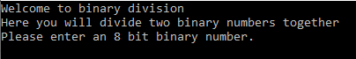

Once there you will be prompted to enter in an 8 digit binary number or a (byte). Then you will be prompted to enter in a second binary number after that.

Once these have been inputted into the system the program will divide the first binary number by the second number.

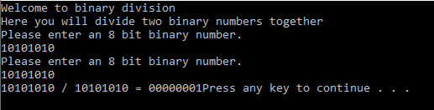

If the number returned is not between 0 and 256 you will get an error as seen below.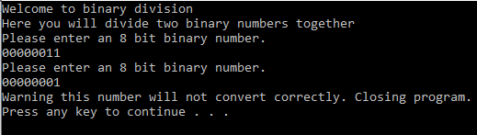

# Binary Modulus

When entering % as your menu choice you will be greeted by the binary modulus screen as shown below.

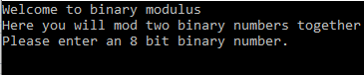

Once there you will be prompted to enter in an 8 digit binary number or a (byte). Then you will be prompted to enter in a second binary number after that.

Once these have been inputted into the system the program will mod the first binary number by the second number.

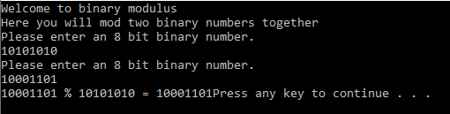

# Binary Conversion

When entering B as your menu choice you will be greeted by the binary conversion screen as shown below.



Here you can convert binary numbers to decimal numbers on the screen. These binary numbers need to be 8 digits long only.

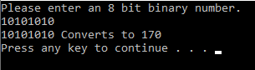

If the user fails to input a 8 bit number or a non binary number they will be met with an error.



# Decimal Conversion

When entering C as your menu choice you will be greeted by the decimal conversion screen as shown below.



Here you can convert decimal integers into binary numbers. The decimal number needs to be in between 0 and 256 or you will receive an error and have 2 more attempts before the program will quit.

When converted it will output to the screen for the user.

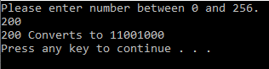

# File Processing

When entering P as your menu choice you will be greeted by the file processing screen as shown below.

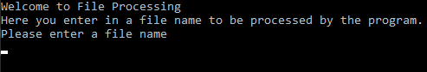

The program will then check if that file exists in the folder. If it does not the user will receive an error as show below.



If the file is found the program will process all of the math functions and numbers in the file then output how many times each function was ran to the results.out file in the program.

