LabSync: An IoT-Based IT Laboratory Availability and Equipment Monitoring System Using QR Codes at Bulacan State University – Sarmiento Campus

A Capstone Project by

Esplana, Charl Jay S. Gabito, Andrei A. Guevarra, Ira R. Naranjo, Nickaela E.
Santos, Rhale Christian C.

Submitted to the Faculty of Information Technology Bulacan State University-Sarmiento Campus

In Partial Fulfillment
of the Requirements for the Degree Bachelor of Science in Information Technology

September 2026

CHAPTER I

Today, universities are turning into smart campuses to make school operations faster, improve facility management, and provide better services for both students and instructors. One of the most important tools in this setup is the Internet of Things (IoT), where sensors and microcontrollers connect to the internet to collect real-time data and automate everyday tasks (Ye et al., 2024). Studies show that having connected devices gives school administrators accurate, up-to-date information on how rooms and equipment are being used throughout the day (Arunkumar et al., 2024). Along with IoT, Quick Response (QR) codes have become widely used in schools because they provide a quick, simple way for people to scan and access digital systems using their smartphones (Teves, 2024). Combining IoT hardware with easy QR code workflows helps academic institutions replace slow, traditional paper processes with a more responsive and organized setup.
Around the world, many universities already use smart monitoring setups to track classroom usage, power consumption, and equipment status. Research shows that these automated monitoring setups help departments manage facilities better by providing clear visibility into whether a room is open or occupied (Taruc & De La Cruz, 2024). At the same time, schools stick QR codes on equipment so users can report broken items directly, saving paper and cutting down reporting delays (Sağıt et al., 2024). Using QR codes for reporting helps technical staff find

and fix issues faster, while keeping inventory records accurate and reducing the paperwork staff usually have to deal with (Sağıt et al., 2024).
Here in the Philippines, however, many colleges and universities still rely heavily on manual methods to handle laboratory schedules and computer equipment. Checking if a lab is available usually means walking over to read printed schedule sheets taped to the door, which are often out of date because of sudden room swaps or makeup classes. On top of that, professors often hand the physical lab key directly to the next teacher in the hallway without logging it at the department office, leaving administrators unsure of who actually has the key or if a room is being used. When computers break down, students have to write the problem in a paper logbook, and instructors or lab staff must manually type those notes into spreadsheets later. This manual setup takes a lot of time, risks losing important records, and often leads to multiple students reporting the exact same broken computer, which clutters the maintenance list and slows down repairs.
This exact situation happens at Bulacan State University – Sarmiento Campus (BulSU-SC), particularly in the IT Department. The computer laboratories across the IT Department building are used constantly every day for regular lectures, hands-on programming classes, and impromptu department activities. Even though schedules are created at the start of each semester, actual daily room use changes often, and physical keys are passed around without a clear log. At the same time, broken computer parts like defective monitors, keyboards, or system units are still tracked by hand, adding extra work for faculty and slowing down the MIS staff when fixing equipment.

To solve these problems, this study developed LabSync: An IoT-Based IT Laboratory Availability and Equipment Monitoring System Using QR Codes. LabSync uses an ESP32-powered box with electronic sensor slots that monitor whether each physical laboratory key is present or removed. When the key is inside the box and no class is ongoing, the web dashboard automatically displays the room as Available. Once an instructor takes the key, the system cross-references their identity with the active timetable: if that instructor is assigned to that time slot, the room status switches to In Session; if an instructor pulls the key outside their assigned schedule, the status flags the room as Borrowed. To handle hallway handoffs between classes, each lab key has an acrylic keychain tag with a QR code so an incoming professor can scan it with their phone to legally accept custody and claim the room. For broken hardware, each computer unit has a unique QR sticker that lets students report defective parts on their phones without needing an account, recording each submission as an individual ticket so the MIS staff can track specific workstation issues directly.
Through web dashboards tailored for the IT Department Head, Faculty, and MIS Staff (assisted by supervised On-the-Job Training interns), the system provides real-time room availability, a drag-and-drop schedule builder that prevents booking conflicts, a deduplicated maintenance tracker with resolver accountability, and centralized physical key management. By bringing together IoT key tracking, mobile QR transfers, and digital fault reporting into one platform, LabSync removes paper logbooks, speeds up computer repairs, and makes lab management much more organized for the IT Department of Bulacan State University – Sarmiento Campus.

Background of the Study

For technical courses, student’s training facility is primarily the computer lab; therefore, ensuring the cleanliness of the computer lab and computer is vital for daily use. Many universities have endeavored to turn their campuses into "smart campuses" so as to realize the automation of room scheduling and equipment maintenance. Some schools overseas have more sophisticated systems such as surveillance cameras or facial recognition scanners, but these are too costly to deploy in Local state universities and are too intrusive for students and teachers to feel comfortable with respect to their privacy (Kunjiapu et al., 2025). This has led to the need for tools in schools that are easy to use, affordable, and can reliably track facilities without having to monitor people's movements (El-Haggar et al., 2023).
A computer lab in Philippine State Universities still requires some amount of manual papers. Logbooks, paper sign-up sheets, and paper and pen signatures are still used by most schools to track rooms and equipment usage. This configuration can easily result in errors, missed logins, and lost documents (Kunjiapu et al., 2025). When a student spots a broken computer, they'll typically jot it down on a piece of paper and then leave it there for days or weeks until it is entered into a spreadsheet. This delay delays repair, makes broken PCs sit in repair areas, and interferes with hands-on classes.
At Bulacan State University – Sarmiento Campus (BulSU-SC), particularly within the IT Department computer laboratories, faculty and students encounter significant friction regarding room visibility and hardware accountability. To verify

whether a laboratory is vacant, instructors and students must walk across the building to check printed schedules posted on laboratory doors or look through windows. This manual process wastes valuable instructional time, especially when arranging makeup lectures, hands-on exam sessions, or departmental student consultations. Furthermore, physical keys are frequently handed over from one instructor to another in the hallway between consecutive class periods without returning to the department office. Without an immediate custody logging mechanism, administrators lose track of key possession and actual room occupancy. Concurrently, non-functional monitors, keyboards, mice, or system units remain unserviced for extended periods due to the delays inherent in manual paper reporting.
To address these challenges, the researchers developed LabSync: An IoT-Based IT Laboratory Availability and Equipment Monitoring System Using QR Codes. The platform connects physical key access directly to a centralized web dashboard using an ESP32 key monitoring box equipped with electronic sensor sockets. Key dock status is continuously cross-referenced with academic timetables in real time: when a key is docked and no class is active, the room is marked as Available; when an authorized instructor pulls the key for a scheduled class, the room switches to In Session; when a key is retrieved outside scheduled hours, the room is classified as Borrowed. To solve the hallway handoff problem, each physical key is paired with an acrylic keychain featuring an embedded QR code, allowing the next instructor to scan the key with a smartphone and log custody immediately. For hardware maintenance, serialized QR code stickers are

affixed to each desktop computer, enabling students to submit individual fault reports directly from their mobile devices without account registration. The system prevents duplicate active maintenance issues by checking whether an unresolved issue already exists for the same computer and issue type. Additional reports may be associated with the existing active issue, providing MIS technicians and student interns with an organized queue of distinct, actionable issues with attributed resolver tracking upon repair.
The LabSync project contributes to the United Nations Sustainable Development Goals (SDGs): SDG 4 (Quality Education), as it continues to keep lab computers functional for students; SDG 9 (Industry, Innovation and Infrastructure), by implementing a practical IoT system for a state university; and SDG 12 (Responsible Consumption and Production), by replacing paper logbooks with a paperless, digital process.
In general, the manual system was very difficult for anyone to receive fast updates on the schedules of the rooms, key custody and broken computers at BulSU-SC. This absence of real-time information results in wasted trips around campus, confused schedules, and lengthy repair periods which negatively impact student learning.
This study is aimed at four major areas to correct the above problems:

- Manual Availability Checks: Eliminate time wasted by students and teachers walking to the lab to check its availability.
- Slow Repair Reporting: Replacing handwritten paper reports by allowing students to scan workstation QR codes to submit individual hardware fault tickets directly to the MIS office.

- Scheduling conflicts in class - Avoiding scheduling double booked rooms during regular class, make up class or consultation sessions with a scheduling builder which will check for scheduling conflicts.
- Key Tracking and Accountability: Automatic registration of key custody on the online dashboard, regardless of the teacher giving the key to another teacher in the hallway.

Objectives of the Study

To design, develop, and evaluate LabSync: An IoT-Based IT Laboratory Availability and Equipment Monitoring System Using QR Codes for Bulacan State University – Sarmiento Campus that integrates physical key tracking, mobile QR key custody transfers, deduplicated workstation fault ticketing with resolver attribution, MIS maintenance and OJT intern management, conflict-free academic scheduling, and administrative security auditing.
The specific goals of the research are as follows:

  - Design and develop an IoT key monitoring box using an ESP32 microcontroller, 6.35mm jack sockets with resistor-divider sensing, an I2C 16x2 LCD screen, an optical GM65 barcode reader, and an active buzzer alarm to detect physical laboratory key presence and status in real time.
  - Develop a centralized web application that dynamically computes laboratory availability (Available, In Session, Borrowed), supports

mobile QR key custody handoffs for faculty, provides zero-login computer fault reporting with automated issue deduplication and resolver attribution for MIS staff and supervised OJT interns, and incorporates a drag-and-drop schedule management studio with real-time visual collision detection.
  - Evaluate the system's performance and user acceptance using the ISO/IEC 25010 software quality model and the Technology Acceptance Model (TAM) to ensure technical reliability and usability across the BulSU Sarmiento Campus community.

Significance of the Study

The development of LabSync: An IoT-Based IT Laboratory Availability and Equipment Monitoring System Using QR Codes provides an automated, reliable alternative to traditional paper logbooks and manual equipment tracking in state university computer laboratories. By combining IoT hardware key detection, live room availability computation, mobile QR key custody transfers, and individualized digital ticketing, this study establishes a practical, cost-effective framework tailored to the daily operational realities of an academic campus.
The findings and implementation of this study directly benefit the following stakeholders:
Students. The system removes the burden of manual paperwork by eliminating physical logbook sign-ins and paper equipment fault slips. Through workstation QR stickers, students can report broken hardware parts directly from their mobile

phones without having to create an account or log in, ensuring their complaints are recorded immediately while allowing them to focus on hands-on laboratory activities using functional computers.
Faculty Members. Instructors can view real-time laboratory availability (Available, In Session, Borrowed) directly from their dashboards without walking to the building to check printed door postings. They can immediately monitor the condition and fault reports of PC units in their assigned laboratories online instead of relying on slow paper forms, allowing them to adjust hands-on seat plans ahead of class. Faculty members can also view and print their official teaching schedules prepared by the Department Head. Furthermore, the mobile QR key transfer feature enables smooth, transparent hallway key handoffs between consecutive classes, eliminating trips to the department office while maintaining clear administrative accountability.
IT Department Head. The system streamlines timetable creation through an interactive Drag-and-Drop Schedule Studio, allowing the Department Head to place class blocks directly onto the timetable canvas. It features real-time visual collision detection—highlighting occupied slots with immediate error warnings and red indicators before a subject block is dropped—to prevent room overlaps and faculty double-booking. The Department Head can also quickly drag and assign official curriculum courses into the grid for faster schedule building, provision and manage login accounts for faculty members, and automatically generate printable class timetables complete with institutional signatory lines.

MIS Staff / Technical Custodians. Centralizing maintenance tickets into a single online queue eliminates delays caused by handwritten notes and manual spreadsheet encoding. The system automatically associates concurrent student fault reports with existing active issues, provides a dedicated interface to manage and supervise On-the-Job Training (OJT) interns, tracks technician resolver attribution upon issue resolution, repairs defects faster, and monitors physical laboratory key custody.
Bulacan State University – Sarmiento Campus. The implementation of LabSync accelerates the university's transition toward smart campus operations using cost-effective, maintainable open-source web technologies and microcontrollers. It optimizes facility utilization across all IT Department laboratories, enforces paperless workflows, and supports institutional sustainability goals.
Future Researchers. This study offers an empirical, verifiable blueprint for integrating ESP32 telemetry, web architecture, and QR code ecosystems within public educational institutions. It provides a reliable technical reference for developing non-intrusive asset monitoring and facility management solutions in resource-constrained environments.

Scope and Delimitations Scope
This study focuses on the design, development, and implementation of LabSync: An IoT-Based IT Laboratory Availability and Equipment Monitoring System Using QR Codes, deployed comprehensively across all computer

laboratories situated within the Information Technology Department building at Bulacan State University – Sarmiento Campus. These specialized instructional facilities are selected because they house the campus’s computing infrastructure and host the highest concentration of hands-on technical coursework, rendering them particularly vulnerable to schedule overlaps, unmonitored room handoffs, and rapid peripheral wear.
The hardware architecture centers on a centralized key monitoring box powered by an ESP32 microcontroller, stationed directly within the department faculty office. The box utilizes 6.35mm jack sockets paired with resistor-divider analog sensing circuits to detect the presence or withdrawal of laboratory keys reliably. Physical operational feedback is delivered through an I2C 16x2 LCD screen, an active buzzer alarm that triggers if a key is placed into an incorrect slot, and an optical GM65 barcode reader. By cross-referencing key dock telemetry with active class timetables, the system dynamically calculates laboratory status into three operational states: Available, In Session, and Borrowed. To support rapid room transitions between consecutive classes, all physical laboratory keys are equipped with QR-coded acrylic keychains, allowing incoming instructors to execute mobile key custody handoffs directly in the hallway without returning to the department office.
For equipment maintenance, every desktop workstation across all IT Department laboratories is labeled with an individual, serialized QR code sticker linked to a mobile-optimized web reporting interface. To eliminate participation barriers and ensure high reporting rates, students can submit hardware fault

reports across monitors, keyboards, mice, and system units without requiring account registration or login credentials. The system prevents duplicate active maintenance issues by verifying whether an unresolved issue already exists for the same computer and issue type before creating a new ticket. Additional reports are associated with the existing active issue, enabling MIS technicians and supervised OJT interns to review user remarks, inspect timestamps, update diagnostic statuses, and record authenticated resolver attribution upon resolution.
The accompanying web portal provides dedicated, role-based modules: the IT Department Head utilizes an interactive drag-and-drop Schedule Studio equipped with visual collision detection to prevent room and instructor double-booking, manages faculty accounts, and exports official timetables with institutional signatories; Faculty Members view live laboratory availability, monitor reported equipment defects in their assigned teaching rooms, and execute peer-to-peer key handoffs; MIS Staff manage laboratory keys, generate workstation QR codes, supervise student interns, track deduplicated repair tickets, and audit key custody; and supervised OJT Interns access filtered maintenance queues to inspect hardware defects, update repair progress, and record resolutions under their authenticated identity.

Delimitations

This study is limited only to the computer laboratories inside the Information Technology Department building at Bulacan State University – Sarmiento Campus. Other areas, such as lecture rooms, science labs, and offices, are not included because the system is made specifically for computer labs that have many desktop units and shared class schedules.

For the hardware, the system only monitors the physical keys using the key box and QR codes. It does not have automatic door locks, magnetic locks, or card-swipe door openers, meaning teachers still have to unlock the doors using the actual key. The project also does not use CCTV cameras or fingerprint scanners, keeping the system simple, low-cost, and non-intrusive.
For equipment reporting, the system only covers the physical parts of the desktop computers: monitors, keyboards, mice, and system units. It does not include software repairs, reformatting, internet connection problems, or operating system troubleshooting.
Lastly, LabSync runs as a web-based system opened through a browser. The researchers did not create a downloadable mobile app for Android or iOS. Students can only use the system to report broken computer parts by scanning the QR code, and they do not need to create an account or log in to do so.

Definition of Terms

This section provides the operational definitions of technical, hardware, and domain-specific terms used throughout the study. Terms are arranged in alphabetical order based on their specific implementation within the LabSync system:
Active Buzzer. An auditory output module connected to GPIO25 of the ESP32 that sounds an alarm loop when a physical key is inserted into an incorrect dock slot.
Audit Logging. An administrative accountability mechanism that persistently records user authentication, administrative modifications, key status updates, and security events in the database with sensitive-data sanitization.

Collision Detection. An algorithmic check built into the Schedule Studio that identifies and visually flags time and room overlaps with red indicators before a subject block is dropped, preventing double-booked laboratories and faculty conflicts.
Data Lag. The operational delay between the occurrence of a computer hardware failure and the formal logging and inspection of that issue by MIS staff under traditional, paper-based reporting workflows.
ESP32 DevKit V1. The central microcontroller board programmed in C++ (Arduino framework) that monitors physical key jack states, controls the LCD screen and buzzer, interfaces with the optical scanner, and transmits 5-second telemetry heartbeats to the web application over local Wi-Fi.
GM65 Barcode/QR Reader. An optical scanning module interfaced with the ESP32 via UART serial communication to scan faculty authentication cards and room key QR codes directly at the key dock.
Internet of Things (IoT). A network of physical devices embedded with sensors, processing ability, and network connectivity that communicate and share telemetry with a centralized software application.
ISO/IEC 25010. An international standard for software quality evaluation used in this study to evaluate the system across functional suitability, performance efficiency, usability, and reliability.
6.35mm Jack Socket (Quarter-Inch Jack). The physical electromechanical port in the key dock that utilizes a resistor-divider circuit on the ESP32’s analog-to-

digital converter (ADC) pins to reliably detect the insertion or withdrawal of a specific room key.
Key Custody Transfer. The mobile process wherein an incoming instructor scans the QR tag on a physical key keychain to digitally assume responsibility for the key and room during class transitions without visiting the department office.
Maintenance Issue Deduplication. An algorithmic database process wherein the system checks whether an unresolved issue already exists for the same computer and issue type before creating a new record, associating additional student reports with the active issue to prevent duplicate work orders.
On-the-Job Training (OJT) Intern. A student trainee account operating under the supervision of permanent MIS Staff, authorized to inspect reported hardware defects, update ticket diagnostic statuses, and record resolutions during a time-bounded internship period.
Perceived Ease of Use (PEOU). A metric within the Technology Acceptance Model (TAM) assessing the degree to which students, faculty, and administrative staff find the LabSync web portal and reporting interfaces effortless to navigate.
Perceived Usefulness (PU). A metric within the Technology Acceptance Model (TAM) assessing how much users believe LabSync enhances laboratory availability visibility, scheduling efficiency, and maintenance turnarounds.
Quick Response (QR) Code. A machine-readable optical label utilized in two ways within the system: serialized stickers on desktop computers for zero-login student fault reporting, and two-sided acrylic keychain tags for mobile key handoffs and key dock identification.
Resolver Attribution. An accountability mechanism that records the authenticated user identity (Resolved_By_User_ID), role, and timestamp (Resolved_At) of the specific technician or OJT intern who marked a maintenance issue as resolved.
Room State. The dynamic operational condition of a laboratory determined by cross-referencing physical key presence with active schedule timetables, classified into three discrete values: Available, In Session, or Borrowed.
Schedule Studio. The interactive drag-and-drop timetable module utilized by the IT Department Head to configure faculty class schedules, validate room availability, and export official timetables with institutional signatories.

CHAPTER II

REVIEW OF RELATED LITERATURE AND SYSTEMS

The aim of this chapter is to provide an overview of previous studies, conceptual frameworks and existing operational platforms that are directly related to the development of LabSync: An IoT Based IT Laboratory Availability and Equipment Monitoring System Using QR Codes. It provides the theoretical background and technical means for physical microcontroller telemetry, mobile QR code interactions and web-based scheduling to be integrated. In addition, the chapter examines the various enterprise and commercial systems in place and pinpoints their operational weaknesses that warrant the development of a solution that is localized, cost effective and relevant to the context of a Philippine state university.
Academic institutions all over the globe have greatly improved operational efficiency by leveraging Internet of Things (IoT) technologies. Campuses can now collect, process and analyze data on the facilities in real time by connecting microcontrollers, hardware sensors and cloud systems. According to Ye et al. (2024), the smart campus architecture based on IoT technology helps to optimize the management of the campus. Using a unified dashboard, people can monitor the status of classrooms and the condition of the equipment. Arunkumar et al. (2024) successfully showed how student and campus information systems using the IoT reduce the amount of paperwork in education and create real-time institutional intelligence.

Centralized telemetry provides education leaders with evidence-based data to guide decisions, efficient use of instructional spaces, and reduced waste of resources. The researchers Mallari et al. (2025) in the Philippines were able to verify that the use of IoT and automated tools in smart classrooms will increase the utilization of educational resources, automate repetitive monitoring tasks, and reduce any time delays required during instruction resulting from administrative delays. In a similar fashion, Taruc and De La Cruz (2024) studied the use cases of the IoT in the educational system in the Philippines and concluded that the use of open-source micro-controller and the standard network telemetry will provide viable solution for local educational campuses in terms of scalability, cost-effectiveness, and long-term solutions. Their results highlight that automated tracking of facilities is possible within state budgets and can be achieved through the design of systems that account for local budgets.
The conventional method of tracking and maintaining the system in the laboratory is based on manual paper logbooks and physical inspection sheets, which create delays in data recording, errors, and delayed repairs. Jadhav et al. (2024) pointed out that manual inventory logging can hinder the productivity of the operations, and suggested the use of a QR-based asset inventory management platform where each asset within a facility is given its own optical tag. This enables staff to use a handheld mobile device to scan the codes, resulting in real-time updates of the database and helping to reduce duplicated paper forms, while providing a more accurate tracking system. This was complemented by the work of Rabiah et al. (2022) who identified the bottlenecks of manual equipment

borrowing and hardware checking, and found that a web-based system with QR code scanners could ease the custody transfer process while maintaining good audit trails.
Sağıt et al. (2024) confirmed that QR code mechanisms are widely used in learning environments with high usability, as they have no specific requirements for hardware usage and can be used by students and teachers without expertise. With the integration of QR code interfaces and automated notification modules, Teves (2024) reiterated how this combination significantly cuts down maintenance response times, preventing equipment failures from impacting instructional delivery.
Although there are many operational benefits to the IoT applications, design is paramount and balancing institutional oversight with user privacy and simplicity of operation is a critical design challenge. El-Haggar et al. (2023) found that the use of non-invasive tracking methods, rather than pervasive surveillance systems like facial recognition cameras or continuous biometric scans, can lead to greater uptake of campus IoT platforms. Non-intrusive sensory approaches are sufficient to meet administrative monitoring needs, but reduce privacy issues and ethical dilemmas in the academic environment.
Kunjiapu et al. (2025) observed that a key problem with digital transformation in Philippine public education is the intricacy of user interfaces and authentication processes. Adoption barriers are eliminated and high reporting compliance is achieved with systems that support frictionless interaction, such as by using public QR scan endpoints without requiring students to create accounts.

Taking into account these views, the literature validates that an IoT framework, which integrates a discrete physical key sensing capability, low friction mobile QR codes interfaces and localized web dashboards, is an effective and affordable solution to the operational challenges of computer laboratories.

Review of Related Systems

Cisco. (Cisco Systems, Inc., n.d.) Cisco Systems, Inc. created the Cisco Smart Campus solution. Cisco Smart Campus is a campus management system with IoT (Internet of Things) features that enhances the operational efficiency, safety and facility monitoring within educational institutions. The system includes connected sensors, network infrastructure and cloud-based analytics that record and track the occupancy of learning spaces, energy usage, environmental conditions and security systems in real time. It allows administrators to have a single view of the building usage, optimize resources and improve campus-wide connectivity. Cisco Smart Campus also has features such as wireless networking, smart lighting, surveillance, and automated alerts, which facilitate data-driven decision-making and smart facility management.
The system offers the advanced analytics and real-time monitoring capabilities needed for large scale campus operations. It has a scalable enterprise architecture to allow for integration between buildings and departments. However, it is costly, and complex infrastructure and technical expertise are necessary for implementation, making it more difficult for smaller institutions. While Cisco Smart

Campus was offered to monitor labs remotely with cameras and higher costs, LabSync is offered for low cost, localized laboratory monitoring via a key monitoring box and QR based reporting which makes it more practical for resource constrained universities.
IBM. (IBM Corporation, n.d.) IBM Intelligent Campus Management system is a product of IBM Corporation. IBM Intelligent Campus Management is a smart campus solution that enhances operation efficiency and facility management in higher education institutions. The system offers predictive maintenance and asset-tracking capabilities that enable administrators to see in real time if equipment is performing well or if there are any issues with assets in the campus. It leverages Internet of Things (IoT), Artificial Intelligence (AI) and cloud computing technologies to analyze data, minimize equipment downtime, and optimize resource use. IBM Intelligent Campus Management provides predictive analysis that enables institutions to avoid equipment failures before they occur, and can integrate enterprise data from various campus systems.
However, it is not suitable for smaller institutions with limited budgets due to its high deployment cost, complex infrastructure and enterprise architecture. LabSync, on the other hand, is a real-time lab availability monitoring and zero login QR computer fault reporting solution, which is cost-effective and practical for State Universities with limited resources.
Google. (Google LLC, n.d.) QR-Integrated Google Forms is a web-based digital reporting application developed by Google that allows users to create their own online forms via QR code. The system enables schools and organizations to

collect the data in an electronic way, where QR codes are linked to reporting forms, thus making data collection easy and without any paper. It is 100% online and receives submissions in real time, directly into cloud-based spreadsheets. Its simplicity, wide access and low cost are its greatest assets. Easy to use, small technical installation and free to use, it is widely used in low-budget institutions.
However, the platform is missing the integration capability with IoT devices, real-time room occupancy detection, and automated maintenance workflows. It is a static digital form that is not hardware-based, and has no diagnostic tracking features. LabSync, on the other hand, is an IoT solution that integrates physical key presence detection with a web-based dashboard for real-time computer equipment condition monitoring, providing a more comprehensive and automated laboratory management solution.
Skedda. (Skedda, n.d.) Skedda Room Booking System is a cloud-based scheduling solution designed by Skedda for universities, offices and organisations to use online to book rooms. The system provides instant booking via an easy-to-use interface, users can check availability and book it easily via web access.
The platform is highly functional in visualizing booking in rooms and gives a user-friendly experience with little training for the user. Skedda's emphasis, however, is solely on reservations. Does not track equipment use or utilize IoT sensors to verify if a room is actually being used. This restriction does not allow it to check if the actual room is occupied or if there are any hardware problems within the premises. In contrast to the simple scheduling view, LabSync can also set up for key detection to verify lab occupancy, and students can use QR codes to report

on the current equipment status, filling in the gaps in monitoring room use and lab equipment.
Brightly Software. (Brightly Software, Inc., n.d.) Brightly Maintenance (formerly SchoolDude) is a cloud-based computerised maintenance management system (CMMS) for school management of maintenance requests and tracking physical assets. It lets administrators and staff log work orders, track maintenance processes, and keep track of equipment and facility conditions.
One of the key benefits of the platform is its structured maintenance workflow management and asset tracking features, enabling institutions to effectively manage repair requests and track equipment history. The platform does not however have zero-login, QR-based equipment-level reporting nor does it support monitoring of IoT keys for real-time detection of facility use. Unlike LabSync, which integrates IoT hardware for detecting lab availability and reports on the condition of computers with a QR code, Brightly Software is more of a work order tracking and asset log software.
LabWare. (LabWare, Inc., n.d.) The LabWare Laboratory Information Management System (LIMS) is an enterprise automation platform to manage laboratory data, sample workflows and inventory processes. The system can be integrated with the bar code and QR code for laboratory equipment and sample tracking. It offers centralized reporting, automated documentation, and secure database management, with a focus on research labs, universities, and industrial testing facilities. The system's robust data management and regulatory compliance

capabilities are among its key advantages and can help streamline complex laboratory workflows.
The deployment and maintenance of the system is however costly and is not feasible for smaller departmental setups. Its high level of clinical features necessitates expertise in technical training for administrators to use it correctly. Furthermore, it is designed specifically for research and sample testing in the laboratory, not for instructional use in a computer laboratory. Unlike LabWare LIMS, LabSync is a narrow-spectrum product designed for use in university IT laboratories, with its key presence detection using ESP32 for occupancy tracking, and QR codes for computer hardware maintenance reporting.

Comparison of Related Systems

Table 1. Comparison of Related Systems

Features | Cisco | IBM | Google | Skedda | SchoolDude | LabWare | LabSync
Real-Time Room Occupancy  Monitoring |  | 
IoT-Based Hardware
Integration

Smart Key-

Based Detection
QR Code Equipment
Reporting
PC Condition

Monitoring
Room

Claim
Schedule Management  Integration |  |  |  |  | Partial | Partial
Cost-Effective for State  Universities |  |  |  |  | Partial

Based on the comparison table, there is a clear gap between expensive enterprise systems like Cisco and IBM, and simple digital tools like Google Forms and Skedda. While enterprise systems have powerful features, they cost too much for state universities to buy and maintain. On the other hand, tools like Google Forms and Skedda are affordable, but they do not have IoT hardware integration to detect physical room keys or check real-time occupancy.

LabSync fills this gap by bringing together IoT hardware and affordable web features in one system. Designed for the computer laboratories in the IT Department building, it is the only system among the choices that combines smart key-based detection, QR code equipment reporting, PC condition monitoring, room claiming, and conflict-free schedule management. LabSync offers a practical and low-cost solution that gives the university reliable hardware monitoring and administrative tools without the heavy cost of enterprise software or the delays of manual logbooks.

Synthesis

Based on the literature review and system analysis, it was revealed that QR code and Internet of Things (IoT) technology are the effective tool for modernizing the school/laboratory management. Research studies highlight the benefits of automated tracking and monitoring web dashboards to increase daily efficiency by providing real-time information about room and equipment condition.
But in between the available options there is clearly some gap as seen in the comparison table. Large enterprise systems such as Cisco and IBM are too costly, complicated and difficult to support for local public schools.However, there are some simple tools, such as Google Forms and Skedda that are free or inexpensive, but may not include IoT hardware integration to detect a physical room key or confirm actual lab use. This indicates that the platforms available are too expensive, or do not provide the hardware capabilities required of a university

computer laboratory. For schools that have limited budgets, a monitoring system should be cost-effective, user-friendly, and should be able to connect physical key movement with online records. Manual logbooks introduce data-lag, impacting on computer repair time, double rooms and key management.
LabSync delivers this solution with affordable IoT hardware and an online management system. It features an ESP32 key monitoring box for detecting room keys, an interactive drag-and-drop scheduling tool for visual conflict notifications, and mobile QR key handoffs for faculty. Students can scan QR stickers on desktop computers without logging in to send individual computer fault reports to technical staff, providing a clear and direct list of issues for technical staff to resolve. LabSync's QR code reporting and physical key discovery makes for an easy-to-use, cost-effective solution that helps state universities to efficiently manage their computer labs without the investment in expensive enterprise software.

CHAPTER III

DESIGN AND METHODOLOGY

This section explains the research design and method used for the development of Labsync. It includes the functional requirements and non-functional requirements, as well as the system architecture, including both hardware and software, also the Integration of IoT devices such as smart key hooks and QR code-based reporting. This Chapter will explain the research

design, system workflow and testing procedures will be applied to ensures system’s functionality, reliability and user acceptability.

Requirement Analysis and Documentation

In this section, presents the functions and quality standards required for LabSync system to effectively address the manual struggles of laboratory management of Bulacan State University – Sarmiento Campus.

Table 2. Functional Requirements

ID | Functional Area | Description
FR-01 | User Authentication and Role Management | The system shall allow authorized users to log in with individual accounts, enforce role-based access control across four distinct roles (Department Head, Faculty, MIS Staff, and OJT Intern), and implement session inactivity timeouts.  role.
FR-02 | Laboratory Room Monitoring | The system shall display the current availability and status of laboratory rooms.
FR-03 | Laboratory Schedule Management | The system shall allow authorized users to create, update, and manage laboratory  schedules while checking for schedule conflicts.
FR-04 | PC Fault Reporting and Maintenance | The system shall allow students to report PC problems through QR codes without login, prevent duplicate active maintenance issues by checking if an unresolved issue already exists for that computer and issue type, and allow MIS staff and supervised OJT interns to manage, diagnose, and resolve reported issues with authenticated resolver attribution.  to manage and resolve the reported issues.

FR-05 | Physical Key  Management | The system shall allow MIS staff to register unique key codes, monitor physical dock status, flag keys as Active or Missing, and generate printable QR keychain tags.
FR-06 | Key Transfer and Room Claim | The system shall allow authorized faculty and the IT Department Head to transfer and claim  laboratory keys using QR codes.
FR-07 | IoT Laboratory Monitoring | The system shall receive data from the ESP32 device to monitor key presence, room activity, and device connectivity.
FR-8 | System Records and Audit Logging | The system shall persistently record administrative and security audit logs with sensitive-field sanitization, and execute automated one-year retention cleanup on room occupancy activity logs.  system events.
FR-09 | OJT Intern Lifecycle Management | The system shall allow MIS staff to provision, supervise, and time-bound student intern accounts with automatic session expiration upon completion of their internship dates.

The functional requirements describe the main functions of the LabSync system that support the management of laboratory rooms, schedules, deduplicated PC maintenance with resolver attribution, physical key lifecycle tracking, OJT intern management, and administrative audit logging. These functions allow authorized users to monitor laboratory status, manage schedules, report and resolve PC problems, transfer laboratory keys, and track important system activities. Overall, these requirements help make laboratory management more organized and easier to monitor.

Table 3. Non-Functional Requirements

ID | Functional Area | Description
NFR-01 | Performance | The system shall provide quick responses and timely updates when users access laboratory information and perform system functions.
NFR-02 | Usability | The system shall provide a simple and organized interface that allows faculty, MIS staff, and administrators to use the system with ease.
NFR-03 | Security | The system shall protect user accounts and system data through authentication, access control, password protection, and other security  measures.
NFR-04 | Reliability | The system shall maintain accurate records and perform system operations consistently without unnecessary errors or data conflicts.
NFR-05 | Compatibility | The system shall be accessible through commonly used web browsers and mobile devices for supported laboratory activities.

NFR-06 | Scalability | The system shall be designed to accommodate additional users, laboratory rooms, schedules, and IoT devices as the laboratory's needs increase.

The non-functional requirements define the qualities and standards that the LabSync system should maintain while performing its functions. These include performance, usability, security, reliability, compatibility, and scalability to ensure that the system is responsive, easy to use, secure, dependable, accessible on supported devices, and capable of handling future increases in users, laboratory rooms, schedules, and IoT devices.

Table 4. Hardware Requirements Table

Component | Specification | Purpose
ESP32 Dev  Module | ESP32 development board with built-in Wi-Fi and programmable GPIO pins | It processes input from the QR scanner and key detection sockets, controls the LCD and buzzer, and communicates with the system server through Wi-Fi.
GM65 QR  Code Scanner | Serial communication interface; 9600 baud rate; | Scans and reads QR codes used for user verification and laboratory access.

 | connected to GPIO 17 (RX) and GPIO 16 (TX) | The scanned data is transmitted to the ESP32 for processing.
I2C LCD 16×2 | 16 columns × 2 rows; I2C interface; GPIO 21 (SDA) and GPIO 22 (SCL); I2C address commonly 0x27 | Provides visual feedback to users by displaying system status, instructions, verification messages, and access results.
6.35 mm Jack Socket | 6.35 mm (¼-inch) jack socket; configured with resistor-divider analog sensing (ADC); connected to GPIO 32 for Room 203 (reads ~1800 ADC for 10kΩ key) and GPIO 33 for Room 204 (reads ~0 ADC for 0Ω key) | Functions as the key-detection mechanism. It allows the ESP32 to determine whether a laboratory key is inserted or removed from the designated key slot.

The hardware requirements of the LabSync system consist of the components needed to support the monitoring and access functions of the laboratory. The ESP32 Dev Module serves as the main controller, processing the information received from the QR code scanner and key detection sockets while also managing the LCD and buzzer. The GM65 QR Code Scanner is used to read and verify the QR codes of users before granting laboratory access. The I2C LCD 16×2 provides immediate visual feedback by displaying instructions, system status, and verification results. The 6.35 mm Jack Sockets are used for detecting whether the laboratory keys are inserted or removed from their designated slots.

Lastly, the active buzzer provides audible notifications for important system events, such as successful verification, key detection, and errors. Together, these hardware components allow the LabSync system to perform its intended laboratory monitoring and access-control functions in an organized and efficient manner.

Conceptual Framework
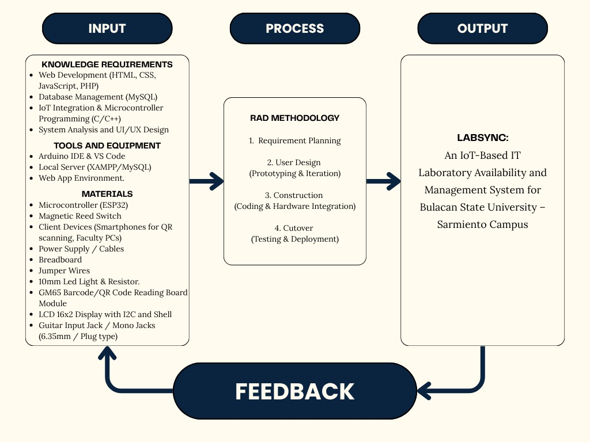

Figure 1. Conceptual Framework
This study has a conceptual framework that is based on the Input-Process-Output-Feedback (IPOF) model. It is a model that demonstrates the movement of the resources, the use of the development methodology, and the resulting system that will be used in Bulacan State University – Sarmiento Campus.

Input

The Input phase involves the preconditions required to start the development of LabSync.
Knowledge Requirements: This includes the technical knowledge needed for the development of the system, such as web development using HTML, CSS, JavaScript, and Node.js with Express.js, database management using MySQL, IoT integration and microcontroller programming using C/C++, and system analysis and UI/UX design.
Tools and Equipment: The software and development environment consist of the Arduino IDE for programming the hardware, VS Code for developing the web application, Node.js runtime environment with npm package manager, MySQL/MariaDB database engine, and modern web browsers.
Materials: These include the physical components needed to build the IoT node, such as the ESP32 microcontroller, 6.35mm audio jack sockets with precision resistor-divider circuits, active buzzer module, client devices such as smartphones and PCs, power supply and cables, breadboard, jumper wires, GM65 Barcode/QR Code Reading Board Module, LCD 16x2 Display with I2C and Shell, and custom two-sided acrylic keychain tags.

Process

The Process stage incorporates the Rapid Application Development (RAD) model. It was selected because the method allows the researchers to develop, test, and improve the system through different stages.

Requirement Planning: Determining the scope of the system and identifying the requirements needed for the laboratory management system.
User Design: Creating the system prototypes, UI mockups, and hardware design based on the identified requirements.
Construction: Developing the Node.js/Express.js REST API backend, MySQL database schema and migrations, modular frontend interfaces, and ESP32 firmware, including the integration of the IoT hardware.
Cutover: Conducting the final testing, deployment, and implementation of the system in the laboratory.

Output

The final output is the completed system “LabSync: An IoT-Based IT Laboratory Availability and Management System for Bulacan State University – Sarmiento Campus.” The system is designed to provide real-time monitoring of laboratory availability, equipment reporting, and centralized laboratory management through the use of web-based and IoT technologies.

Feedback

The Feedback loop provides a way for the system to be continuously improved. The results of testing, together with the observations and recommendations from the intended users, can be used to identify parts of the system that need improvement. This allows the researchers to make necessary

changes to the system requirements, hardware configuration, and other features to better suit the needs of the department.

Development Methodology
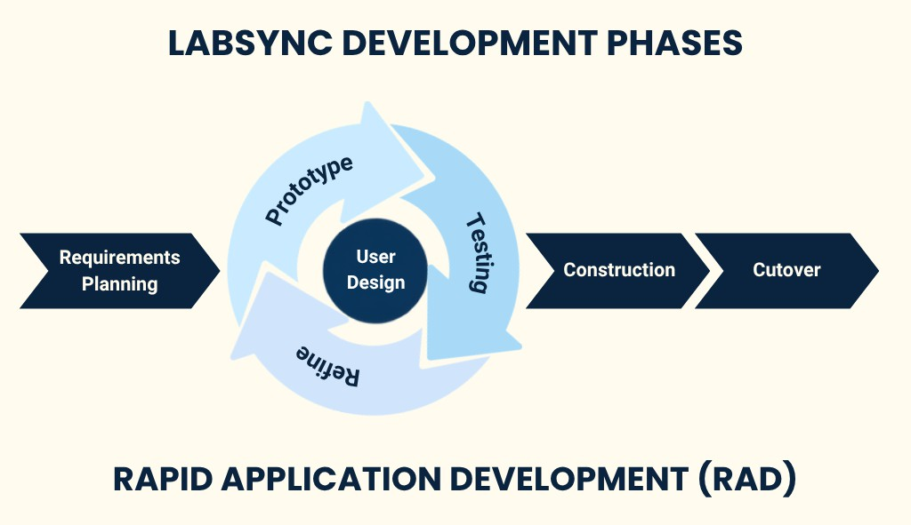

Figure 2. Development Methodology (RAD)

The researchers used the Rapid Application Development (RAD) method to build LabSync. This approach was chosen because it allows the team to quickly create working prototypes, test them with users, and make changes based on their feedback. As shown in the diagram, the development process has four main steps: Requirements Planning, User Design, Construction, and Cutover.
In Requirements Planning, the researchers looked into the daily problems inside the IT computer labs, such as missing key records, room schedule conflicts,

and slow PC repair reporting. From there, the team listed the exact features, hardware parts, and software tools needed for the project.
The User Design stage was done in repeated cycles of prototyping, testing, and refining. The team created early layouts of the website and basic test circuits for the ESP32 key box. By showing these mockups to teachers and staff, the researchers saw what worked and what was confusing, allowing them to adjust features like the drag-and-drop schedule and the mobile QR scanner before building the final version.
In the Construction phase, the actual system was built. The web pages, REST API backend, and database integration were coded using JavaScript (ES6+), Node.js, Express.js, and MySQL, while the ESP32 code was written in C++. At the same time, the physical acrylic box was assembled with its 6.35mm key jacks, LCD screen, buzzer, and QR scanner.
In the final phase, the Cutover stage involved bringing the finished system to the IT Department for testing and evaluation. Students, faculty, and staff tested the website and the key box. Their feedback was measured using the ISO/IEC 25010 software standard and the Technology Acceptance Model (TAM) to see if LabSync was reliable, easy to use, and ready for actual campus use.

System Design

The system design serves as the overall blueprint showing how the software and hardware components of LabSync connect and operate together. Rather than functioning solely as a typical website, the system links an online dashboard

directly with an electronic key monitoring box so that room availability and key custody update immediately. This setup directly replaces manual logbooks and door schedules, establishing a more accurate and organized process for tracking laboratory rooms and computer equipment.
To clearly illustrate how the system is structured, several design models are presented. The Context Diagram outlines the general system boundary and shows how the platform interacts with its external entities: the IT Department Head, Faculty, Students, MIS Staff (including supervised OJT interns), and the ESP32 key box. The Use Case Diagram defines the specific actions and access permissions granted to each user role. The Data Flow Diagrams (DFD) trace the movement of information across the system, mapping how schedule updates, key presence signals, and workstation fault reports travel from user interactions into the database.
For the data and hardware structure, the Entity-Relationship Diagram (ERD) defines the database tables and relationships used to store user accounts, class timetables, workstation assets, key logs, and repair tickets. The System Architecture Diagram illustrates the hardware-to-software pipeline, showing how the ESP32 microcontroller communicates sensor events to the web server over local Wi-Fi. Detailed Flowcharts document the step-by-step logic of essential operations, including dynamic room status calculation, mobile QR key custody transfers, visual schedule conflict detection, and individual fault reporting. Together, these diagrams provide a complete overview of how LabSync connects physical laboratory tracking with centralized web management.

Context Diagram
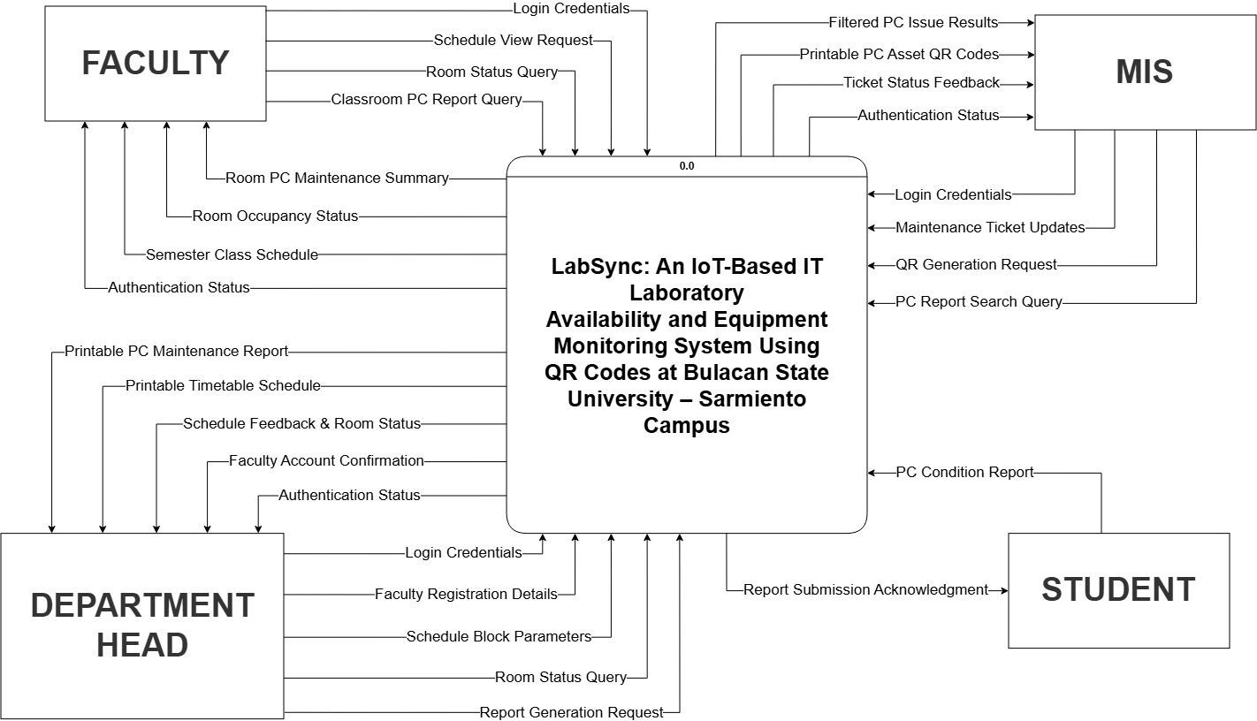

Figure 3. Context Diagram

The Context Diagram provides a high-level overview of the boundary and data interactions of the LabSync system with its four external entities: the Department Head, Faculty, MIS, and Student.
The Department Head manages the academic and administrative setup by supplying login credentials, faculty registration details, schedule block parameters, room status queries, and report generation requests. In response, the system provides authentication status, faculty account confirmations, schedule feedback with room status updates, printable timetable schedules, and printable PC maintenance reports.

Faculty members interact with the system by inputting login credentials, schedule view requests, room status queries, and classroom PC report queries. The system returns authentication status, the assigned semester class schedule, real-time room occupancy status (Available, In Session, Borrowed), and a summary of room PC maintenance to help them manage seat plans and room custody.
For equipment maintenance, the Student entity acts as an external reporter, submitting PC condition reports for defective desktop parts without needing an account, and receiving an immediate report submission acknowledgment. The system prevents duplicate active issues by checking whether an unresolved issue already exists for that computer and component, associating additional reports with the active issue. The MIS staff and supervised OJT interns manage these records by providing login credentials, maintenance ticket updates, QR generation requests, and PC report search queries. In return, the system outputs authentication status, ticket status feedback with attributed resolver tracking, printable PC asset QR codes, and filtered PC issue results to guide physical computer repairs across the laboratories.

Data Flow Diagram
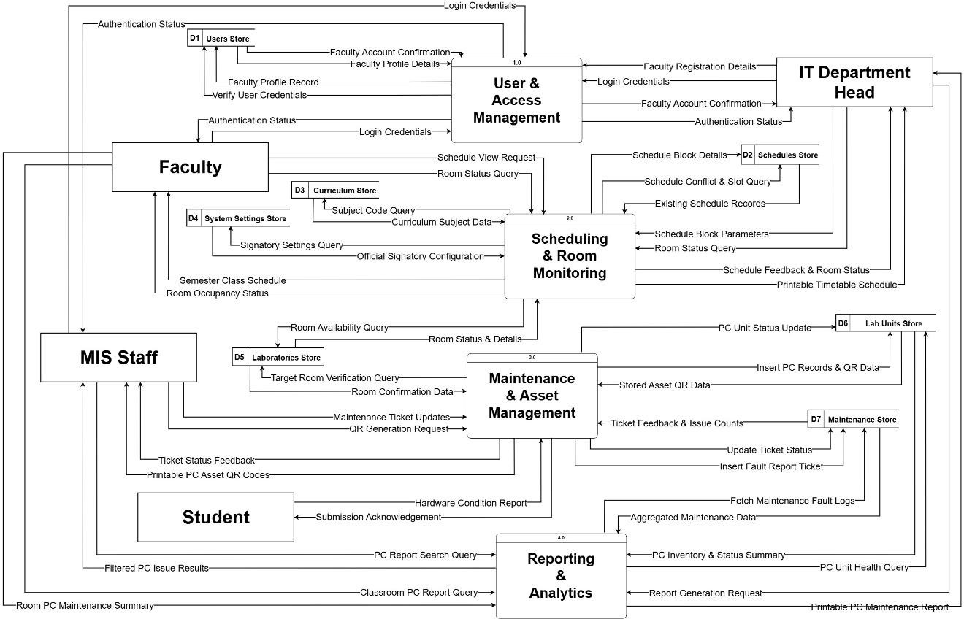

Figure 4. Data Flow Diagram

The Level 1 Data Flow Diagram (DFD) in Figure 4 explains how information moves inside LabSync through four main processes: User & Access Management (1.0), Scheduling & Room Monitoring (2.0), Maintenance & Asset Management (3.0), and Reporting & Analytics (4.0).
User & Access Management (1.0) handles system security and role authentication for the IT Department Head, Faculty, and MIS Staff. When users enter their login credentials, the process checks them against the Users Store (D1) to verify accounts and enforce role permissions. The IT Department Head also submits faculty registration details through this process, which creates profile records in D1 and returns confirmation notices.

Scheduling & Room Monitoring (2.0) manages class schedules and real-time room status tracking. The IT Department Head inputs schedule block parameters and queries room statuses, which the process cross-references against the Schedules Store (D2) to detect time overlaps or conflicts. The system also consults the Curriculum Store (D3) for subject codes, the System Settings Store (D4) for official signatory lines, and the Laboratories Store (D5) for room availability. In return, the Department Head receives schedule feedback, room updates, and printable timetables, while Faculty members can view their semester class schedules and live room occupancy states (Available, In Session, or Borrowed).
Maintenance & Asset Management (3.0) processes hardware tracking and repair tickets for laboratory workstations. Students submit hardware condition reports without logging in, which the system checks against unresolved issues for that workstation and component within the Maintenance Issues Store (D7), linking matching reports to the active issue and sending an immediate submission acknowledgment back to the student. MIS Staff and supervised OJT interns submit status updates, record inspection progress, and attribute the authenticated resolver upon issue completion. MIS Staff also verify room data via the Laboratories Store (D5), and store computer records and QR codes into the Lab Units Store (D6). This updates PC unit statuses in D6 and returns printable asset QR codes and ticket feedback to the technical personnel.
Reporting & Analytics (4.0) handles data retrieval and summary generation across the laboratories. It queries the Lab Units Store (D6) for inventory health and pulls active fault logs from the Maintenance Store (D7). From this combined data, the process delivers printable PC maintenance reports to the Department Head,

filtered issue lists to MIS Staff for inspections, and room maintenance summaries to Faculty to help them monitor equipment conditions in their classrooms.

Use Case Diagram
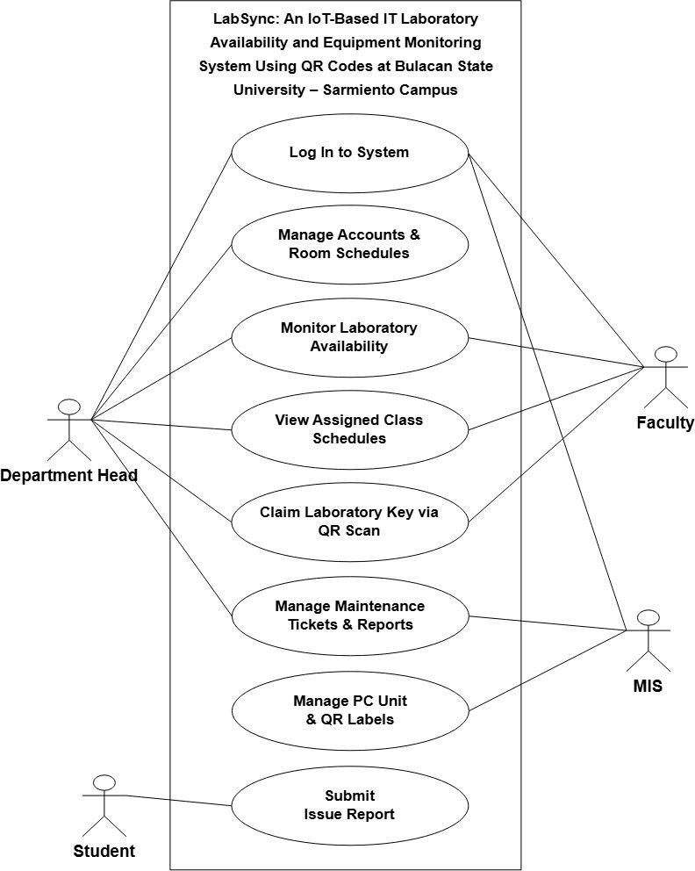

Figure 5. Use Case Diagram

The Use Case Diagram displays the system boundary and interactions between the different users of LabSync—Department Head, Faculty, MIS Staff,

and Student. The system segregates its features according to the roles as that every person has access only to what he or she needs for his or her task.
The Department Head has the highest level of control of accounts, room schedule, lab availability and maintenance reports. This configuration is required since the class schedule and teacher accounts must be centrally approved. It guarantees that room assignments and instructor profiles are appropriately approved prior to classes.
Faculty members will have access to their class schedules, live room availability, and key claiming through QR scan. Teachers are not allowed to make any changes to schedules or accounts on the system to avoid inadvertent changes of master records, but will have access to the tools they need to determine the location of their classes and record who has custody of their lab keys.
The MIS Staff is dedicated 100% to hardware maintenance and inventory with a particular emphasis on ticket tracking, tracking repair status, and printing QR code labels for Lab PCs. Assisting the staff, the OJT Intern role is authorized to inspect reported workstation defects, update ticket progress (Pending, In Progress, Resolved), and record resolutions under their authenticated identity, while administrative functions such as key management, user provisioning, and QR generation remain restricted to permanent MIS personnel. Sharing the resolution of tickets with MIS technicians and interns ensures that computers are marked as fixed only after a real inspection or repair.
Lastly, the Student role can only submit issue reports with zero login. Students never need to register, remember passwords or navigate administrative dashboards. The system allows them to report a broken mouse, keyboard or monitor just by scanning the QR sticker on the PC, so it eliminates the obstacles associated with reporting and excludes the risk of paper logbook inaccuracies without compromising the security of the rest of the system.

Circuit Diagram & Pin Mapping Table

Circuit Diagram
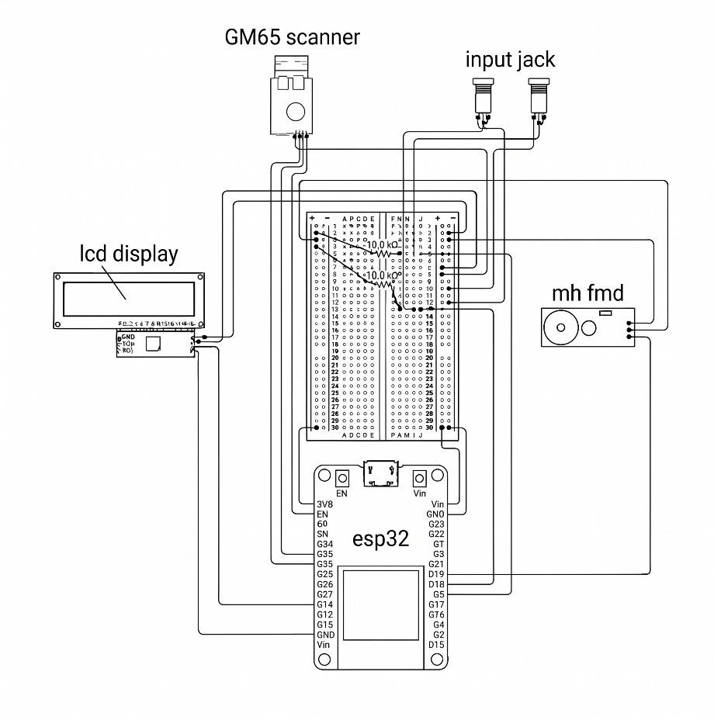

Figure C. Circuit Diagram
The circuit diagram details the schematic wiring and signal routing of the system, governed by an ESP32 microcontroller that manages all data processing. Input data is transmitted from a GM65 Scanner via serial communication for code scanning, while two input jacks are connected across a breadboard utilizing dual
$10\text{k}\Omega$ pull-up resistors to enforce stable logic voltage levels on the input pins. For output handling, the microcontroller interfaces with an LCD Display over I2C communication (SDA/SCL lines) for visual status updates, and drives an MH-FMD Buzzer Module to output audible alert signals, with all operational modules tied to common power and ground rails.

Pictorial Diagram
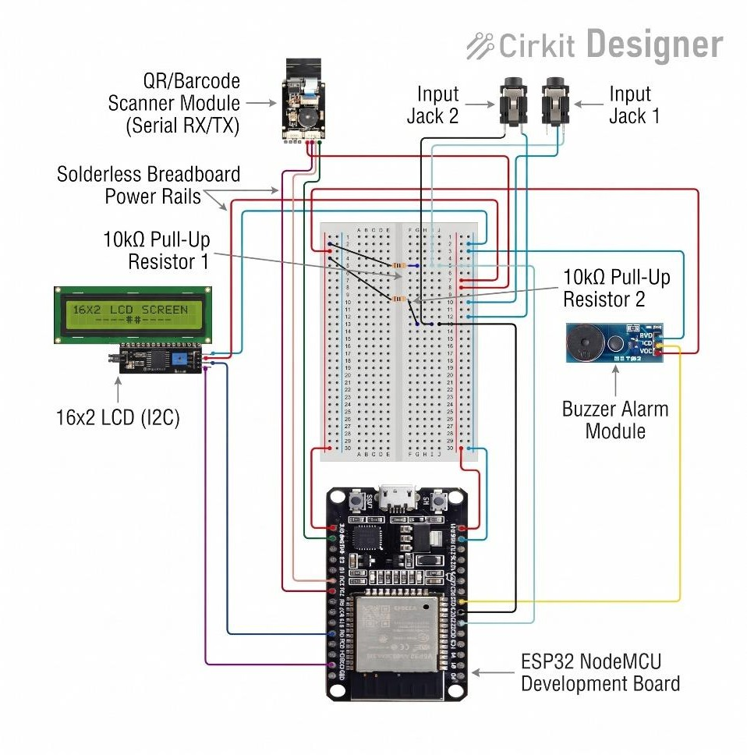

Figure 7. Pictorial Diagram

The pictorial diagram illustrates the complete physical hardware integration of the system, centered around an ESP32 NodeMCU Development Board which serves as the main processing unit. System input is captured through a QR/Barcode Scanner Module using Serial RX/TX pins for credential reading, alongside Input Jack 1 and Input Jack 2 which interface with external sensors, stabilized by two 10kΩ pull-up resistors on a solderless breadboard to prevent floating signal states. For visual feedback and status monitoring, the microcontroller is wired to a 16x2 LCD display integrated with an I2C module to simplify data lines, while a Buzzer Alarm Module provides immediate auditory feedback during system operations. All peripheral components receive power and

ground connections routed directly through the solderless breadboard power rails, establishing a unified hardware circuit.

Pin Mapping Table

Table 5. Pin Mapping Table

Component | Pin Label | ESP32 Pin (GPIO) | Function / Description
6.35mm Jack Socket (Slot 203) | Tip / Sense Line | GPIO 32 | ADC Analog Input (detects 10kΩ resistor key, ADC ~1800)
6.35mm Jack Socket (Slot 204) | Tip / Sense Line | GPIO 33 | ADC Analog Input (detects 0Ω direct wire key, ADC ~0)
GM65 Barcode/QR Scanner | TX Pin | GPIO 17 | Hardware Serial2 RX (Data reception from scanner)
GM65 Barcode/QR Scanner | RX Pin | GPIO 16 | Hardware Serial2 TX (Configuration / trigger output)
16×2 Character LCD (I2C) | SDA Line | GPIO 21 | I2C Serial Data line (Screen display updates)
16×2 Character LCD (I2C) | SCL Line | GPIO 22 | I2C Serial Clock line (Screen display clock)
Active Buzzer Module | I/O Pin | GPIO 25 | Digital Output (Active-low alarm trigger for wrong key / errors)
Common Power & Ground | VCC / GND | 3.3V / 5V / GND | Power distribution rails across all peripheral modules

The LabSync Pin Mapping Table lists the specific wiring connections between the external hardware peripherals and the ESP32 microcontroller as implemented in the active firmware. The hardware configuration centers on analog voltage-divider sensing and serial peripheral communication. For key detection, 6.35mm jack sockets connect to analog ADC pins GPIO 32 (Slot 203) and GPIO 33 (Slot 204), reading distinct analog voltage thresholds to reliably detect key insertion and verify key identity (10kΩ resistor key for Room 203, and 0Ω direct wire for Room 204). The GM65 optical scanner interfaces via Hardware Serial2 on GPIO 17 (RX) and GPIO 16 (TX) at 9600 baud. For visual and auditory feedback, a 16×2 character LCD communicates over the I2C bus via GPIO 21 (SDA) and GPIO 22 (SCL) at address 0x27 or 0x3F, while an active buzzer module connects to GPIO 25 with an active-low trigger to alert users of wrong-key insertions or operational errors.

System Architecture Diagram
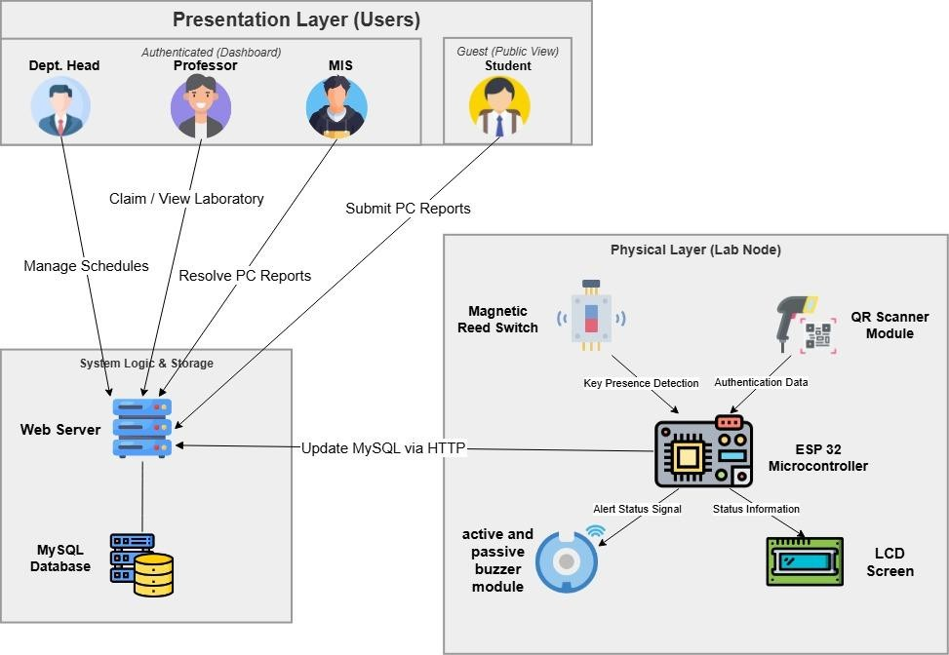

Figure 8. System Architecture Diagram
The LabSync system is built on a three-tier architecture, connecting user Web interfaces, a central system with logic, and a physical IoT device in the computer laboratories.

l. Presentation layer

This layer is created using Vanilla HTML, CSS, and JavaScript and gives out the user interface:
- Unauthenticated Users (Dashboard): Students and guests log in to view and interact with public information. The Dept. Head can use the dashboard to schedule and plot lab schedules, the Professor can use the dashboard to

view assigned schedules and book labs, and the MIS staff can book and resolve lab equipment tickets.
- Guest User (Public View): The Student can submit a zero login hardware fault report directly from a workstation by scanning a QR code which is displayed on the workstation.

II. System Logic & Storage

This layer is the centralized backend which handles requests from the system and application data.
- Web Server: Receives a request from the user through the Web dashboards, receives the student mobile form's issue reports, and accepts the real-time sensor data from the laboratory hardware using HTTP.
- MySQL Database: Contains system’s fundamental data such as user accounts, room scheduling, key transaction logs, and equipment maintenance reports submitted by students.

III. Physical Layer (Lab Node)

The physical layer includes the IoT hardware in each laboratory room used to automate important tracking and occupancy monitoring:
- ESP32 Microcontroller: It is to act as the brain of the node, gathering data from the sensors and providing up-to-the-minute data about the node's condition to the web server through Wi-Fi using HTTP.

- 6.35mm Jack Sockets with Resistor-Divider Analog Sensing: Electromechanical audio jack ports connected to ESP32 ADC pins (GPIO 32 and GPIO 33) that read distinct voltage signatures to reliably verify physical key presence and detect if an incorrect key is inserted into a room slot.
- QR Scanner Module: Capture the QR codes and recognized from the physical world and provide the data to the Microcontroller directly.
- LCD Screen: It is used to show the room status immediately outside of the lab for instructor and student viewing.
- Active and Passive Buzzer Module: Provides audible alarms to indicate successful scan and/or unauthorized key access.

Flowchart Login
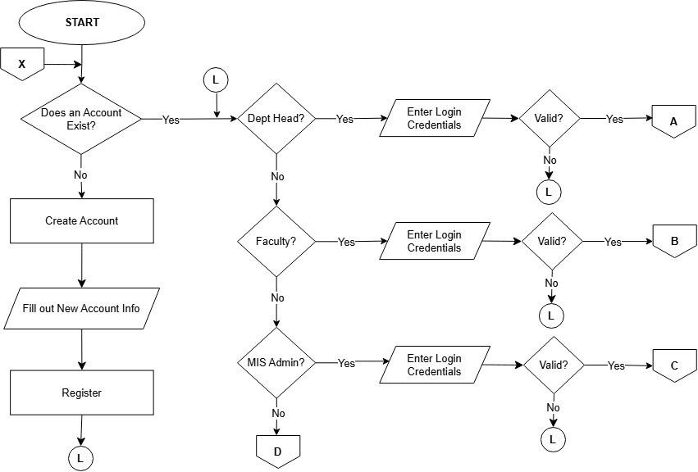

Figure 9. Login

The Login screen is the main entry point for the authorized users of LabSync: the Department Head, Faculty, and MIS Staff. It has a simple layout where users only need to type in their email and password to access their accounts. Once a user logs in, the system checks their role and takes them straight to their specific dashboard, making sure they only see and edit the features meant for them. Students do not need to log in or create an account on this page because they can report broken computers directly by scanning a QR code, which keeps the login screen simple and prevents unauthorized people from messing with schedules and records.

Department Head User
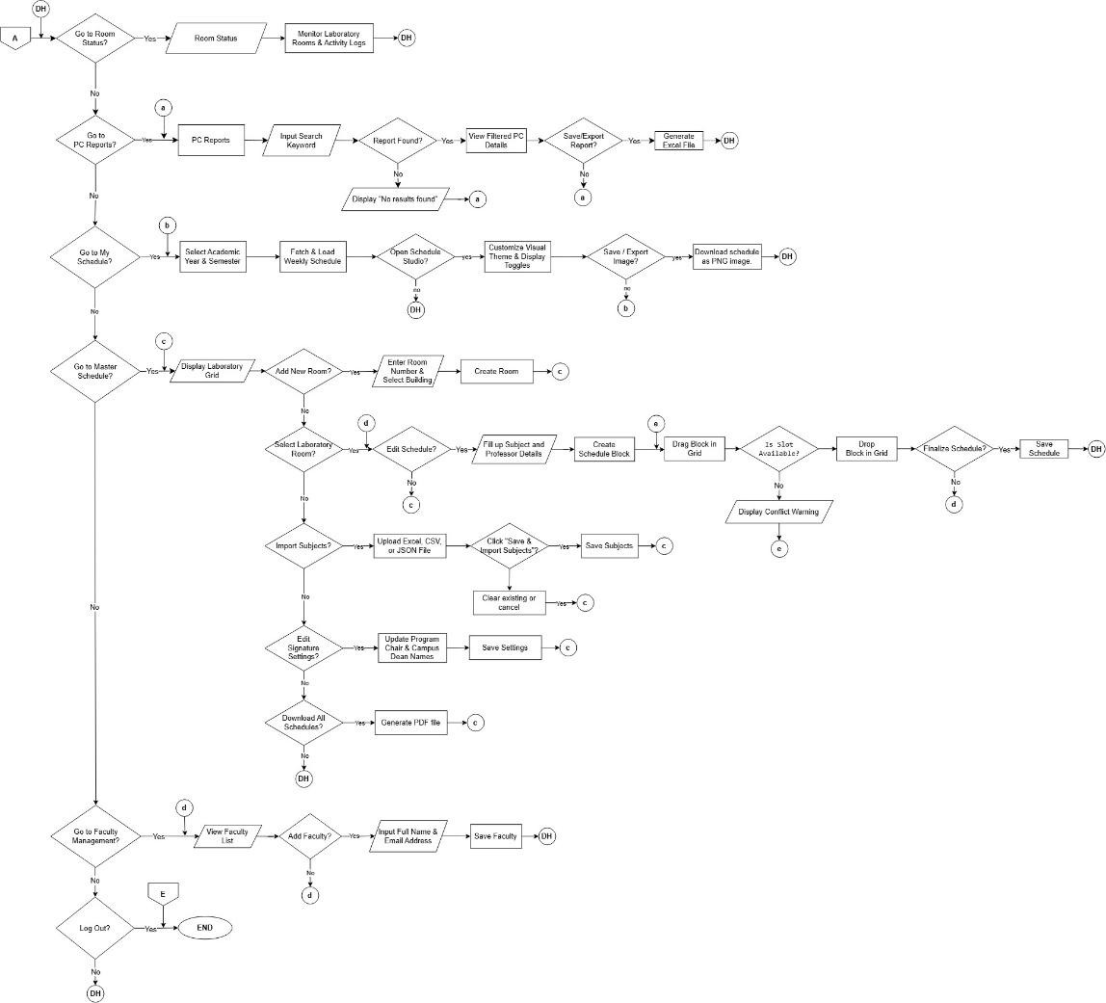

Figure 10. Department Head

This flowchart shows the highest level of access in the system, as department heads are the main administrators. The Department Head can view the status of rooms in real time, search and export PC issue reports and download their schedule from the main dashboard. The primary reason for this flow is "Go to Master Schedule" branch. In this area the Department Head can add rooms, import subjects from the CSV/Excel files and create the timetable. This important validation step in the schedule builder flow is a question: "Is Slot Available?". Otherwise, it shows an error message that states there is a conflict. This is an in-built logic that explains why the system will not allow double booking and overlapping times before saving the last timetable.

Faculty User
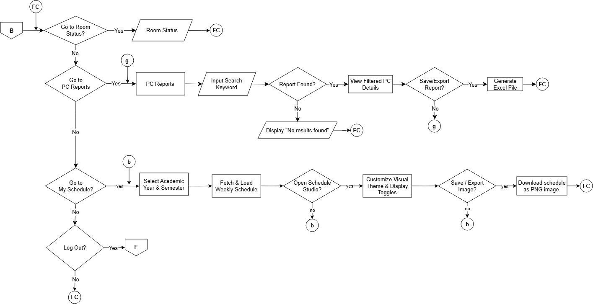
Figure 11. Faculty

The Faculty flowchart calls for a constrained, non-writable system for managing laboratories. Instructors are able to update the real-time room statuses without changing system settings or getting to know the master schedules, so their workflow is simplified into three main branches: checking room statuses, viewing the PC fault reports of their assigned classrooms, and accessing "My Schedule. In the schedule branch they can choose an academic year and semester, they can tailor the visual theme in Schedule Studio and they can export their timetable as a PNG image.

Management Information System (MIS) User
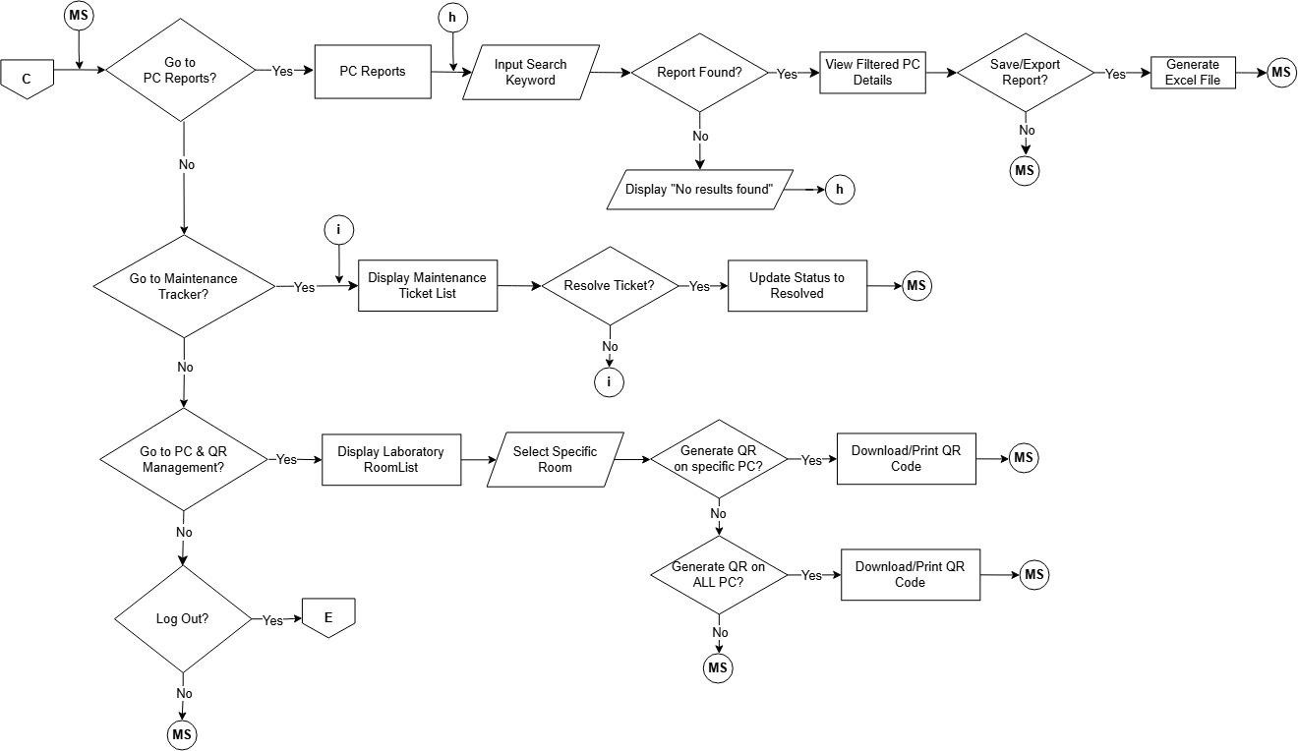

Figure 12. Management Information System (MIS)

The MIS Admin flowchart describes the process for technical staff to track hardware and make repairs. Under this workflow, MIS personnel oversee campus-wide equipment health, register workstation QR codes, manage physical key allocations, and supervise OJT intern accounts. When addressing defect tickets, technicians and interns investigate reported symptoms, update progress statuses (Pending, In Progress, Resolved), and record authenticated resolver attribution upon closing an issue. The system prevents ticket clutter by associating repeated student reports with the existing active issue until service is complete.

perspective. They have the first branch to search and export detailed PC reports submitted by students. The "Maintenance Tracker" branch is consistent with its job in the repair lifecycle – the only users who can choose a ticket and update it to "Resolved" to close out an issue. Lastly, the "PC & QR Management" branch lets the technician know how physical tracking is maintained as they can choose to generate and print QR codes for a particular PC or for all the PCs in a particular lab room. This flow directly links the digital database to the actual lab equipment.

Student User

Figure 13. Student
The "zero-login" reporting feature on the platform is justified by the Student flowchart. Students just scan the QR sticker on the PC, which instantly identifies the computer and room location without asking for an account or password. Behind the scenes, the reporting pipeline checks whether an unresolved issue already exists for that computer and component; if an issue is active, the submission is associated with the existing issue rather than creating a duplicate ticket. This direct approach makes reporting quick and effortless, encouraging students to submit broken computer parts right away while maintaining an organized, deduplicated maintenance backlog for the technical staff.

Mockups Login
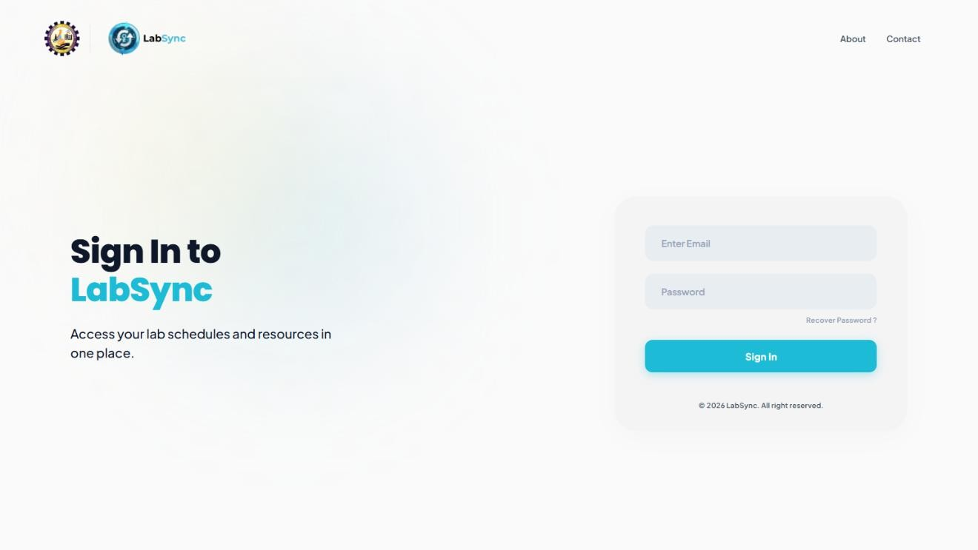

Figure 14. Login Screen

The Login screen is the main entry point for the authorized users of LabSync: the Department Head, Faculty, and MIS Staff. It has a simple layout where users only need to type in their email and password to access their accounts. Once a user logs in, the system checks their role and takes them straight to their specific dashboard, making sure they only see and edit the features meant for them. Students do not need to log in or create an account on this page because they can report broken computers directly by scanning a QR code, which keeps the login screen simple and prevents unauthorized people from messing with schedules and records.

Department Head

Department Head Dashboard
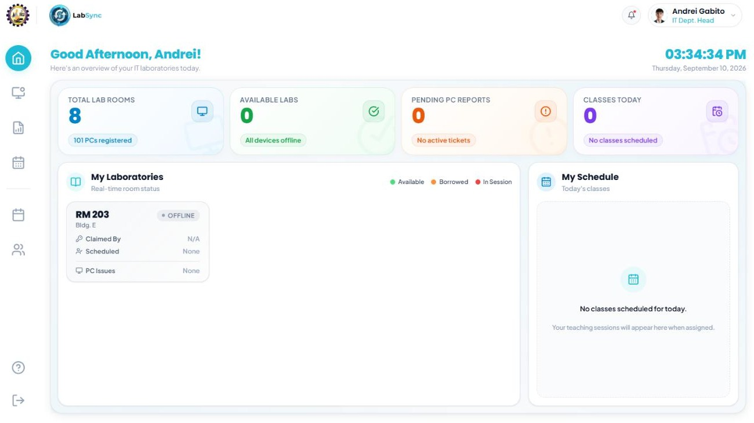

Figure 15. Department Head Dashboard

The Department Head Dashboard serves as the central control panel for overseeing all IT computer laboratories in real time. The top section displays summary cards showing the total registered rooms and computers, currently available laboratories, pending fault reports, and today's scheduled classes. Below this, the screen provides live status cards for each laboratory room—tracking whether a space is Available, Borrowed, In Session, or Offline—along with who claimed the room, the active schedule, and unresolved PC defects. It also includes a personal daily schedule pane for the Department Head. This setup justifies the platform’s need for centralized monitoring, allowing the administrator to verify room

availability, track key custody, and check urgent maintenance needs at a glance without having to rely on physical logbooks.

Department Head Room Status
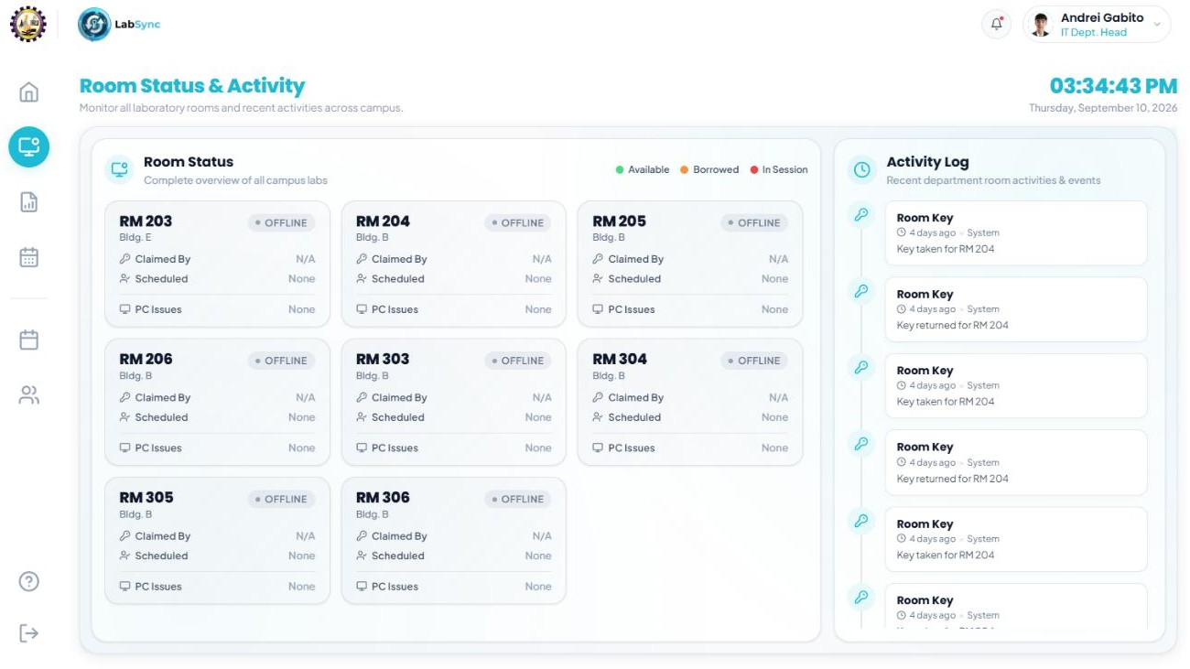

Figure 16. Department Head Room Status

The Room Status & Activity interface pairs real-time laboratory room conditions with an audit timeline of campus room events. The left panel shows live status cards for each laboratory across campus buildings—displaying keyholder custody, active class schedules, and open hardware defects—while the right-hand Activity Log records timestamped key transactions, such as when physical keys are taken or returned. This interface justifies the platform's security and monitoring objectives, eliminating manual logbooks by providing an instant, verifiable record of room possession and current laboratory availability.

PC Issue Reports
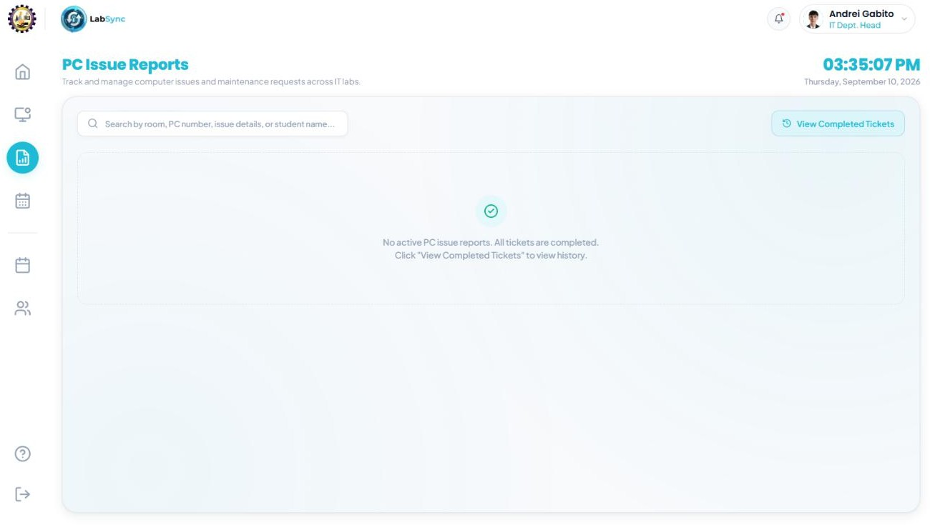

Figure 17. Department Head Pc Reports

The PC Issue Reports interface allows the department head to track and manage submitted workstation defect tickets across all campus laboratories. It features a universal search bar to look up reports by room, PC number, issue details, or student name, along with a button to review historical completed tickets. This interface justifies the department head's administrative oversight role in laboratory upkeep, ensuring that workstation breakdowns reported by students are visible at the departmental level so resource allocation, replacement purchasing, and repair delays can be properly monitored.

My Schedule

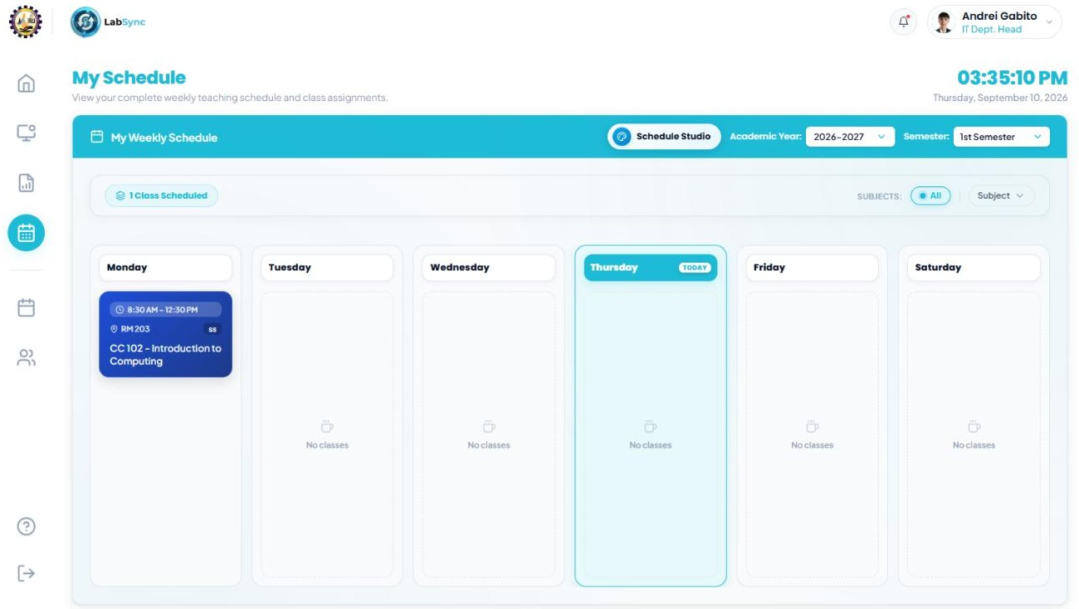

Figure 18. Department Head My Schedule

The My Schedule interface provides a personalized weekly view of the department head's own assigned classes, organized by academic year and semester. It highlights the current day's classes, displays room assignments and time slots, and integrates a "Schedule Studio" button for adjusting visual export preferences. This screen justifies the necessity of separating individual teaching commitments from administrative oversight, allowing department heads who actively teach to quickly check their daily laboratory assignments, room locations, and time allocations without sifting through the institution-wide master timetable.

Master Schedule Overview

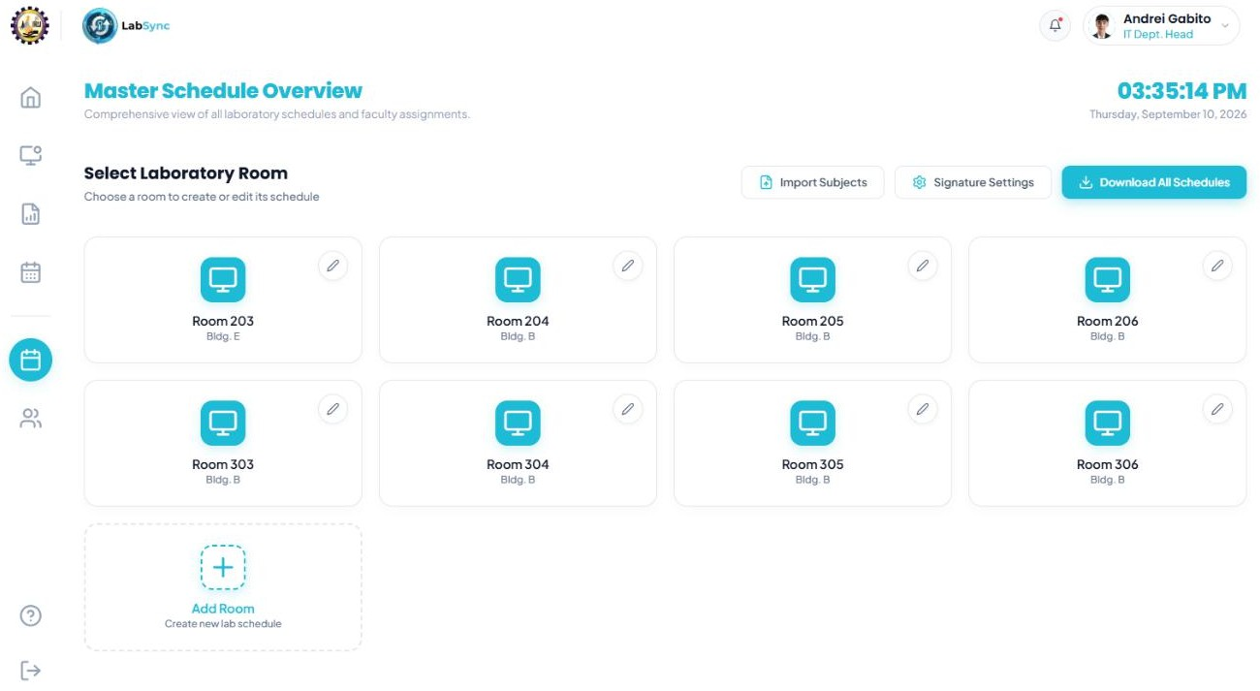

Figure 19. Department Head Master Schedule

The Master Schedule Overview serves as the department head’s main workspace for room timetable management, presenting a grid of all registered laboratory rooms alongside administrative tools to import subjects, configure signatory settings, and download complete schedules. Each room card provides direct access to its specific timetable editor, while an "Add Room" action allows expansion when new laboratory facilities are established. This interface justifies the platform’s need for centralized, room-based schedule planning, giving the administrator an organized starting point to manage room assignments, bulk-import curriculum loads, and ensure consistent signatory approvals across the entire department.

Master Schedule

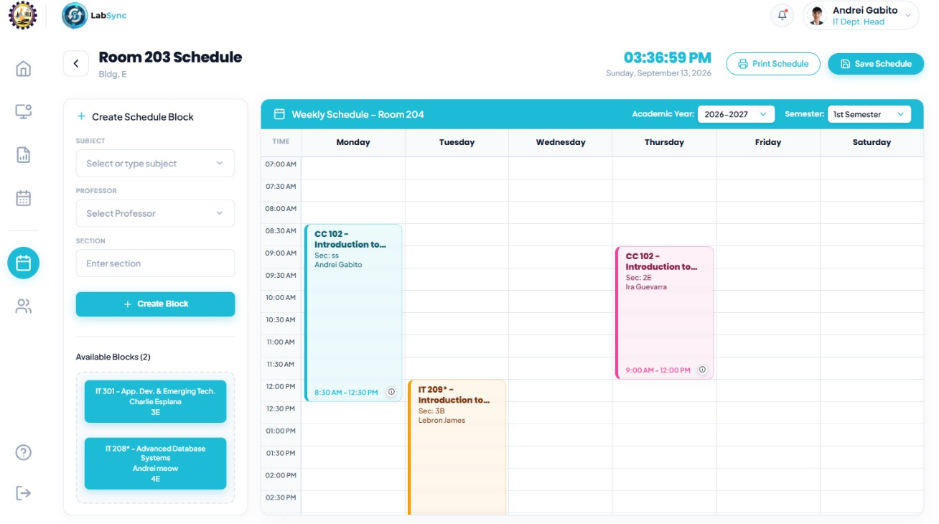

Figure 20. Department Head Master Schedule ll

The Master Schedule Builder provides an interactive drag-and-drop timetable interface for plotting a specific laboratory room's weekly schedule across Monday to Saturday. The administrator creates custom schedule blocks on the left panel—specifying the subject, instructor, and section—and drags them directly into designated time slots on the weekly calendar grid, with dedicated buttons to save changes or print the finalized timetable. This layout justifies the system's conflict-free scheduling approach: by displaying clear visual time blocks and validating time availability on drop, it prevents room double-booking and schedule collisions while giving the department head full control over laboratory loading.

Faculty

Faculty Dashboard

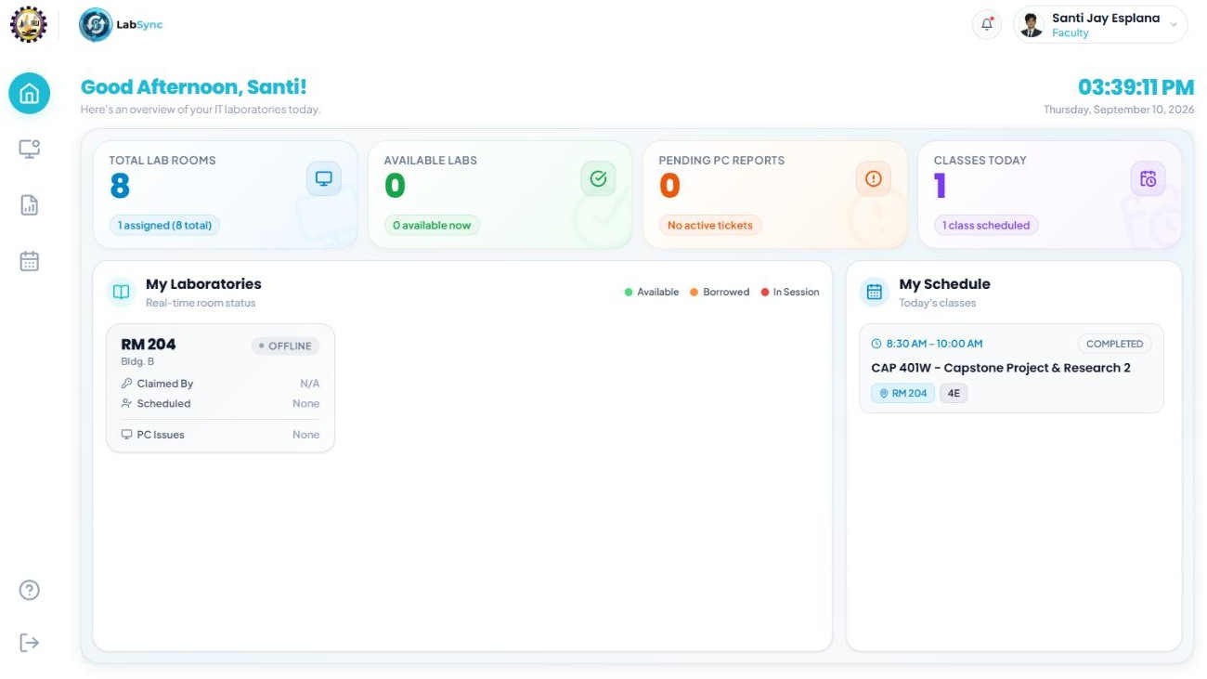

Figure 21. Faculty Dashboard

The Faculty Dashboard gives teachers a quick summary of their daily classes and the current state of each computer laboratory. At the top, counter cards display practical figures like total teaching hours, classes for the day, upcoming class blocks, and pending computer defect reports. Right below, teachers can check their own daily class list complete with time slots, course codes, and assigned rooms beside live laboratory status cards that show if a room is open, currently occupied, or dealing with broken PCs. This setup keeps teachers informed before they even head out to class, letting them check their daily lineup

and confirm their lab is ready for hands-on activities without needing to ask around or flip through paper logbooks.

Faculty Room status

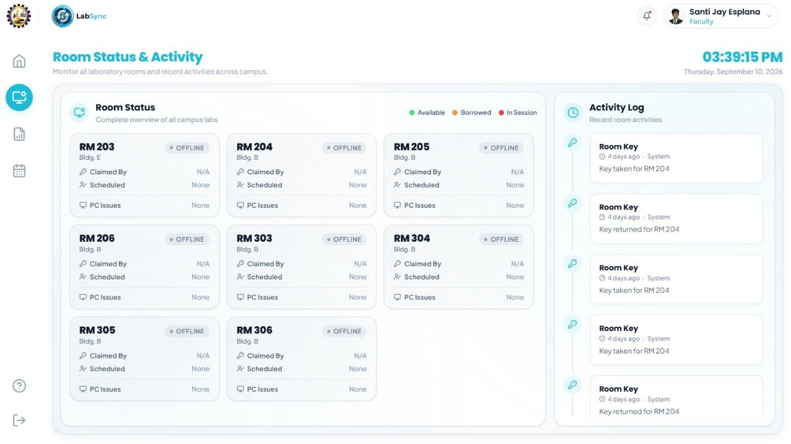

Figure 22. Faculty Room Status

The Room Status interface gives faculty members a live, campus-wide view of all computer laboratories. Each laboratory card shows whether a space is Available, Borrowed, or In Session, who currently holds the physical key, and how many broken computers are reported inside. Beside the room cards, an activity log records key pull-outs, returns, and room handoffs as they happen. This setup saves teachers from making unnecessary trips across the building, letting them verify beforehand if a lab is unlocked, vacant, or ready for their next lecture.

Faculty Pc issue report

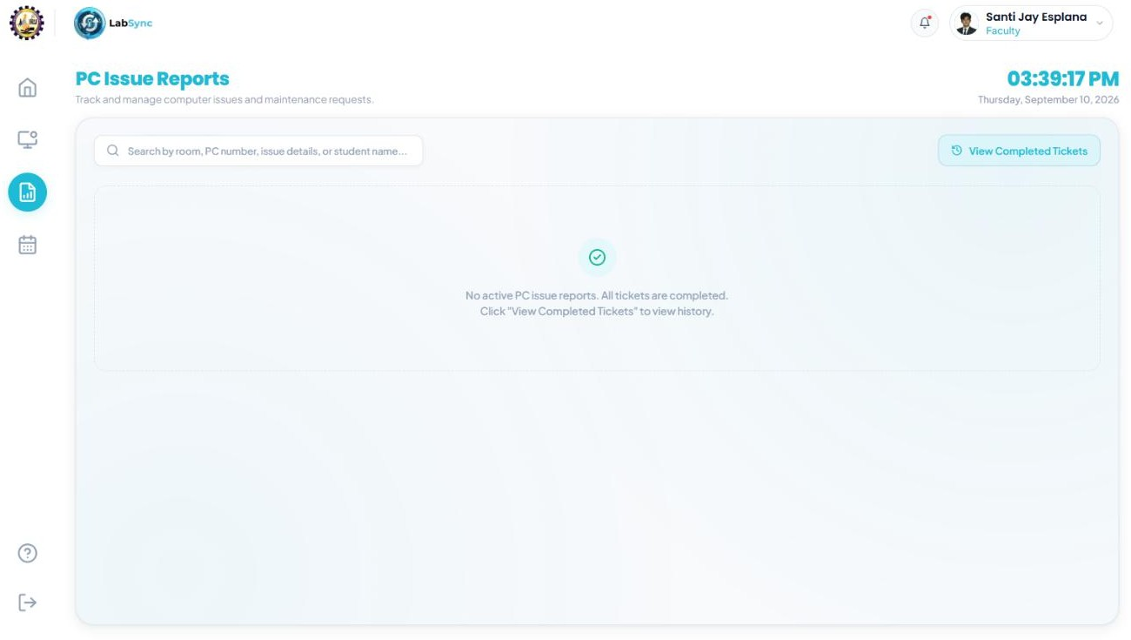

Figure 23. Faculty Pc Issue Reports

The PC Issue Reports screen allows instructors to monitor computer hardware problems reported by students across different laboratories. Each report card specifies the room name, PC number, defective parts like a mouse, keyboard, or monitor, the student's note describing what went wrong, and the submission date. The page also includes quick search and filter tools so professors and instructors can easily find specific issues. Having access to these reports helps faculty plan ahead for laboratory tasks, ensuring they can seat students at working computers and stay updated on ongoing equipment repairs.

Faculty My schedule

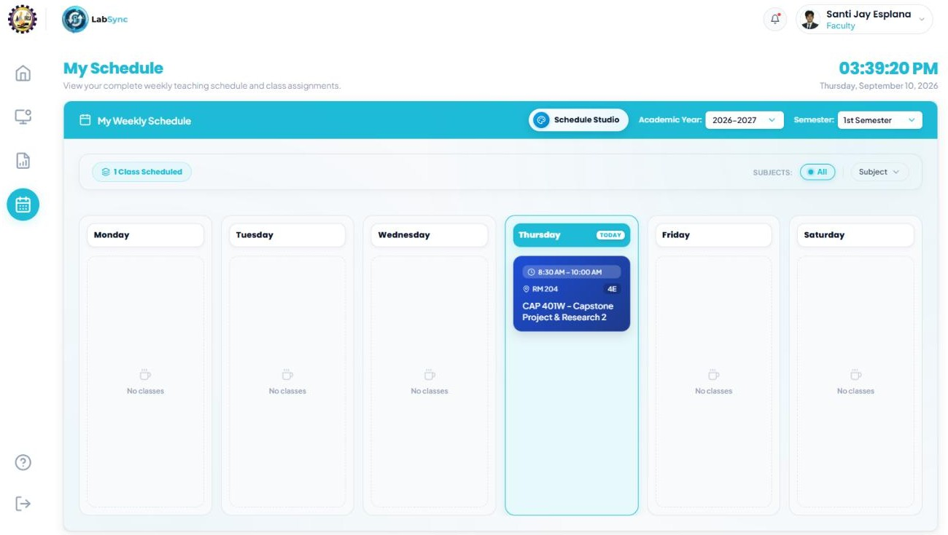

Figure 24. Faculty My Schedule

The My Schedule interface lays out an instructor's assigned classes in an easy-to-read weekly timetable. Classes are arranged across morning and afternoon periods, clearly listing the subject name, student section, room assignment, and exact time slot, with an option to export or print the schedule. Having this personalized view makes it simple for teachers to manage their teaching load and transition between back-to-back classes without second-guessing their room assignments or digging through the master schedule.

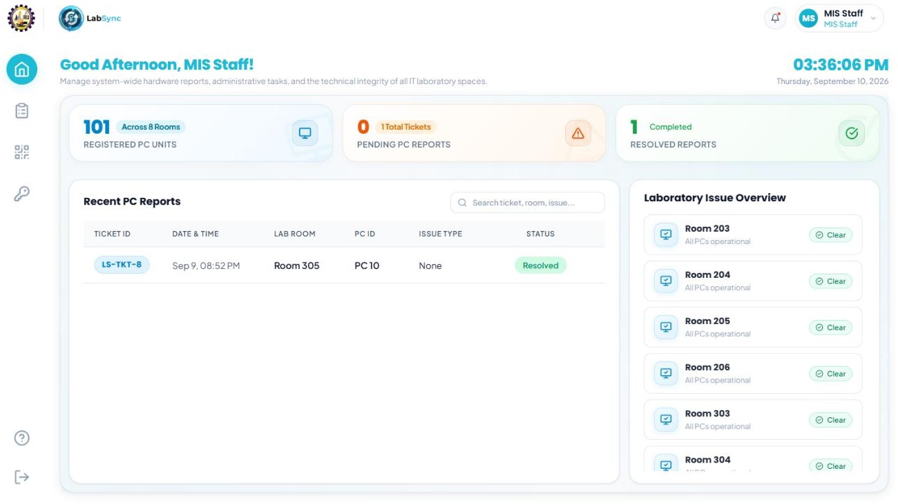
Management Information System (MIS) MIS Dashboard

Figure 25. MIS Dashboard
The MIS Dashboard serves as the main command center for the technical staff to monitor laboratory equipment and room operations across the department. The top summary counters track total registered computer units, available laboratories, pending fault tickets, and workstations currently marked as operational or defective. Below, the screen displays real-time laboratory room status cards showing live occupancy, key possession, and active defect tallies alongside a quick-view queue of the most recently submitted PC issue reports. This layout allows technical personnel to assess campus-wide maintenance demands at a glance and quickly prioritize urgent hardware repairs without checking multiple rooms in person.

MIS Pc Qr Management

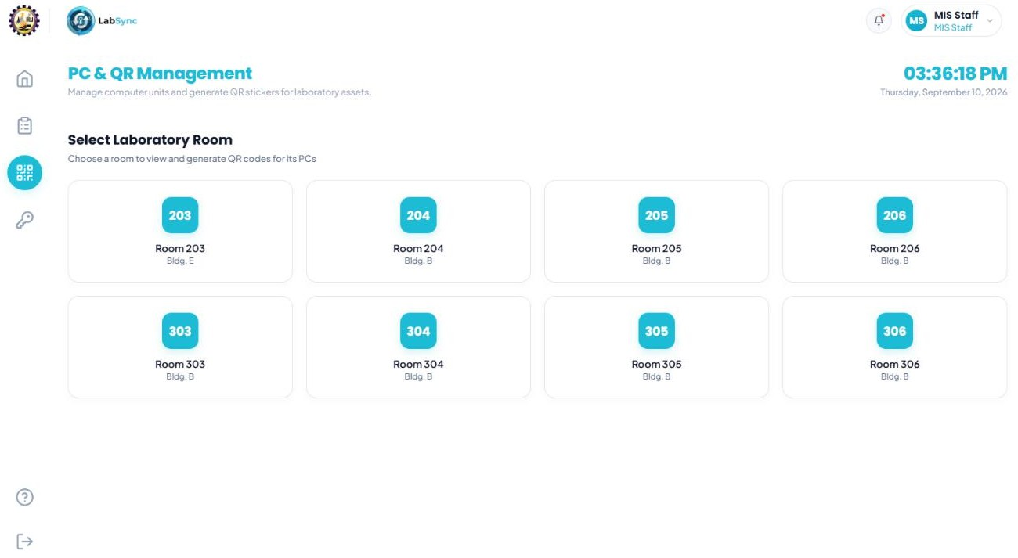

Figure 26. MIS PC QR Management

The PC QR Management screen provides MIS staff with an organized inventory of every computer workstation grouped by laboratory room. Each entry details the specific room assignment, PC unit number, serial tag, and hardware status, paired with dedicated tools to generate, preview, and print individual asset QR code stickers. It also includes search filters to look up specific machines and an option to register new PC units as lab capacity grows. This setup ensures every physical computer has an accurate digital label, making sure that student issue scans correctly route to the exact machine without confusing room locations or workstation numbers.

MIS Key Management

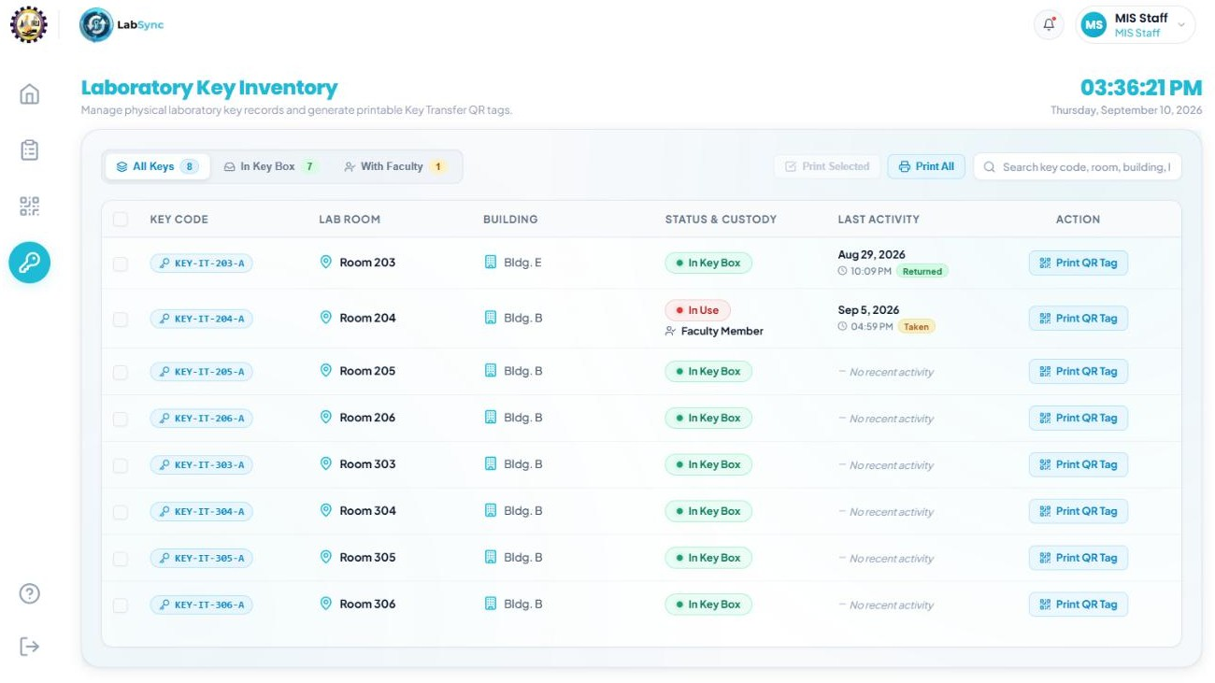

Figure 27. MIS Key Management

The Key Management interface gives the technical custodians an audit trail of physical laboratory keys and dock slot assignments. The central view lists each laboratory room alongside its designated hardware sensor socket, registered unique key code (e.g., KEY-IT-203-A), key status (Active or Missing), current physical dock status (docked or removed), the authorized keyholder, and the timestamp of the last recorded custody movement. Staff can also register new key slots, generate and print durable acrylic keychain QR tags for hallway transfers, toggle missing key alerts, inspect hardware telemetry, and track keys that are currently pulled out outside regular class hours. This replaces traditional handwritten logbooks with an automated, verifiable tracking record that helps staff spot missing or unreturned keys right away.

MIS Maintenance Tracker

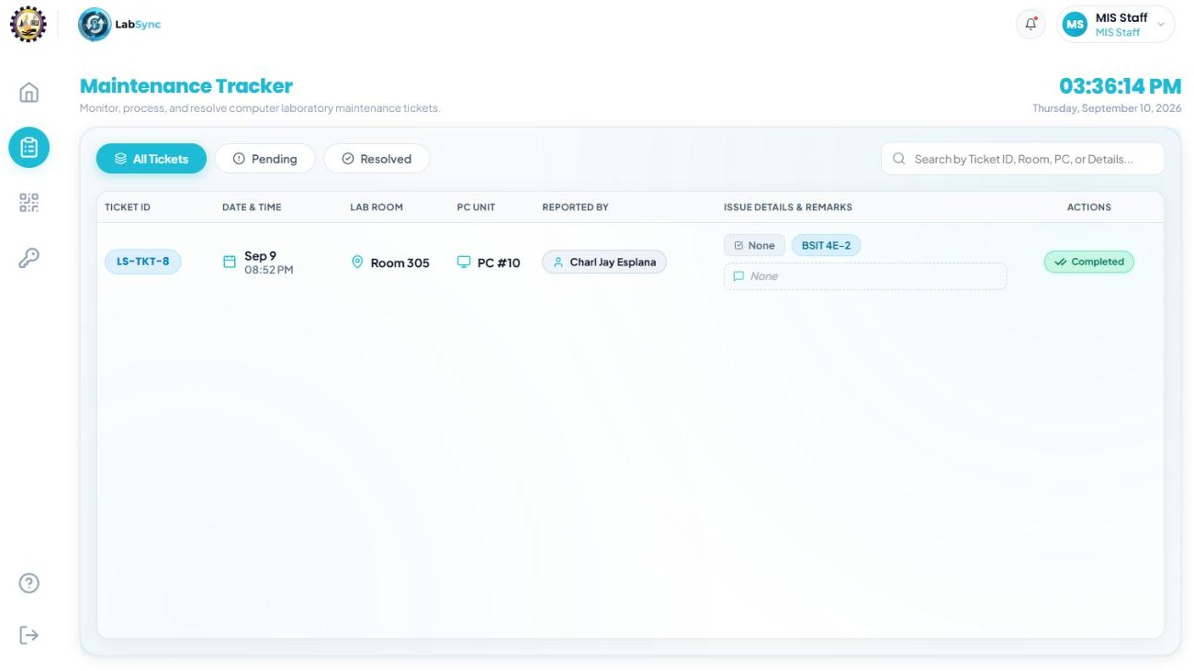

Figure 28. MIS Maintenance Tracker

The Maintenance Tracker serves as the central ticket resolution workspace where MIS technicians and supervised OJT interns handle, investigate, and close student-reported hardware defects. The interface organizes incoming tickets into clear diagnostic queues—such as Open, In Progress, and Resolved—automatically grouping student reports for the same computer component into unified active issue cards. Technicians and interns can inspect specific student remarks, update diagnostic statuses, and record resolutions through a resolver confirmation modal that permanently attributes the repair to their authenticated user account. This keeps all maintenance workflows accountable in one place, preventing duplicate complaints and making sure workstation breakdowns are fixed promptly.

MIS OJT Management
The MIS OJT Management screen provides technical administrators with a dedicated interface to manage student interns rendering required hours in the IT laboratories. MIS Staff can provision new intern accounts, configure official internship start and end dates, toggle account statuses between Active and Deactivated, and execute secure password resets. The system enforces time-bounded access control, automatically terminating active sessions once an intern's scheduled duration concludes, while granting interns necessary privileges to inspect hardware reports and record repair resolutions under their authenticated identity.

Student Form

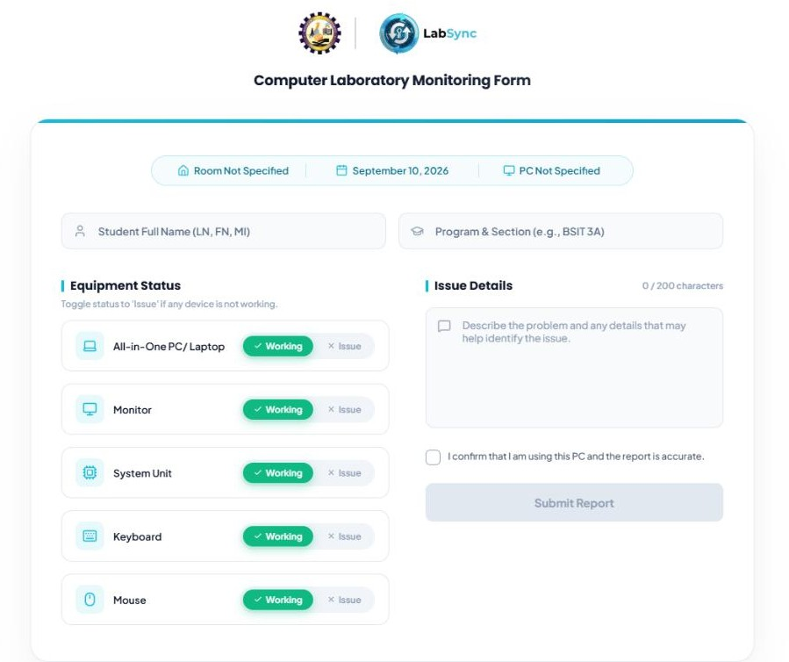

Figure 29. Student Form

The form works as a direct reporting tool that opens whenever a student scans the QR code on a lab computer. It automatically detects the room and PC number so the student does not have to type them. The student simply types their name and section, clicks "Issue" on whichever part is broken—like the mouse, monitor, or keyboard—adds a quick note describing the problem, and hits submit. This sends a ticket straight to the MIS staff without making the student sign up or log in.

Table 6. Tools, Technologies, and Development Environment

Category | Tool/ Technology | Version
Frontend | HTML5 CSS3  Vanilla JavaScript | HTML5 CSS3  ES6+
Backend | Node.js  Express.js | Node.js v18.0.0+  Express 5
Database | MySQL  MariaDB | 8.4.8 (LTS)
IDE/ Code Editor | Visual Studio Code | 1.112
Diagram Tools | Draw.io | Web-based (Always Latest)
UI/UX Design | CSS3  Custom Design System | 3.0
Deployment | Railway | v5.49.1

The Tools, Technologies, and Development Environment section outlines the software technologies and development tools used to develop, test, and manage the LabSync system, supporting the process from initial design to system implementation. The system uses HTML5, CSS3, and Vanilla JavaScript for the frontend to provide a responsive and accessible user interface, while Node.js and Express.js handle the backend logic and API communication. MySQL/MariaDB is used as the database for storing laboratory information, schedules, maintenance records, user accounts, and key management data. Mermaid is used for system diagrams and architecture planning, while the custom CSS design system is used to maintain the overall interface and visual design. The system runs through a Node.js server and is tested in a local development environment before being prepared for actual use.

Development Cost

Cost and Benefit Analysis

Table 7. Human Resource Cost

DEVELOPMENT COST
A. Human Resource Cost
DEVELOPMENT TEAM | MONTHLY  SALARY | QUANTITY | MONTHS | SUB TOTAL
Project Manager | ₱30,000.00 | 1 | 5 | ₱150,000.00
Front-End Developer | ₱25,000.00 | 1 | 5 | ₱125,000.00
Back-End Developer | ₱30,000.00 | 1 | 5 | ₱150,000.00
Hardware/IoT Developer | ₱25,000.00 | 1 | 5 | ₱125,000.00
Document Specialist | ₱20,000.00 | 1 | 5 | ₱100,000.00
Quality Assurance(QA Tester) | ₱20,000.00 | 1 | 2 | ₱40,000.00
TOTAL: |  |  |  | ₱690,000.00

This category covers the estimated cost of the people involved in developing the LabSync system throughout the five-month project period. It

includes the estimated compensation for the development team, such as the Project Manager, Front-end Developer, Back-end Developer, Hardware/IoT Developer, and Documentation Specialist.

Table 8. Software & Licensing Cost

DEVELOPMENT COST
B. Software and Licensing
ITEM NAME | UNIT COST | QUANTITY | MONTHS | SUB TOTAL
Cloud Web Hosting (Annual) | ₱3,763.20 | 1 | 5 | ₱3,763.20
Domain Name Registration (Annual) | ₱0.00 | 1 | 5 | ₱0.00
Visual Studio Code | ₱0.00 | 2 | 5 | ₱0.00
Arduino IDE | ₱0.00 | 1 | 5 | ₱0.00
Figma | ₱0.00 | 1 | 5 | ₱0.00
XAMPP | ₱0.00 | 1 | 5 | ₱0.00
Draw.io | ₱0.00 | 1 | 5 | ₱0.00

Node.js | ₱0.00 | 1 | 5 | ₱0.00
TOTAL: |  |  |  | ₱3,763.20

The table above shows the software and licensing costs for the LabSync system. The development team minimized expenses by using available software and development tools that do not require additional licensing fees. The main cost is allocated to the cloud hosting service, which provides the live environment needed to host and manage the system during the project period.

Table 9. Hardware Cost

DEVELOPMENT COST
C. Hardware Cost
ITEM NAME | UNIT COST | QUANTITY | SUB TOTAL
GM65 QR Code Recognition Module | ₱1,055.00 | 1 | ₱1,055.00
ESP32 Dev Module | ₱198.00 | 1 | ₱198.00
16x2 Character LCD Module with I2C | ₱119.00 | 1 | ₱119.00

Active and Passive Buzzer Module | ₱32.00 | 1 | ₱32.00
Wall Mounted key plugs | ₱114.00 | 4 | ₱114.00
40-Pin Jumper Wire (Male - Female, 20cm) | ₱68.00 | 1 | ₱68.00
40-Pin Jumper Wire (Male - Male, 20cm) | ₱39.00 | 2 | ₱78.00
Resistor Through-Hole 1/4w 10pcs | ₱20.00 | 1 | ₱20.00
6.35 mm ¼ Guitar Input Jack Copper Mono, Female Connector | ₱47.00 | 8 | ₱376.00
16x2 LCD Bezel/Panel Mounting Frame | ₱109.00 | 1 | ₱109.00
Heat Shrink Tube Assortment wrap wire | ₱28.00 | 10 | ₱28.00
Blank Acrylic key chain 4.5*2.8cm 10 pcs | ₱59.00 | 1 | ₱59.00
Acrylic Case and Manual Labor fee | ₱1,700.00 | 1 | ₱1,700.00
Sticker Design Acrylic Case | ₱770.00 | 1 | ₱770.00
TOTAL: |  |  | ₱4,726.00

The table above presents the estimated hardware costs required for the development of the IoT components of the LabSync system. It includes the essential electronic components used for QR scanning, key detection, and system feedback, such as the ESP32 Dev Module, GM65 scanner, LCD display, buzzer, and wiring materials. These components support the implementation of the system’s key monitoring and IoT functions and represent a one-time hardware investment for the development of the project.

Table 10. Utilities & Resource Cost

DEVELOPMENT COST
D. Utilities & Resource Cost
ITEM NAME | UNIT COST | QUANTITY | MONTHS | SUB TOTAL
Laptop | ₱40,000.00 | 5 |  | ₱200,000.00
Transportation | ₱1,000.00 | 1 | 5 | ₱5,000.00
Internet | ₱1,600.00 | 1 | 5 | ₱8,000.00
Electricity | ₱2,000.00 | 1 | 5 | ₱10,000.00
Printer | ₱6,000.00 | 1 |  | ₱6,000.00

Printing Supplies | ₱2,000.00 | 1 |  | ₱2,000.00
TOTAL: |  |  |  | ₱231,000.00

This category outlines the operational expenses and essential hardware required throughout the 5-month development period of the system. It encompasses the estimated capital for five developer laptops, a dedicated printer, and necessary printing supplies, alongside the recurring monthly allocations for electricity consumption, internet connectivity, and team transportation. The projected expenses for these utilities and resources amount to a corrected total of
₱231,000.00.

Table 11. Summary of Total Development Cost

Summary of Total Development Cost
PARTICULARS |  | TOTAL COST
A. Human Resource Cost |  | ₱690,000.00
B. Software and Licensing |  | ₱3,763.00
C. Hardware Cost |  | ₱4,726.00
D. Utilities & Resource Cost |  | ₱231,000.00

TOTAL: |  | ₱929,489.00

This table provides the overall estimated cost required to develop and implement the LabSync system over the five-month timeframe. The expenses are divided into four main categories: Human Resource Cost, Software and Licensing, Hardware Cost, and Utilities and Resource Cost. In total, the estimated budget needed to complete the project is ₱929,489.00.

Evaluation Methods

This section describes how the system will be evaluated following implementation. The objective of the evaluation is to assess the technical quality of the system and its acceptability to users.
To achieve this, two established evaluation models will be used:

- ISO/IEC 25010 Software Product Quality Model

- Technology Acceptance Model (TAM)

Evaluation Using ISO/IEC 25010

The ISO/IEC 25010 Software Quality Model will be used to evaluate the technical quality of the LabSync. This evaluation will be conducted by Information Technology (IT) Experts who have knowledge and experience in system development and software evaluation.

Table 12. Evaluation Using ISO/IEC 25010

Criteria | Description
Usability: | to assess software quality using international standards.
Functional Suitability: | to determine if the system provides required features such as real-time laboratory availability monitoring, QR code-based reporting, and schedule management.
Reliability: | determines the system’s ability to perform consistently and maintain stable operation under normal conditions.
Performance Efficiency: | to measure the system’s responsiveness in displaying real-time data.
Maintainability: | assesses how easy it is to modify, update, and improve the system when necessary.
Portability: | evaluates the system’s ability to operate in different environments, devices, or platforms with minimal adjustments.
Respondents: | a minimum of 3 IT Professionals will be selected to evaluate the system.
Instrument: | an evaluation questionnaire will be prepared based on the  ISO/IEC 25010 software quality characteristics. A 5-point

Likert Scale (1 = Strongly Disagree to 5 = Strongly Agree) will be used for each item.

Evaluation Using Technology Acceptance Model (TAM)

The Technology Acceptance Model (TAM) will be used to evaluate the system from the perspective of the actual end-users, specifically the students, faculty members, and MIS personnel of Bulacan State University – Sarmiento Campus.
- Purpose: To measure user perceptions of usefulness, ease of use, and their intention to adopt the system.
- Perceived Usefulness (PU): The evaluation will measure whether users believe that utilizing the LabSync system will improve the efficiency of monitoring laboratory availability and reporting equipment issues.
- Perceived Ease of Use (PEOU): The evaluation will assess whether users find the system easy to learn, navigate, and operate, particularly in accessing real-time laboratory status and QR code reporting features.
- Respondents: A group of fifteen (15) to thirty (30) end-users who have interacted with the system will be selected.
- Sampling Method: Purposive sampling will be used to ensure that respondents have prior experience using the system.
- Instrument: A TAM-based questionnaire with a 5-point Likert scale (1 – Strongly Disagree to 5 – Strongly Agree) will be used to collect responses.

Data Handling and Analysis

- Respondents and Population Description

State the total population (N) and break it down by role. Identify the two evaluator groups:
  - End-user respondents for TAM — 27, purposive sampling

  - IT professional evaluators for ISO/IEC 25010 — minimum 3, purposive sampling

Data Analysis

Write these three things in order:

  - Describe the 5-point Likert scale:

5 – Strongly Agree, 4 – Agree, 3 – Neutral, 2 – Disagree, 1 – Strongly Disagree

  - Insert the Likert Scale Conversion Table:

Rating Range | Interpretation
4.51 – 5.00 | Highly Acceptable
3.51 – 4.50 | Acceptable
2.51 – 3.50 | Moderately Acceptable
1.51 – 2.50 | Slightly Acceptable
1.00 – 1.50 | Not Acceptable

  - Write a narrative paragraph describing what each range means for your specific system.

Statistical Treatment of Data

State that the Arithmetic Mean (AM) is used. Present the formula: AM = Σ(wᵢfᵢ) / n
Define each variable:

- AM = Arithmetic Mean

- wᵢ = Likert scale weight (5, 4, 3, 2, 1)

- fᵢ = Frequency of responses for each weight

- n = Total number of respondents

Explain that AM is computed per item, per quality characteristic, per TAM construct, and for the overall score.

Statistical Tools Used

Present three tools in this order:

Frequency — used to count how many respondents chose each rating per item. Percentage — used to express the proportion of responses. Formula:
P = (F × 100) / N

Where: P = Percentage, F = Frequency, N = Total respondents

Weighted Mean — connects back to the AM formula. This is the main tool for interpreting results.

CHAPTER IV

RESULTS AND DISCUSSION

This chapter presents the results of the study based on the specific objectives stated in Chapter I. Each objective is addressed in sequence, supported by data, screenshots, tables, or figures, with a brief explanation of what the results show.
- Results for Specific Objective 1: [state objective] Present the evidence (screenshots, features, data) that answers this objective. Briefly explain how it satisfies the objective.
- Results for Specific Objective 2: [state objective] Present the evidence and briefly discuss how it addresses this objective.
- Results for Specific Objective 3: [state objective] Present the evidence (system modules, functions, outputs) and briefly discuss how it fulfills this objective.
Evaluation Results (ISO/IEC 25010 and/or TAM) Present the number of respondents, a summary table of mean scores, and their verbal interpretation. Briefly discuss the system's strengths and areas for improvement based on the results.

System Testing Results Present a summary table of test cases (input, expected result, actual result, status). Briefly state the testing methods used (unit, integration, system testing) and any issues resolved.
Discussion of Findings Summarize how the results answer the study's objectives and solve the problem stated in Chapter I. Briefly compare findings with related studies from Chapter II and note any limitations.

CHAPTER V

CONCLUSIONS AND RECOMMENDATIONS

This chapter summarizes the key findings of the study based on the project’s objectives, presents conclusions drawn from the results and evaluation, and provides practical recommendations for system enhancement, deployment, or future research.

Conclusions

This section presents concise conclusions based on the specific objectives listed in Chapter I and the results discussed in Chapter IV. Each conclusion should:
  - Correspond one-to-one with the specific objectives.

  - Be derived directly from evaluation findings (e.g., ISO/IEC 25010, TAM).

  - Avoid repeating raw results — focus on interpretation and insight.

  - Be written in the past tense, maintaining an objective tone.

Recommendations

This section outlines practical suggestions based on the study’s limitations, user feedback, or potential system improvements. Recommendations may be directed toward:
- Future developers (for additional features, technical refinement)

- The client institution (for deployment, user training, or support)

- Researchers (for studies extending or adapting the system)

REFERENCES

Arunkumar, V., Rengarajan, V., Vijay Anand, V., Shreenivasan, K. A., Thiyagarajan, S., & Swaminathan, R. (2024). Impact of IOT on campus; Smart student information system in the educational sector. Journal of Informatics Education and Research, 4(2), 729–736. https://jier.org/index.php/journal/article/view/729
Brightly Software, Inc. (n.d.). Maintenance and asset management solutions. Retrieved September 13, 2026, from https://www.brightlysoftware.com
Cisco Systems, Inc. (n.d.). Smart campuses and smart building solutions. Cisco Spaces. Retrieved September 13, 2026, from https://spaces.cisco.com/education/
El-Haggar, N., Amouri, L., Alsumayt, A., Alghamedy, F. H., & Aljameel, S. S. (2023). The effectiveness and privacy preservation of IoT on ubiquitous learning: Modern learning paradigm to enhance higher education. Applied Sciences, 13(15), Article 9003. https://doi.org/10.3390/app13159003
Google LLC. (n.d.). Google Forms: Online form creator for business. Retrieved September 13, 2026, from https://forms.google.com
IBM Corporation. (n.d.). IBM TRIRIGA application suite. Retrieved September 13, 2026, from https://www.ibm.com/products/tririga
Jadhav, M. N., Naik, N. V., Marathe, H. B., & Patil, N. V. (2024). Lab inventory management using QR code. International Journal of Scientific Research in Engineering and Management (IJSREM), 8(3), 1–6. https://doi.org/10.55041/IJSREM29806

Kunjiapu, S., Sinnappan, P., Anor Salim, F. A., & Kunasegaran, M. (2025). Challenges and dilemmas of digitalization in Philippine education: A grassroots perspective. Journal of Public Administration and Governance, 14(2), 45–61. https://doi.org/10.5296/jpag.v14i2.22325
LabWare, Inc. (n.d.). Laboratory information management system (LIMS). Retrieved September 13, 2026, from https://www.labware.com
Mallari, M. O., Cabugos, A. C., Macapas, V. II A., & Sonza, R. L. (2025). The impact of AI and IoT-based smart classrooms: A data-driven approach to business intelligence in education. THE QUEST: Journal of Multidisciplinary Research and Development, 4(1), 12–28. https://neust.journalintellect.com/quest
Rabiah, N. N., Lindawati, & Sarjana. (2022). Web-based laboratory inventory application using QR code and RFID in telecommunication engineering laboratories/workshops. Sinkron: Jurnal dan Penelitian Teknik Informatika, 7(4), 2390–2398. https://doi.org/10.33395/sinkron.v7i4.11624
Sağıt, P., Uçak, E., & Savran Gencer, A. (2024). A systematic review on the pedagogical use of QR codes. Journal of STEM Teacher Institutes, 4(2), 106–126. https://jstei.com/index.php/jsti/article/view/73
Skedda. (n.d.). Smart space management & online booking system. Retrieved September 13, 2026, from https://www.skedda.com
Taruc, L. F., & De La Cruz, A. R. (2024). Narrowband-IoT (NB-IoT) and IoT use cases in universities, campuses, and educational institutions: A research analysis.

International Journal of Computing Sciences Research, 8, 3042–3057. https://doi.org/10.25147/ijcsr.2017.001.1.202
Teves, L. L. (2024). Smart educational resource management: A QR code-enabled system with notification and alerting capabilities. Journal of Innovative Technology Convergence, 6(2), 59–66. https://doi.org/10.69478/JITC2024v6n002a06
Ye, X., Peng, H., & Liao, H. (2024). Research and practice of IoT technology based on smart campus. Frontiers in Computing and Intelligent Systems, 10(1), 13–19. https://doi.org/10.54097/fcis.v10i1.13

