INTRODUCTION

Supporting Video on Why HTML is called a Markup language?:

(19) Why HTML is called markup language? | Markup Language - YouTube

Steps for Installation of VS code in Windows, Linux and macOS

Installation steps for Windows-10

HTML BASICS

HTML Elements

Above HTML in Step 5 Explained:

What is an HTML Element?

Web Browsers

HTML Page Structure

HTML Documents

The <!DOCTYPE> Declaration

HTML Headings

HTML Images

Viewing HTML Source

Inspect an HTML Element:

What is the difference between View Source code and Inspect Element?

HTML Attributes

href Attribute: href is an attribute of <a></a> tag in html and specifies the URL of the link to a web-page.

src Attribute: src is an attribute of <img/> tag in html and specifies the URL of the image to be displayed.

HTML Text Formatting

HTML Quotation and Citation Elements

HTML <blockquote> for Quotations

HTML <q> for Short Quotations

HTML <abbr> for Abbreviations

HTML <address> for Contact Information

HTML <cite> for Work Title

HTML <bdo> for Bi-Directional Override

HTML Comments

HTML Comment Tag(Syntax):

Add Comments for Reminders and Notifications(Example):

Hiding Content with HTML Comments(Example):

a) Hiding an HTML element:

b) Hiding everything within HTML comment tag (more than one HTML Element):

c) Hiding parts of HTML code by putting a comment tag in the middle of the code:

FURTHER LEARNING:

ADVANCED TOPICS:

# INTRODUCTION

* HTML stands for Hypertext Markup Language (HTML), which is used to create and structure web pages.
* With HTML, one can create his/her own Website.
* Following is an image of the most basic web-page that is created using HTML:

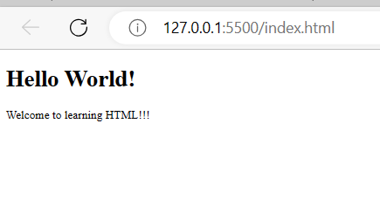

##### Supporting Video on Why HTML is called a Markup language?:

##### [(19) Why HTML is called markup language? | Markup Language - YouTube](https://www.youtube.com/watch?v=RXBk-FETPdQ)

To create the above web page first one needs to install a platform to develop html codes. Usually, platforms used for any kind of coding are called IDEs that stands for - **Integrated Developement Environments.**

There are several Integrated Development Environments (IDEs) available for developing HTML code. Some popular ones are:

* Visual Studio Code
* Sublime Text
* Atom
* Brackets
* Dreamweaver

These are just a few examples of IDEs commonly used for writing HTML. Depending on one’s preferences and requirements, one chooses an IDE from all the options available in the market.

This document describes the development of HTML codes using Visual Studio Code IDE in a Windows-10 system.

**Quick Introduction to Visual Studio Code (VS Code):**

Visual Studio Code (VS Code) is a widely used and highly customizable IDE developed by Microsoft. It offers a rich set of features for HTML development, including syntax highlighting, IntelliSense (code completion and suggestions), debugging capabilities, Git integration, extensions, and more. It is available for Windows, macOS, and Linux.

As described in the above introduction to VS code, it is preferred as an IDE because it supports a number of features that makes writing HTML very easy and efficient. The specific details of the advantages will be explored further as and when applicable in the document-flow.

##### Steps for Installation of VS code in Windows, Linux and macOS

##### Installation steps for Windows-10

1. **Open a web browser:** Launch your preferred web browser, such as Microsoft Edge, Google Chrome, or Mozilla Firefox.
2. **Go to the VS Code download page:** Visit the official VS Code website at<https://code.visualstudio.com/>
3. **Download the installer:** On the VS Code website, click on the "Download for Windows" button. This should download the installer file (.exe) to your computer.
4. **Run the installer:** Once the download is complete, locate the downloaded file (usually in your Downloads folder) and double-click on it to run the installer.
5. **User Account Control (UAC) prompt:** You may see a User Account Control prompt asking for permission to make changes to your system. Click "Yes" to proceed.
6. **Select installation options:** The installer will launch. You can choose the installation location or accept the default settings. You can also choose whether to add shortcuts to the Start Menu and desktop.
7. **Start the installation:** Click on the "Next" button to start the installation process.
8. **Select additional tasks (optional):** You can choose whether to associate specific file types with VS Code or add it to the system's PATH environment variable. These are optional settings, so you can leave them unchecked if you're unsure.
9. **Start Visual Studio Code:** Once the installation is complete, you can choose to launch VS Code immediately by leaving the "Launch Visual Studio Code" option checked. Alternatively, you can manually launch it later by unchecking the option.
10. **Complete the installation:** Click on the "Finish" button to complete the installation process.

After following these steps, Visual Studio Code should be successfully installed on the Windows 10 system.

**Supporting Video Link:** [**(19) How to install Visual Studio Code on Windows 10/11 [ 2023 Update ] Complete Guide - YouTube**](https://www.youtube.com/watch?v=JPZsB_6yHVo)

**Post Installation Steps:**

1. VS Code allows installation of additional extensions that support development. For writing HTML the Live Server extension (or any other similar software/extension) should be installed by clicking on the Extension symbol and searching for “Live Server”.
2. **Supporting Video Link:** [**(19) How To Install Live Server in Visual Studio Code - YouTube**](https://www.youtube.com/watch?v=9kEOkw_LvGU)
3. A folder with any name (example: HTML) is to be created at any preferred location in the computer/system.
4. Open VS code > Go to File (top left corner) > Select Open Folder option > Browse and choose the HTML folder to open in VS code.
5. Go to the Explorer below File and create a new file named *“index.html”* under HTML folder opened in VS code.
6. **Note:** Conventionally the first html file is named as *“index”* and all html files must be created with the extension *“.html”*.

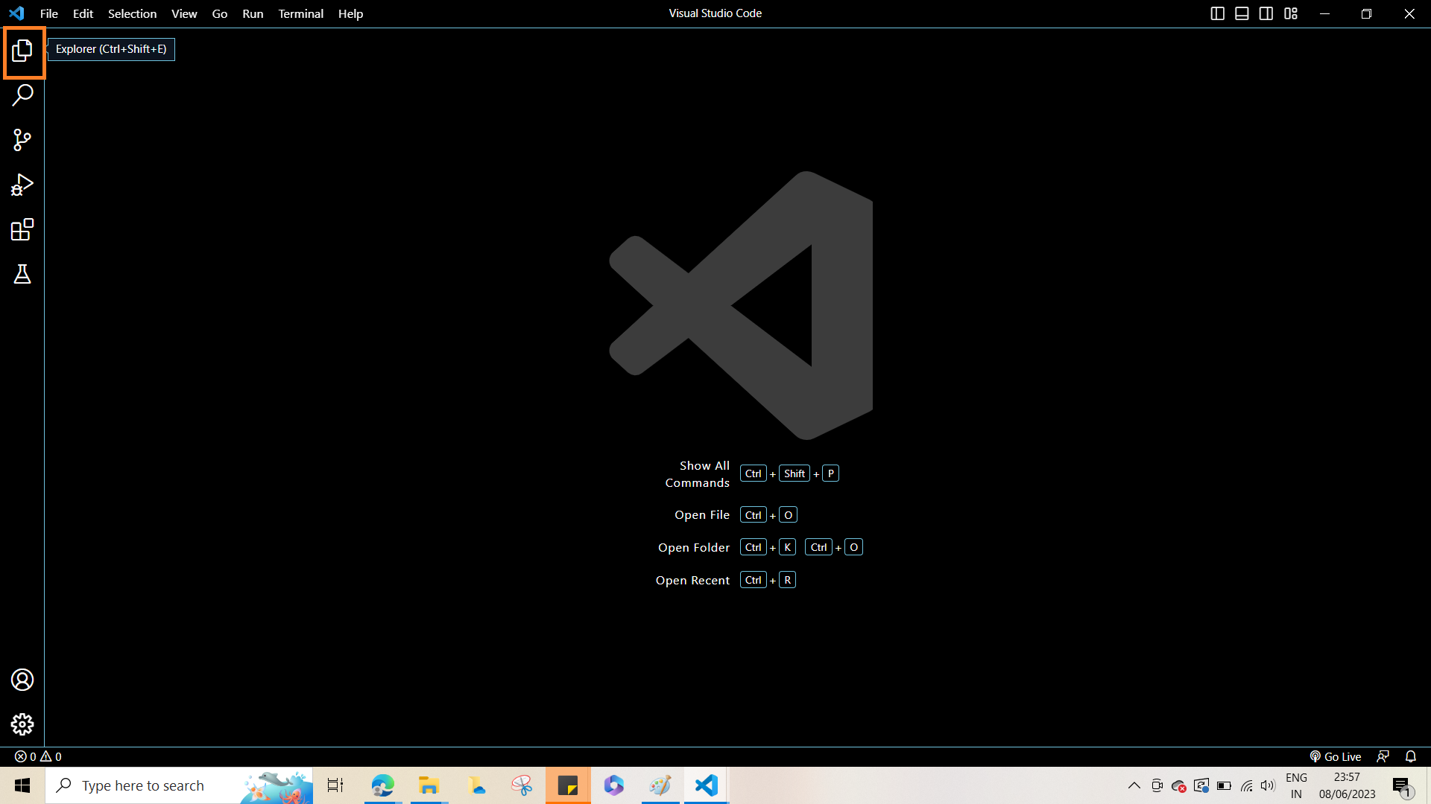

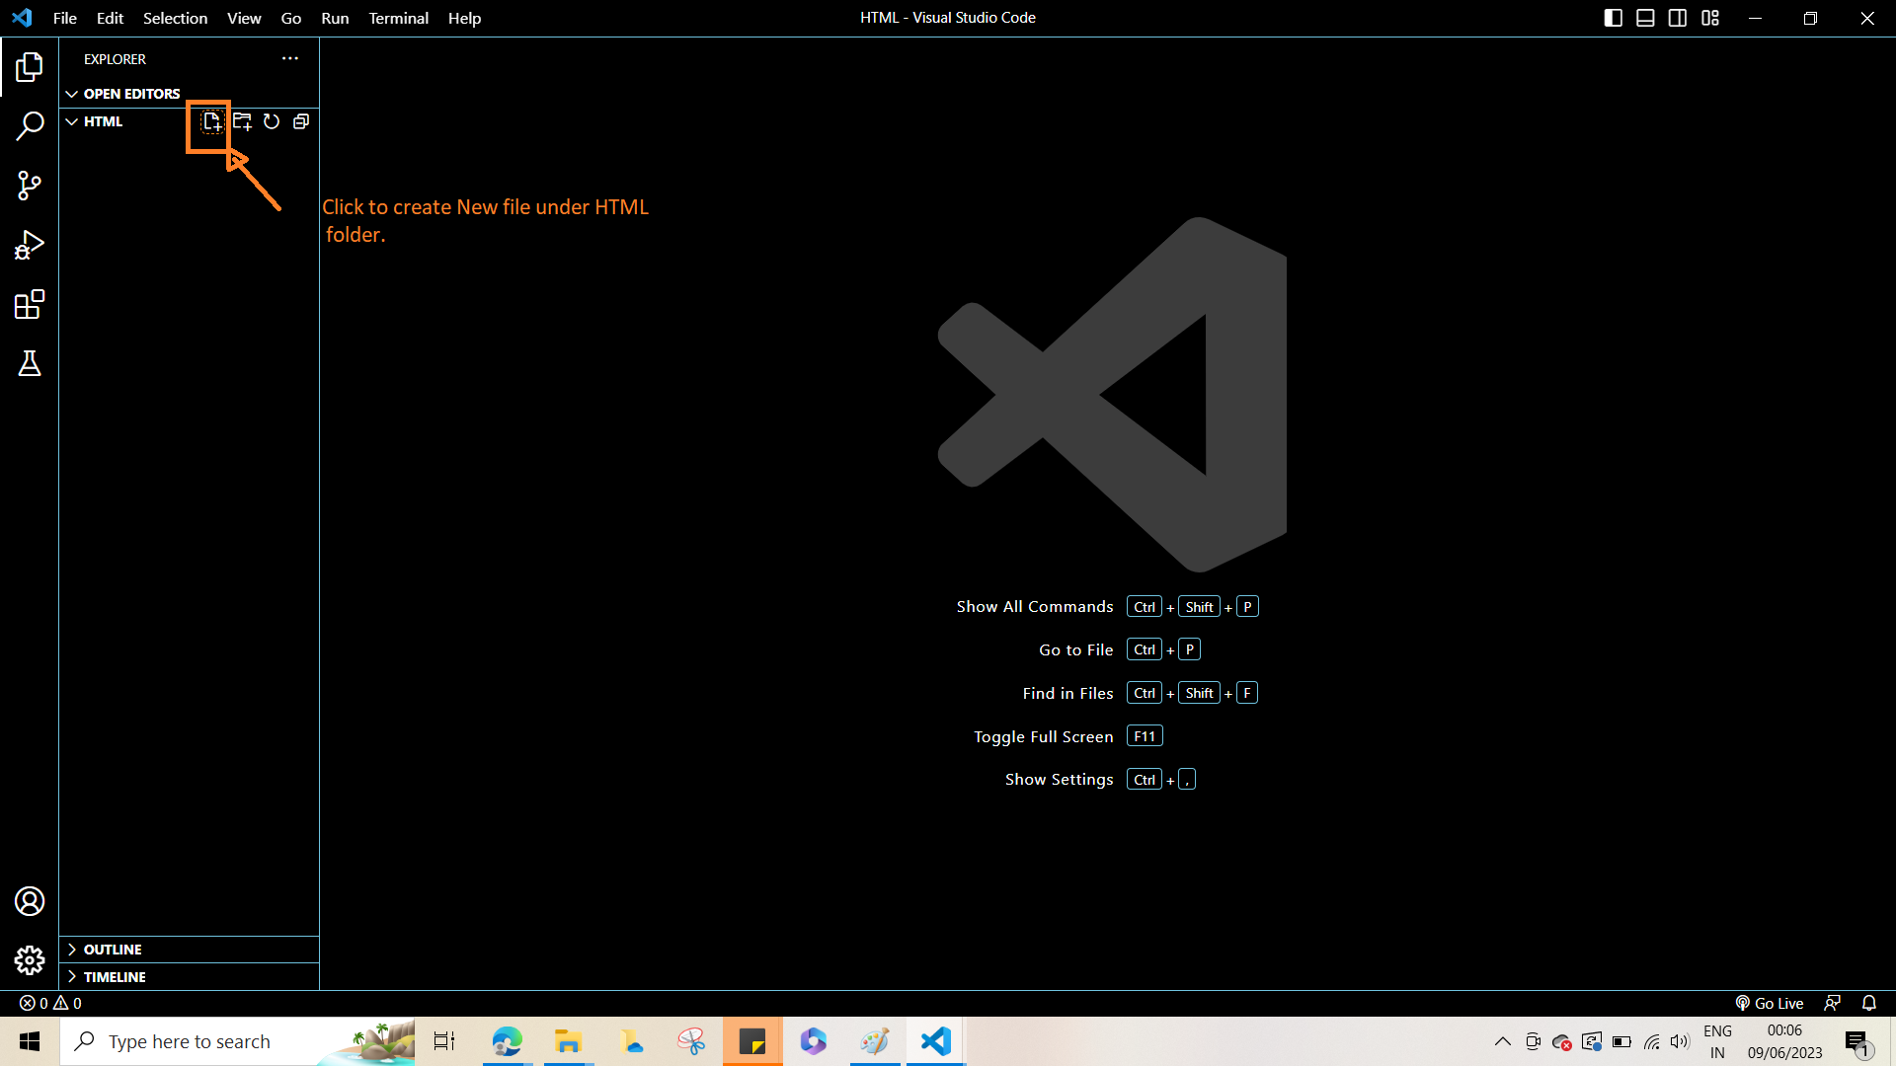

1. Click and open the index.html file and type in the following lines of HTML:

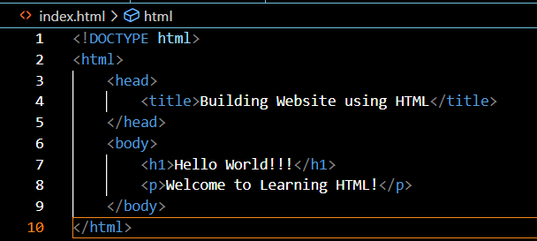

1. Click on the Go Live option in the Right hand corner to launch the basic website:

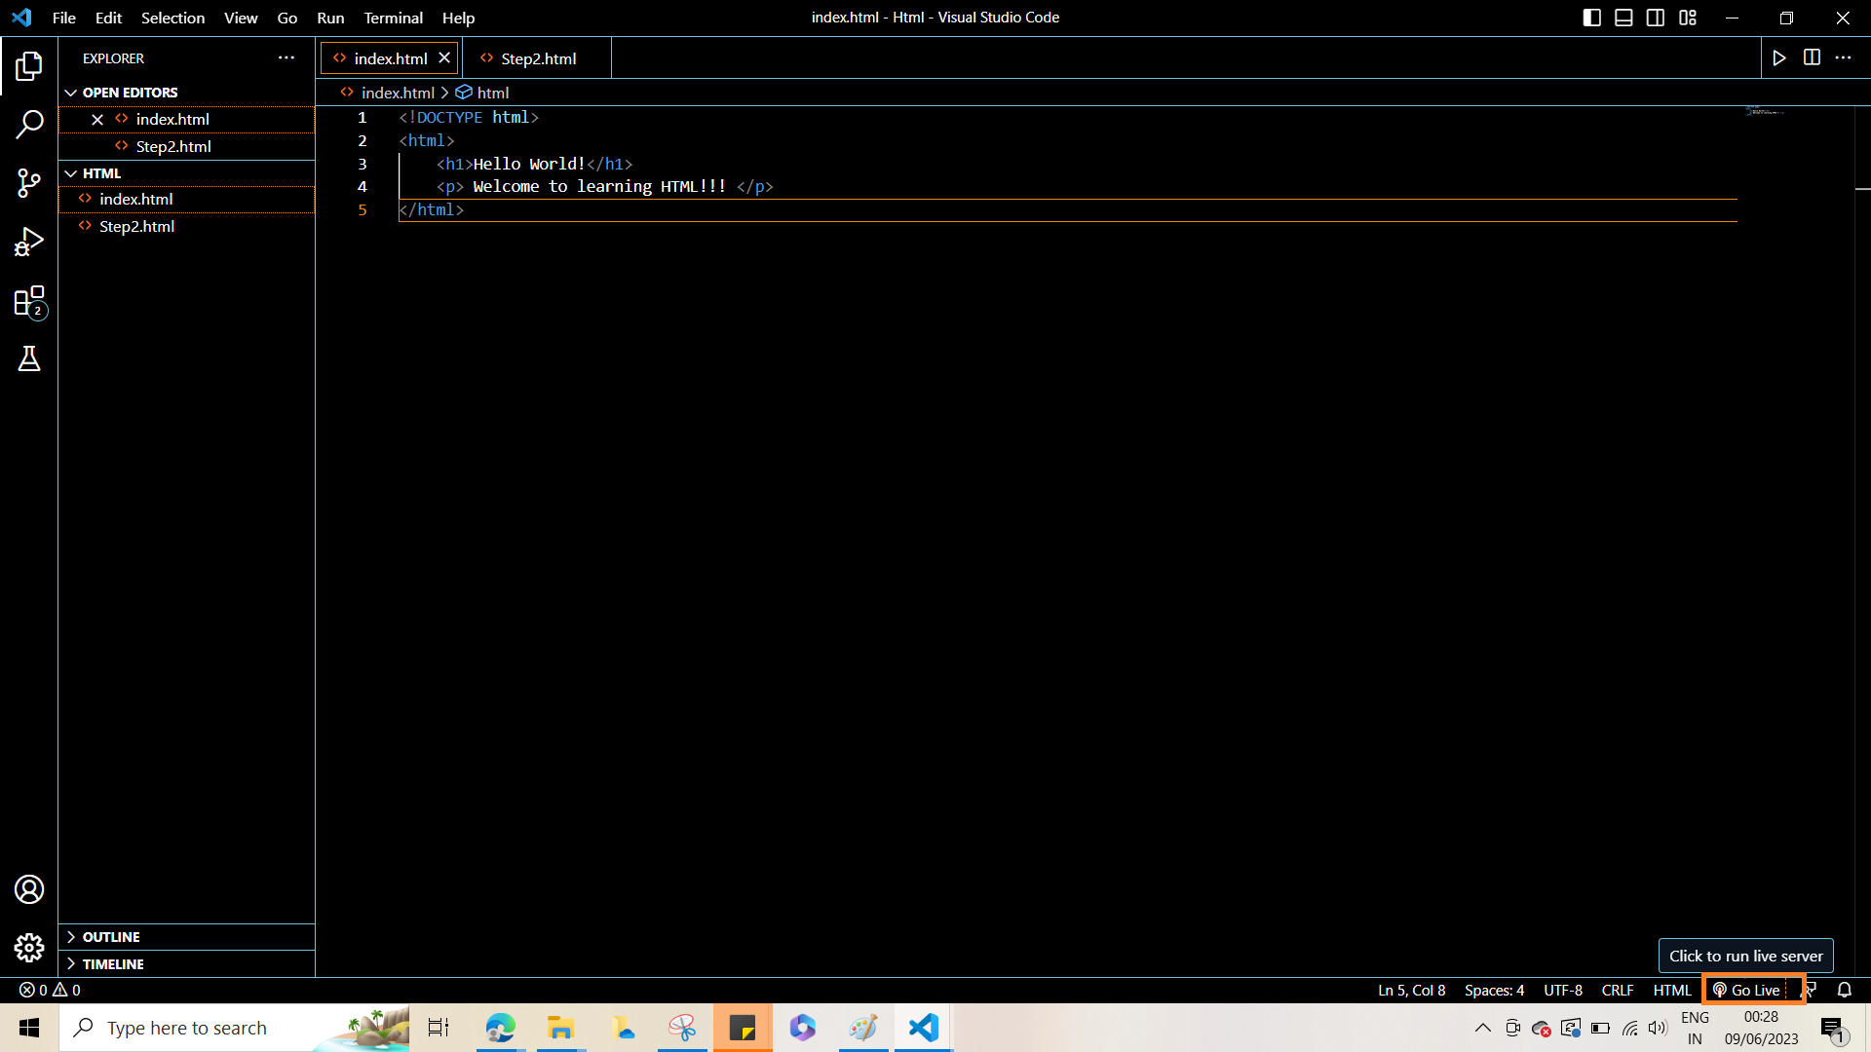

**Note: Each time any HTML is written the “Go Live” option/button must be clicked to view it in the browser.**

# HTML BASICS

## HTML Elements



##### Above HTML in Step 5 Explained:

* The <!DOCTYPE html> declaration defines that this document is an HTML5 document
* The <html> element is the root element of an HTML page
* The <head> element contains meta information about the HTML page
* The <title> element specifies a title for the HTML page (which is shown in the browser's title bar or in the page's tab)
* The <body> element defines the document's body, and is a container for all the visible contents, such as headings, paragraphs, images, hyperlinks, tables, lists, etc.
* The <h1> element defines a large heading.
* The <p> element defines a paragraph.

##### What is an HTML Element?

An HTML element is defined by a start tag, some content, and an end tag:

**<tagname> Content goes here... </tagname>**

The HTML element is everything from the start tag to the end tag:

**<h1>My First Heading</h1>**

**<p>My first paragraph.</p>**

**NOTE: Some HTML elements have no content (like the <br> element). These elements are called empty elements.Empty elements do not have an end tag!**

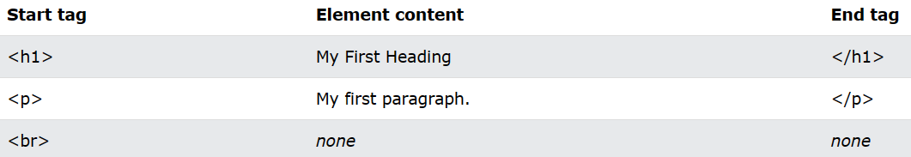

##### Web Browsers

The purpose of a web browser (Chrome, Edge, Firefox, Safari) is to read HTML documents and display them correctly.

A browser does not display the HTML tags, but uses them to determine how to display the document.

##### HTML Page Structure

Below is a visualization of an HTML page structure: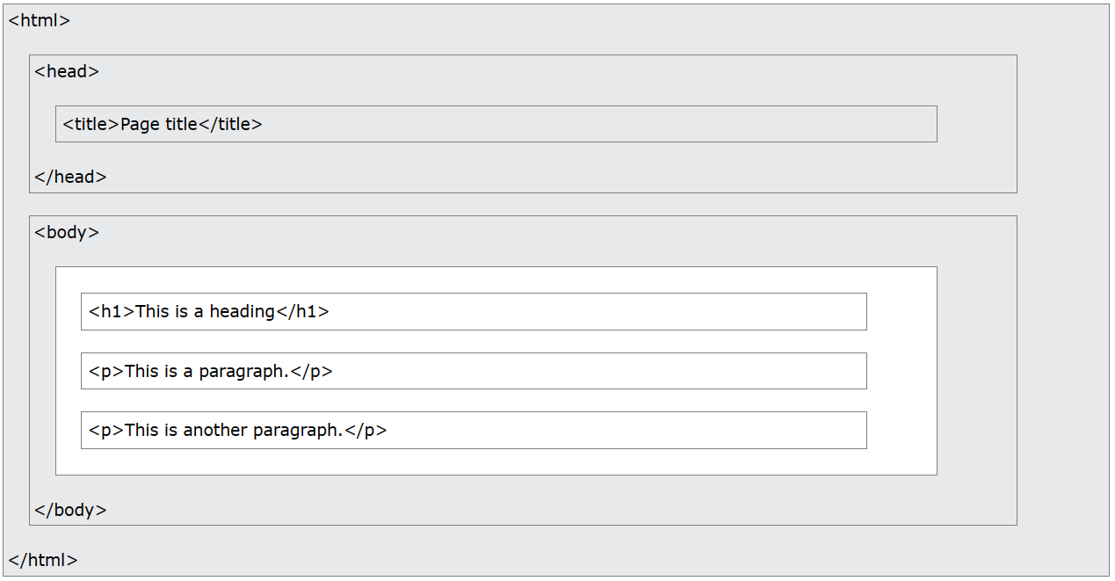

**Note: The content inside the <body> section will be displayed in a browser. The content inside the <title> element will be shown in the browser's title bar or in the page's tab.**

##### HTML Documents

* All HTML documents must start with a document type declaration: <!DOCTYPE html>.
* The HTML document itself begins with <html> and ends with </html>.
* The visible part of the HTML document is between <body> and </body>.



##### The <!DOCTYPE> Declaration

* The <!DOCTYPE> declaration represents the document type, and helps browsers to display web pages correctly.
* It must only appear once, at the top of the page (before any HTML tags).
* The <!DOCTYPE> declaration is not case sensitive.
* The <!DOCTYPE> declaration for HTML5 is:



**Note:** HTML5 is the latest version of HTML released in 2017.

##### HTML Headings

* HTML headings are defined with the <h1> to <h6> tags.
* <h1> defines the most important heading. <h6> defines the least important heading.

**HTML Paragraphs**

* HTML paragraphs are defined with the <p> tag.
* HTML Links:



* HTML links are defined with the <a> tag.
* The url for the link is specified in the **href** attribute.
* Attributes are used to provide additional information about HTML elements.
* Further details of attributes has been provided later.

##### HTML Images

* HTML images are defined with the <img> tag.
* The source file (src), alternative text (alt), width, and height are provided as attributes:



##### Viewing HTML Source

When a user right-clicks on an HTML page and selects "View Page Source" in Chrome or "View Source" in Edge, a window opens displaying the HTML source code1 of the page.

##### Inspect an HTML Element:

When a user right-clicks on an element or a blank area and chooses "Inspect" or "Inspect Element," they can observe the composition of the elements, including both the HTML and CSS2. This action opens the Elements or Styles panel, where the user can view and modify the HTML or CSS in real-time.

###### What is the difference between View Source code and Inspect Element?

The main difference between "View Source code" and "Inspect Element" is the level of interaction and functionality they provide for examining and modifying the code of a webpage.

"View Source code" typically refers to the action of viewing the HTML source code of a webpage in its entirety. It opens a separate window or tab displaying the raw HTML code that was sent by the server and rendered by the browser. This provides a static snapshot of the page's code, allowing users to analyze its structure, content, and any embedded scripts or resources. However, "View Source code" does not provide real-time interaction or editing capabilities.

On the other hand, "Inspect Element" offers a more dynamic and interactive way to examine and modify the elements of a webpage. By right-clicking on an element or a blank area and selecting "Inspect" or "Inspect Element," a developer tool called the "Elements" panel is opened. This panel provides a live representation of the HTML structure and CSS styling of the page.

With "Inspect Element," users can navigate and explore the HTML tree, inspect individual elements, view and modify their properties and styles, and even experiment with changes on-the-fly. It also provides access to the associated CSS rules, allowing users to understand and adjust the styling applied to specific elements.

In summary, "View Source code" provides a static view of the entire HTML source code, while "Inspect Element" offers a dynamic and interactive way to explore and manipulate individual elements, including their HTML and CSS, in real-time.

Above is a short Introduction to HTML. The other necessary basic topics of HTML may be covered from w3schools. A list of the links to the topics and additional supporting video links is provided below:

**Points to Remember - HTML Elements**

* **The HTML element is everything from the start tag to the end tag.**
* **Some HTML elements may display correctly, even without the corresponding end tag but in some cases may lead to unexpected results/errors.**
* **HTML elements with no content are called empty elements.**
* **Empty Elements do not have end tag and are self-closing. Eg <br/>**
* **HTML is not case sensitive. Hence both <p></p> and <P></P> refer to paragraph tag.**

**NOTE: Conventionally lower case is used for all HTML tags and the same is recommended.**

## HTML Attributes

* All HTML elements can have attributes
* Attributes provide additional information about elements
* Attributes are always specified in the start tag
* Attributes usually come in name/value pairs like: name="value"

###### href Attribute: href is an attribute of <a></a> tag in html and specifies the URL of the link to a web-page.

###### src Attribute: src is an attribute of <img/> tag in html and specifies the URL of the image to be displayed.

There are 2 types urls that may be specified as a value to the src attribute:

**Absolute URL:** Links to an external image that is hosted on another website.

**Example:** src="[OIP.9vm8bJe-w0YxB-z8EpFHOQHaF0 (474×372) (bing.com)](https://th.bing.com/th/id/OIP.9vm8bJe-w0YxB-z8EpFHOQHaF0?pid=ImgDet&rs=1)"

**Relative URL (preferred to use):** Links to an image that is hosted within the website.

**Relative url without slash:** Indicates that url is relative to current page. This means that the image to which the url points and the file in which the image url is used, are contained in the same directory(folder) that is opened in the VS code - that is the current working directory(or folder).

**Relative url with slash:** Indicates that url is relative to the domain. This means that the image to which the url points and the file in which the image url is used,both though contained in the working or current folder, are **not** directly contained in the current folder. Explained further with following images:

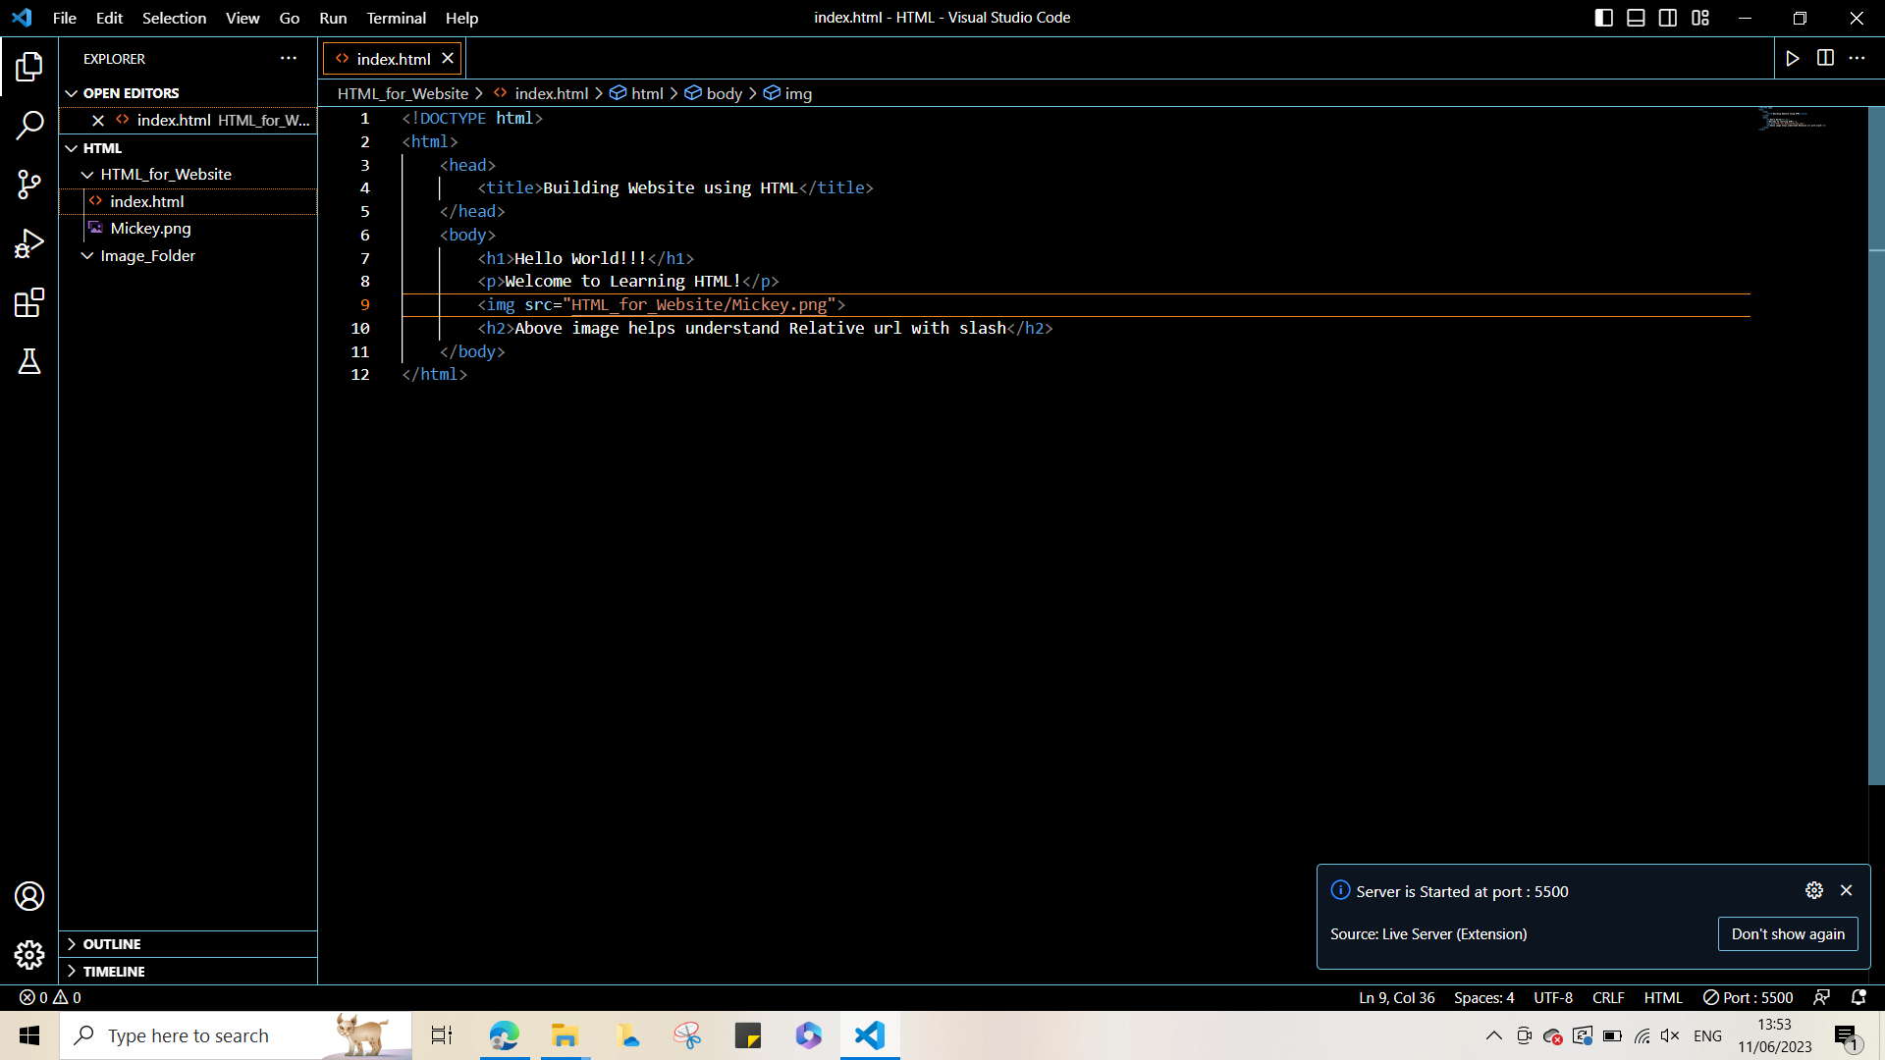

In the image above:

The image file Mickey and the file using image Mickey - index.html are contained in the HTML_for_Website folder. The HTML_for_Website folder is contained in the current folder - HTML.

Case 1: The url of src attribute does not start with slash.

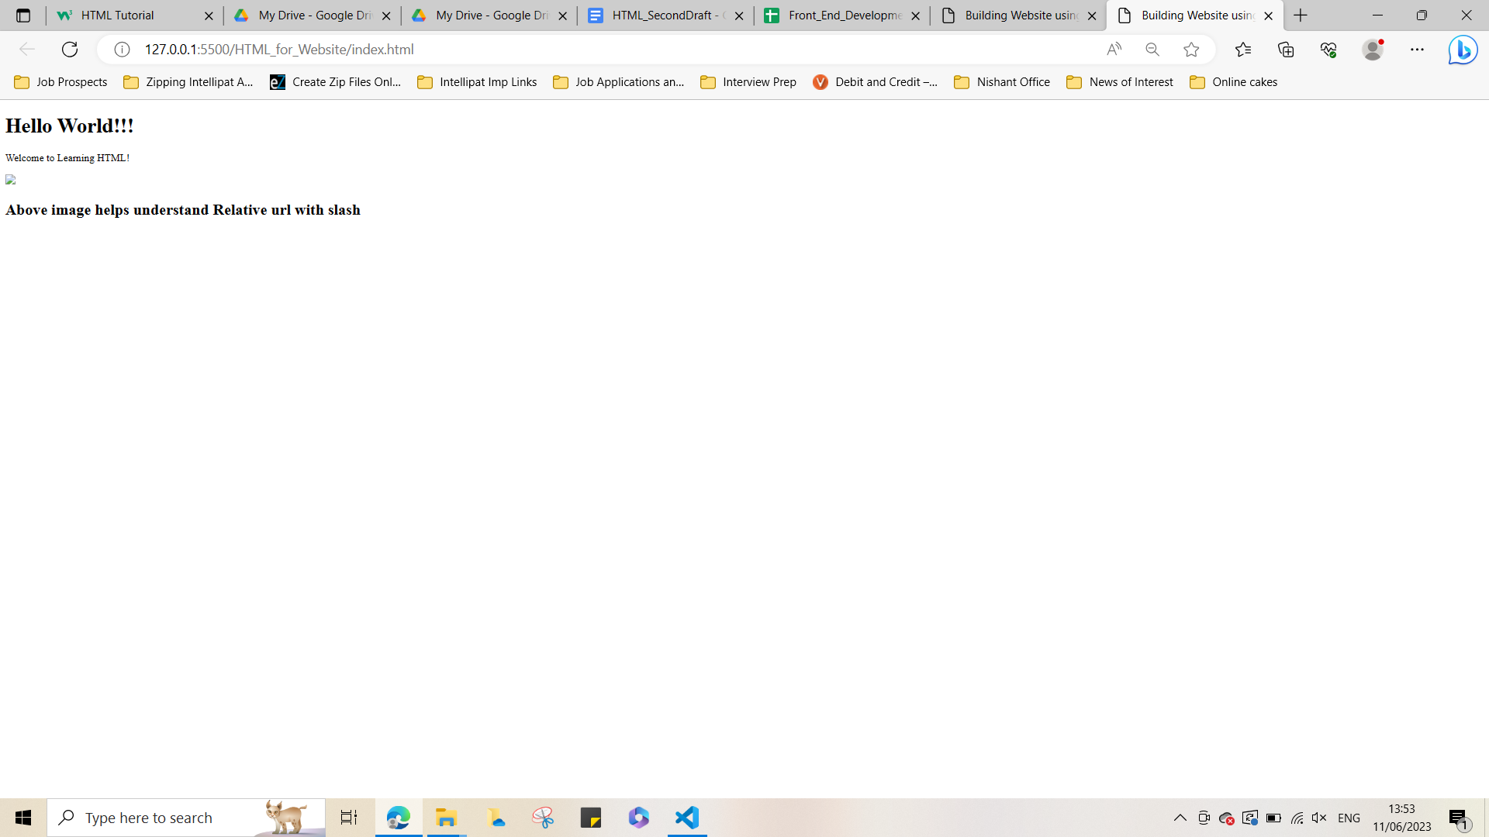

Output 1: Image not rendered on website.

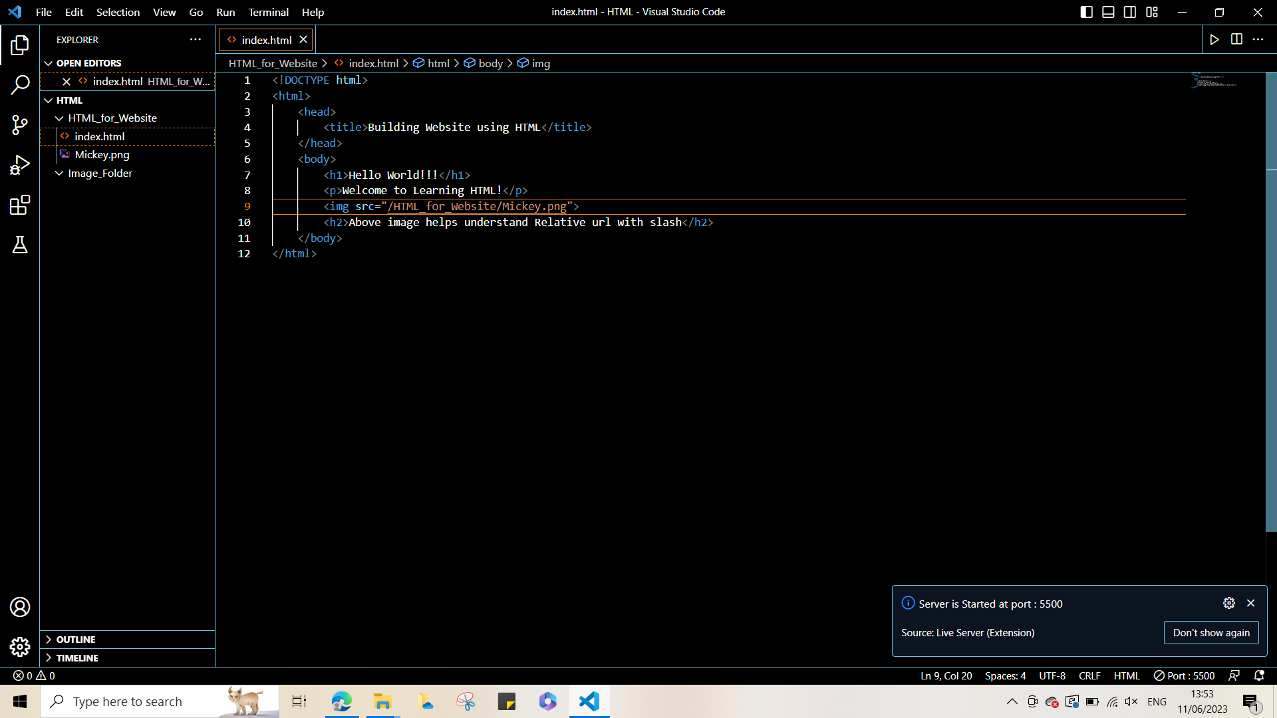

Case 2: The url of src attribute starts with a slash.

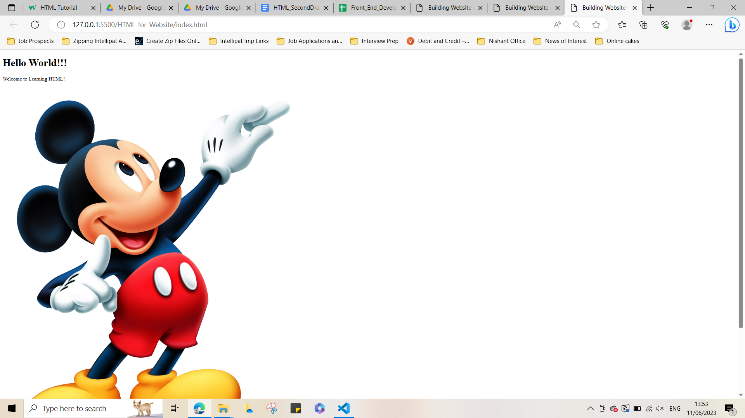

Output 2: Image successfully rendered on website.

This occurs because: image used is relative to domain but not the current folder - HTML.

The current folder is changed from HTML to HTML_for_Website folder by the “Open Folder” option in VS code. Thus the current folder now is - HTML_for_Website. Now:

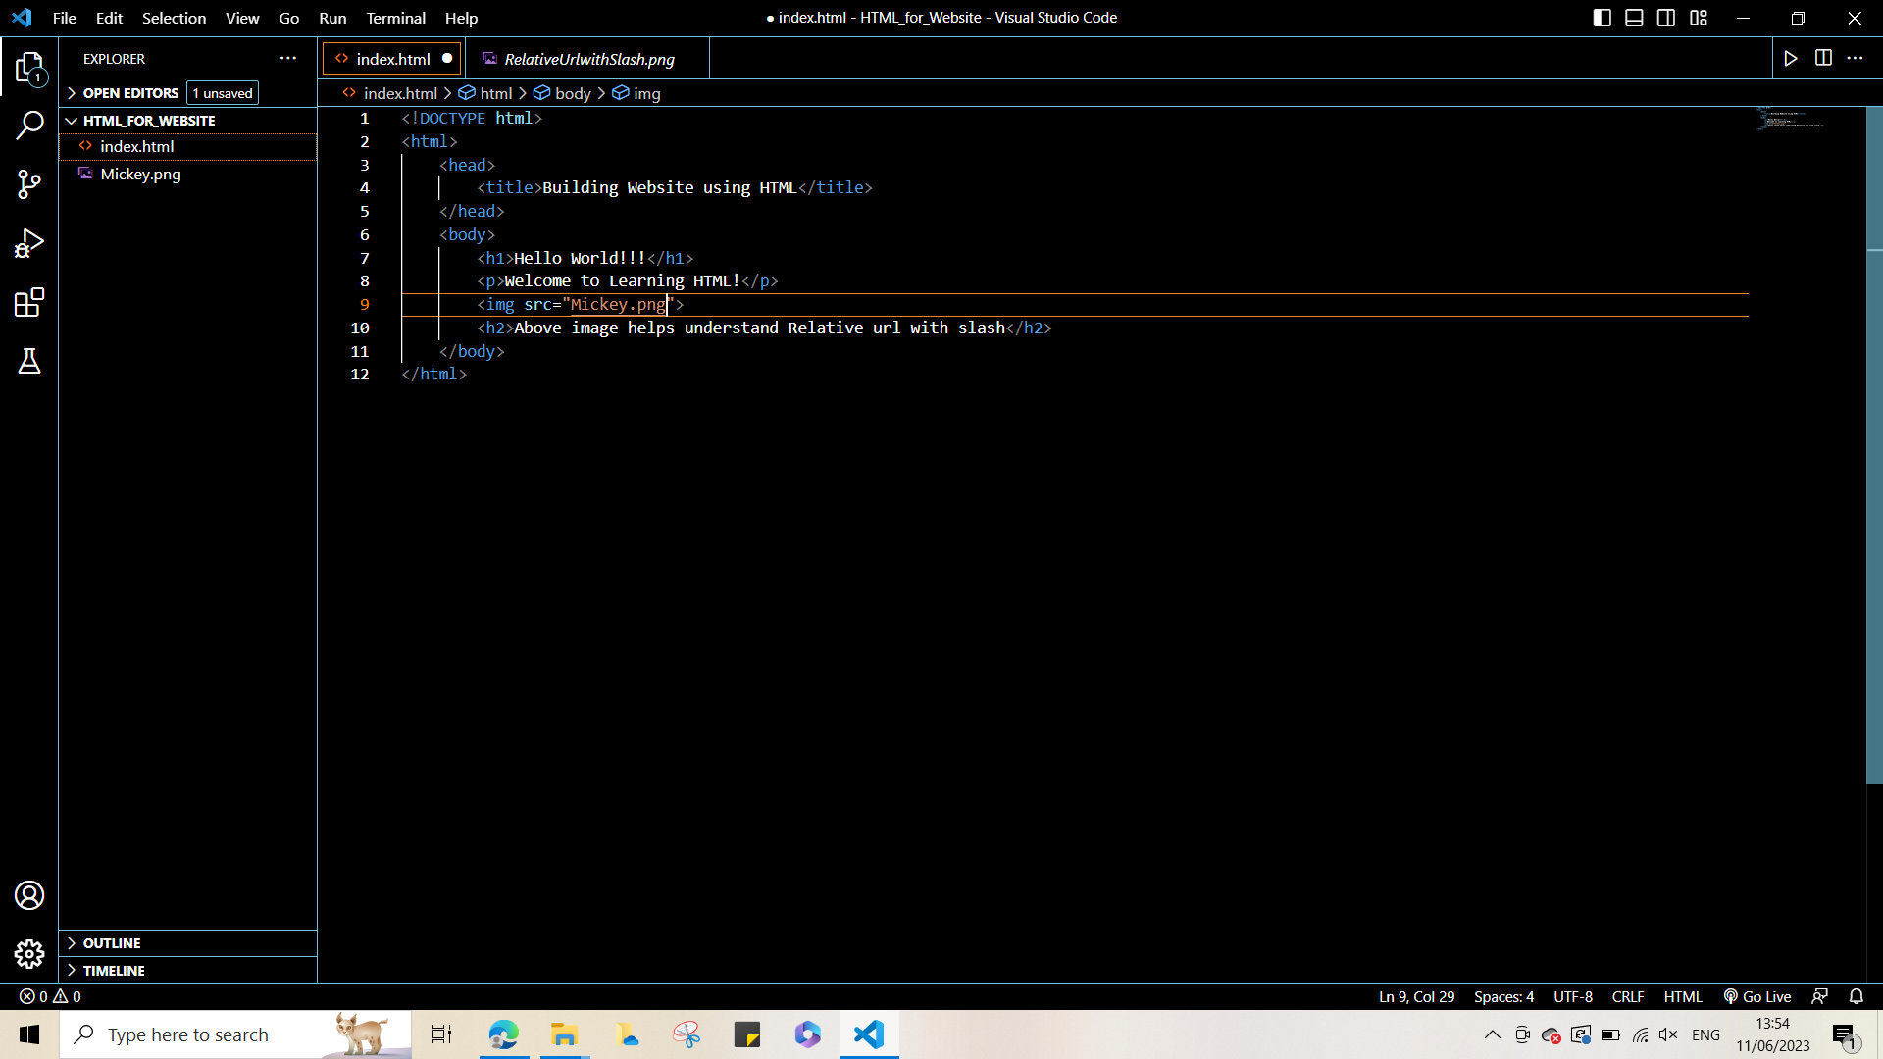

Case 3: The url of src attribute does not start with slash.



Output 3: Image successfully rendered on website.

This is because the image used is now relative to the current folder - HTML_for_Website.

**The lang Attribute:** the lang attribute inside the <html> tag, to declare the language of the Web page. This is meant to assist search engines and browsers. Country codes can also be added to the language code in the lang attribute. The first two characters define the language of the HTML page, and the last two characters define the country. So if one wanted to define the value of lang attribute as English, India it may be written as follows:



Link to ISO 639-1 defined abbreviations for languages: [HTML ISO Language Code Reference (w3schools.com)](https://www.w3schools.com/tags/ref_language_codes.asp)

Link to ISO 639-1 defined abbreviations for Countries: [HTML ISO Country Code Reference (w3schools.com)](https://www.w3schools.com/tags/ref_country_codes.asp)

**The title Attribute:** In HTML, the title attribute can be used with different tags to provide additional information.

When used with the <head> tag, the title attribute specifies the title of the HTML document and appears in the browser's title bar or tab.

When used with <h2></h2>, <p></p> or <a></a> tags, the title attribute provides a tooltip or additional information about the content within the heading, paragraph or to a link, as applicable.

* **NOTE: The title attribute is not typically used with the <h1> tag in HTML since the <h1> tag is used to define the main heading of a webpage.**
* **The title attribute is commonly used with various other HTML elements like <a>, <img>, or <abbr>. It provides additional information or tooltips specific to those elements.**

**Case of HTML Attributes:**

* The HTML standard does not require lowercase attribute names.
* The title attribute (and all other attributes) can be written with uppercase or lowercase like title or TITLE.

**However, it is recommended to use lowercase attributes in HTML, esp. for stricter document types like XHTML that demands lowercase attributes.**

**Attribute Values should be quoted:**

* The HTML standard does not require quotes around attribute values.

**However, it is recommended to use quotes in HTML, esp for stricter document types like XHTML. Also, in cases where the value of attributes contain spaces, it is necessary to use quotes, otherwise the attribute is not displayed correctly.**

**Summary of Mostly Used Attributes:**

**All HTML elements can have attributes**

* The href attribute of <a> specifies the URL of the page the link goes to
* The src attribute of <img> specifies the path to the image to be displayed
* The width and height attributes of <img> provide size information for images
* The alt attribute of <img> provides an alternate text for an image
* The style attribute is used to add styles to an element, such as colour, font, size, and more
* The lang attribute of the <html> tag declares the language of the Web page
* The title attribute defines some extra information about an element

**HTML Headings**

* HTML headings are titles or subtitles that are displayed on a webpage.
* HTML headings are defined with the <h1> to <h6> tags.
* <h1> defines the most important heading. <h6> defines the least important heading.
* **NOTE: Browsers automatically add some white space (a margin) before and after a heading.**
* Apart from enhancing the readability and scannability of a webpage and presenting users a clear, organised content, HTML headings allow Search engines and assistive technologies to understand the content and provide better accessibility to the webpage and improve its visibility in search results.

**Note: HTML headings should be used for headings only and not to make text BIG or bold.**

**Heading Size**

Each HTML heading has a **default** size. However, the size for any heading can be specified with the style attribute, using the CSS font-size property.

**HTML Paragraphs**

* The HTML <p> element defines a paragraph that is usually a block of text.
* A paragraph always starts on a new line, and browsers automatically add some white space (a margin) before and after a paragraph.

**HTML Display of Paragraphs**

HTML rendering can vary based on screen size, window resizing, and extra spaces/lines in the code. Browsers remove extra spaces and lines when displaying the page.

**<hr> Tag**

* The <hr> tag defines a thematic break in an HTML page.
* It is used to separate content in an HTML page and is most often displayed as a horizontal rule.

**<br> Tag**

* The <hr> tag defines a thematic break in an HTML page.
* It is used to separate content in an HTML page and is most often displayed as a horizontal rule.

**NOTE: Both <hr/> tag and < br/> tag are empty HTML tags.**

**<pre> Tag**

* The HTML <pre> element defines preformatted text.
* The text inside a <pre> element is displayed in a fixed-width font (usually Courier), and it preserves both spaces and line breaks.
* The font-family of a <pre> tag can be changed from courier to a font family of choice using CSS style property.

Above are some of the commonly used HTML tags and their attributes.

A complete list of all available HTML tags and their attributes can be found in this link:

[HTML Reference (w3schools.com)](https://www.w3schools.com/tags/default.asp)

## HTML Text Formatting

List of Html tags that provide text formatting:

* <b> - Bold text
* <i> - Italic text
* <sub> - Subscript text
* <sup> - Superscript text
* <strong> - Important text
* <em> - Emphasised text
* <mark> - Marked text
* <small> - Smaller text
* <del> - Deleted text
* <ins> - Inserted text

**Summary:**

* <b> and <strong> - have almost the same effect on text content.
* <i> and <em> - have almost the same effect on text content.
* <mark> - highlights the text content in yellow by default.
* If font-size CSS property is applied to style attribute in <small> tag, then text content follows the CSS font-size and overrules <small> tag effect on text.
* <sub> - creates subscript text.
* <sup> - creates superscript text.
* <del> - Any text within the <del></del> tag appears as a strikethrough text.
* <ins> - Any text within the <ins></ins> tag by default appears as an underlined text.

## HTML Quotation and Citation Elements

The citation elements or tags associated with HTML quotation are - <blockquote>,<q>, <abbr>, <address>, <cite>, and <bdo> HTML tags.

### HTML <blockquote> for Quotations

* The HTML <blockquote> element defines a section that is quoted from another source.
* Browsers usually indent <blockquote> elements.

### HTML <q> for Short Quotations

* The HTML <q> tag defines a short quotation.
* Browsers normally insert quotation marks around the quotation.

### HTML <abbr> for Abbreviations

* The HTML <abbr> tag defines an abbreviation or an acronym, like "HTML", "CSS", "Mr.", "Dr.", "ASAP", "ATM".
* Marking abbreviations can give useful information to browsers, translation systems and search-engines.
* **Tip:** The global title attribute can be used to show the description for the abbreviation/acronym when a user hovers mouse over the element.

### HTML <address> for Contact Information

* The HTML <address> tag defines the contact information for the author/owner of a document or an article.
* The contact information can be an email address, URL, physical address, phone number, social media handle, etc
* The text in the <address> element usually renders in italic, and browsers will always add a line break before and after the <address> element.

### HTML <cite> for Work Title

* The HTML <cite> tag defines the title of a creative work (e.g. a book, a poem, a song, a movie, a painting, a sculpture, etc.)

**Example:** <p><cite>The Scream</cite> by Edvard Munch. Painted in 1893.</p>

* The text in the <cite> element usually renders in italic.

### HTML <bdo> for Bi-Directional Override

* BDO stands for Bi-Directional Override.
* The HTML <bdo> tag is used to override the current text direction:

**Example:** <bdo dir="rtl">This is a bdo tag that facilitates Bi-Directional Override</bdo>

**Note: The default text-direction of the bdo tag is left to right, but it allows setting it to right-to-left (“rtl”)with the help of the “dir” or direction attribute as shown in the example above.**

## HTML Comments

HTML comments are used to add explanations or descriptive notes within an HTML code, which are not visible to the users viewing the webpage.

These comments are intended for developers and webmasters, providing them with a means to communicate and organise their HTML codes by adding reminders or temporarily disabling specific sections.

Some of the common uses of HTML comments are:

* **Documentation:** Comments allow developers to explain the purpose or functionality of certain HTML elements, sections, or code snippets. This can be useful for future reference or when collaborating with other developers.
* **Troubleshooting:** Comments can be used to isolate or disable sections of HTML code temporarily. By commenting out problematic code, developers can test and debug their web pages more easily without deleting the code entirely.
* **Reminder and TODOs:** Comments serve as reminders for future modifications or additions to the code. Developers can leave notes for themselves or their colleagues, indicating areas that need improvement or additional work.
* **Hiding code:** Sometimes, developers may want to hide a section of HTML code from rendering on the webpage without deleting it. Comments provide a convenient way to "comment out" that code temporarily.

**NOTE: HTML Comments are not displayed in the browser, so they don't affect the appearance or functionality of the webpage.**

### HTML Comment Tag(Syntax):



<!-- - -> is the HTML comment tag.

### Add Comments for Reminders and Notifications(Example):

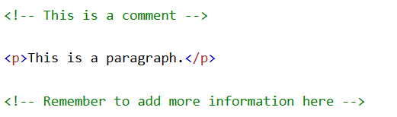

### Hiding Content with HTML Comments(Example):

###### Hiding an HTML element:

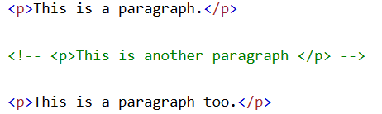

###### Hiding everything within HTML comment tag (more than one HTML Element):

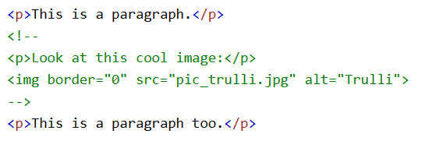

###### Hiding parts of HTML code by putting a comment tag in the middle of the code:



## HTML Colors

# FURTHER LEARNING:

# ADVANCED TOPICS:

**HTML Tag Reference**

W3Schools' tag reference contains additional information about these tags and their attributes.

**HTML <html> Tag:**

1. **‘lang’ attribute of <html></html> tag:** The "lang" attribute of the <html></html> tag in HTML is used to specify the language of the document. It should always be included inside the <html> tag, to declare the language of the Web page. This is meant to assist search engines and browsers. Here are some examples of valid values for the "lang" attribute:

English (United States): <html lang="en-US">

* Spanish (Spain): <html lang="es-ES">
* French (France): <html lang="fr-FR">
* German (Germany): <html lang="de-DE">
* Japanese: <html lang="ja">
* Chinese (Simplified): <html lang="zh-Hans">
* Arabic: <html lang="ar">
* Russian: <html lang="ru">
* Hindi: <html lang="hi">
* Portuguese (Brazil): <html lang="pt-BR">

These are just a few examples, and the "lang" attribute can accept a wide range of language codes and language subtags based on the IETF language tag standard.

**Link to IETF language tag standard:** <https://tools.ietf.org/html/rfc5646> (for any specific project requirement)

1. **‘Xmlns’ attribute:** Specifies the XML namespace attribute in cases where the content needs to conform to XHTML.

Appendix

1. "Source code" refers to the underlying human-readable text-based representation of an HTML page. It contains the HTML tags, attributes, and content that define the structure, formatting, and elements of the webpage. Source code is used by web browsers to render and display the page correctly. By viewing the source code, users can examine the inner workings of a webpage and understand how it is constructed.
2. CSS: CSS stands for Cascading Style Sheets. It is a style-sheet language. CSS is used to define the presentation and formatting of an HTML element in an HTML document. presentation and formatting of an HTML element may include - layout, colours, fonts, and other visual properties.