ROS:
- Robot Operating System
- Supports modular software design – NODES

Notes:
- catkin init – to initilization
- catkin build – to build your environment

build
- contains build info
- program to machine language

logs
- reports of run exceution

devel
- running nodes (codes)

src
- warehouse of projects

Creating Packages:

Publish and Subscribe

Note: There are many default packages comes along with ros installtion.
command: rospack list

catkin_create_pkg <name>

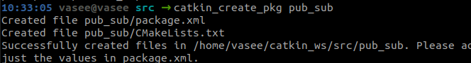

Note:
Good to have codes inside scripts

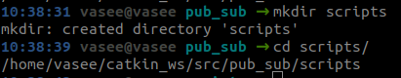

create python file (code):

note: permission should be enabled to these newly created files

publisher file:

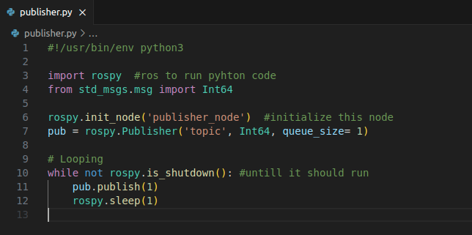

publishing topic:

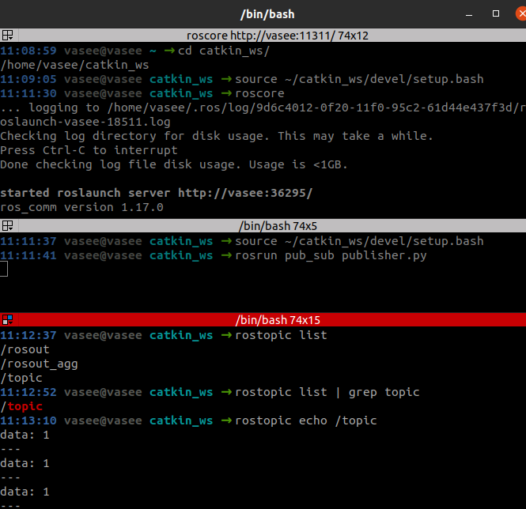
Note:
Add this to avoid sourcing again and again.
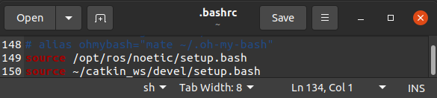

Subscriber file:

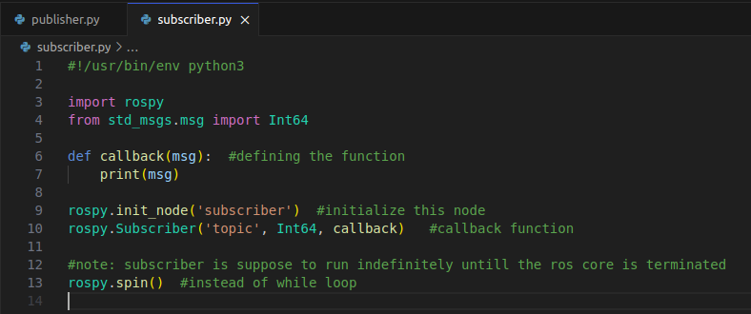

subscribing topic:

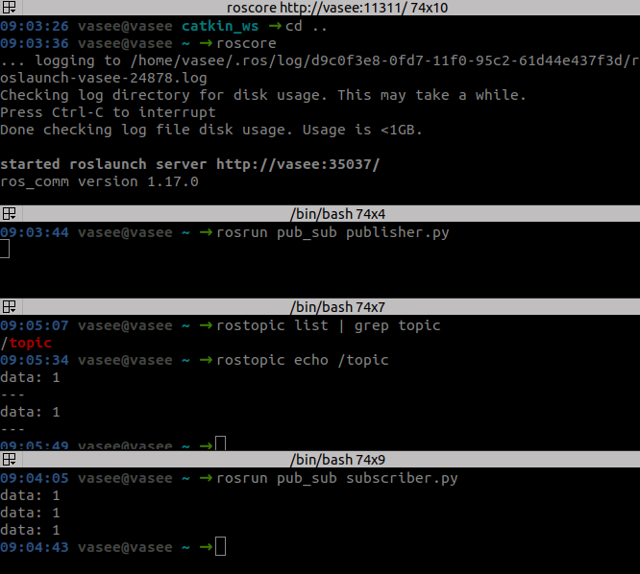

Note: If we want to delete the packages, direct deletion cannot remove all related files inside build, devel and logs. We still need to remove them.
Command: catkin clean –orphans

ROS LAUNCH:

Let’s say we have 10 different nodes, how can we run all these nodes at a particular time, then the ros launch came into action.

Create launch file:

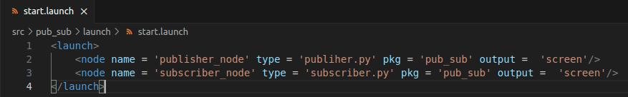

running launch file:

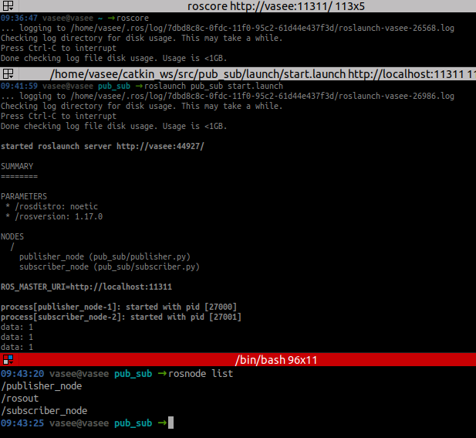

note: while running roslaunch, both publisher and subscriber nodes are running simultaneously
we can feel this on running rosnode list and rostopic list

About RQT Tool:
command: rqt

we can examine relationship between publisher node, subscriber node and topics.

PLAY with Turle sim, it is really crazy!!
Turtle sim automatically publisher/subscribe topic (check – rostopic info), just we only need to create publisher/subscriber node to publish topics accordingly.

- just to move turtle in x direction
- just check rostopic echo

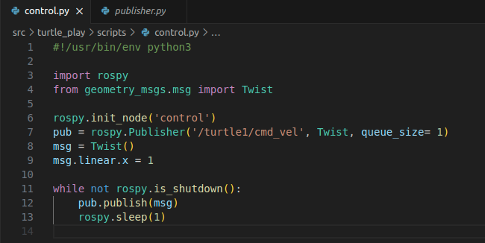

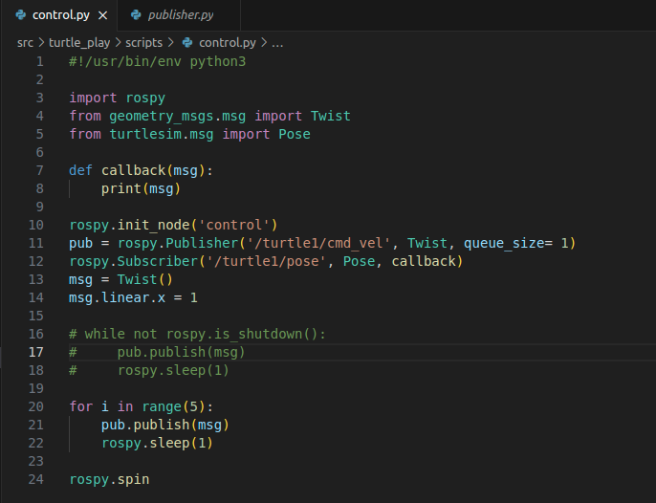

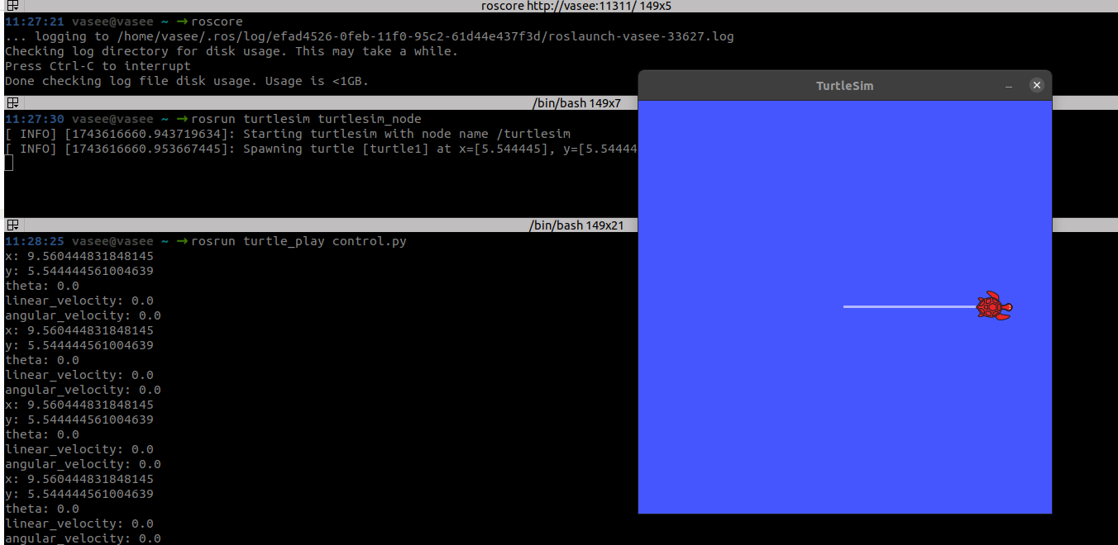

Client and Server

- client request for service from the server | server is mandatory
- request and response

creating server-client package:

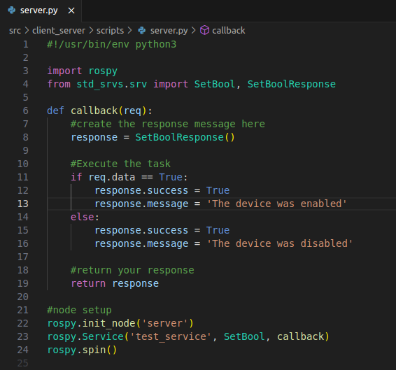

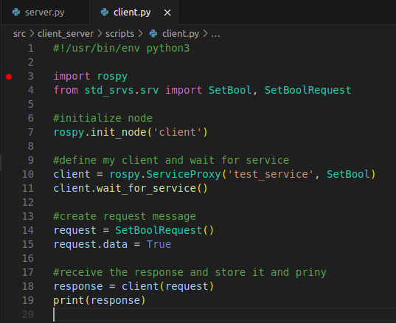

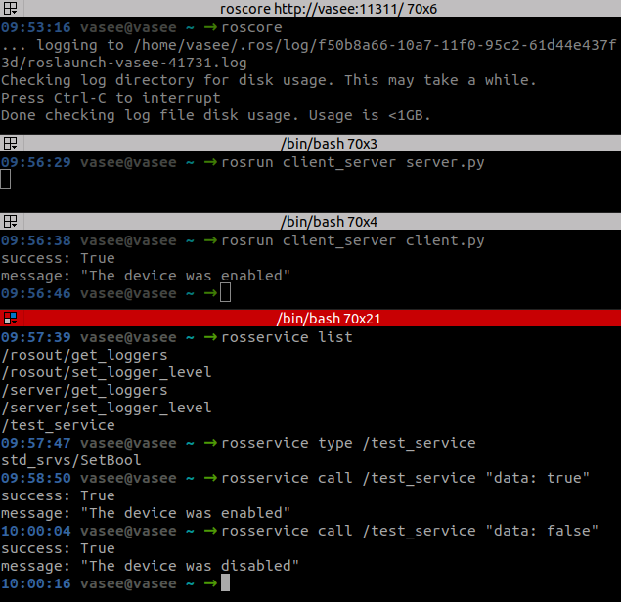

rosservice call <service_name> “date: true/false”

Note: in publish and subscribe – there is no need for subscriber all time

search in ros installation for service
computer/opt/ros/noetic/share/std_srvs

we can say ~ msgs are subset of services

ROS Parameter Server:
- associated with roscore
- stores parameter

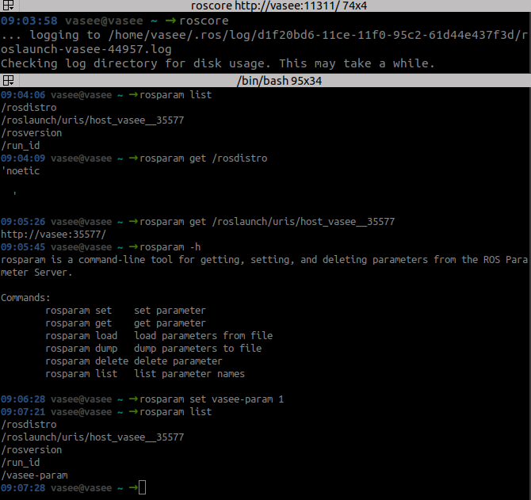

Notes:

we cannot do this everytime in terminal. We need this in some automated scripts
we can only get this running only from roslaunch command
we need to create ‘yaml’ file – basically a database

Create – Ros Param Yaml File

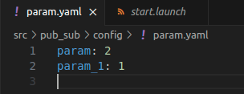

Simillary like, to run many topic at a particular time – we use ros launch file.
We need to include this yaml file aslo there in launch file

create – Launch File (for param (yaml file))

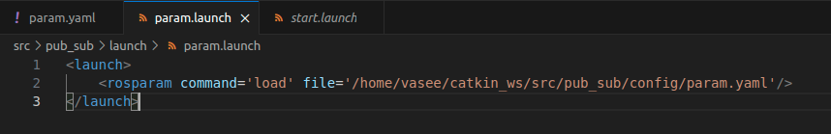

running launch file:
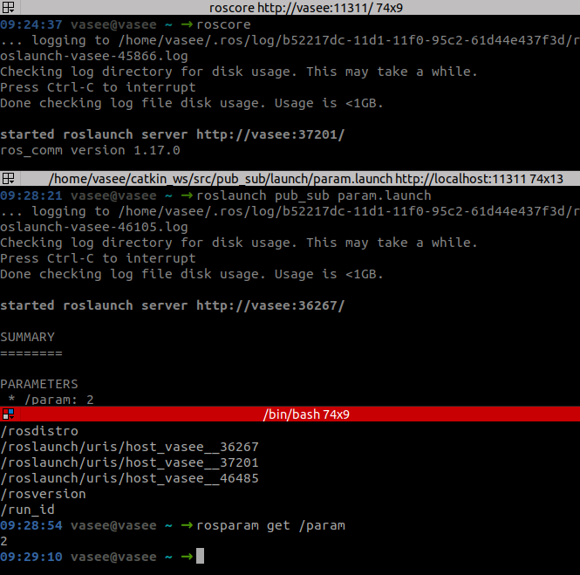
Here, in launch file, path of config is little tedious (not same for everyone)
edit like this

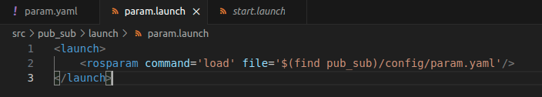

Rosbags:
Bags for storing ros-data

- run roscore
- record rosbag
- publish topic varibales

- play rosbag (where you can see traces)
- rostopic echo and look for traces

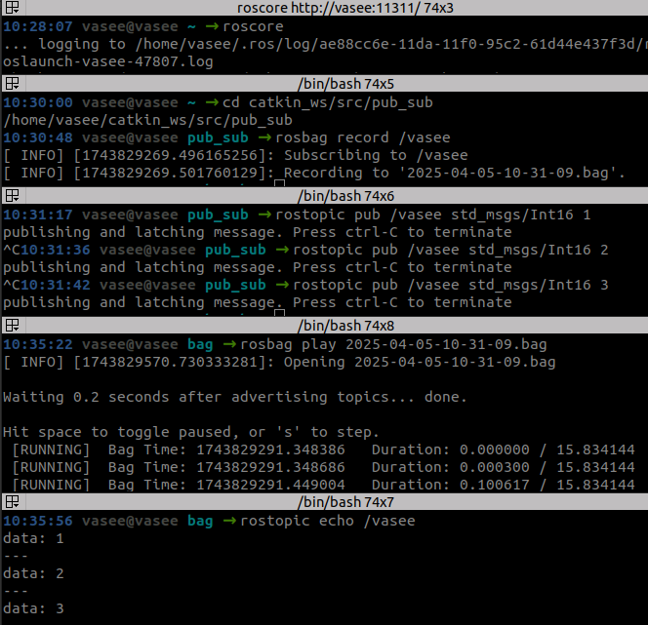

create python file to view bags contents instead of echoing

read_bag file:

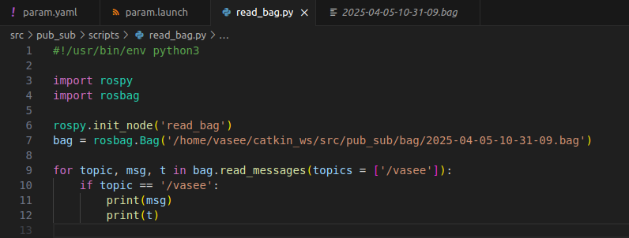

output:

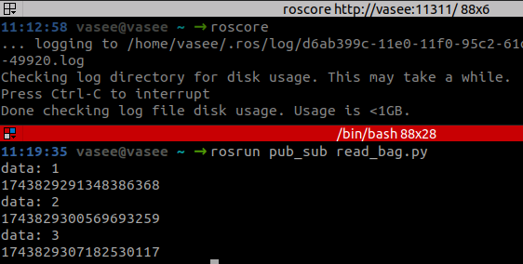

Quick Collective Works:
publisher:

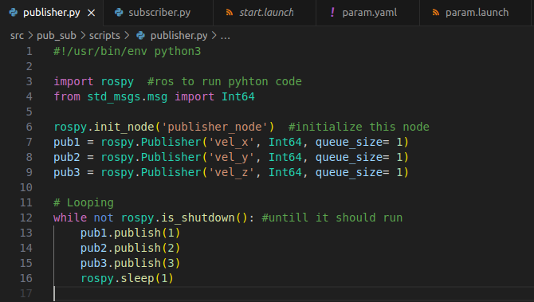

subscriber:

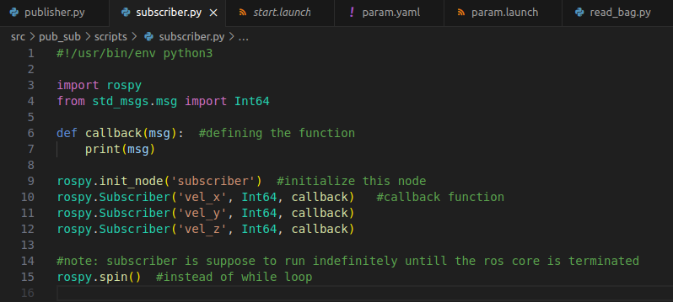

launch:

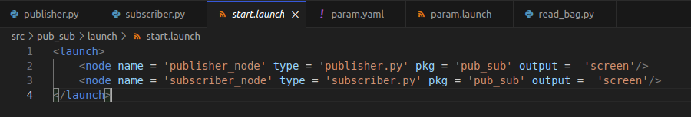

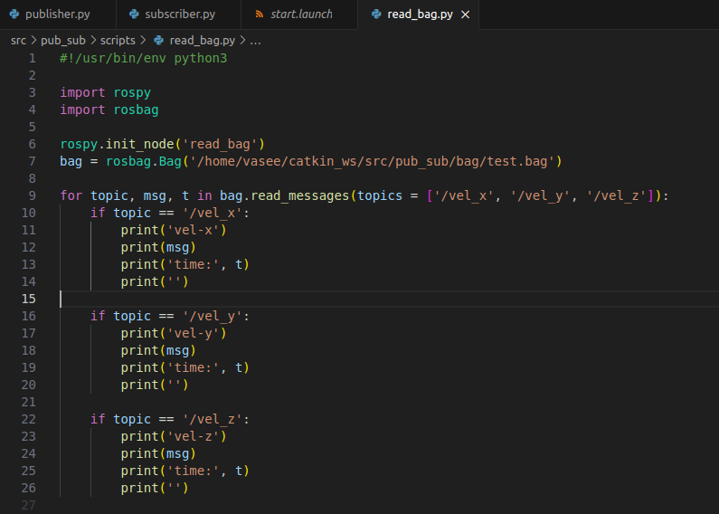
read bag:

running roscore:
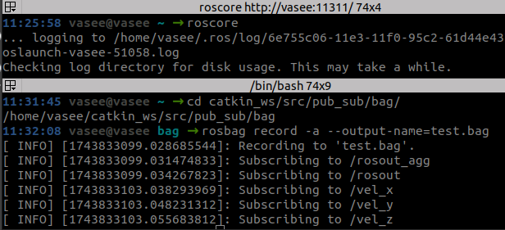
recording rosbags with all topics:
running launch file:

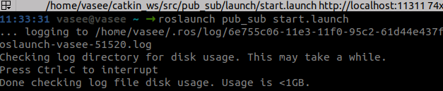
Playing rosbag:
