PCOSINA Benchmark Code Screenshot Evidence
Generated 2026-06-10 from repository source files
Purpose: This pack provides printable code-level evidence for how the T01-T20 planner benchmark was defined, executed, measured, summarized, and validated. It does not invent benchmark values; screenshots are rendered from the exact local source files and archived report.
Defense boundary: The final 100-run benchmark is archived as machine-readable JSON/CSV. The earliest two Table 32 speed rows are documented development benchmark values, but their raw JSON/CSV artifacts were not retained.

1. Benchmark Fixture and CLI Controls
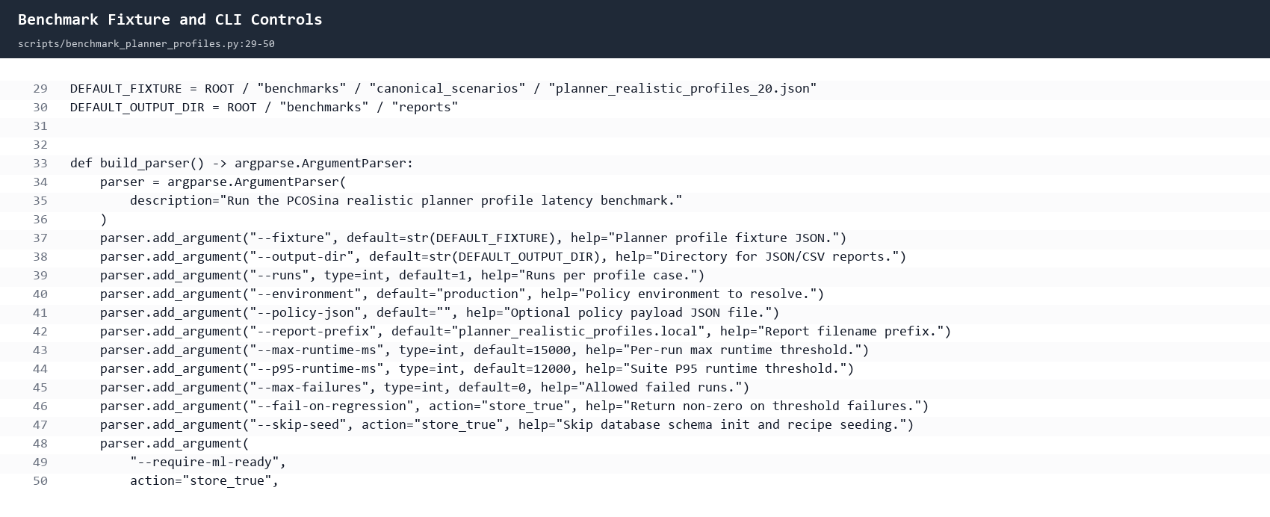
Shows that the benchmark runner uses the fixed T01-T20 fixture path, supports repeated runs per profile, and can require the ML ranker to be ready.

2. P95 Runtime Formula
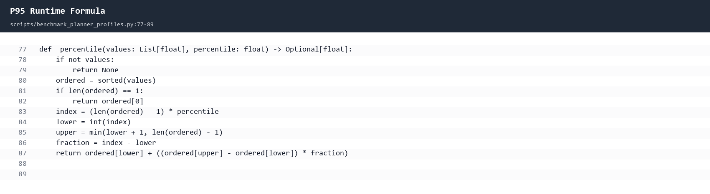
Shows the script's interpolated percentile computation used for P95 runtime.

3. Per-Run Validation Metrics
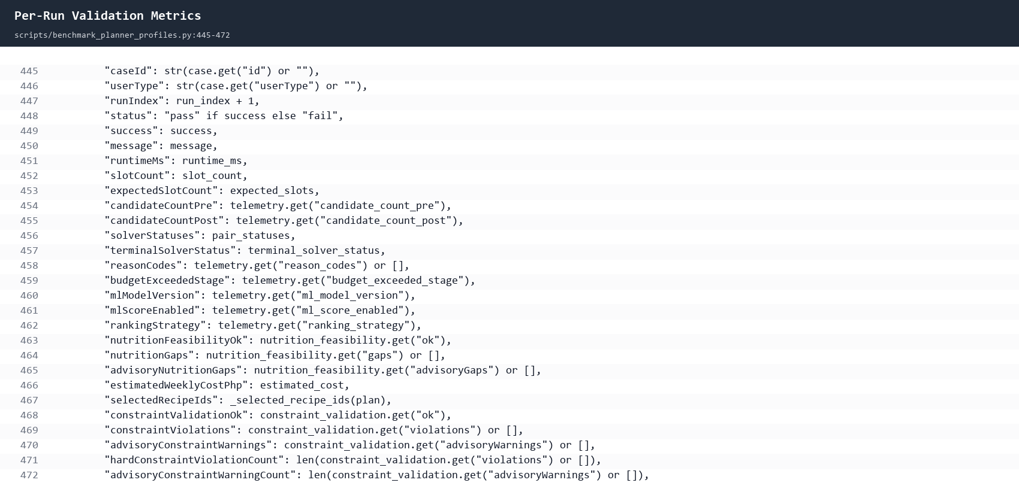
Shows that each run records slot count, solver status, nutrition feasibility, constraint validation, and hard-rule violation count.

4. Final Suite Summary Formulas
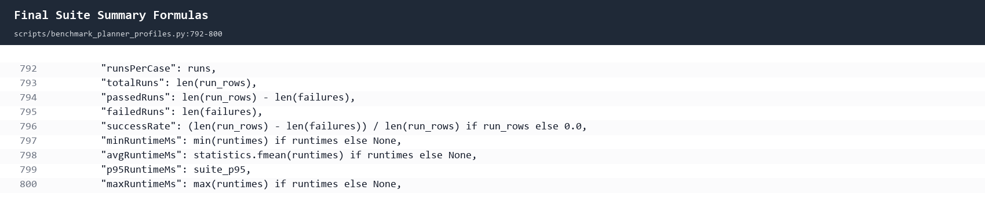
Shows how total runs, passed runs, average runtime, P95 runtime, and maximum runtime are computed for the benchmark suite.

5. ML-Ready Benchmark Guard
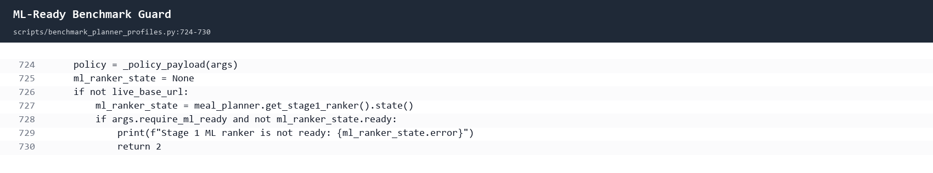
Shows that --require-ml-ready fails the benchmark if the LightGBM ranker is not ready.

6. Archived Final Benchmark Result
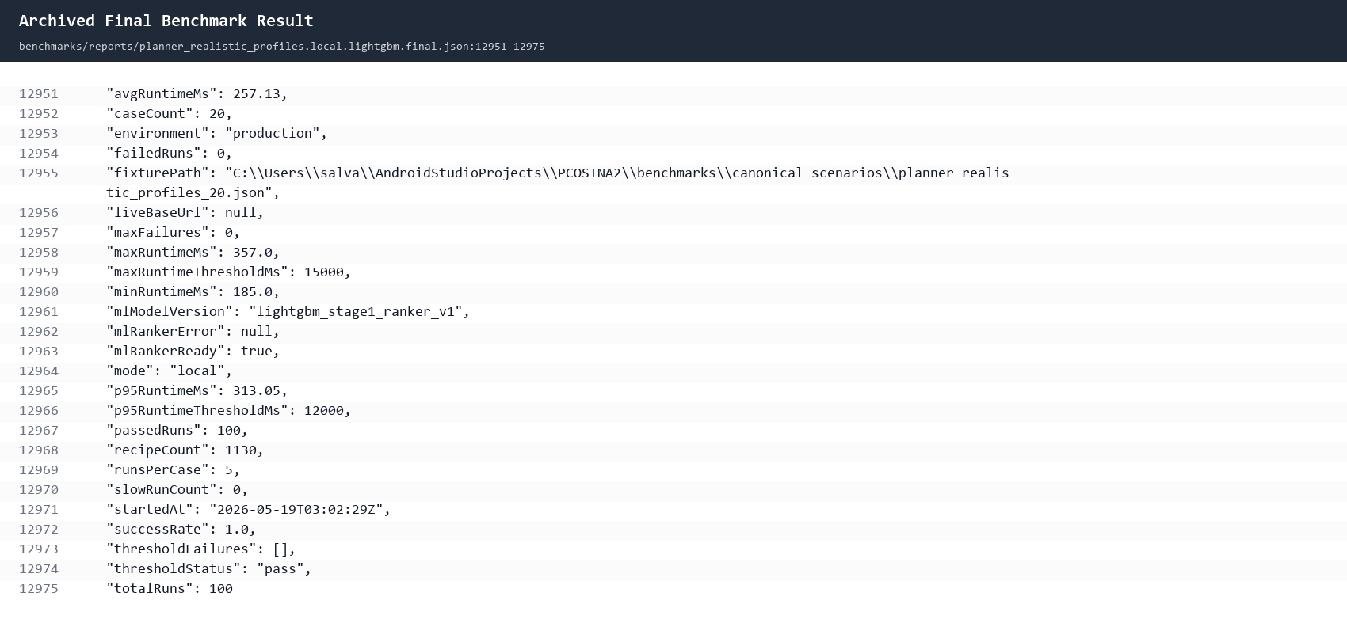
Shows the archived final result: 100 total runs, 100 passed, 5 runs per case, 257.13 ms average, 313.05 ms P95, 357 ms max, and LightGBM ready.

7. PHP 20 No-Safe-Plan Boundary Test
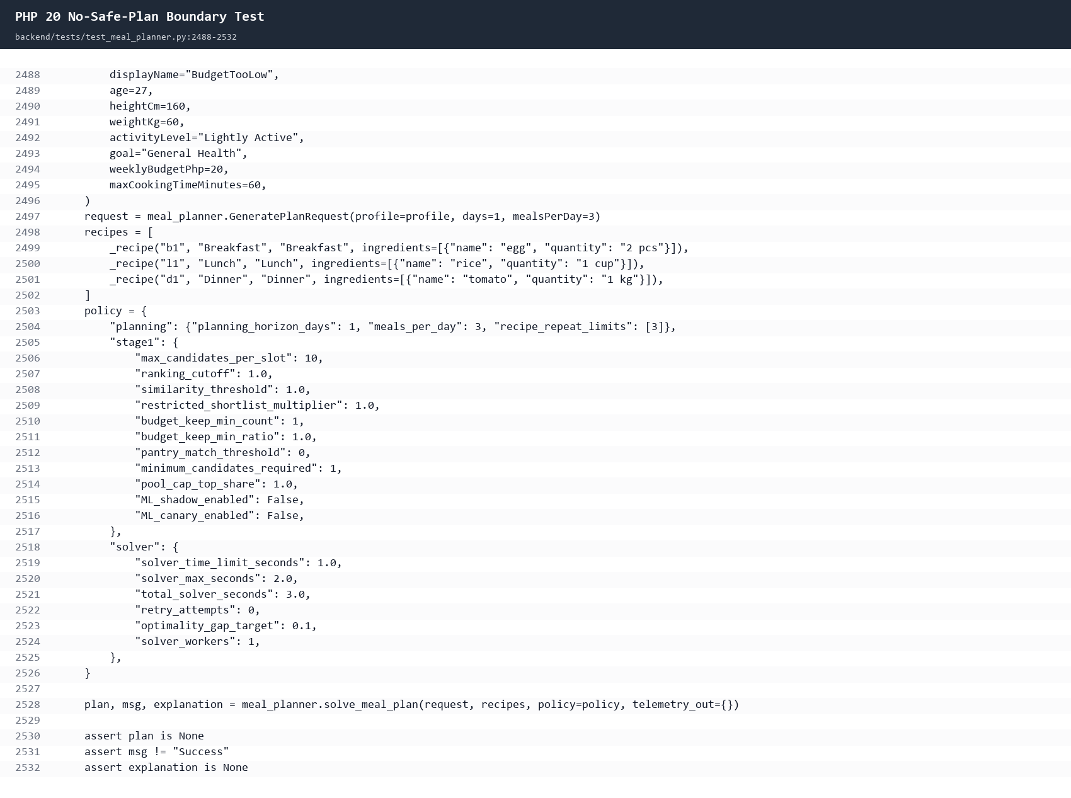
Shows the separate automated budget-infeasibility test where weeklyBudgetPhp=20 must return no plan instead of an unsafe or impossible recommendation.

8. T01-T20 Fixture Summary
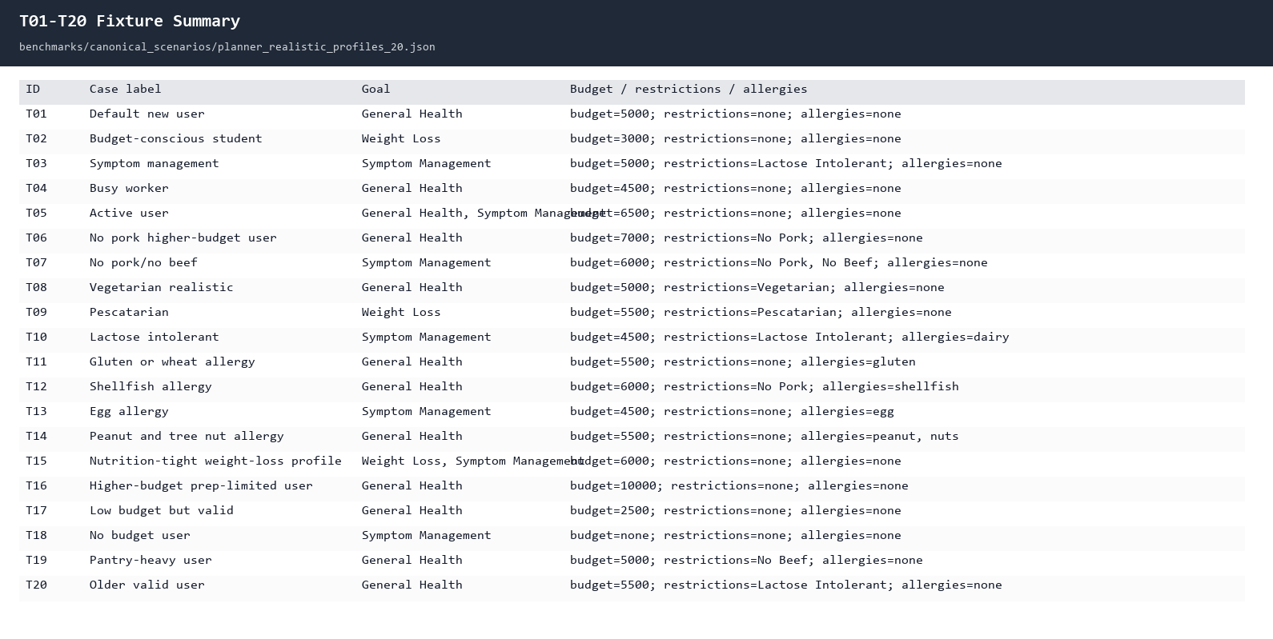
Shows the 20 fixed benchmark cases read from the canonical fixture.

