PCOSina Code Evidence Dossier
Stage 1 Filtering and Stage 2 MILP-Style OR-Tools CP-SAT Formulation
Primary source: backend/services/meal_planner.py
Defense wording: Our Stage 2 is a MILP-style 0-1 linear optimization formulation implemented with OR-Tools CP-SAT. It uses binary decision variables, linear constraints, and a weighted minimization objective. Stage 1 uses deterministic rule-based filtering and scoring so unsafe or incompatible recipes are removed before optimization.
Important clarification: The code uses if-statements for normal control flow, validation, and safety checks. That does not mean the meal plan is hard-coded. The final meal combination is selected from solver decision variables.

Quick Evidence Map
Evidence | Source line(s) | What it proves | Defense use
OR-Tools CP-SAT import | backend/services/meal_planner.py:10 | Shows the backend imports OR-Tools CP-SAT, the solver API used for the planner model. | This proves we use a solver library, not only handcrafted if-else meal selection.
Main two-stage planner entry point | backend/services/meal_planner.py:2468-2475 | Defines the production meal-plan generation function. | This is where the Stage 1 shortlist and Stage 2 solver process are connected.
Stage 1 starts inside planner | backend/services/meal_planner.py:2601-2613 | Marks the start of Stage 1 pruning, shortlist preparation, and feature context setup. | Stage 1 prepares safe candidate recipes before optimization.
Stage 1 shortlist call | backend/services/meal_planner.py:2643-2651 | Calls shortlist_candidates using the user's profile, recipes, policy, pricing context, and ML feature context. | The production planner does not send the whole catalog directly to the solver; it filters and ranks first.
Stage 2 model starts | backend/services/meal_planner.py:2893-2898 | Creates the CP-SAT model and the binary decision variables. | This is the start of the MILP-style 0-1 optimization formulation.
Stage 1 function definition | backend/services/meal_planner.py:1654-1662 | Defines shortlist_candidates, the deterministic candidate filtering and shortlisting stage. | Stage 1 is a real planner stage, not only UI-side filtering.
Read user constraints | backend/services/meal_planner.py:1665-1669 | Reads dietary restrictions, allergies, weekly budget, maximum cooking time, and pantry tokens. | The user profile directly affects the planning constraints and candidate filtering.
Normalize ingredients | backend/services/meal_planner.py:287-299 | Converts recipe ingredients into normalized tokens for consistent matching. | This supports allergy, pantry, tag, and feature matching using comparable tokens.
Normalize pantry | backend/services/meal_planner.py:306-313 | Converts user pantry items into normalized tokens. | Pantry use is not guessed; pantry strings are processed into the same token format as recipe ingredients.
Normalize allergies | backend/services/meal_planner.py:321-350 | Maps allergy inputs into allergen families and custom allergy tokens. | Allergy filtering is based on normalized allergy categories and ingredient-token matching.
Symptom and goal adjustments | backend/services/meal_planner.py:394-444 | Applies deterministic nutrition nudges for goals and selected symptoms. | PCOS-related profile fields affect fiber, sugar, protein, calorie, and Stage 1 preference boosts.
Recipe feature extraction | backend/services/meal_planner.py:680-697 | Builds tags, ingredient tokens, protein group, vegetable tokens, and allowed meal labels. | The planner extracts structured recipe features before scoring and solving.
Meal-slot eligibility inference | backend/services/meal_planner.py:613-628 | Maps recipe mealType values into allowed meal labels such as Breakfast, Lunch, Dinner, and snacks. | Recipes are not randomly placed in slots; meal-type compatibility is computed first.
Hard restriction check | backend/services/meal_planner.py:1036-1059 | Detects allergy, pork, beef, vegetarian, pescatarian, and lactose-intolerant failures. | The if-statements here are safety gates, which are normal and necessary in any decision-support app.
Exclude unsafe recipes | backend/services/meal_planner.py:1726-1737 | Applies static features and skips recipes that fail hard restriction checks. | Unsafe recipes are removed before Stage 2 optimization.
Prep-time exclusion | backend/services/meal_planner.py:1738-1742 | Excludes recipes above the user's maximum cooking-time limit. | This is a user feasibility rule, not a hard-coded meal decision.
Pantry overlap scoring | backend/services/meal_planner.py:1757-1760 | Counts how many recipe ingredients overlap with saved pantry items. | Pantry data influences ranking and later solver reward, while still preserving hard safety rules.
Stage 1 score formula | backend/services/meal_planner.py:805-810 | Ranks candidates using protein, cost estimate, calorie distance, pantry match, and Stage 1 boost. | Stage 1 ranking is deterministic and explainable.
Cost estimate | backend/services/meal_planner.py:761-802 | Estimates recipe cost using ingredient pricing context and serving multiplier, with a bounded fallback. | Cost is computed before optimization so budget can affect planning.
Meal bucket assignment | backend/services/meal_planner.py:1823-1831 | Places safe recipes into Breakfast, Lunch, Dinner, or Universal buckets. | Stage 1 organizes the candidates by meal type before Stage 2.
Optional ML scoring | backend/services/meal_planner.py:1850-1869 | Uses a ranker or deterministic shadow score only after hard filtering. | ML is optional and assistive; it does not override hard constraints.
Sort, deduplicate, and trim | backend/services/meal_planner.py:1875-1889 | Sorts by base score, removes near-duplicates, applies limits, and does budget-aware trimming. | Stage 1 narrows the search space while keeping safe and relevant options.
Stage 1 returns buckets | backend/services/meal_planner.py:1901-1912 | Records Stage 1 diagnostics and returns the final buckets to the planner. | Stage 1 produces explicit output consumed by Stage 2.
Binary decision variable x[s,i] | backend/services/meal_planner.py:2893-2898 | Creates x[s,i] as a Boolean variable for each meal slot and recipe candidate. | x[s,i] = 1 means recipe i is selected for slot s; x[s,i] = 0 means it is not selected.
Exactly one recipe per slot | backend/services/meal_planner.py:2901-2905 | Adds a linear equality requiring one allowed recipe for each meal slot. | This is a formal assignment constraint, not a manual if-else selection.
Disallow wrong meal type | backend/services/meal_planner.py:2906-2910 | Forces non-allowed recipe-slot pairs to zero. | The solver is prevented from assigning Breakfast-only recipes to the wrong slot type.
Greedy warm-start hint | backend/services/meal_planner.py:2913-2927 | Adds a greedy starting hint for the solver search. | This hint can guide the solver, but it does not replace the CP-SAT optimization.
No adjacent duplicate | backend/services/meal_planner.py:2928-2937 | Prevents adjacent repeats and limits weekly repeats. | Variety constraints are directly encoded in the solver model.
Repeat penalty variable | backend/services/meal_planner.py:2947-2953 | Creates repeat_over variables to penalize repeated recipe use. | The model can discourage repetition without making every repeat impossible.
Protein group variety | backend/services/meal_planner.py:2955-2968 | Groups recipes by protein source and penalizes overuse of the same group. | Variety is handled as a model term, not only by random shuffling.
Vegetable diversity | backend/services/meal_planner.py:2970-2987 | Tracks vegetable token coverage and adds a minimum diversity target with slack. | Ingredient diversity is explicitly represented in the formulation.
Pantry reward | backend/services/meal_planner.py:2989-2998 | Builds a pantry-match expression from selected recipe variables. | Pantry utilization affects the objective through selected recipes.
Total cost expression and optional rough cap | backend/services/meal_planner.py:3000-3002 | Computes total selected cost and optionally applies a rough budget cap. | Budget is part of the mathematical model when the policy enables the rough cap.
Daily calorie constraints | backend/services/meal_planner.py:3013-3021 | Computes daily calories from selected meals and enforces calorie bounds. | Daily calorie feasibility is enforced by linear constraints.
Macro, fiber, sodium, and sugar constraints | backend/services/meal_planner.py:3022-3040 | Computes daily protein, carbs, fats, fiber, sodium, and sugar from selected meals. | Macros and fiber are hard bounded; sodium and sugar are tracked through overage variables.
Meal calorie distribution | backend/services/meal_planner.py:3042-3049 | Creates meal-level calorie deviation variables around meal distribution targets. | The planner does not only hit daily totals; it also balances individual meals.
Objective component totals | backend/services/meal_planner.py:3051-3067 | Combines error, sodium/sugar overage, repeat pressure, group pressure, pantry reward, and diversity reward. | The model has measurable optimization terms before the final objective is declared.
Objective weights | backend/services/meal_planner.py:3068-3092 | Applies user planning priority, variety preference, budget, pantry, prep time, and acceptance weights. | User priorities affect objective weights, not hard-coded final meals.
Weighted minimization objective | backend/services/meal_planner.py:3093-3100 | Calls model.Minimize with the full weighted objective expression. | This is the strongest proof that Stage 2 is an optimization model.
Solver created and configured | backend/services/meal_planner.py:3111-3145 | Creates the CP-SAT solver and sets time, gap, worker, memory, and solution-count parameters. | The system uses an actual solver run with configured search limits.
Solver execution | backend/services/meal_planner.py:3151-3165 | Runs solver.Solve(model) and reads the solver status. | The selected plan comes from the solver result.
Accept feasible or optimal | backend/services/meal_planner.py:3197-3202 | Stops only when the solver returns OPTIMAL, FEASIBLE, INFEASIBLE, or exits retry logic. | The planner respects solver status instead of always forcing an output.
Read selected meals from variables | backend/services/meal_planner.py:3215-3229 | Uses solver.Value(x[idx, i]) to convert selected binary variables into planned meals. | The final displayed meal plan is literally read from the solved decision variables.
Final grocery budget validation | backend/services/meal_planner.py:3232-3268 | Builds grocery output, checks final budget authority, and rejects/retries over-budget plans. | The system verifies the selected plan against final grocery cost, not only the rough solver estimate.
Success return with explanation | backend/services/meal_planner.py:3297-3349 | Builds the explanation object and returns the successful plan. | The system returns both a plan and explanation metadata for defense/debugging.
Infeasible fallback | backend/services/meal_planner.py:3378-3382 | Returns budget failure, timeout, or infeasible instead of pretending a safe plan exists. | The planner handles infeasibility gracefully.

Solver and Stage Boundary

1. OR-Tools CP-SAT import
Source: backend/services/meal_planner.py:10
What it does: Shows the backend imports OR-Tools CP-SAT, the solver API used for the planner model.
Use in defense: This proves we use a solver library, not only handcrafted if-else meal selection.
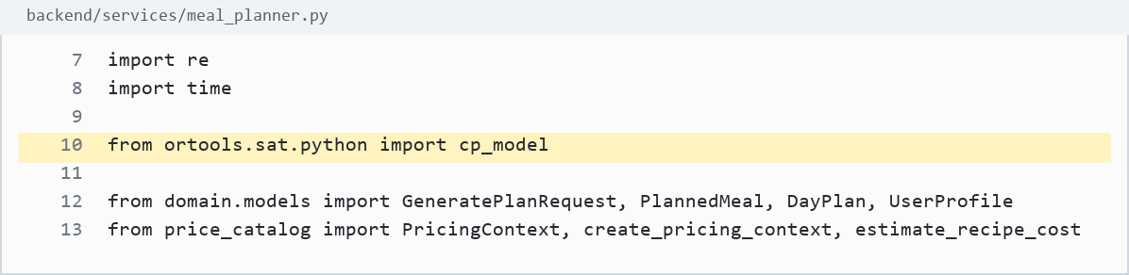
Screenshot evidence: backend/services/meal_planner.py:10

2. Main two-stage planner entry point
Source: backend/services/meal_planner.py:2468-2475
What it does: Defines the production meal-plan generation function.
Use in defense: This is where the Stage 1 shortlist and Stage 2 solver process are connected.
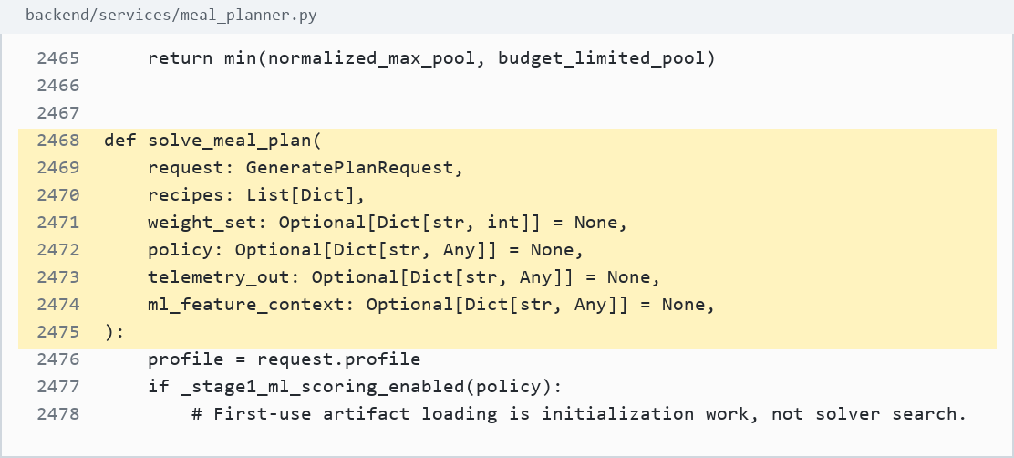
Screenshot evidence: backend/services/meal_planner.py:2468-2475

3. Stage 1 starts inside planner
Source: backend/services/meal_planner.py:2601-2613
What it does: Marks the start of Stage 1 pruning, shortlist preparation, and feature context setup.
Use in defense: Stage 1 prepares safe candidate recipes before optimization.
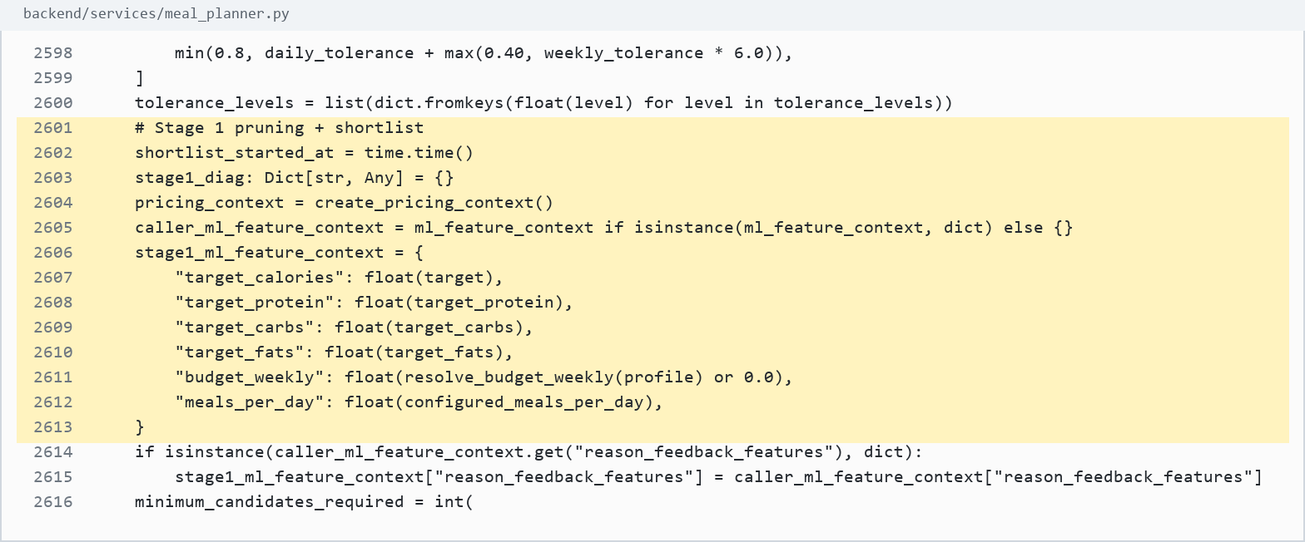
Screenshot evidence: backend/services/meal_planner.py:2601-2613

4. Stage 1 shortlist call
Source: backend/services/meal_planner.py:2643-2651
What it does: Calls shortlist_candidates using the user's profile, recipes, policy, pricing context, and ML feature context.
Use in defense: The production planner does not send the whole catalog directly to the solver; it filters and ranks first.
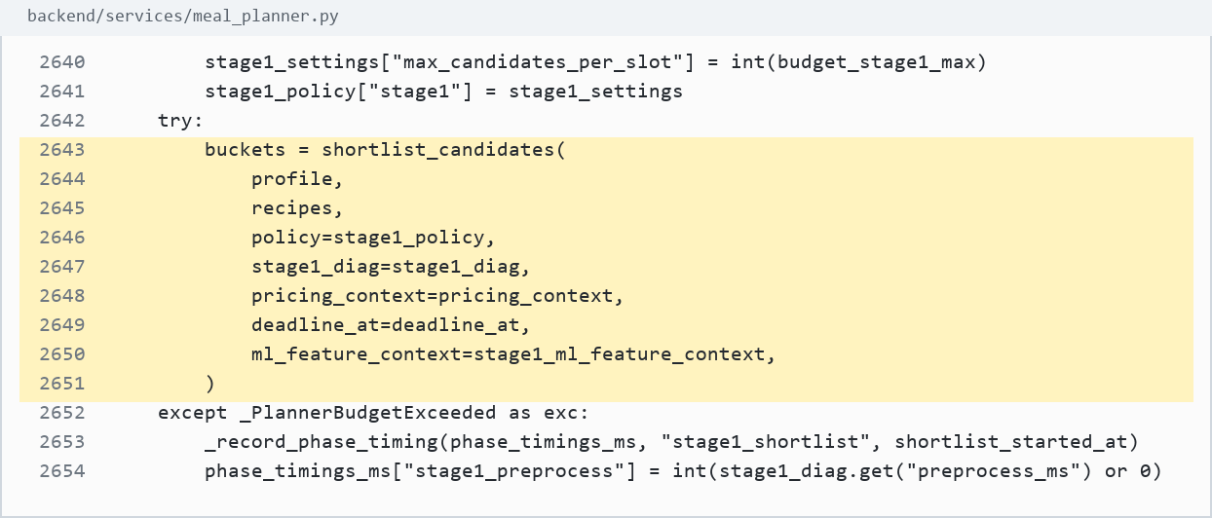
Screenshot evidence: backend/services/meal_planner.py:2643-2651

5. Stage 2 model starts
Source: backend/services/meal_planner.py:2893-2898
What it does: Creates the CP-SAT model and the binary decision variables.
Use in defense: This is the start of the MILP-style 0-1 optimization formulation.
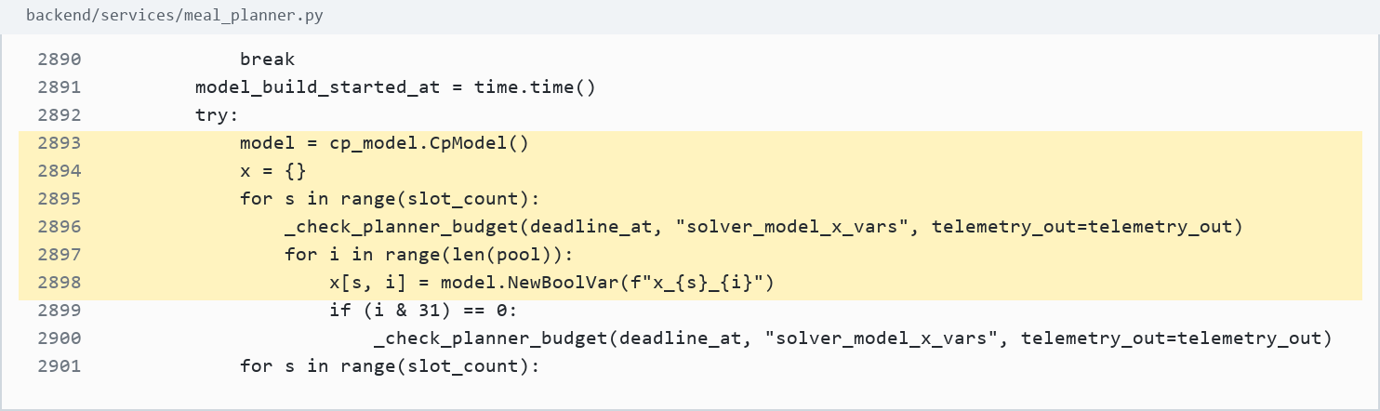
Screenshot evidence: backend/services/meal_planner.py:2893-2898

Stage 1 Evidence

6. Stage 1 function definition
Source: backend/services/meal_planner.py:1654-1662
What it does: Defines shortlist_candidates, the deterministic candidate filtering and shortlisting stage.
Use in defense: Stage 1 is a real planner stage, not only UI-side filtering.
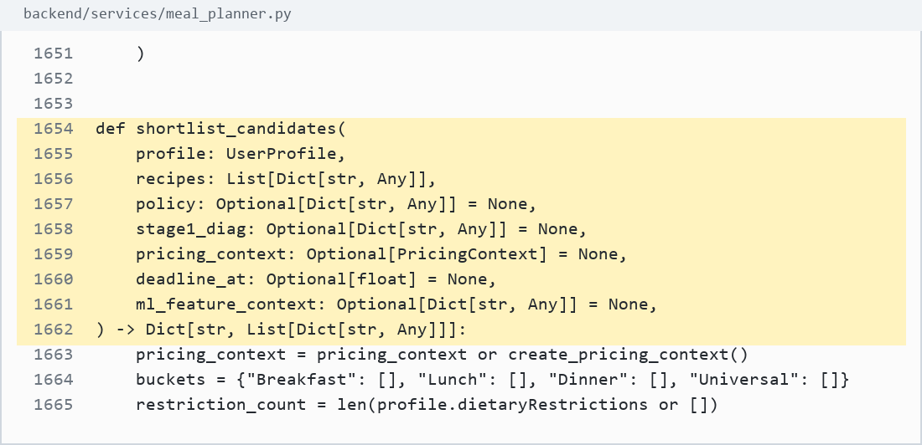
Screenshot evidence: backend/services/meal_planner.py:1654-1662

7. Read user constraints
Source: backend/services/meal_planner.py:1665-1669
What it does: Reads dietary restrictions, allergies, weekly budget, maximum cooking time, and pantry tokens.
Use in defense: The user profile directly affects the planning constraints and candidate filtering.
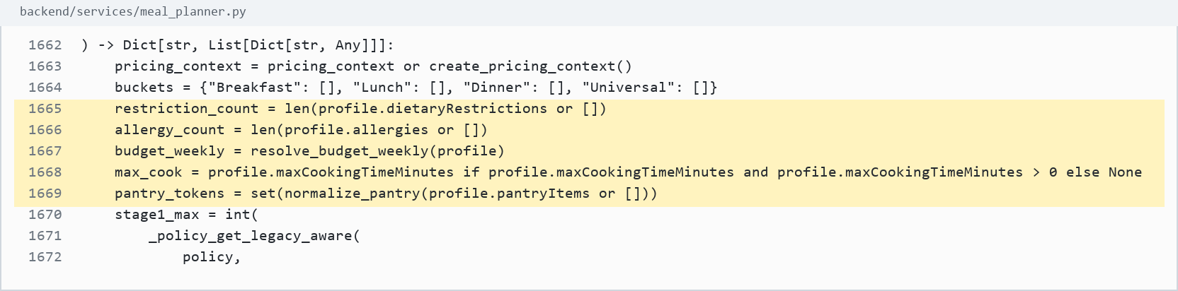
Screenshot evidence: backend/services/meal_planner.py:1665-1669

8. Normalize ingredients
Source: backend/services/meal_planner.py:287-299
What it does: Converts recipe ingredients into normalized tokens for consistent matching.
Use in defense: This supports allergy, pantry, tag, and feature matching using comparable tokens.
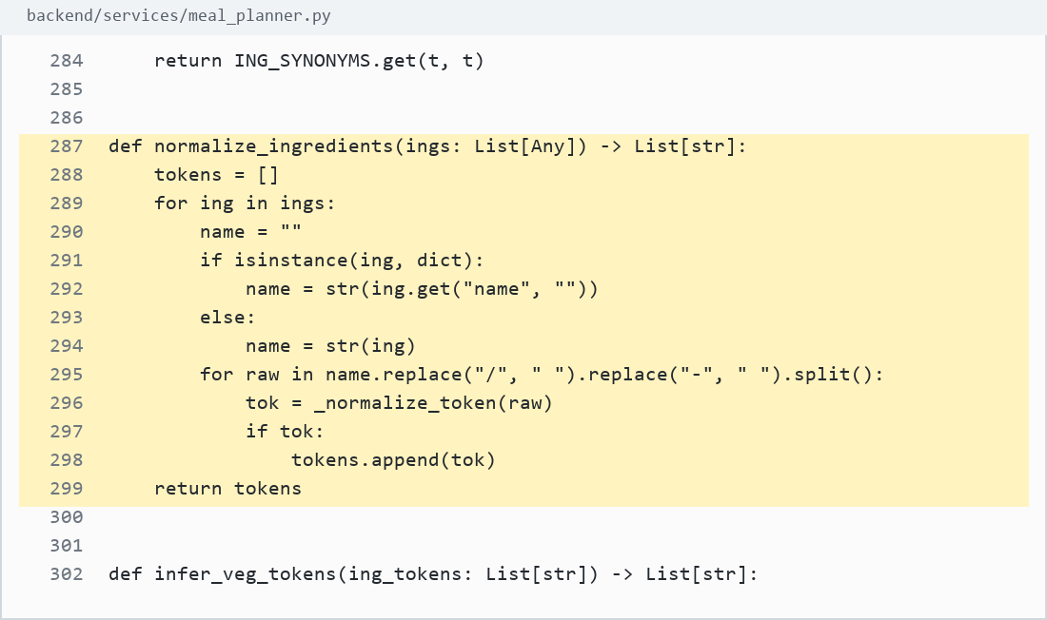
Screenshot evidence: backend/services/meal_planner.py:287-299

9. Normalize pantry
Source: backend/services/meal_planner.py:306-313
What it does: Converts user pantry items into normalized tokens.
Use in defense: Pantry use is not guessed; pantry strings are processed into the same token format as recipe ingredients.
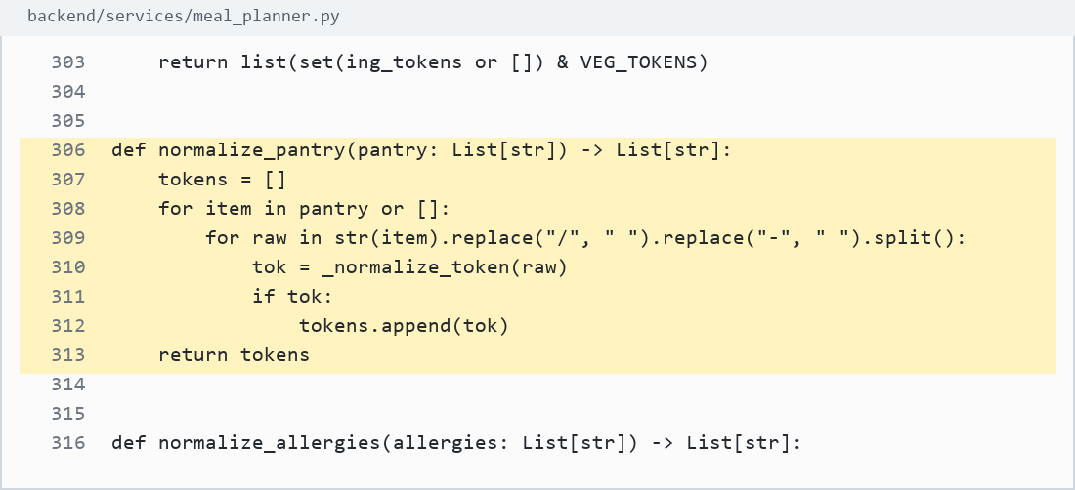
Screenshot evidence: backend/services/meal_planner.py:306-313

10. Normalize allergies
Source: backend/services/meal_planner.py:321-350
What it does: Maps allergy inputs into allergen families and custom allergy tokens.
Use in defense: Allergy filtering is based on normalized allergy categories and ingredient-token matching.
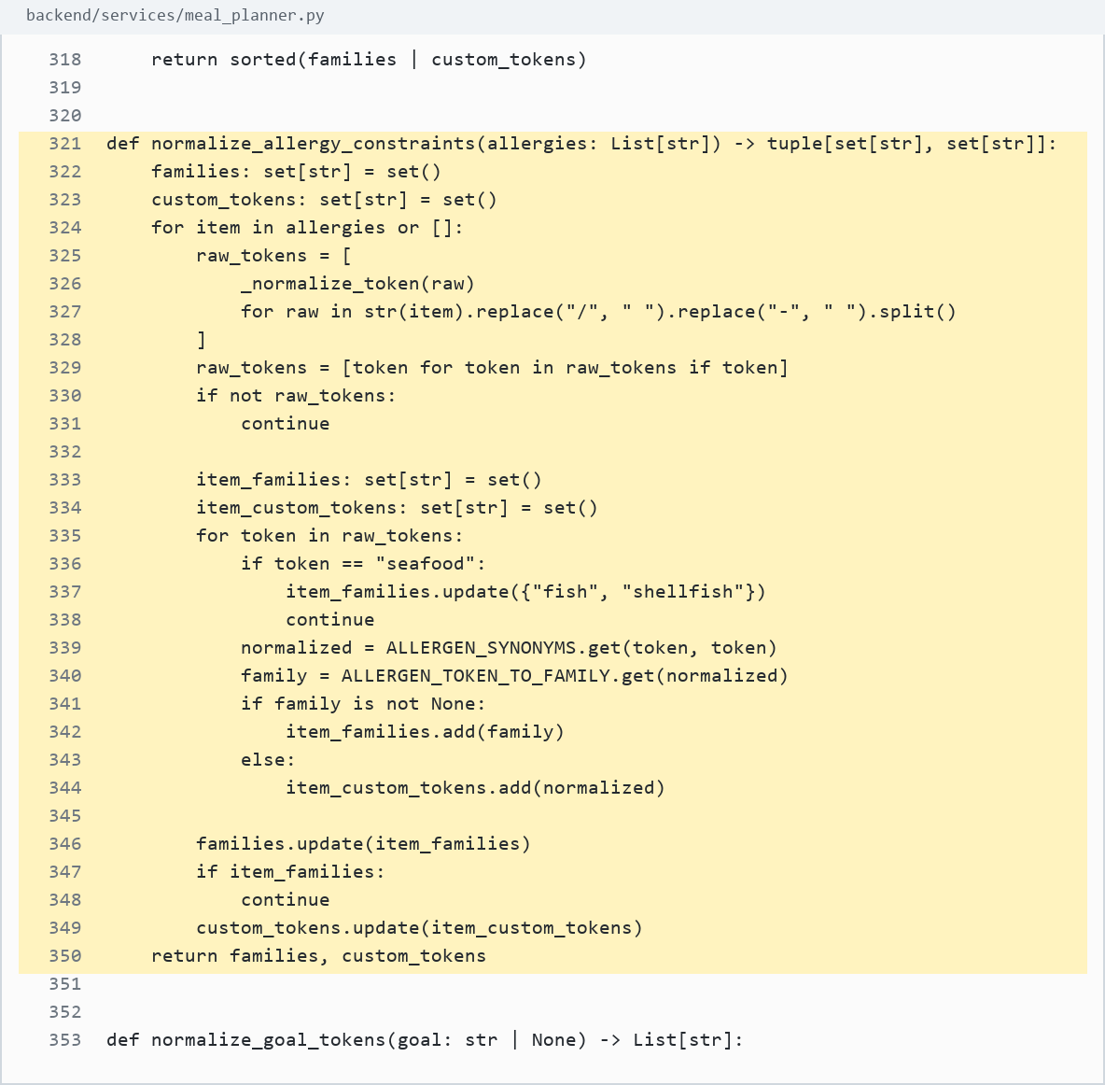
Screenshot evidence: backend/services/meal_planner.py:321-350

11. Symptom and goal adjustments
Source: backend/services/meal_planner.py:394-444
What it does: Applies deterministic nutrition nudges for goals and selected symptoms.
Use in defense: PCOS-related profile fields affect fiber, sugar, protein, calorie, and Stage 1 preference boosts.
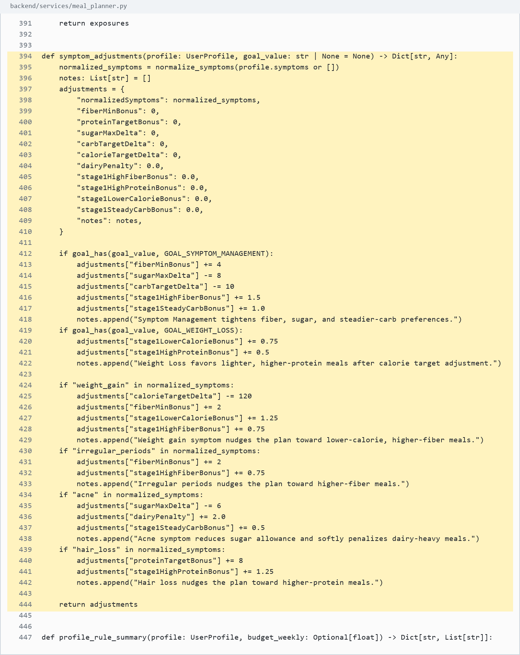
Screenshot evidence: backend/services/meal_planner.py:394-444

12. Recipe feature extraction
Source: backend/services/meal_planner.py:680-697
What it does: Builds tags, ingredient tokens, protein group, vegetable tokens, and allowed meal labels.
Use in defense: The planner extracts structured recipe features before scoring and solving.
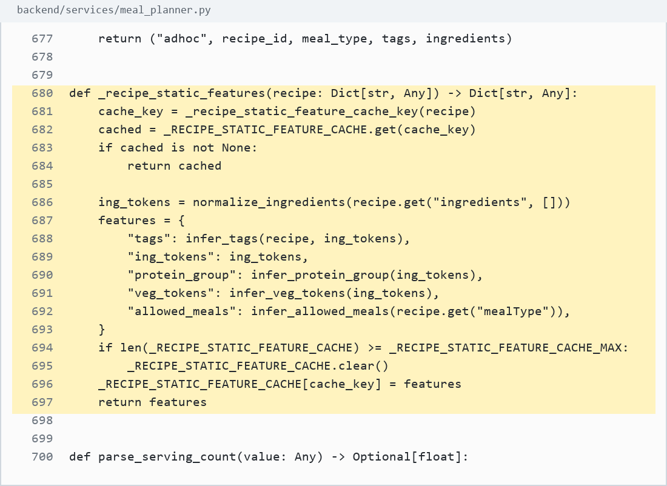
Screenshot evidence: backend/services/meal_planner.py:680-697

13. Meal-slot eligibility inference
Source: backend/services/meal_planner.py:613-628
What it does: Maps recipe mealType values into allowed meal labels such as Breakfast, Lunch, Dinner, and snacks.
Use in defense: Recipes are not randomly placed in slots; meal-type compatibility is computed first.
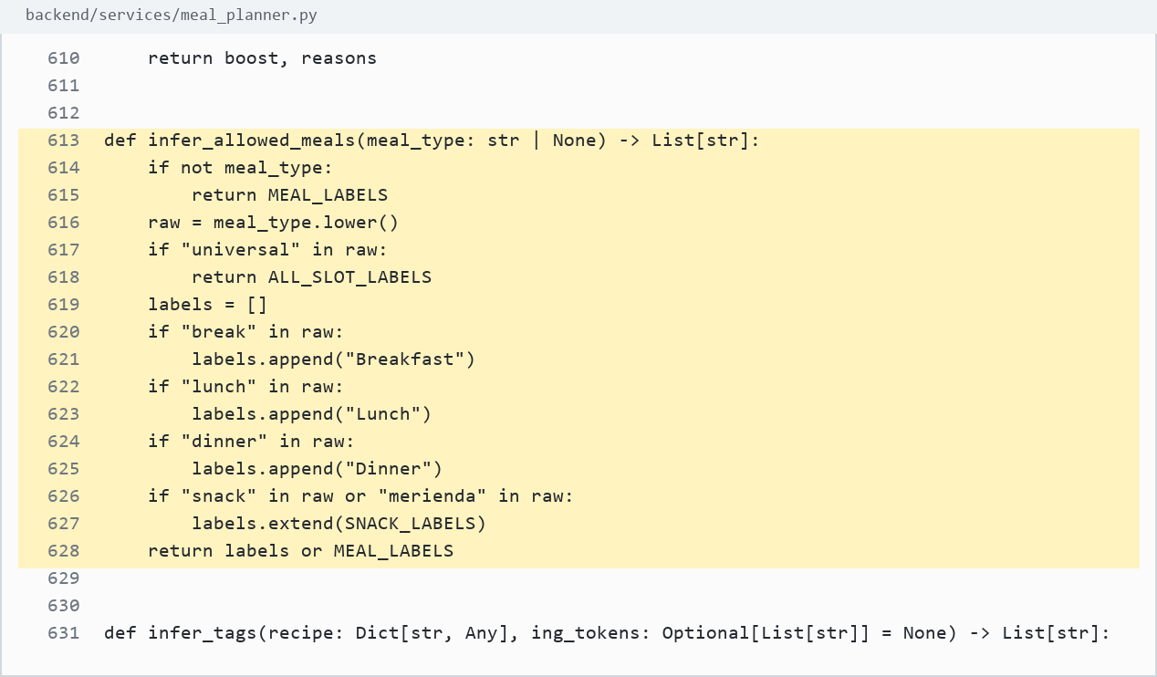
Screenshot evidence: backend/services/meal_planner.py:613-628

14. Hard restriction check
Source: backend/services/meal_planner.py:1036-1059
What it does: Detects allergy, pork, beef, vegetarian, pescatarian, and lactose-intolerant failures.
Use in defense: The if-statements here are safety gates, which are normal and necessary in any decision-support app.
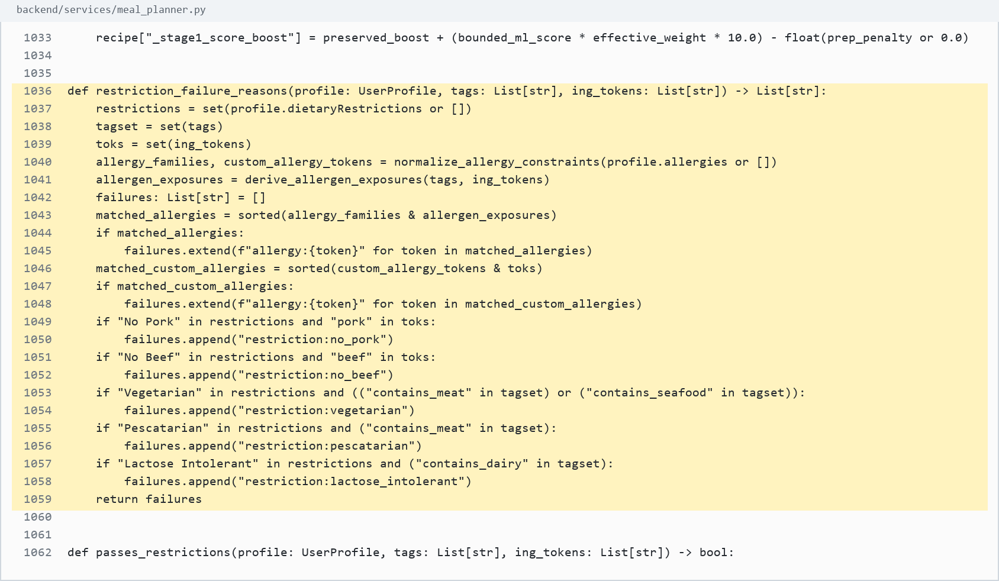
Screenshot evidence: backend/services/meal_planner.py:1036-1059

15. Exclude unsafe recipes
Source: backend/services/meal_planner.py:1726-1737
What it does: Applies static features and skips recipes that fail hard restriction checks.
Use in defense: Unsafe recipes are removed before Stage 2 optimization.
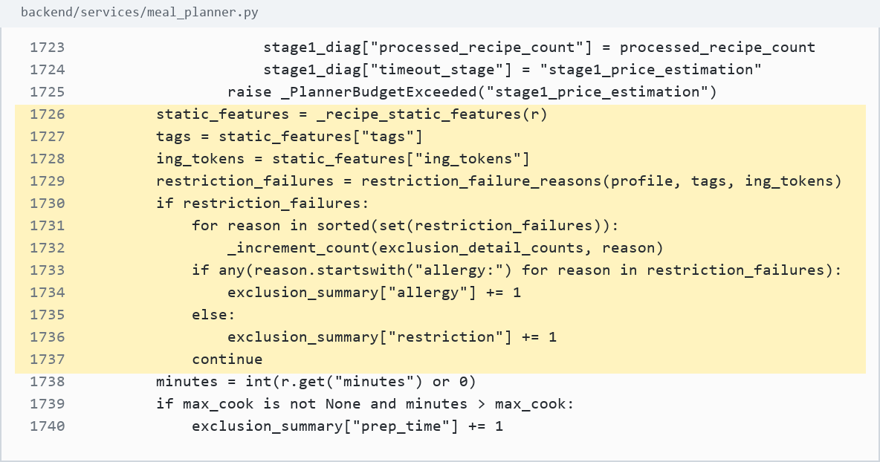
Screenshot evidence: backend/services/meal_planner.py:1726-1737

16. Prep-time exclusion
Source: backend/services/meal_planner.py:1738-1742
What it does: Excludes recipes above the user's maximum cooking-time limit.
Use in defense: This is a user feasibility rule, not a hard-coded meal decision.
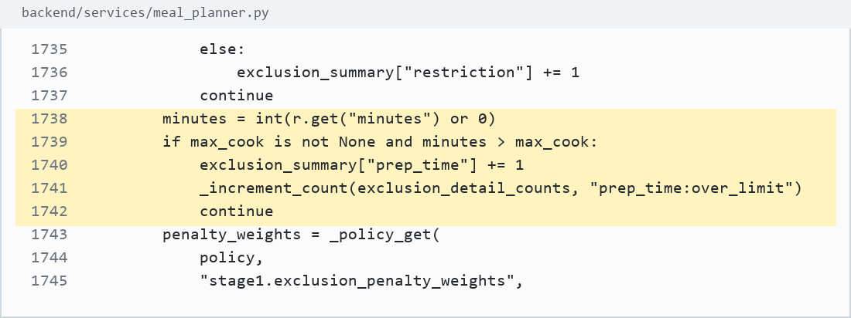
Screenshot evidence: backend/services/meal_planner.py:1738-1742

17. Pantry overlap scoring
Source: backend/services/meal_planner.py:1757-1760
What it does: Counts how many recipe ingredients overlap with saved pantry items.
Use in defense: Pantry data influences ranking and later solver reward, while still preserving hard safety rules.
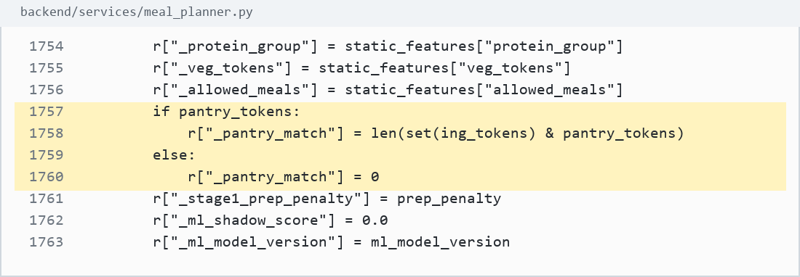
Screenshot evidence: backend/services/meal_planner.py:1757-1760

18. Stage 1 score formula
Source: backend/services/meal_planner.py:805-810
What it does: Ranks candidates using protein, cost estimate, calorie distance, pantry match, and Stage 1 boost.
Use in defense: Stage 1 ranking is deterministic and explainable.
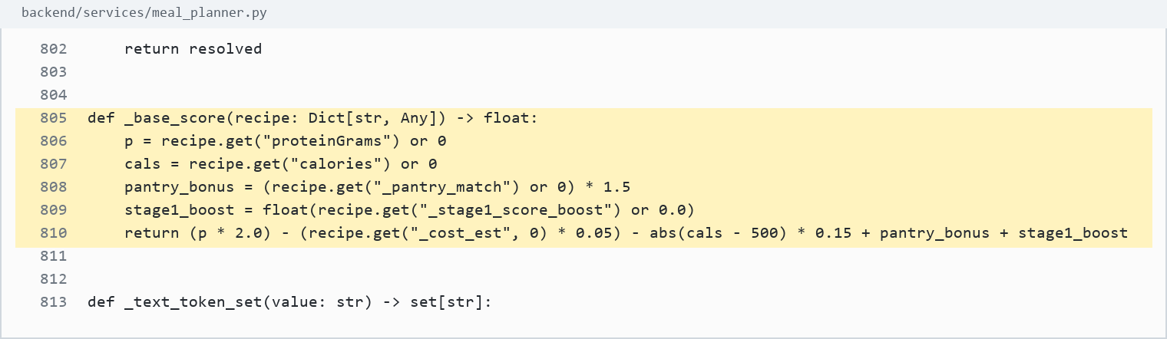
Screenshot evidence: backend/services/meal_planner.py:805-810

19. Cost estimate
Source: backend/services/meal_planner.py:761-802
What it does: Estimates recipe cost using ingredient pricing context and serving multiplier, with a bounded fallback.
Use in defense: Cost is computed before optimization so budget can affect planning.
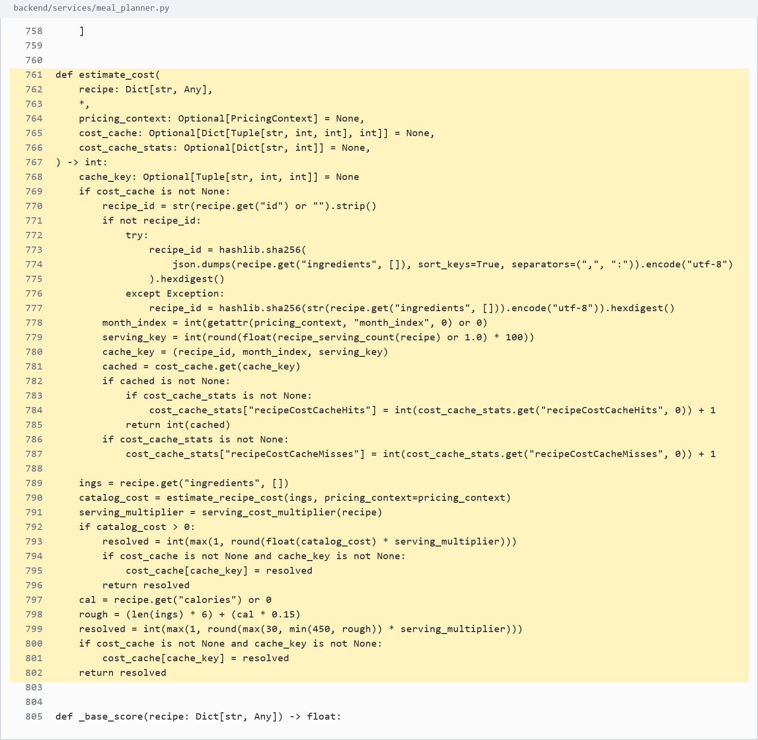
Screenshot evidence: backend/services/meal_planner.py:761-802

20. Meal bucket assignment
Source: backend/services/meal_planner.py:1823-1831
What it does: Places safe recipes into Breakfast, Lunch, Dinner, or Universal buckets.
Use in defense: Stage 1 organizes the candidates by meal type before Stage 2.
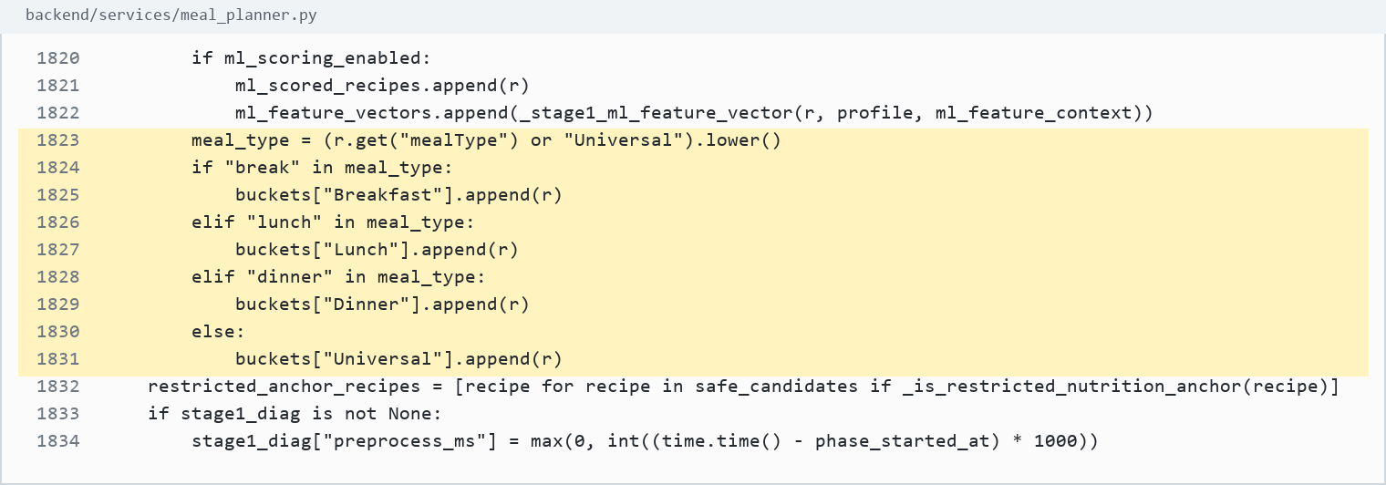
Screenshot evidence: backend/services/meal_planner.py:1823-1831

21. Optional ML scoring
Source: backend/services/meal_planner.py:1850-1869
What it does: Uses a ranker or deterministic shadow score only after hard filtering.
Use in defense: ML is optional and assistive; it does not override hard constraints.
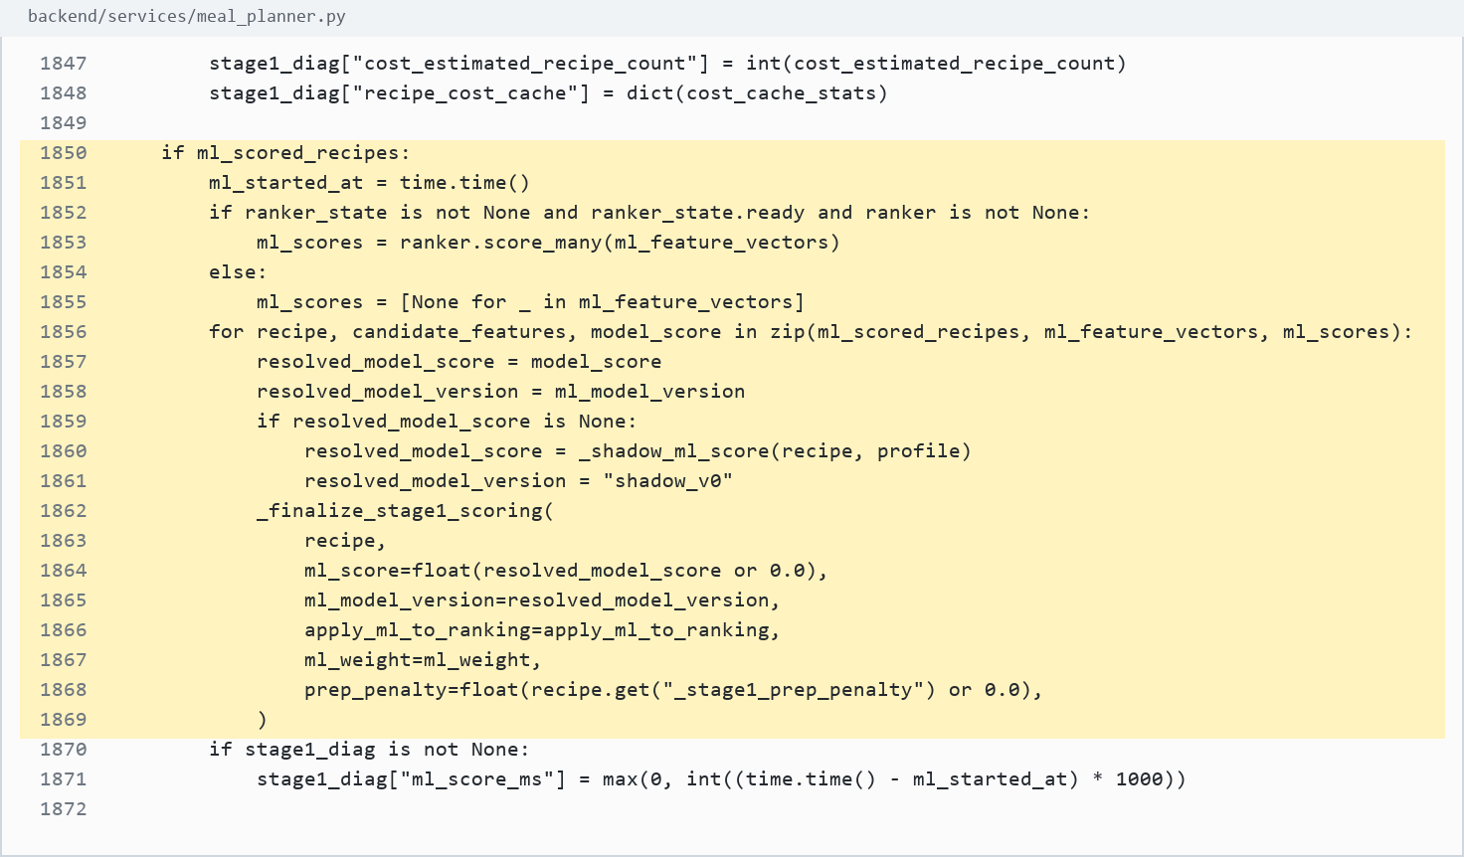
Screenshot evidence: backend/services/meal_planner.py:1850-1869

22. Sort, deduplicate, and trim
Source: backend/services/meal_planner.py:1875-1889
What it does: Sorts by base score, removes near-duplicates, applies limits, and does budget-aware trimming.
Use in defense: Stage 1 narrows the search space while keeping safe and relevant options.
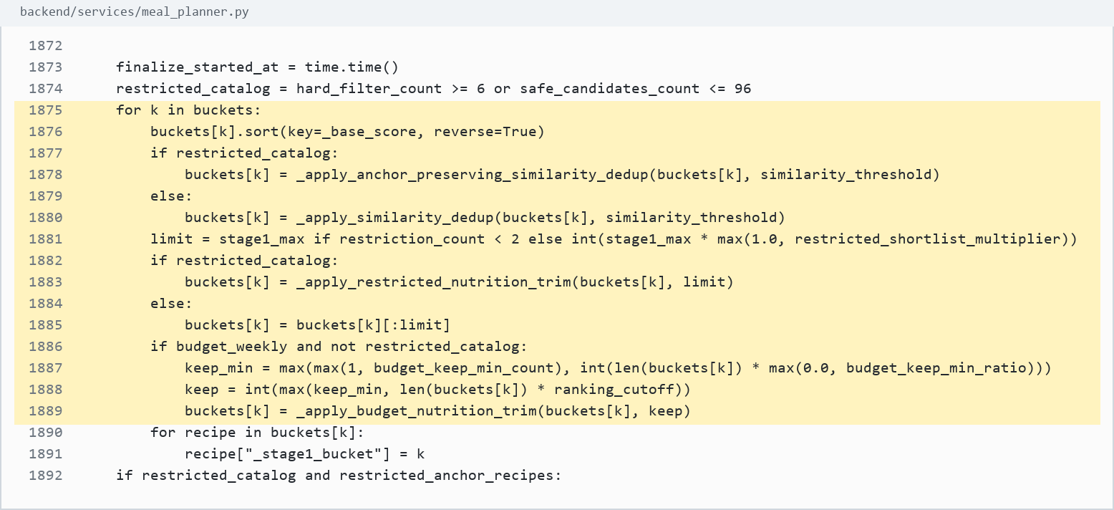
Screenshot evidence: backend/services/meal_planner.py:1875-1889

23. Stage 1 returns buckets
Source: backend/services/meal_planner.py:1901-1912
What it does: Records Stage 1 diagnostics and returns the final buckets to the planner.
Use in defense: Stage 1 produces explicit output consumed by Stage 2.
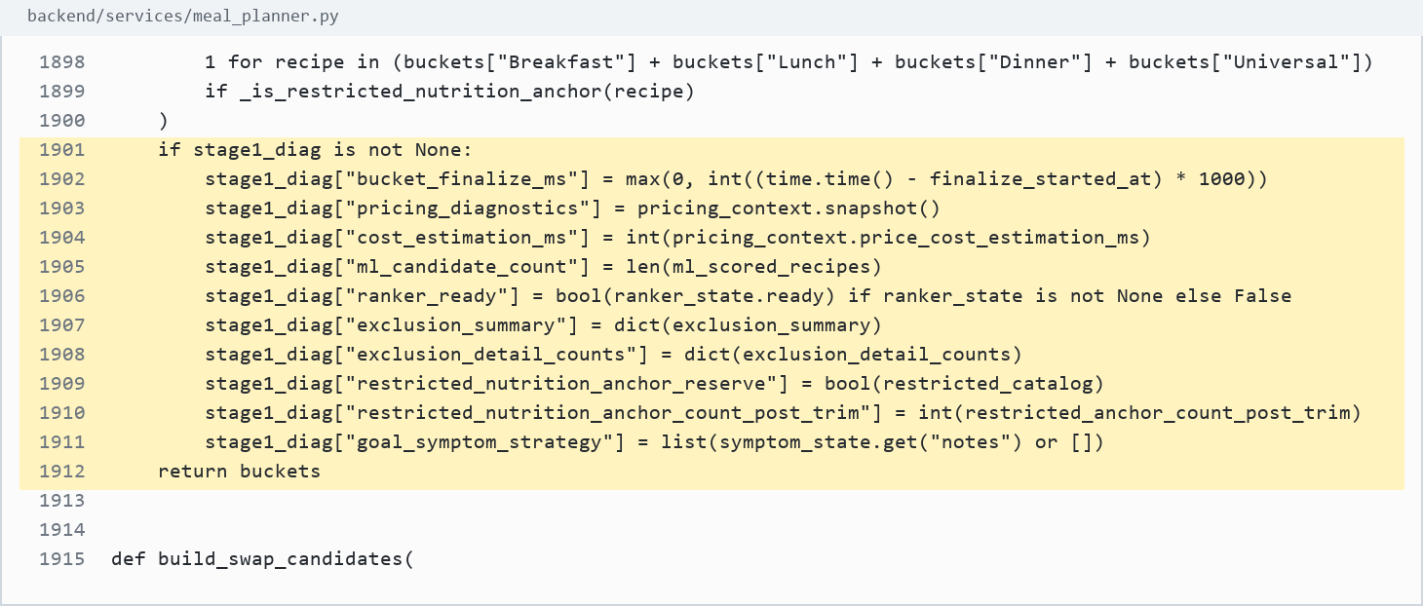
Screenshot evidence: backend/services/meal_planner.py:1901-1912

Stage 2 MILP-Style Formulation Evidence

24. Binary decision variable x[s,i]
Source: backend/services/meal_planner.py:2893-2898
What it does: Creates x[s,i] as a Boolean variable for each meal slot and recipe candidate.
Use in defense: x[s,i] = 1 means recipe i is selected for slot s; x[s,i] = 0 means it is not selected.
Screenshot evidence: backend/services/meal_planner.py:2893-2898

25. Exactly one recipe per slot
Source: backend/services/meal_planner.py:2901-2905
What it does: Adds a linear equality requiring one allowed recipe for each meal slot.
Use in defense: This is a formal assignment constraint, not a manual if-else selection.
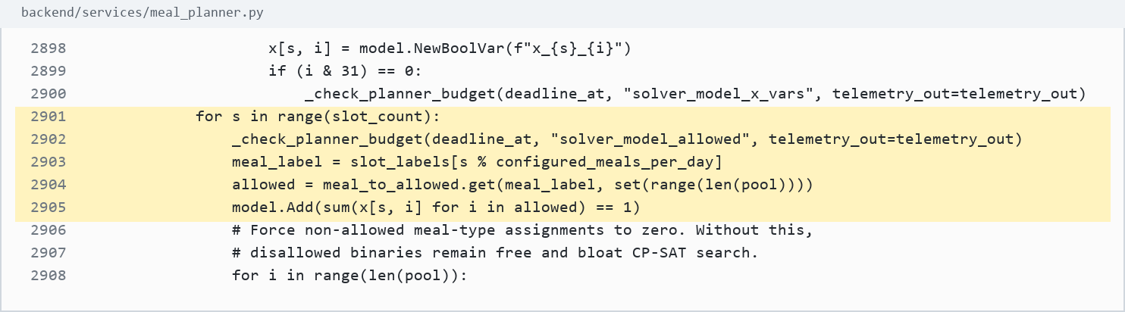
Screenshot evidence: backend/services/meal_planner.py:2901-2905

26. Disallow wrong meal type
Source: backend/services/meal_planner.py:2906-2910
What it does: Forces non-allowed recipe-slot pairs to zero.
Use in defense: The solver is prevented from assigning Breakfast-only recipes to the wrong slot type.
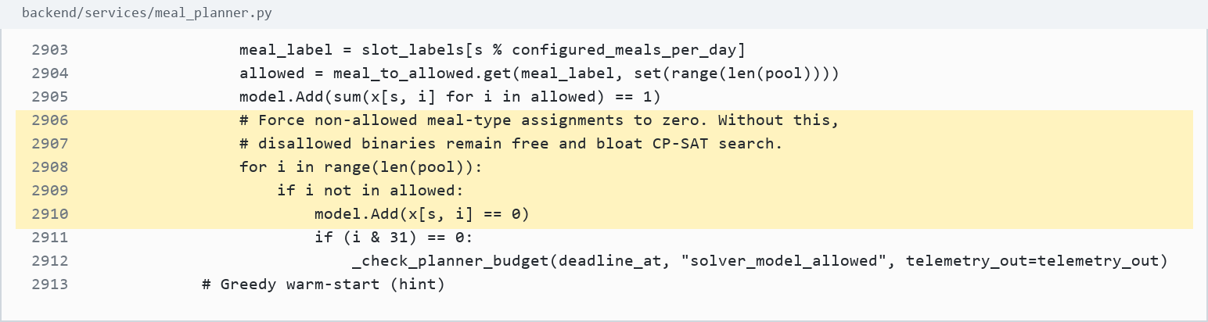
Screenshot evidence: backend/services/meal_planner.py:2906-2910

27. Greedy warm-start hint
Source: backend/services/meal_planner.py:2913-2927
What it does: Adds a greedy starting hint for the solver search.
Use in defense: This hint can guide the solver, but it does not replace the CP-SAT optimization.
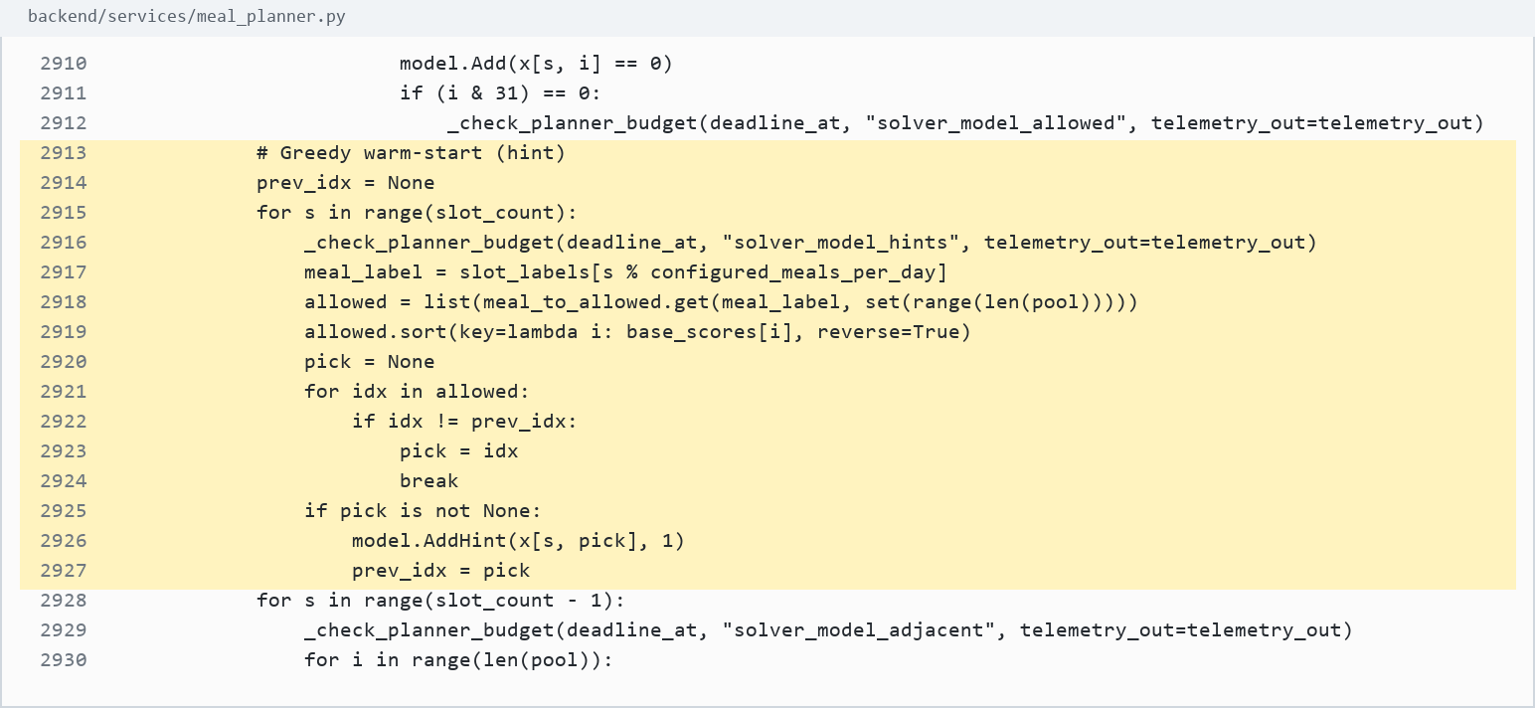
Screenshot evidence: backend/services/meal_planner.py:2913-2927

28. No adjacent duplicate
Source: backend/services/meal_planner.py:2928-2937
What it does: Prevents adjacent repeats and limits weekly repeats.
Use in defense: Variety constraints are directly encoded in the solver model.
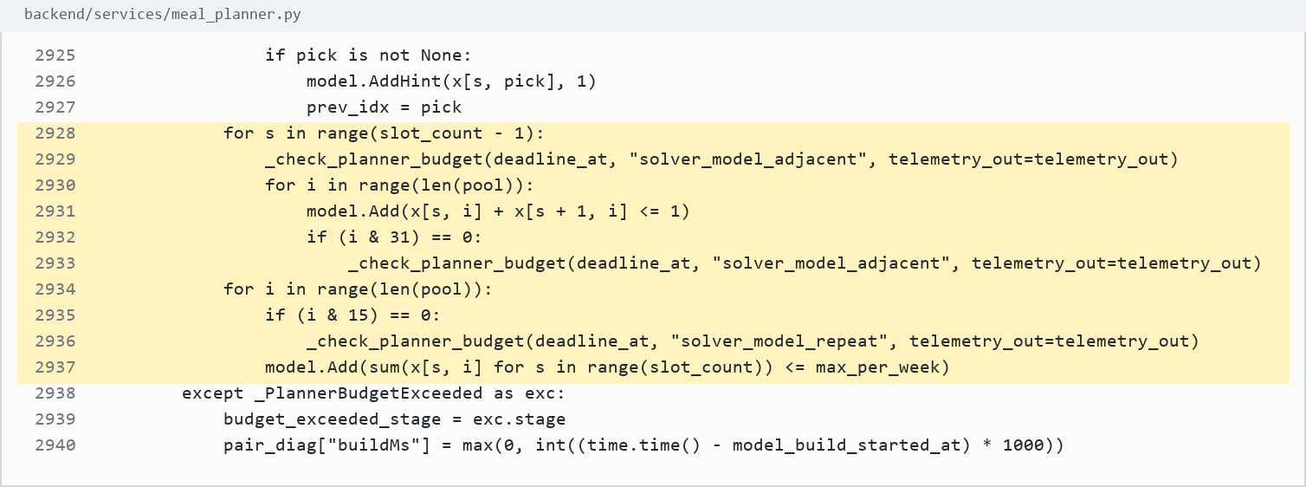
Screenshot evidence: backend/services/meal_planner.py:2928-2937

29. Repeat penalty variable
Source: backend/services/meal_planner.py:2947-2953
What it does: Creates repeat_over variables to penalize repeated recipe use.
Use in defense: The model can discourage repetition without making every repeat impossible.
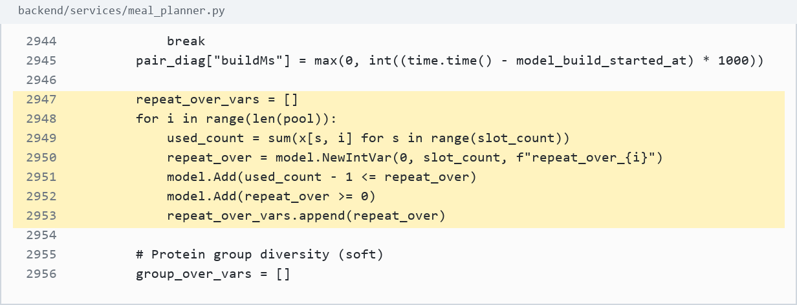
Screenshot evidence: backend/services/meal_planner.py:2947-2953

30. Protein group variety
Source: backend/services/meal_planner.py:2955-2968
What it does: Groups recipes by protein source and penalizes overuse of the same group.
Use in defense: Variety is handled as a model term, not only by random shuffling.
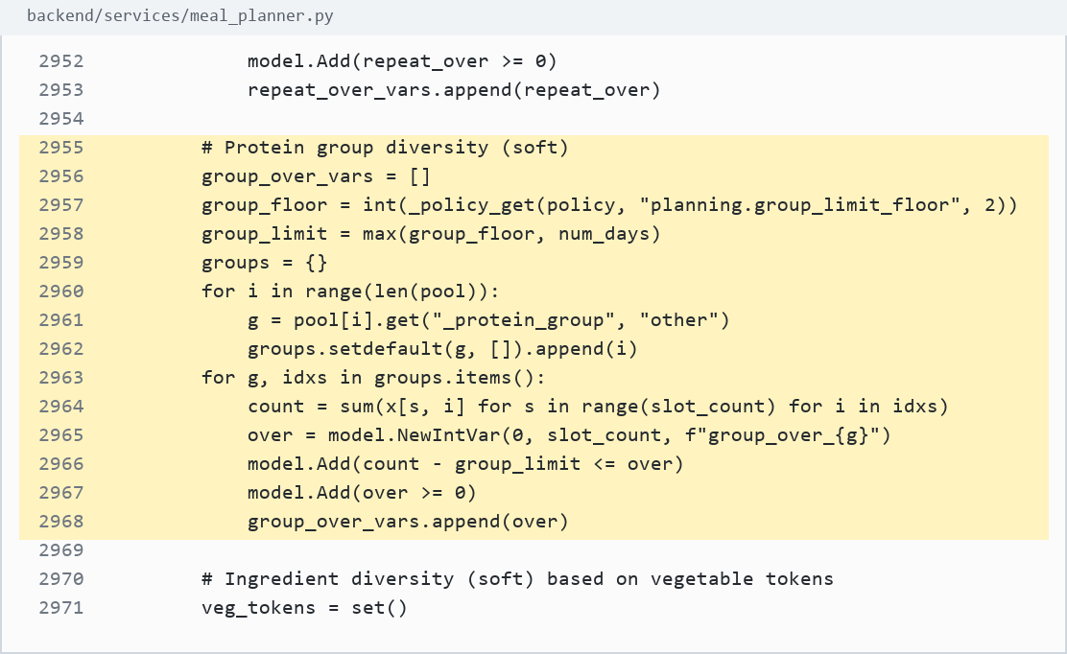
Screenshot evidence: backend/services/meal_planner.py:2955-2968

31. Vegetable diversity
Source: backend/services/meal_planner.py:2970-2987
What it does: Tracks vegetable token coverage and adds a minimum diversity target with slack.
Use in defense: Ingredient diversity is explicitly represented in the formulation.
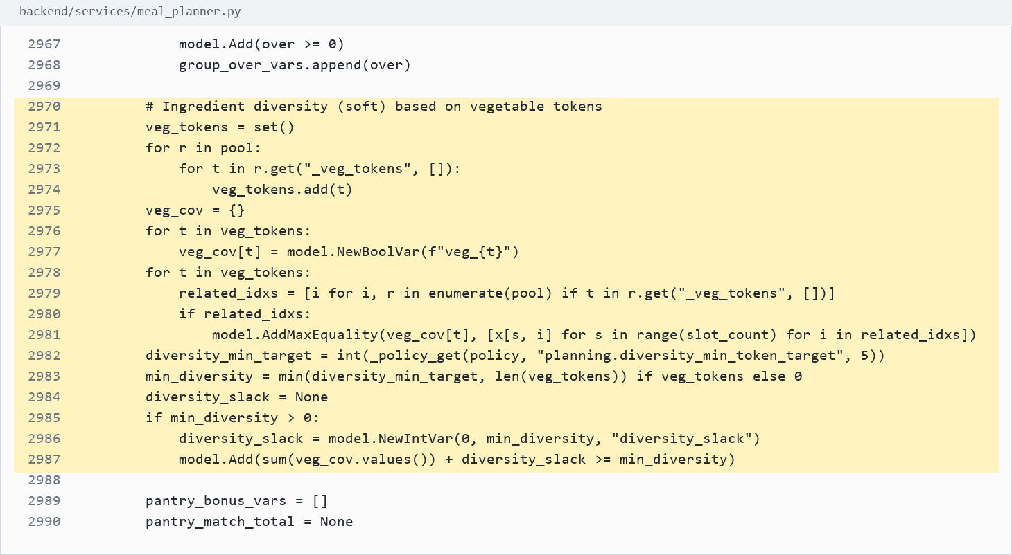
Screenshot evidence: backend/services/meal_planner.py:2970-2987

32. Pantry reward
Source: backend/services/meal_planner.py:2989-2998
What it does: Builds a pantry-match expression from selected recipe variables.
Use in defense: Pantry utilization affects the objective through selected recipes.
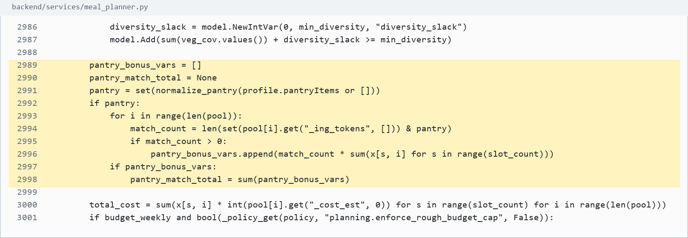
Screenshot evidence: backend/services/meal_planner.py:2989-2998

33. Total cost expression and optional rough cap
Source: backend/services/meal_planner.py:3000-3002
What it does: Computes total selected cost and optionally applies a rough budget cap.
Use in defense: Budget is part of the mathematical model when the policy enables the rough cap.
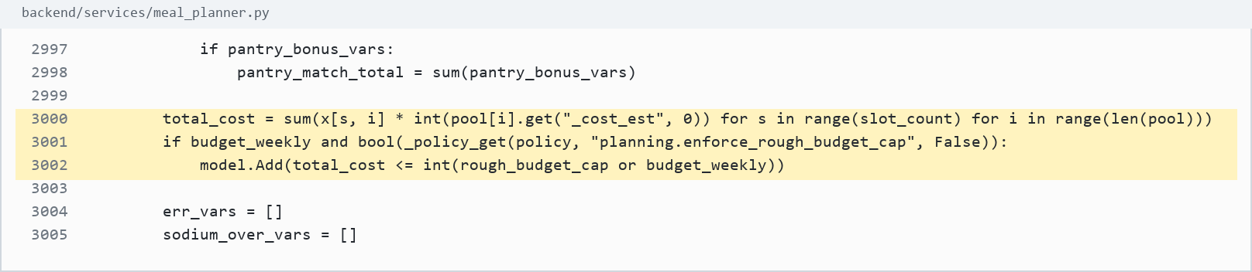
Screenshot evidence: backend/services/meal_planner.py:3000-3002

34. Daily calorie constraints
Source: backend/services/meal_planner.py:3013-3021
What it does: Computes daily calories from selected meals and enforces calorie bounds.
Use in defense: Daily calorie feasibility is enforced by linear constraints.
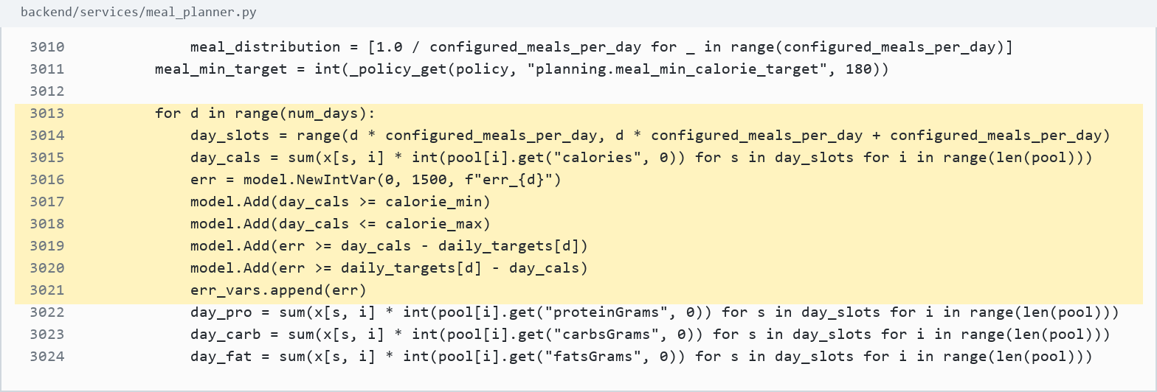
Screenshot evidence: backend/services/meal_planner.py:3013-3021

35. Macro, fiber, sodium, and sugar constraints
Source: backend/services/meal_planner.py:3022-3040
What it does: Computes daily protein, carbs, fats, fiber, sodium, and sugar from selected meals.
Use in defense: Macros and fiber are hard bounded; sodium and sugar are tracked through overage variables.
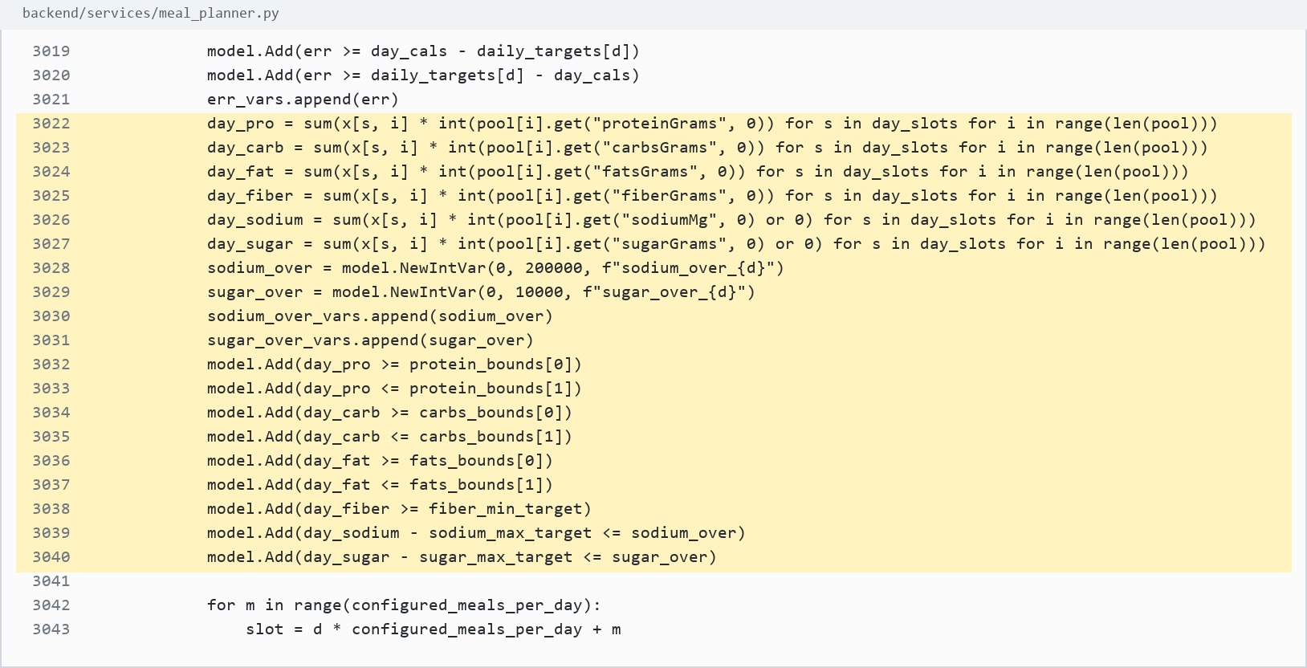
Screenshot evidence: backend/services/meal_planner.py:3022-3040

36. Meal calorie distribution
Source: backend/services/meal_planner.py:3042-3049
What it does: Creates meal-level calorie deviation variables around meal distribution targets.
Use in defense: The planner does not only hit daily totals; it also balances individual meals.
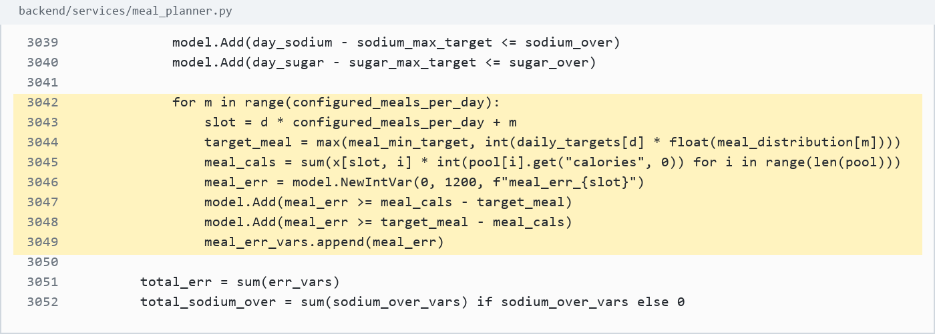
Screenshot evidence: backend/services/meal_planner.py:3042-3049

37. Objective component totals
Source: backend/services/meal_planner.py:3051-3067
What it does: Combines error, sodium/sugar overage, repeat pressure, group pressure, pantry reward, and diversity reward.
Use in defense: The model has measurable optimization terms before the final objective is declared.
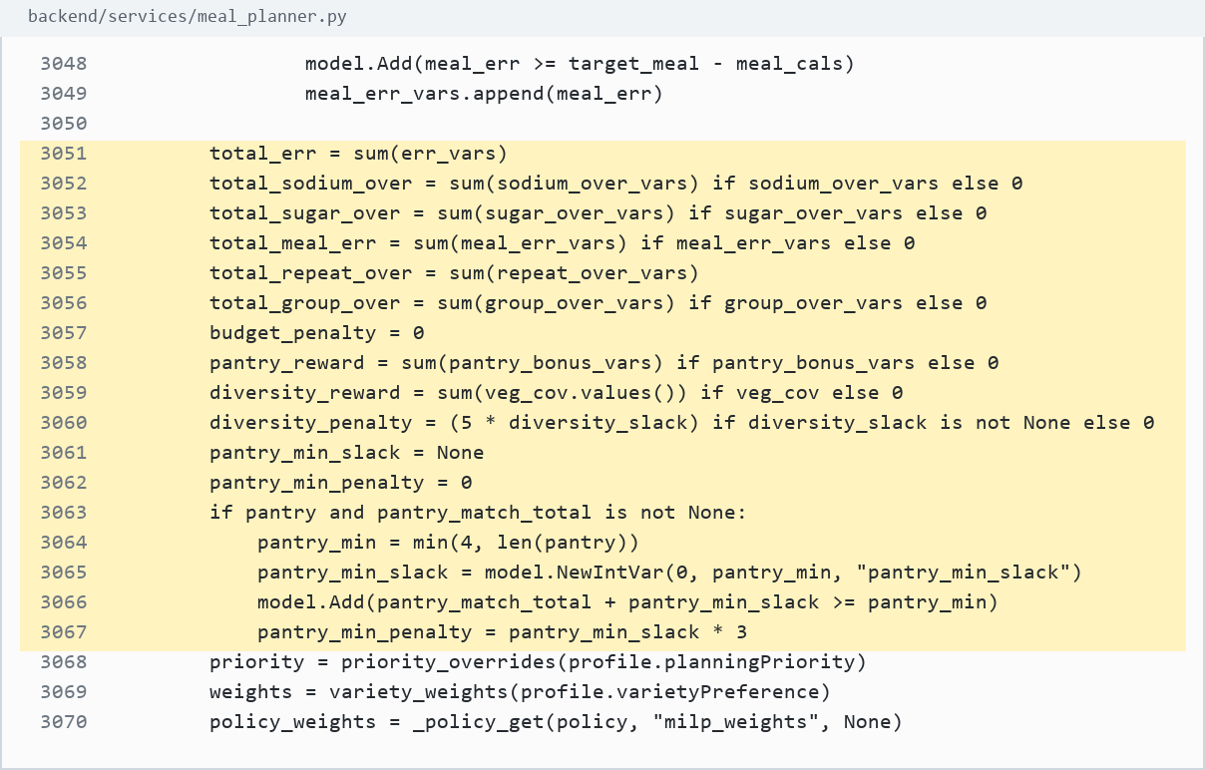
Screenshot evidence: backend/services/meal_planner.py:3051-3067

38. Objective weights
Source: backend/services/meal_planner.py:3068-3092
What it does: Applies user planning priority, variety preference, budget, pantry, prep time, and acceptance weights.
Use in defense: User priorities affect objective weights, not hard-coded final meals.
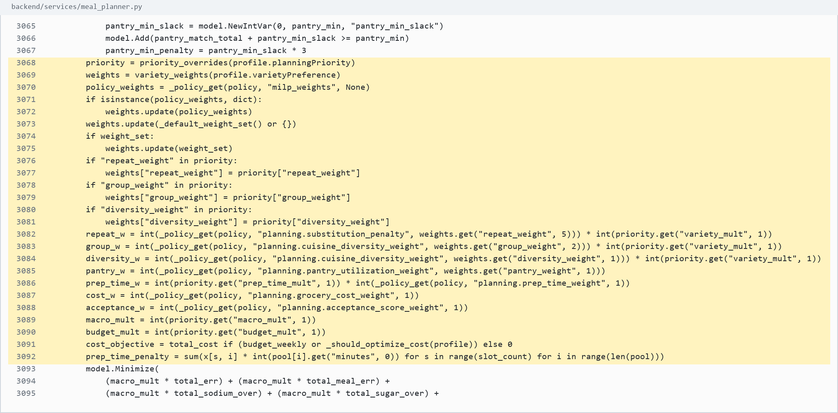
Screenshot evidence: backend/services/meal_planner.py:3068-3092

39. Weighted minimization objective
Source: backend/services/meal_planner.py:3093-3100
What it does: Calls model.Minimize with the full weighted objective expression.
Use in defense: This is the strongest proof that Stage 2 is an optimization model.
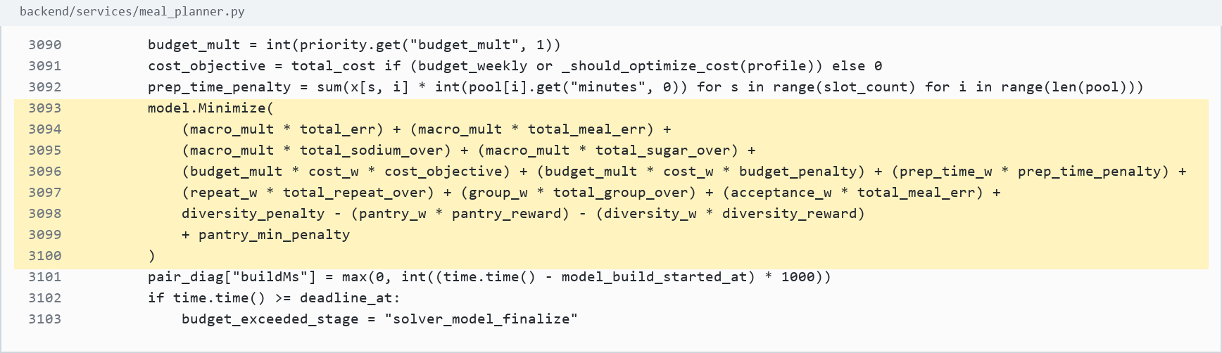
Screenshot evidence: backend/services/meal_planner.py:3093-3100

40. Solver created and configured
Source: backend/services/meal_planner.py:3111-3145
What it does: Creates the CP-SAT solver and sets time, gap, worker, memory, and solution-count parameters.
Use in defense: The system uses an actual solver run with configured search limits.
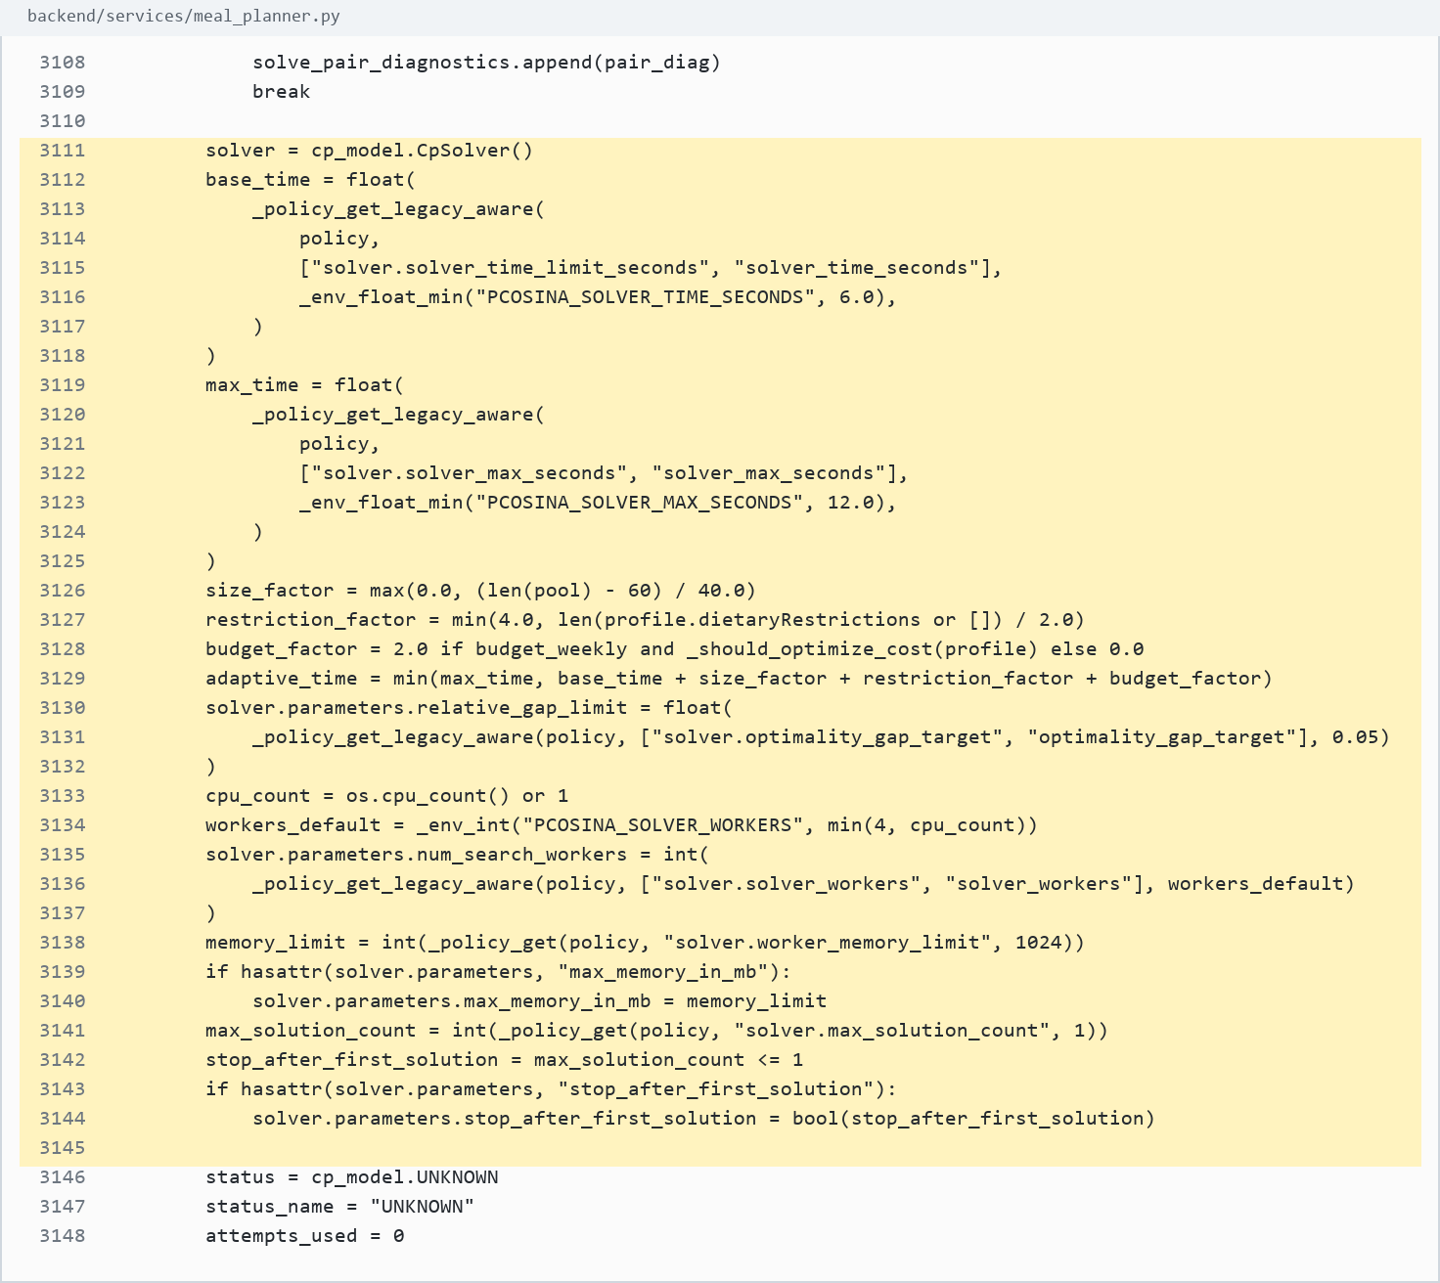
Screenshot evidence: backend/services/meal_planner.py:3111-3145

41. Solver execution
Source: backend/services/meal_planner.py:3151-3165
What it does: Runs solver.Solve(model) and reads the solver status.
Use in defense: The selected plan comes from the solver result.
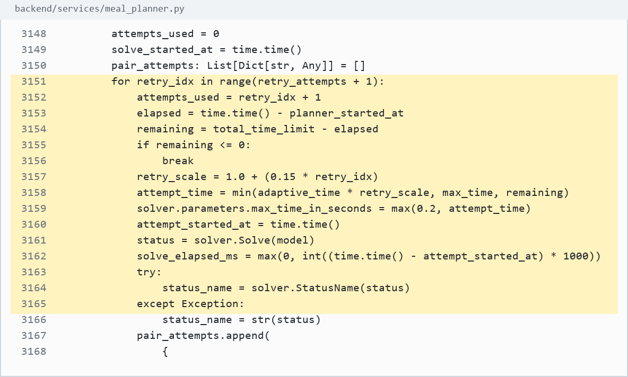
Screenshot evidence: backend/services/meal_planner.py:3151-3165

42. Accept feasible or optimal
Source: backend/services/meal_planner.py:3197-3202
What it does: Stops only when the solver returns OPTIMAL, FEASIBLE, INFEASIBLE, or exits retry logic.
Use in defense: The planner respects solver status instead of always forcing an output.
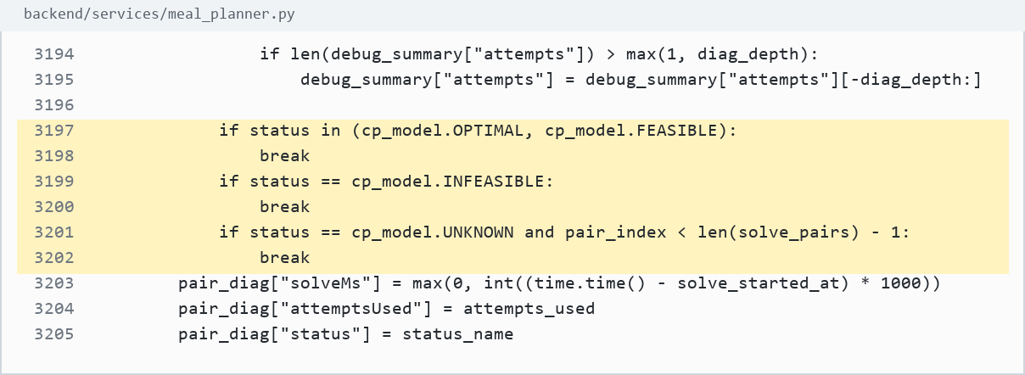
Screenshot evidence: backend/services/meal_planner.py:3197-3202

43. Read selected meals from variables
Source: backend/services/meal_planner.py:3215-3229
What it does: Uses solver.Value(x[idx, i]) to convert selected binary variables into planned meals.
Use in defense: The final displayed meal plan is literally read from the solved decision variables.
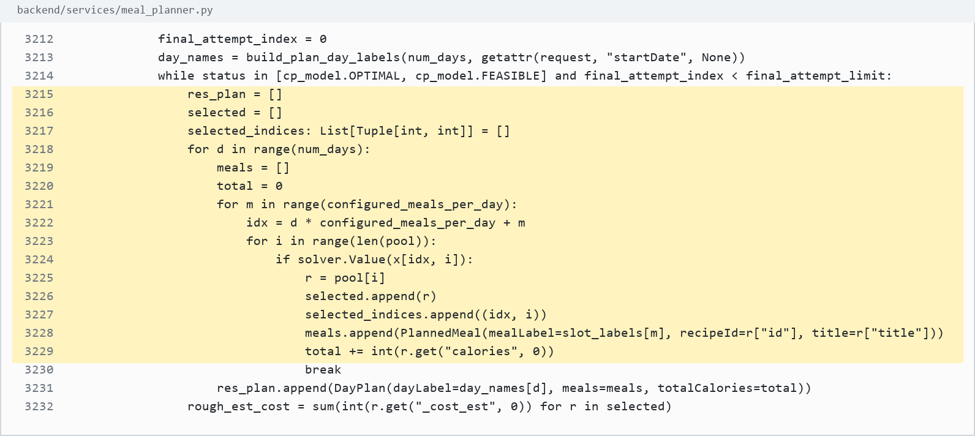
Screenshot evidence: backend/services/meal_planner.py:3215-3229

44. Final grocery budget validation
Source: backend/services/meal_planner.py:3232-3268
What it does: Builds grocery output, checks final budget authority, and rejects/retries over-budget plans.
Use in defense: The system verifies the selected plan against final grocery cost, not only the rough solver estimate.
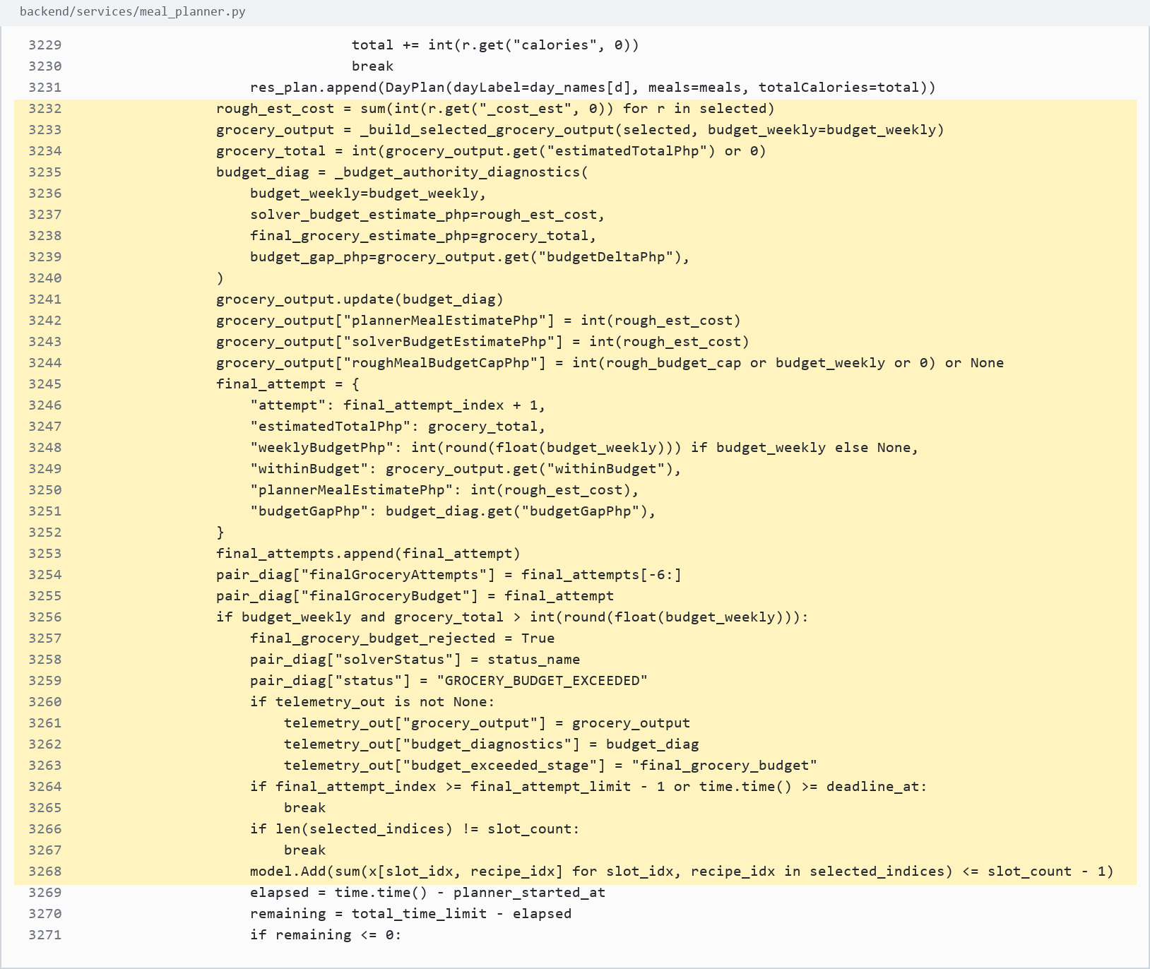
Screenshot evidence: backend/services/meal_planner.py:3232-3268

45. Success return with explanation
Source: backend/services/meal_planner.py:3297-3349
What it does: Builds the explanation object and returns the successful plan.
Use in defense: The system returns both a plan and explanation metadata for defense/debugging.
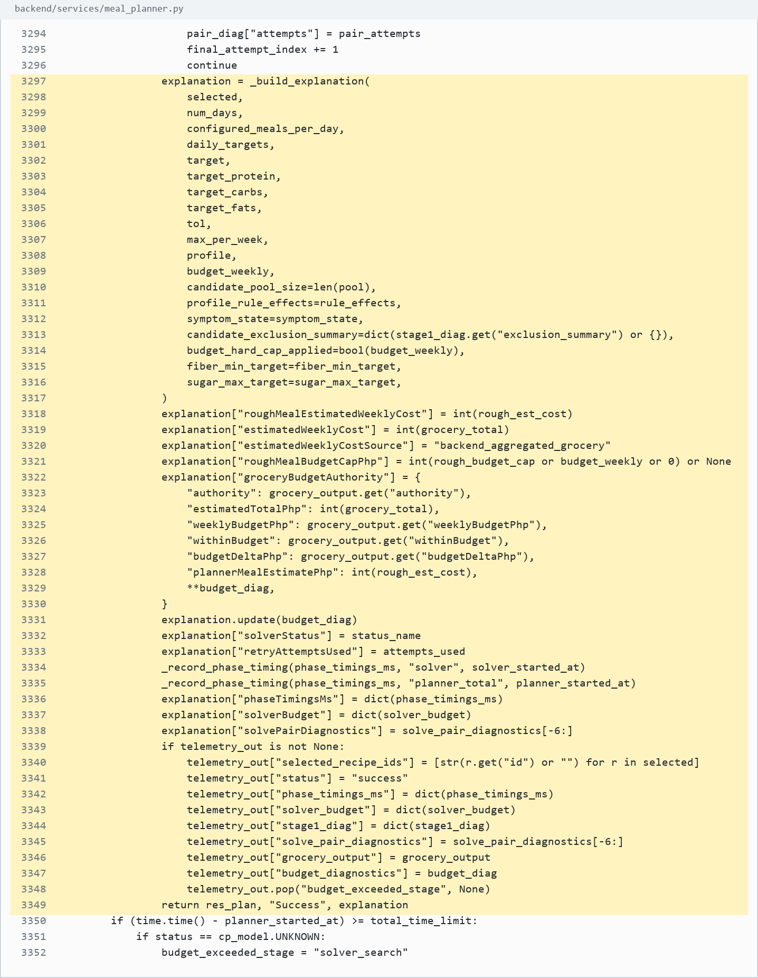
Screenshot evidence: backend/services/meal_planner.py:3297-3349

46. Infeasible fallback
Source: backend/services/meal_planner.py:3378-3382
What it does: Returns budget failure, timeout, or infeasible instead of pretending a safe plan exists.
Use in defense: The planner handles infeasibility gracefully.
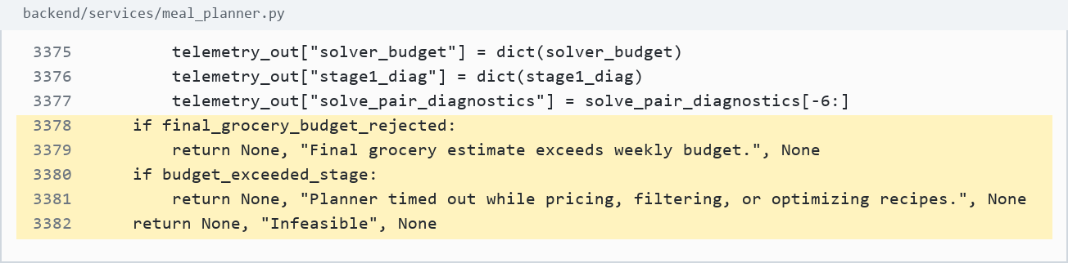
Screenshot evidence: backend/services/meal_planner.py:3378-3382

