PCOSina Manuscript Figures 1 to 26
Numbered manuscript figures only, organized for final-defense study
Source manuscript: docs/[Manuscript] Quadrant_Revised_Ch 1-6_S2526T3 (3).docx
Scope: Only numbered manuscript items are included. Appendix images and extra Word table objects used for equations are excluded.
Total numbered figures included: 26

Figure Index
Figure 1. Figure 1. Conceptual Framework
Figure 2. Figure 2. Review of Related Literature Map
Figure 3. Figure 3. Review of Related Studies Map
Figure 4. Figure 4. Activity Diagram
Figure 5. Figure 5. Sequence Diagram
Figure 6. Figure 6. Use Case Diagram
Figure 7. Figure 7. Class Diagram
Figure 8. Figure 8. System Architecture
Figure 9. Figure 9. Offline-First Planning Workflow
Figure 10. Figure 10. Offline and Online Feature Availability Map
Figure 11. Figure 11. Scrum / Agile Development Process
Figure 12. Figure 12. Two-Stage MILP-Based Meal Planning Algorithm
Figure 13. Figure 13. Adaptive fallback flowchart for weekly meal-plan generation
Figure 14. Figure 14. Relaxation ladder used by adaptive fallback
Figure 15. Figure 15. High-Level Pseudocode
Figure 16. Figure 16. ISO-Based Software Evaluation Model
Figure 17. Figure 17. User Universe Definition
Figure 18. Figure 18. Effectiveness dimensions, metrics, and output artifacts
Figure 19. Figure 19. Effectiveness-evaluation flowchart (software-evaluation scope)
Figure 20. Figure 20. Twenty-Profile Planner Runtime Optimization Progression
Figure 21. Figure 21. Pantry-overlap evidence from algorithm evaluation assets
Figure 22. Figure 22. Scenario-level runtime and nutrition comparison
Figure 23. Figure 23. Online optimization and local-save sequence for offline-first continuity
Figure 24. Figure 24. Offline-first survey evidence for saved-data continuity
Figure 25. Figure 25. Nutrition Deviation
Figure 26. Figure 26. Algorithm Choice Comparison

Figure 1. Conceptual Framework
Source: caption paragraph 243
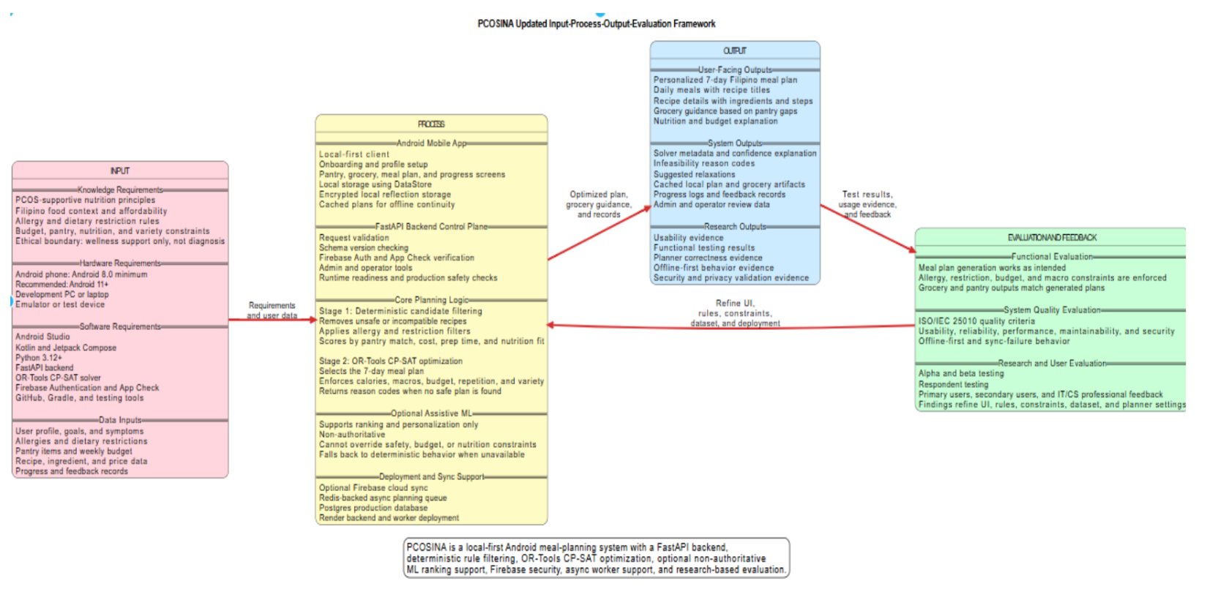
Figure 1. Conceptual Framework

Figure 2. Review of Related Literature Map
Source: caption paragraph 447
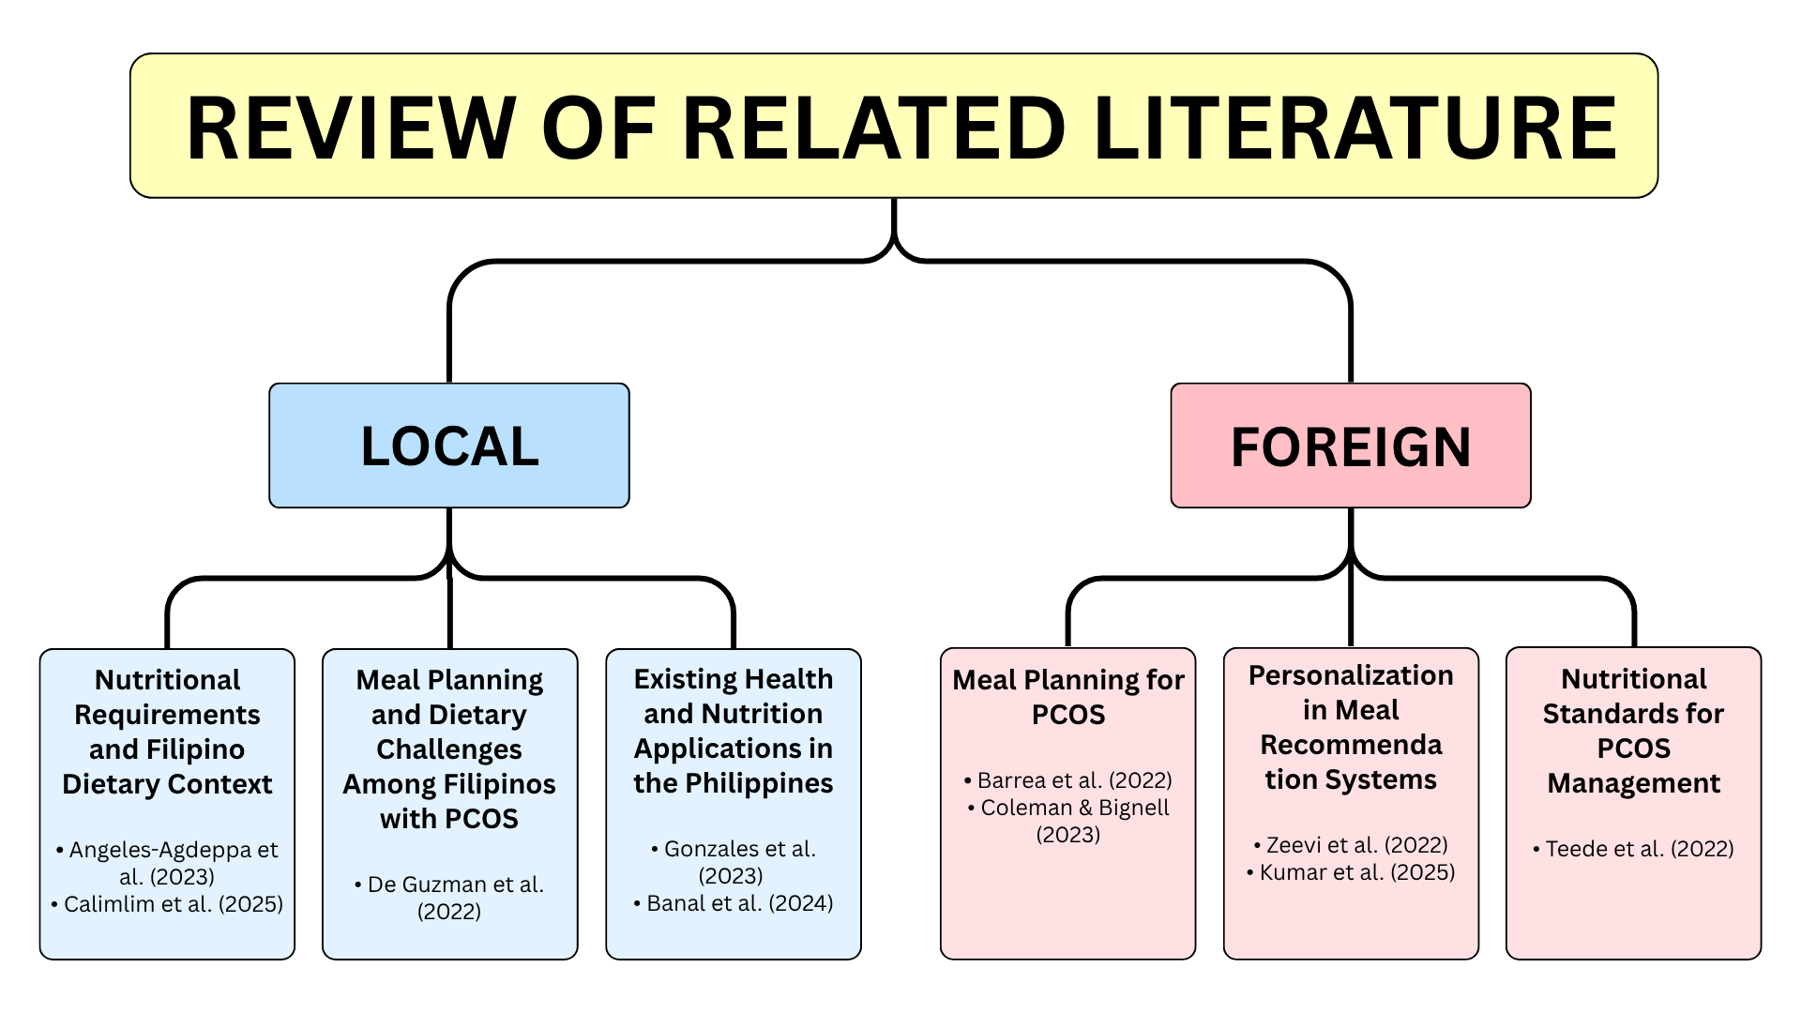
Figure 2. Review of Related Literature Map

Figure 3. Review of Related Studies Map
Source: caption paragraph 488
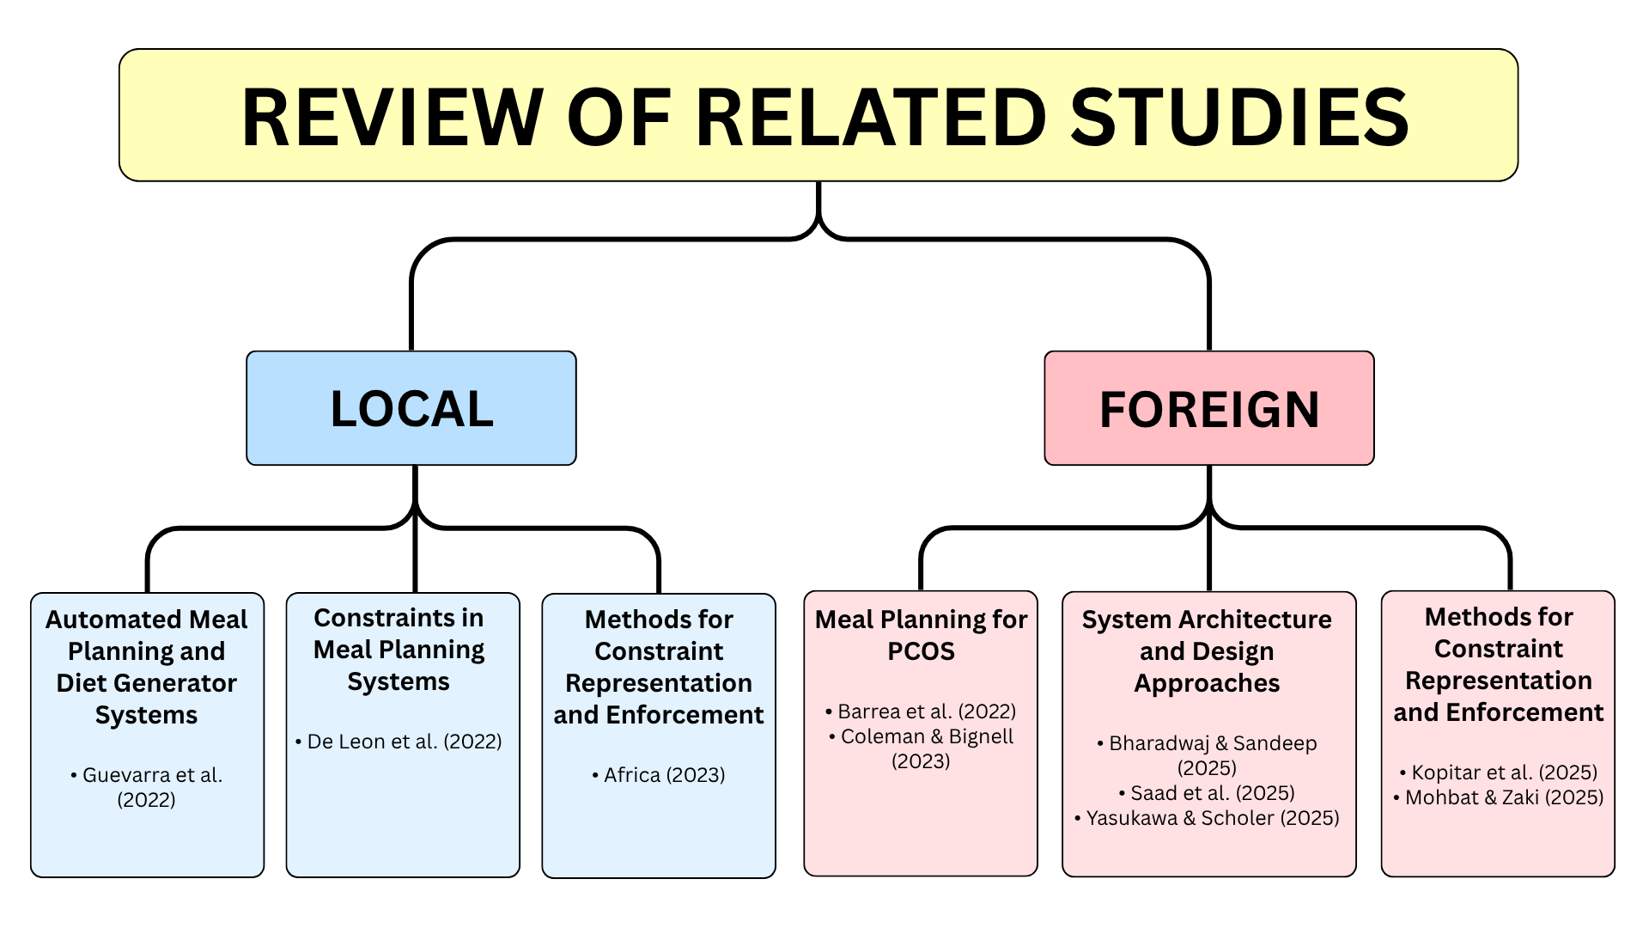
Figure 3. Review of Related Studies Map

Figure 4. Activity Diagram
Source: caption paragraph 562
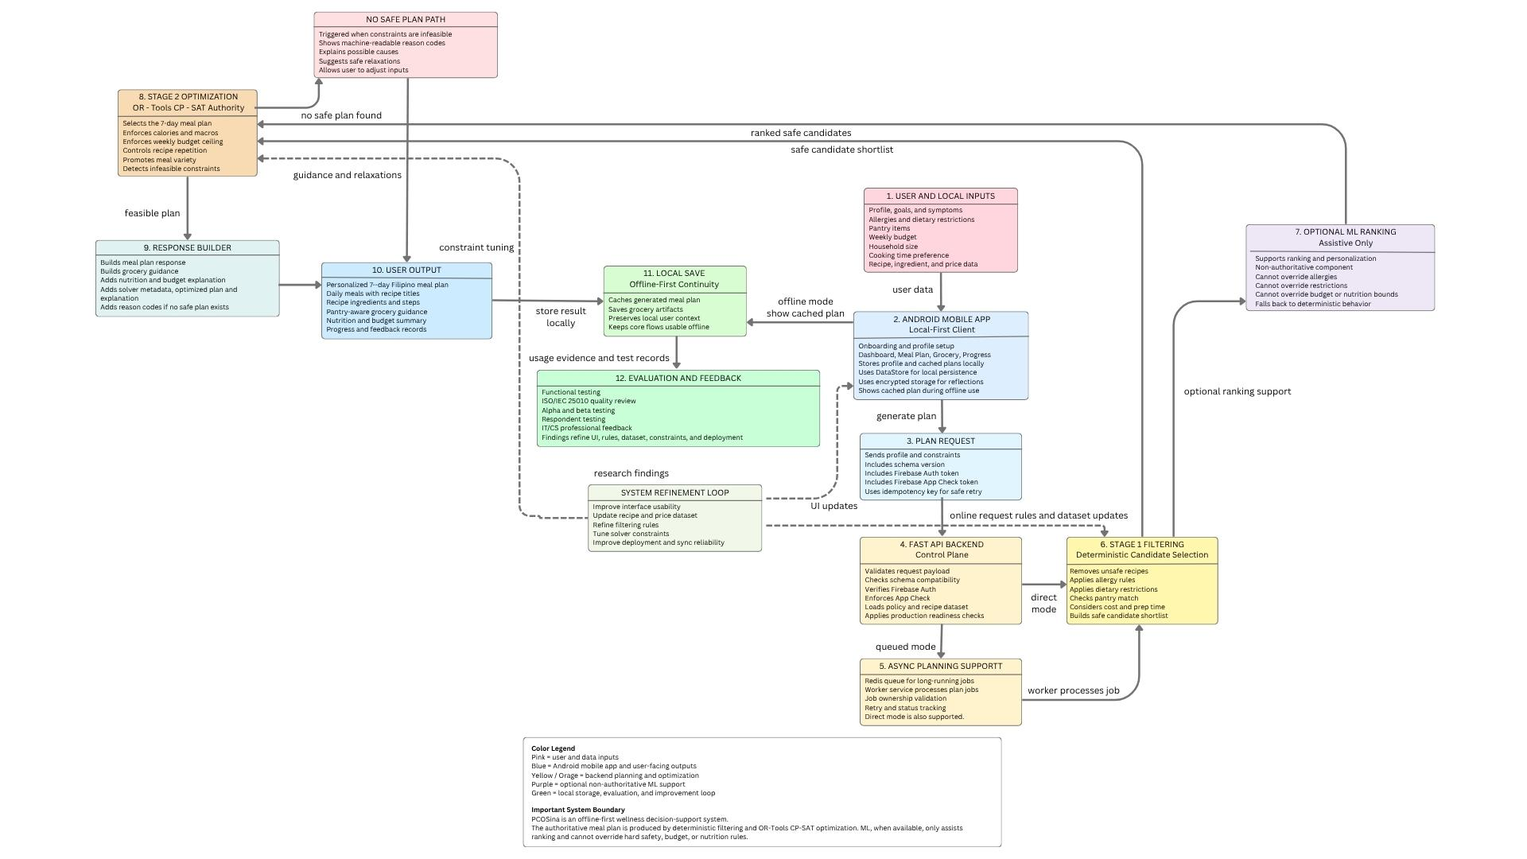
Figure 4. Activity Diagram

Figure 5. Sequence Diagram
Source: caption paragraph 569
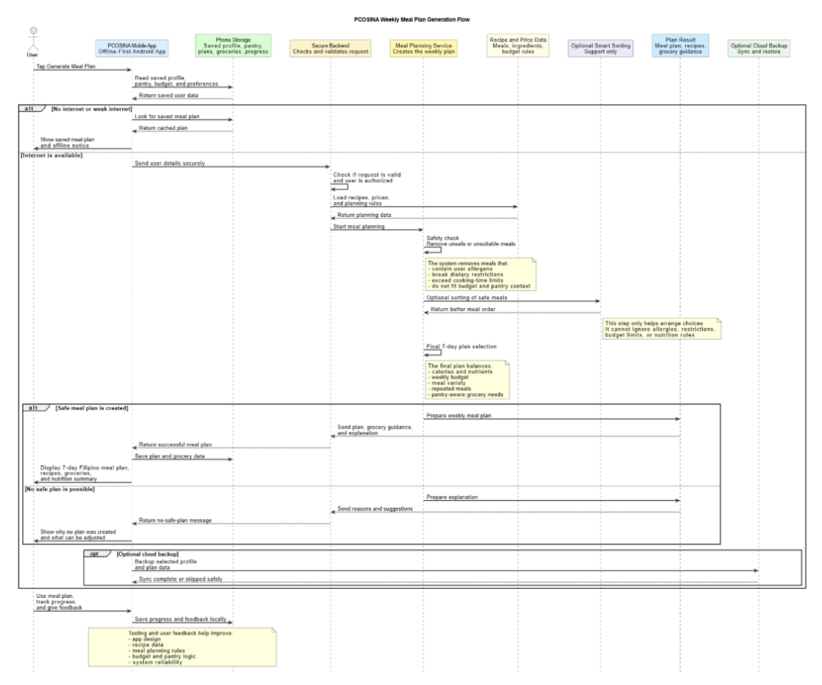
Figure 5. Sequence Diagram

Figure 6. Use Case Diagram
Source: caption paragraph 574
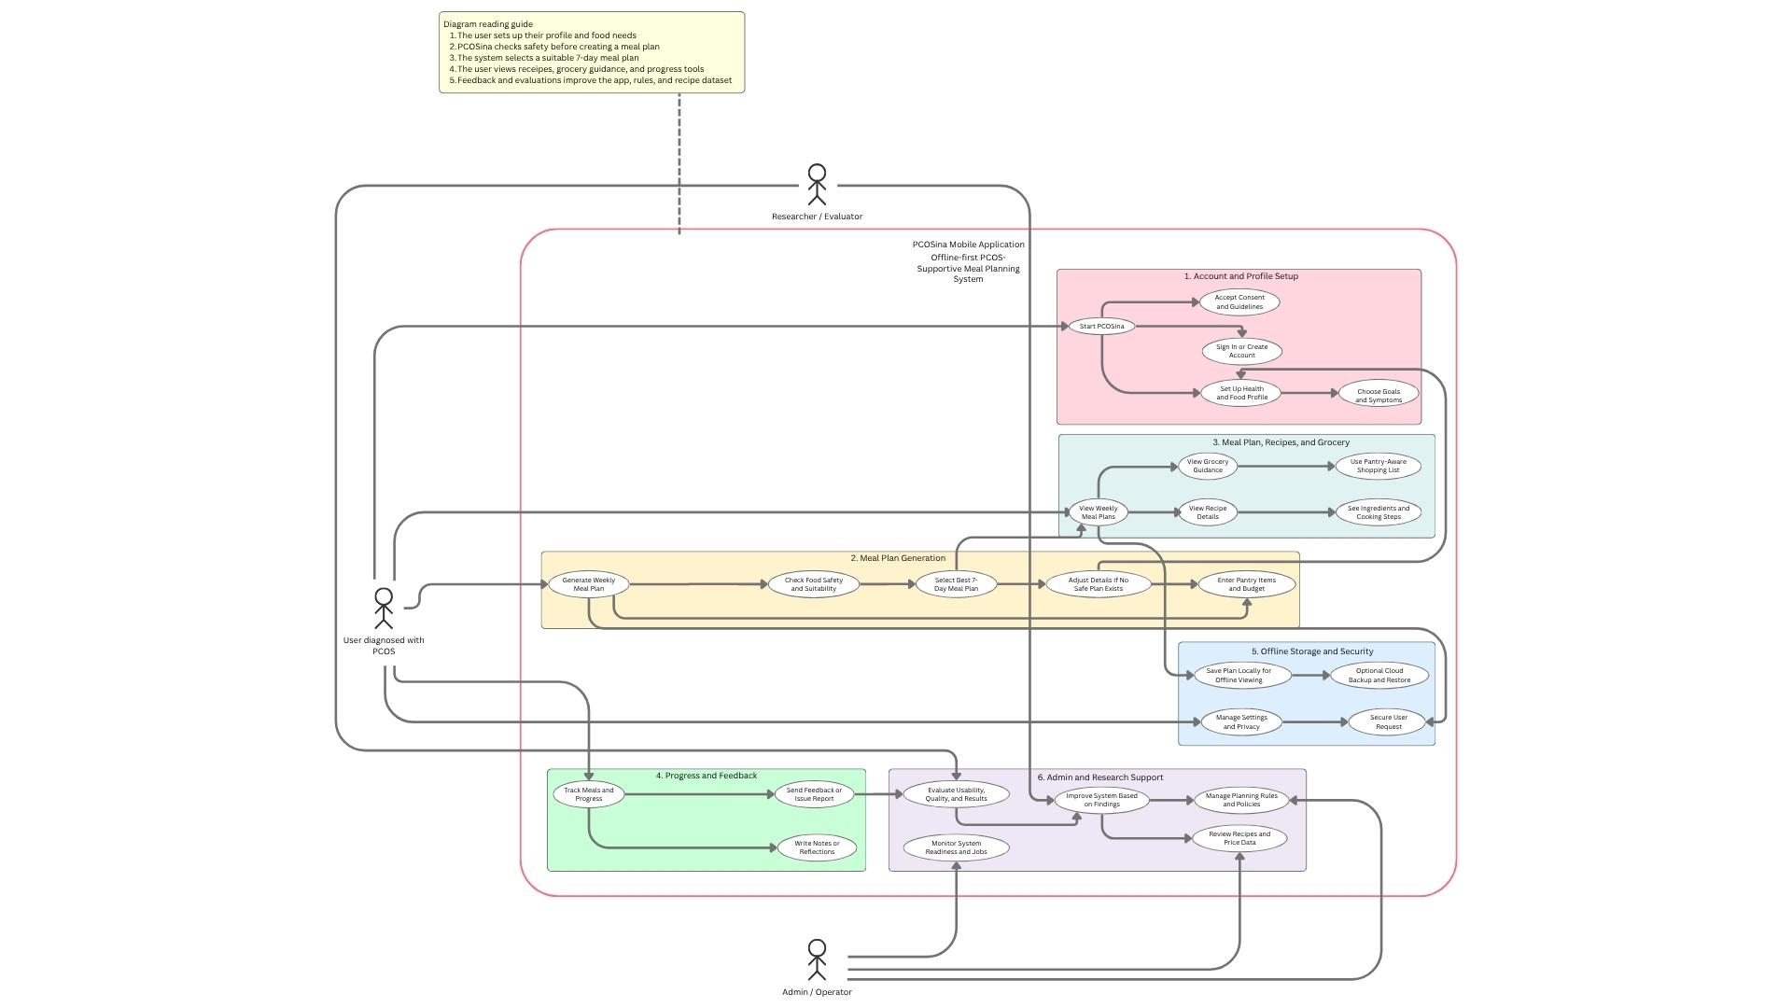
Figure 6. Use Case Diagram

Figure 7. Class Diagram
Source: caption paragraph 585
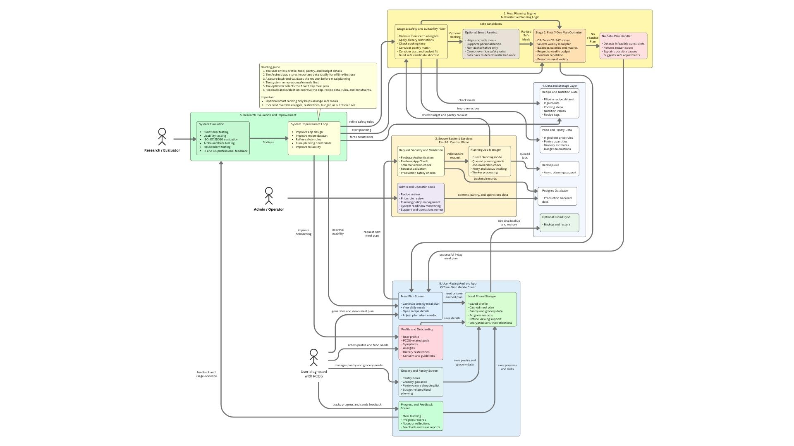
Figure 7. Class Diagram

Figure 8. System Architecture
Source: caption paragraph 589
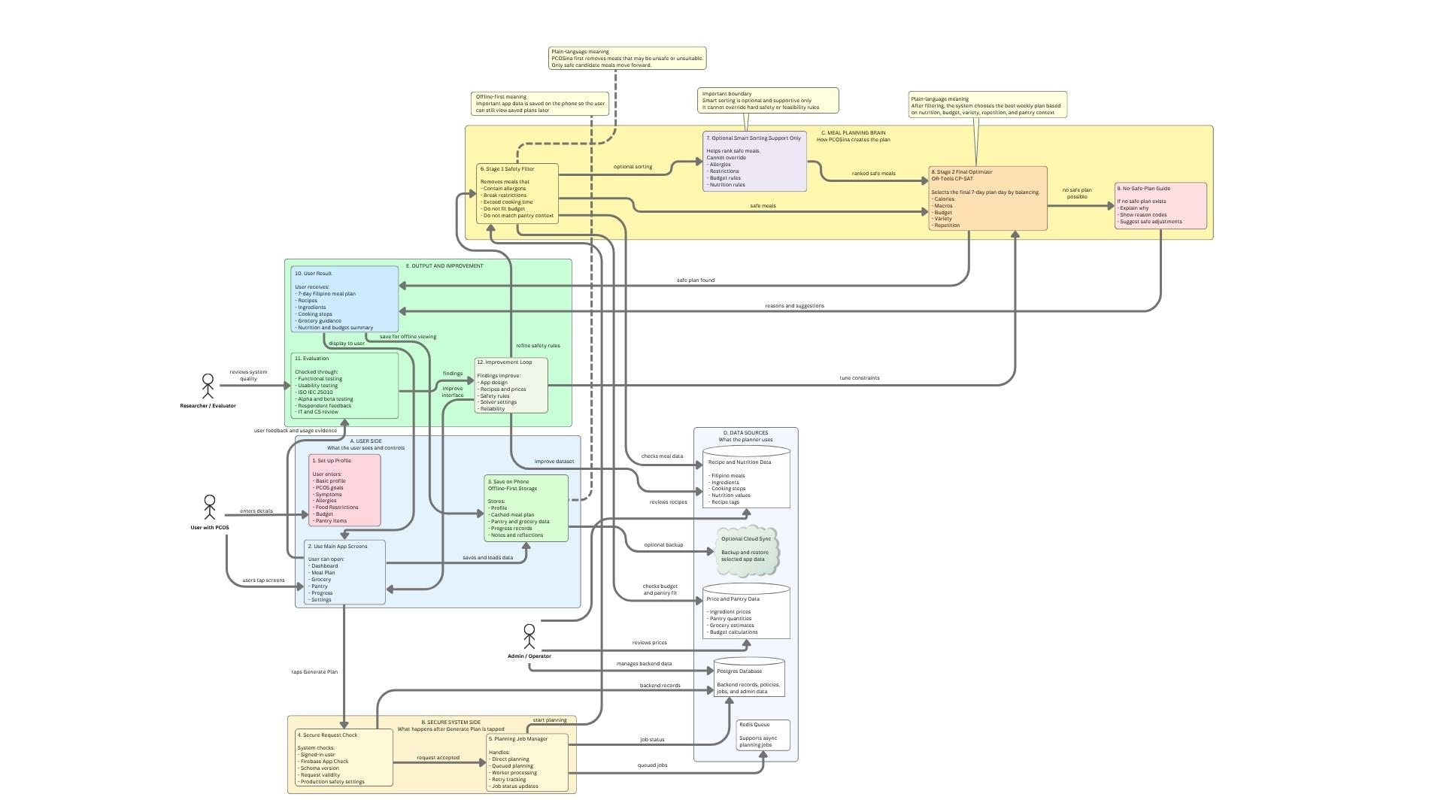
Figure 8. System Architecture

Figure 9. Offline-First Planning Workflow
Source: caption paragraph 613
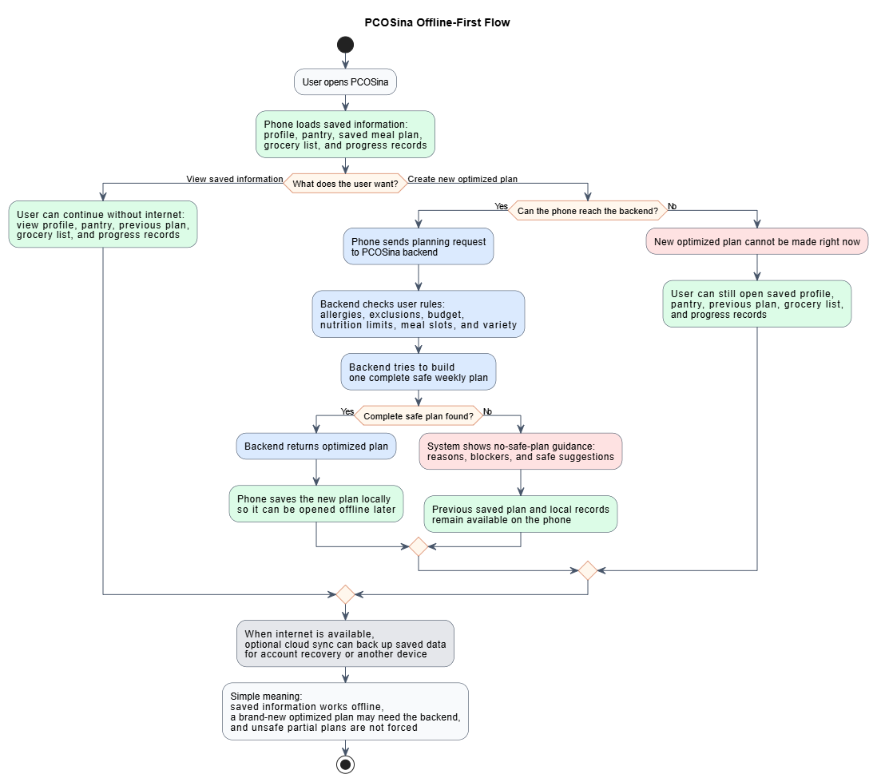
Figure 9. Offline-First Planning Workflow

Figure 10. Offline and Online Feature Availability Map
Source: caption paragraph 649
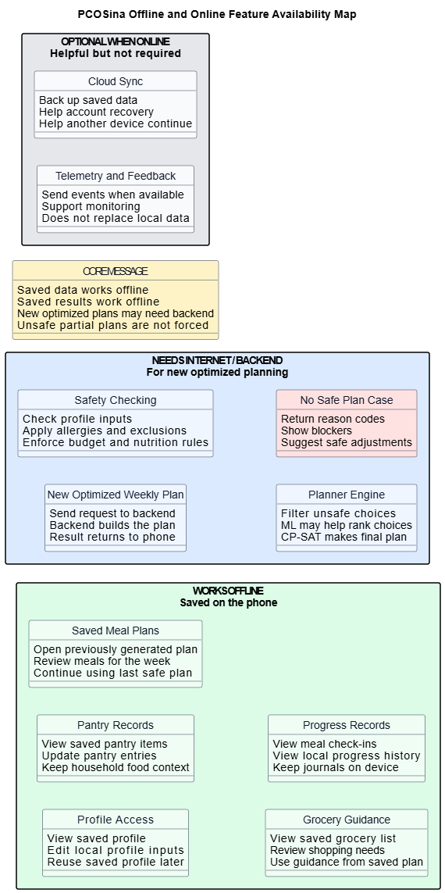
Figure 10. Offline and Online Feature Availability Map

Figure 11. Scrum / Agile Development Process
Source: caption paragraph 676
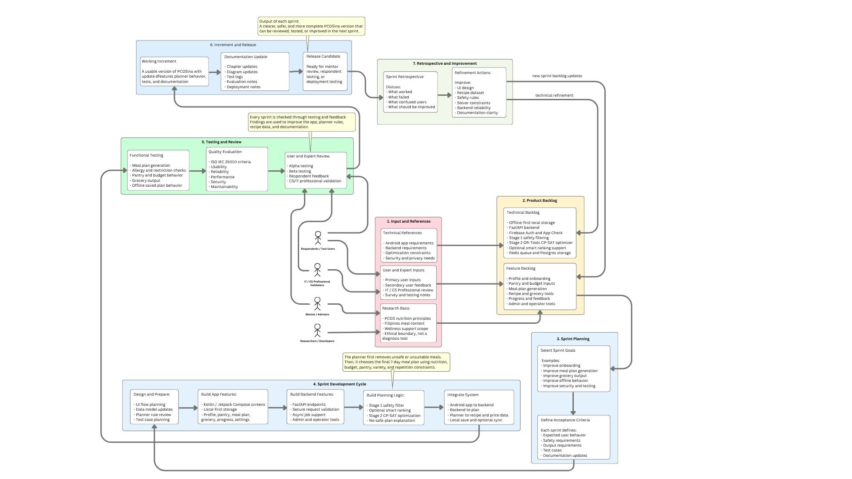
Figure 11. Scrum / Agile Development Process

Figure 12. Two-Stage MILP-Based Meal Planning Algorithm
Source: caption paragraph 686
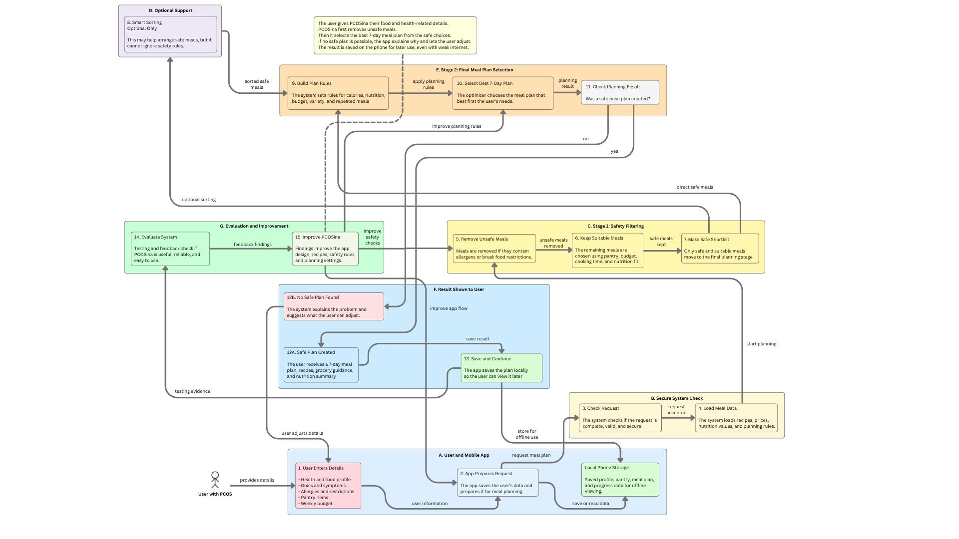
Figure 12. Two-Stage MILP-Based Meal Planning Algorithm

Figure 13. Adaptive fallback flowchart for weekly meal-plan generation
Source: caption paragraph 689
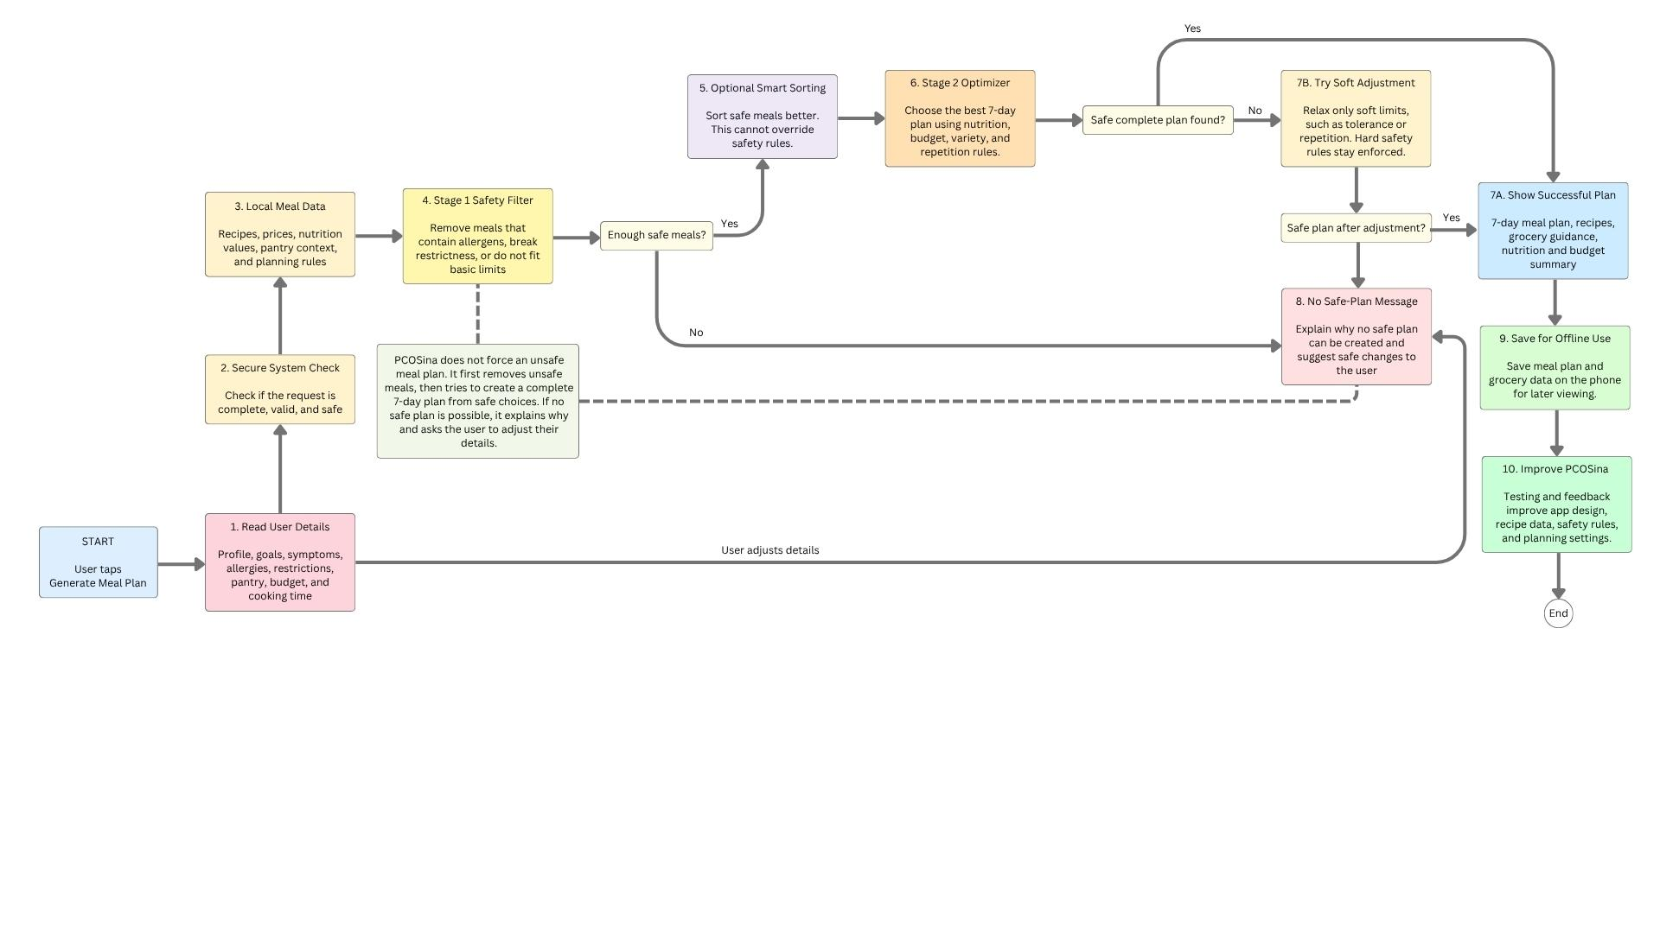
Figure 13. Adaptive fallback flowchart for weekly meal-plan generation

Figure 14. Relaxation ladder used by adaptive fallback
Source: caption paragraph 703
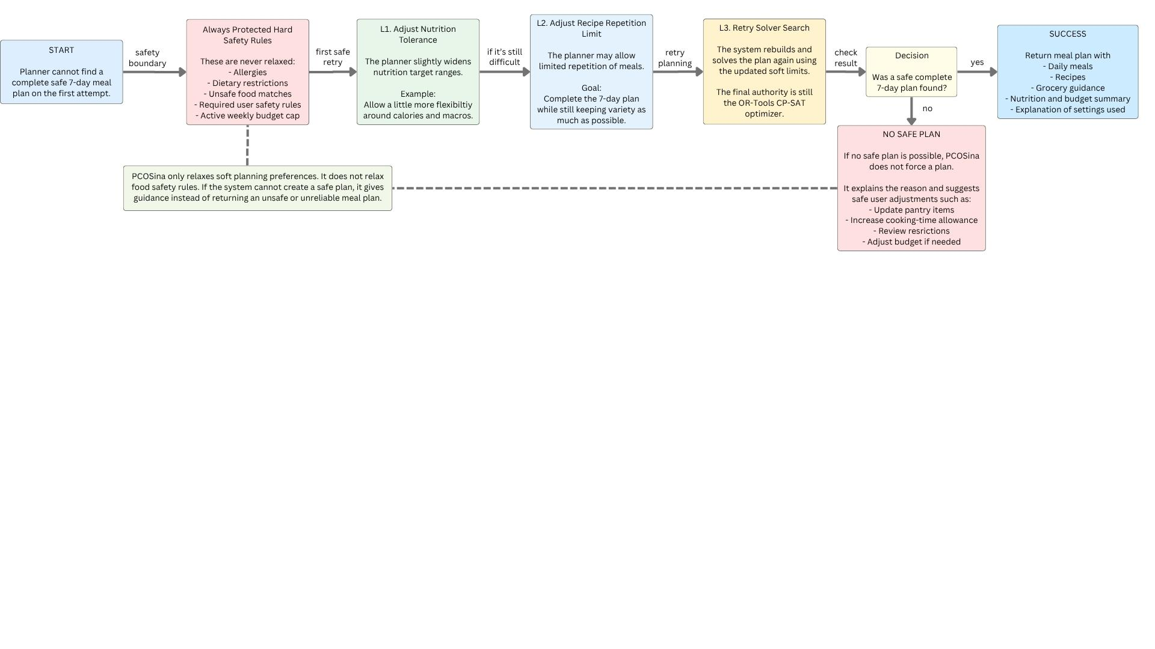
Figure 14. Relaxation ladder used by adaptive fallback

Figure 15. High-Level Pseudocode
Source: caption paragraph 840
Stored form: Word table object 27 in the source manuscript
Start plan generation
Load and validate user profile
If required inputs are missing or conflicting:
Return validation guidance
Run Stage 1 candidate construction
If candidate coverage is insufficient:
Return no-safe-plan guidance with blocker summary
For each supported nutrition tolerance level:
For each supported recipe repeat-limit setting:
Build CP-SAT weekly assignment model
Solve model within configured time budget
If a complete feasible 21-slot plan is found:
Return optimized weekly meal plan
If all supported attempts fail:
Return structured no-safe-plan response
Include reason codes, diagnostics, and suggested non-safety adjustments
Figure 15. High-Level Pseudocode

Figure 16. ISO-Based Software Evaluation Model
Source: caption paragraph 863
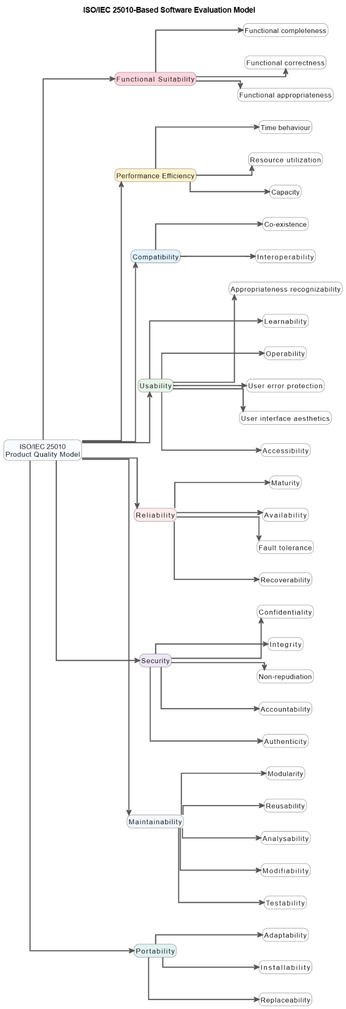
Figure 16. ISO-Based Software Evaluation Model

Figure 17. User Universe Definition
Source: caption paragraph 927
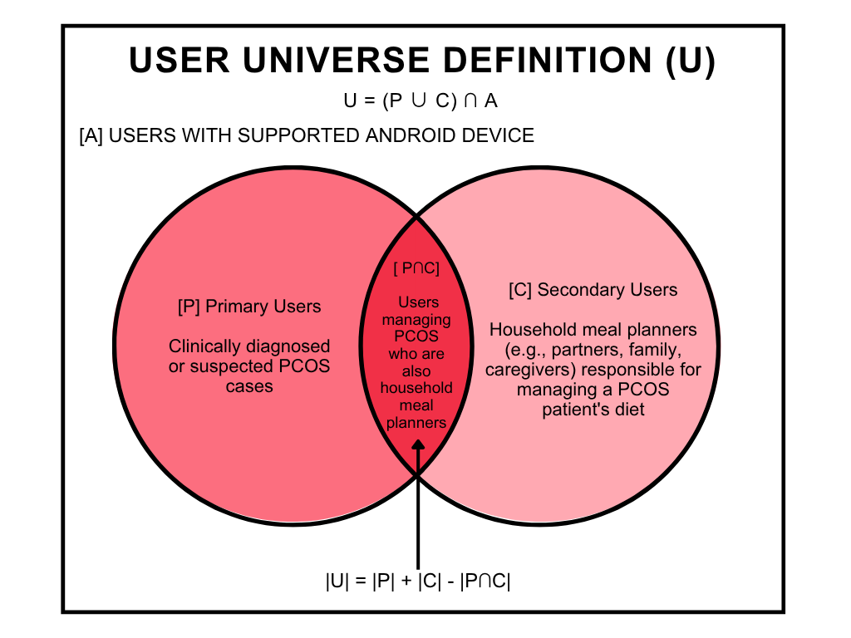
Figure 17. User Universe Definition

Figure 18. Effectiveness dimensions, metrics, and output artifacts
Source: caption paragraph 970
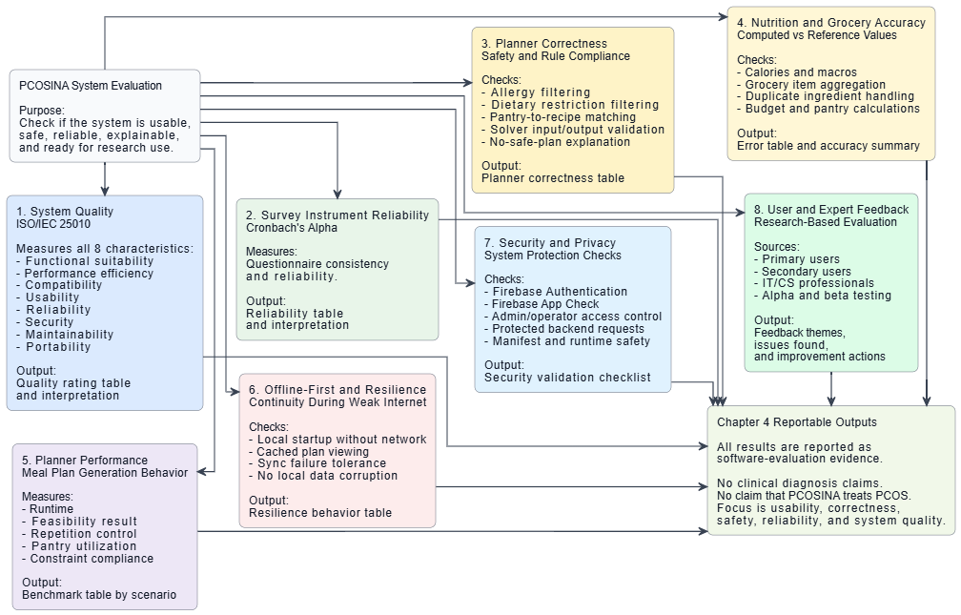
Figure 18. Effectiveness dimensions, metrics, and output artifacts

Figure 19. Effectiveness-evaluation flowchart (software-evaluation scope)
Source: caption paragraph 977
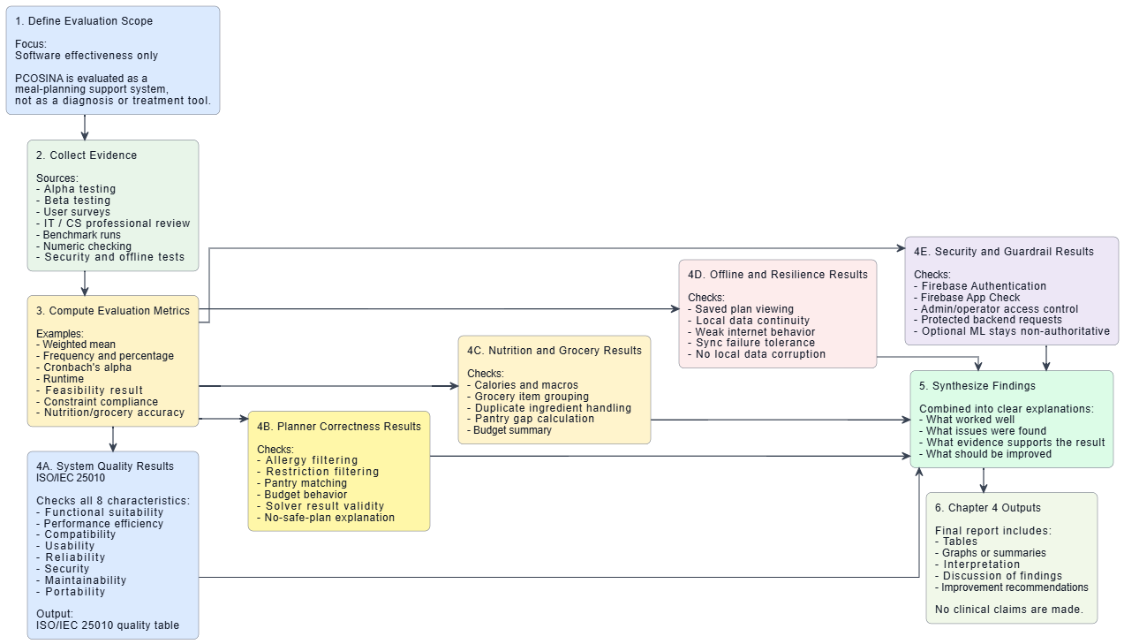
Figure 19. Effectiveness-evaluation flowchart (software-evaluation scope)

Figure 20. Twenty-Profile Planner Runtime Optimization Progression
Source: caption paragraph 1116
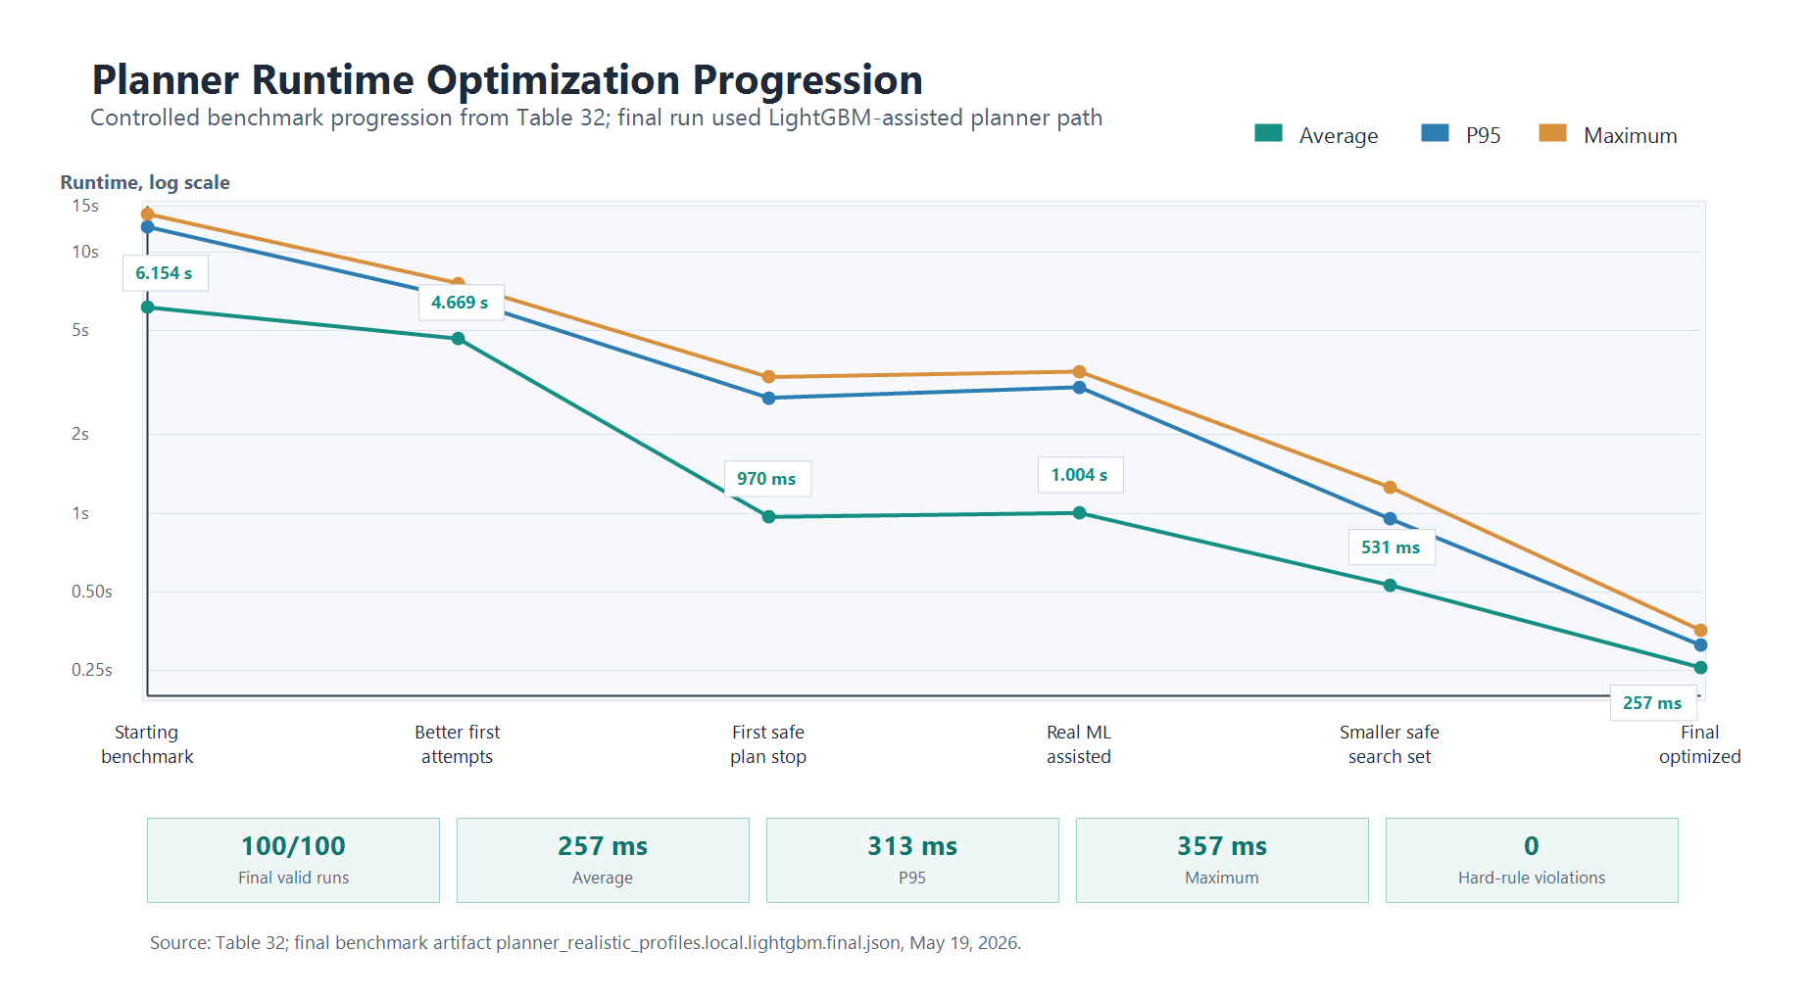
Figure 20. Twenty-Profile Planner Runtime Optimization Progression

Figure 21. Pantry-overlap evidence from algorithm evaluation assets
Source: caption paragraph 1206
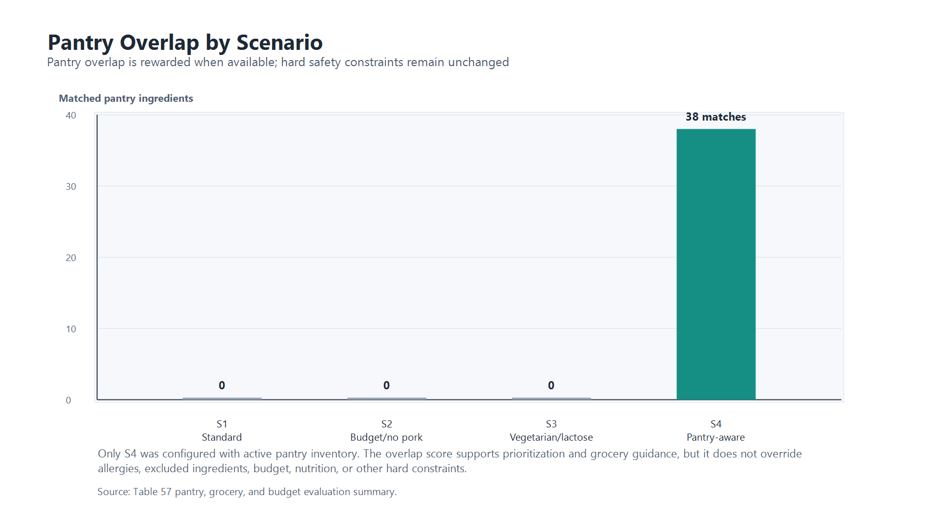
Figure 21. Pantry-overlap evidence from algorithm evaluation assets

Figure 22. Scenario-level runtime and nutrition comparison
Source: caption paragraph 1210
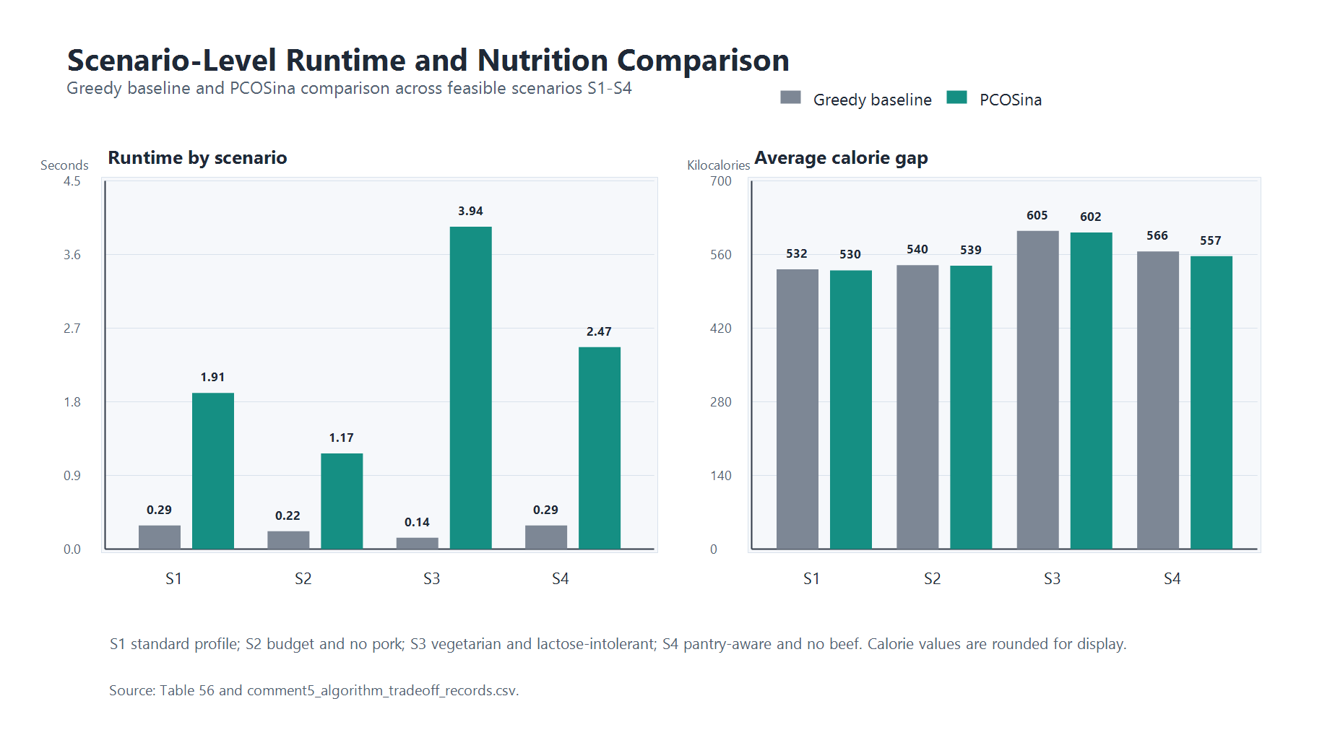
Figure 22. Scenario-level runtime and nutrition comparison

Figure 23. Online optimization and local-save sequence for offline-first continuity
Source: caption paragraph 1317
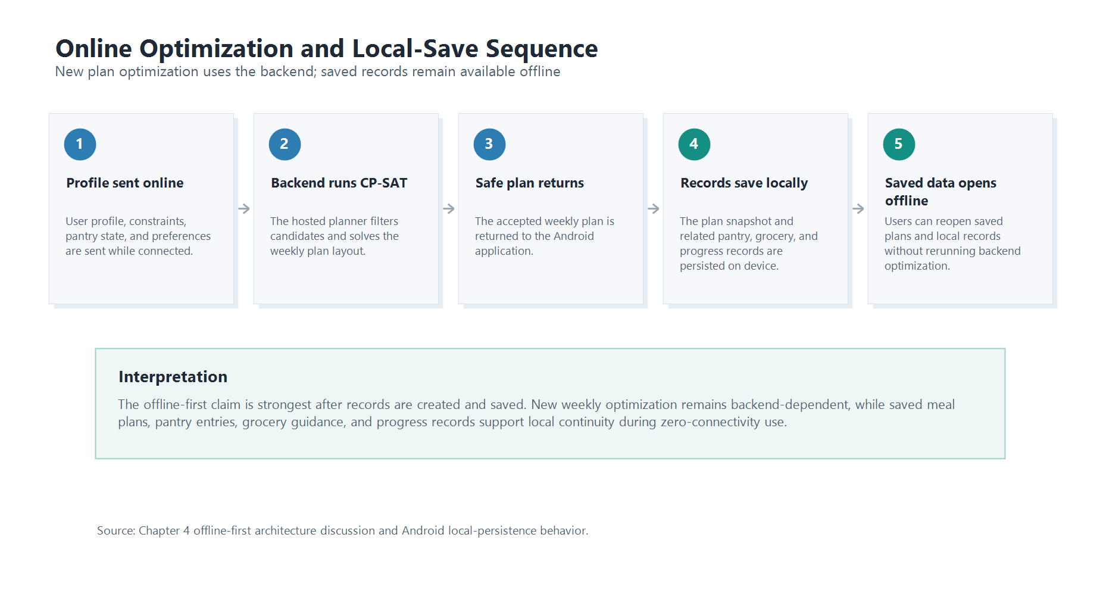
Figure 23. Online optimization and local-save sequence for offline-first continuity

Figure 24. Offline-first survey evidence for saved-data continuity
Source: caption paragraph 1326
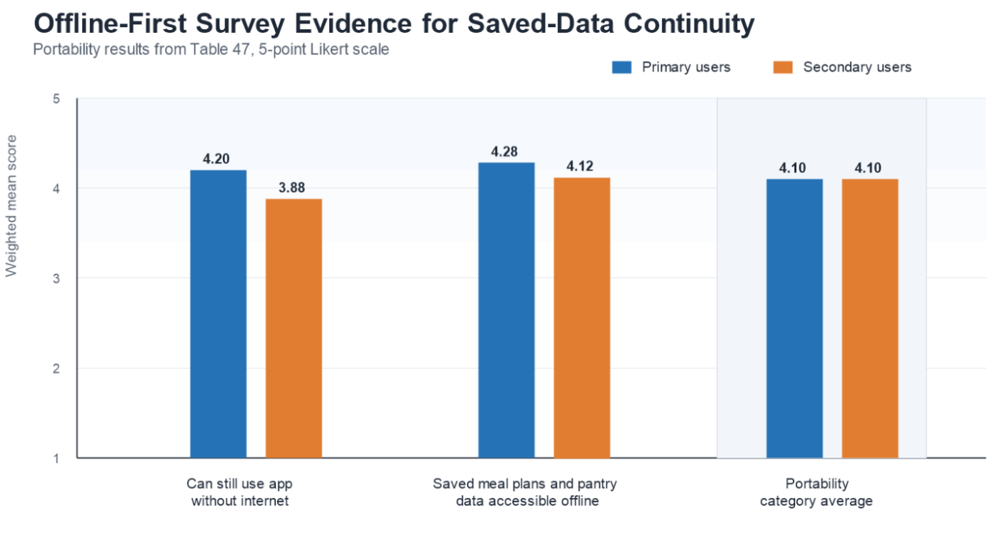
Figure 24. Offline-first survey evidence for saved-data continuity

Figure 25. Nutrition Deviation
Source: caption paragraph 1377
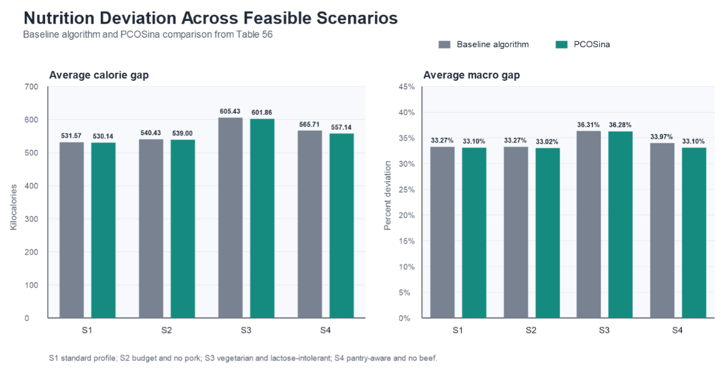
Figure 25. Nutrition Deviation

Figure 26. Algorithm Choice Comparison
Source: caption paragraph 1384
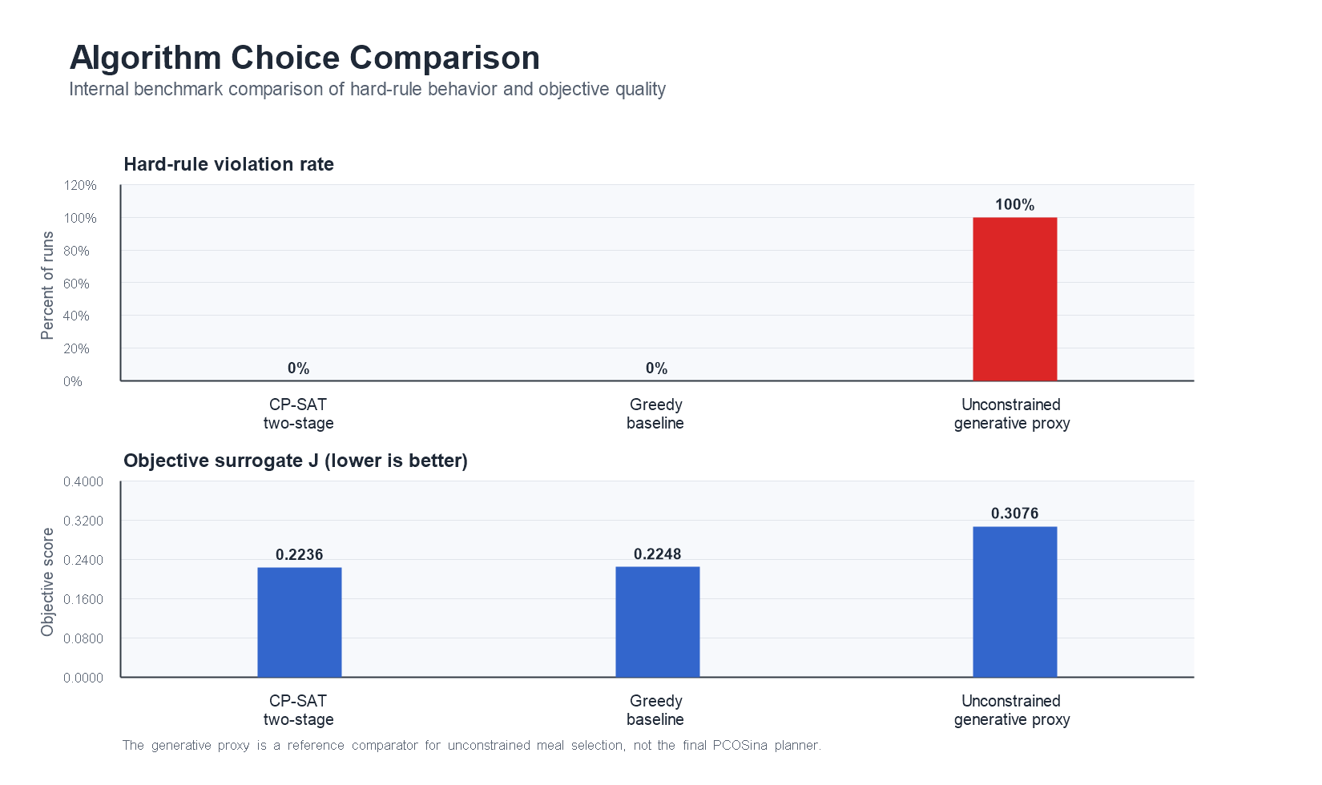
Figure 26. Algorithm Choice Comparison

