PCOSina Table 6 Software Stack Code Evidence
Concrete implementation proof for software specifications
Purpose: This document maps each Table 6 software item to concrete source-code or repository evidence. It is intended for final-defense study and panel questioning.
Important scope note: Some Table 6 items are runtime technologies with code evidence, such as FastAPI, DataStore, PostgreSQL, CP-SAT, and LightGBM. Draw.io is a diagramming tool, so its evidence is the manuscript/system diagrams rather than runtime source code.

Manuscript Table 6 Software Specifications
Software | Description | Version | Purpose | Platform
Android Studio | IDE | Latest | App development | Windows/macOS
Kotlin | Mobile Programming Language | Project-compatible version | Android Application Logic | Android
Jetpack Compose | Android UI toolkit | Project-compatible version | Declarative mobile user interface | Android
Android DataStore / Encrypted Shared Preferences / Local Artifacts | Local persistence technologies | Built-in / library-supported | Offline-first storage of saved profiles, pantry records, generated plans, settings, and progress-related data | Android
Firebase | Optional cloud service | Optional | Authentication, distribution, backup, or supplementary synchronization when enabled | Cloud
FastAPI | Backend web framework | Project-compatible version | API layer for plan-generation requests and optimizer service endpoints | Backend
PostgreSQL | Relational Database | Project-compatible version | Backend data storage and persistent server-side records | Backend / Cloud
OR-Tools CP-SAT | Optimization Solver | Project-compatible version | Solving the MILP-style 0-1 weekly assignment formulation | Backend
LightGBM | Machine-learning ranking library | Project-compatible version | Assistive candidate ranking during Stage 1 candidate construction | Backend
Git / GitHub | Version control and repository platform | Latest available | Collaboration, version tracking, issue tracking, and implementation traceability | Web/Desktop
Draw.io | Diagram Tool | Web-based | System modeling | Web
Python | Backend programming language | Project-compatible | FastAPI backend, optimizer service, CP-SAT planning logic, LightGBM-assisted ranking, backend utilities | Backend

Evidence Index
Software | Evidence | Source | Defense use
Backend dependency proof | Pinned backend software dependencies | backend/requirements.txt:1-15 | This proves the backend stack is declared as actual dependencies, not only mentioned in the manuscript.
Android Studio / Gradle | Android project plugins | app/build.gradle.kts:5-13 | Android Studio uses this Gradle configuration to build and manage the PCOSina Android application.
Android Studio / Android app configuration | Android app SDK and package configuration | app/build.gradle.kts:237-263 | This is concrete evidence that the mobile client is a native Android application.
Kotlin and Jetpack Compose | Kotlin and Compose build configuration | app/build.gradle.kts:379-400 | This supports the claim that the mobile app is built in Kotlin using Jetpack Compose.
Jetpack Compose | Compose entry point in MainActivity | app/src/main/java/com/pcosina/app/MainActivity.kt:1-24 | This is where Android launches the PCOSina Compose UI.
Jetpack Compose | Actual Compose screen function | app/src/main/java/com/pcosina/app/ui/screens/MealPlanRefinedScreen.kt:211-231 | Compose is not only installed; it is used directly in the app screens.
Android DataStore | DataStore declaration for local preferences | app/src/main/java/com/pcosina/app/data/repository/UserPreferencesRepository.kt:1-40 | This is the local-first storage foundation for saved user app data.
Android DataStore | Saving user profile fields locally | app/src/main/java/com/pcosina/app/data/repository/UserPreferencesRepository.kt:455-489 | This proves profile inputs used by planning are stored locally on the Android device.
Android DataStore / Local artifacts | Saving generated plans and groceries locally | app/src/main/java/com/pcosina/app/data/repository/UserPreferencesRepository.kt:1097-1131 | This supports the offline-first claim for saved plans and grocery data after they already exist locally.
Encrypted Shared Preferences | Encrypted local storage setup | app/src/main/java/com/pcosina/app/data/repository/ReflectionStore.kt:1-40 | This proves sensitive reflection/progress-style local artifacts are not stored only as plain shared preferences.
Encrypted Shared Preferences | Safe encrypted storage read/write wrappers | app/src/main/java/com/pcosina/app/data/repository/ReflectionStore.kt:68-84 | This supports reliability and graceful handling of unreadable local encrypted records.
Firebase | Firebase dependencies in Android app | app/build.gradle.kts:409-416 | Firebase is used for authentication, optional cloud sync/support services, crash reporting, and App Check protection.
Firebase / Firestore | Profile cloud sync using Firestore | app/src/main/java/com/pcosina/app/data/repository/UserPreferencesRepository.kt:493-528 | This proves Firebase is not just a login label; it is also used for optional profile persistence/sync.
Firebase Admin / Backend auth | Backend Firebase initialization and auth guard | backend/main.py:581-627 | This is how the backend verifies authenticated requests when Firebase is configured.
FastAPI | FastAPI app initialization | backend/main.py:1-20 | This proves the backend API layer is built with FastAPI.
FastAPI | FastAPI application object | backend/main.py:349-357 | This is the actual FastAPI application object served by the backend.
FastAPI REST API | GET and POST recipe endpoints | backend/main.py:3942-3984 | This is concrete evidence of FastAPI route decorators and admin content API operations.
FastAPI REST API | PUT and DELETE recipe endpoints | backend/main.py:3996-4026 | This proves the backend has update/delete API methods, not only a single planner endpoint.
FastAPI planner API | Generate-plan API endpoint | backend/main.py:5416-5436 | This is the backend doorway used by the Android app to request meal-plan generation.
PostgreSQL | PostgreSQL backend mode and connection | backend/database.py:27-35 | PostgreSQL is selected through a real database URL, not hardcoded text in the manuscript.
PostgreSQL | PostgreSQL connection and production guard | backend/database.py:199-305 | This proves PostgreSQL is the backend production database path, while SQLite fallback is for non-production/local cases.
OR-Tools CP-SAT | CP-SAT import and binary decision variables | backend/services/meal_planner.py:1-16 | This proves the optimization solver is used in the planner module.
OR-Tools CP-SAT | CP-SAT model and x[s,i] binary variables | backend/services/meal_planner.py:2893-2910 | This is the code-level proof of the 0-1 meal assignment formulation.
OR-Tools CP-SAT | Objective and solver execution | backend/services/meal_planner.py:3093-3161 | This proves the final plan is solved through an optimization model, not manually selected by if-else rules.
LightGBM | LightGBM model loading | backend/services/ml_ranker.py:71-108 | This proves LightGBM is implemented as an optional Stage 1 ranking artifact, when available.
LightGBM | LightGBM scoring functions | backend/services/ml_ranker.py:127-160 | This is the actual ML scoring logic used for assistive candidate ranking.
Python | Python backend implementation | backend/main.py:1-20 | Python is the backend language used to implement the API, solver bridge, and backend services.
GitHub Actions | GitHub workflow evidence | .github/workflows/ci.yml:1-45 | This supports the Git/GitHub purpose: version tracking, collaboration, and validation automation.
Git / GitHub | Repository remote and branch metadata | git command output | Shows the local project is connected to the GitHub repository for version control.
Draw.io | Diagram tool clarification | Manuscript/system diagram artifacts | Draw.io is not runtime source code; it is used for diagrams such as architecture, workflow, use case, and sequence figures.

1. Backend dependency proof - Pinned backend software dependencies
Source: backend/requirements.txt:1-15
What it proves: Shows FastAPI, OR-Tools, Firebase Admin, PostgreSQL driver, Redis, LightGBM, and test dependencies used by the backend.
Defense use: This proves the backend stack is declared as actual dependencies, not only mentioned in the manuscript.
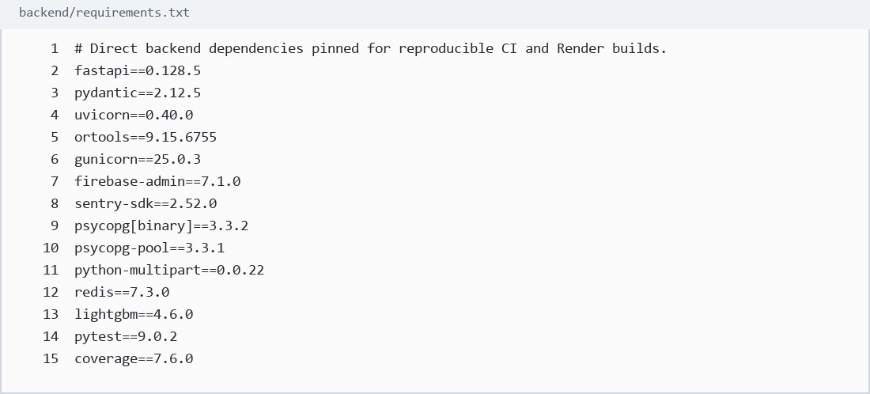

2. Android Studio / Gradle - Android project plugins
Source: app/build.gradle.kts:5-13
What it proves: Shows the Android application, Kotlin Android, Kotlin Compose, Firebase App Distribution, and Crashlytics Gradle plugins.
Defense use: Android Studio uses this Gradle configuration to build and manage the PCOSina Android application.
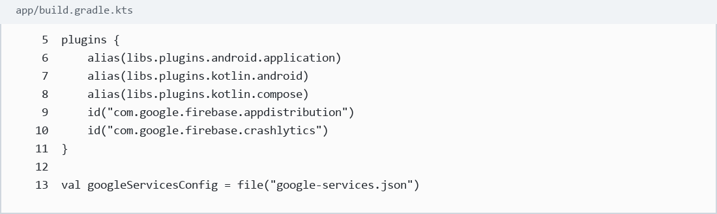

3. Android Studio / Android app configuration - Android app SDK and package configuration
Source: app/build.gradle.kts:237-263
What it proves: Shows compile SDK, application ID, minimum SDK, target SDK, version code, and version name.
Defense use: This is concrete evidence that the mobile client is a native Android application.
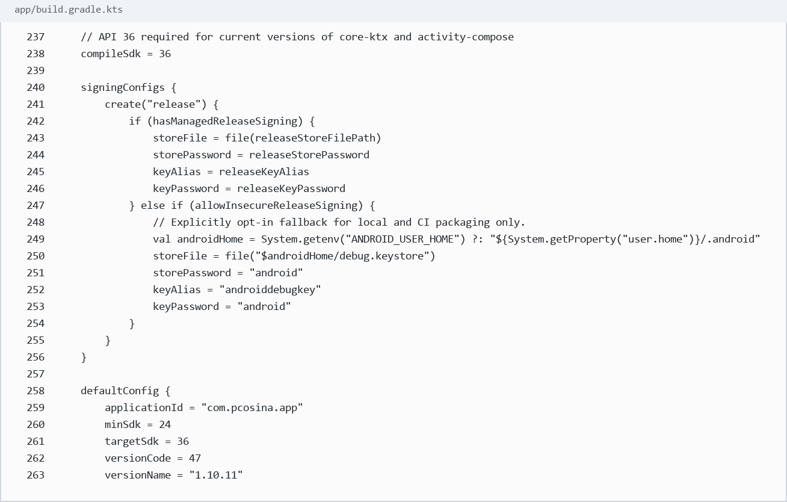

4. Kotlin and Jetpack Compose - Kotlin and Compose build configuration
Source: app/build.gradle.kts:379-400
What it proves: Shows Kotlin JVM target, Compose enabled in build features, and Compose UI/Material dependencies.
Defense use: This supports the claim that the mobile app is built in Kotlin using Jetpack Compose.
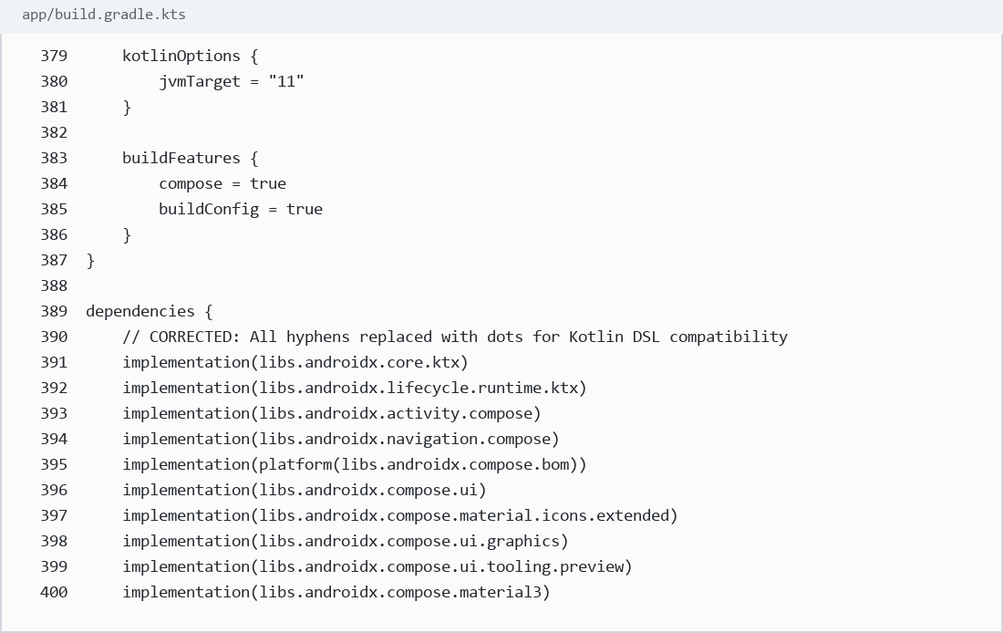

5. Jetpack Compose - Compose entry point in MainActivity
Source: app/src/main/java/com/pcosina/app/MainActivity.kt:1-24
What it proves: Shows setContent and the Compose app entry point.
Defense use: This is where Android launches the PCOSina Compose UI.
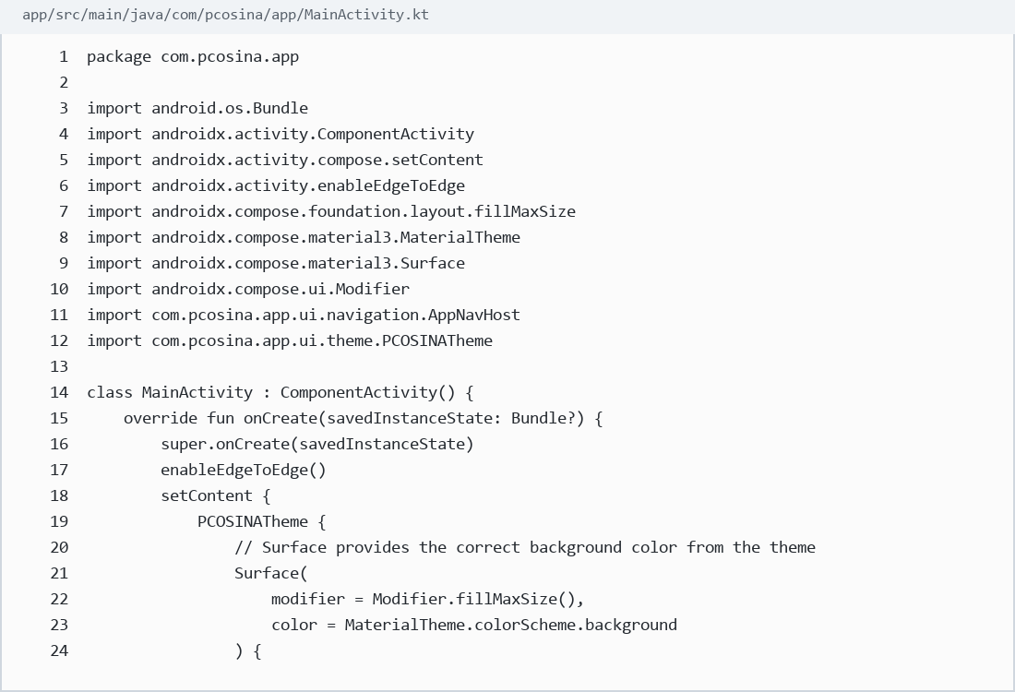

6. Jetpack Compose - Actual Compose screen function
Source: app/src/main/java/com/pcosina/app/ui/screens/MealPlanRefinedScreen.kt:211-231
What it proves: Shows a real @Composable screen for the meal-plan UI.
Defense use: Compose is not only installed; it is used directly in the app screens.
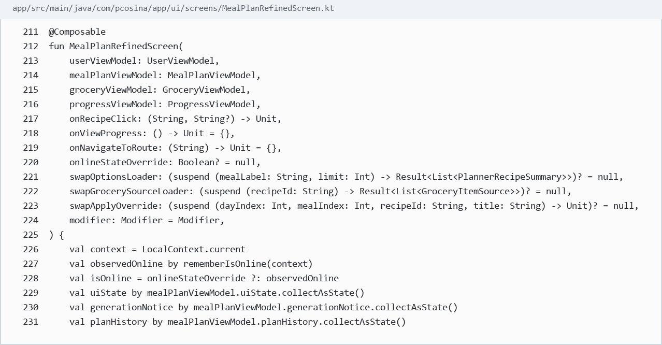

7. Android DataStore - DataStore declaration for local preferences
Source: app/src/main/java/com/pcosina/app/data/repository/UserPreferencesRepository.kt:1-40
What it proves: Shows DataStore imports and the user_prefs DataStore declaration.
Defense use: This is the local-first storage foundation for saved user app data.
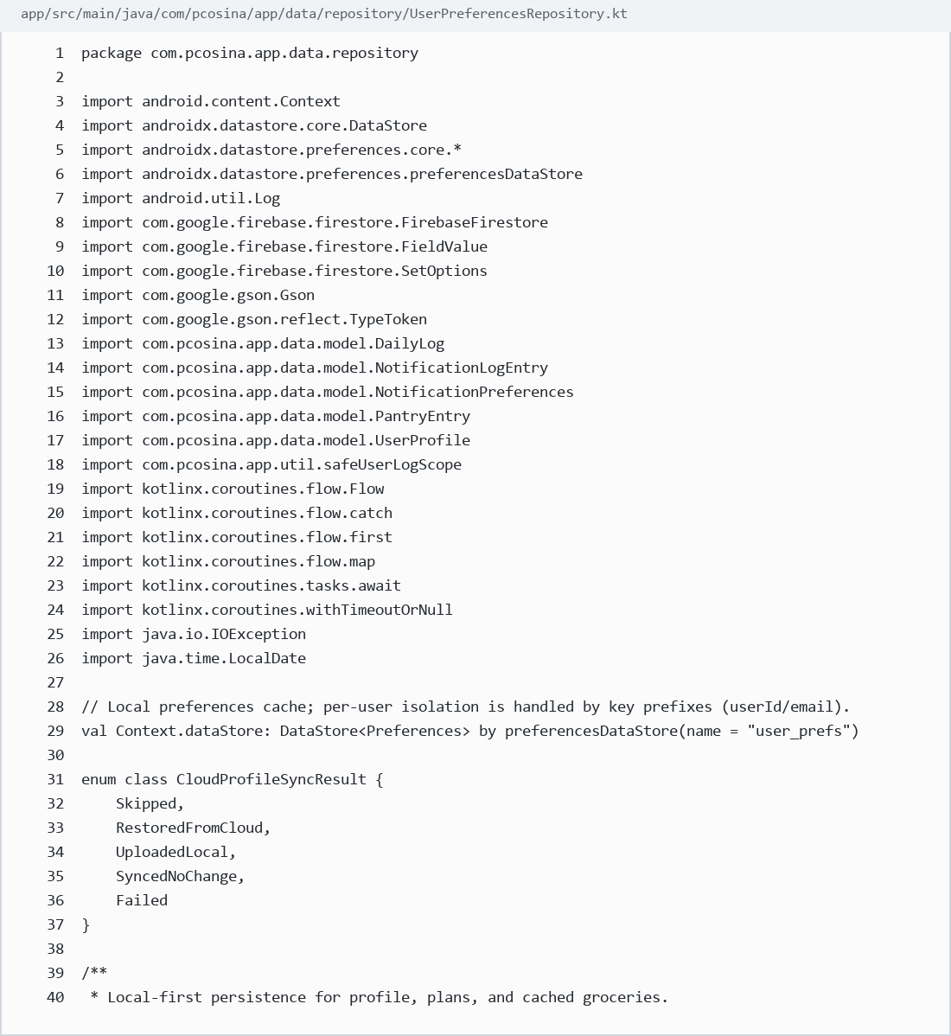

8. Android DataStore - Saving user profile fields locally
Source: app/src/main/java/com/pcosina/app/data/repository/UserPreferencesRepository.kt:455-489
What it proves: Shows profile fields written to local DataStore preferences: name, age, height, weight, activity, goal, symptoms, restrictions, allergies, pantry, budget, cooking time, variety, and planning priority.
Defense use: This proves profile inputs used by planning are stored locally on the Android device.
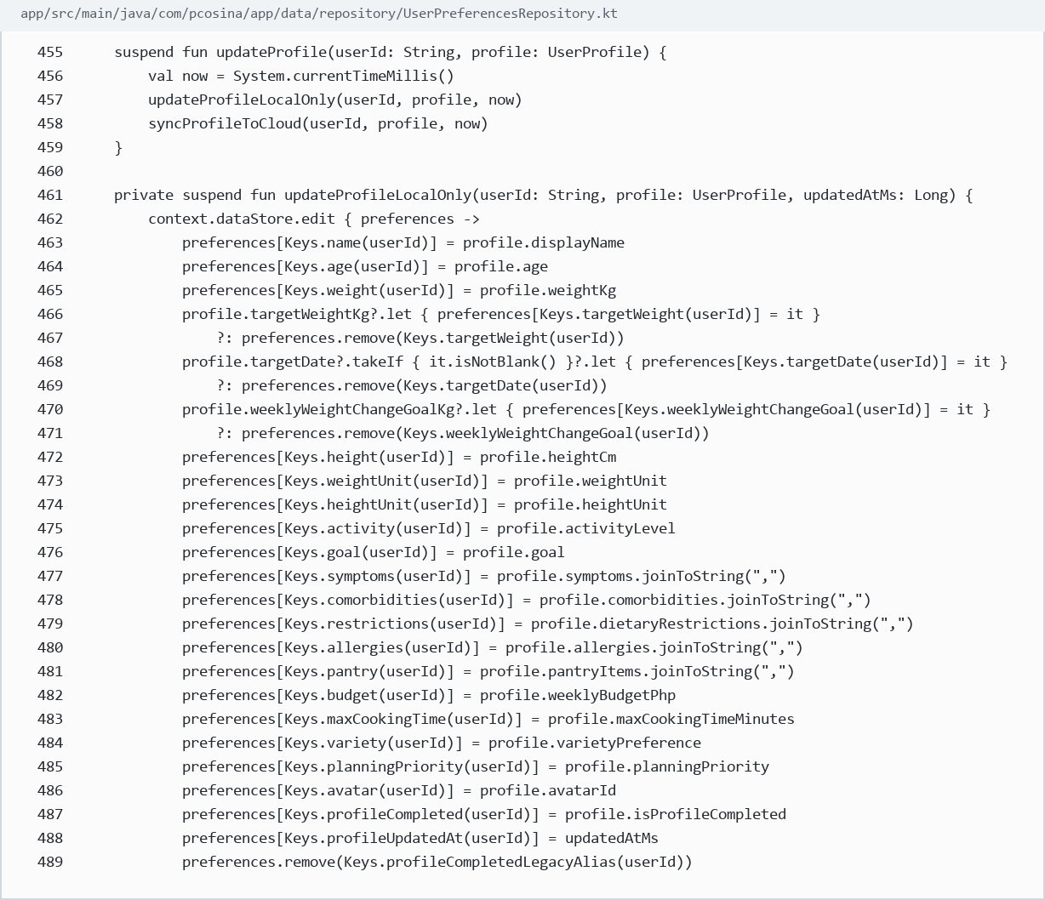

9. Android DataStore / Local artifacts - Saving generated plans and groceries locally
Source: app/src/main/java/com/pcosina/app/data/repository/UserPreferencesRepository.kt:1097-1131
What it proves: Shows saved plan, plan history, active plan, and grocery JSON persistence.
Defense use: This supports the offline-first claim for saved plans and grocery data after they already exist locally.
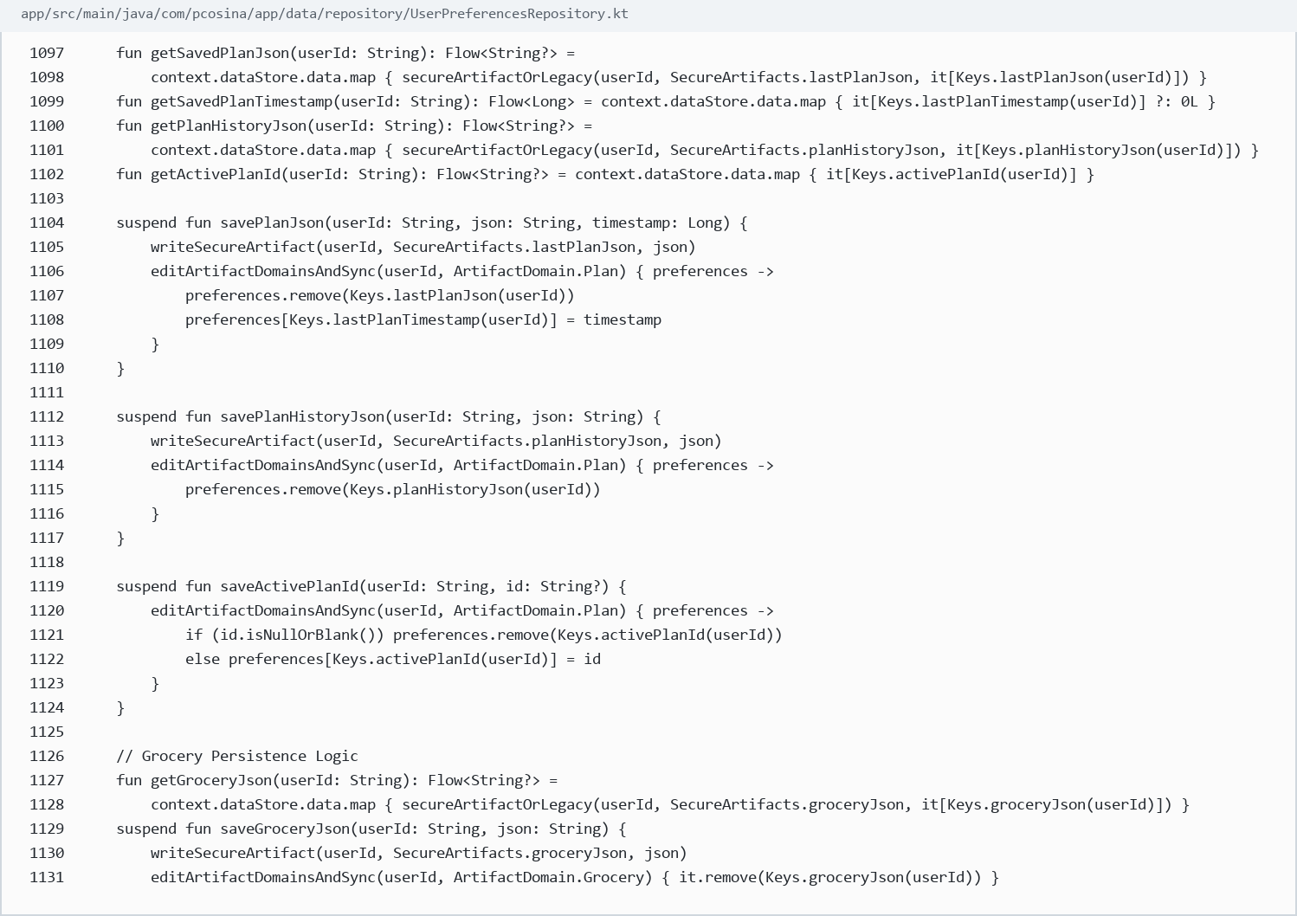

10. Encrypted Shared Preferences - Encrypted local storage setup
Source: app/src/main/java/com/pcosina/app/data/repository/ReflectionStore.kt:1-40
What it proves: Shows EncryptedSharedPreferences with AES-based key/value encryption schemes.
Defense use: This proves sensitive reflection/progress-style local artifacts are not stored only as plain shared preferences.
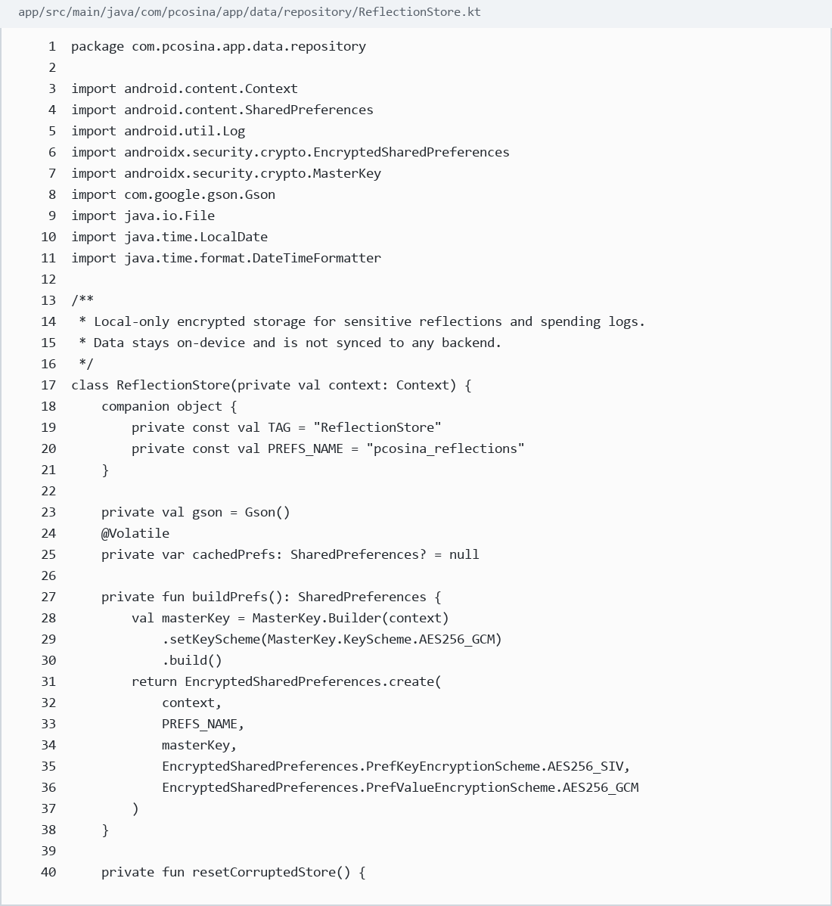

11. Encrypted Shared Preferences - Safe encrypted storage read/write wrappers
Source: app/src/main/java/com/pcosina/app/data/repository/ReflectionStore.kt:68-84
What it proves: Shows safe read/write wrappers around encrypted local storage.
Defense use: This supports reliability and graceful handling of unreadable local encrypted records.
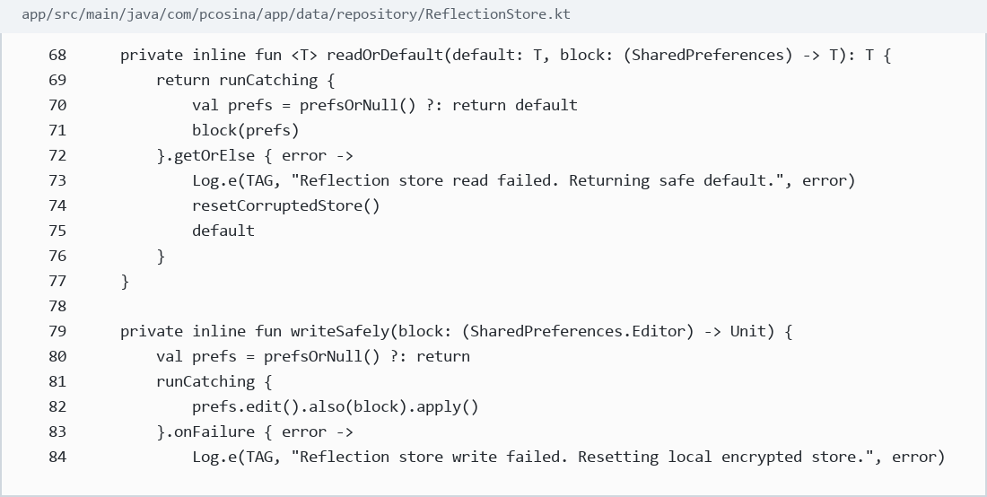

12. Firebase - Firebase dependencies in Android app
Source: app/build.gradle.kts:409-416
What it proves: Shows Firebase Analytics, Auth, Firestore, Crashlytics, and App Check dependencies.
Defense use: Firebase is used for authentication, optional cloud sync/support services, crash reporting, and App Check protection.
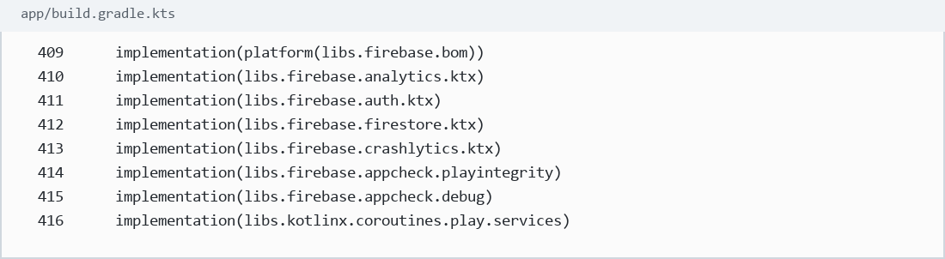

13. Firebase / Firestore - Profile cloud sync using Firestore
Source: app/src/main/java/com/pcosina/app/data/repository/UserPreferencesRepository.kt:493-528
What it proves: Shows profile payload fields synced to Firestore when cloud sync is available.
Defense use: This proves Firebase is not just a login label; it is also used for optional profile persistence/sync.
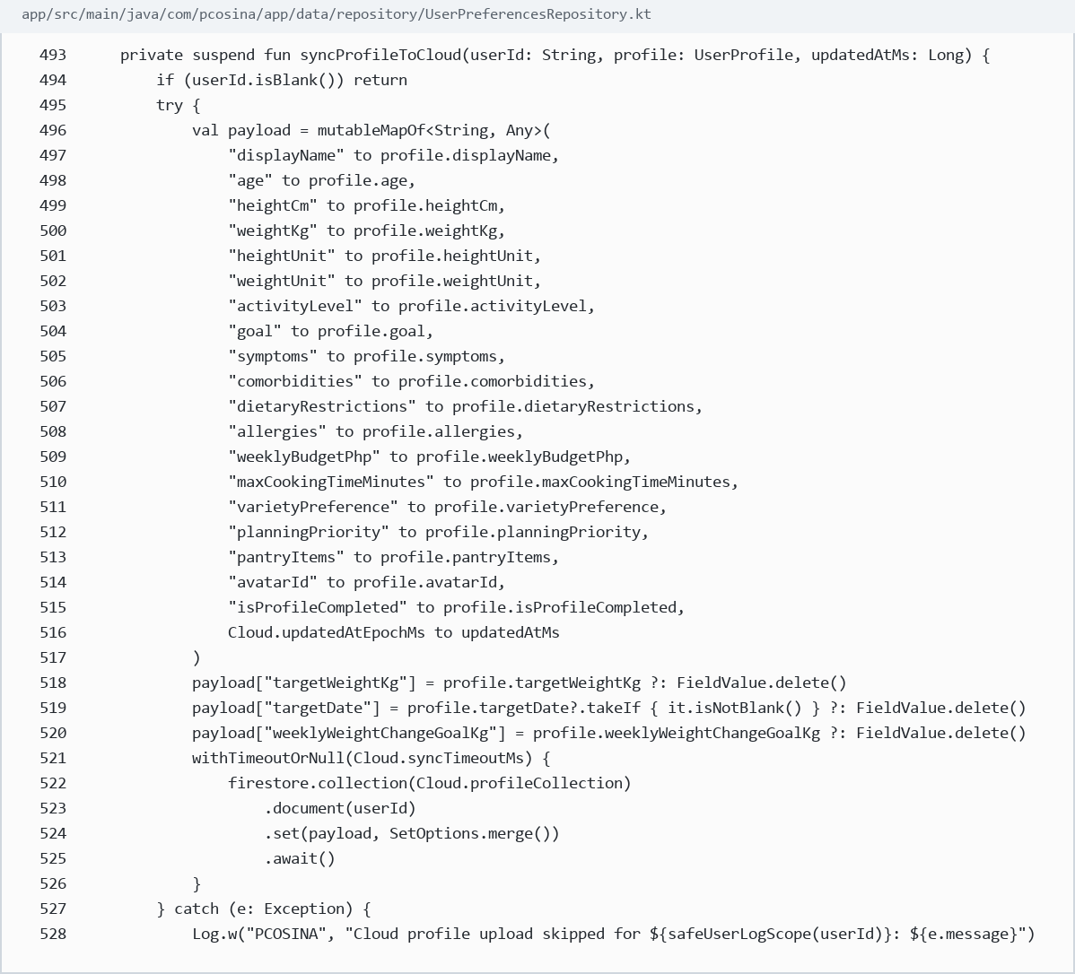

14. Firebase Admin / Backend auth - Backend Firebase initialization and auth guard
Source: backend/main.py:581-627
What it proves: Shows backend Firebase Admin initialization and authentication dependency.
Defense use: This is how the backend verifies authenticated requests when Firebase is configured.
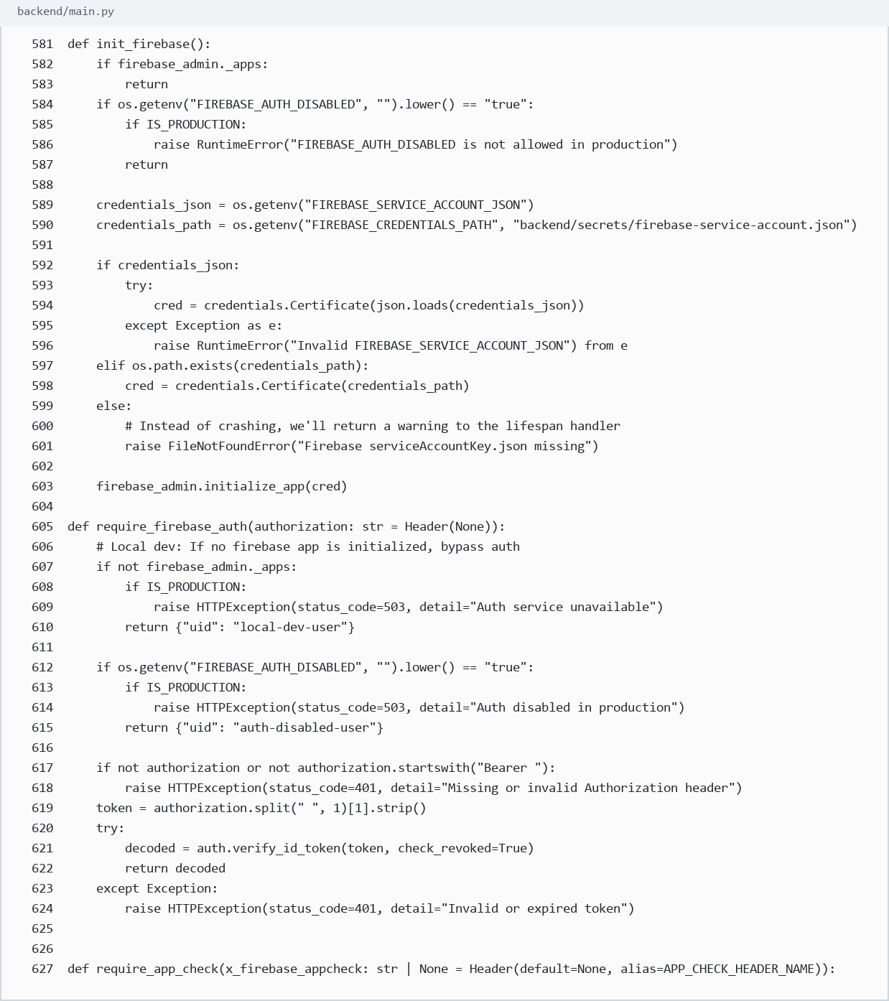

15. FastAPI - FastAPI app initialization
Source: backend/main.py:1-20
What it proves: Shows FastAPI imported alongside request/response utilities.
Defense use: This proves the backend API layer is built with FastAPI.
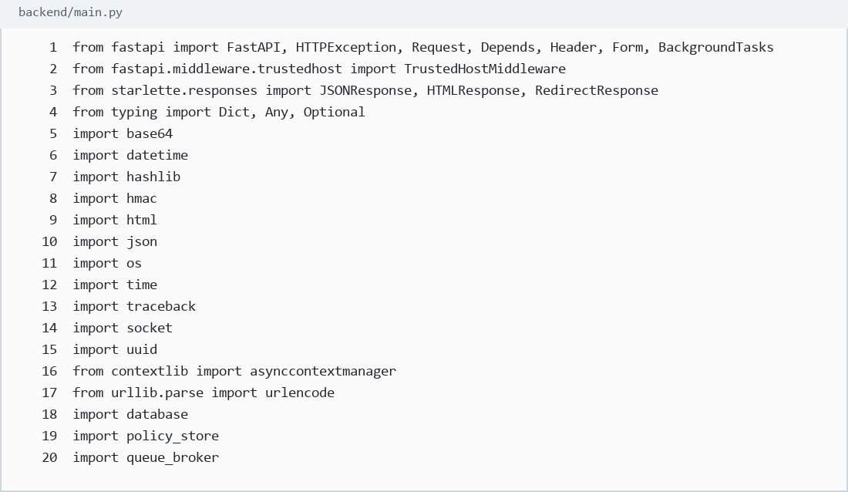

16. FastAPI - FastAPI application object
Source: backend/main.py:349-357
What it proves: Shows app = FastAPI(...) with metadata and lifespan configuration.
Defense use: This is the actual FastAPI application object served by the backend.
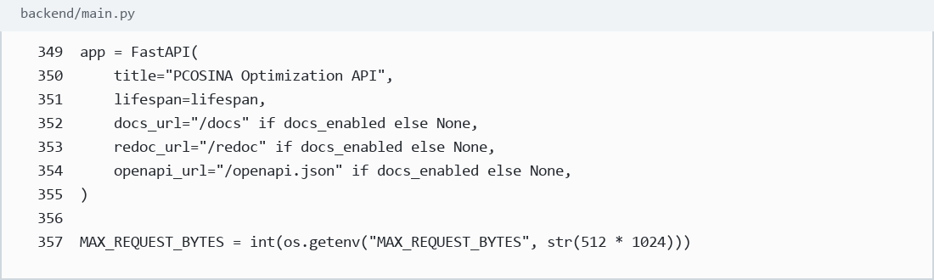

17. FastAPI REST API - GET and POST recipe endpoints
Source: backend/main.py:3942-3984
What it proves: Shows GET list/status/detail endpoints and POST create/seed recipe endpoints.
Defense use: This is concrete evidence of FastAPI route decorators and admin content API operations.
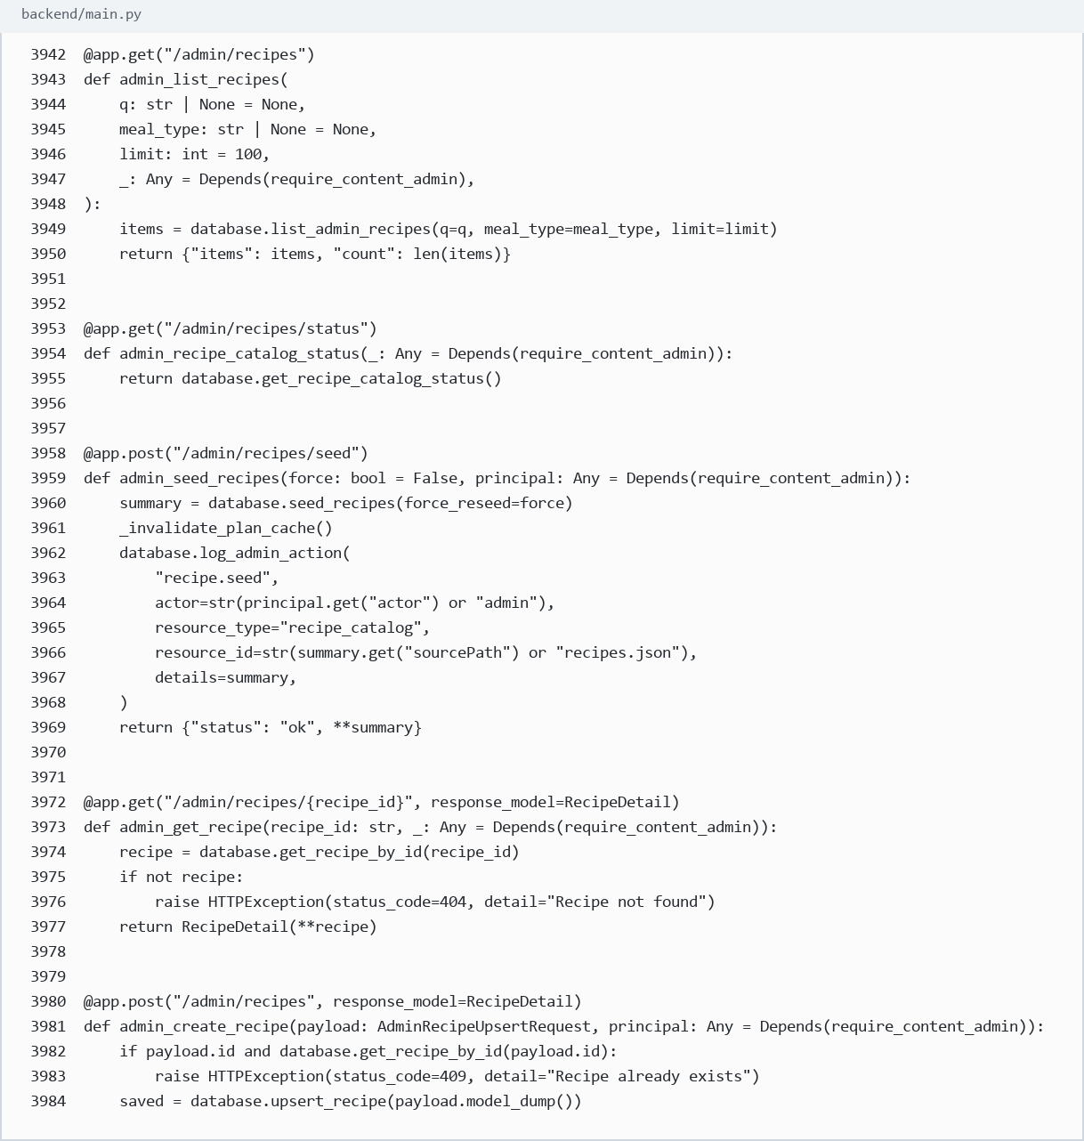

18. FastAPI REST API - PUT and DELETE recipe endpoints
Source: backend/main.py:3996-4026
What it proves: Shows PUT update and DELETE recipe endpoints.
Defense use: This proves the backend has update/delete API methods, not only a single planner endpoint.
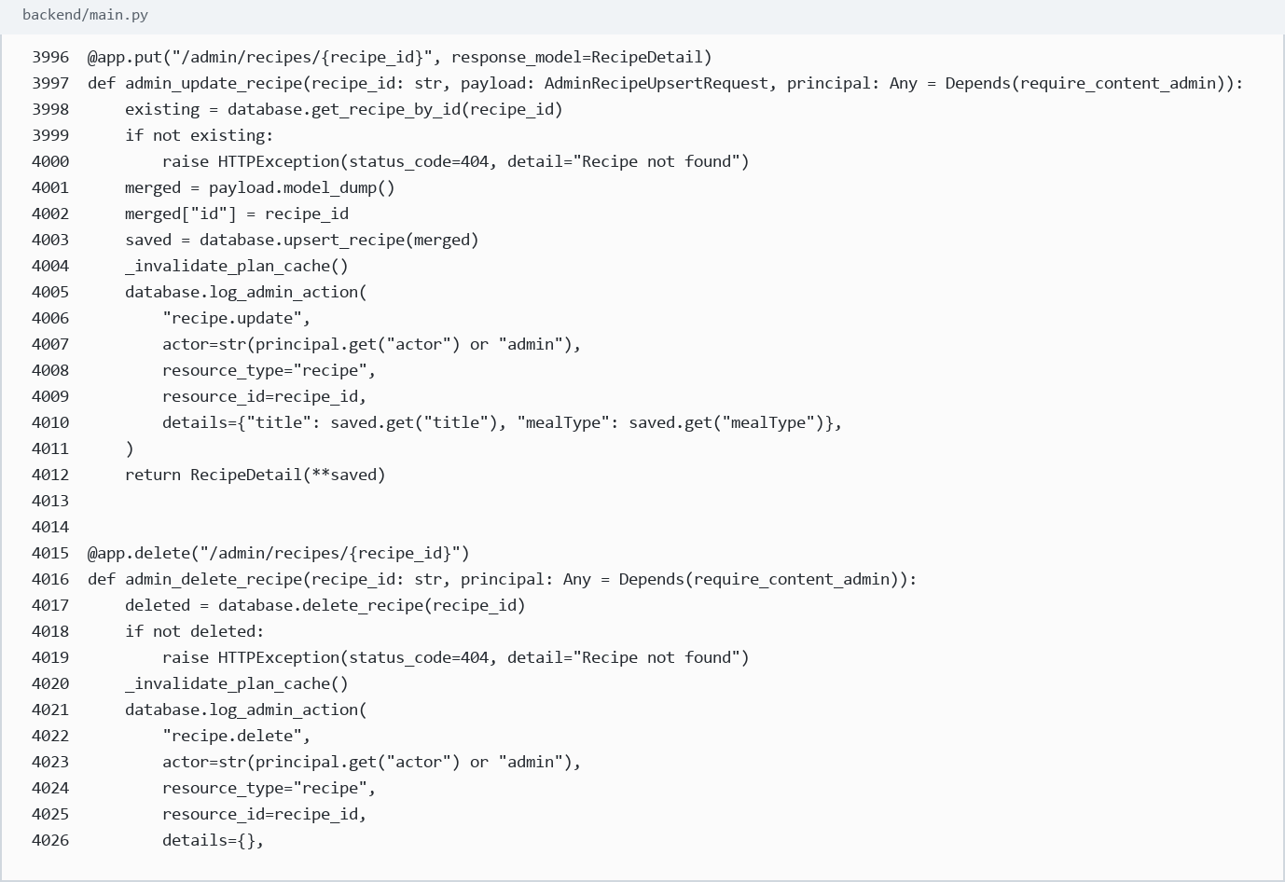

19. FastAPI planner API - Generate-plan API endpoint
Source: backend/main.py:5416-5436
What it proves: Shows POST /generate-plan with request model, Firebase auth, App Check, schema version, and planner policy setup.
Defense use: This is the backend doorway used by the Android app to request meal-plan generation.
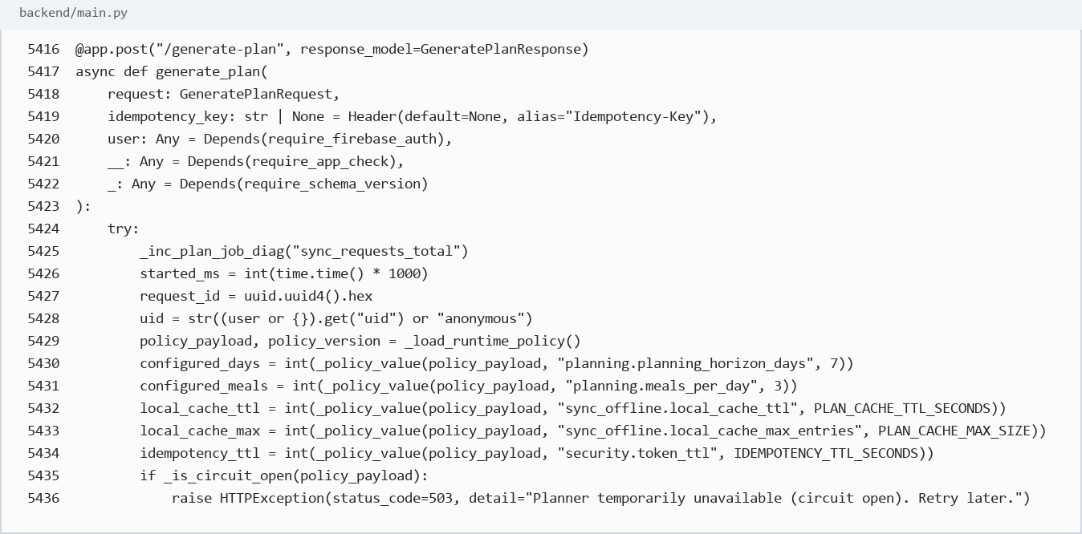

20. PostgreSQL - PostgreSQL backend mode and connection
Source: backend/database.py:27-35
What it proves: Shows DATABASE_URL as the backend database connection setting.
Defense use: PostgreSQL is selected through a real database URL, not hardcoded text in the manuscript.
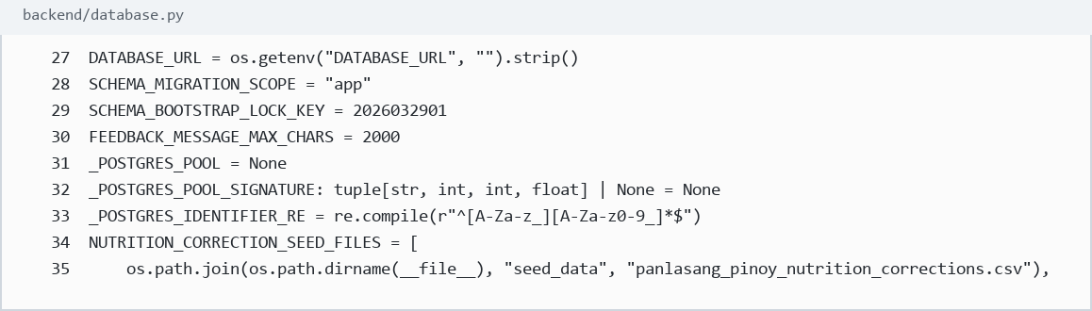

21. PostgreSQL - PostgreSQL connection and production guard
Source: backend/database.py:199-305
What it proves: Shows postgres mode detection, connection pooling, psycopg connection, and production guard requiring Postgres.
Defense use: This proves PostgreSQL is the backend production database path, while SQLite fallback is for non-production/local cases.
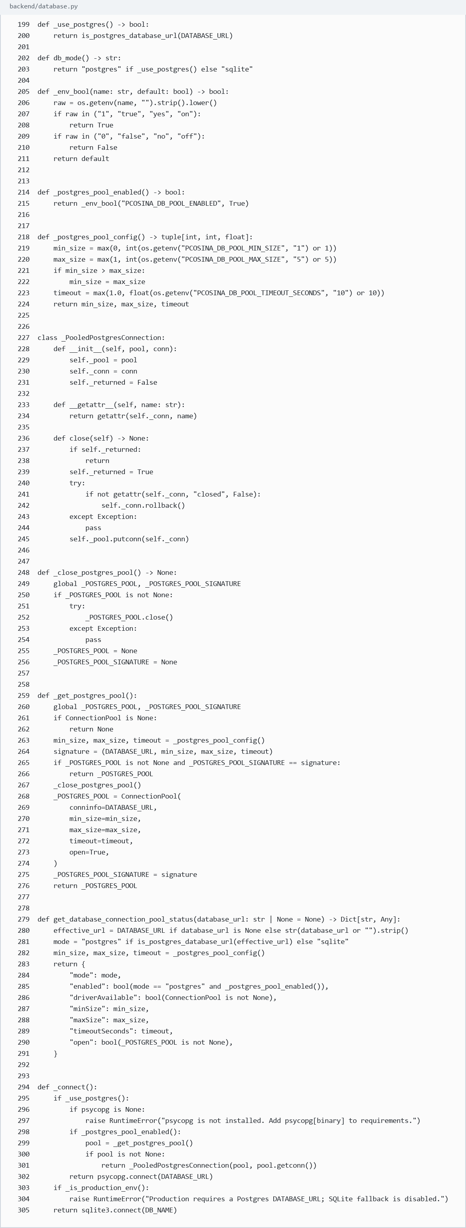

22. OR-Tools CP-SAT - CP-SAT import and binary decision variables
Source: backend/services/meal_planner.py:1-16
What it proves: Shows OR-Tools CP-SAT imported by the planner.
Defense use: This proves the optimization solver is used in the planner module.
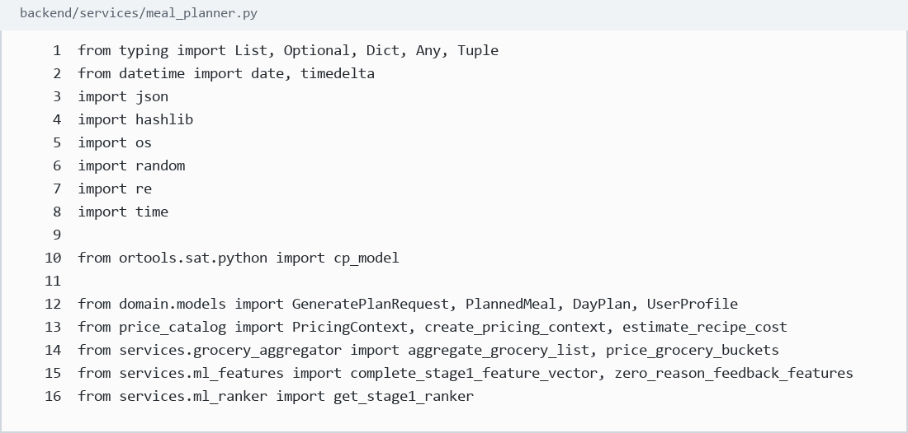

23. OR-Tools CP-SAT - CP-SAT model and x[s,i] binary variables
Source: backend/services/meal_planner.py:2893-2910
What it proves: Shows CpModel creation, NewBoolVar variables, exactly-one slot assignment, and disallowed meal-type constraints.
Defense use: This is the code-level proof of the 0-1 meal assignment formulation.
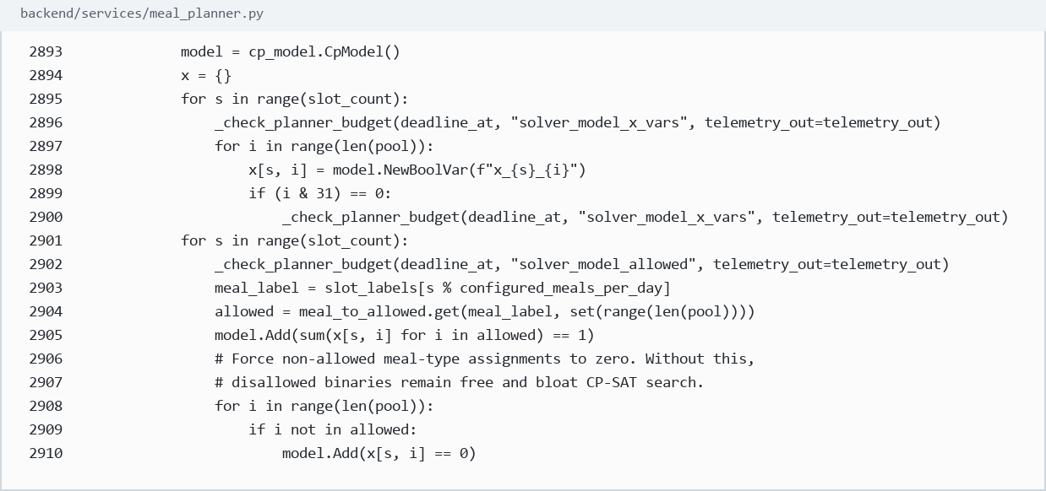

24. OR-Tools CP-SAT - Objective and solver execution
Source: backend/services/meal_planner.py:3093-3161
What it proves: Shows model.Minimize, CpSolver creation, solver parameter setup, and solver.Solve(model).
Defense use: This proves the final plan is solved through an optimization model, not manually selected by if-else rules.
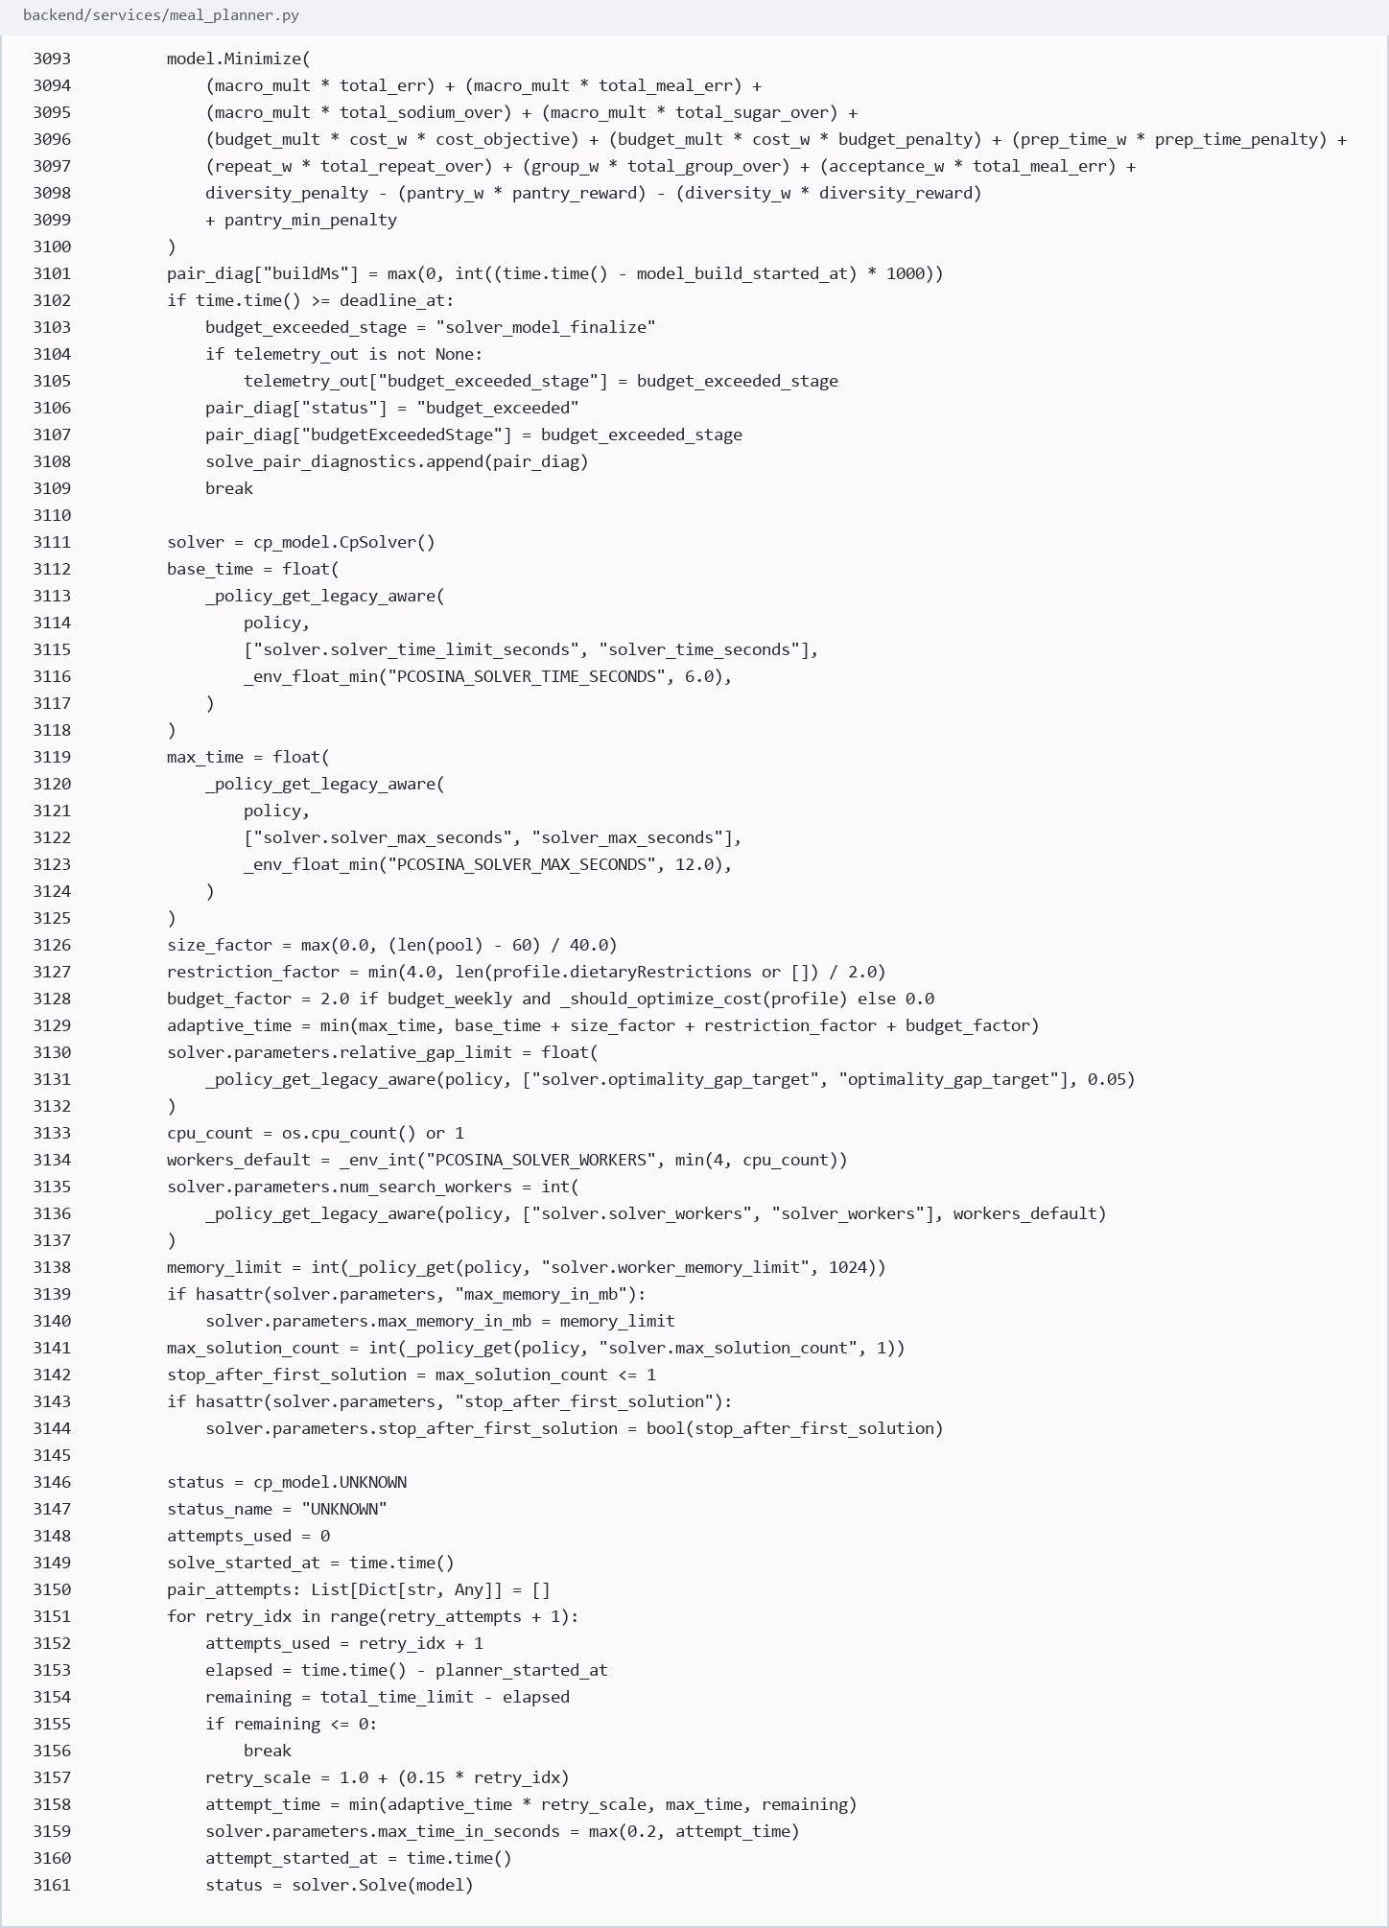

25. LightGBM - LightGBM model loading
Source: backend/services/ml_ranker.py:71-108
What it proves: Shows import lightgbm as lgb and loading a Booster model file.
Defense use: This proves LightGBM is implemented as an optional Stage 1 ranking artifact, when available.
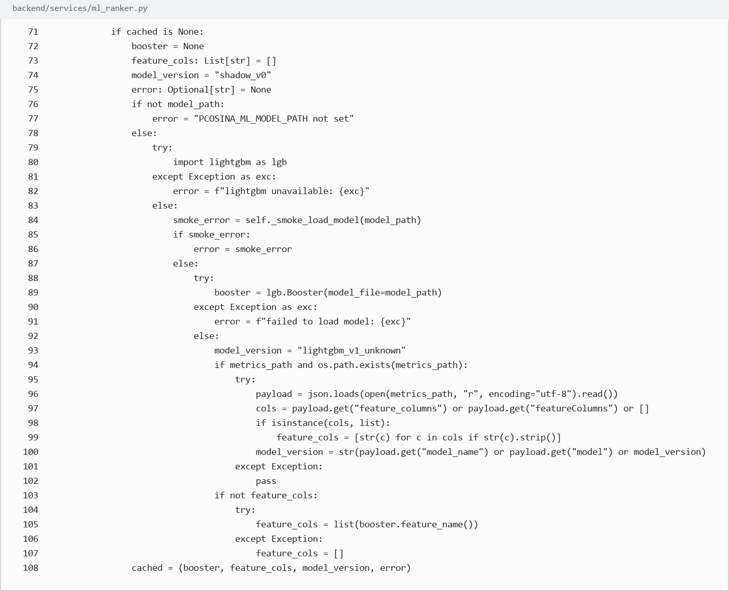

26. LightGBM - LightGBM scoring functions
Source: backend/services/ml_ranker.py:127-160
What it proves: Shows score and score_many predictions using feature vectors.
Defense use: This is the actual ML scoring logic used for assistive candidate ranking.
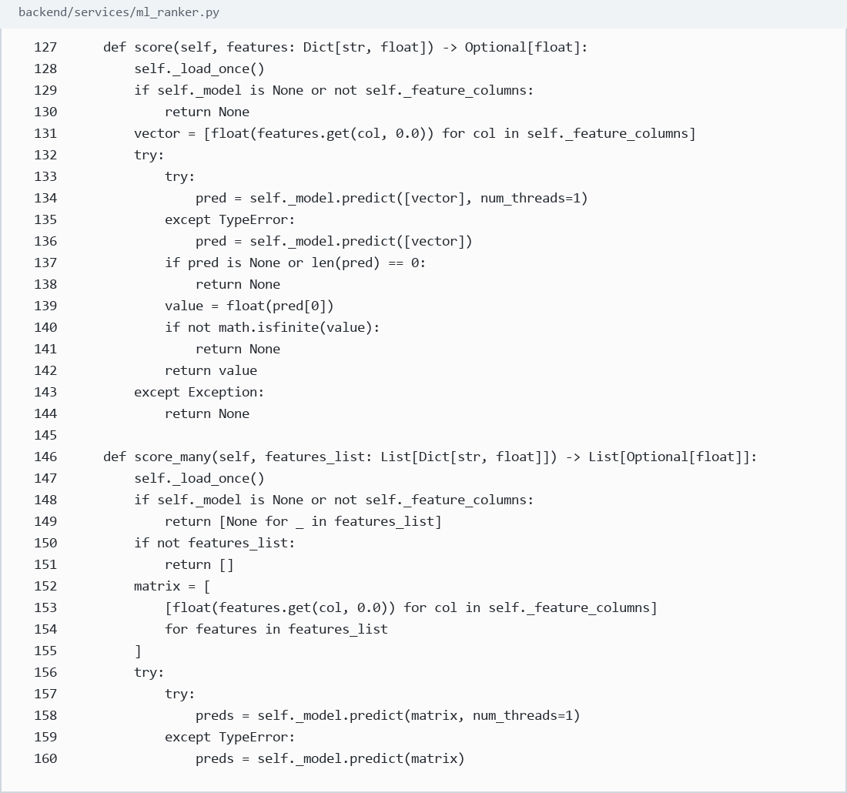

27. Python - Python backend implementation
Source: backend/main.py:1-20
What it proves: Shows the backend is implemented in Python and imports FastAPI, Firebase Admin, and backend modules.
Defense use: Python is the backend language used to implement the API, solver bridge, and backend services.

28. GitHub Actions - GitHub workflow evidence
Source: .github/workflows/ci.yml:1-45
What it proves: Shows repository CI workflow configuration.
Defense use: This supports the Git/GitHub purpose: version tracking, collaboration, and validation automation.
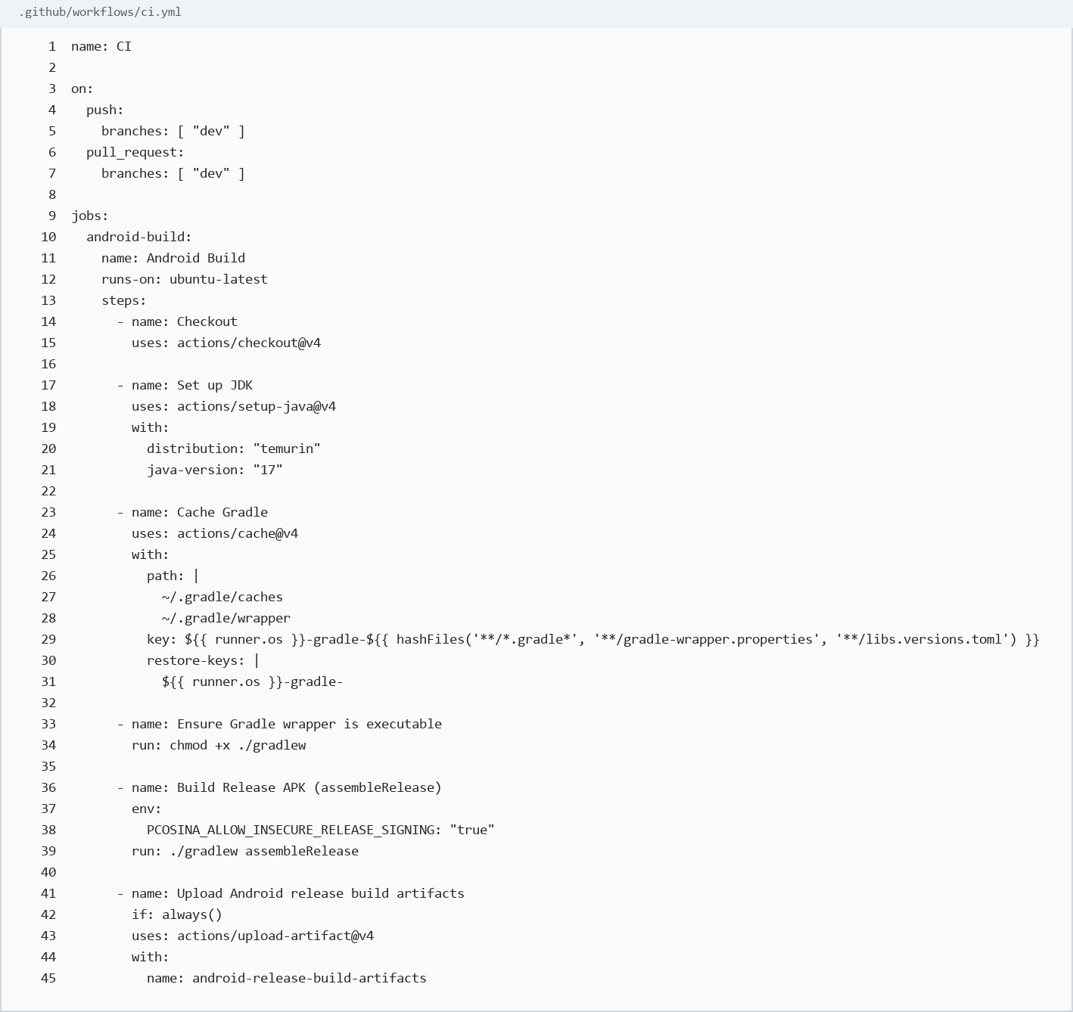

Git / GitHub - Repository Evidence
Git/GitHub is not a runtime framework. The evidence is the repository metadata showing this workspace is a Git repository connected to the GitHub remote.
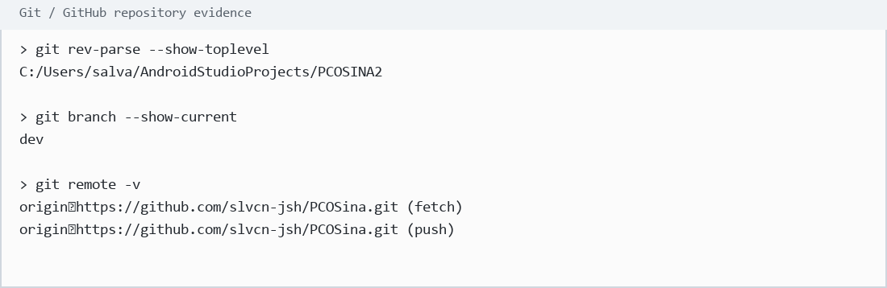

Draw.io - Diagram Tool Clarification
Draw.io is used for system modeling and diagrams, not as runtime application code. The evidence for this item is the manuscript's diagram figures such as conceptual framework, activity diagram, sequence diagram, use case diagram, class diagram, system architecture, and workflow diagrams.
Defense wording: Draw.io helped prepare visual system-modeling artifacts; it does not execute inside PCOSina.

