Chapter 4 SOP-Format Process Narrative
Sections 4.1 to 4.5 - Process, Evidence, Formulas, Figures, and Results
Research framing used throughout this section
PCOSina is presented as an offline-first Filipino-PCOS meal-planning wellness decision-support system. The section uses the proposed revised SOPs and removes the previous restricted wording from SOP 1. The system is not described as a diagnosis engine, treatment engine, medical device, or clinical outcome monitor. ML is described as assistive ranking only; deterministic filtering and OR-Tools CP-SAT remain the authority for hard constraints.

Chapter 4 section | Revised SOP focus | Primary proof included
4.1 | Weekly nutrition and weight-management meal planning | Input-to-target formulas, CP-SAT process, 21-slot benchmark, runtime chart, planner figures.
4.2 | Preferences, Filipino food practices, and dietary restrictions | Restriction enforcement, cultural fit, LightGBM role boundary, usability and functional-suitability evidence.
4.3 | Pantry-aware planning and grocery reduction support | Pantry matching formula, pantry-overlap visuals, grocery-gap boundary, pantry/grocery evaluation results.
4.4 | Offline-first mobile support | Local artifact flow, offline availability map, Android UI baseline, Portability/Reliability survey evidence.
4.5 | Nutrition quality, usability, cultural relevance, and computational efficiency evaluation | Cronbach alpha, ISO summary chart, benchmark tables, runtime and ML metrics, known evidence boundaries.

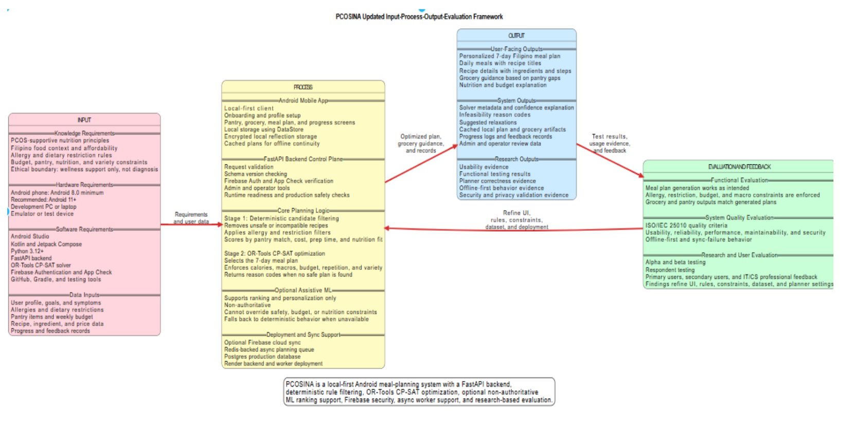
Figure 4.1. Conceptual framework source visual used as the overall traceability anchor.

4.1 Weekly Nutrition and Weight-Management Meal Planning
Revised SOP 1 question
How can a weekly meal-planning system be designed to generate nutritionally adequate meal plans for Filipinos with PCOS while considering weight-management goals and dietary constraints?

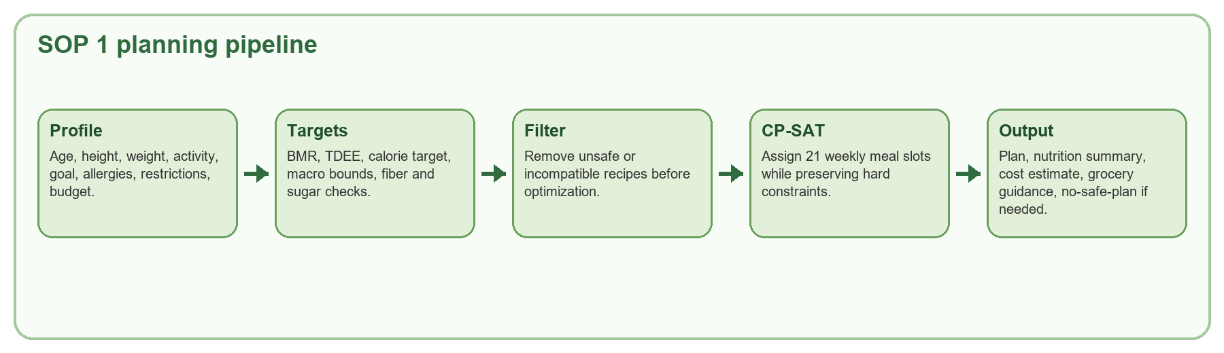
Figure 4.2. Process flow for SOP 1 from profile input to validated weekly plan.
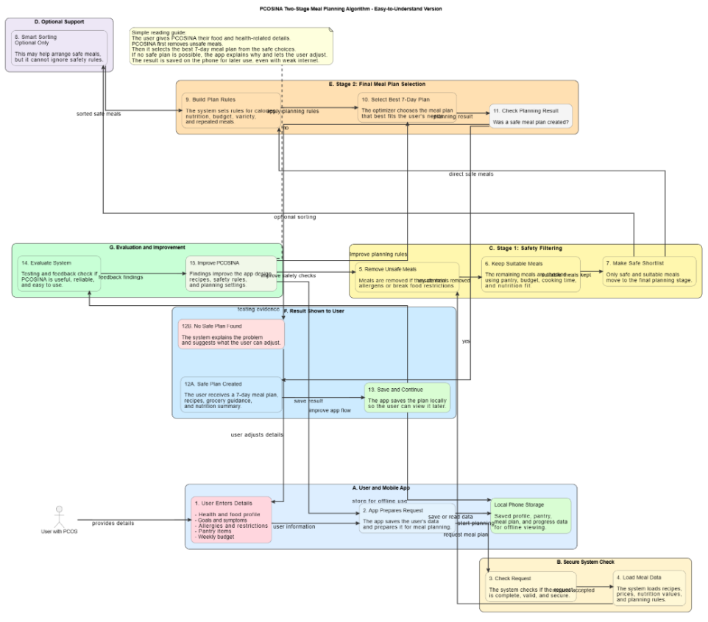
Figure 4.3. Two-stage weekly planning algorithm from the evidence dossier.

4.1.1 User Profile and Input Preparation
The planning process starts with the user profile because PCOSina must convert personal and practical user data into solver-ready values before it can generate a meal plan. The profile captures age, height, weight, activity level, weight-management goal, dietary restrictions, allergies, explicit ingredient exclusions, preferred food behavior, weekly budget, cooking-time preference, variety preference, and pantry entries. These are not used for diagnosis. They are planning inputs that help the system compute targets, filter unsafe recipes, and assemble a feasible weekly plan.
The application normalizes free-form and categorical inputs before planning. Allergy names, restricted ingredients, exclusion terms, and pantry items are converted into comparable text tokens. Numerical values are bounded so that invalid or missing entries do not produce unsafe planning targets. This preparation step is necessary because the solver can only enforce constraints reliably when the user profile is represented as structured data rather than unprocessed text.
Input group | Examples captured by the app | How the planner uses it
Anthropometric profile | Age, height, weight, activity level | Computes BMR, TDEE, target calories, and nutrition bounds.
Goal and wellness context | Weight-management goal and supported planning adjustments | Adjusts calorie target and nutrition pressure within policy bounds.
Hard dietary constraints | Allergies, restrictions, explicit exclusions | Removes unsafe or incompatible recipes before final optimization.
Practical constraints | Budget, cooking time, variety preference | Controls cost feasibility, candidate filtering, and repetition behavior.
Pantry context | Available ingredients at home | Adds pantry-aware ranking and grocery guidance without overriding nutrition safety.

4.1.2 Nutrition Target Computation
After the profile is prepared, PCOSina computes a bounded nutrition target for the primary user. The system uses the Mifflin-St Jeor style BMR computation, applies an activity multiplier to estimate TDEE, adjusts the target according to the selected weight-management goal and policy-supported wellness adjustments, and clamps the result within configured calorie limits. This makes the calorie target measurable and prevents extreme outputs.
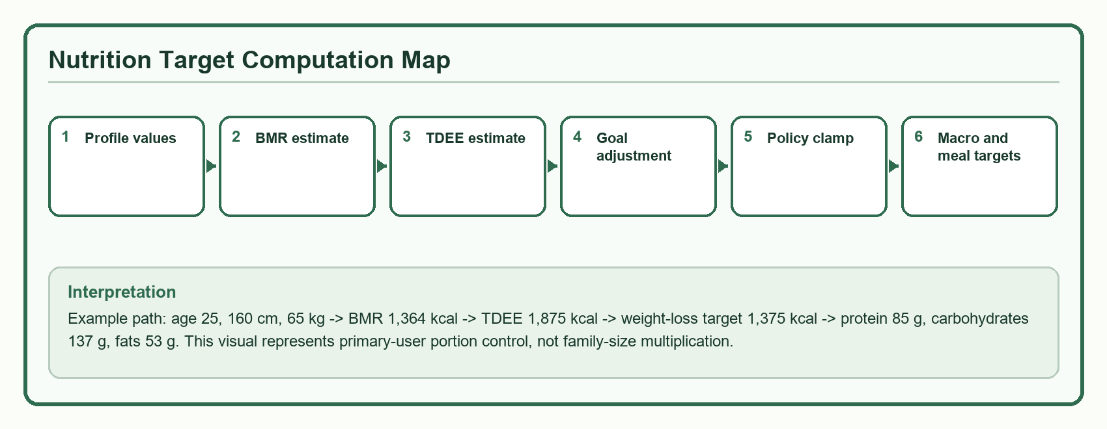
Figure 4.4. Nutrition-target computation map derived from the current system computation documentation.
Formula | Formula / computation | Use in PCOSina
BMI | BMI = weightKg / (heightCm / 100)^2 | Profile display and health-context computation.
BMR | BMR = (10 * weightKg) + (6.25 * heightCm) - (5 * age) - 161 | Baseline energy estimate for the primary user.
TDEE | TDEE = int(BMR * activityMultiplier) | Daily energy estimate before goal adjustment.
Target calories | TargetCalories = clamp(TDEE + goalDelta + wellnessDelta, 1200, 3200) | Bounded calorie target used by the planner.
Macro grams | Protein = int(TargetCalories * proteinRatio / 4); Carbs = int(TargetCalories * carbRatio / 4); Fats = int(TargetCalories * fatRatio / 9) | Daily macro targets are clamped to policy min/max values.
Meal distribution | Breakfast 30 percent; Lunch 35 percent; Dinner 35 percent | Guides per-meal calorie balance in the solver objective.

Computation step | Readable result and interpretation
Profile used for demonstration | Age 25, height 160 cm, weight 65 kg, activity multiplier 1.375, weight-loss goal. This is an illustrative computation, not a respondent record.
1. BMI | 65 / (1.60^2) = 25.39. This describes weight-height context for profile display and planning context.
2. BMR | (10*65) + (6.25*160) - (5*25) - 161 = 1,364 kcal. This estimates baseline daily energy use.
3. TDEE | int(1,364 * 1.375) = 1,875 kcal. This applies the selected activity level.
4. Goal adjustment | 1,875 - 500 = 1,375 kcal. This gives the weight-loss planning target before policy clamping.
5. Policy clamp | clamp(1,375, 1,200, 3,200) = 1,375 kcal. This prevents extreme calorie targets.
6. Protein target | int(1,375 * 0.25 / 4) = 85 g. This is the daily protein guide used in nutrition balancing.
7. Carbohydrate target | int(1,375 * 0.40 / 4) = 137 g. This is the daily carbohydrate guide used in nutrition balancing.
8. Fat target | int(1,375 * 0.35 / 9) = 53 g. This is the daily fat guide used in nutrition balancing.
9. Meal distribution | Breakfast about 412 kcal; lunch about 481 kcal; dinner about 481 kcal. These values guide per-meal balance rather than family-size multiplication.

Interpretation for portion control
In this paper section, portion control means the primary user's meal plan is computed against calorie, macro, fiber, sugar, sodium, and meal-distribution rules. It does not mean family-size multiplication or nutrition adequacy for other household members.

4.1.3 Candidate Filtering and Safety Rules
Before optimization, recipes pass through deterministic filtering. This stage checks whether each recipe is appropriate for the requested meal slot and whether it conflicts with allergies, explicit exclusions, dietary restrictions, budget behavior, cooking-time limits, and repetition policy. Recipes that fail hard rules are removed before final planning. This is the safety layer that prevents the optimizer from considering meals that should never be returned to the user.
Rule family | Enforcement type | Concrete effect
Allergy and exclusion matching | Hard filter | Blocked recipes do not enter final candidate domains.
Dietary restrictions | Hard filter | Restriction-violating candidates are removed before solver assignment.
Budget ceiling | Hard constraint when configured | The total estimated weekly plan cost cannot exceed the accepted budget limit.
Nutrition bounds | Hard and deviation-controlled solver rules | Daily calories and macro bounds must stay within policy limits while deviations are minimized.
Repetition and variety | Hard or weighted constraints | Prevents repetitive weekly plans and improves practical usability.
Pantry overlap | Soft reward or thresholded planning signal | Encourages use of available items but does not replace safety or nutrition adequacy.

4.1.4 Weekly Optimization Process
The second stage builds a 0-1 assignment model solved through OR-Tools CP-SAT. Each decision variable represents whether a recipe is assigned to a specific weekly slot. The solver must fill the seven-day structure, usually 21 meal slots, while preserving hard constraints. The model evaluates the plan as a whole because a recipe can be acceptable alone but still make the total day or week nutritionally unbalanced.
CP-SAT model elements | Formula / computation | Use in PCOSina
Decision variable | x[s,r] = 1 if recipe r is assigned to meal slot s; otherwise 0 | Defines the weekly assignment decision.
Slot coverage | sum_r x[s,r] = 1 for each required slot s | Ensures every breakfast/lunch/dinner slot is filled.
Budget rule | totalCost <= weeklyBudget when a budget is configured | Keeps cost ceilings as hard constraints.
Daily nutrition | calorieMin <= dailyCalories <= calorieMax; macro lower <= dailyMacro <= macro upper | Preserves nutrition adequacy and bounded deviations.
Fiber/sugar/sodium | dailyFiber >= fiberMin; sugar and sodium overage variables are penalized | Keeps nutrition quality visible even when advisory nutrients require slack.
Objective | Minimize nutrition deviation, meal calorie error, repetition/group penalties, cost pressure, and selected slacks; reward pantry overlap | Balances feasible plans without allowing soft goals to override hard rules.

4.1.5 Generated Outputs and Validation Evidence
When the solver succeeds, the backend returns a structured seven-day plan with meal schedules, nutrition summaries, estimated weekly cost, explanation values, pantry-aware indicators, and grocery guidance. If no complete safe plan is possible, the system returns structured no-safe-plan feedback rather than forcing a recommendation. This behavior is critical because a decision-support system must be allowed to reject infeasible input combinations.
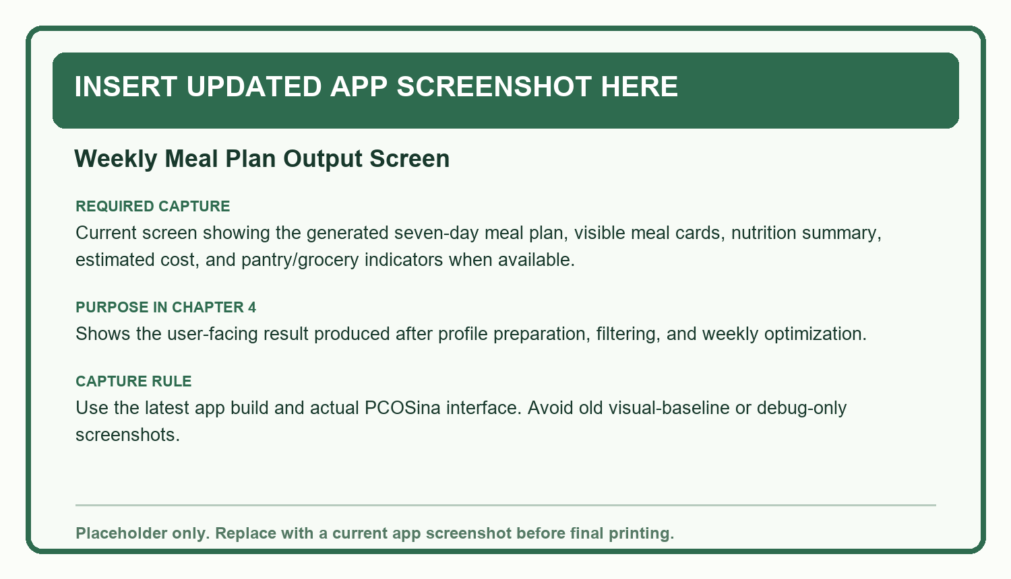
Figure 4.5. Placeholder for updated app screenshot: weekly meal-plan output screen.
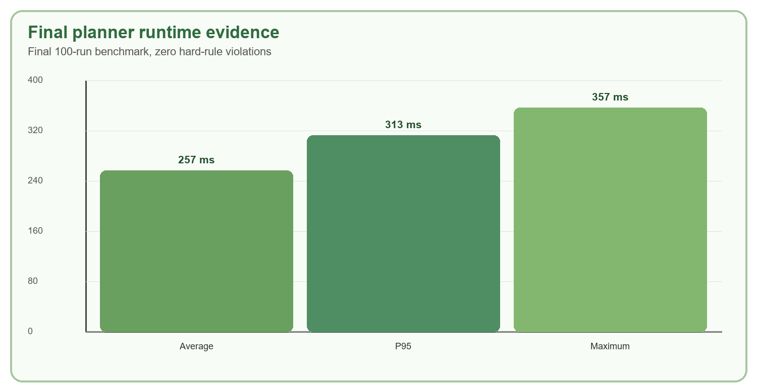
Figure 4.6. Final runtime evidence for weekly planning.
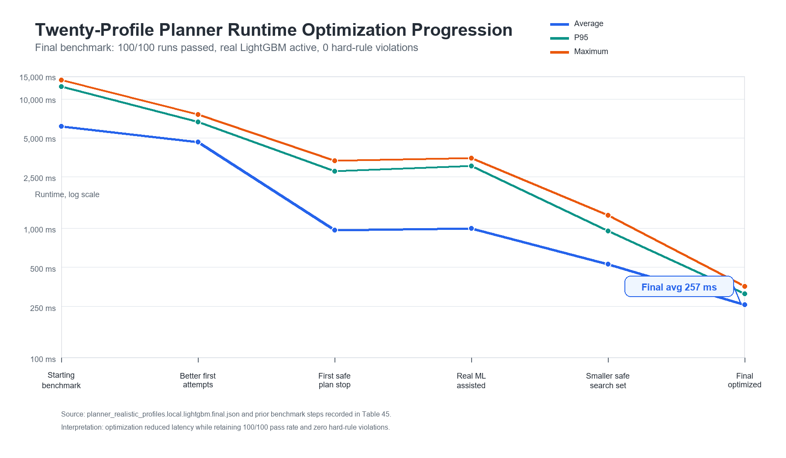
Figure 4.7. Planner runtime optimization progression from Chapter 4 assets.
Validation item | Reported result | Meaning for SOP 1
Weekly plan structure | 100/100 final benchmark runs produced complete 21-slot plans. | The system produced complete weekly schedules under tested profiles.
Hard-rule violations | 0 hard-rule violations. | All tested final outputs preserved configured hard constraints.
Nutrition feasibility | Passed in 100/100 final benchmark runs. | The final plans satisfied the tested nutrition feasibility checks.
Runtime | Average 257 ms, P95 313 ms, maximum 357 ms. | The tested planner path was computationally practical.

4.2 Integration of Preferences, Filipino Food Practices, and Dietary Restrictions
Revised SOP 2 question
How can user preferences, Filipino food practices, and dietary restrictions be effectively integrated into a personalized meal-planning algorithm for individuals with PCOS?

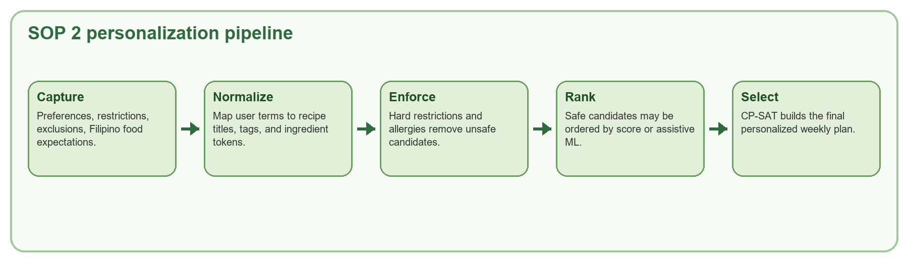
Figure 4.8. Process flow for SOP 2 personalization and restriction enforcement.
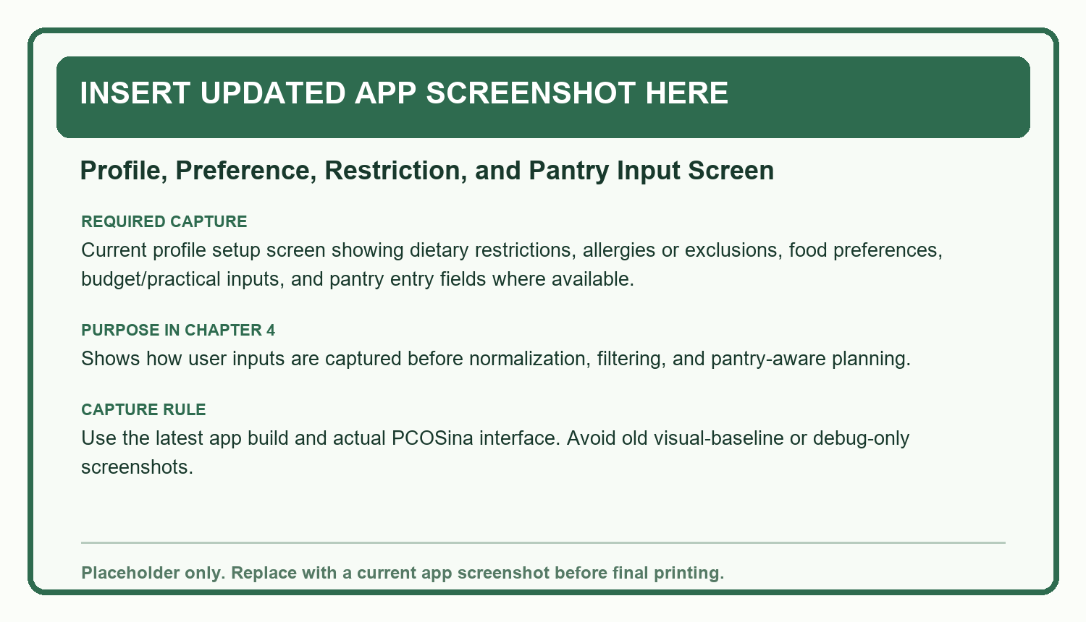
Figure 4.9. Placeholder for updated app screenshot: profile, preference, restriction, and pantry input screen.

4.2.1 Preference and Restriction Input Capture
Preference integration begins before meal generation. The user provides food preferences, dietary restrictions, allergies, explicit exclusions, cooking-time preference, budget behavior, variety preference, and pantry context. The system must capture these inputs early because they affect candidate eligibility and not merely the appearance of the final output.
The important design decision is the separation between hard restrictions and soft preferences. Allergies, explicit exclusions, and mandatory restrictions are hard. Familiar Filipino dishes, preparation time, pantry overlap, and variety are preference or optimization signals. This separation allows personalization while protecting user safety.
User input | Planner interpretation | Paper-ready interpretation
Allergy or explicit exclusion | Hard removal from candidate pool | The system must not return recipes containing declared forbidden ingredients.
Dietary restriction | Hard compatibility check | The system filters incompatible meals before ranking and optimization.
Filipino food preference | Cultural and usability signal | Familiar meals are preferred when they remain feasible and safe.
Cooking time | Practical feasibility signal | Meals outside user time limits can be deprioritized or removed depending on policy.
Variety preference | Repetition and diversity control | Controls whether weekly meals may repeat or should be more diverse.

4.2.2 Normalization of User and Recipe Data
The system compares user restrictions against recipe titles, tags, and ingredient tokens. Since Filipino food data often uses mixed English and Filipino terms, normalization is required before matching. The same concept may appear through local names, translated names, plural forms, or recipe-specific phrasing. Normalization reduces the chance that unsafe or unwanted items bypass filtering because of spelling or wording differences.
Candidate scoring and personalization formulas | Formula / computation | Use in PCOSina
Base candidate score | Score = 2*protein - 0.05*cost - 0.15*abs(calories - 500) + 1.5*pantryMatch + stage1Boost | Orders safe candidates before final assignment.
Pantry overlap | pantryMatch = count(recipeTokens intersect pantryTokens) | Rewards meals that can use available ingredients.
ML ranking boundary | LightGBM ranks or reorders safe candidates only | ML cannot override allergies, restrictions, exclusions, budget, meal-slot eligibility, or CP-SAT assignment.

4.2.3 Filipino Food Practice Integration
Filipino food practice is integrated through the recipe catalog, familiar recipe titles, local ingredient references, and meal-slot organization. The goal is not to replace the user's normal food culture with generic diet meals. The goal is to choose culturally recognizable meals when they can still satisfy restrictions, nutrition targets, budget behavior, and variety requirements.
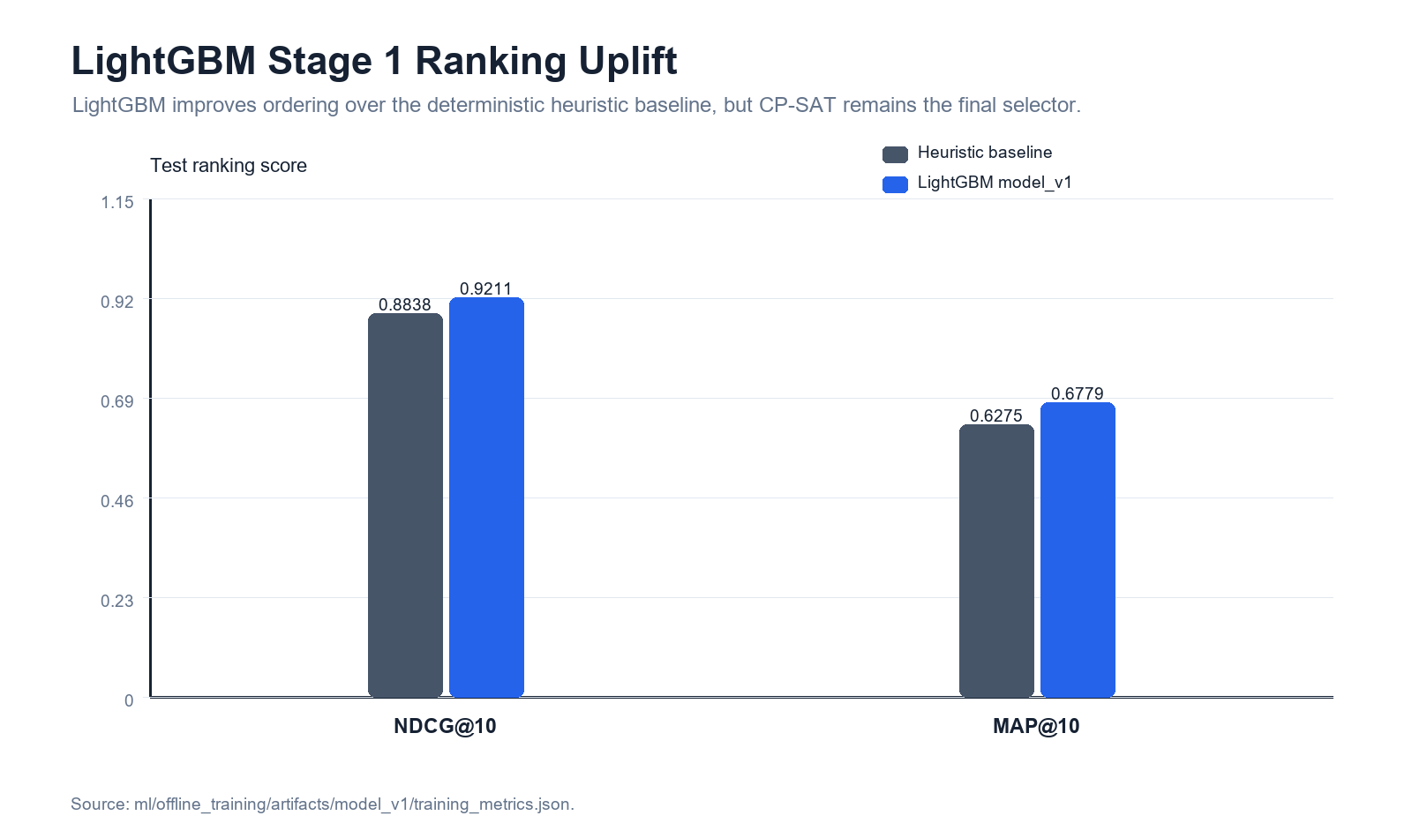
Figure 4.10. Ranking evidence showing Stage-1 candidate-ordering uplift.

4.2.4 Deterministic Restriction Enforcement
Restriction enforcement remains deterministic. If a recipe conflicts with hard constraints, it is removed or blocked regardless of its score, cultural familiarity, or expected preference match. This is why the system supports personalization without becoming a free-form recommendation engine. Preferences personalize the safe space; they do not redefine what is safe.
Layer | Can influence | Cannot override
Deterministic filters | Candidate eligibility | N/A; this is the safety gate.
Assistive ranking | Ordering of already-safe candidates | Allergies, exclusions, restrictions, budget, nutrition, meal-slot rules.
CP-SAT optimizer | Final weekly assignment | Profile hard constraints and no-safe-plan handling.
User feedback | Future preference signal when implemented | Current hard safety constraints.

4.2.5 Personalized Outputs and Evidence
The output of SOP 2 is a meal plan that reflects user restrictions and Filipino food context while preserving the system's hard-rule boundary. The evaluation evidence supports this through Functional Suitability, Usability, cultural-relevance protocol, and final safety checks.
Evidence item | Reported result | Interpretation
Functional Suitability | Overall mean 3.93, interpreted as Agree. | Users recognized the core meal-planning functions as suitable.
Usability | Overall mean 4.06, interpreted as Agree. | Users found the app generally understandable and navigable.
Filipino food item | 4.28 primary / 3.84 secondary. | Users recognized culturally familiar food options.
Safety acceptance | Safety violations must remain zero. | Cultural fit is accepted only when safety constraints are preserved.

4.3 Pantry-Aware Planning and Grocery Reduction Support
Revised SOP 3 question
How can pantry inventory data be integrated into meal planning to help promote reduced food waste and unnecessary grocery purchases while maintaining nutritional adequacy?

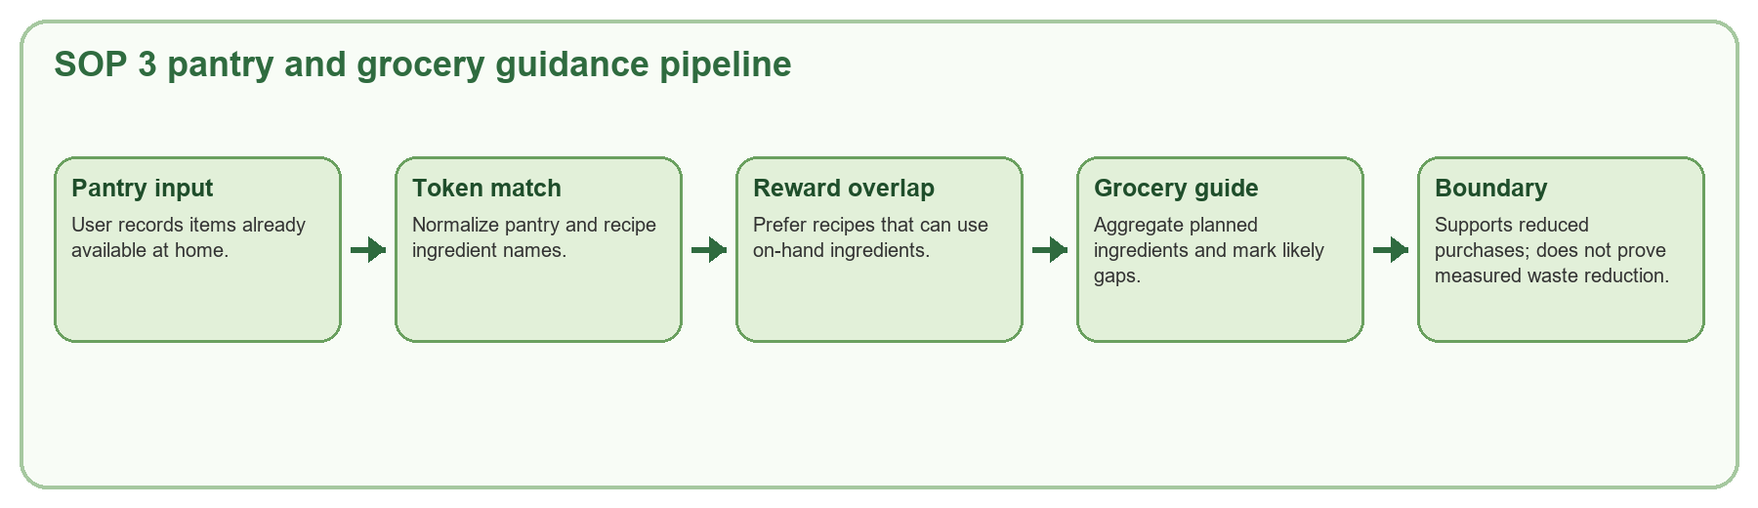
Figure 4.11. Process flow for SOP 3 pantry-aware planning and grocery guidance.
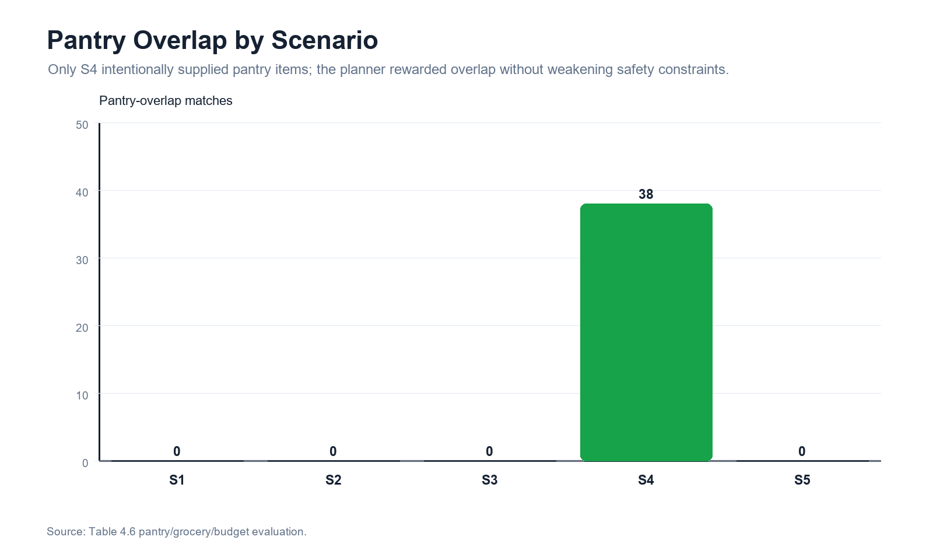
Figure 4.12. Pantry-overlap evidence from algorithm evaluation assets.

4.3.1 Pantry Input and Inventory Meaning
The pantry process begins when users enter ingredients they already have at home. These entries provide practical planning context. The system can then prefer recipes that overlap with the pantry and organize grocery guidance around likely missing ingredients. The pantry is not treated as a clinical nutrition input; it is a household resource signal used to reduce unnecessary purchasing pressure.
The correct paper wording is pantry-aware, not a claim of fully proven waste reduction. The evidence shows that pantry data are used in planning and grocery guidance. It does not prove actual household food-waste reduction through measured before-and-after waste records.
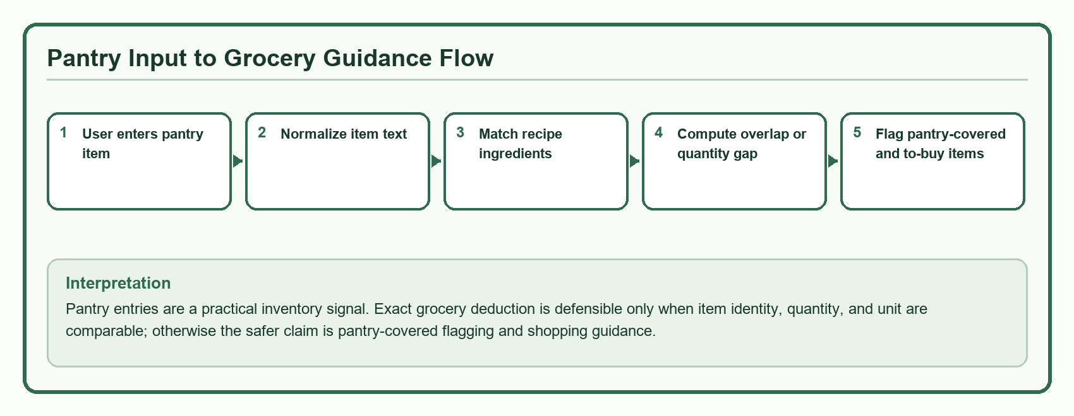
Figure 4.13. Pantry input-to-grocery guidance flow with quantity-deduction boundary.
Interpretation: Pantry data should be presented as inventory-aware planning support. A matched pantry item can reduce or flag grocery need only when the system has enough comparable ingredient information; otherwise, the paper should describe pantry use as overlap-based guidance rather than exact household waste reduction.

4.3.2 Pantry Normalization and Matching
Pantry entries are normalized into comparable tokens before matching against recipe ingredients. This makes it possible to identify overlap even when ingredient text varies. For example, a pantry entry for eggs should be normalized toward the same ingredient concept used by recipe ingredient tokens so it can contribute to pantry overlap and grocery guidance.
Pantry and grocery computations | Formula / computation | Use in PCOSina
Pantry tokenization | normalizedPantry = normalize(pantry item names) | Makes pantry entries comparable with recipe ingredients.
Overlap count | pantryMatch = |recipeTokens intersect pantryTokens| | Measures how many recipe ingredients align with available pantry items.
Score contribution | pantry bonus = 1.5 * pantryMatch | Encourages but does not force pantry-use recipes.
Grocery gap | g_i = max(0, plannedQuantity_i - pantryQuantity_i), when comparable quantities exist | Separates likely to-buy items from pantry-covered items where quantity data allow it.

4.3.3 Pantry-Aware Planning Signal
Pantry overlap can influence candidate ranking and objective rewards. A recipe with stronger pantry overlap may be preferred over an otherwise similar recipe because it uses what the user already has. However, pantry overlap must not override nutrition adequacy, allergy safety, explicit restrictions, budget ceilings, or repetition controls. This is why pantry is described as a planning signal and grocery-support mechanism rather than the sole decision rule.
Pantry behavior | Supported by current evidence | Claim boundary
Pantry overlap | Scenario 4 recorded 38 pantry-overlap matches such as chicken, egg, garlic, and tomato. | Shows pantry signals are used in planning, not measured food-waste reduction.
Grocery guidance | The grocery module consolidates recipe requirements and flags pantry-covered items. | Estimated guidance depends on ingredient and quantity data quality.
Budget interaction | Budget remains a hard constraint when configured. | Pantry convenience cannot justify violating budget or nutrition rules.
Nutrition adequacy | Final benchmark passed nutrition feasibility in 100/100 final runs. | Pantry-aware planning remains subordinate to nutrition safety.

4.3.4 Grocery Guidance Outputs
After meal planning, the grocery list aggregates planned recipe ingredients and estimated costs. The user-facing grocery list can separate to-buy items, bought items, and pantry-covered items where supported by the current interface. This makes pantry data actionable because users do not only see a meal plan; they also see how the plan translates into shopping guidance.
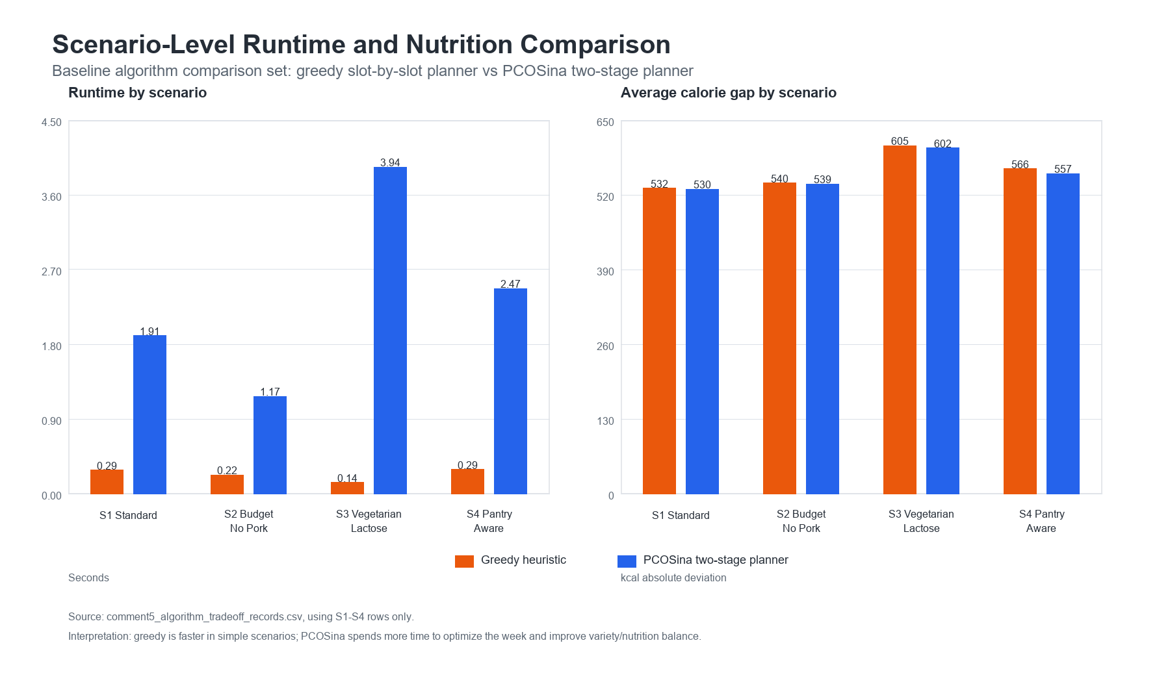
Figure 4.14. Scenario-level runtime and nutrition comparison from Chapter 4 assets.

4.3.5 Evidence and Boundary
The final interpretation for SOP 3 is that PCOSina integrates pantry records to support pantry-aware recipe prioritization and grocery guidance. It helps promote reduced unnecessary purchases, but the paper should avoid saying that actual household food waste was proven to decrease. The credible claim is system-level support, not measured household outcome.
Evidence item | Result / observation | Paper-ready wording
Pantry-overlap behavior | Scenario 4 recorded 38 pantry-overlap matches. | The planner considered available ingredients during ranking and planning.
Grocery deficit guidance | Grocery requirements are consolidated and pantry-covered items can be identified. | The app supports shopping-list organization from planned meals.
Functional Suitability | Positive evaluation for pantry-aware recommendations and grocery reduction features. | Users recognized the usefulness of pantry-aware support.
Boundary | No measured household food-waste reduction study. | Use 'helps promote' or 'supports' reduced purchases, not 'proves' waste reduction.

4.4 Offline-First Mobile Support
Revised SOP 4 question
How can an offline-first mobile application be designed to support saved meal planning, saved recipe access, grocery/pantry management, and progress tracking in environments with limited or no internet connectivity?

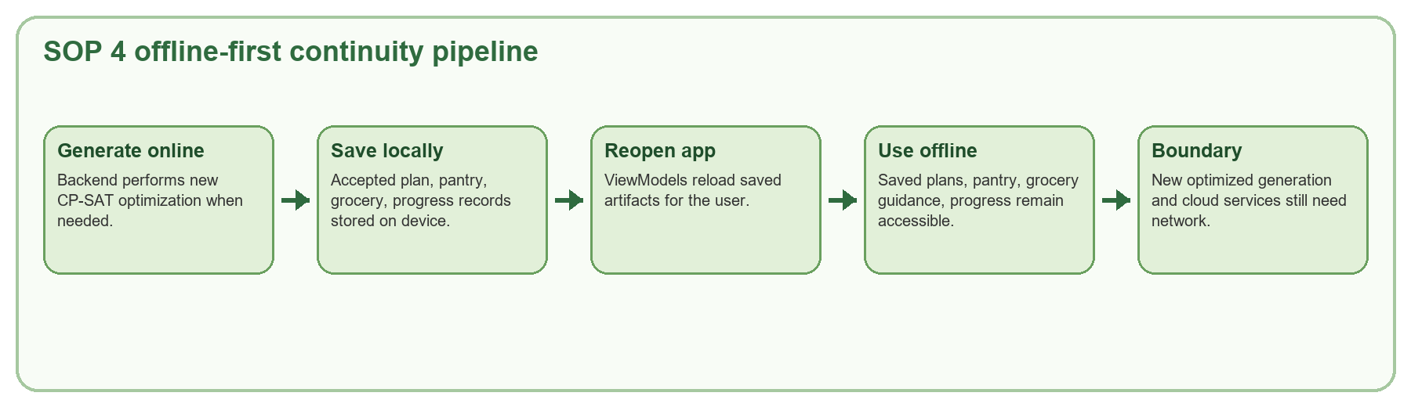
Figure 4.15. Process flow for SOP 4 offline-first continuity.
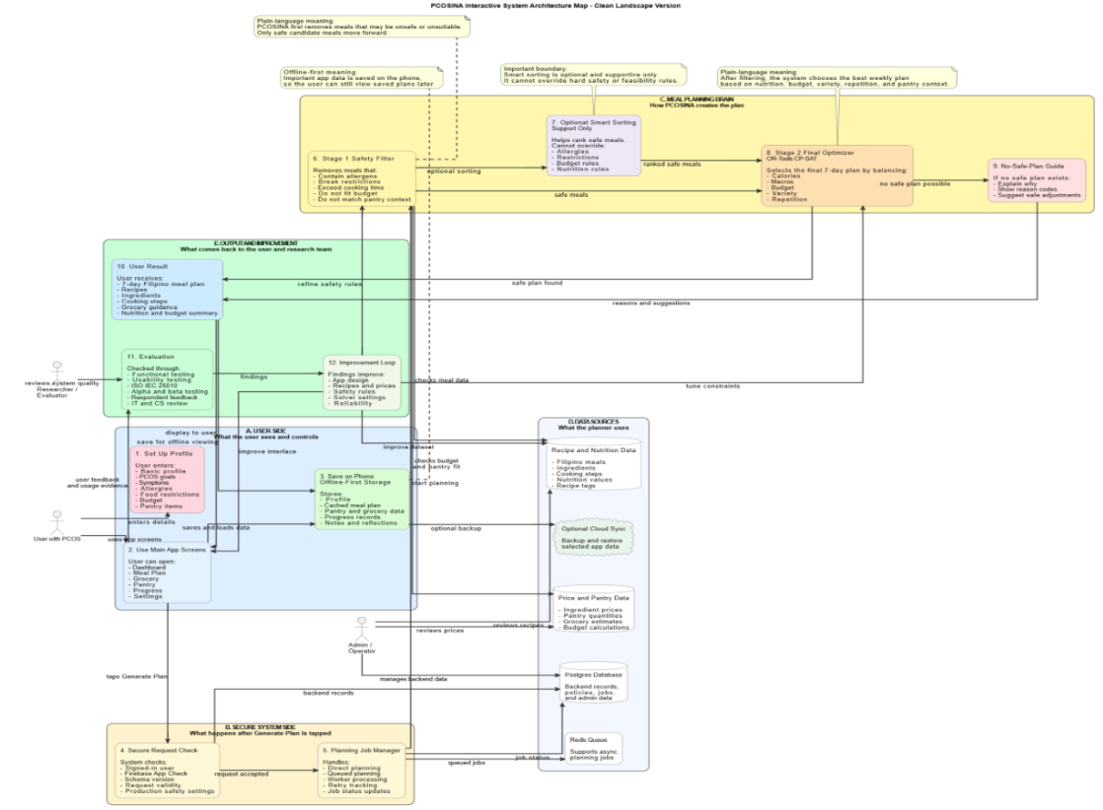
Figure 4.16. System architecture source visual from the evidence dossier.
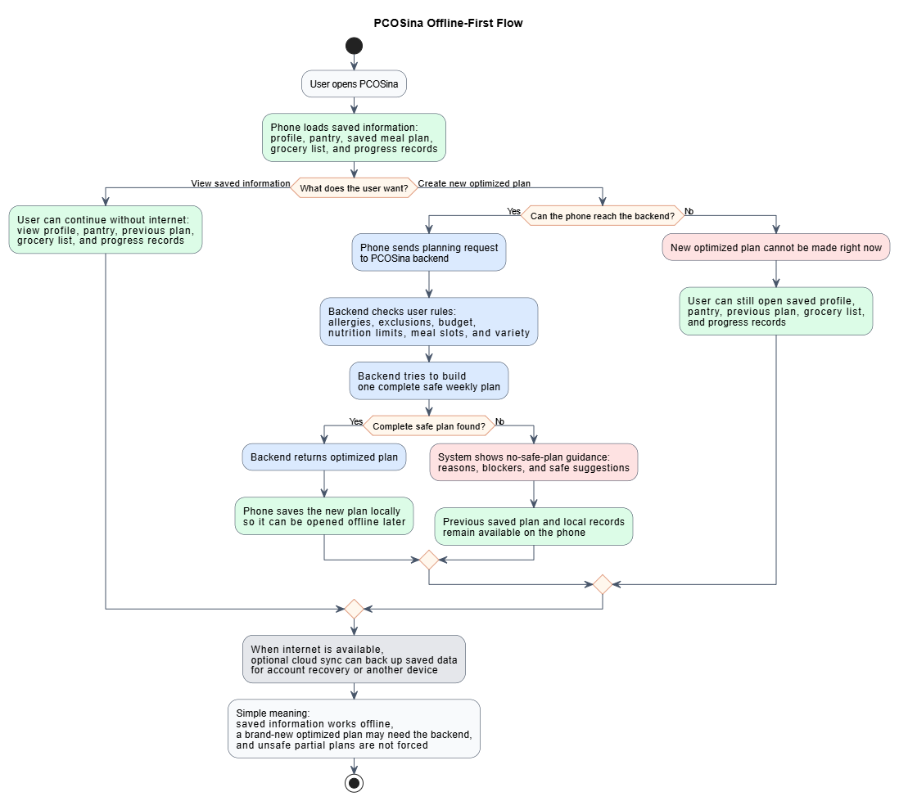
Figure 4.17. Offline-first workflow source visual from the evidence dossier.
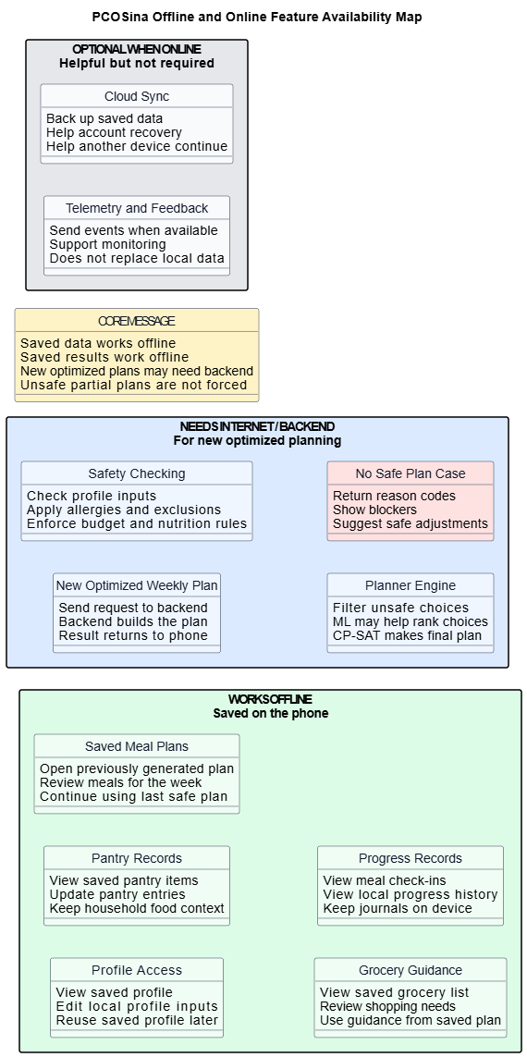
Figure 4.18. Online and offline availability map source visual from the evidence dossier.

4.4.1 Offline-First Scope and Boundary
Offline-first in PCOSina means saved user-facing artifacts remain accessible after they have been created or retrieved. It does not mean every feature is fully offline. New optimized plan generation remains backend-dependent because the current planner uses the remote CP-SAT optimization service. The important design promise is saved-data continuity under limited connectivity.
Feature group | Offline after saved? | Network-dependent boundary
Profile and preferences | Yes, saved profile data are local. | Initial account recovery or cloud restore may need internet.
Generated meal plan | Yes, previously generated plans can be reopened. | New optimized generation needs backend execution.
Pantry and grocery guidance | Yes, saved pantry/grocery records can be viewed. | Fresh recipe detail retrieval or remote updates may need internet.
Progress and history | Yes, self-reported progress records are local. | Feedback submission or sync services may need network.
Recipe detail and swap alternatives | Partial or online-dependent depending on cache/state. | Do not claim all recipe detail and swap paths work offline.

4.4.2 Local Data Storage and Recovery Flow
The app persists saved plan JSON, plan history, pantry records, grocery records, grocery sources, daily logs, weekly journals, weekly spending, reminder preferences, and progress UI preferences through local repositories and secure local artifacts. On app restart, ViewModels reload these artifacts and reconstruct the visible plan, grocery, pantry, dashboard, and progress states for the signed-in user.
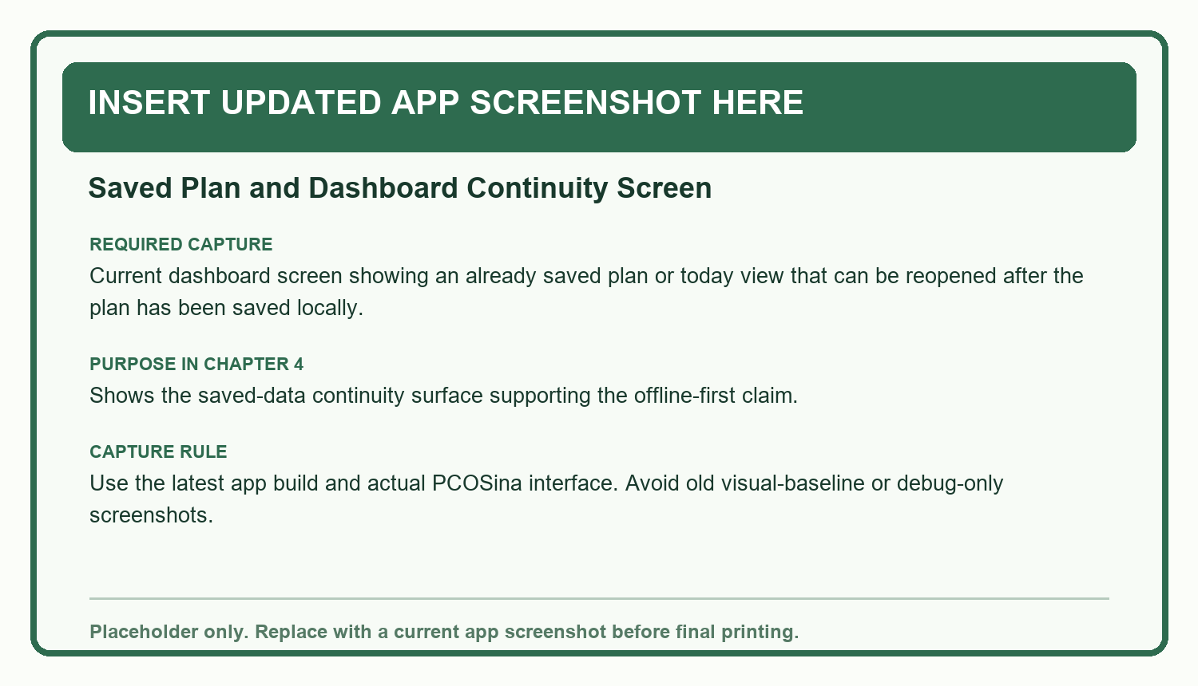
Figure 4.19. Placeholder for updated app screenshot: saved-plan dashboard continuity screen.
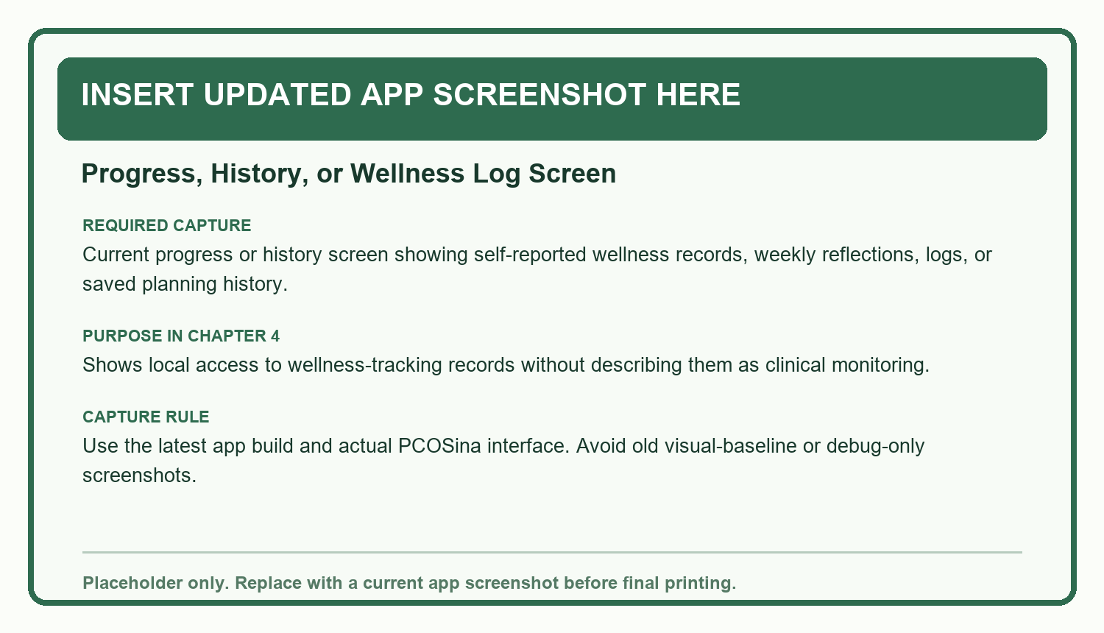
Figure 4.20. Placeholder for updated app screenshot: progress, history, or wellness log screen.

4.4.3 Online Generation and Local Save Sequence
When a user requests a new plan, the mobile app sends the prepared profile to the backend. The backend filters candidates and solves the weekly assignment model. The accepted plan returns to Android, where it is saved locally as the latest plan and appended to plan history. This sequence allows the system to combine backend optimization with offline access to the accepted result.
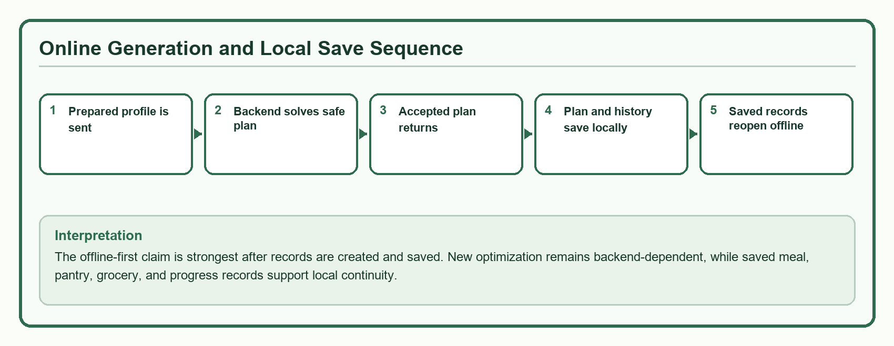
Figure 4.21. Online optimization and local-save sequence for offline-first continuity.
Interpretation: Section 4.4.3 should be read as the handoff between online optimization and local continuity. The system supports saved-plan offline access, but it should not claim that new optimized plan generation is fully offline.

4.4.4 Offline Access to Meal, Grocery, Pantry, and Progress Data
Once saved, core records can be reviewed without re-running the optimizer. The user can view saved meal plans, pantry entries, grocery guidance, progress logs, weekly reflections, and spending notes. Progress entries remain self-reported wellness records. They should not be described as clinical monitoring or proof of health improvement.
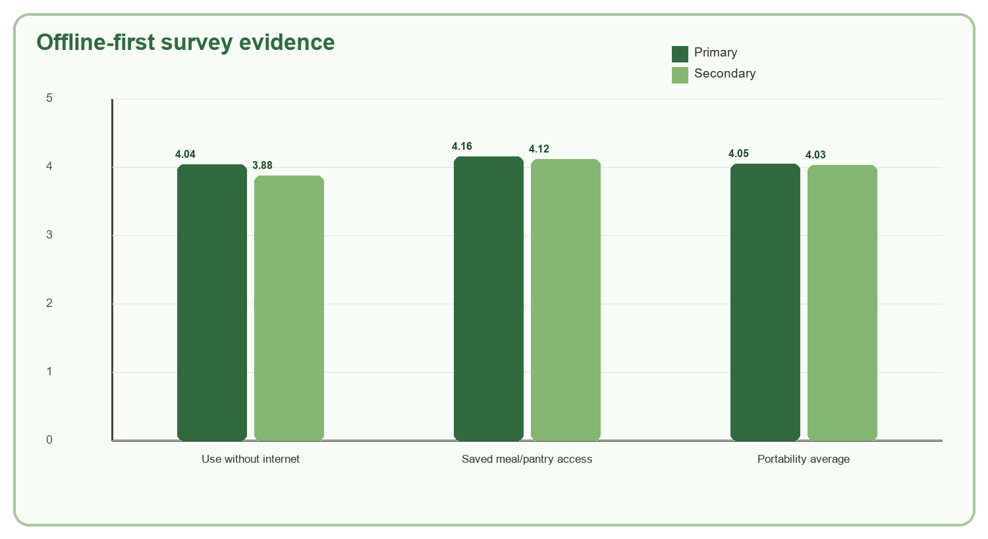
Figure 4.22. Offline-first survey evidence for saved-data continuity.

4.4.5 Evidence and Offline Claim Limits
Offline evidence | Reported result | Interpretation
Portability average | 4.04 overall, interpreted as Agree. | Respondents generally agreed that the app is portable and usable under device conditions.
Use without internet | 4.04 primary / 3.88 secondary. | Supports the saved-data offline access claim.
Saved plans and pantry offline | 4.16 primary / 4.12 secondary. | Strongest survey support for local continuity.
Reliability average | 4.00 overall, interpreted as Agree. | Supports general stability perception under evaluated use.
Boundary | New optimized generation remains backend-dependent. | Do not claim full offline optimization.

4.5 Evaluation of Nutrition Quality, Usability, Cultural Relevance, and Computational Efficiency
Revised SOP 5 question
How does the proposed system perform in terms of nutritional quality, usability, cultural relevance, and computational efficiency based on algorithmic, expert, and user-centered evaluation metrics?

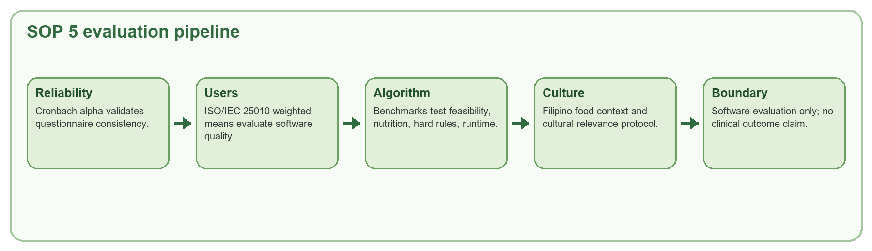
Figure 4.23. Process flow for SOP 5 evaluation evidence.
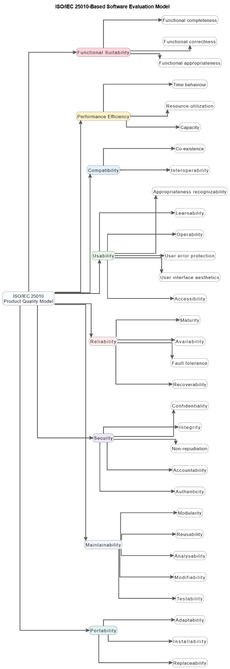
Figure 4.24. ISO-based software evaluation model from the evidence dossier.
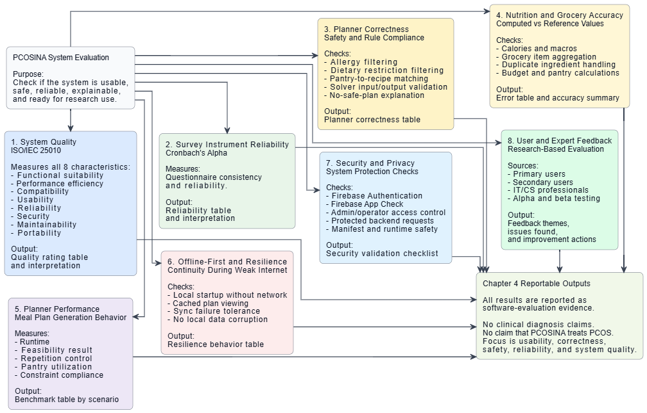
Figure 4.25. Effectiveness dimensions, metrics, and output artifacts.
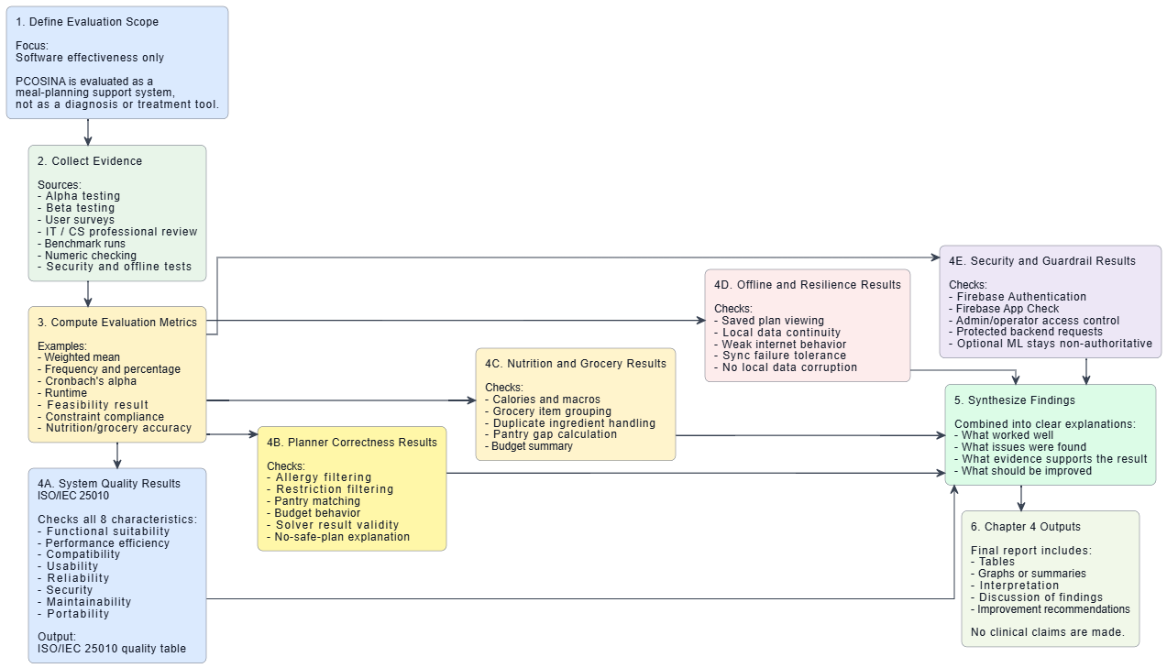
Figure 4.26. Evaluation flowchart showing software-evaluation scope.

4.5.1 Evaluation Scope and Data Sources
SOP 5 is answered through combined algorithmic, expert, and user-centered evidence. The evaluation does not rely on one metric. It uses questionnaire reliability, ISO/IEC 25010 weighted means, functional tests, benchmark scenarios, nutrition and safety validation, ML ranking metrics, pantry/offline summaries, and runtime results. The evaluation scope remains software quality and decision-support performance, not clinical outcome measurement.
Evaluation dimension | Evidence source | What it proves
Instrument reliability | Cronbach alpha per ISO/IEC 25010 category | Questionnaire consistency before interpreting scores.
User-centered quality | Weighted mean across eight ISO/IEC 25010 categories | Perceived software quality, usability, security, reliability, and portability.
Nutrition quality | Planner benchmark, nutrition feasibility, macro and calorie checks | System output satisfies implemented nutrition rules under tested profiles.
Safety | Hard-rule violations and no-safe-plan behavior | Unsafe plans are rejected rather than forced.
Cultural relevance | Filipino food context, cultural protocol, user ratings | Meal outputs support familiar Filipino food practices within constraints.
Computational efficiency | Runtime average, P95, max, completion rate | Planner is practical under evaluated benchmark conditions.

4.5.2 Instrument Reliability and User-Centered Evaluation
Statistical formulas | Formula / computation | Use in PCOSina
Weighted mean | WM = sum(score_i) / N, or sum(f_i*x_i) / N for grouped responses | Interprets survey agreement per ISO/IEC 25010 category.
Cronbach alpha | alpha = (k / (k - 1)) * (1 - sum(item variances) / total score variance) | Checks internal consistency of questionnaire items.
Interpretation threshold | alpha >= 0.700 | Minimum accepted reliability threshold used in the dossier.

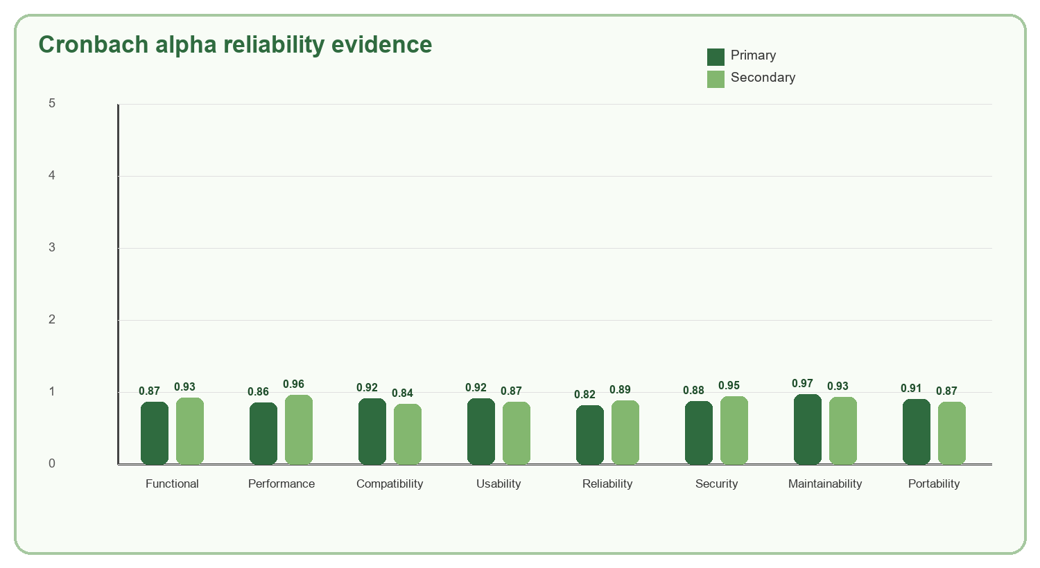
Figure 4.27. Cronbach alpha reliability evidence by category.
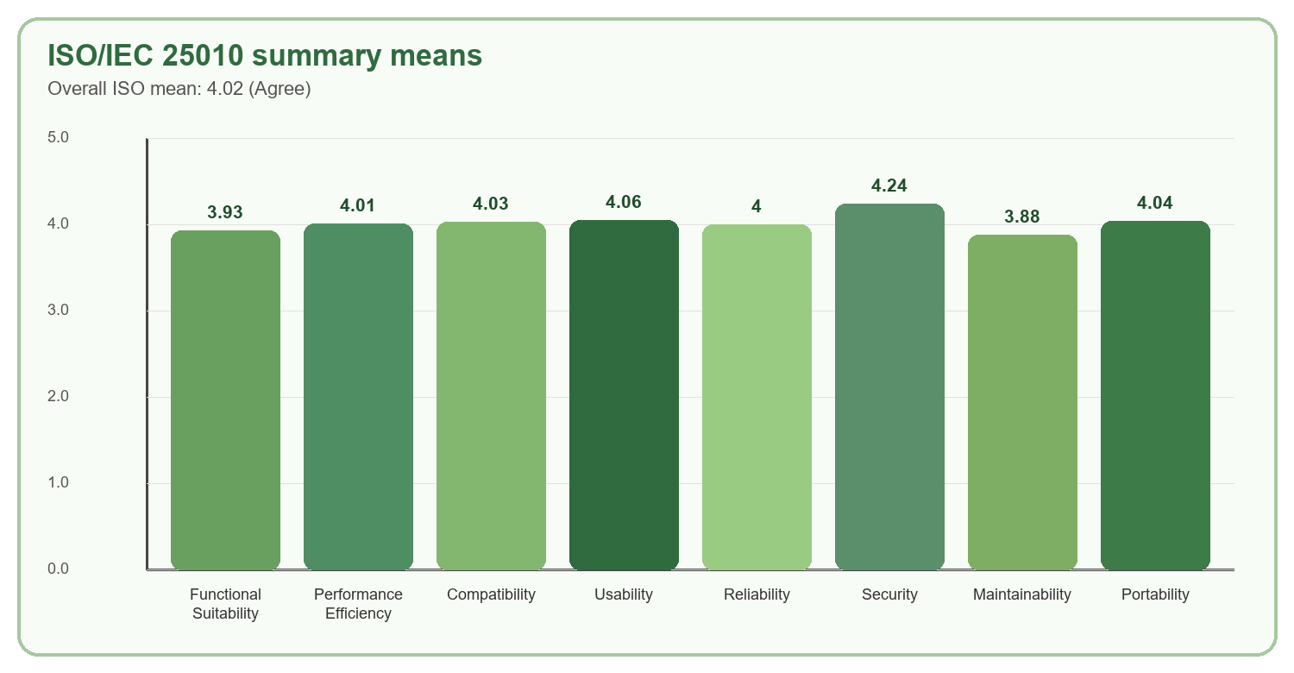
Figure 4.28. ISO/IEC 25010 weighted-mean summary.
ISO/IEC 25010 category | Overall mean | Interpretation
Functional Suitability | 3.93 | Agree
Performance Efficiency | 4.01 | Agree
Compatibility | 4.03 | Agree
Usability | 4.06 | Agree
Reliability | 4.00 | Agree
Security | 4.24 | Strongly Agree
Maintainability | 3.88 | Agree
Portability | 4.04 | Agree

4.5.3 Nutrition Quality and Constraint-Safety Evaluation
Nutrition quality is evaluated through plan completeness, nutrition feasibility, macro and calorie behavior, and preservation of hard constraints. The strongest benchmark evidence is the final 20-profile evaluation repeated five times per profile, producing 100 final runs. The planner generated complete 21-slot weekly plans in all 100 final runs and recorded zero hard-rule violations.
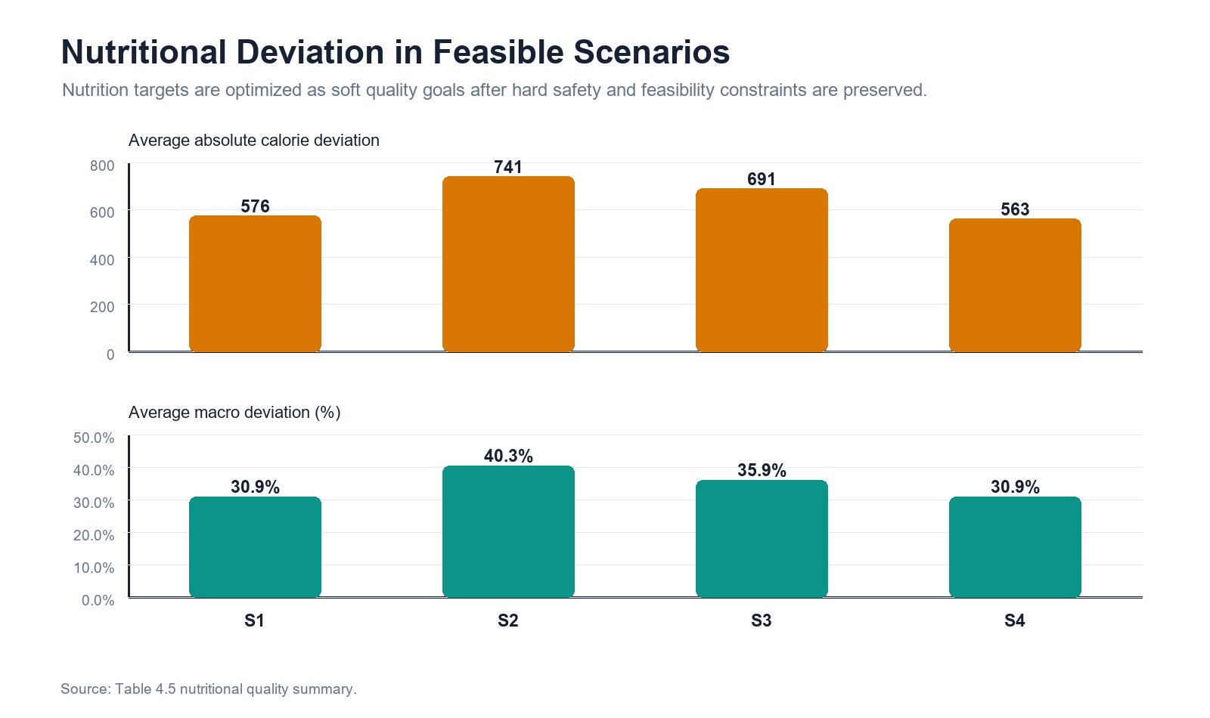
Figure 4.29. Nutrition deviation evidence from algorithm evaluation assets.
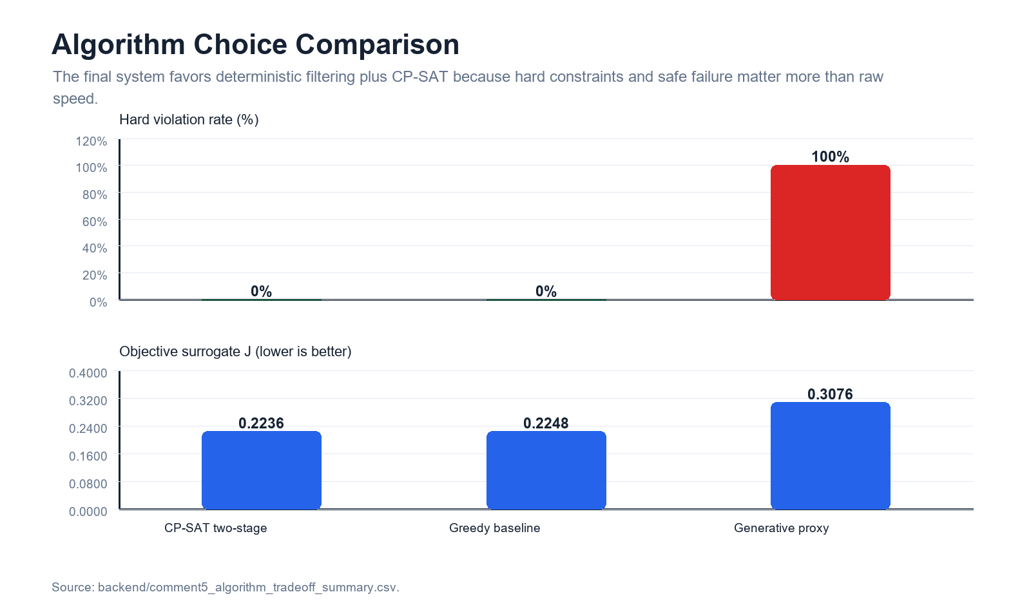
Figure 4.30. Algorithm comparison evidence from algorithm evaluation assets.
Planner evidence | Result | Interpretation
Benchmark test set | 20 realistic planner profiles, repeated five times each for 100 runs. | Evaluation covers ordinary planning, budget limits, allergies, dietary restrictions, pantry use, and no-budget planning.
Weekly structure | 100/100 runs produced 21 meal slots. | The planner reliably produced complete weekly plans under valid tested profiles.
Hard-rule violations | 0. | The planner preserved hard constraints during final benchmark testing.
Nutrition feasibility | Passed in 100/100 final runs. | The system met implemented nutrition feasibility checks.
No-safe-plan behavior | Intentionally infeasible cases return no-safe-plan feedback. | The system reports infeasibility instead of forcing unsafe output.

4.5.4 Cultural Relevance and Usability Evaluation
Cultural relevance is supported by familiar Filipino recipes, local ingredient context, and user evaluation. The key boundary is that cultural relevance must pass together with safety. A culturally familiar recipe is not acceptable if it violates allergies, explicit exclusions, dietary restrictions, budget ceilings, or nutrition feasibility.
Cultural relevance evidence | Use in paper | Boundary
Filipino recipe catalog | Shows the system plans using culturally recognizable meals. | Must still satisfy nutrition and safety constraints.
Filipino food survey item | 4.28 primary / 3.84 secondary. | Supports perceived cultural familiarity.
Cultural relevance protocol | Provides evaluation structure for cultural title and ingredient fit. | Final CTS/CIS values were not visible in extracted result tables.
User-centered usability | Usability mean 4.06 Agree. | Supports navigation and understandability, not long-term adherence proof.

4.5.5 Computational Efficiency Evaluation
Computational efficiency was evaluated through final benchmark runtime and completion behavior. The final optimized planner completed all 100 final runs with average runtime of 257 ms, P95 runtime of 313 ms, and maximum runtime of 357 ms. The evidence also reports that the final planner path preserved zero hard-rule violations while improving practical runtime.
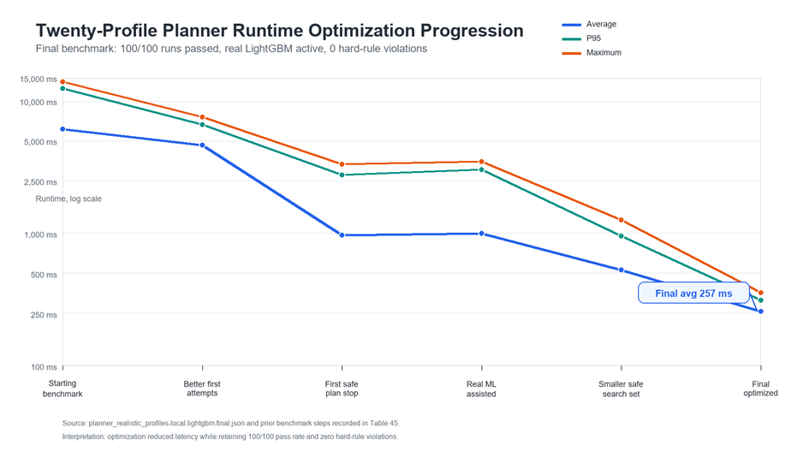
Figure 4.31. Twenty-profile planner runtime optimization progression.
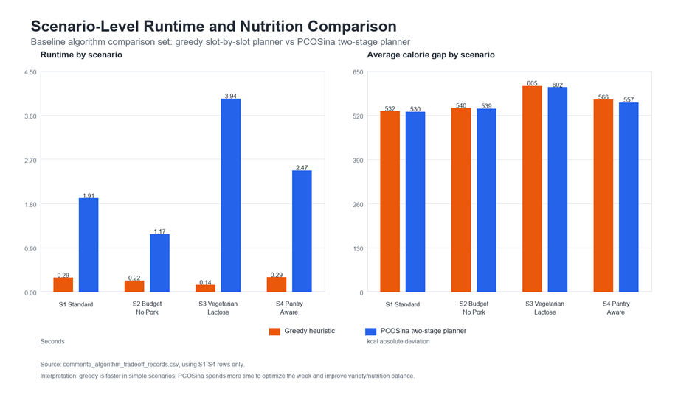
Figure 4.32. Scenario-level runtime and nutrition comparison.
Metric | Result | Meaning
Final run count | 100/100 passed. | No final benchmark failures under tested profiles.
Average runtime | 257 ms. | Typical run completed below one second in the local benchmark.
P95 runtime | 313 ms. | 95 percent of runs completed at or below this time.
Maximum runtime | 357 ms. | Worst final benchmark run remained below one second.
ML NDCG@10 | 0.9211 vs baseline 0.8838. | Assistive ranking improved candidate ordering, while hard rules remained deterministic.

4.5.6 Integrated Interpretation and Claim Boundary
Together, the evidence supports the revised SOP 5 because the system is evaluated through both numerical system behavior and user-centered software quality. The planner generated complete nutrition-aware weekly plans, preserved hard constraints, and ran efficiently in the final benchmark. Users rated software quality positively across ISO/IEC 25010 categories, and the questionnaire reliability results support interpretation of those survey scores.
Known evidence boundaries to keep in the final paper
Cronbach alpha proves questionnaire consistency, not system effectiveness by itself. Cultural relevance has protocol and user evidence, but final CTS/CIS values were not visible in the extracted result tables. Standard deviation values requested by the SOP report were not visible in the manuscript result tables. Pantry evidence supports reduced-purchase guidance, not measured household food-waste reduction. Offline-first evidence supports saved-data continuity, not full offline optimization.

End of 4.1 to 4.5 SOP Narrative
Final integration note
This section is the Chapter 4 SOP process narrative only. It should be inserted into the paper after final alignment of manuscript numbering, captions, and table sequence.

