BAN 502 Course Project

Winslow Goins

2/20/2022

library(tidyverse)  
library(tidymodels)  
library(mice)   
library(VIM)   
library(naniar)   
library(skimr)   
library(GGally)  
library(lmtest)  
library(MASS)  
library(car)  
library(ggcorrplot)  
library(glmnet)  
library(lubridate)  
library(splines)  
library(gridExtra)

ames_student<- read_csv("ames_student.csv")

## Rows: 2053 Columns: 81

## -- Column specification --------------------------------------------------------  
## Delimiter: ","  
## chr (47): MS_SubClass, MS_Zoning, Street, Alley, Lot_Shape, Land_Contour, Ut...  
## dbl (34): Lot_Frontage, Lot_Area, Year_Built, Year_Remod_Add, Mas_Vnr_Area, ...

##   
## i Use `spec()` to retrieve the full column specification for this data.  
## i Specify the column types or set `show_col_types = FALSE` to quiet this message.

summary(ames_student)

## MS_SubClass MS_Zoning Lot_Frontage Lot_Area   
## Length:2053 Length:2053 Min. : 0.00 Min. : 1300   
## Class :character Class :character 1st Qu.: 43.00 1st Qu.: 7500   
## Mode :character Mode :character Median : 62.00 Median : 9548   
## Mean : 57.38 Mean : 10258   
## 3rd Qu.: 78.00 3rd Qu.: 11600   
## Max. :313.00 Max. :215245   
## Street Alley Lot_Shape Land_Contour   
## Length:2053 Length:2053 Length:2053 Length:2053   
## Class :character Class :character Class :character Class :character   
## Mode :character Mode :character Mode :character Mode :character   
##   
##   
##   
## Utilities Lot_Config Land_Slope Neighborhood   
## Length:2053 Length:2053 Length:2053 Length:2053   
## Class :character Class :character Class :character Class :character   
## Mode :character Mode :character Mode :character Mode :character   
##   
##   
##   
## Condition_1 Condition_2 Bldg_Type House_Style   
## Length:2053 Length:2053 Length:2053 Length:2053   
## Class :character Class :character Class :character Class :character   
## Mode :character Mode :character Mode :character Mode :character   
##   
##   
##   
## Overall_Qual Overall_Cond Year_Built Year_Remod_Add  
## Length:2053 Length:2053 Min. :1875 Min. :1950   
## Class :character Class :character 1st Qu.:1953 1st Qu.:1965   
## Mode :character Mode :character Median :1972 Median :1993   
## Mean :1971 Mean :1984   
## 3rd Qu.:2000 3rd Qu.:2004   
## Max. :2010 Max. :2010   
## Roof_Style Roof_Matl Exterior_1st Exterior_2nd   
## Length:2053 Length:2053 Length:2053 Length:2053   
## Class :character Class :character Class :character Class :character   
## Mode :character Mode :character Mode :character Mode :character   
##   
##   
##   
## Mas_Vnr_Type Mas_Vnr_Area Exter_Qual Exter_Cond   
## Length:2053 Min. : 0.0 Length:2053 Length:2053   
## Class :character 1st Qu.: 0.0 Class :character Class :character   
## Mode :character Median : 0.0 Mode :character Mode :character   
## Mean : 103.8   
## 3rd Qu.: 164.0   
## Max. :1600.0   
## Foundation Bsmt_Qual Bsmt_Cond Bsmt_Exposure   
## Length:2053 Length:2053 Length:2053 Length:2053   
## Class :character Class :character Class :character Class :character   
## Mode :character Mode :character Mode :character Mode :character   
##   
##   
##   
## BsmtFin_Type_1 BsmtFin_SF_1 BsmtFin_Type_2 BsmtFin_SF_2   
## Length:2053 Min. :1.00 Length:2053 Min. : 0.00   
## Class :character 1st Qu.:3.00 Class :character 1st Qu.: 0.00   
## Mode :character Median :3.00 Mode :character Median : 0.00   
## Mean :4.21 Mean : 52.57   
## 3rd Qu.:7.00 3rd Qu.: 0.00   
## Max. :7.00 Max. :1526.00   
## Bsmt_Unf_SF Total_Bsmt_SF Heating Heating_QC   
## Min. : 0.0 Min. : 0 Length:2053 Length:2053   
## 1st Qu.: 226.0 1st Qu.: 793 Class :character Class :character   
## Median : 460.0 Median : 988 Mode :character Mode :character   
## Mean : 561.2 Mean :1055   
## 3rd Qu.: 801.0 3rd Qu.:1304   
## Max. :2336.0 Max. :5095   
## Central_Air Electrical First_Flr_SF Second_Flr_SF   
## Length:2053 Length:2053 Min. : 432 Min. : 0.0   
## Class :character Class :character 1st Qu.: 882 1st Qu.: 0.0   
## Mode :character Mode :character Median :1088 Median : 0.0   
## Mean :1168 Mean : 326.1   
## 3rd Qu.:1402 3rd Qu.: 701.0   
## Max. :5095 Max. :1862.0   
## Low_Qual_Fin_SF Gr_Liv_Area Bsmt_Full_Bath Bsmt_Half_Bath   
## Min. : 0.000 Min. : 480 Min. :0.0000 Min. :0.00000   
## 1st Qu.: 0.000 1st Qu.:1137 1st Qu.:0.0000 1st Qu.:0.00000   
## Median : 0.000 Median :1447 Median :0.0000 Median :0.00000   
## Mean : 4.973 Mean :1499 Mean :0.4301 Mean :0.05796   
## 3rd Qu.: 0.000 3rd Qu.:1737 3rd Qu.:1.0000 3rd Qu.:0.00000   
## Max. :1064.000 Max. :5095 Max. :3.0000 Max. :2.00000   
## Full_Bath Half_Bath Bedroom_AbvGr Kitchen_AbvGr   
## Min. :0.000 Min. :0.0000 Min. :0.000 Min. :1.000   
## 1st Qu.:1.000 1st Qu.:0.0000 1st Qu.:2.000 1st Qu.:1.000   
## Median :2.000 Median :0.0000 Median :3.000 Median :1.000   
## Mean :1.564 Mean :0.3751 Mean :2.855 Mean :1.047   
## 3rd Qu.:2.000 3rd Qu.:1.0000 3rd Qu.:3.000 3rd Qu.:1.000   
## Max. :4.000 Max. :2.0000 Max. :6.000 Max. :3.000   
## Kitchen_Qual TotRms_AbvGrd Functional Fireplaces   
## Length:2053 Min. : 3.000 Length:2053 Min. :0.000   
## Class :character 1st Qu.: 5.000 Class :character 1st Qu.:0.000   
## Mode :character Median : 6.000 Mode :character Median :1.000   
## Mean : 6.442 Mean :0.603   
## 3rd Qu.: 7.000 3rd Qu.:1.000   
## Max. :15.000 Max. :4.000   
## Fireplace_Qu Garage_Type Garage_Finish Garage_Cars   
## Length:2053 Length:2053 Length:2053 Min. :0.000   
## Class :character Class :character Class :character 1st Qu.:1.000   
## Mode :character Mode :character Mode :character Median :2.000   
## Mean :1.774   
## 3rd Qu.:2.000   
## Max. :5.000   
## Garage_Area Garage_Qual Garage_Cond Paved_Drive   
## Min. : 0 Length:2053 Length:2053 Length:2053   
## 1st Qu.: 320 Class :character Class :character Class :character   
## Median : 478 Mode :character Mode :character Mode :character   
## Mean : 472   
## 3rd Qu.: 576   
## Max. :1488   
## Wood_Deck_SF Open_Porch_SF Enclosed_Porch Three_season_porch  
## Min. : 0.00 Min. : 0.00 Min. : 0.00 Min. : 0.000   
## 1st Qu.: 0.00 1st Qu.: 0.00 1st Qu.: 0.00 1st Qu.: 0.000   
## Median : 0.00 Median : 27.00 Median : 0.00 Median : 0.000   
## Mean : 93.52 Mean : 48.17 Mean : 23.02 Mean : 2.799   
## 3rd Qu.: 168.00 3rd Qu.: 72.00 3rd Qu.: 0.00 3rd Qu.: 0.000   
## Max. :1424.00 Max. :742.00 Max. :584.00 Max. :407.000   
## Screen_Porch Pool_Area Pool_QC Fence   
## Min. : 0.00 Min. : 0.000 Length:2053 Length:2053   
## 1st Qu.: 0.00 1st Qu.: 0.000 Class :character Class :character   
## Median : 0.00 Median : 0.000 Mode :character Mode :character   
## Mean : 16.68 Mean : 1.339   
## 3rd Qu.: 0.00 3rd Qu.: 0.000   
## Max. :576.00 Max. :800.000   
## Misc_Feature Misc_Val Mo_Sold Year_Sold   
## Length:2053 Min. : 0.00 Min. : 1.000 Min. :2006   
## Class :character 1st Qu.: 0.00 1st Qu.: 4.000 1st Qu.:2007   
## Mode :character Median : 0.00 Median : 6.000 Median :2008   
## Mean : 60.12 Mean : 6.189 Mean :2008   
## 3rd Qu.: 0.00 3rd Qu.: 8.000 3rd Qu.:2009   
## Max. :17000.00 Max. :12.000 Max. :2010   
## Sale_Type Sale_Condition Longitude Latitude   
## Length:2053 Length:2053 Min. :-93.69 Min. :41.99   
## Class :character Class :character 1st Qu.:-93.66 1st Qu.:42.02   
## Mode :character Mode :character Median :-93.64 Median :42.03   
## Mean :-93.64 Mean :42.03   
## 3rd Qu.:-93.62 3rd Qu.:42.05   
## Max. :-93.58 Max. :42.06   
## Above_Median   
## Length:2053   
## Class :character   
## Mode :character   
##   
##   
##

ames = ames_student %>% mutate(MS_SubClass = as_factor(MS_SubClass)) %>%  
 mutate(MS_Zoning = as_factor(MS_Zoning)) %>%  
 mutate(Street = as_factor(Street)) %>%  
 mutate(Alley = as_factor(Alley)) %>%  
 mutate(Lot_Shape = as_factor(Lot_Shape)) %>%  
 mutate(Land_Contour = as_factor(Land_Contour)) %>%  
 mutate(Utilities = as_factor(Utilities)) %>%  
 mutate(Lot_Config = as_factor(Lot_Config)) %>%  
 mutate(Land_Slope = as_factor(Land_Slope)) %>%  
 mutate(Neighborhood = as_factor(Neighborhood)) %>%  
 mutate(Condition_1 = as_factor(Condition_1)) %>%  
 mutate(Condition_2 = as_factor(Condition_2)) %>%  
 mutate(Bldg_Type = as_factor(Bldg_Type)) %>%  
 mutate(House_Style = as_factor(House_Style)) %>%  
 mutate(Overall_Qual = as_factor(Overall_Qual)) %>%  
 mutate(Exter_Cond = as_factor(Exter_Cond)) %>%  
 mutate(Year_Built = as_factor(Year_Built)) %>%  
 mutate(Year_Remod_Add = as_factor(Year_Remod_Add)) %>%  
 mutate(Roof_Style = as_factor(Roof_Style)) %>%  
 mutate(Roof_Matl = as_factor(Roof_Matl)) %>%  
 mutate(Exterior_1st = as_factor(Exterior_1st)) %>%  
 mutate(Exterior_2nd = as_factor(Exterior_2nd)) %>%  
 mutate(Mas_Vnr_Type = as_factor(Mas_Vnr_Type)) %>%  
 mutate(Exter_Qual = as_factor(Exter_Qual)) %>%  
 mutate(Exter_Cond = as_factor(Exter_Cond)) %>%  
 mutate(Foundation = as_factor(Foundation)) %>%  
 mutate(Bsmt_Qual = as_factor(Bsmt_Qual)) %>%  
 mutate(Bsmt_Cond = as_factor(Bsmt_Cond)) %>%  
 mutate(Bsmt_Exposure = as_factor(Bsmt_Exposure)) %>%  
 mutate(BsmtFin_Type_1 = as_factor(BsmtFin_Type_1)) %>%  
 mutate(MS_SubClass = as_factor(MS_SubClass)) %>%  
 mutate(BsmtFin_Type_2 = as_factor(BsmtFin_Type_2)) %>%  
 mutate(Heating = as_factor(Heating)) %>%  
 mutate(Heating_QC = as_factor(Heating_QC)) %>%  
 mutate(Central_Air = as_factor(Central_Air)) %>%  
 mutate(Electrical = as_factor(Electrical)) %>%  
 mutate(Bsmt_Full_Bath = as_factor(Bsmt_Full_Bath)) %>%  
 mutate(Bsmt_Half_Bath = as_factor(Bsmt_Half_Bath)) %>%  
 mutate(Full_Bath = as_factor(Full_Bath)) %>%  
 mutate(Half_Bath = as_factor(Half_Bath)) %>%  
 mutate(Bedroom_AbvGr = as_factor(Bedroom_AbvGr)) %>%  
 mutate(Kitchen_AbvGr = as_factor(Kitchen_AbvGr)) %>%  
 mutate(Kitchen_Qual = as_factor(Kitchen_Qual)) %>%  
 mutate(Functional = as_factor(Functional)) %>%  
 mutate(Fireplaces = as_factor(Fireplaces)) %>%  
 mutate(Fireplace_Qu = as_factor(Fireplace_Qu)) %>%  
 mutate(Garage_Type = as_factor(Garage_Type)) %>%  
 mutate(Garage_Finish = as_factor(Garage_Finish)) %>%  
 mutate(Garage_Cars = as_factor(Garage_Cars)) %>%  
 mutate(Garage_Qual = as_factor(Garage_Qual)) %>%  
 mutate(Garage_Cond = as_factor(Garage_Cond)) %>%  
 mutate(Paved_Drive = as_factor(Paved_Drive)) %>%  
 mutate(Pool_QC = as_factor(Pool_QC)) %>%  
 mutate(Fence = as_factor(Fence)) %>%  
 mutate(Misc_Feature = as_factor(Misc_Feature)) %>%  
 mutate(Mo_Sold = as_factor(Mo_Sold)) %>%  
 mutate(Year_Sold = as_factor(Year_Sold)) %>%  
 mutate(Sale_Type = as_factor(Sale_Type)) %>%  
 mutate(Sale_Condition = as_factor(Sale_Condition)) %>%  
 mutate(Above_Median = as_factor(Above_Median)) %>%  
 mutate(Overall_Cond = as_factor(Overall_Cond))

summary(ames)

## MS_SubClass MS_Zoning   
## One_Story_1946_and_Newer_All_Styles :772 Residential_Low_Density :1600   
## Two_Story_1946_and_Newer :383 Residential_High_Density : 20   
## One_and_Half_Story_Finished_All_Ages:204 Floating_Village_Residential: 87   
## One_Story_PUD_1946_and_Newer :129 Residential_Medium_Density : 326   
## One_Story_1945_and_Older : 98 C_all : 17   
## Two_Story_1945_and_Older : 95 A_agr : 2   
## (Other) :372 I_all : 1   
## Lot_Frontage Lot_Area Street Alley   
## Min. : 0.00 Min. : 1300 Pave:2046 No_Alley_Access:1914   
## 1st Qu.: 43.00 1st Qu.: 7500 Grvl: 7 Paved : 45   
## Median : 62.00 Median : 9548 Gravel : 94   
## Mean : 57.38 Mean : 10258   
## 3rd Qu.: 78.00 3rd Qu.: 11600   
## Max. :313.00 Max. :215245   
##   
## Lot_Shape Land_Contour Utilities Lot_Config   
## Slightly_Irregular : 714 Lvl:1833 AllPub:2052 Corner : 359   
## Regular :1275 HLS: 94 NoSewr: 1 Inside :1495   
## Moderately_Irregular: 53 Bnk: 81 CulDSac: 135   
## Irregular : 11 Low: 45 FR2 : 56   
## FR3 : 8   
##   
##   
## Land_Slope Neighborhood Condition_1 Condition_2 Bldg_Type   
## Gtl:1951 North_Ames : 327 Norm :1771 Norm :2027 OneFam :1706   
## Mod: 89 College_Creek: 183 Feedr : 113 Feedr : 12 TwnhsE : 157   
## Sev: 13 Old_Town : 181 Artery : 67 PosA : 4 Twnhs : 67   
## Edwards : 129 RRAn : 35 Artery : 4 Duplex : 76   
## Somerset : 119 PosN : 24 PosN : 3 TwoFmCon: 47   
## Gilbert : 109 RRAe : 19 RRNn : 1   
## (Other) :1005 (Other): 24 (Other): 2   
## House_Style Overall_Qual Overall_Cond   
## One_Story :1052 Average :587 Average :1143   
## Two_Story : 590 Above_Average:518 Above_Average: 376   
## One_and_Half_Fin: 225 Good :411 Good : 286   
## SLvl : 90 Very_Good :237 Very_Good : 98   
## SFoyer : 56 Below_Average:169 Below_Average: 73   
## Two_and_Half_Unf: 19 Excellent : 70 Fair : 35   
## (Other) : 21 (Other) : 61 (Other) : 42   
## Year_Built Year_Remod_Add Roof_Style Roof_Matl Exterior_1st  
## 2005 : 104 1950 : 256 Hip : 404 CompShg:2023 VinylSd:705   
## 2006 : 93 2006 : 147 Gable :1607 WdShake: 8 MetalSd:319   
## 2007 : 76 2007 : 116 Mansard: 9 Tar&Grv: 17 Wd Sdng:313   
## 2003 : 62 2005 : 94 Gambrel: 14 WdShngl: 3 HdBoard:303   
## 2004 : 60 2004 : 80 Shed : 5 Roll : 1 Plywood:151   
## 1977 : 40 2003 : 70 Flat : 14 Metal : 1 CemntBd: 90   
## (Other):1618 (Other):1290 (Other):172   
## Exterior_2nd Mas_Vnr_Type Mas_Vnr_Area Exter_Qual   
## VinylSd:699 Stone : 166 Min. : 0.0 Typical :1272   
## MetalSd:317 None :1231 1st Qu.: 0.0 Good : 682   
## Wd Sdng:302 BrkFace: 638 Median : 0.0 Excellent: 78   
## HdBoard:277 BrkCmn : 17 Mean : 103.8 Fair : 21   
## Plywood:190 CBlock : 1 3rd Qu.: 164.0   
## CmentBd: 90 Max. :1600.0   
## (Other):178   
## Exter_Cond Foundation Bsmt_Qual Bsmt_Cond   
## Typical :1787 CBlock:880 Typical :911 Good : 80   
## Good : 213 PConc :911 Good :849 Typical :1833   
## Fair : 43 Wood : 4 Excellent :178 Poor : 4   
## Excellent: 9 BrkTil:216 No_Basement: 57 No_Basement: 57   
## Poor : 1 Slab : 36 Fair : 57 Fair : 76   
## Stone : 6 Poor : 1 Excellent : 3   
##   
## Bsmt_Exposure BsmtFin_Type_1 BsmtFin_SF_1 BsmtFin_Type_2  
## Gd : 199 BLQ :196 Min. :1.00 Unf :1740   
## No :1331 Rec :216 1st Qu.:3.00 LwQ : 64   
## Av : 284 ALQ :298 Median :3.00 BLQ : 47   
## Mn : 179 GLQ :578 Mean :4.21 Rec : 79   
## No_Basement: 60 Unf :602 3rd Qu.:7.00 GLQ : 23   
## LwQ :106 Max. :7.00 No_Basement: 58   
## No_Basement: 57 ALQ : 42   
## BsmtFin_SF_2 Bsmt_Unf_SF Total_Bsmt_SF Heating   
## Min. : 0.00 Min. : 0.0 Min. : 0 GasA :2019   
## 1st Qu.: 0.00 1st Qu.: 226.0 1st Qu.: 793 GasW : 21   
## Median : 0.00 Median : 460.0 Median : 988 Grav : 6   
## Mean : 52.57 Mean : 561.2 Mean :1055 Wall : 5   
## 3rd Qu.: 0.00 3rd Qu.: 801.0 3rd Qu.:1304 Floor: 1   
## Max. :1526.00 Max. :2336.0 Max. :5095 OthW : 1   
##   
## Heating_QC Central_Air Electrical First_Flr_SF Second_Flr_SF   
## Fair : 61 Y:1916 SBrkr :1887 Min. : 432 Min. : 0.0   
## Typical : 618 N: 137 FuseA : 126 1st Qu.: 882 1st Qu.: 0.0   
## Excellent:1040 FuseF : 33 Median :1088 Median : 0.0   
## Good : 333 FuseP : 6 Mean :1168 Mean : 326.1   
## Poor : 1 Unknown: 1 3rd Qu.:1402 3rd Qu.: 701.0   
## Max. :5095 Max. :1862.0   
##   
## Low_Qual_Fin_SF Gr_Liv_Area Bsmt_Full_Bath Bsmt_Half_Bath Full_Bath  
## Min. : 0.000 Min. : 480 0:1201 0:1936 0: 10   
## 1st Qu.: 0.000 1st Qu.:1137 1: 823 1: 115 1: 920   
## Median : 0.000 Median :1447 2: 27 2: 2 2:1080   
## Mean : 4.973 Mean :1499 3: 2 3: 41   
## 3rd Qu.: 0.000 3rd Qu.:1737 4: 2   
## Max. :1064.000 Max. :5095   
##   
## Half_Bath Bedroom_AbvGr Kitchen_AbvGr Kitchen_Qual TotRms_AbvGrd   
## 0:1300 0: 7 1:1959 Typical :1070 Min. : 3.000   
## 1: 736 1: 73 2: 92 Good : 790 1st Qu.: 5.000   
## 2: 17 2: 527 3: 2 Excellent: 142 Median : 6.000   
## 3:1105 Fair : 50 Mean : 6.442   
## 4: 297 Poor : 1 3rd Qu.: 7.000   
## 5: 32 Max. :15.000   
## 6: 12   
## Functional Fireplaces Fireplace_Qu Garage_Type   
## Typ :1896 0:993 Good :538 Attchd :1204   
## Min2 : 54 1:891 No_Fireplace:993 BuiltIn : 127   
## Min1 : 51 2:161 Typical :409 Basment : 29   
## Mod : 27 3: 7 Poor : 36 Detchd : 549   
## Maj1 : 15 4: 1 Excellent : 21 No_Garage : 108   
## Maj2 : 6 Fair : 56 CarPort : 15   
## (Other): 4 More_Than_Two_Types: 21   
## Garage_Finish Garage_Cars Garage_Area Garage_Qual Garage_Cond   
## Fin :509 0: 108 Min. : 0 Typical :1839 Typical :1872   
## Unf :872 1: 539 1st Qu.: 320 No_Garage: 109 No_Garage: 109   
## RFn :563 2:1131 Median : 478 Fair : 85 Fair : 53   
## No_Garage:109 3: 261 Mean : 472 Good : 16 Excellent: 1   
## 4: 13 3rd Qu.: 576 Excellent: 2 Poor : 8   
## 5: 1 Max. :1488 Poor : 2 Good : 10   
##   
## Paved_Drive Wood_Deck_SF Open_Porch_SF Enclosed_Porch   
## Partial_Pavement: 42 Min. : 0.00 Min. : 0.00 Min. : 0.00   
## Paved :1848 1st Qu.: 0.00 1st Qu.: 0.00 1st Qu.: 0.00   
## Dirt_Gravel : 163 Median : 0.00 Median : 27.00 Median : 0.00   
## Mean : 93.52 Mean : 48.17 Mean : 23.02   
## 3rd Qu.: 168.00 3rd Qu.: 72.00 3rd Qu.: 0.00   
## Max. :1424.00 Max. :742.00 Max. :584.00   
##   
## Three_season_porch Screen_Porch Pool_Area Pool_QC   
## Min. : 0.000 Min. : 0.00 Min. : 0.000 No_Pool :2047   
## 1st Qu.: 0.000 1st Qu.: 0.00 1st Qu.: 0.000 Excellent: 2   
## Median : 0.000 Median : 0.00 Median : 0.000 Typical : 2   
## Mean : 2.799 Mean : 16.68 Mean : 1.339 Fair : 1   
## 3rd Qu.: 0.000 3rd Qu.: 0.00 3rd Qu.: 0.000 Good : 1   
## Max. :407.000 Max. :576.00 Max. :800.000   
##   
## Fence Misc_Feature Misc_Val Mo_Sold   
## No_Fence :1661 None:1978 Min. : 0.00 6 :352   
## Minimum_Privacy : 225 Gar2: 5 1st Qu.: 0.00 7 :320   
## Good_Privacy : 81 Shed: 66 Median : 0.00 5 :275   
## Good_Wood : 77 Othr: 3 Mean : 60.12 4 :187   
## Minimum_Wood_Wire: 9 Elev: 1 3rd Qu.: 0.00 8 :169   
## Max. :17000.00 3 :164   
## (Other):586   
## Year_Sold Sale_Type Sale_Condition Longitude Latitude   
## 2006:442 WD :1789 Normal :1712 Min. :-93.69 Min. :41.99   
## 2007:499 New : 163 Partial: 169 1st Qu.:-93.66 1st Qu.:42.02   
## 2008:445 COD : 54 Family : 30 Median :-93.64 Median :42.03   
## 2009:456 ConLD : 16 Abnorml: 121 Mean :-93.64 Mean :42.03   
## 2010:211 ConLI : 8 Alloca : 16 3rd Qu.:-93.62 3rd Qu.:42.05   
## CWD : 8 AdjLand: 5 Max. :-93.58 Max. :42.06   
## (Other): 15   
## Above_Median  
## Yes:1043   
## No :1010   
##   
##   
##   
##   
##

skim(ames)

Data summary

|  |  |
| --- | --- |
| Name | ames |
| Number of rows | 2053 |
| Number of columns | 81 |
| _______________________ |  |
| Column type frequency: |  |
| factor | 59 |
| numeric | 22 |
| ________________________ |  |
| Group variables | None |

**Variable type: factor**

| skim_variable | n_missing | complete_rate | ordered | n_unique | top_counts |
| --- | --- | --- | --- | --- | --- |
| MS_SubClass | 0 | 1 | FALSE | 16 | One: 772, Two: 383, One: 204, One: 129 |
| MS_Zoning | 0 | 1 | FALSE | 7 | Res: 1600, Res: 326, Flo: 87, Res: 20 |
| Street | 0 | 1 | FALSE | 2 | Pav: 2046, Grv: 7 |
| Alley | 0 | 1 | FALSE | 3 | No_: 1914, Gra: 94, Pav: 45 |
| Lot_Shape | 0 | 1 | FALSE | 4 | Reg: 1275, Sli: 714, Mod: 53, Irr: 11 |
| Land_Contour | 0 | 1 | FALSE | 4 | Lvl: 1833, HLS: 94, Bnk: 81, Low: 45 |
| Utilities | 0 | 1 | FALSE | 2 | All: 2052, NoS: 1 |
| Lot_Config | 0 | 1 | FALSE | 5 | Ins: 1495, Cor: 359, Cul: 135, FR2: 56 |
| Land_Slope | 0 | 1 | FALSE | 3 | Gtl: 1951, Mod: 89, Sev: 13 |
| Neighborhood | 0 | 1 | FALSE | 28 | Nor: 327, Col: 183, Old: 181, Edw: 129 |
| Condition_1 | 0 | 1 | FALSE | 9 | Nor: 1771, Fee: 113, Art: 67, RRA: 35 |
| Condition_2 | 0 | 1 | FALSE | 8 | Nor: 2027, Fee: 12, Pos: 4, Art: 4 |
| Bldg_Type | 0 | 1 | FALSE | 5 | One: 1706, Twn: 157, Dup: 76, Twn: 67 |
| House_Style | 0 | 1 | FALSE | 8 | One: 1052, Two: 590, One: 225, SLv: 90 |
| Overall_Qual | 0 | 1 | FALSE | 10 | Ave: 587, Abo: 518, Goo: 411, Ver: 237 |
| Overall_Cond | 0 | 1 | FALSE | 9 | Ave: 1143, Abo: 376, Goo: 286, Ver: 98 |
| Year_Built | 0 | 1 | FALSE | 114 | 200: 104, 200: 93, 200: 76, 200: 62 |
| Year_Remod_Add | 0 | 1 | FALSE | 61 | 195: 256, 200: 147, 200: 116, 200: 94 |
| Roof_Style | 0 | 1 | FALSE | 6 | Gab: 1607, Hip: 404, Gam: 14, Fla: 14 |
| Roof_Matl | 0 | 1 | FALSE | 6 | Com: 2023, Tar: 17, WdS: 8, WdS: 3 |
| Exterior_1st | 0 | 1 | FALSE | 16 | Vin: 705, Met: 319, Wd : 313, HdB: 303 |
| Exterior_2nd | 0 | 1 | FALSE | 17 | Vin: 699, Met: 317, Wd : 302, HdB: 277 |
| Mas_Vnr_Type | 0 | 1 | FALSE | 5 | Non: 1231, Brk: 638, Sto: 166, Brk: 17 |
| Exter_Qual | 0 | 1 | FALSE | 4 | Typ: 1272, Goo: 682, Exc: 78, Fai: 21 |
| Exter_Cond | 0 | 1 | FALSE | 5 | Typ: 1787, Goo: 213, Fai: 43, Exc: 9 |
| Foundation | 0 | 1 | FALSE | 6 | PCo: 911, CBl: 880, Brk: 216, Sla: 36 |
| Bsmt_Qual | 0 | 1 | FALSE | 6 | Typ: 911, Goo: 849, Exc: 178, No_: 57 |
| Bsmt_Cond | 0 | 1 | FALSE | 6 | Typ: 1833, Goo: 80, Fai: 76, No_: 57 |
| Bsmt_Exposure | 0 | 1 | FALSE | 5 | No: 1331, Av: 284, Gd: 199, Mn: 179 |
| BsmtFin_Type_1 | 0 | 1 | FALSE | 7 | Unf: 602, GLQ: 578, ALQ: 298, Rec: 216 |
| BsmtFin_Type_2 | 0 | 1 | FALSE | 7 | Unf: 1740, Rec: 79, LwQ: 64, No_: 58 |
| Heating | 0 | 1 | FALSE | 6 | Gas: 2019, Gas: 21, Gra: 6, Wal: 5 |
| Heating_QC | 0 | 1 | FALSE | 5 | Exc: 1040, Typ: 618, Goo: 333, Fai: 61 |
| Central_Air | 0 | 1 | FALSE | 2 | Y: 1916, N: 137 |
| Electrical | 0 | 1 | FALSE | 5 | SBr: 1887, Fus: 126, Fus: 33, Fus: 6 |
| Bsmt_Full_Bath | 0 | 1 | FALSE | 4 | 0: 1201, 1: 823, 2: 27, 3: 2 |
| Bsmt_Half_Bath | 0 | 1 | FALSE | 3 | 0: 1936, 1: 115, 2: 2 |
| Full_Bath | 0 | 1 | FALSE | 5 | 2: 1080, 1: 920, 3: 41, 0: 10 |
| Half_Bath | 0 | 1 | FALSE | 3 | 0: 1300, 1: 736, 2: 17 |
| Bedroom_AbvGr | 0 | 1 | FALSE | 7 | 3: 1105, 2: 527, 4: 297, 1: 73 |
| Kitchen_AbvGr | 0 | 1 | FALSE | 3 | 1: 1959, 2: 92, 3: 2 |
| Kitchen_Qual | 0 | 1 | FALSE | 5 | Typ: 1070, Goo: 790, Exc: 142, Fai: 50 |
| Functional | 0 | 1 | FALSE | 8 | Typ: 1896, Min: 54, Min: 51, Mod: 27 |
| Fireplaces | 0 | 1 | FALSE | 5 | 0: 993, 1: 891, 2: 161, 3: 7 |
| Fireplace_Qu | 0 | 1 | FALSE | 6 | No_: 993, Goo: 538, Typ: 409, Fai: 56 |
| Garage_Type | 0 | 1 | FALSE | 7 | Att: 1204, Det: 549, Bui: 127, No_: 108 |
| Garage_Finish | 0 | 1 | FALSE | 4 | Unf: 872, RFn: 563, Fin: 509, No_: 109 |
| Garage_Cars | 0 | 1 | FALSE | 6 | 2: 1131, 1: 539, 3: 261, 0: 108 |
| Garage_Qual | 0 | 1 | FALSE | 6 | Typ: 1839, No_: 109, Fai: 85, Goo: 16 |
| Garage_Cond | 0 | 1 | FALSE | 6 | Typ: 1872, No_: 109, Fai: 53, Goo: 10 |
| Paved_Drive | 0 | 1 | FALSE | 3 | Pav: 1848, Dir: 163, Par: 42 |
| Pool_QC | 0 | 1 | FALSE | 5 | No_: 2047, Exc: 2, Typ: 2, Fai: 1 |
| Fence | 0 | 1 | FALSE | 5 | No_: 1661, Min: 225, Goo: 81, Goo: 77 |
| Misc_Feature | 0 | 1 | FALSE | 5 | Non: 1978, She: 66, Gar: 5, Oth: 3 |
| Mo_Sold | 0 | 1 | FALSE | 12 | 6: 352, 7: 320, 5: 275, 4: 187 |
| Year_Sold | 0 | 1 | FALSE | 5 | 200: 499, 200: 456, 200: 445, 200: 442 |
| Sale_Type | 0 | 1 | FALSE | 10 | WD: 1789, New: 163, COD: 54, Con: 16 |
| Sale_Condition | 0 | 1 | FALSE | 6 | Nor: 1712, Par: 169, Abn: 121, Fam: 30 |
| Above_Median | 0 | 1 | FALSE | 2 | Yes: 1043, No: 1010 |

**Variable type: numeric**

| skim_variable | n_missing | complete_rate | mean | sd | p0 | p25 | p50 | p75 | p100 | hist |
| --- | --- | --- | --- | --- | --- | --- | --- | --- | --- | --- |
| Lot_Frontage | 0 | 1 | 57.38 | 33.20 | 0.00 | 43.00 | 62.00 | 78.00 | 313.00 | ▇▇▁▁▁ |
| Lot_Area | 0 | 1 | 10258.40 | 8427.38 | 1300.00 | 7500.00 | 9548.00 | 11600.00 | 215245.00 | ▇▁▁▁▁ |
| Mas_Vnr_Area | 0 | 1 | 103.75 | 183.59 | 0.00 | 0.00 | 0.00 | 164.00 | 1600.00 | ▇▁▁▁▁ |
| BsmtFin_SF_1 | 0 | 1 | 4.21 | 2.24 | 1.00 | 3.00 | 3.00 | 7.00 | 7.00 | ▅▆▁▁▇ |
| BsmtFin_SF_2 | 0 | 1 | 52.57 | 175.99 | 0.00 | 0.00 | 0.00 | 0.00 | 1526.00 | ▇▁▁▁▁ |
| Bsmt_Unf_SF | 0 | 1 | 561.19 | 441.72 | 0.00 | 226.00 | 460.00 | 801.00 | 2336.00 | ▇▅▂▁▁ |
| Total_Bsmt_SF | 0 | 1 | 1054.57 | 435.33 | 0.00 | 793.00 | 988.00 | 1304.00 | 5095.00 | ▇▇▁▁▁ |
| First_Flr_SF | 0 | 1 | 1167.52 | 391.79 | 432.00 | 882.00 | 1088.00 | 1402.00 | 5095.00 | ▇▃▁▁▁ |
| Second_Flr_SF | 0 | 1 | 326.07 | 422.44 | 0.00 | 0.00 | 0.00 | 701.00 | 1862.00 | ▇▂▂▁▁ |
| Low_Qual_Fin_SF | 0 | 1 | 4.97 | 49.09 | 0.00 | 0.00 | 0.00 | 0.00 | 1064.00 | ▇▁▁▁▁ |
| Gr_Liv_Area | 0 | 1 | 1498.56 | 487.84 | 480.00 | 1137.00 | 1447.00 | 1737.00 | 5095.00 | ▇▇▁▁▁ |
| TotRms_AbvGrd | 0 | 1 | 6.44 | 1.54 | 3.00 | 5.00 | 6.00 | 7.00 | 15.00 | ▅▇▃▁▁ |
| Garage_Area | 0 | 1 | 471.96 | 213.43 | 0.00 | 320.00 | 478.00 | 576.00 | 1488.00 | ▃▇▂▁▁ |
| Wood_Deck_SF | 0 | 1 | 93.52 | 127.71 | 0.00 | 0.00 | 0.00 | 168.00 | 1424.00 | ▇▁▁▁▁ |
| Open_Porch_SF | 0 | 1 | 48.17 | 69.51 | 0.00 | 0.00 | 27.00 | 72.00 | 742.00 | ▇▁▁▁▁ |
| Enclosed_Porch | 0 | 1 | 23.02 | 60.59 | 0.00 | 0.00 | 0.00 | 0.00 | 584.00 | ▇▁▁▁▁ |
| Three_season_porch | 0 | 1 | 2.80 | 25.65 | 0.00 | 0.00 | 0.00 | 0.00 | 407.00 | ▇▁▁▁▁ |
| Screen_Porch | 0 | 1 | 16.68 | 57.94 | 0.00 | 0.00 | 0.00 | 0.00 | 576.00 | ▇▁▁▁▁ |
| Pool_Area | 0 | 1 | 1.34 | 27.74 | 0.00 | 0.00 | 0.00 | 0.00 | 800.00 | ▇▁▁▁▁ |
| Misc_Val | 0 | 1 | 60.12 | 662.76 | 0.00 | 0.00 | 0.00 | 0.00 | 17000.00 | ▇▁▁▁▁ |
| Longitude | 0 | 1 | -93.64 | 0.03 | -93.69 | -93.66 | -93.64 | -93.62 | -93.58 | ▅▅▇▇▁ |
| Latitude | 0 | 1 | 42.03 | 0.02 | 41.99 | 42.02 | 42.03 | 42.05 | 42.06 | ▂▂▇▇▇ |

ggplot(ames, aes(x=Above_Median, fill = MS_SubClass)) + geom_bar(position = "fill") + theme_bw()

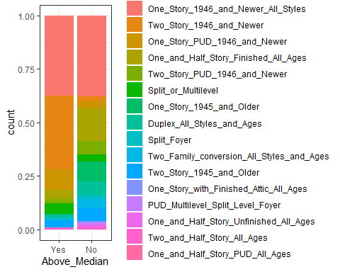

ggplot(ames, aes(x=Above_Median, fill = MS_Zoning)) + geom_bar(position = "fill") + theme_bw()

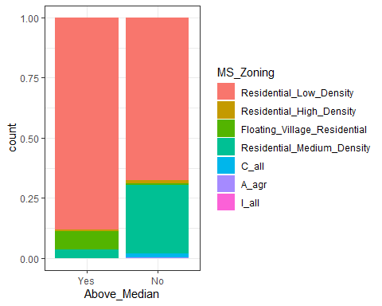

ggplot(ames, aes(x=Above_Median, fill = Street)) + geom_bar(position = "fill") + theme_bw()

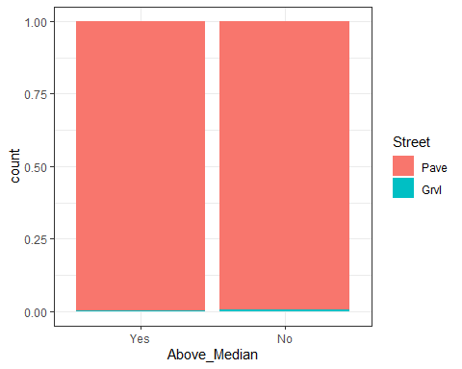

ggplot(ames, aes(x=Above_Median, fill = Alley)) + geom_bar(position = "fill") + theme_bw()

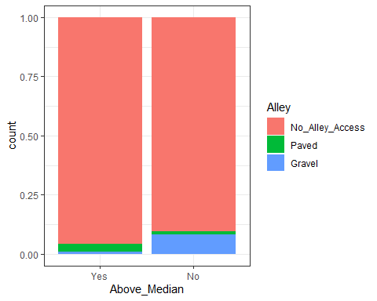

ggplot(ames, aes(x=Above_Median, fill = Lot_Shape)) + geom_bar(position = "fill") + theme_bw()

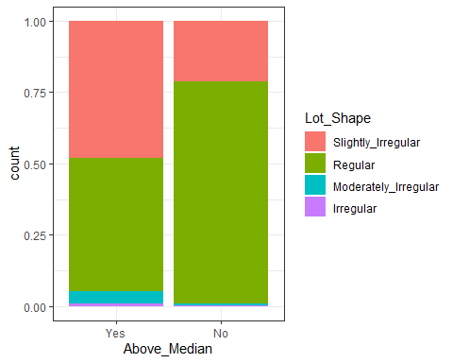

ggplot(ames, aes(x=Above_Median, fill = Land_Contour)) + geom_bar(position = "fill") + theme_bw()

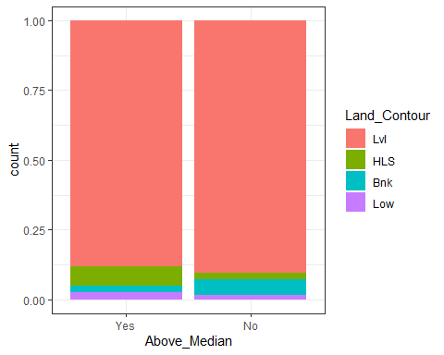

ggplot(ames, aes(x=Above_Median, fill = Utilities)) + geom_bar(position = "fill") + theme_bw()

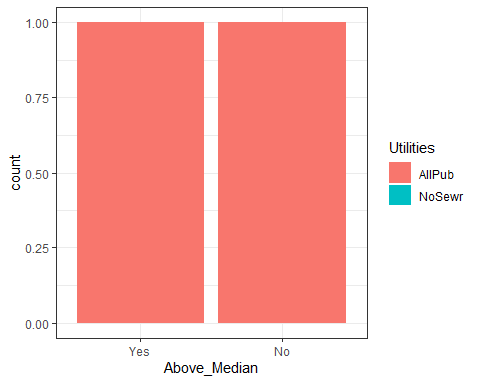

ggplot(ames, aes(x=Above_Median, fill = Lot_Config)) + geom_bar(position = "fill") + theme_bw()

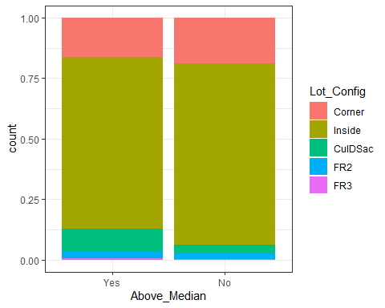

ggplot(ames, aes(x=Above_Median, fill = Land_Slope)) + geom_bar(position = "fill") + theme_bw()

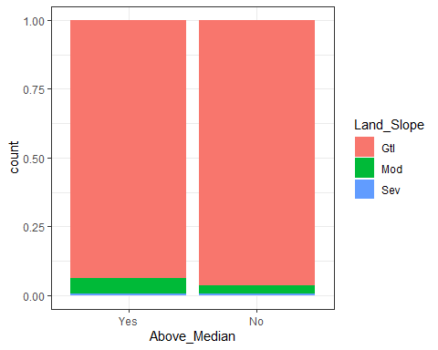

ggplot(ames, aes(x=Above_Median, fill = Condition_1)) + geom_bar(position = "fill") + theme_bw()

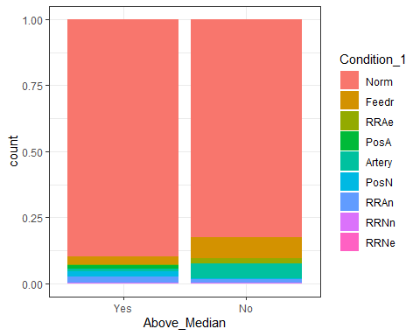

ggplot(ames, aes(x=Above_Median, fill = Condition_2)) + geom_bar(position = "fill") + theme_bw()

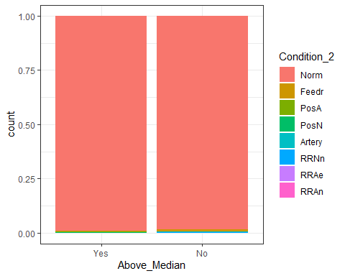

ggplot(ames, aes(x=Above_Median, fill = Overall_Qual)) + geom_bar(position = "fill") + theme_bw()

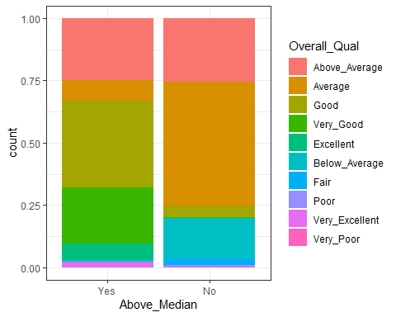

ggplot(ames, aes(x=Above_Median, fill = Overall_Cond)) + geom_bar(position = "fill") + theme_bw()

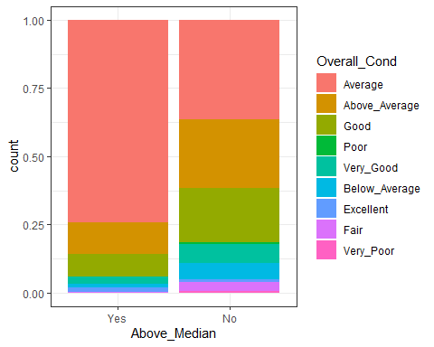

ggplot(ames, aes(x=Neighborhood, fill = Above_Median)) + geom_bar(position = "fill") +   
 theme(axis.text.x = element_text(angle = 90))

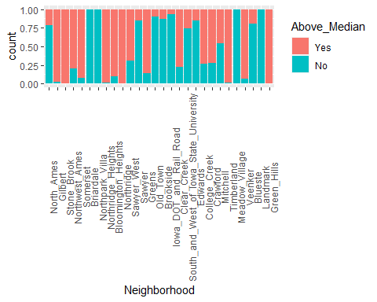

ggplot(ames, aes(x=Bldg_Type, fill = Above_Median)) + geom_bar(position = "fill") + theme_bw()+   
 theme(axis.text.x = element_text(angle = 90))

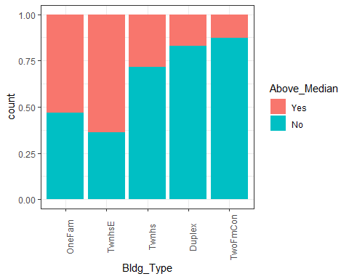

ggplot(ames, aes(x=House_Style, fill = Above_Median)) + geom_bar(position = "fill") + theme_bw()+   
 theme(axis.text.x = element_text(angle = 90))

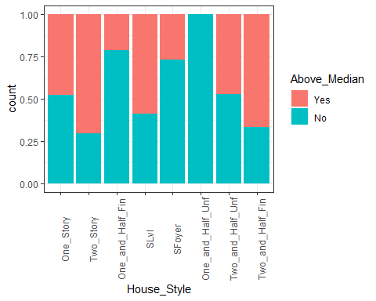

ggplot(ames, aes(x=Year_Built, fill = Above_Median)) + geom_bar(position = "fill") + theme_bw()+   
 theme(axis.text.x = element_text(angle = 90, vjust =0.5, hjust = 0.5))

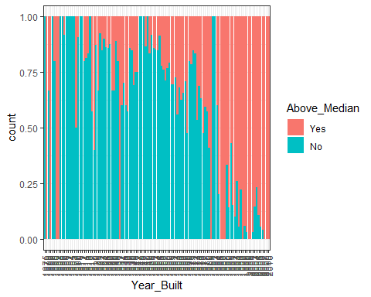

ggplot(ames, aes(x=Above_Median, fill = Year_Built)) + geom_bar(position = "fill") + theme_bw()

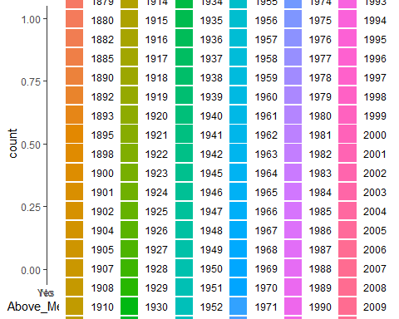

ggplot(ames, aes(x=Above_Median, fill = Year_Remod_Add)) + geom_bar(position = "fill") + theme_bw()

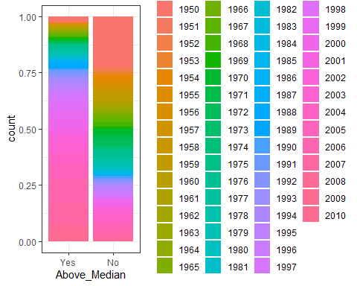

ggplot(ames, aes(x=Above_Median, fill = Roof_Style)) + geom_bar(position = "fill") + theme_bw()

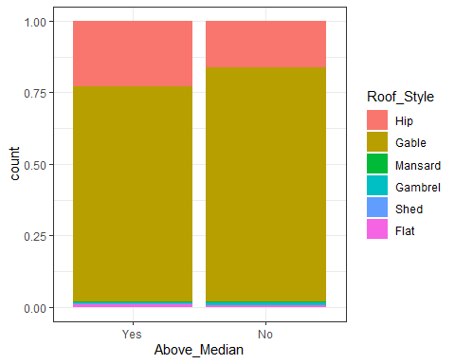

ggplot(ames, aes(x=Above_Median, fill = Roof_Matl)) + geom_bar(position = "fill") + theme_bw()

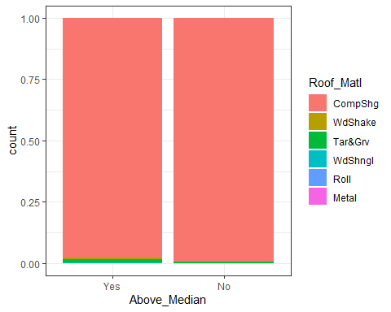

ggplot(ames, aes(x=Above_Median, fill = Exterior_1st)) + geom_bar(position = "fill") + theme_bw()

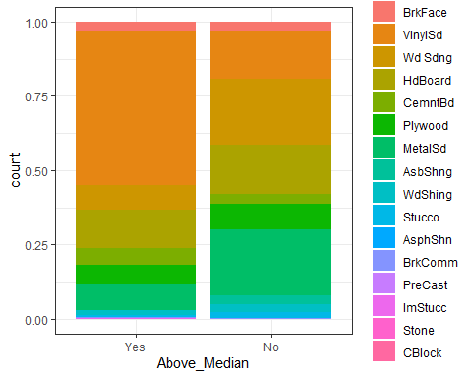

ggplot(ames, aes(x=Above_Median, fill = Exterior_2nd)) + geom_bar(position = "fill") + theme_bw()

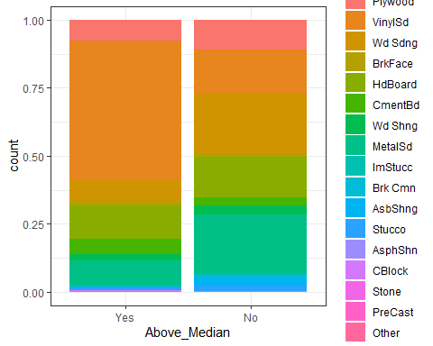

ggplot(ames, aes(x=Above_Median, fill = Mas_Vnr_Type)) + geom_bar(position = "fill") + theme_bw()

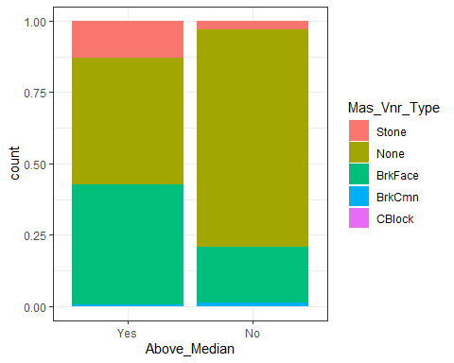

ggplot(ames, aes(x=Above_Median, fill = Exter_Qual)) + geom_bar(position = "fill") + theme_bw()

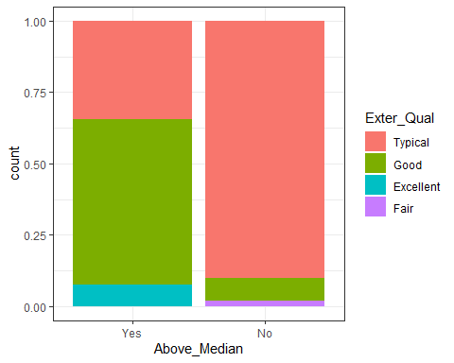

ggplot(ames, aes(x=Above_Median, fill = Exter_Cond)) + geom_bar(position = "fill") + theme_bw()

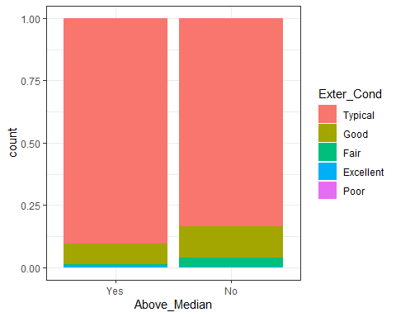

ggplot(ames, aes(x=Above_Median, fill = Foundation)) + geom_bar(position = "fill") + theme_bw()

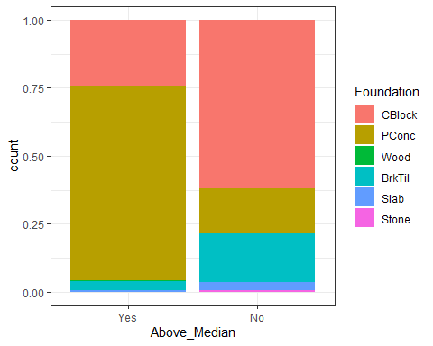

ggplot(ames, aes(x=Above_Median, fill = Bsmt_Qual)) + geom_bar(position = "fill") + theme_bw()

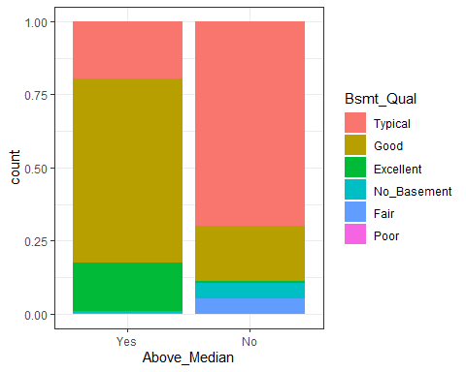

ggplot(ames, aes(x=Above_Median, fill = Bsmt_Cond)) + geom_bar(position = "fill") + theme_bw()

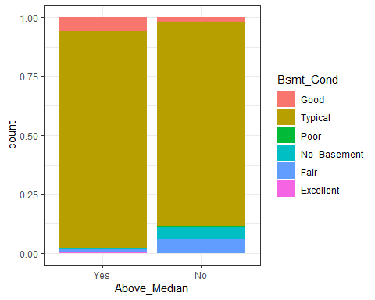

ggplot(ames, aes(x=Above_Median, fill = Bsmt_Exposure)) + geom_bar(position = "fill") + theme_bw()

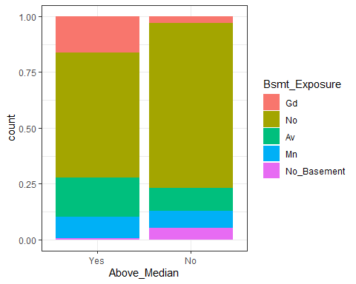

ggplot(ames, aes(x=Above_Median, fill = BsmtFin_Type_1)) + geom_bar(position = "fill") + theme_bw()

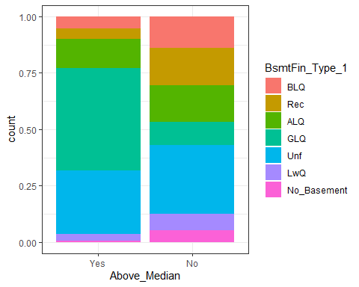

ggplot(ames, aes(x=Above_Median, fill = BsmtFin_Type_2)) + geom_bar(position = "fill") + theme_bw()

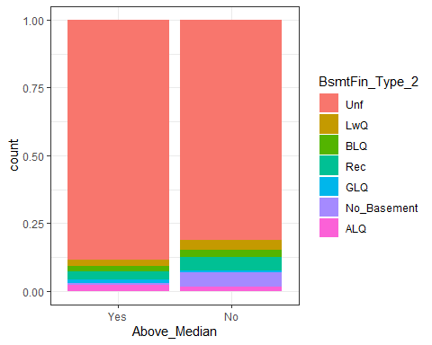

ggplot(ames, aes(x=Above_Median, fill = Heating)) + geom_bar(position = "fill") + theme_bw()

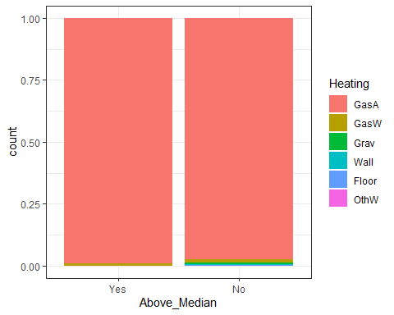

ggplot(ames, aes(x=Above_Median, fill = Heating_QC)) + geom_bar(position = "fill") + theme_bw()

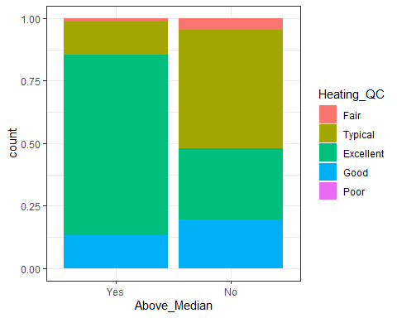

ggplot(ames, aes(x=Above_Median, fill = Central_Air)) + geom_bar(position = "fill") + theme_bw()

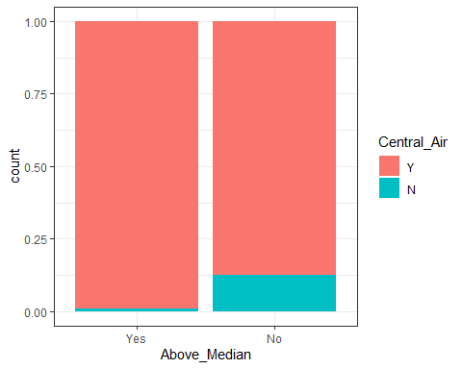

ggplot(ames, aes(x=Above_Median, fill = Electrical)) + geom_bar(position = "fill") + theme_bw()

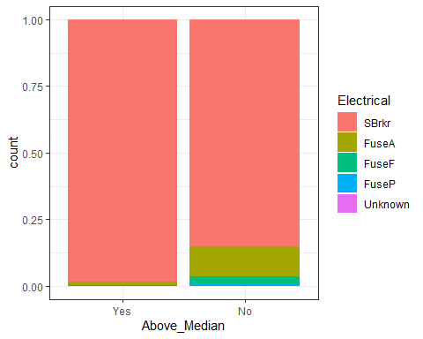

ggplot(ames, aes(x=Above_Median, fill = Bsmt_Full_Bath)) + geom_bar(position = "fill") + theme_bw()

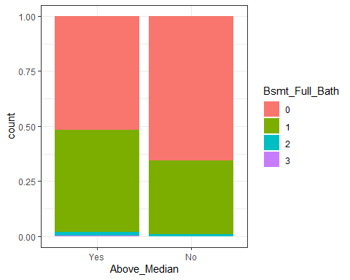

ggplot(ames, aes(x=Above_Median, fill = Bsmt_Half_Bath)) + geom_bar(position = "fill") + theme_bw()

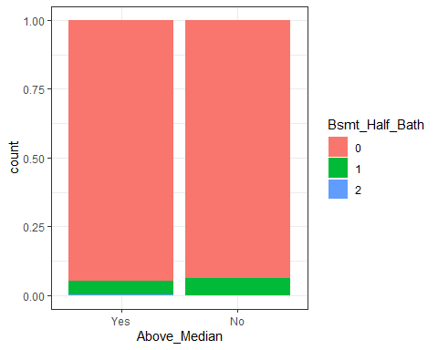

ggplot(ames, aes(x=Above_Median, fill = Full_Bath)) + geom_bar(position = "fill") + theme_bw()

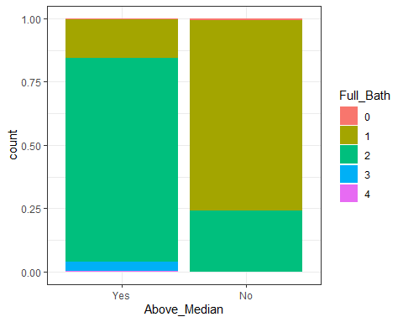

ggplot(ames, aes(x=Above_Median, fill = Half_Bath)) + geom_bar(position = "fill") + theme_bw()

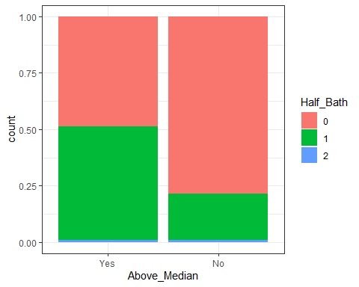

ggplot(ames, aes(x=Above_Median, fill = Bedroom_AbvGr)) + geom_bar(position = "fill") + theme_bw()

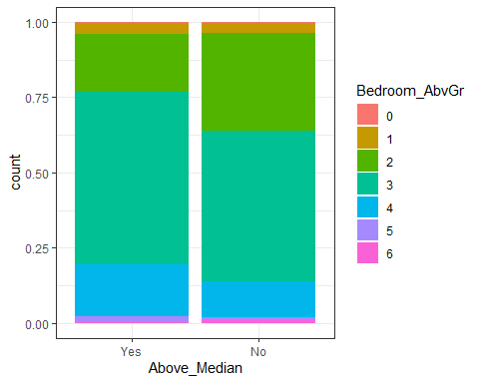

ggplot(ames, aes(x=Above_Median, fill = Kitchen_AbvGr)) + geom_bar(position = "fill") + theme_bw()

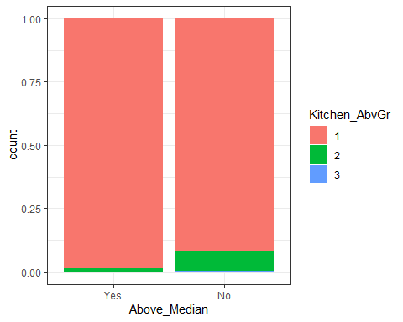

ggplot(ames, aes(x=Above_Median, fill = Kitchen_Qual)) + geom_bar(position = "fill") + theme_bw()

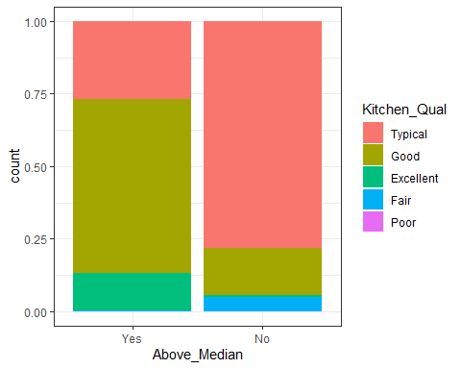

ggplot(ames, aes(x=Above_Median, fill = Functional)) + geom_bar(position = "fill") + theme_bw()

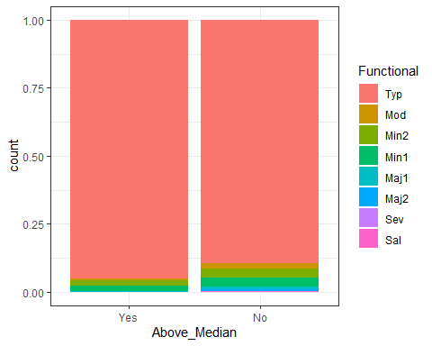

ggplot(ames, aes(x=Above_Median, fill = Fireplaces)) + geom_bar(position = "fill") + theme_bw()

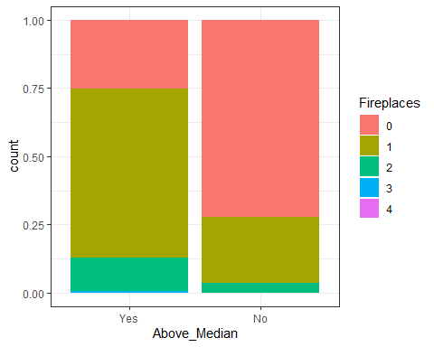

ggplot(ames, aes(x=Above_Median, fill = Fireplace_Qu)) + geom_bar(position = "fill") + theme_bw()

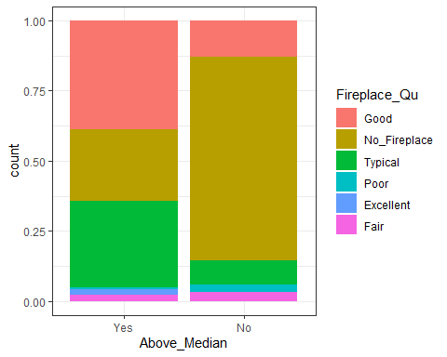

ggplot(ames, aes(x=Above_Median, fill = Garage_Type)) + geom_bar(position = "fill") + theme_bw()

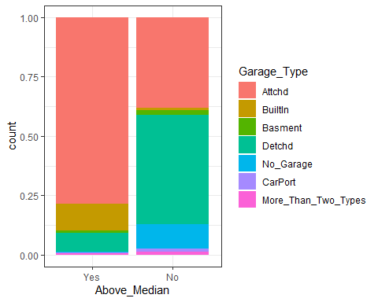

ggplot(ames, aes(x=Above_Median, fill = Garage_Finish)) + geom_bar(position = "fill") + theme_bw()

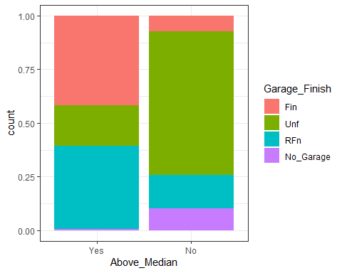

ggplot(ames, aes(x=Above_Median, fill = Garage_Cars)) + geom_bar(position = "fill") + theme_bw()

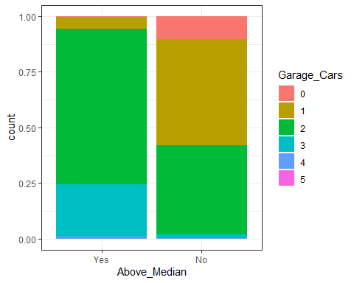

ggplot(ames, aes(x=Above_Median, fill = Garage_Qual)) + geom_bar(position = "fill") + theme_bw()

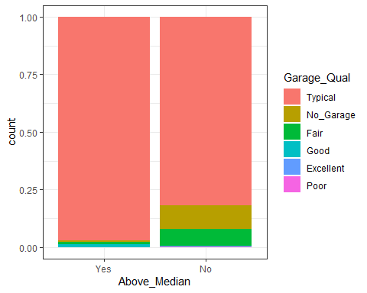

ggplot(ames, aes(x=Above_Median, fill = Garage_Cond)) + geom_bar(position = "fill") + theme_bw()

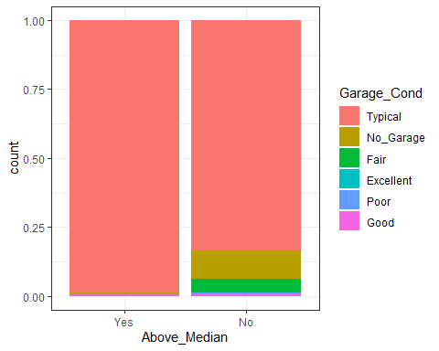

ggplot(ames, aes(x=Above_Median, fill = Paved_Drive)) + geom_bar(position = "fill") + theme_bw()

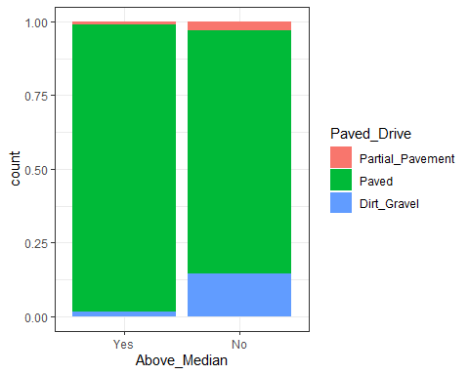

ggplot(ames, aes(x=Above_Median, fill = Pool_QC)) + geom_bar(position = "fill") + theme_bw()

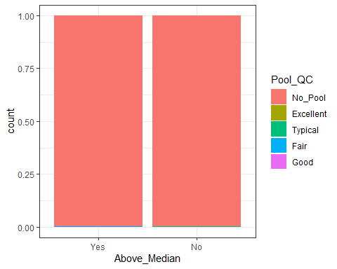

ggplot(ames, aes(x=Above_Median, fill = Fence)) + geom_bar(position = "fill") + theme_bw()

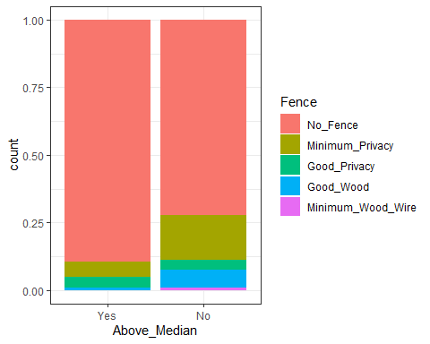

ggplot(ames, aes(x=Above_Median, fill = Misc_Feature)) + geom_bar(position = "fill") + theme_bw()

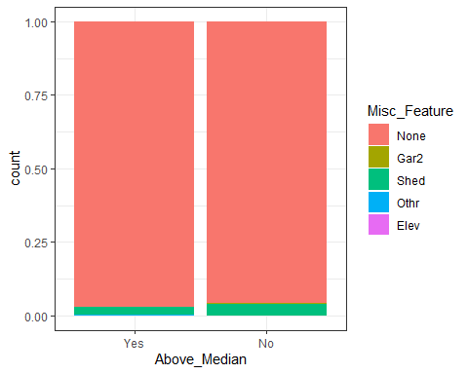

ggplot(ames, aes(x=Above_Median, fill = Mo_Sold)) + geom_bar(position = "fill") + theme_bw()

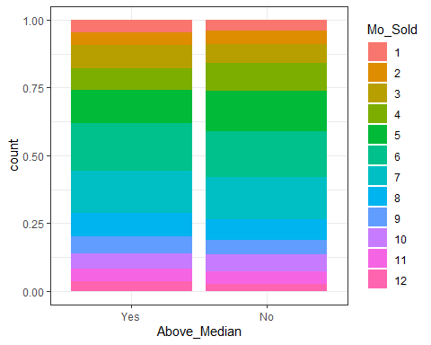

ggplot(ames, aes(x=Above_Median, fill = Year_Sold)) + geom_bar(position = "fill") + theme_bw()

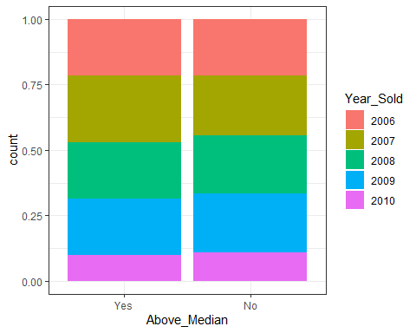

ggplot(ames, aes(x=Above_Median, fill = Sale_Type)) + geom_bar(position = "fill") + theme_bw()

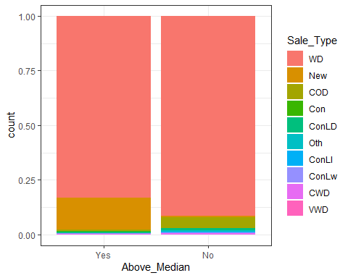

ggplot(ames, aes(x=Above_Median, fill = Sale_Condition)) + geom_bar(position = "fill") + theme_bw()

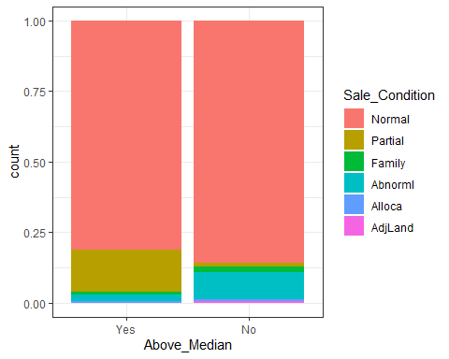

X1 = ggplot(ames, aes(x=Above_Median, y = Lot_Frontage)) + geom_boxplot() + theme_bw()  
  
X2 = ggplot(ames, aes(x=Above_Median, y = Lot_Area)) + geom_boxplot() + theme_bw()  
  
X3 = ggplot(ames, aes(x=Above_Median, y = Mas_Vnr_Area)) + geom_boxplot() + theme_bw()  
  
X4 = ggplot(ames, aes(x=Above_Median, y = BsmtFin_SF_1)) + geom_boxplot() + theme_bw()  
  
X5 = ggplot(ames, aes(x=Above_Median, y = BsmtFin_SF_2)) + geom_boxplot() + theme_bw()  
  
X6 = ggplot(ames, aes(x=Above_Median, y = Bsmt_Unf_SF)) + geom_boxplot() + theme_bw()  
  
X7 = ggplot(ames, aes(x=Above_Median, y = Total_Bsmt_SF)) + geom_boxplot() + theme_bw()  
  
X8 = ggplot(ames, aes(x=Above_Median, y = First_Flr_SF)) + geom_boxplot() + theme_bw()  
  
grid.arrange(X1, X2, X3, X4, X5, X6, X7, X8, ncol = 4)

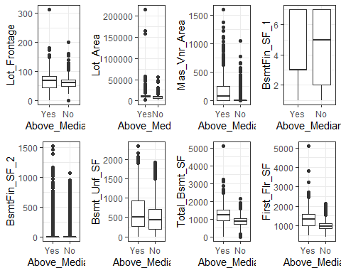

X9 = ggplot(ames, aes(x=Above_Median, y = Second_Flr_SF)) + geom_boxplot() + theme_bw()  
  
X10 = ggplot(ames, aes(x=Above_Median, y = Low_Qual_Fin_SF)) + geom_boxplot() + theme_bw()  
  
X11 = ggplot(ames, aes(x=Above_Median, y = Gr_Liv_Area)) + geom_boxplot() + theme_bw()  
  
X12 = ggplot(ames, aes(x=Above_Median, y = TotRms_AbvGrd)) + geom_boxplot() + theme_bw()  
  
X13 = ggplot(ames, aes(x=Above_Median, y = Garage_Area)) + geom_boxplot() + theme_bw()  
  
X14 = ggplot(ames, aes(x=Above_Median, y = Wood_Deck_SF)) + geom_boxplot() + theme_bw()  
  
X15 = ggplot(ames, aes(x=Above_Median, y = Open_Porch_SF)) + geom_boxplot() + theme_bw()  
  
X16 = ggplot(ames, aes(x=Above_Median, y = Enclosed_Porch)) + geom_boxplot() + theme_bw()  
  
grid.arrange(X9, X10, X11, X12, X13, X14, X15, X16, ncol = 4)

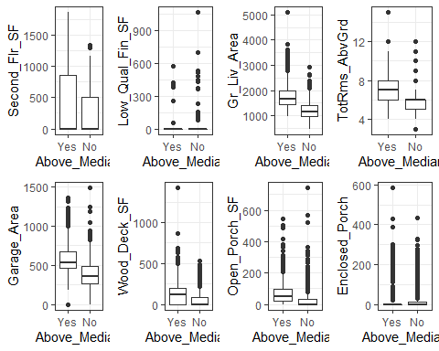

X17 = ggplot(ames, aes(x=Above_Median, y = Three_season_porch)) + geom_boxplot() + theme_bw()  
  
X18 = ggplot(ames, aes(x=Above_Median, y = Screen_Porch)) + geom_boxplot() + theme_bw()  
  
X19 = ggplot(ames, aes(x=Above_Median, y = Pool_Area)) + geom_boxplot() + theme_bw()  
  
X20 = ggplot(ames, aes(x=Above_Median, y = Misc_Val)) + geom_boxplot() + theme_bw()  
  
X21 = ggplot(ames, aes(x=Above_Median, y = Longitude)) + geom_boxplot() + theme_bw()  
  
X22 = ggplot(ames, aes(x=Above_Median, y = Latitude)) + geom_boxplot() + theme_bw()  
  
  
  
grid.arrange(X17, X18, X19, X20, X21, X22, ncol = 4)

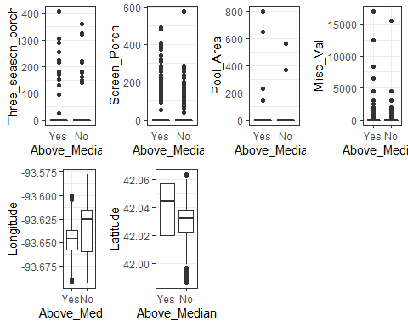

ggplot(ames, aes(x=Above_Median, y = Lot_Area)) + geom_boxplot() + theme_bw()

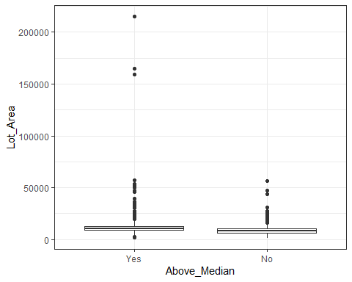

ggplot(ames, aes(x=Above_Median, y = Gr_Liv_Area)) + geom_boxplot() + theme_bw()

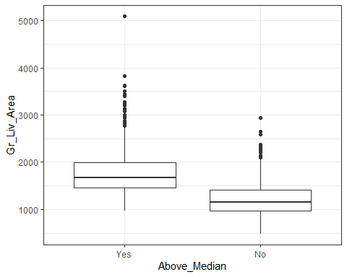

ggplot(ames, aes(x=Above_Median, y = Lot_Frontage)) + geom_boxplot() + theme_bw()

