Homework #5 535

Shayna Warner

11/21/2019

#Packages to load and set global options

#Load in Homicide data set

#load in data set, filter by city, select columns, rename   
homicide_data <- read.csv("data_HW5/homicide-data.csv") %>%  
 filter(city=="Denver") %>%  
 select(lat,lon,disposition,victim_race)  
Denver_data <- homicide_data

#Plot by zipcodes

#plot by zip codes  
  
denver_zipcodes <- zctas(cb=TRUE,starts_with=c("802"),class="sf")  
plot(denver_zipcodes)

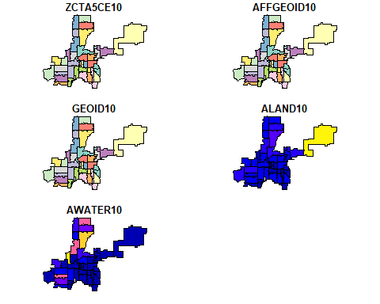

#Filter by race

#filter by race  
race <- Denver_data %>%  
 group_by(victim_race) %>%  
 mutate(count=n()) %>%  
 arrange(desc(count)) %>%  
 ungroup() %>%  
 filter(victim_race==c("Black","White","Hispanic"))  
race

## # A tibble: 100 x 5  
## lat lon disposition victim_race count  
## <dbl> <dbl> <fct> <fct> <int>  
## 1 39.8 -105. Open/No arrest Black 113  
## 2 39.8 -105. Closed by arrest Black 113  
## 3 39.8 -105. Open/No arrest Black 113  
## 4 39.7 -105. Open/No arrest Black 113  
## 5 39.8 -105. Closed by arrest Black 113  
## 6 39.7 -105. Closed without arrest Black 113  
## 7 39.8 -105. Closed by arrest Black 113  
## 8 39.8 -105. Closed by arrest Black 113  
## 9 39.8 -105. Open/No arrest Black 113  
## 10 39.8 -105. Closed without arrest Black 113  
## # ... with 90 more rows

#Set Denver with crs for zips

#set Denver with crs code for zips  
denver_crs <- race%>%  
 filter(!is.na(lat))%>%  
 st_as_sf(coords=c("lon","lat")) %>%  
 st_set_crs(4269)

#Seperate into solved vs unsolved

#seperate into solved vs unsolved and rename accordingly  
denver_disp <- denver_crs %>%  
 mutate(disposition= factor(disposition,levels = c("Closed without arrest",  
 "Closed by arrest",  
 "Open/No arrest"),  
 labels=c("unsolved","unsolved","solved")))  
denver_disp

## Simple feature collection with 100 features and 3 fields  
## geometry type: POINT  
## dimension: XY  
## bbox: xmin: -105.0603 ymin: 39.63327 xmax: -104.7514 ymax: 39.79665  
## epsg (SRID): 4269  
## proj4string: +proj=longlat +ellps=GRS80 +towgs84=0,0,0,0,0,0,0 +no_defs  
## # A tibble: 100 x 4  
## disposition victim_race count geometry  
## * <fct> <fct> <int> <POINT [°]>  
## 1 solved Black 113 (-104.9499 39.76179)  
## 2 unsolved Black 113 (-104.9309 39.75934)  
## 3 solved Black 113 (-104.9592 39.76442)  
## 4 solved Black 113 (-104.9108 39.73973)  
## 5 unsolved Black 113 (-104.8104 39.77525)  
## 6 unsolved Black 113 (-104.9003 39.6991)  
## 7 unsolved Black 113 (-104.9645 39.76563)  
## 8 unsolved Black 113 (-104.9915 39.75154)  
## 9 solved Black 113 (-104.9256 39.76356)  
## 10 unsolved Black 113 (-104.9887 39.755)  
## # ... with 90 more rows

#Final map

map<- ggplot()+  
 geom_sf(data = denver_zipcodes,color= "lightgray")+  
 geom_sf(data = denver_disp,aes(color=factor(victim_race)),show.legend='point')+  
 facet_wrap(~disposition,ncol=1)+  
 ggtitle("Homicide cases in Denver, Co")+  
 labs(x="Longitude",y="Latitude")+  
 theme(axis.text.x=element_text(angle=90,hjust=1))+  
 labs(colour="Victim Race")  
  
  
map

