Section |  | Informatics · 10-A, 10-B, 10-C, 10-D · Week 24 · 10-A 03.03.2026 (Tuesday); 10-B 03.03.2026 (Tuesday); 10-C 26.02.2026 (Thursday); 10-D 26.02.2026 (Thursday)
Teacher name |  | Süleyman Tongut
Date |  | 10-A 03.03.2026 (Tuesday); 10-B 03.03.2026 (Tuesday); 10-C 26.02.2026 (Thursday); 10-D 26.02.2026 (Thursday)
Grade: 10 |  | Present: | Absent:
Lesson topic |  | Software, Quiz
Learning objectives (curriculum link) |  | Explain the core concepts of Software, Quiz using correct terminology. Identify key components, roles, or stages related to Software, Quiz. Analyze a real-world example where Software, Quiz is applied. Compare two representations or approaches within Software, Quiz. Apply Software, Quiz concepts to a short practical task or scenario.
Lesson goal |  | Students will be able to: Explain the core concepts of Software, Quiz using correct terminology. Identify key components, roles, or stages related to Software, Quiz. Analyze a real-world example where Software, Quiz is applied. Compare two representations or approaches within Software, Quiz. Apply Software, Quiz concepts to a short practical task or scenario.
Success criteria |  | Uses technical vocabulary accurately in explanations. Identifies correct components or stages of Software, Quiz. Provides a valid real-world example and justification. Completes the practice task with clear reasoning.
45 minutes
Lesson stages | Teacher activity |  |  | Student activity | Assessment | Resources
Organizational stage | Organizational stage (5 min): Starter: Present a short real-world case related to Software, Quiz (news, product, or school system). Ask guiding questions to activate prior knowledge. Teacher: Define Software, Quiz and outline the lesson goals. Students: Share what they already know or have used. |  |  | Students: Share what they already know or have used. | Observation during discussion and practice. Short written check: 3-5 questions on key concepts. Oral Q&A on real-world application. | Lesson visual
New material | New material (30 min): Explain the main concepts and components of Software, Quiz with a clear diagram. Show a real-world example and map it to the concepts. Discuss advantages, limitations, or common issues. Teacher: Model a simple analysis or walkthrough. Students: Take notes and answer quick concept checks. Case task: Students analyze a short scenario and identify how Software, Quiz is used. Small group: Build a mini summary (3-4 bullet points) of key ideas. Teacher: Provide feedback and clarify misconceptions. |  |  | Students: Take notes and answer quick concept checks. | Observation during discussion and practice. Short written check: 3-5 questions on key concepts. Oral Q&A on real-world application. | 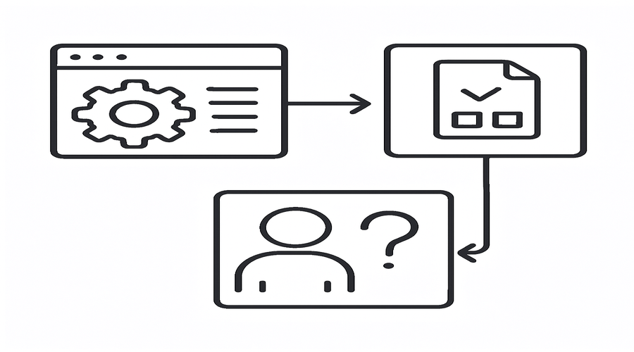
Reflection | Reflection (10 min): Which concept was most challenging for students? Which example worked best to explain Software, Quiz? What should be improved for the next lesson? |  |  | Find a real-world case where Software, Quiz is used and write a 150-200 word summary. Create a one-page study sheet with definitions, components, and one diagram of Software, Quiz.

