Section |  | Informatics · 5-A · Week 32 · 05.05.2026 (Tuesday)
Teacher name |  | Süleyman Tongut
Date |  | 05.05.2026 (Tuesday)
Grade: 5 |  | Present: | Absent:
Lesson topic |  | Creating shared folders and files
Learning objectives (curriculum link) |  | Distinguish information from data using simple classroom examples. Identify at least four forms of information (text, image, sound, numbers, video). Match a real-world message to multiple forms of presentation. Use key vocabulary in short explanations about Creating shared folders and files. Explain why the same idea can be shown in different formats.
Lesson goal |  | Students will be able to: Distinguish information from data using simple classroom examples. Identify at least four forms of information (text, image, sound, numbers, video). Match a real-world message to multiple forms of presentation. Use key vocabulary in short explanations about Creating shared folders and files. Explain why the same idea can be shown in different formats.
Success criteria |  | Correctly classifies examples into information forms with minimal errors. Gives at least two real-life examples related to Creating shared folders and files. Uses key terms accurately when answering oral questions. Completes the practice task and labels each example clearly.
45 minutes
Lesson stages | Teacher activity |  |  | Student activity | Assessment | Resources
Organizational stage | Organizational stage (5 min): Hook: Show a simple message in two or three forms (written note, picture, spoken sentence). Ask: What is the same? What is different? Connect to daily life: announcements, signs, phone notifications, or classroom rules. Teacher: Define Creating shared folders and files with a simple example. Students: Share one place they see information today. |  |  | Students: Share one place they see information today. | Observation during sorting task. Oral Q&A: Students define Creating shared folders and files and name two forms with examples. Quick check: 3 short questions (match example to form). | Lesson visual
New material | New material (30 min): Explain the idea: Creating shared folders and files can be presented in different forms that keep the same meaning. Show examples: weather (icon, text, number), school rules (poster, spoken reminder). Introduce forms: text, numbers, images, sound, video with one example each. Mini-demo: Take one message and show it as text, picture, and spoken message. Link to systems: input ? process ? output using a simple classroom example. Students: Identify the form of each example shown on the board. Sorting task: Students label examples as text, image, sound, number, or video. Pair share: Compare labels and explain one choice to a partner. Teacher: Review two examples together and correct misconceptions. Extension: Students add two examples from their own experience. |  |  | Students: Identify the form of each example shown on the board. | Observation during sorting task. Oral Q&A: Students define Creating shared folders and files and name two forms with examples. Quick check: 3 short questions (match example to form). | 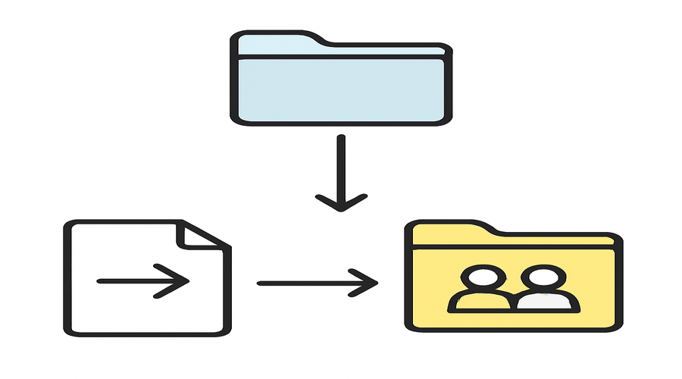
Reflection | Reflection (10 min): Which examples were easiest for students to classify? Which form (text/image/sound/number/video) needs more practice? What should be adjusted for the next lesson? |  |  | Find 3 real-life examples of information at home or school and write 1 sentence for each. Create a small poster that shows the same idea in two different forms (text + picture).

