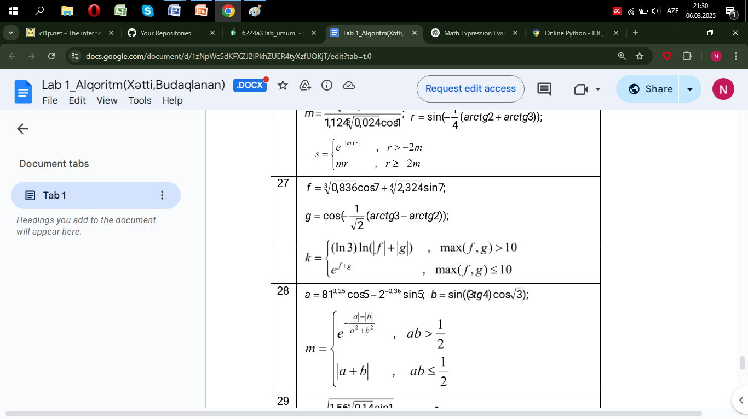

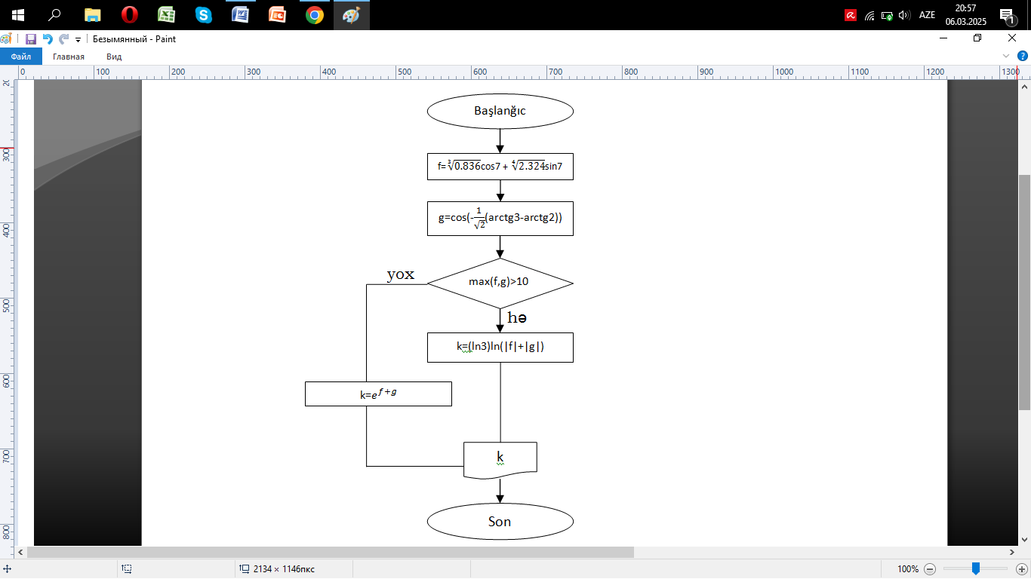

import math

f=(0.836)\*\*(1/3)\*(math.cos(7)) + (2.324)\*\*(1/4)\*math.sin(7)

g=math.cos(-1/(2\*\*1/2)\*(math.atan(3)-math.atan(2)))

if max(f,g)>10:

k=math.log(3)\*math.log(abs(f)+abs(g))

else:

k=math.exp(f+g)

print(k)