Kafka Deployment and Publisher/Consumer for REST based Services

Project by-
Karuna Nidhan Upadhyay (MT2018048)
Rahul Kumar Rai (MT2018089)
Harsh Tripathi (MT2018039)

1.Kafka Introduction
Messaging System : A Messaging System is responsible for transferring data from one application to another, so the applications canfocus on data, but not worry about how to share it.
Distributed messaging is based on the concept of reliable message queuing. Messages are queued asynchronously between client applications and messaging system.

Apache Kafka is a distributed messaging system and a robust queue that can handle a high volume of data and enables you to pass messages from one end point to another.

Zookeeper is a service that helps Kafka to maintain the information about the current state of the consumers and helps in the management of coordination of Kafka system.

Broker: Kafka cluster typically consists of multiple brokers to maintain load balance. Kafka brokers are stateless, so they use ZooKeeper for maintaining their cluster state. Also Zookeeper sends notification to the producer and consumer regarding any failure of the brokers.

Producer: Producers push data to brokers. When the new broker is started, all the producers search it and automatically sends a message to that new broker.

Consumer: Consumers read data from brokers. Consumers subscribes to one or more topics and consume published messages by pulling data from the brokers.

Topic: A stream of messages belonging to a particular category is called a topic. Data is stored in topics.

2.Kafka deployment
Start the Zookeeper service first and then start the kafka server. Detail explaination is given in readme.md file of submitted github link.

Zookeeper running:
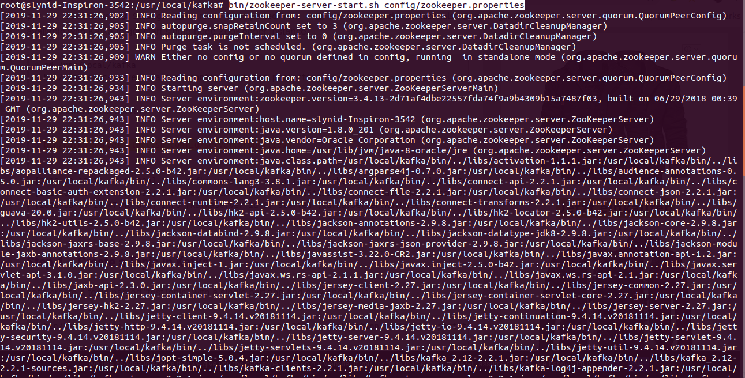

Kafka running:

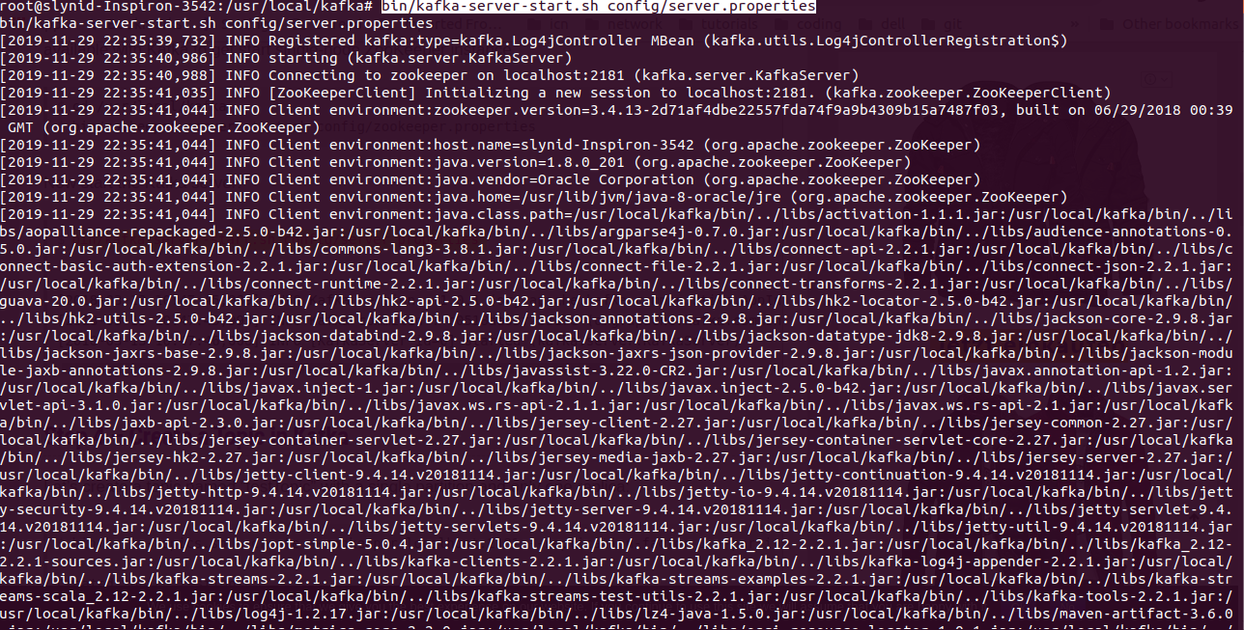

3. Topic
Creating and listing topic:
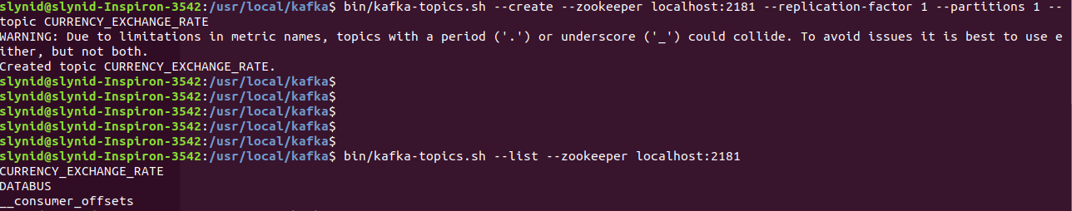

4. Elastic Search

Running status:
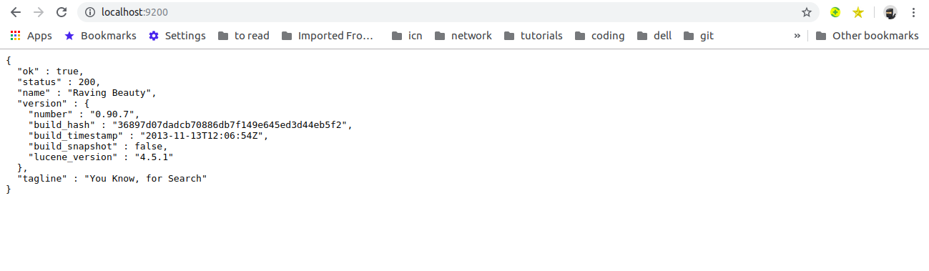

showing data in elastic search:
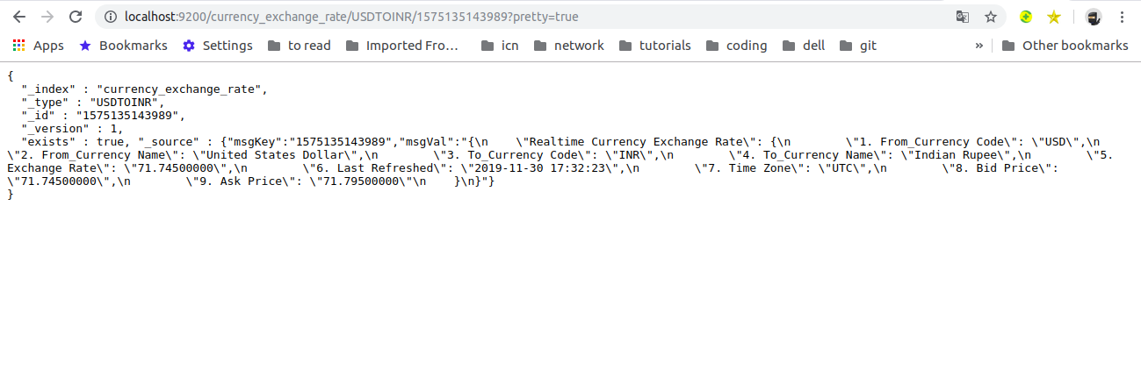

5. Consumer 1

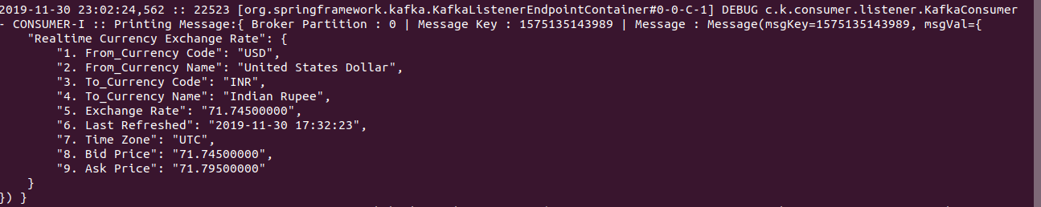

6. Consumer 2

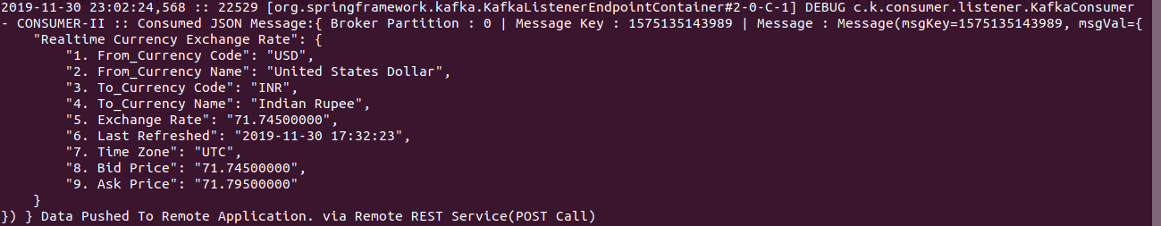

7. Consumer 3

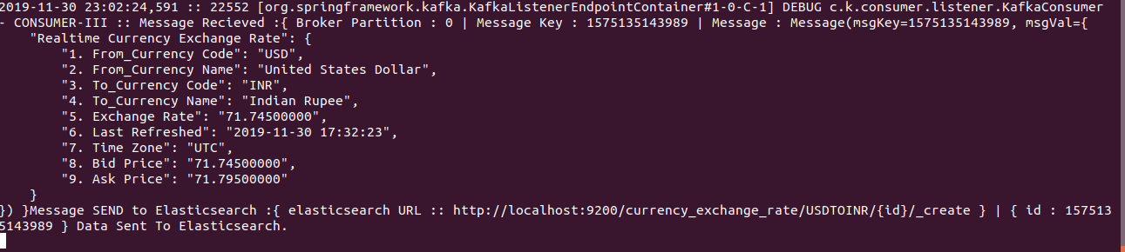

8. Github link: https://github.com/slynid/SDN-Project-Kafka-Deployment

