

Documentation

Ibragimov Atai, Olimov Mukhammad, Kabiyev Raiymbek

W65934 , W68655 ,W68636

***1***

**Table Of Contents**

Beginning…………………..…………………………………………………………………………………………………………..…………...1

Table of Contents………………………..……………………………………………………………………………………………..………..2

Introduction/Project Overview/Technologies used….……….…………………………………………………………..……..3

Functional Requirements/ Non-Functional Requirements ……………………………………………………………………4

Screenshots………………………………………………………………………………………………………………………………………....5

Conclusio………………………………………………………………………………………………………………………………….............6

***2***

### Introduction

The **Decentralized Freelance Marketplace** project aims to revolutionize how freelancers and clients interact by leveraging blockchain technology. It provides a secure, transparent, and trustless environment where freelancers can offer their services and clients can hire them without the need for traditional intermediaries.

**Project Overview**

The decentralized freelance marketplace allows freelancers to list their services categorized into various fields like web development, graphic design, AI services, content writing, and more. Clients can browse these services, connect with freelancers, and securely transact using smart contracts.

**Technologies Used**

Solidity: Ethereum's smart contract language used for defining the marketplace's logic on the blockchain.

HTML/CSS/JavaScript: Front-end technologies for creating the user interface and client-side interactions.

Metamask: Browser extension enabling users to connect their Ethereum wallets to interact with the marketplace.

Web3.js: JavaScript library facilitating communication with the Ethereum blockchain from the front-end.

FontAwesome: Icon toolkit used for enhancing the visual elements and user experience.

.

***3***

**Functional Requirements**

1. **Deposit Functionality**

Description: Users can deposit cryptocurrency into their wallet on the platform.

Implementation: Smart contract function deposit(uint256 amount) ensures secure handling of deposited funds.

1. **Initiate and Finalize Transfers**

Description: Freelancers can initiate transfers of funds to clients upon completing tasks.

Implementation: Functions startTransfer(address to, uint256 amount) and finalizeTransfer(address from, address to, uint256 amount, uint256 rollupBlock) handle the transfer process securely.

1. **Advance Rollup Block**

Description: Operator can advance the rollup block number for batch processing of transactions.

Implementation: Function advanceRollupBlock() facilitates efficient handling of multiple transactions within a single blockchain block.

1. **Dispute Resolution**

Description: Mechanism for resolving disputes between freelancers and clients.

Implementation: Placeholder function disputeTransfer() designed for future implementation of dispute resolution logic.

**Non-Functional Requirements**

1. **Security**

Description: Ensure smart contracts are secure against potential vulnerabilities and attacks.

Implementation: Adherence to best practices in smart contract development, including thorough testing and possibly audits.

1. **User Experience**

Description: Create an intuitive and user-friendly interface for seamless navigation and interaction.

Implementation: Styling with CSS, inclusion of FontAwesome icons, and responsive design to enhance usability.

1. **Performance**

Description: Optimize transaction processing and scalability to handle a large volume of transactions efficiently.

Implementation: Continuous optimization of smart contract functions and front-end interactions to ensure smooth performance.

***4***

**Screenshots**

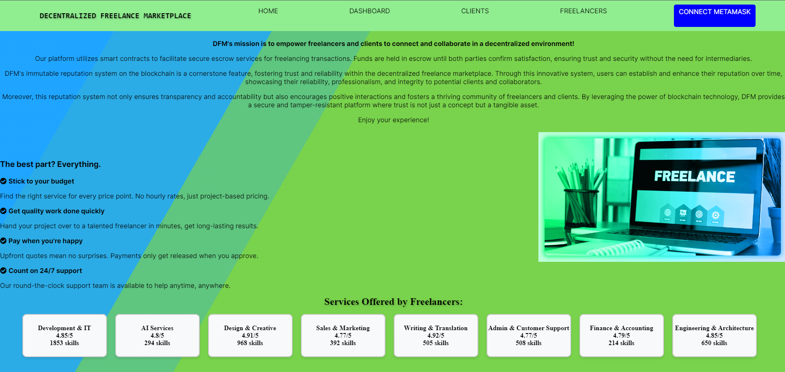 1)project screen

1)Here, you can explore the site's functionality and review its design. 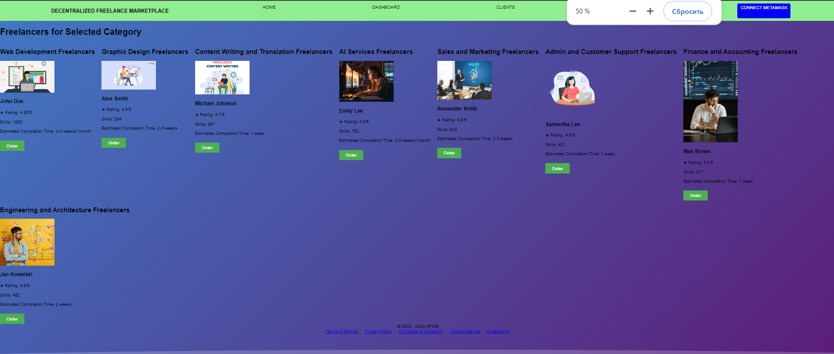2)second screen of project workd

2)Here you can order.

***5***

### Conclusion

The Decentralized Freelance Marketplace represents a groundbreaking approach to the freelance economy, leveraging blockchain technology to redefine how freelancers and clients interact. By eliminating intermediaries and enhancing transparency, security, and trust through smart contracts, this platform empowers freelancers to showcase their skills and clients to access a global pool of talent with confidence.

With its robust architecture built on Solidity smart contracts and integrated with user-friendly front-end technologies like HTML, CSS, JavaScript, and Metamask, the marketplace offers a seamless user experience. Features such as secure deposits, streamlined fund transfers, and future-proof dispute resolution mechanisms ensure reliability and efficiency in every transaction.

Looking ahead, our commitment to continuous improvement includes enhancing security measures, optimizing performance, and refining user interfaces to meet evolving user needs. The Decentralized Freelance Marketplace not only addresses current challenges in the freelance industry but also sets a new standard for decentralized applications, fostering a community-driven ecosystem where integrity and innovation thrive.

Join us in reshaping the freelance landscape, where collaboration is empowered, transactions are secure, and opportunities are limitless.