**Assignment-3**

**ID. 22301182**

**Task-01**

select customer.customer_name, loan.loan_number from customer inner join borrower on customer.customer_id=borrower.customer_id inner join loan on loan.loan_number=borrower.loan_number where branch_name='Downtown';

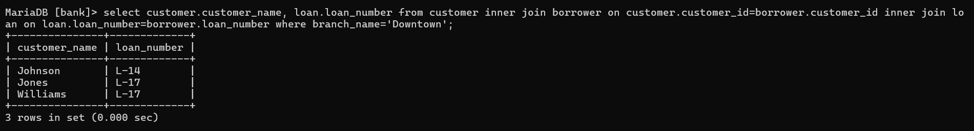

**Task-02**

select c1.customer_name as Customer1, c2.customer_name as Customer2, c1.customer_city as City from customer c1 inner join customer c2 on c1.customer_city=c2.customer_city and c1.customer_id<c2.customer_id;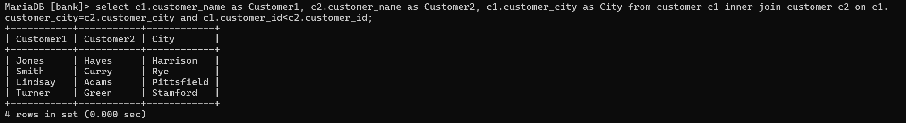

**Task-03**

select branch_name, sum(balance*0.04) as total_interest from account group by branch_name;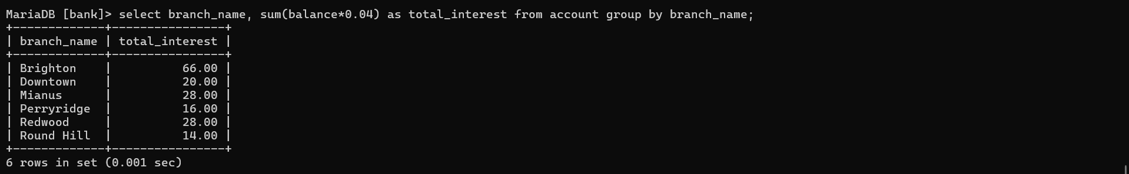

**Task-04**

select a1.account_number from account a1 inner join branch b1 on a1.branch_name=b1.branch_name where a1.balance=(select max(a2.balance) from account a2 inner join branch b2 on a2.branch_name=b2.branch_name where b1.branch_city=b2.branch_city);

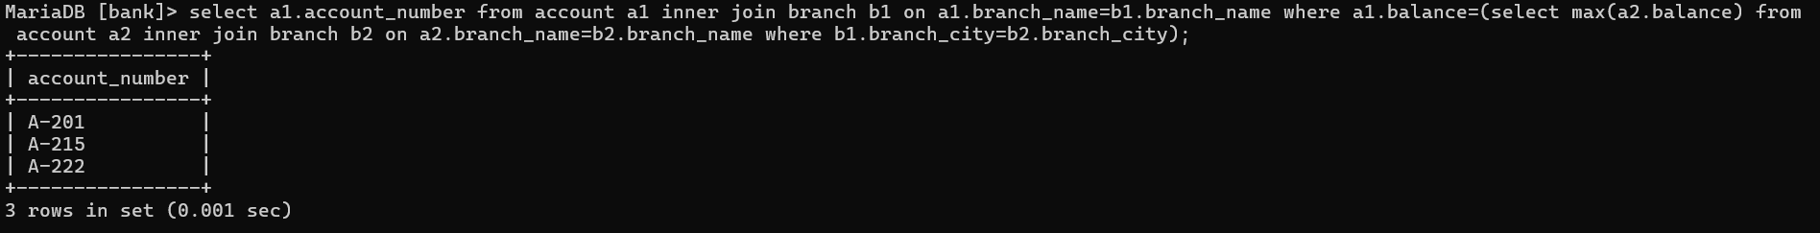

**Task-05**

select l.loan_number, l.amount as loan_amount, c.customer_name from loan l inner join borrower b on l.loan_number=b.loan_number inner join customer c on b.customer_id=c.customer_id order by l.amount desc, l.loan_number asc limit 5;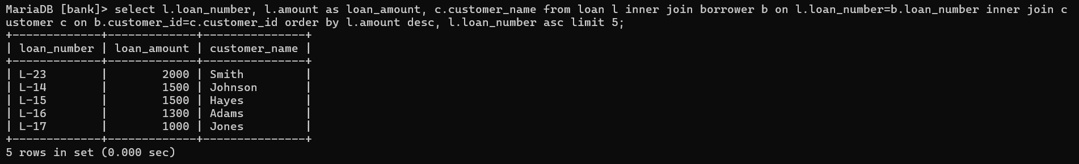

**Task-06**

select distinct c.customer_name from customer c inner join depositor d on c.customer_id=d.customer_id inner join account a on d.account_number=a.account_number inner join loan l on a.branch_name=l.branch_name where a.branch_name='Perryridge' and l.branch_name='Perryridge';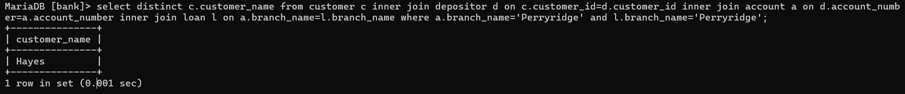

**Task-07**

select c.customer_name, sum(l.amount) as total_loan from customer c inner join borrower b on c.customer_id=b.customer_id inner join loan l on b.loan_number=l.loan_number group by c.customer_name having count(b.loan_number)>=2;

