**Premier University**

***Dept. of Computer Science & Engineering***

|  |
| --- |
| **Pharmacy Management System** |



**Mr. Dhrubajyoti Das**

***Lecturer Department of Computer Science Engineering (CSE)***

***PREMIER UNIVERSIRTY, CHITTAGONG***

***12th November - ©2022***

|  |
| --- |
| **Submitted by** |
| ***Name*  : *Sayed MD. Sadik Iqbal Akil***  ***Miraj Hossain***  ***ID* : *1803510201664***  ***1803510201749***  ***Batch*  : *35th***  ***Course* : *SEISDL***  ***Semester*  : *5th(B1)***  ***Submission Date* : *13th November 2022*** |

***Signature: ______________***

***Date: ________________***

***Table of Contents* *:***

***1. Introduction.***

***2. SRS Report.***

***3. Implementation.***

***4. Limitations and future works.***

***5. Conclusion.***

***6. Reference.***



***ACKNOWLEDGEMENT***

***We are extremely grateful and remain indebted to our honorable teacher Mr. Dhrubajyoti Das for being a source of inspiration and for his constant support in the Design, Implementation and Evaluation of the project. We also thankful to him for his constant constructive criticism and invaluable suggestions, which benefited me a lot while developing the project on "Pharmacy Management System"***

***INTRODUCTION* :**

***Pharmacy Management System is application to help pharmacist to manage pharmacy in the systematic ways. Pharmacy Management System can make the work easier by giving the details of medicine when its name is entered. A computer gives the details of the machine-like rate of medicine and expiry date of the medicine. It becomes very difficult in big medical stores to handle the details of all the medicine manually. So, by using the pharmacy management system, we can maintain the all records of all the medicine. It is fed with the information whenever new medicines are bought and its id provided with proper expire date with search option. When we entire the name of Medicine it gives the details of medicine.***

***The Pharmacy Management System application has more benefits, Easy to find medicine because we use strong search option and easy to add medicine, medicine type, medicine deadline and also delete and modify option its help to both of customer and pharmacist. We add four categories of user. We use four different types of users.***

***Types of users are:***

***1. ADMIN***

***2. MANAGER***

***3. CUSTOMER***

***4. SUPPLIER***

***The application is reduced as much as possible to avoid errors while entering the data. It as provides error message which entering invalid data. No formal knowledge is needed for the users to use this system•***

***SRS Report* :**

***In Software Requirement Specification, we can discuss about Problem statement, Features, Overview of existing System, Others required diagram :***

***Problem Statement :* *First, selecting the suitable medicine for the type of illness is usually take time and makes the patient or customer waiting. Therefore, the time is waste for the customer to be waiting.***

***Second, for the medicines stock management, the pharmacist must check it manually and no warning message for the medicine that decrease to finish. So, Pharmacy Management System provide the advantage to setup the process in selecting and alert program to warn about the medicine stock.***

***Finally, yet important, no analyses are done for the frequency type of medicine usually buy by the customer or patient at that area. This is also important to determine the medicines that are demanded more from the customers so that pharmacist can be prepared to order more for that type of medicine.***

***Discuss about Features****,*

***Reporting : Creating and maintaining employee working records is a key HR responsibility in any organization. Basic report generation, such as the billing, overtime, total working time, total payment etc. should be available in an exportable report format*.**

***Calendar integration : A pharmacy management system can also be synced with digital calendars such as Google Calendar, Outlook, and the like. This lets everyone on the team know about a person’s availability. Calendar integrations are especially relevant for remote teams where you can simply check on a person’s attendance via a shared calendar.***

***Mobile and cloud support : A cloud-based Pharmacy management system is widely accessible from any device. This also implies a browser integration – which means the system can be opened without installing an app. Also, a mobile platform could help boost field workers and remote employee productivity, enabling accurate information capture from any location.***

***Discuss about existing system,***

***Overview of existing System : The traditional pharmacy is more time-consuming and traditional paper based System Pharmacy Check is an earlier online pharmacy which created in 2003. Now there are lots of Pharmacy in Bangladesh.***

***1. There are so way to find medicine by depends on user reviews.***

***2. Existing systems are less efficient.***

***Others required diagram*s are given billow,**

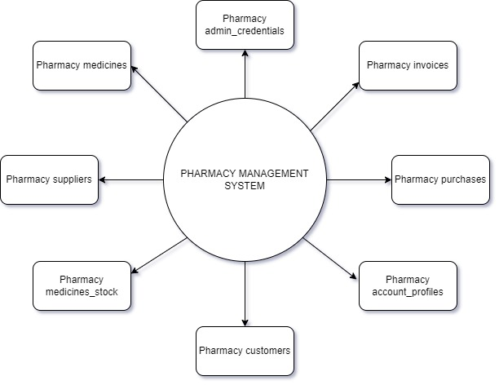*Data flow Diagram* ***:***

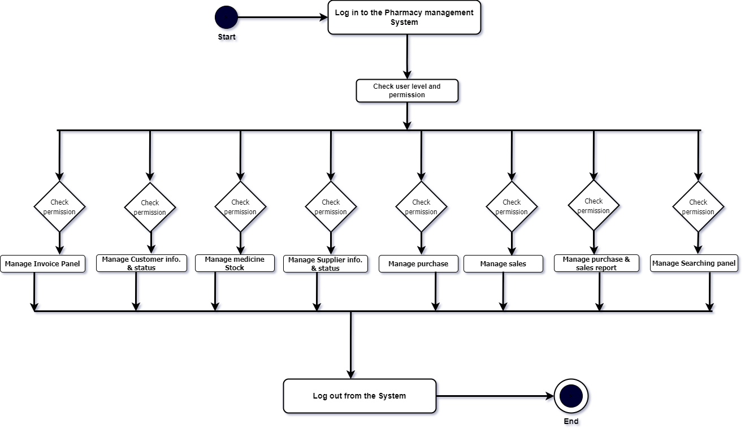*Activity Diagram* ***:***

***Use case Diagram :***

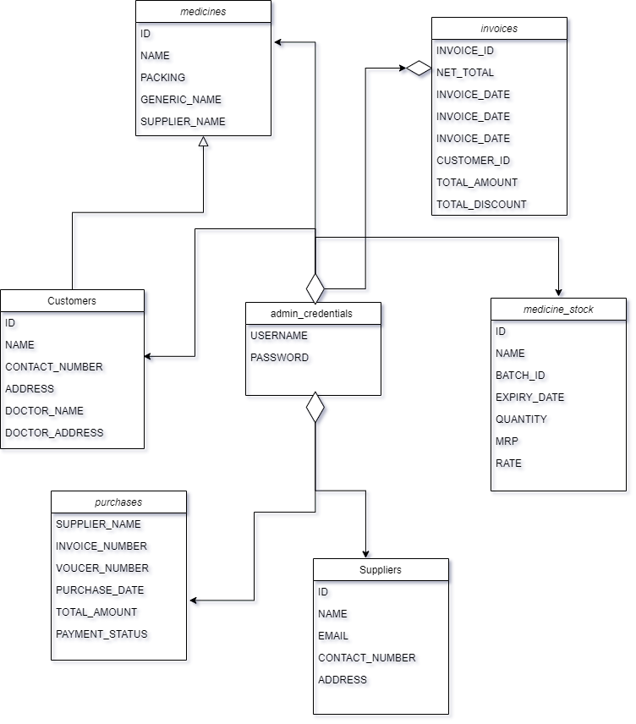*Class Diagram* ***:***

*Use case Diagram* ***:***

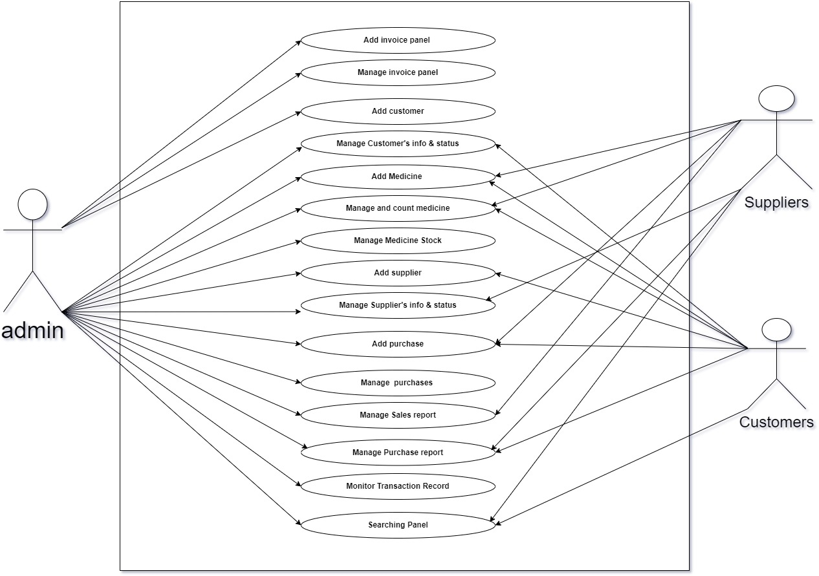

*Log in Flowchart Diagram* ***:***

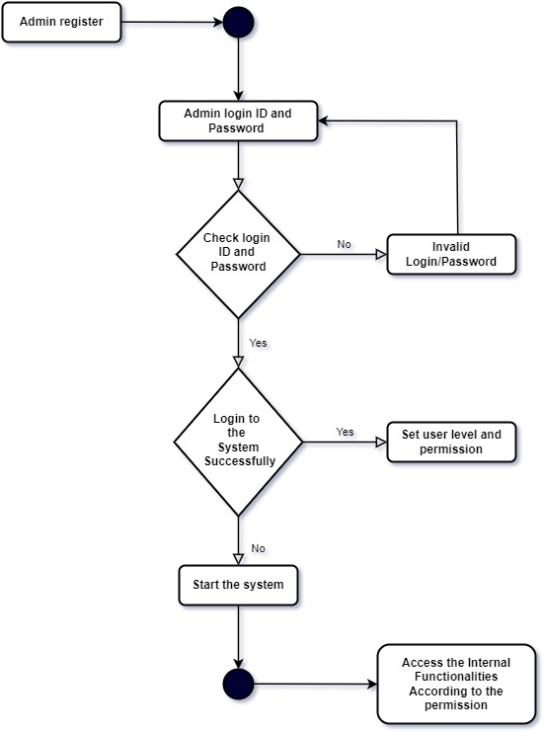

***Implementation* :**

**System Implementation** **: *The tools and technologies used during the development and implementation of my project include : -***

* **Programming & Scripting Languages ​​used : -**

**HTML :**

***HTML AND CSS HTML stands for Hypertext Markup Language and CSS stands for Cascading Style Sheets are the crucial technologies for creating web pages. HTML supplies the structure of the page, and CSS the layout, for diversity of devices. Together with scripting and graphics, HTML and CSS are the fundamental of building Web Applications and Web pages. HTML provides designers and developers the following facilities,***

***1. To design forms for directing transactions with remote services, for use in making reservation, searching for information, ordering products,***

***and others.***

***2. Retrieving online information through hypertext links.***

***3. To include video and sound clips, spread sheets, and other applications straight in their documents.***

***4. Designer can publish online documents with text, headings, tables, photos and others.***

**JavaScript :**

***JavaScript Framework (jQuery), jQuery is JavaScript library intended to make simple the client-side scripting of HTML. It is the most popular***

***JavaScript framework, which is free and open-source software licensed***

***under the MIT License. Several of the largest companies, including…***

***1. Google***

***2. IBM***

***3. Microsoft and Netflix are using the jQuery.***

**Frame Work :**

***Frameworks Bootstrap is front-end framework and collection of tools and mechanisms for building web applications. It consists of HTML and CSS based design templates for navigations, forms, logo, buttons, typography, and other interface elements, and also JavaScript extensions.***

***Bootstrap is free and open source, and its purpose is to make the easy development of dynamic websites and web applications. It is the most***

***starred project on GitHub, with more than 85,000 stars and 34,000 forks.***

***Bootstrap was developed by Mark Otto and Jacob Thomson and named***

***Twitter Blueprint. Before Bootstrap framework, designers were using***

***different libraries for interface development, which had many inconsistencies and their maintenance were difficult. On Jan 31, 2012***

***Bootstrap 2 was released. This framework has brought many changes to***

***the existing components and, also, added 12 column grid layout and***

***responsive design constituents. On August, 19, 2013, Bootstrap 3 was***

***announced, which moved to the first approach of mobile and using a flat design. The first alpha version of Bootstrap was spread out on 19, Aug,2015.***

**PHP :**

***PHP It stands for PHP: Hypertext Preprocessor but, originally stood for***

***Personal Home Page. Is a server-side scripting language that designed for web development, as well as used for general purpose language. It was created in 1994 by Rasmus Lerdorf, in the present time the reference execution of PHP is produced by the PHP group. In January 2013, PHP was installed on more than 240 million websites, and 2.1 million web servers. The PHP code can be combined with several web frameworks and templating engines or simply it can be mixed with HTML code. The PHP code is generally processed by a PHP interpreter, which is commonly executed as native module of web server or a Common Gateway Interface (CGI) executable. After interpretation and execution of the PHP code, the results will be sent by web server to its client. Zend Engine has powered the standard PHP interpreter, which is free software liberated under the PHP license. There are many versions of the PHP, and the version, I have used for my Pharmacy web application is the PHP.***

***PhpMyAdmin: It is an open-source tool and also, it is free written in PHP,***

***XHTML, CSS, and JavaScript planned to manage the administration of MySQL by using of a web. It is able to perform various missions like creating, modifying databases, tables, fields, executing SQL statements or managing and supervising users. PhpMyAdmin is being translated into 72 languages ​​in order to make the usage easy to a wide domain of people and it supports both LTR and RTL languages. Following is some features of the phpMyAdmin,***

***1. It is web interface***

***2. It administers multiple severs***

***3. It is able to create PDF graphics of the database layout of Pharmacy Management System.***

***4. Importing data from SQL.***

***5. Export data to different formats such as SQL, PDF, XML and others.***

***6. It works with various Operating Systems***

**7. *And others.***

**CSS :**

***CSS describes the Web pages presentation, involving layout, colors, and fonts. It enables the designer to adjust the presentation to various types of devices, like a small screens, large screens, or printers. CSS is separate from HTML, and their separation makes it easy to preserve and maintain sites, share style sheets across pages, and accommodate pages to various environments.***

* **Software tools Used :**
* ***Sublime Text***
* ***Microsoft Edge***
* ***Visual Studio***
* ***MySQL Database***
* ***XAMM Server***

***Limitation’s & Feature’s work :***

* **Efficiency and accuracy :-** ***This software developed is very fast, flexible, efficient and is 100% accurate.***
* **Frame work :-** ***Contains a very special Frame work which is more effective for running software smoothly.***
* ***Web Services* :- *Web service is a service offered by an electronic device to another electronic device, communicating with each other via the World Wide Web. In a Web service, Web technology such as HTTP, originally designed for human to-machine communication, is utilized for machine- to machine communication, more specifically for machine readable file formats such as XML*.**

***In this Pharmacy Application,***

***The Web service typically provides an object-oriented Web-based interface to database server, utilized by another Web server, or by a mobile application, that provides a user interface to the end user.***

* ***Availability of Both Computer and Android Version*** :**- *This software can be used in either computer or mobile depending on the user's choice, by signing in with both devices everything will work normally. People are always with their mobile phones, so where ever you are you can use your mobile to use our software in any situation and work splendid.***

***Conclusion* :**

***Apparently in our today world things cannot be done organized, accurately and efficiently using file-based system so making things globally in a digitized way is a tremendous advantage in especially this type of Pharmacy management system program. Just think what if your institution does not have an online presence, the chances are you could be losing valuable and efficient data and by doing so you will eventually lose business and customers to your competitors who have effective and active online presences.***

**Purpose : *The purpose of developing this attendance management system is to computerize the tradition way of taking attendance. Another purpose for developing this software is to generate the report automatically at the end of the semester.***

**Scope : *The scope of the project is the system on which the software is installed, i.e. The project is developed as a laptop or phone (android) application, and it will work for a particular school or college. But later on, the project can be modified to operate it online.***

***Reference* :**

***Especially, previous semester Database management system lab final report helps me properly. Another guideline are given bellow which is help me a lot :***

[***https://www.arogga.com/***](https://www.arogga.com/)

[***http://www.pcb.gov.bd/***](http://www.pcb.gov.bd/)

[***https://www.coursehero.com/file/105156270/SRS-PHARMACY MANAGEMENT-SYSTEMdocx/***](https://www.coursehero.com/file/105156270/SRS-PHARMACY%20MANAGEMENT-SYSTEMdocx/)

[***https://www.w3schools.com/js/***](https://www.w3schools.com/js/)

[***https://getbootstrap.com/***](https://getbootstrap.com/)

[***https://www.w3schools.com/php/***](https://www.w3schools.com/php/)

[***https://en.wikipedia.org/wiki/Pharmacy_management_system***](https://en.wikipedia.org/wiki/Pharmacy_management_system)

[***https://lingojam.com/FontChanger***](https://lingojam.com/FontChanger)

[***https://onlinepngtools.com/create-transparent-png***](https://onlinepngtools.com/create-transparent-png)

[***https://www.free-css.com/free-css-templates***](https://www.free-css.com/free-css-templates)

***Those websites are helps me for develop this web application.***