# **Experience**

04/2019 to 10/2024

**Journey to Cyber Security & Networking –**

* Network administration, penetration testing for my personal outcome.
* Create communication system for academic educational purpose. Given some project:

**MikroTik Failover Setup**: Configured dual ISP failover on MikroTik routers to ensure uninterrupted service for clients.

**Multiple SSID Setup:** Deployed multiple SSIDs on MikroTik routers for segregated network environments (internal, guest).

**Hotspot with Custom Login Page:** Created and designed a custom login page for a MikroTik hotspot for user authentication and bandwidth management.

**PPPoE Server Configuration**: Set up PPPoE server and clients for local ISPs, including user authentication and bandwidth control.

**VPN Configuration:** Established secure VPN connections for remote ISP clients for secure access to core networks.

**Router Configuration for ISP Clients:** Full router setup including NAT

firewall rules, and VLAN configuration for various ISP clients.

**Journey to Web Design & Database –**

* Create different types of websites and web application (Hospital-management, Attendance-management, Pharmacy-management, Courier-management etc. using Laravel) for educational purpose.

Project1: *https://github.com/sm-akil/Hospital_Management_System*

Project2: *https://github.com/sm-akil/PharmacyManagementSystem*

* Design frontend by HTML, CSS -Bootstrap, JavaScript & Worked on MySQL, Warm, XAMM server for backend.

**Journey to OS Handling –**

* Worked on service center for fixing Computer OS (Linux/Windows), Android OS and software related issues.

**Others –**

* 6-month work experience in Receptionist & Manager post at hotel Heritage-BR Chittagong.
* 3-years teaching experience.

Leveraging extensive expertise in Operating Systems, Networking, and Web Design, I provide a set of versatile skills and practical experience to deliver effective and innovative IT solutions. I’m skilled in configuring, maintaining and troubleshooting **Android**, **Windows and Linux’OS systems**, as well as designing and maintaining reliable **network infrastructures** including TCP/IP protocols, routing, switching, and network security. I also create responsive and user-friendly websites using **HTML, CSS, JavaScript and Laravel framework**. I’m determined to deliver practical and effective solutions that improve system performance, strengthen networks and enhance user experiences.

Sayed MD. Sadik Iqbal Akil

* **BANGLA**

**Phone**:

**E-Mail:**

**GitHub:**



+8801940759675



[akil.ckb@gmail.com](mailto:akil.ckb@gmail.com)



github.com/sm-akil

# **Skill Highlights**

* **Networking:** Failover, Subnetting, VLAN, OSPF, BGP, VPN

**ISP Setup:** Hotspot, PPPoE, Multiple SSID, Bandwidth Management, etc.

**Security:** Firewall, NAT, VPN Tunneling.

* **Software Management**: VS Code, Sublime text, Anaconda, MySQL Workbench, Xampp/Wamp server, Adobe Photoshop/Illustrator, Audacity, Microsoft (Word, Excel, Power Point, Planner) etc.
* **Programming Language:** (C, Python, Java).

**Library**: (TensorFlow, PyTorch, Keras, Matplot, Tkinter, NLP etc.)

**Web Design:** (PHP, Laravel, HTML, CSS, JS)

**Database Management**: (SQL, MongoDB)

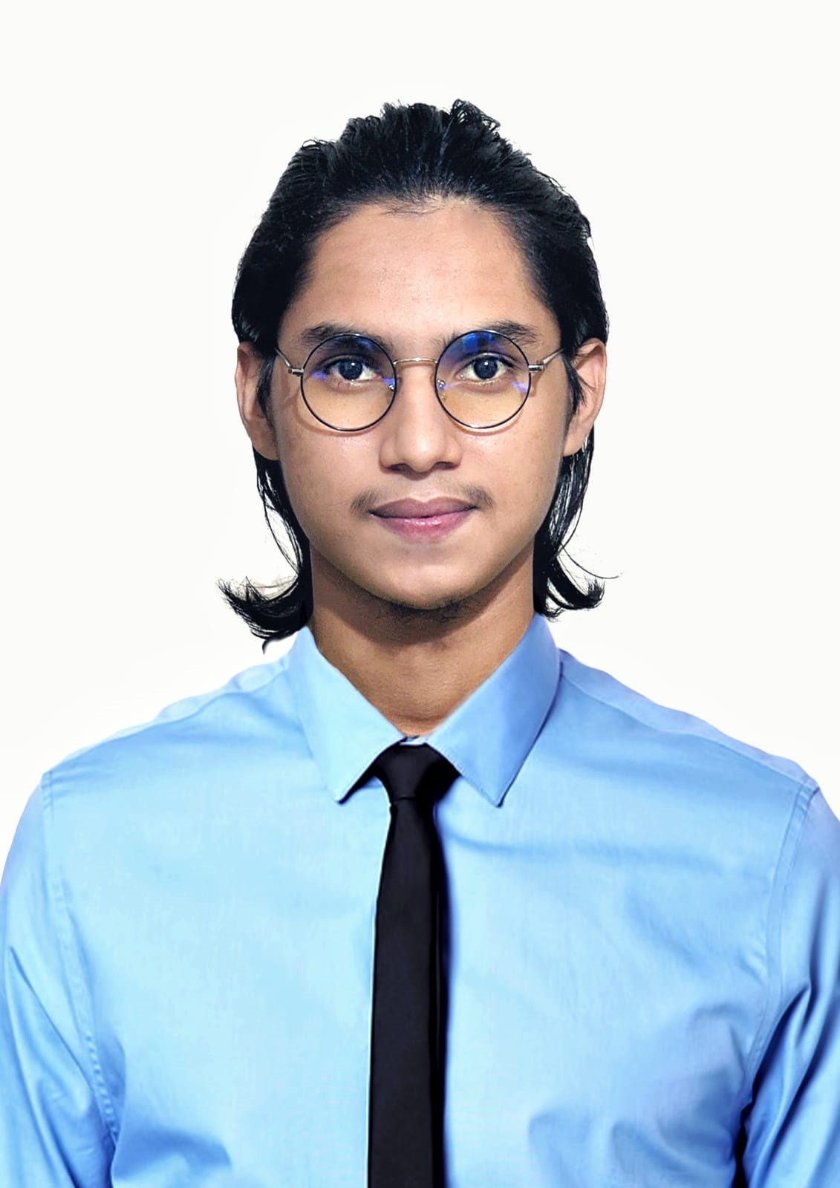

# **Educational Qualification**

**Secondary School Certificate (SSC):**

GPA- 5.00

Chittagong Board from Chakaria Korak Biddyapith.

Passing-Year: 2016

**Higher School Certificate (HSC):**

GPA- 3.08

Chittagong Board from Hazera Tazu Degree College.

Passing-Year: 2018

**BSc in Computer Science and Engineering (CSE)**:

CGPA: 3.33 from Premier University, Chittagong.(8th semester)

# **Certification**

* Cisco Certified Network Associate (CCNA) (2024)
* MikroTik Certified Network Associate (MTCNA) (2024)

# **Reference**

**Sattajit Barua**

Sr. Network Engineer INFRACORE(NOC)

Phone: :01787686021

# **Address**

**Permanent Address:**

Moheshkhali, Cox’s Bazer, Chattagram, Bangladesh

Post Code: 4710

**Present Address:**

Bahaddarhat, Chittagong, Bangladesh

Post Code: 4212

# **Languages**

# 

Bangla

English

Hindi

Urdu

Arabic