# **Professional Experience**

04/2019 to 01/2025

**Cybersecurity & Networking Projects–**

* Utilized Kali Linux and Parrot Security OS tools for penetration testing and security assessments.
* Configured MikroTik Failover Setup ensuring uninterrupted dual ISP service.
* Implemented Multiple SSID Setup for secure and segregated networks.
* Designed and deployed a custom login page for MikroTik Hotspot authentication.
* Set up PPPoE Server and VPN Configuration for ISP clients.
* Configured routers with NAT, firewall rules, and VLAN for secure ISP operations.

**Web Development & Database Management–**

* Developed various web applications using Laravel, including:

Project-1: <https://github.com/sm-akil/Hospital_Management_System>

Project-2: <https://github.com/sm-akil/PharmacyManagementSystem>

* Built an **Attendance Management System** using Laravel for efficient student and employee tracking
* Created a **Courier Management System**, streamlining package tracking and delivery processes.
* Designed front-end with HTML, CSS, Bootstrap, and JavaScript.
* Managed databases using MySQL and MongoDB.

Passionate IT professional with expertise in networking, cybersecurity, operating systems, web development, and machine learning. Skilled in configuring and troubleshooting network infrastructures, deploying secure systems, developing web applications using Laravel, PHP, and JavaScript, and implementing machine learning models for real-world applications. Strong problem-solving skills with hands-on experience in system administration, software management, and AI-driven solutions. Enthusiastic about learning and implementing advanced technologies to optimize performance and security.



+880 1940759675



[akil.ckb@gmail.com](mailto:akil.ckb@gmail.com)



github.com/sm-akil

# **Skills & Expertise**

**Networking & Security:** Failover, Subnetting, VLAN, OSPF, BGP, VPN, Firewall, NAT, VPN Tunneling, Bandwidth Management, Penetration Testing, Kali Linux- Parrot OS Security Tools

**ISP Setup:** Hotspot, PPPoE, Multiple SSID Configuration

**Software & Tools:** VS Code, Sublime Text, MySQL Workbench, XAMPP/WAMP, Adobe Photoshop, Illustrator, Microsoft Office, Google Colab, etc.

`

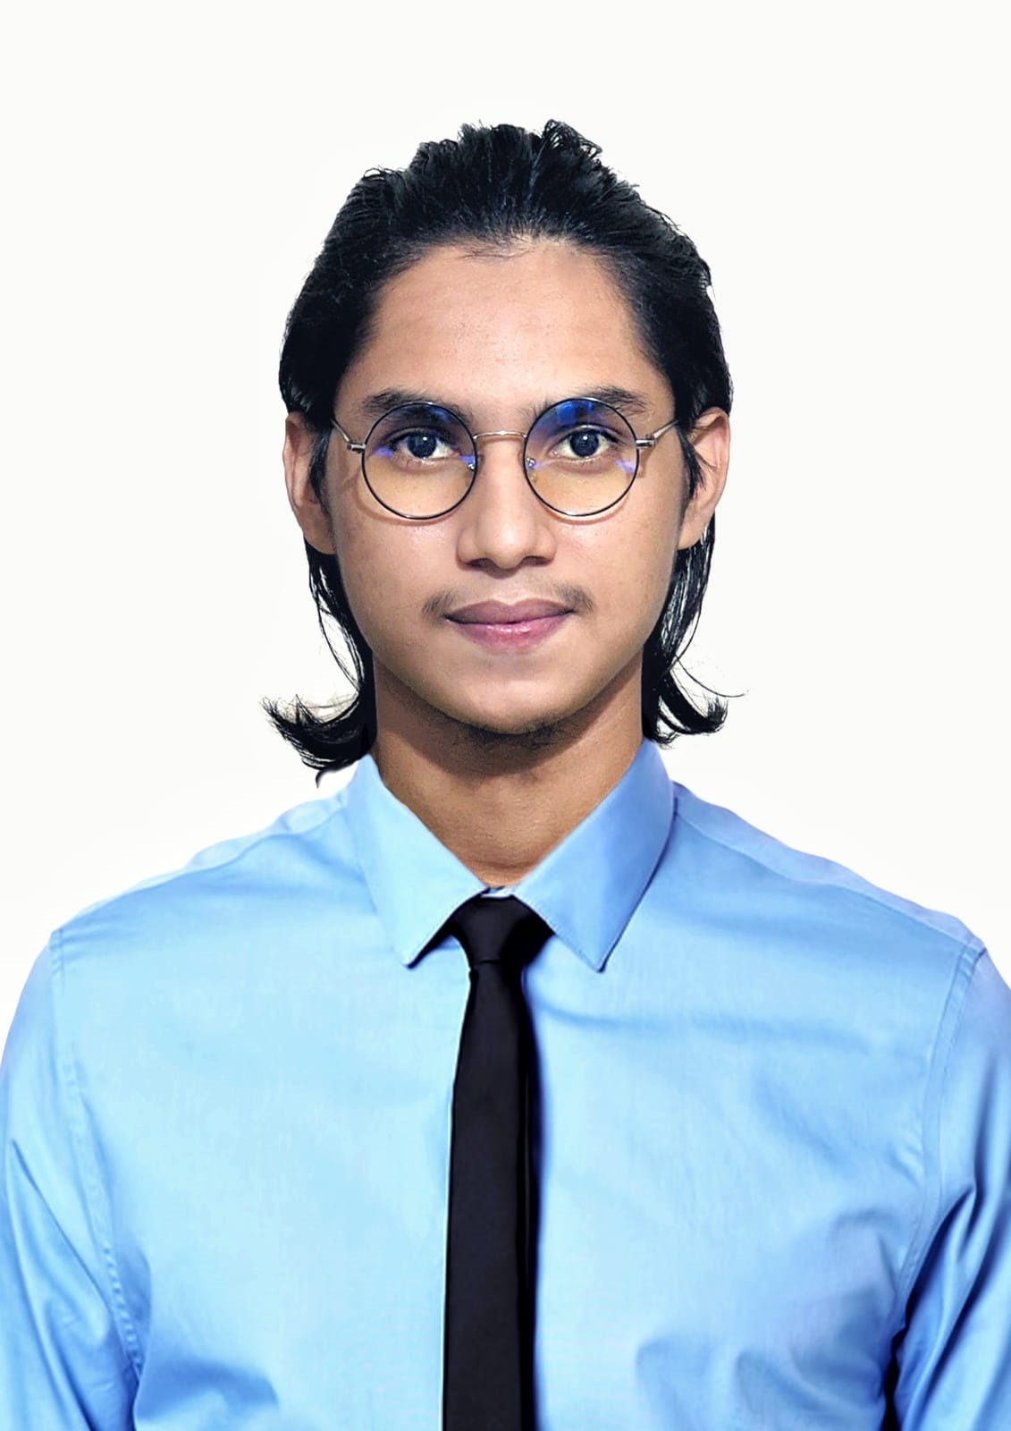

Sayed MD. Sadik Iqbal Akil

GitHub:

E-Mail:

Phone:

* **BANGLA**

**Machine Learning Projects–**

(Recyclable Bottle Detection Using Machine Learning)

* Implemented YOLOv8 and YOLO11 for object detection.
* Trained CNN and RCNN models for classification and segmentation.

**Technical Support & OS Administration–**

* Troubleshot and repaired Linux/Windows OS, Android systems, and software-related issues.
* Provided IT support and maintenance for academic and business environments.
* Experience with various Linux distributions, including Ubuntu, Debian, Kali Linux, and Parrot OS, for system administration, cybersecurity testing, and development environments.

**Other Experience–**

* Receptionist & Manager (Hotel Heritage-BR, Chittagong) – 6 months and Teaching Experience – 5 years.

# **Educational Qualification**

**Bachelor of Science in Computer Science & Engineering (CSE)**  
Premier University, Chittagong (Ongoing, CGPA: 3.33)

**Higher Secondary Certificate (HSC)**  
Hazera Tazu Degree College, Chittagong (GPA: 3.08, 2018)

**Secondary School Certificate (SSC)**  
Chakaria Korak Biddyapith, Chittagong (GPA: 5.00, 2016)

# **Certification**

* Cisco Certified Network Associate (CCNA) – 2024
* MikroTik Certified Network Associate (MTCNA) – 2024

# **Reference**

**Sattajit Barua**

Sr. Network Engineer INFRACORE(NOC)

Chief Executive Officer (CEO) at Ping-Bd

📞 +880 1787686021

**Dr. Shahid Md. Asif Iqbal**

Chairman

Premier University, Chittagong

Email: asif.iqbal@puc.ac.bd

**Programming:** C, Python, Java

**Frameworks & Libraries:** Laravel, TensorFlow, PyTorch, Keras, Tkinter.

**Database Management:** MySQL, MongoDB.

**Machine Learning:** YOLOv8, YOLO11, CNN, RCNN, NLP, Data Preprocessing.

**Operating Systems:** Windows, Linux, Android.

# **Address**

**Present / Permanent:**

Chawkbazar, Chittagong, Bangladesh

Post Code: 4203

# **Languages**

# 

Urdu

Hindi

Bangla

Arabic

English