Sayed MD. Sadik Iqbal Akil

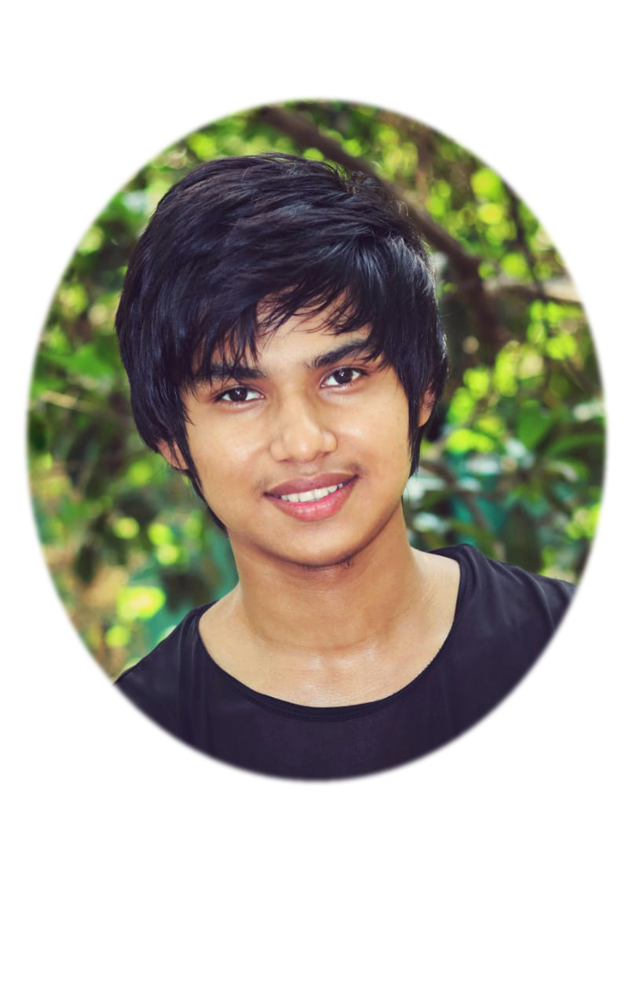

**BANGLA**

**HINDI**

**ENGLISH**

**GitHub :**

**E-Mail :**

**Phone :**



**+8801940759675**



[**akil.ckb@gmail.com**](mailto:akil.ckb@gmail.com)



**github.com/sm-akil**

# Skill Highlights

* **Microsoft Office**
* **Database Management**
* **Web Design**
* **Software Management**
* **Adobe Photoshop**
* **Proper Knowledge about (Window, Linux & Android Operating System)**
* **Programming Language (C, Python, Java)**

# Languages

# Experience

09/2017 to 05/2021

**Web Design –**

* Create different types of websites for educational purpose.
* Design frontend by HTML, CSS & Bootstrap.
* Worked on MySQL server for backend.

**Database Management –**

* Create different types of Databases for educational purpose.
* Worked on MySQL server & Warm server.

**OS Handling –**

* Worked on service center for fixing Computer & Android software related issues.

**Receptionist –**

* 6-month work experience in hotel Heritage-BR Chittagong.

# Educational Qualification

**Secondary School Certificate (SSC):**

Result/Board/Institute: GPA- 5.00 in Chittagong Board, from Chakaria Korak Byddapit.

**Higher School Certificate (HSC):**

Result/Board/Institute: GPA- 3.80 in Chittagong Board, from Hazera Tazu Degree College.

**Recent Studies:** Bachelor of Science in Computer Science and Engineering (CSE) - from Premier University, Chittagong.5th semester. (Last Semester CGPA: 3.60 out of 5.00)

# Address

**Permanent Address:** Gorakghat, Cox’s Bazer, Chittagong, Bangladesh

Post Code: 4710

**Web Developer** specializing in front end development. Experienced with all stages of the development cycle for dynamic web projects. And Well-versed in Database management and numerous programming languages including Java, PHP, C, Python, CSS, MySQL. Strong background in project management.