Web Developer & OS specializing in development. Experienced with all stages of the development cycle for given highlight. And well-versed in Android system, Linux/windows machine and numerous programming languages including Java, C, Python, MySQL, PHP Laravel frame work. Strong background in project management. All types of documents and abidance are provided in my GitHub account.

**GitHub :**

**E-Mail :**

**Phone :**



**+8801940759675**



[**akil.ckb@gmail.com**](mailto:akil.ckb@gmail.com)



**github.com/sm-akil**

# Skill Highlights

* **Microsoft (Word, Excel, Power- Point)**
* **Database Management (SQL)**
* **Web Design (Laravel)**
* **Software Management**
* **Adobe Photoshop**
* **Networking & Cyber Security**
* **Proper Knowledge about (Window, Linux & Android Operating System)**
* **Programming Language (C, Python, Java)**
* **AI(Currently doing thesis on Machine learning)**

# Languages

# Experience

04/2021 to 10/2023

**Journey to Web Design & Database –**

* Create different types of websites/web application (Hospital-management, Attendance-management, Pharmacy-management, Courier-management etc. using Laravel) for educational purpose. [All documents link: ***github.com/sm-akil*** ]
* Design frontend by HTML, CSS & Bootstrap.
* Worked on MySQL/Warm/XAMM server for backend.

**Journey to Cyber Security & Networking –**

* Create communication system for academic educational purpose.
* Network administration, penetration testing for my personal outcome.

**Journey to OS Handling –**

* Worked on service center for fixing Computer OS (Linux/Windows) , Android OS and software related issues.

**Others –**

* 6-month work experience in Receptionist & Manager post at hotel Heritage-BR Chittagong.
* 3-years teaching experience.

# Educational Qualification

**Secondary School Certificate (SSC):**

Result/Board/Institute: GPA- 5.00 in Chittagong Board, from Chakaria Korak Byddapit.

**Higher School Certificate (HSC):**

Result/Board/Institute: GPA- 3.08 in Chittagong Board, from Hazera Tazu Degree College.

**Recent Studies:** Bachelor of Science in Computer Science and Engineering (CSE) - from Premier University, Chittagong.8th semester. (Last Semester CGPA: 3.33 out of 5.00)

# Address

**Permanent Address:** Gorakghata, Cox’s Bazer, Chittagong, Bangladesh

Post Code: 4710

**Present Address:** Badurtola, Bahaddarhat, Chittagong, Bangladesh

Post Code: 4212

**HINDI**

**ENGLISH**

**BANGLA**

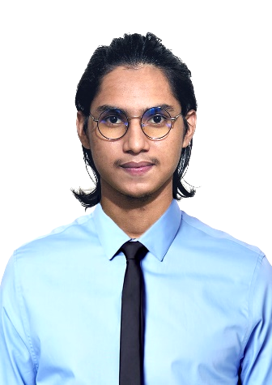

Sayed MD. Sadik Iqbal Akil