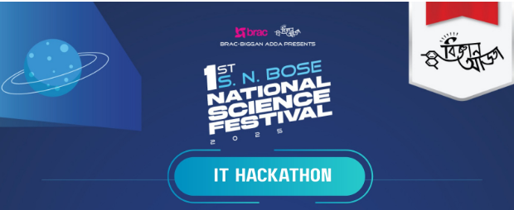
Project Title:[Bigganখিচুড়ি]
Team Bug এর হাট
Team Members:
Shah Md Khalil Ullah
Sayaka Alam
Shayka Islam

BRAC-Biggan Adda Presents 1st-SN Bose National Science Festival 2025: IT Hackathon

Team Name : Bug এর হাট

Project Title: Bigganখিচুড়ি

Team Members: Shah Md Khalil Ullah, Sayaka Alam, Shayka Islam

Date: 20-05-2025 to 22-05-2025

1. Introduction
Our app helps students, especially those in rural areas, learn science in a fun way. It uses an AI chatbot, voice commands, and text-to-speech to make learning easier. There are also interactive simulations and gamified quizzes to help students understand tough topics. The app is made for everyone, including students with disabilities, so everyone can enjoy learning.

2. Objectives
• To create an interactive learning platform that makes science subjects like Physics, Chemistry, and Biology fun and relatable for secondary school students in rural areas through simulation-based learning.
• To integrate AI-powered chatbots, voice command to text, and text-to-speech features to ensure personalized learning support, especially for students with limited resources or disabilities.
• To offer a gamified quiz experience that motivates students to learn through fun and competition, enhancing engagement and knowledge retention.
• To support inclusive science education by designing the platform to be accessible for students with disabilities, including visual, auditory, and motor impairments.
• To empower students to share ideas and collaborate, fostering a community of learners who can learn from each other, regardless of their geographical location.

3. Target Audience
Our app is made for secondary school students in rural areas who don’t have easy access to good science education. It helps them learn science in a fun and easy way with tools like quizzes and simulations. The app also supports students with disabilities, making learning possible for everyone.

4. Key Features
- User-Friendly Interface (UI) and UX:
The app’s AI chatbot, voice command to text, and text-to-speech ensure an accessible and intuitive learning experience for all students.
- Content Delivery:
Interactive simulations and gamified quizzes present science concepts in a fun and engaging way.
- Personalization:
AI-powered chatbots adapt learning paths based on student needs and progress.
- Collaboration:
The app fosters idea-sharing opportunities, allowing students to collaborate and learn together.
- Accessibility:
The platform supports students with disabilities using voice and text-to-speech features, ensuring inclusivity.
- Data Management:
The app tracks and visualizes student progress through quizzes and simulations.
- Scalability:
The platform is scalable, reaching students across rural and urban Bangladesh.
- Impact Measurement:
The app measures learning progress and provides feedback through gamified quizzes and interactive content.

5. Technical Architecture
- Frontend: React.js for a dynamic, responsive user interface.
- Backend: Python Flask for handling APIs and core app functionalities.
- Database & Cloud Platform: Supabase for real-time data storage, authentication, and backend services.
- APIs & Tools: llm model GPT-4 (via OpenAI API)
- Offline Support & Accessibility: Offline-first and low-bandwidth solutions to

6. Impact & Future Vision
Our platform aims to revolutionize science education in rural Bangladesh by providing accessible, interactive, and inclusive learning tools. In the future, we plan to enhance the app with a personalized exam and quiz system, where AI generates customized assessments based on the student's progress and learning style. The chat-based suggestions will offer personalized learning paths, helping students improve in areas where they struggle. Additionally, we aim to expand the platform to cover more subjects, add mobile support, and incorporate real-time collaboration features for students across Bangladesh.

