Data Visualization: Bad Drivers Data

Sowmya

2022-09-23

# Data Importation

#Importing Data and creating overview   
data <- read.csv(("https://raw.githubusercontent.com/fivethirtyeight/data/master/bad-drivers/bad-drivers.csv"))  
head(data)

## State Number.of.drivers.involved.in.fatal.collisions.per.billion.miles  
## 1 Alabama 18.8  
## 2 Alaska 18.1  
## 3 Arizona 18.6  
## 4 Arkansas 22.4  
## 5 California 12.0  
## 6 Colorado 13.6  
## Percentage.Of.Drivers.Involved.In.Fatal.Collisions.Who.Were.Speeding  
## 1 39  
## 2 41  
## 3 35  
## 4 18  
## 5 35  
## 6 37  
## Percentage.Of.Drivers.Involved.In.Fatal.Collisions.Who.Were.Alcohol.Impaired  
## 1 30  
## 2 25  
## 3 28  
## 4 26  
## 5 28  
## 6 28  
## Percentage.Of.Drivers.Involved.In.Fatal.Collisions.Who.Were.Not.Distracted  
## 1 96  
## 2 90  
## 3 84  
## 4 94  
## 5 91  
## 6 79  
## Percentage.Of.Drivers.Involved.In.Fatal.Collisions.Who.Had.Not.Been.Involved.In.Any.Previous.Accidents  
## 1 80  
## 2 94  
## 3 96  
## 4 95  
## 5 89  
## 6 95  
## Car.Insurance.Premiums....  
## 1 784.55  
## 2 1053.48  
## 3 899.47  
## 4 827.34  
## 5 878.41  
## 6 835.50  
## Losses.incurred.by.insurance.companies.for.collisions.per.insured.driver....  
## 1 145.08  
## 2 133.93  
## 3 110.35  
## 4 142.39  
## 5 165.63  
## 6 139.91

# Data Cleaning and Summary

sum(is.na(data)) #check for NA

## [1] 0

colnames(data) #get column names

## [1] "State"   
## [2] "Number.of.drivers.involved.in.fatal.collisions.per.billion.miles"   
## [3] "Percentage.Of.Drivers.Involved.In.Fatal.Collisions.Who.Were.Speeding"   
## [4] "Percentage.Of.Drivers.Involved.In.Fatal.Collisions.Who.Were.Alcohol.Impaired"   
## [5] "Percentage.Of.Drivers.Involved.In.Fatal.Collisions.Who.Were.Not.Distracted"   
## [6] "Percentage.Of.Drivers.Involved.In.Fatal.Collisions.Who.Had.Not.Been.Involved.In.Any.Previous.Accidents"  
## [7] "Car.Insurance.Premiums...."   
## [8] "Losses.incurred.by.insurance.companies.for.collisions.per.insured.driver...."

#changing column names  
colnames(data) <-  
 c("State","Fatal_collisions", "Percentage_speeding","percentage_alcohol_impared", "Percentage_no_distracted", "percentage_with_no_prior_accidents", "Car_Insurance_Premiums", "Losses_to_insurance_companies_per_driver")   
colnames(data)

## [1] "State"   
## [2] "Fatal_collisions"   
## [3] "Percentage_speeding"   
## [4] "percentage_alcohol_impared"   
## [5] "Percentage_no_distracted"   
## [6] "percentage_with_no_prior_accidents"   
## [7] "Car_Insurance_Premiums"   
## [8] "Losses_to_insurance_companies_per_driver"

#Getting Summary  
summary(data)

## State Fatal_collisions Percentage_speeding  
## Length:51 Min. : 5.90 Min. :13.00   
## Class :character 1st Qu.:12.75 1st Qu.:23.00   
## Mode :character Median :15.60 Median :34.00   
## Mean :15.79 Mean :31.73   
## 3rd Qu.:18.50 3rd Qu.:38.00   
## Max. :23.90 Max. :54.00   
## percentage_alcohol_impared Percentage_no_distracted  
## Min. :16.00 Min. : 10.00   
## 1st Qu.:28.00 1st Qu.: 83.00   
## Median :30.00 Median : 88.00   
## Mean :30.69 Mean : 85.92   
## 3rd Qu.:33.00 3rd Qu.: 95.00   
## Max. :44.00 Max. :100.00   
## percentage_with_no_prior_accidents Car_Insurance_Premiums  
## Min. : 76.00 Min. : 642.0   
## 1st Qu.: 83.50 1st Qu.: 768.4   
## Median : 88.00 Median : 859.0   
## Mean : 88.73 Mean : 887.0   
## 3rd Qu.: 95.00 3rd Qu.:1007.9   
## Max. :100.00 Max. :1301.5   
## Losses_to_insurance_companies_per_driver  
## Min. : 82.75   
## 1st Qu.:114.64   
## Median :136.05   
## Mean :134.49   
## 3rd Qu.:151.87   
## Max. :194.78

# Density Plot

The plot below in Fig 1 gives the density plot of the Fatal Collisions variable from the data. From the density plot, we observe that the data on the Fatal collisions is reasonably normally distributed.

#Loading ggplot package  
library(ggplot2)  
  
#Plotting the density plot for the Fatal Collisions  
ggplot(data) +  
 aes(x = Fatal_collisions) +  
 geom_density(adjust = 1L, fill = "#B22222") +  
 labs(title = "Fatal Collisions", subtitle = "Density Plot") +  
 theme_minimal()

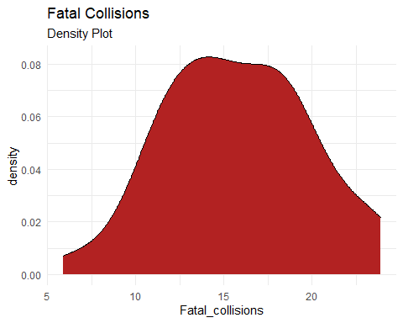

Fig 1

# Scatterplot

The plot below in Fig 2 gives the scatterplot of the Percentage Alcohol Impaired for the driver against the Fatal Collisions. The scatterplot shows that there is no linear relationship between Percentage Alcohol Impaired and Fatal Collision.

#Plotting the Scatterplot for Percentage Alcohol Impaired against Fatal Collisions  
ggplot(data) +  
 aes(x = percentage_alcohol_impared, y = Fatal_collisions) +  
 geom_point(shape = "circle", size = 1.5, colour = "#4682B4") +  
 labs(  
 title = "Percentage Alcohol Impaired vs Fatal Collisions",  
 subtitle = "Scatterplot"  
 ) +  
 theme_minimal()

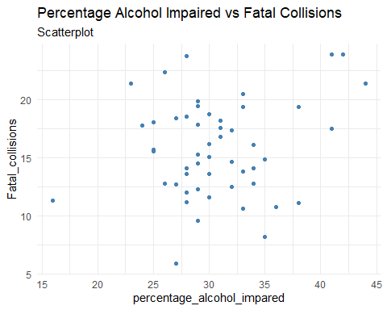

Fig 2