Demonstration:

Demonstrate that the illuminance value is displayed on the OLED display every second
________

Demonstrate that the illuminance value is changing on the OLED display every second as illuminance sensor is exposed to less or more light.
________

Requirements:

Interface the illuminance sensor (TSL2561) with the ESP8266 NodeMcu board 1 (B1) using the I2C bus ________

Read the illuminance value (lux) every second and transmit the value as string to ESP8266 NodeMcu board 2 (B2) ________

Use the UART bus protocol to transmit the illuminance value from ESP8266 NodeMcu board 1 (B1) to ESP8266 NodeMcu board 2 (B2) ________

Interface an 128x64 OLED display with ESP8266 NodeMcu board 2 (B2) using the I2C bus and display the illuminance value on the OLED display. ________

Learning Objectives:
This lab gives the understanding of ESP8266 board and the Arduino IDE software tool.

General Steps:
The general steps needed to complete this lab were . . .

- Setup both the ESP8266 Boards (B1 and B2) on a breadboard and connect the micro USB cable to the USB port of the board. Do not connect to computer
- Connect the illuminance sensor (TSL2561) to board B1 as described in sensorapi code where sensor’s SCL is connected to board B1 port D1 and sensor’s SDA is connected to board B1 port D2.
- Download and run the code to see if the illuminance sensor is sending the lux values to be printed on the serial console.
- Interface the 128x64 OLED display with the board B2.
- Connect the UART0 bus of board B1 and board B2 so that you can send strings using the UART bus. Also, connect the grounds of both the boards.
- Display the lux value on the OLED display connected to board B2.

Detailed Steps:
Some detailed steps to complete this lab were . . . .
Firstly, both the ESP8266 boards (B1, B2) are connected to the breadboard.
- All the libraries for TSL2561 are installed in the Arduino.
- Then the illuminance sensor (TSL2561) is connected to the B1. The connections are as follows.
- Sensor's SCL is connected port D1 of B1
- Sensor's SDA is connected port D2 of B1
- Now, in order to test whether the sensor is sending the data to board, Connect USB to B1 and run the sensor code and see the values in lux displayed in the serial monitor.
- Now OLED display is connected to the board B2.
- Also, these boards B1, B2 are connected using UART bus in the following way.
- B1 Tx port is connected to the B2 Rx port
- B1 Rx port is connected to the B2 Tx port.
- Connect both ground of the two boards to the common ground.
- Now we dump both the codes on the respective boards.
- The TSL2561 sensor will detect the illuminance value of the light around it and it will send the data to the ESP8266 board B1 using the I2C bus.
- The board B1 will send the data serially to the board B2 using UART protocol.
- Then the board B2 will send the data to OLED via its I2C bus.
- See the displayed lux values on the OLED display.

Circuit Diagram:

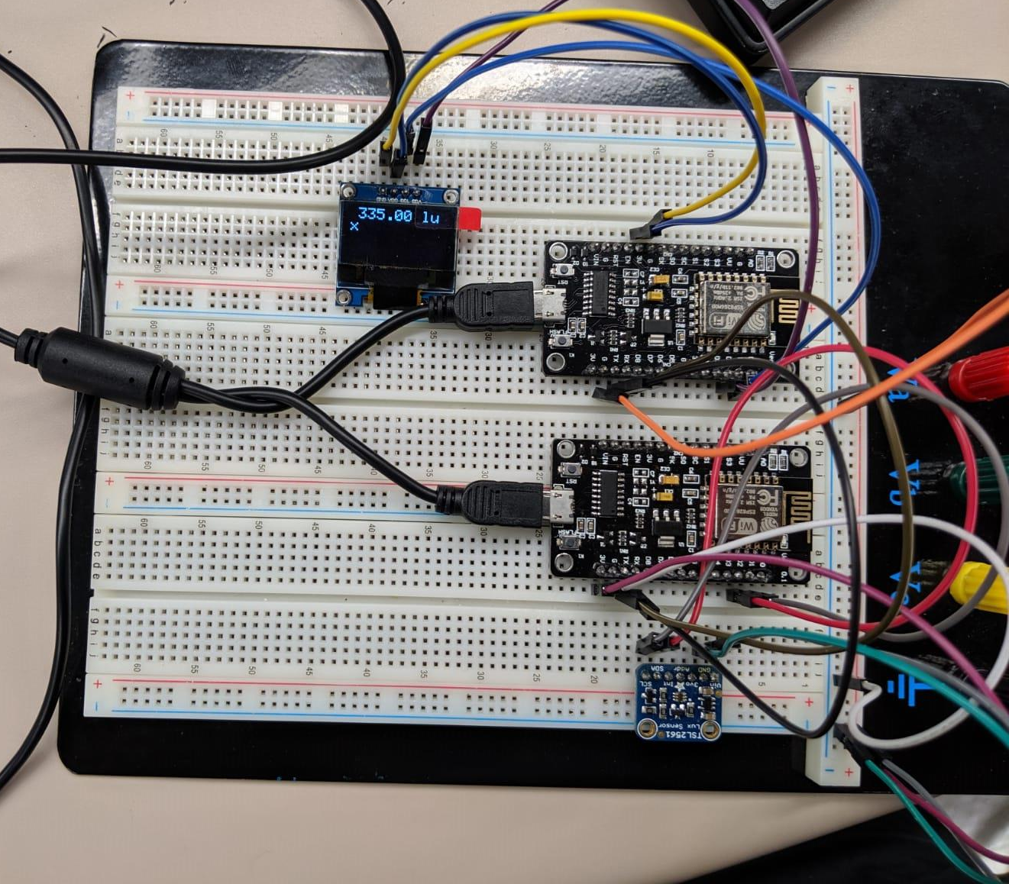

OLED Connections:

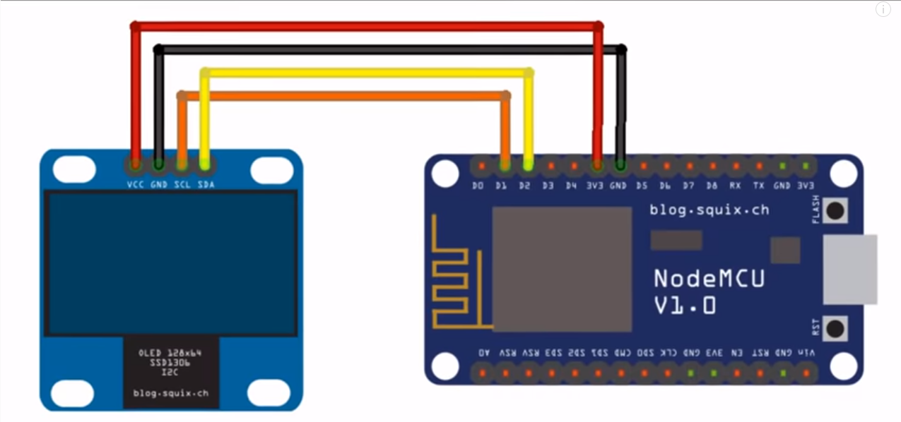

Observations:
Some important observations while completing/testing this lab were . . .

Sensor code:

void loop(void)
{
/* Get a new sensor event */
sensors_event_t event;
tsl.getEvent(&event);
if(value == LOW){
time1 = millis();
value = HIGH;
}

/* Display the results (light is measured in lux) */
if((millis() - time1) >= 1000)
{
if (event.light)
{
Serial.print(event.light);
//Serial.println(" lux");
value = LOW;
}
else
{
/* If event.light = 0 lux the sensor is probably saturated
and no reliable data could be generated! */
Serial.println("Sensor overload");
value = LOW;
}
}
}

OLED Code:

void loop() {
display.clearDisplay(); // This will clear the previous display
display.setTextSize(2); // This will select the pixel size on the OLED
display.setTextColor(WHITE); //This will color the pixels to white on the OLED
display.setCursor(10,0); // This will move the cursor.
String s;
if (Serial.available())
{
s = Serial.readString(); //getting string input in variable "s"
display.println(s);
display.display();
}
}

- When we connect the TSL2561 sensor to the ESP8266 module and dump the code for the detection of the light, the lux values of the light illumination will be read by the TSL2561 sensor and it will printed on the serial monitor.
- When the module is connected and powered the sensor will detect the light and send it to the board B1 using I2C protocol.
- Now the B1 sends the data serially using the UART protocol B2.
- Finally board B2 will send the received data to its slave i.e., OLED display using its I2C bus and then we can see the flux values on it.
- When we try to reduce the intensity of the light around the sensor by placing any obstacle just over it, we can see the diminished lux values on the serial monitor.
- When we remove the obstacle then the full lux values are read by the sensor and will be displayed accordingly.
- These lux values are read continuously but we have to read them and print them for every second.
- Once the lux values are read every second, those are to sent to another ESP8266 module via UART communication.
- We will connect the Tx and Rx of both the 8266 modules in a cross coupling manner for the serial communication to happen between them.
- Once the OLED receives the lux values, it will display them accordingly.

Summary:
We have to display the lux values captured by the TSL2561 sensor every second and display those values on the OLED display. Here the mode of communication is serial between the two ESP8266 modules and the serial data is displayed on the OLED screen.

