Kimuntu AI
Week 1: System Design and Baseline Legal Query Classifier
Course: AI and Expert Systems in Action
Industry partner: Kimuntu Power Inc. (Riipen industry project)
Lecturer: Dr. Chinwe Peace Igiri
Student name: [PLACEHOLDER]
Assigned role: [PLACEHOLDER]
Date: 2026-10-20
Disclaimer: Kimuntu AI supports user understanding of legal situations. It does not provide legal advice and does not replace a qualified legal professional.

Contents
1. Problem and scope statement
2. Proposed legal text classification categories
3. System architecture
4. Dataset and preprocessing
5. Baseline text classification model
6. Model evaluation results
7. Interpretation, limitations and Week 2 improvements
8. Group output and individual contribution
Appendix A. How to reproduce
Appendix B. References and data sources

1. Problem and scope statement
Project: Kimuntu AI (Riipen industry project, partner: Kimuntu Power Inc.) Course: AI and Expert Systems in Action Week 1 focus: system design and baseline legal text classifier
Disclaimer: Kimuntu AI is designed to support a user's understanding of a legal situation. It does not give legal advice and does not replace a qualified legal professional.

The problem
People who face an everyday legal problem, such as a landlord keeping a deposit, an employer not paying wages, or uncertainty about registering a business, often do not know which area of law their problem belongs to or where to go for help. Kimuntu AI aims to help them by understanding the question, retrieving approved information, structuring the relevant considerations, recommending resources or next steps, and presenting this through a chatbot.
Before the system can do any of that, it must first understand what kind of legal problem the user is describing. A query about a security deposit must be routed to housing and tenancy material, not to employment or criminal material. If the query is not a legal question at all, or the system is unsure, it must say so instead of answering confidently.

What Week 1 delivers
1. A set of legal query categories that the system should recognise (docs/categories.md).
2. A system architecture showing how the text classifier, legal decision support system, recommendation system and chatbot work together (docs/architecture.md).
3. A prepared dataset, built while company data is awaited (data/).
4. A baseline text classifier (TF-IDF with Logistic Regression / Naive Bayes) that returns a category and a confidence score for a user query (notebooks/, src/, models/).
5. Evaluation results and an interpretation with proposed Week 2 improvements (results/, docs/interpretation.md).

Scope
In scope (Week 1) | Out of scope (later weeks)
English-language user queries | Other languages / translation
Uganda-context and international queries | Jurisdiction-specific legal answers
Single-label, domain-level classification into 9 categories (8 legal + out-of-scope) | Issue-level or intent-level labels, multi-label classification
Confidence score and a "needs clarification" flag | Retrieval, decision support, recommendation and chatbot implementation
Interpretable scikit-learn baseline | Large language models, deep learning, embeddings
Saved model with a callable predict() function | FastAPI/Flask service, front end, database, payment integration

Users and stakeholders
- End users: members of the public with an everyday legal question.
- Kimuntu Power Inc.: industry partner, owner of the platform and of future company data.
- Project team and lecturer: build and assess the prototype.

Key assumptions (to be confirmed with Kimuntu)
- The jurisdiction focus is Uganda plus international queries, as agreed by the team. Kimuntu has not yet confirmed jurisdictions or priority categories.
- Kimuntu will provide data later. Until then, a combination of a public dataset (Law Stack Exchange) and a clearly labelled synthetic dataset is used.
- The categories are a team proposal and may be revised once Kimuntu's priorities are known.

2. Proposed legal text classification categories
The classifier assigns one category to each user query. There are 8 legal categories and 1 out-of-scope category. The categories are at the level of legal domain, because:
- the lecturer note's example ("My landlord has refused to return my security deposit" → housing law, tenancy dispute, legal guidance) mixes domain, issue and intent. Picking a single level keeps labelling consistent and the model explainable;
- domain labels are what the later components need first: retrieval needs to know which body of law to search, and recommendation needs to know which family of resources to offer;
- issue- or intent-level labels (e.g. "deposit dispute", "wants a template letter") can be added in a later week as a second layer once Kimuntu's priorities and data are known.
These categories are a team proposal. Kimuntu Power Inc. has not yet confirmed jurisdictions or priority categories. The example queries below are illustrative and were written for this project with AI assistance. They are not real user data.
# | Label | Definition | Example queries | Basis
1 | housing_tenancy | Renting a home or room: landlord–tenant relations, rent, deposits, repairs, eviction. | "My landlord has refused to return my security deposit." / "The landlord wants to evict me without notice." | Lecturer note example (security deposit)
2 | employment_labour | Work relationships: wages, dismissal, employment contracts, leave, workplace treatment. | "My employer has not paid my salary for three months." / "I was dismissed without any reason. What can I do?" | Lecturer note examples (employment termination, unpaid wages)
3 | business_commercial | Starting, registering or running a business: registration, licences, partnerships, company matters. | "How do I register a small business in Kampala?" / "My business partner is withdrawing money without telling me." | Lecturer note example (business registration)
4 | land_property | Owning, buying, selling or using land and buildings: titles, boundaries, land sales. | "A neighbour has moved the boundary marks onto my land." / "How can I check that a land title is genuine before buying?" | Team addition: land is a frequent source of disputes in Uganda. Kept separate from tenancy (owning vs renting).
5 | family | Marriage, separation and divorce, child custody, child maintenance, domestic relations. | "My husband refuses to support our children after we separated." / "What is the process for getting a divorce?" | Team addition: common legal-aid area
6 | succession_inheritance | Wills, inheritance and administering the estate of someone who has died. | "My father died without a will. How is his property shared?" / "My uncle took over my late mother's house." | Team addition: common in Uganda; deliberately tests confusion with land and family
7 | criminal | Arrest, police, bail, criminal charges, or being the victim of a crime. | "The police arrested my brother and he has not been charged." / "Someone stole my phone and threatened me." | Team addition: high-risk area that will always require escalation to a professional
8 | consumer_contract | Buying goods and services, faulty products, debts, loans and general contracts between individuals. | "The shop refused to refund a phone that stopped working after a week." / "A friend borrowed money and refuses to pay it back." | Team addition: common everyday category
9 | other_out_of_scope | Not a legal question, or a request the system should not handle (e.g. general chat, medical, cooking). | "What is the weather in Entebbe tomorrow?" / "Give me a recipe for rolex (the Ugandan chapati-and-egg snack)." | Lecturer note: the system must recognise situations it cannot safely answer

How the categories connect to later components
Category | Information retrieval (approved sources only) | Decision support | Recommendation
housing_tenancy | Tenancy material for the user's jurisdiction | Structure: type of tenancy, notice, deposit, documents held | Tenancy resources, template letters, mediation/legal-aid contacts
employment_labour | Employment/labour material | Structure: contract type, length of service, reason for dismissal, unpaid amounts | Labour office or complaint guidance, documents to gather
business_commercial | Business registration and commercial material | Structure: business type, registration stage | Registration services, checklists, Kimuntu business resources
land_property | Land material | Structure: type of ownership, documents, nature of dispute | Land-office resources; referral when ownership is disputed
family | Family material | Structure: relationship, children involved, safety concerns | Family / legal-aid referral; urgent help if safety risk
succession_inheritance | Succession material | Structure: will or no will, relationship to the deceased | Estate guidance, referral to a professional
criminal | Only general information | Always escalates to a professional | Legal-aid / advocate referral, emergency contacts
consumer_contract | Consumer and contract material | Structure: what was agreed, evidence, amount | Complaint routes, demand-letter templates
other_out_of_scope | None | None | Chatbot explains the system's scope or asks the user to rephrase

A query predicted with low confidence (below a threshold tuned on validation data) is treated like an uncertain case: the chatbot asks a clarifying question or suggests a professional instead of proceeding with a possibly wrong category.

Labelling rules
- One label per query: the main legal problem the user wants help with.
- Renting → housing_tenancy. Owning or buying → land_property.
- Property of someone who has died → succession_inheritance, even if it is land.
- Money owed under an employment relationship → employment_labour. Money owed by anyone else → consumer_contract.
- Police involvement or a crime → criminal.

3. System architecture
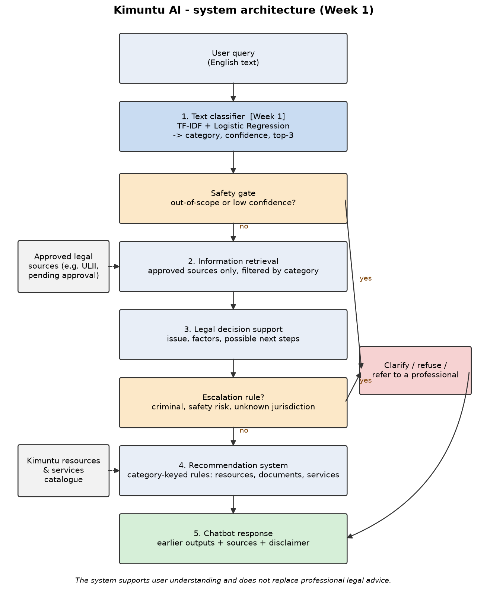
Kimuntu AI architecture
The Mermaid source is in architecture.mmd. The PNG is drawn by src/draw_architecture.py and shows the same flow.
Disclaimer: the system supports user understanding and does not replace professional legal advice.

Flow
The design follows the lecturer note's recommended flow: User Query → Text Classification → Information Retrieval → Decision Support → Recommendation → Chatbot Response.
Step | Component | Input | Output | Built in
1 | Text classifier | User's query text | {category, confidence, top_3, needs_clarification} | Week 1 (this work)
– | Safety gate | Classifier output | Continue, or route to clarify/refer | Week 1 logic (threshold); used by chatbot later
2 | Information retrieval | Query + category | Passages from approved sources, with references | Later weeks
3 | Legal decision support | Query + category + retrieved passages | Issue, relevant factors, possible next steps; escalation flag | Later weeks
4 | Recommendation system | Category + decision-support output | Kimuntu resources, documents, services or next actions, with a reason | Later weeks
5 | Chatbot | Outputs of steps 1–4 | Clear conversational answer with sources and disclaimer | Later weeks

Why it is designed this way
- Classification first. Every later step depends on knowing the legal area. The category narrows retrieval to the right material and selects the right recommendation rules.
- One shared interface. All components use the classifier's output dictionary. This avoids the "four disconnected applications" risk named in the lecturer note.
- Safety and uncertainty sit in two places:
1. Safety gate after classification: if the query is predicted other_out_of_scope, or the confidence is below a threshold chosen on validation data, the system does not continue. It asks the user to clarify, explains its scope, or refers them to a professional.
2. Escalation rules in decision support: some situations always go to a professional, for example criminal matters, a risk to someone's safety, or a jurisdiction the system does not cover.
- Grounded answers only. Retrieval uses only approved sources. The Uganda Legal Information Institute (ULII, https://ulii.org/), run by the Law Reporting Unit of the Uganda Judiciary, is a candidate source for Ugandan legislation and judgments, pending Kimuntu's approval. The chatbot presents what the earlier components produced, with references, rather than generating free-form legal statements.
- Simple, explainable technology. The Week 1 classifier is a scikit-learn pipeline saved with joblib. Recommendation starts with rules keyed on category (explainable and testable). A FastAPI or Flask layer is added only when the chatbot needs to call the classifier as a service.

Example walk-through
User: "My landlord has refused to return my security deposit."
1. Classifier → housing_tenancy with a confidence score.
2. Safety gate → confidence above threshold, in scope → continue.
3. Retrieval → approved tenancy material for the user's jurisdiction.
4. Decision support → issue: deposit not returned; factors: tenancy agreement, condition of the property, notice given; next steps: gather evidence, write to the landlord.
5. Recommendation → template demand letter, mediation or legal-aid contact.
6. Chatbot → explains the above in plain language, cites sources and adds the disclaimer.

4. Dataset and preprocessing
The company dataset promised by Kimuntu Power Inc. is not yet available. The baseline therefore uses a combination of one public dataset and one synthetic dataset. Every row records its origin in the source column, so results can be checked per source.

Files
File | What it is | In Git?
raw/law-stackexchange-questions-answers.json | Original Law Stack Exchange download (106,154,624 bytes) | No: re-created by src/prepare_data.py
synthetic/synthetic_queries.csv | 450 synthetic queries (text, label) | Yes
processed/dataset.csv | Final prepared dataset: id, text, label, source, split (7,071 rows) | Yes

Source 1: Law Stack Exchange (public, real questions)
- Dataset: Law-StackExchange Dataset, Yasmin Moslem (2023), Hugging Face. https://huggingface.co/datasets/ymoslem/Law-StackExchange, DOI 10.57967/hf/4792
- Version used: repository commit ab2dbaad9a71b6550316994c8fcd69f24f7f16e6 (pinned in the script).
- Content: 24,370 questions (and answers) from the Law Stack Exchange website, collected up to 14 August 2023. Each question has a title, body (HTML) and user-assigned tags. Only titles, bodies and tags are used; answers are ignored.
- Licence: CC BY-SA 4.0 (dataset card). Individual posts are CC BY-SA 3.0 or 4.0 under Stack Exchange's content licence. processed/dataset.csv contains text derived from these posts and is therefore shared under CC BY-SA 4.0 with attribution to the dataset author and Law Stack Exchange contributors.
- Why chosen: real questions from people in many countries (international), a clear open licence, and tags that can be mapped to our categories.

How tags were mapped to categories
A question is kept only if (a) none of its tags is an out-of-taxonomy domain, and (b) its remaining tags map to exactly one of our categories. Questions whose tags point to two categories (e.g. lease + real-estate) are dropped because their label would be ambiguous. Tags were chosen after counting tag frequencies in the downloaded file. Only tags that exist in the data are used.
Category | Law Stack Exchange tags used
housing_tenancy | landlord, tenant, rental-property, lease, eviction, residential-lease, rent, tenancy-rules, tenancy
employment_labour | employment, labor-law, employer, employee, workplace, unemployment, salary
business_commercial | business, corporate-law, limited-liability-company, partnership, shareholders, incorporation, non-profit
land_property | real-estate, real-property, easement, zoning, homeownership, hoa
family | family-law, divorce, marriage, child-support, parental-rights, adoption
succession_inheritance | inheritance, wills, estate-planning, probate, executor, trusts-and-estates
criminal | criminal-law, police, arrest, criminal-procedure, theft, assault, sentencing, murder, sexual-assault, rape, bail
consumer_contract | consumer-protection, contract-law, debt, warranties, warranty, refund, breach-of-contract

- Ambiguous tags deliberately not used: property (could be intellectual property), ownership, fraud (criminal or civil), death, children, trespass.
- Excluded out-of-taxonomy tags (question dropped if present): copyright, intellectual-property, trademark, patents, fair-use, dmca, creative-commons, gdpr, privacy, data-protection, software, open-source-software, licensing, eula, gpl, terms-of-service, internet, tax-law, immigration, constitutional-law, us-constitution.
- Result: 6,621 of 24,370 questions kept.

Source 2: Synthetic Uganda-context queries (SYNTHETIC)
This data is synthetic. It was written for this project by an AI assistant (Claude, by Anthropic). It is not real user data and does not describe real people or cases.
- How it was generated: 50 short queries per category (450 in total) were written by hand by the AI assistant in one pass: one query per line, in plain everyday English, some informal or lower-case, many with Ugandan context (place names such as Kampala, Mbarara, Wakiso; terms such as kibanja, mailo land, boda boda, NSSF, URSB, SACCO, shillings). No templates or automatic generation were used. Each query was assigned its label by the author following the labelling rules in docs/categories.md.
- Why it is needed:
1. it is the only source for other_out_of_scope (Law Stack Exchange contains only legal questions);
2. it gives short, chat-style queries like those a chatbot will receive;
3. no public labelled dataset of Ugandan legal queries could be found.
- Known bias: a single author's style, cleaner than real user text, and much shorter than Law Stack Exchange posts (mean 11.7 words vs 148.5 words). See docs/interpretation.md for the effect on results.
- The legal statements implied by the queries were not verified, and they do not need to be: the queries are only examples of questions, used to teach the classifier which category a question belongs to. No legal facts are taken from them.

Preprocessing (src/prepare_data.py)
Step | What | Why
1 | Combine Law Stack Exchange title + body | The title alone is often too short to show the legal area
2 | Remove HTML tags, decode HTML entities, remove URLs | Law Stack Exchange bodies are HTML; tags and links are not legal content
3 | Lowercase and collapse whitespace | "Landlord" and "landlord" should be the same word
4 | Keep only the first 300 words | Very long posts would dominate the word statistics; the topic is normally clear early on
5 | Drop empty texts | None needed to be dropped in the final run
6 | Remove exact duplicate texts | Prevents the same text appearing in train and test (leakage); 0 duplicates found
7 | Stratified split 70 / 15 / 15 (train / validation / test), random_state=42, stratified on label + source | Every split has the same mix of categories and sources; seed makes it reproducible
8 | Assert that no text occurs in two splits | Leakage check

Stop-word removal and n-grams are not done here. They are settings of the TF-IDF vectoriser, tested on the validation set in src/train_baseline.py.
The same cleaning function (src/text_utils.py) is applied to new queries at prediction time.

Final dataset (processed/dataset.csv)
Category | LSE train | LSE val | LSE test | Synthetic train | Synthetic val | Synthetic test | Total
business_commercial | 356 | 77 | 76 | 35 | 7 | 8 | 559
consumer_contract | 1057 | 227 | 226 | 35 | 7 | 8 | 1560
criminal | 1573 | 337 | 337 | 35 | 7 | 8 | 2297
employment_labour | 445 | 95 | 95 | 35 | 8 | 7 | 685
family | 279 | 60 | 60 | 35 | 7 | 8 | 449
housing_tenancy | 521 | 112 | 112 | 35 | 7 | 8 | 795
land_property | 220 | 47 | 47 | 35 | 8 | 7 | 364
other_out_of_scope | 0 | 0 | 0 | 35 | 8 | 7 | 50
succession_inheritance | 183 | 40 | 39 | 35 | 7 | 8 | 312
Total | 4634 | 995 | 992 | 315 | 66 | 69 | 7071

The classes are clearly imbalanced: criminal has 2,297 examples while other_out_of_scope has 50.

Re-creating the data
python src/prepare_data.py
This downloads the pinned Law Stack Exchange file (if not already in data/raw/) and rebuilds processed/dataset.csv. With the same file and seed the output is identical.

5. Baseline text classification model
The baseline is implemented in src/train_baseline.py and, equivalently, in notebooks/baseline_classifier.ipynb (Google Colab compatible). It is a scikit-learn Pipeline: TfidfVectorizer followed by a classifier. Three model types were compared on the validation set (majority-class dummy, Multinomial Naive Bayes and Logistic Regression, 33 configurations in total) and the configuration with the best validation macro-F1 was kept. The model is saved to models/baseline_classifier.joblib and called through predict() in src/predict.py.

Why these choices
- TF-IDF turns each query into word weights: frequent-but-generic words get low weight, distinctive legal words (landlord, probate, dismissal) get high weight. It is simple, fast and explainable.
- Logistic Regression and Naive Bayes are the methods recommended in the brief, train in seconds and can be inspected (top words per class), following the lecturer note's guidance to start with interpretable baselines in scikit-learn.
- class_weight='balanced' makes mistakes on small classes cost more, to counter class imbalance.
- The vectoriser sits inside the pipeline, so it is fitted on training data only (no leakage); the test set was used once, after model selection.

Model output: predict() on new example queries
These queries were written for this demonstration and are not in the dataset. The output below was produced by the saved model when this report was built.
Query | Predicted category | Confidence | Needs clarification
The landlord is refusing to give back the deposit I paid when I moved in. | housing_tenancy | 0.9708 | no
I have not received my wages from my employer since July. | employment_labour | 0.9473 | no
What do I need to register my new business? | business_commercial | 0.9869 | no
My contract of employment was terminated without notice. | employment_labour | 0.7217 | no
Who will win the election next year? | succession_inheritance | 0.4826 | no
I have a problem, can you help? | other_out_of_scope | 0.5206 | yes

Threshold used by the safety gate: 0.35. The fifth query is a real failure case, discussed in Section 7.

6. Model evaluation results
Disclaimer: the classifier supports user understanding and does not replace professional legal advice.
All numbers below come from src/train_baseline.py (identical results from notebooks/baseline_classifier.ipynb), saved in results/.

What was compared (validation set, 1,061 queries)
Model (best setting of each) | Validation accuracy | Validation macro-F1
Dummy: always predicts the most frequent class | 0.3242 | 0.0544
Multinomial Naive Bayes (unigrams, English stop words removed, alpha = 0.01) | 0.7917 | 0.6685
Logistic Regression (unigrams, no stop-word removal, C = 5, balanced class weights) | 0.8709 | 0.8574

Logistic Regression was selected because it had the highest validation macro-F1. Two further observations:
- Bigrams did not help. The best unigram+bigram Logistic Regression reached 0.8200 macro-F1.
- Naive Bayes was much weaker on the small classes, which macro-F1 makes visible. Its accuracy gap (0.79 vs 0.87) is smaller than its macro-F1 gap (0.67 vs 0.86).
The full table is in results/validation_comparison.csv.

Test results (run once, 1,061 queries)
Subset | n | Accuracy | Macro precision | Macro recall | Macro F1 | Weighted F1
All test | 1061 | 0.8652 | 0.8136 | 0.7924 | 0.8020 | 0.8644
Law Stack Exchange only | 992 | 0.8669 | 0.7543 | 0.7344 | 0.7432 | 0.8669
Synthetic only | 69 | 0.8406 | 0.8503 | 0.8393 | 0.8362 | 0.8385

Per category (test):
Category | Precision | Recall | F1 | Support
business_commercial | 0.7303 | 0.7738 | 0.7514 | 84
consumer_contract | 0.8858 | 0.8291 | 0.8565 | 234
criminal | 0.8849 | 0.9362 | 0.9099 | 345
employment_labour | 0.8687 | 0.8431 | 0.8557 | 102
family | 0.8462 | 0.8088 | 0.8271 | 68
housing_tenancy | 0.9040 | 0.9417 | 0.9224 | 120
land_property | 0.8163 | 0.7407 | 0.7767 | 54
other_out_of_scope | 0.5000 | 0.4286 | 0.4615 | 7
succession_inheritance | 0.8864 | 0.8298 | 0.8571 | 47

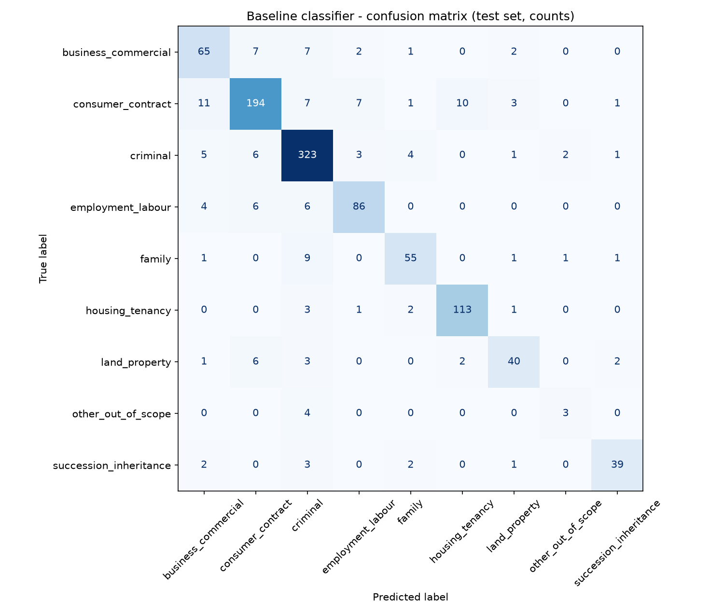
Confusion matrix

7. Interpretation, limitations and Week 2 improvements

What the results show
1. The baseline clearly learns the legal areas. Macro-F1 is 0.80 on unseen test queries, against 0.05 for the dummy baseline on validation. The top words per class are sensible legal vocabulary, e.g. landlord, lease, tenant, rent for housing and will, estate, trust, inherit, probate for succession (results/top_terms_per_class.txt). The model is therefore explainable.
2. Accuracy alone would be misleading. Accuracy (0.8652) is higher than macro-F1 (0.8020), because the large classes (criminal, 345 test queries) are easier and dominate accuracy. Macro-F1 shows that the small classes are weaker.
3. The weakest class is the most safety-relevant one. other_out_of_scope has recall 0.4286 (3 of 7 test queries). The other 4 were predicted criminal. Its top words are question-style words (what, how, help), so the model learned the style of the synthetic out-of-scope queries rather than the idea of "not a legal question".
4. The safety gate partly compensates. The confidence threshold of 0.35 was chosen on validation as the lowest value giving at least 90% accuracy on accepted queries. On the test set:
- 91.42% of queries are answered directly (coverage), with 90.52% accuracy;
- 51 of the 143 errors are caught by the threshold and would trigger a clarifying question;
- all 4 misclassified out-of-scope test queries had confidence between 0.24 and 0.33, so all 4 were flagged.
This still leaves 92 errors that pass with confidence ≥ 0.35.
5. Most confusions are between legally neighbouring areas:
- consumer_contract → business_commercial (11) and → housing_tenancy (10);
- family → criminal (9).
These are areas that genuinely overlap: contracts appear in business and tenancy, and family situations can involve abuse or crime. Some "errors" are label noise from user-assigned tags. For example, a question asking for help with an LSAT exam answer is tagged criminal-law.
6. Synthetic queries are not easier. On synthetic test queries, accuracy was 0.8406, slightly lower than on Law Stack Exchange (0.8669). The Law Stack Exchange macro scores (0.7432) are lower than its accuracy partly because 2 Law Stack Exchange questions were predicted other_out_of_scope, a class with no Law Stack Exchange examples, which counts as a zero-scoring class in that subset's macro average. The synthetic test subset is only 69 queries, so its scores are uncertain.

Limitations of the baseline
Limitation | Evidence from this work
Out-of-scope detection is weak and relies on 50 synthetic examples | Recall 0.4286 on 7 test queries; top words are generic question words
No understanding of word meaning or context (bag of words) | "Who will win the election next year?" was predicted succession_inheritance at confidence 0.4826 and not flagged, because "will" is the strongest succession word
Data is mostly not Ugandan. Law Stack Exchange is international and dominated by US/UK questions | 6,621 of 7,071 rows are Law Stack Exchange; Ugandan context comes only from the 450 synthetic rows
Style mismatch between sources | Law Stack Exchange texts average 148.5 words, synthetic queries 11.7 words; real chatbot queries will be short like the synthetic ones
Synthetic bias. One AI author, clean English, no code-switching (e.g. Luganda/English mixing) | All 450 synthetic queries written in one pass by one author
Class imbalance | criminal 2,297 rows vs other_out_of_scope 50 rows
Noisy labels. Tags are assigned by users, not experts | e.g. LSAT exam question tagged criminal-law
Single label only | A query can involve two areas (e.g. inheritance of land); only one is predicted
No jurisdiction awareness | The model does not detect the user's country, which decision support will need
Demo queries partly overlap the training data | Two queries used in early manual checks matched synthetic training sentences; the notebook demo therefore uses newly written queries

Proposed Week 2 improvements
1. Obtain Kimuntu's data and priorities. Replace or supplement synthetic data with approved real queries; confirm jurisdictions and the priority categories.
2. Strengthen out-of-scope detection. Add real non-legal questions (e.g. from a licensed public general-question dataset) and legal questions outside our 8 areas (e.g. copyright, immigration) to other_out_of_scope; evaluate it with a larger test set.
3. Reduce the style gap. Train and test on Law Stack Exchange titles only, or on the first sentence, which are closer to chatbot-length queries, and compare.
4. Error analysis with the team: review results/misclassified_test_examples.csv, fix clear label noise, and refine the tag mapping and labelling rules.
5. Better calibrated confidence: use probability calibration and evaluate the threshold with the chatbot team, so that clarifying questions are asked at the right rate.
6. Try one stronger but still explainable model, e.g. a linear SVM or sentence embeddings with Logistic Regression. Keep it only if validation macro-F1 clearly improves.
7. Expose predict() through a small FastAPI endpoint once the chatbot component needs to call it, using the output format already defined in src/predict.py.
8. Add a jurisdiction question to the chatbot flow (the classifier cannot infer it), feeding the decision support escalation rules.

8. Group output and individual contribution
This report and the repository it describes form the complete group output for Week 1. The individual statement below must be completed by the student.
Complete every [PLACEHOLDER] yourself. Do not submit with placeholders left in. This assessment is individual: describe only what you did.

Student details
Field | Entry
Full name | [PLACEHOLDER: your full name]
Student / registration number | [PLACEHOLDER]
GitHub username | [PLACEHOLDER: e.g. the account the commits were made from]
Assigned role in the group | [PLACEHOLDER: the role your group assigned to you]

Group members
Name | Assigned role
KAZIBWE BENJAMIN | [PLACEHOLDER]
NAMUSANA REBECCA | [PLACEHOLDER]
CHOL MANGONG AJAL BOL | [PLACEHOLDER]
KAWUMA MICHAEL | [PLACEHOLDER]
Mustapha suleiman Ali | [PLACEHOLDER]
NAZIF SABO DANLADI | [PLACEHOLDER]
Henok Tesfahiwet Lbab Fidel | [PLACEHOLDER]
BIYINZIKA EMMANUEL ONYUTA | [PLACEHOLDER]
TWIJUKYE DISMAS | [PLACEHOLDER]
NASSEJJE RACHEAL | [PLACEHOLDER]
ATUHAIRE LYNNET | [PLACEHOLDER]
TUGUME ANDREW | [PLACEHOLDER]
Baboucarr A Bobb | [PLACEHOLDER]

My specific contribution
[PLACEHOLDER: describe in your own words what you did. Examples of the kind of detail to give: which deliverables you worked on, decisions you made or proposed, problems you found and fixed.]

Evidence
Evidence | Where to find it
Git commits | [PLACEHOLDER: e.g. output of "git log --oneline" or the GitHub commit history link]
Files I worked on | [PLACEHOLDER]
Meetings / discussions | [PLACEHOLDER]

Use of AI assistance
This repository was developed with the help of an AI coding assistant (Claude, by Anthropic). Commits made with its help carry a Co-Authored-By: Claude line, and the synthetic dataset was written with AI assistance (see data/README.md). [PLACEHOLDER: describe how you directed, checked and understood the AI-assisted work, in line with your course's policy on AI use.]

Understanding of the complete solution
[PLACEHOLDER: in your own words, explain how the text classifier connects to retrieval, decision support, recommendation and the chatbot (see docs/architecture.md).]

Evidence: Git commit history
Commit history of the repository at the time this report was built (the commit that adds the report itself comes after). Run 'git log' for the current history.
Commit | Date | Author | Message
430b6b7 | 2026-10-20 | sm172620-bit | chore: initialise repository with .gitignore and README skeleton
c8d071b | 2026-10-20 | sm172620-bit | docs: add problem and scope statement
bd68ac4 | 2026-10-20 | sm172620-bit | docs: propose legal query categories with definitions and examples
4719938 | 2026-10-20 | sm172620-bit | chore: pin Python dependencies in requirements.txt
2b8b28f | 2026-10-20 | sm172620-bit | docs: add system architecture diagram and explanation
719ba8b | 2026-10-20 | sm172620-bit | data: add synthetic Uganda-context query set (clearly marked synthetic)
e860ff8 | 2026-10-20 | sm172620-bit | data: add Law Stack Exchange download, tag mapping and preprocessing script
d13de2c | 2026-10-20 | sm172620-bit | data: add prepared dataset and data documentation
a49f383 | 2026-10-20 | sm172620-bit | model: add baseline training script with validation model selection
bddd3e9 | 2026-10-20 | sm172620-bit | model: add saved baseline model bundle (joblib)
1de1ad3 | 2026-10-20 | sm172620-bit | eval: add test-set metrics, classification report and confusion matrix
cb148f2 | 2026-10-20 | sm172620-bit | notebook: add Colab-compatible baseline notebook
9f5ee68 | 2026-10-20 | sm172620-bit | docs: add interpretation, limitations and Week 2 improvements
e805dc8 | 2026-10-20 | sm172620-bit | docs: add individual contribution template
7af45df | 2026-10-20 | sm172620-bit | docs: complete README with run, reproduce and structure instructions

All commits carry a 'Co-Authored-By: Claude' line, recording the use of an AI assistant.

Appendix A. How to reproduce

How to run locally (Windows, Python 3.14)
python -m venv .venv
.venv\Scripts\activate # Git Bash: source .venv/Scripts/activate
pip install -r requirements.txt
python src/prepare_data.py # downloads Law Stack Exchange (~106 MB) and builds data/processed/dataset.csv
python src/train_baseline.py # trains, evaluates, writes results/ and models/
python src/predict.py "My landlord has refused to return my security deposit."
python src/draw_architecture.py # redraws docs/architecture.png
python src/build_report.py # rebuilds report/Kimuntu_AI_Week1_Report.docx
data/processed/dataset.csv is already committed, so prepare_data.py is only needed to rebuild it.

Using the classifier from other code
import sys; sys.path.append("src")
from predict import predict
predict("My employer has not paid my salary")
# {'category': ..., 'confidence': ..., 'top_3': [...], 'needs_clarification': ..., 'threshold': 0.35}
needs_clarification is True when the query is out of scope or the confidence is below the threshold. The chatbot should then ask the user to rephrase or refer them to a professional.

How to run on Google Colab
1. Open https://colab.research.google.com → File → Upload notebook → choose notebooks/baseline_classifier.ipynb.
2. Runtime → Run all. When asked, upload data/processed/dataset.csv.
Colab already includes scikit-learn, pandas, numpy, matplotlib and joblib, but its versions may differ from requirements.txt, which can cause very small differences in the numbers. For identical results, first run !pip install scikit-learn==1.9.1 pandas==3.0.6 numpy==2.5.4 in a cell, if Colab's Python version supports these versions.

Reproducibility
- Random seed 42 for the data split and the model.
- The Law Stack Exchange download is pinned to commit ab2dbaad9a71b6550316994c8fcd69f24f7f16e6.
- The test set is used once, after model selection on the validation set.
- notebooks/baseline_classifier.ipynb was checked to give the same numbers as src/train_baseline.py.

Appendix B. References and data sources
- Moslem, Y. (2023). Law-StackExchange Dataset. Hugging Face. https://huggingface.co/datasets/ymoslem/Law-StackExchange. DOI: 10.57967/hf/4792. Licence: CC BY-SA 4.0.
- Law Stack Exchange contributors. Questions licensed CC BY-SA 3.0 / 4.0. https://law.stackexchange.com
- Uganda Legal Information Institute (ULII), Law Reporting Unit of the Uganda Judiciary. https://ulii.org/ (candidate retrieval source for later weeks, pending Kimuntu approval).
- Pedregosa, F. et al. (2011). Scikit-learn: Machine Learning in Python. Journal of Machine Learning Research, 12, 2825-2830.
- Assessment brief (AI.pdf) and Kimuntu AI Riipen Project Discussion Note (lecturer guide), course documents.
- Synthetic queries: written for this project by an AI assistant (Claude, Anthropic); not real user data.

