

**School of Computer Science and Engineering**

**J Component report**

**Programme :** B. Tech CSE

**Course Title :** Image Processing

**Course Code :** CSE4019

**Slot :** E1

**Skin Cancer Classification and Melanoma Detection using Deep Learning and Medical Assistance**

Gadiparthy Harika Sai | 19BCE1182

Meghna Manoj Nair | 19BCE1459

Jessenth Ebenezer | 19BCE1462

**Team Members:**

**Date:** 09/05/22

**Faculty:** Dr. Geetha S

**Skin Cancer Classification and Melanoma Detection using Deep Learning and Medical Assistance**

Gadiparthy Harika Sai, Meghna Manoj Nair, Jessenth Ebenezer - 19BCE1462

**Abstract**

This application will be developed using programming languages which include Python, JavaScript, HTML, and CSS. The input and image set for this project would include a huge dataset of thousands of image files. The image dataset used for training would consist of images of skin which have been affected by Melanoma at various stages and the dataset will be pulled from a medical repository in Kaggle. The user can upload an image of a portion of his/her skin and the trained detection model will be loaded to output the prediction rate of the skin cancer for the uploaded image. The prediction rate will be displayed to the user and if the prediction of occurrence of Melanoma Cancer exceeds a threshold of 75%, then the user will be intimated regarding the same as they fall under the high-risk category. Furthermore, for high-risk category users, the application will prompt the user to provide their location and other basic details and will display the details and locations of nearby hospitals which specialize in dermatology detection and related services which would encourage the users to avail the required services to cure their disease at the earliest. Furthermore, the application would also be incorporated with a user-friendly and interactive chatbot which would further assist the user on various queries and clarifications related to cancer, it’s detection and the latest news and updates in this domain.

# Literature Survey

This section focuses on the existing works and implementations by authors and researchers in the field of skin cancer classification and detection. The authors of [1] have researched on diagnosis of skin cancer using optimized convolutional neural networks. They have made use of the Dermaquest database which is considered as the online medical atlas for dermatologists. In order to measure the model generated, specificity, sensitivity, precision and net present value were the metrics used. The authors were able to curate an optimized and efficient CNN based model for skin cancer diagnosis based on the input images fed to the model after sufficient training from the database. The work and research path of [2] is very similar to that of the previous discussed paper as they also follow a CNN based model for skin cancer detection. However, the dataset used here is an anonymous public dataset. The metrics of recall, specificity, precision and F-measure were used to assess the curated model. The authors basically developed and CNN based approach for specifically classifying Melanoma and severe malignant forms of skin cancer in order to differentiate it from the benign forms. The authors of [3] have also made use of a CNN based model for classifying Melanoma Skin Cancer. The model was trained using a dataset of images which are used for dermascopic examination and analysis. The CNN architecture used here is eNet-5 and they have used a confusion matrix to parameterize and assess the model. The model ultimately detects the skin lesion and classifies it as a Melanoma or Non-Melanoma disease. The work portrayed by authors of [4] cater to deep neural networks being superior and efficient than manual dermatological analysis. The dataset used is a biopsy-proven dermoscopic image set of Melanoma and Nevus. The CNN based model generated is assessed on factors like sensitivity and specificity and the researchers were able to observe and conclude that the automated melanoma detection was significantly and consistently superior and efficient when compared to junior and board-certified health care fraternity. The research work mentioned in [5] is one of the early computer aided diagnosis techniques which makes use of Raman Spectroscopy. The Raman Spectra is acquired by concentrating and pointing a laser beam persistently at a sample which leads to the excitation of particles in the sample leading to a scattering effect. The shifting of frequencies is what enables the spectroscopy to provide information and details regarding the molecular structure of chemical compounds. They have further made use of a nonlinear neural network classifier based on a feature extraction scheme. The model suggested by the author also overcomes the possibility of overfitting through adaptive filtering and outlier detection. Metrics like sensitivity and confusion matrix were used to assess the model.

# Proposed Work

The project proposed in this paper revolves around the classification and identification of skin cancer forms so as to analyze its severity and put forth suitable healthcare institutions which the user can make use of for treatment and cure. In order to classify and identify the different forms of skin cancer, a series of image processing techniques are required which would extract the suitable lesion from the image which is likely to be affected by cancerous cells. Image enhancement, contrast enhancement, brightening and smoothing are some of the possible techniques which may have to be applied on the input image to convert it into an extractable form. Following this, a CNN based model will be utilized to classify the extracted lesion surface as Melanoma, Nevus, or Seborrheic Keratosis. Fig. 1 shown below elucidates the major processes involved during the execution of the proposed work.

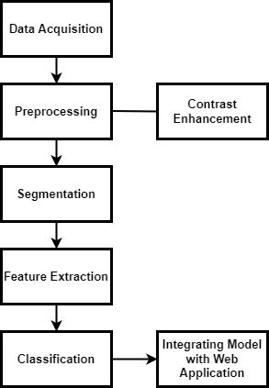

Fig. 1 Work Flow of Proposed Work

Each and every stage/step right from the beginning to the end are explained as follows:

**a. Data Collection**

The image dataset for this project has been acquired from the International Skin Imaging Collaboration (ISIC) which is considered as the official organization for dermatologists approved images. There are three classes of images – melanoma, nevus, and seborrheic keratosis which are used for training the model.

**b. Data Acquisition**

This step involves the acquiring of images onto the local system which was used for the project implementation. The images were acquired in JPG/JPEG format with around 400 images in each of the classes. A sample image is shown in Fig. 2 below.

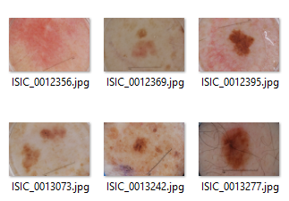

Fig. 2 Sample Images from the dataset

**c. Pre-Processing**

After acquiring the dataset, it was ensured that all images had the same size and dimensions for ease of computation and processing. All images were rescaled to the same dimension of around 256x256. Further, the images were subdivided into different folders for training and testing. Each of the training and testing folders have images belonging to three classes – Melanoma, Seborrheic Keratosis, and Nevus.

**d. Building the model**

The next step is to build the CNN model using the VGG-16 architecture which is considered to one of the best classification and detection models till date. The CNN model contains three levels of neural layers to assemble and arrange the architectural aspects – convolutional layer, pooling layer and fully connected layer. The proposed model has three main phases to complete at its core – feature extraction, detection and classification. Initially, the concurrent layers of convolution are used following which the parallel layers get activated. Convolution is one of the important processes in image processing. After the feature extraction phase, the next step is the classification process. This is achieved by the flattened level fed into a two-layer multi-layer perceptron. All throughout the training process, the dropout layer would keep removing the fully connected layers weights in order to reduce and decrease the chances of overfitting. The accuracy and validity of the model is tested and is found to be around eighty percent. Further accuracy can be improved up to around ninety percent by training the model for a hundred epochs but due to the limited resources and hardware constraints at hand, we have run the model for only twenty epochs. The precision, recall, and F1-Score are 76.19, 78.15 and 76.92 respectively. The model is then saved and can be used for the next level of implementation. Fig. 3 elaborates on the internal flow of the working of the neural networks and segmentation within a CNN model.

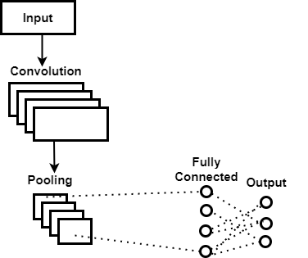

Fig. 3 CNN Model Working

**e. Web Application**

The major and final step left in the completion of the project is to utilize the model created in the previous step and to integrate with an application which can be used by the society easily. An interactive, simple and user-friendly Web UI is created using HTML, CSS, JavaScript and Flask. The saved model is then integrated with the Flask framework. Each time the user uploads an image from the frontend UI, the CNN based classification model is called which extracts the lesion from the segmented image, parses through it and classifies it as Melanoma, Nevus or Seborrheic Keratosis. The classification is then displayed along with the accuracy of prediction. Based on the convenience of the user, the app would also request for the user location and then suggest nearby hospitals and clinics which offer suitable treatment.

# Conclusion

The Deep Learning CNN based model for Skin Cancer classification has been successfully implemented and integrated with a web application. The main motive of this project is to utilize the massive platform and technologies provided by Image Processing and Deep Learning to ensure an early-stage detection of Melanoma so as to positively impact millions of people who fall prey to this deadly disease due to lack of early prediction.

**References**

[1] Zhang, N., Cai, Y.X., Wang, Y.Y., Tian, Y.T., Wang, X.L. and Badami, B., 2020. Skin cancer diagnosis based on optimized convolutional neural network. Artificial intelligence in medicine, 102, p.101756.

[2] Hasan, M., Barman, S.D., Islam, S. and Reza, A.W., 2019, April. Skin cancer detection using convolutional neural network. In Proceedings of the 2019 5th international conference on computing and artificial intelligence (pp. 254-258).

[3] Refianti, R., Mutiara, A.B. and Priyandini, R.P., 2019. Classification of melanoma skin cancer using convolutional neural network. IJACSA, 10(3), pp.409-417.

[4] Titus J. Brinker, Achim Hekler, Alexander H. Enk, Carola Berking, Sebastian Haferkamp, Axel Hauschild, Michael Weichenthal, Joachim Klode, Dirk Schadendorf, Tim Holland-Letz, Christof von Kalle, Stefan Fröhling, Bastian Schilling, Jochen S. Utikal, Deep neural networks are superior to dermatologists in melanoma image classification, European Journal of Cancer, Volume 119, 2019, Pages 11-17, ISSN 0959-8049

[5] Sigurdsson, S., Philipsen, P.A., Hansen, L.K., Larsen, J., Gniadecka, M. and Wulf, H.C., 2004. Detection of skin cancer by classification of Raman spectra. IEEE transactions on biomedical engineering, 51(10), pp.1784-1793.