**An introduction to Virtual Machines**

In computing, a virtual machine (VM) is an emulation of a particular computer system. Virtual machines operate based on the computer architecture and functions of a real or hypothetical computer and their implementations may involve specialized hardware, software, or a combination of both.

Various different kinds of virtual machines exist, each with different functions.

System virtual machines (also known as full virtualization VMs) provide a complete substitute for the targeted real machine and a level of functionality required for the execution of a complete operating system.

A hypervisor uses native execution to share and manage hardware, allowing multiple different environments, isolated from each other, to be executed on the same physical machine.

Modern hypervisors use hardware-assisted virtualization, which provides efficient and full virtualization by using virtualization-specific hardware capabilities, primarily from the host CPUs.

Process virtual machines are designed to execute a single computer program by providing an abstracted and platform-independent program execution environment.

Some virtual machines, such as QEMU, are designed to also emulate different architectures and allow execution of software applications and operating systems written for another CPU or architecture.

Operating-system-level virtualization allows the resources of a computer to be partitioned via the kernel's support for multiple isolated user space instances, which are usually called containers and may look and feel like real machines to the end users.

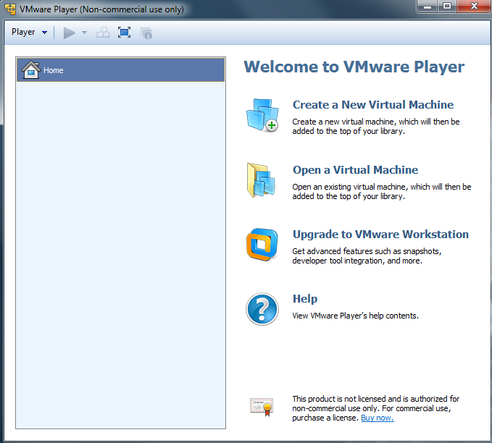This instructional guide assumes you have already started the VMware player program and are viewing the splash screen as seen in figure 1-1.

Figure -1

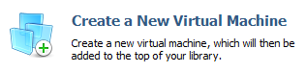Once you have reached this screen you should hover over the “Create a virtual machine” a header, as seen in figure 1-2, and select it.

Figure 1-2

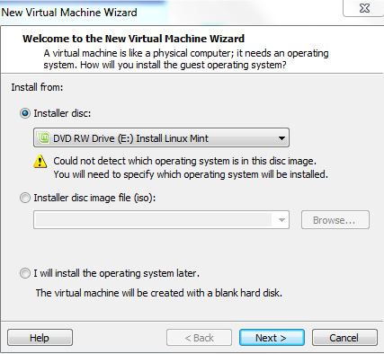Pressing this will open second window, with the title “Welcome to the New Virtual Machine wizard”, that allows you to select where to install from. The pre-selected option should be “Installer disk”, but if it is not select the radio button as shown in figure 1-3.

After selecting the installer disk option press the “Next” button and the program will bring you to the next options window.

Figure 1-3

Select the radio button behind the “Linux” title, and if needed change the version to “Ubuntu”. This is done because VMware has no pre-set option for Linux mint.

Figure 1-4

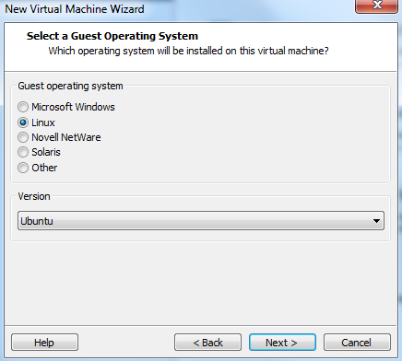After doing this press next and allow the program to go to the next options window.

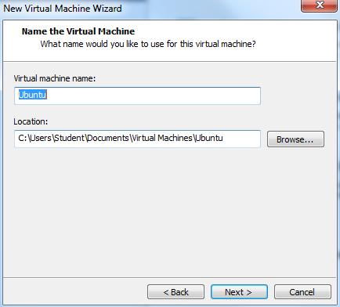This next window is where you will set the Virtual Machines name and the location it is stored on. This is shown on figure 1-5. To set a different location for storage than default select the “Browse…” button and navigate to the file location where you wish to save the Virtual Machine.

Figure 1-5

After doing this press the next button to continue.

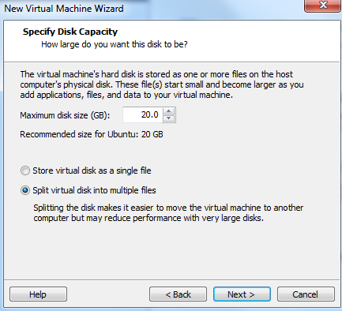

Figure 1-6

This next window is where you will set the “size” of the Virtual Machine. To set the size of the machine select inside of the textbox and replace the default suggestion with the size you require.

The suggested size according to VMware is 20gb but this is just a suggestion, (set it to whatever size you wish, though I personally suggest above 30gb’s). The choice of whether to store the hard disk as a single or split file is completely up to you.

As it shows in figure 1-6, storing as a split file will be slower than storing as a single file when dealing with larger Virtual Machines.

After selecting the required size and how it will be stored press the next button to continue.

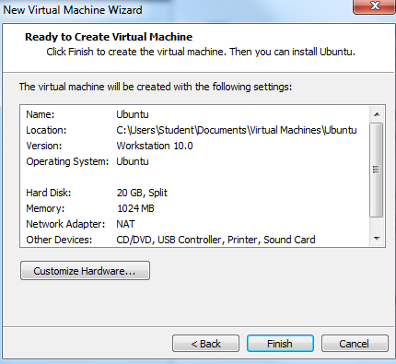This next window is shows the default hardware options that VMware selects for your host system and Virtual Machine. This is shown in figure 1-7.

Figure 1-7

Often leaving this as the default will provide the best performance but if you wish to change these options, select the customise hardware button and in the next window (shown in figure 1-8) set the specifications required.

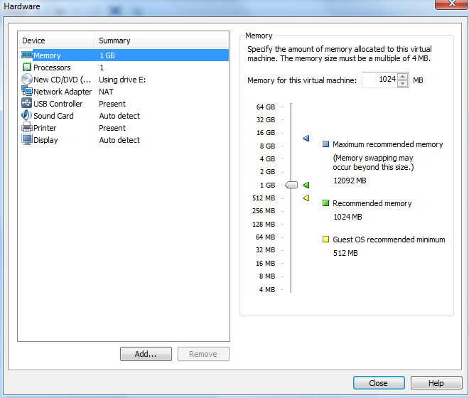The options that can be changed include:

* Memory
* Processors
* Cd/dvd adapters
* Network adapters
* Usb controller
* Sound card
* Printer
* Display

Of these I suggest only tweaking the memory and processor options as changing the others from default may decrease the functionality of the Virtual Machine.

Figure 1-8

Once done with tweaking the virtual hardware options press close and it will save the selected options. After this press the finish button (as shown in figure 1-7), VMware will finalise your Virtual Machine and bring you back to the splash screen where you will be able to see your virtual machine has been added (shown in figure 1-9).

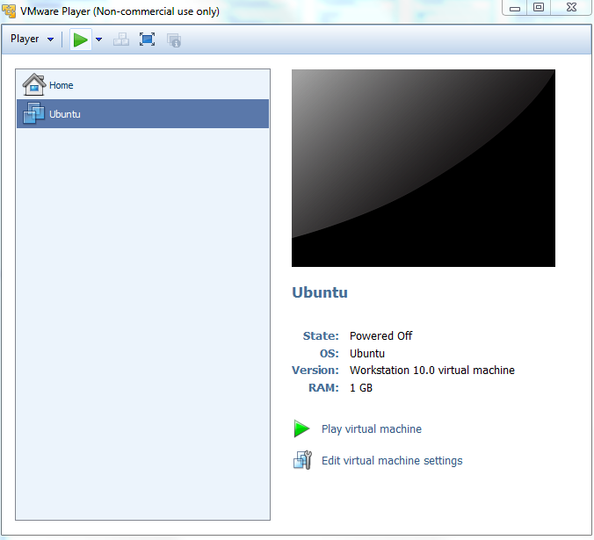To launch the Virtual machine, ensure it has been selected by hovering over the name given to the machine earlier and select it. Then, either press the “Play virtual machine” option under the Virtual Machines specifications, or press the green sideways arrow next to the “player” dropdown in the top left corner of the program.

Doing so will begin the install process.

Congratulations, you have created your first Virtual Machine.

Figure 1-9