Foundations of Medical Statistics

Statistical Inference Assignment

Introductory details

This assignment is set to test your ability to fulfil the following criteria:

1. To define a statistical model for a set of data.
2. To use the methods taught to derive maximum likelihood estimators of model parameters and approximate standard errors of these estimators.
3. To use the MLEs and standard errors to calculate approximate confidence intervals for the parameters.
4. To set up, perform and interpret hypothesis tests appropriate for specific clinical questions.
5. To define algebraic notation clearly, and manipulate algebra so the logic from one step to the next is clear, while aiming to be as concise as possible.

In assessing your work, a pre-prepared marking scheme will be used which takes into account all the criteria defined above. To achieve the highest grade, you will need to fulfil all 5 criteria defined above.

Answers should be clearly handwritten (though typed answers may also be submitted). There is no page/word limit, but as criterion 5 above indicates, credit will be given to answers which are clear, logical and concise. There is no need to write answers as if they were to appear in a statistical or medical journal — no extra credit will be given to such answers.

You should attempt to answer all four questions. A rough guide to the marking weights for the four questions is:
Question 1, 18%; Question 2, 20%; Question 3, 37%; Question 4, 25%.

Please hand in your work electronically (scanning handwritten scripts) via Moodle by 2pm, Monday 28th November 2022.

Notes on Questions 1 and 2
For questions 1 and 2 you may at any point refer to statements A and B, stated below, without proof, provided your logic in referring to them is clear. Longer derivations which do not require these statements will be given no extra credit.

Statement A: MLEs are invariant under transformation. In other words, if is the MLE of , 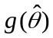 is the MLE of 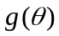 for any regular function . This is also true for functions of several variables: for example, the MLE of 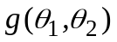is 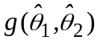.

Statement B: If β₀ and β₁ are parameters estimated from two independent sets of data, with MLEs 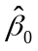 and 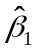, and standard errors of those estimates S₀ and S₁, then for 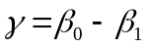 the MLE (which from Statement A is 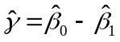) has standard error 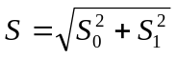.

Throughout, log(x) is the natural logarithm of x.

Question 1

Suppose there are two independent sets of data, as follows:

 | Subjects | Events | Parameters
Group 0 | n₀ | k₀ | π₀
Group 1 | n₁ | k₁ | π₁

(a) Propose a model for the data in terms of two random variables which you should define. Hence write down the joint log likelihood for the parameters π₀ and π₁. (5%)
(b) Write down, with justification, the maximum likelihood estimates (MLEs) of
(i) π₀ (6%)
(ii) logit(π₀) (2%)

By using a quadratic approximation to the true log likelihood it can be shown that the approximate standard error (SE) of the MLE of π₀ is 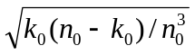and the SE of MLE of logit(π₀) is 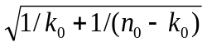

(c) Derive the following results.
(i) the MLE of the risk difference π₁ −π₀ is k₁/n₁ − k₀/n₀
with SE 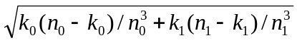 (2%)
(ii) the MLE of the log odds ratio 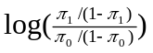is 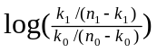
with SE 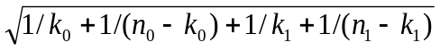. (3%)

Question 2

In a randomised trial comparing radiotherapy alone vs radiotherapy and surgery combined in the treatment of patients with stomach cancer, 12 out of 32 patients randomised to radiotherapy died within 3 months, and 5 out of 29 patients randomised to radiotherapy and surgery combined died within 3 months.

(a) Write the results in the form of a 2×2 table, and use the results from question 1 to calculate maximum likelihood estimates of the risk difference and odds ratio. (6%)
(b) Use the results from question 1 to calculate approximate 90% confidence intervals for the estimated risk difference and odds ratio. Interpret your results, and briefly indicate why these confidence intervals are only approximate. (14%)

Question 3

A laboratory assay performed on blood specimens involves an internal control so that the mean value of the assay measurements is known to be zero. In a quality assurance program, the variability of the assay is checked on a regular basis by evaluating whether there is evidence that the variance of the assay measurements departs from the usual value of 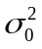. This is done using a number of specimens from healthy subjects, for which there is good evidence that the assay measurements are Normally distributed.

(a) Let random variables X₁,..., X_{n} be the assay measurements for n specimens. Identify a model and appropriate hypotheses for evaluating whether the variance has changed from the usual value. (2%)
(b) Derive, in terms of the variance parameter, (i) the likelihood ratio and (ii) the Wald test statistics for evaluating evidence against your null hypothesis, expressing them in terms of the null value, the sample size n, and (to simplify your working)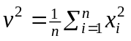. In your answers indicate also the sampling distribution of the test statistics under the null hypothesis. (14%)
(c)
i) Why, in the context of this particular parameter, might the performance of the Wald test be unsatisfactory in small samples? (5%)
ii) Justify and derive an improved Wald test statistic. (7%)
iii) Demonstrate by use of examples (or otherwise) the circumstances in which the quadratic approximation used to derive the Wald statistic in part c)ii) results in a substantially improved approximation to the true log-likelihood function (as compared to the approximation used in b)ii)). For the purposes of this demonstration, each example could use fixed values of n and 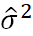. (9%)

Question 4

Five patients have participated in a crossover clinical trial which was undertaken to compare the pain relief of two treatments, A and B. In a crossover trial, participants receive both treatments in a random order over time. At the end of the trial, patients were asked to indicate their relative preference for the two treatments by putting a cross on a visual analogue scale:



You may assume no patients put their crosses at identical distances from the point of no preference.

To analyse the resulting data, patients were ranked from 1 (closest) to 5 (furthest) in terms of the distance of their cross from the point of no preference (ignoring which treatment they preferred). Then a test statistic was constructed by adding the ranks for the patients who preferred treatment B over treatment A.

For example, consider the schematic below. The test statistic would be 1+2+3=6.

x
x
x
x
x
Rank (distance from
no preference)
5
4
3
2
1
Score
-2
-0.8
-0.4
3.9
4.5

(a) What is the sample space for the test statistic? (3%)
(b) If the null hypothesis of interest is that the two treatments A and B are identical in their effects on pain, obtain the sampling distribution for the test statistic under the null hypothesis (i.e. obtain the probability that the test statistic takes on each value in the sample space, under the null hypothesis). (10%)
Hint: the test statistic does not follow any standard statistical distribution taught on the Foundations of Statistical Inference module. You will need to derive the sampling distribution from first principles, based on the description of how the test statistic is constructed
(c) Define a rejection region which gives a type I error probability of at most 0.1 for a two-sided test of the null hypothesis. (6%)
(d) If the results of the trial were scores of 3.1, 5.2, −0.7, 4.8 and 5.0 (using 0 as the point of no preference, and interpreting negative values as being to the left of that point in the diagram above), what do you conclude about the two treatments, based on the test statistic defined above? (6%)

