

Product Dissection for Amazon (e-Commerce Website)

# Introduction

In the present assessment context, the Amazon application and its new features are to be discussed in terms of developing the idea about the system functionality. The schema design and the Entity Relations are also to be developed and established based on the different data of the system.

# Company Overview:

Amazon was founded by Jeff Bezos on 5th July 1994 in Bellevue, Washington to establish a marketplace for selling books. In the present day, Amazon has become a multinational corporation with a huge market worldwide with millions of products and over 12 million classifications of products. Amazon has been a pioneer in including and acquiring new technologies to its business system and it is one of the most trusted online platforms for selling and buying products.

# Product Dissection and Real-World Problems Solved by Amazon:

The present discussions are subjected to analysis of the product dissection of Amazon and the platform for Amazon is the product in this context. Amazon Application was developed in 2010 and was launched in March 2011. This application is widely used worldwide and accessed through the users' mobile devices. It helps the customers choose and order their desired products and also helps communicate with customer support for any assistance with the orders. The company has developed its application with the evolution of technology and it has included chatbots and voice search features a few years before. The recent update in 2019 is the image search feature. These features have made the application appealing and user-friendly. The following discussions are subjected to develop an idea of the system and how different data related to the application are connected to provide the users with an effective experience.

## Case Study:

Amazon is one of the best online shopping platforms and it has several operations performed on the platform regularly. In this present context, the idea is necessary to be developed about the problems with the platform faced by the consumers and sellers. The following discussions show different problems and they also provide the solutions to be implemented through the betterment of the database management system.

***Problem 1***: Market Competition for Sellers and Shipping Charges from the Sellers

***Solution***: The Amazon platform has collaborated with different sellers to join their portal with some additional facilities than the customers. They provided price cutting and also helped with accommodation and handled logistics. These are effectively established with the online platform of Amazon where the sellers can easily track their sent items. These helped Amazon grow their business and several other sellers have gained free charges for sending their deliveries through the platform. It connected the worldwide sellers and promoted the growth of both the organisation and the sellers. This has made it possible for the better design of the system to handle different tasks and create effective logs.

***Problem 2***: Issues with product finding, sorting and selection and less effective site search

***Solution***:

The Amazon platform has provided the user facilities and equipped them with the feature to select the price range for the products before selecting a product for purchase. This platform has also created an opportunity for better user engagement. It has enabled features like suggesting similar products and a price comparison feature was added several years ago to help customers find suitable products. Omnichannel customer experience is one of the best characteristics of the platform and Fast loading speed, Easy navigation, Site Search, Sorting and Filtering are some useful features of the Amazon platform for delivering a better user experience. There is also a provision for image search powered by image processing algorithms, and Amazon provides a voice search facility.

***Problem 3***: The issues of product return and refund

***Solution***: Multiple payment options are an effective method which has made the product return and refund process easy for Amazon. The platform helps customers engage with the customer support team for any queries with the orders. It also helps the Amazon facilities to cooperate and develop a strong mode of communication about the orders. This platform has become effective with the intervention of a chatbot for getting an automatic response from the customer and replying is also automatic. It allows users to choose from the provided options for the orders and it generates automatic responses based on the AI algorithms. With simple and secure payment methods, the refund is also effectively generated.

***Problem 4***: Insecurity of the customer and sellers about the security of the financial data

***Solution***: The need for online identity verification is the key to the success of the platform. It has provided security of data to consumers’ financial data. The platform has identification protocols with login ID and password and there is also provision for mobile verification to be double sure of the identity. The financial data is secured with different protocols and the company allows only the users to see the full details of the cards saved in the platform.

## Conclusion of the Solutions

The mobile application and the web platform of Amazon provide several modes of services and in terms of product buying and selling, these platform features are useful. Image and Voice search are the two prime features of Amazon which were developed around 2017 and 2019 respectively. Security of data is also an important aspect of the platform. In the following context, the schema design of the system is essential and for this, understanding the operations of the platform and the features provided are necessary to be understood.

## Top Features of Amazon:

***Review***: The review feature helps accommodate the views of the customers for a specific product. This helps the users identify the products which are suitable for buying. This enables the establishment of a communication of the purchases and it also helps spread the word to deliver the idea of effectiveness of the products.

***Shopping Cart***: This is also an effective method to store the required products by the users. The users can be helped by taking different products from themselves and putting them in a cart like in a store. This also helps the users to gather the products and the total payment to be made is also done using the feature.

***Carrier Details***: The carrier details are also an effective feature where the users can track their products in the logistics. This helps the users identify the carrier who will bring their products. The users can be helped by the carriers to deliver the products on time.

***Easy Return and Refund***: The effective system to be discussed later helps the Amazon portal to track the problems with the product and users can get easy refunds. This is effective in terms of protecting the goodwill of the company.

***Security of Information***: The complete well-established database is effective in terms of security and includes the information of the users.

# Schema Description and Relationships of the Entities:

**User Entity:** amz_user

The amz_user is the user entity of the complete system and it contains the following details:

* **user_id (Primary Key)**: Identifies the specific user through a unique identity
* **email**: Besides the user_id, the email can also be a mode of identification (Amazon has become quite strict about one email-one user policy)
* **fname**: This signifies the first name of the user.
* **lname**: This indicates the last name of the user.
* **password**: This stores the unique password set by the user and it is kept hidden and only the user can have the knowledge (In case the user forgets and email verification is required for the identification)
* **user_type**: This can be consumers or sellers as these are the two types of users accessing the platform. The monitoring staff from Amazon also have accounts of their own on the platform.

**Contact Entity:** contact_detail

This entity contains the contact details of the users and it is specifically designed to have delivery services from sellers to the consumers.

* **user_id (Foreign Key)**: This is a foreign key for this entity and it connects the contract entity to the user entity.
* **address_id (Primary Key)**: It enrols the addresses of the user for making contact for product purchases and receives. This is the primary key for contact entities.
* **street1**: This contains the street name of the user’s address.
* **street2**: This contains more details of the address.
* **city**: This holds the city name of the user.
* **state**: This enlists the state name of the user.
* **country**: This includes the country name to the address details.
* **zipcode**: It includes the zip code of the address.
* **phone**: The phone number details are included in the user's contact details.
* **is_default**: This includes the additional details and it is left with 0 value if nothing is added.

**Card Entity:** card_info

The card entity includes details of the credit or debit card saved in the Amazon portal by the user. The following are the attributes of the entity and it acquires different information about the card saved by the user.

* **card_id (Primary Key)**: This is the primary key for card entities and provides a unique identification to the cards saved by the user.
* **user_id (Foreign Key)**: This is the foreign key for the card entity and it enables the user entity to be connected to this card entity.
* **card_number**: The card number details are saved in this attribute and it is safe with protected measures to ensure data security.
* **expiry_date**: It acquires the expiry date of the card and it ensures notification validity of the card.
* **cvv**: In some cases, CVV is stored in the database for easy transfers. In other cases, this is kept empty.
* **buyer_id**: This is related to the buyer entity of the user details.
* **is_default**: This is kept empty or it acquires a default value for the card details.

**Buyer Entity:** buyer

The buyer Entity acquires the details of the buyer who is also a user of the portal. This entity enables the buyer_id and user_id to identify the buyers. The details of the attributes for this entity are:

* **buyer_id (Primary Key)**: The buyer_id includes an identifier for the buyer entity. It includes a specific identity for the users who are buying things on the Amazon platform.
* **user_id (Foreign Key)**: This connects the buyer entity with the user entity.
* **is_prime**: This holds a Boolean value depending on the user being part of prime membership on the platform.
* **prime_expiry_date**: This holds the information on the expiry date of the prime membership for the user.

**Seller Entity:** seller

The seller entity acquires the details of sellers who are also users of the platform and uses it to deliver the products to the consumers.

* **seller_id (Primary Key)**: The seller_id provides a unique identification to the sellers in the database. This enables the database managers to connect the entities.
* **company_name**: The company name of the sellers is stored in this attribute.
* **url**: This includes the seller's domain name.
* **description**: The seller’s and the related products’ descriptions are included in this attribute.
* **average_rating**: The rating of the seller and the products are included in this attribute.
* **rating_count**: The count of Ratings is included in this attribute.
* **buyer_id (Foreign Key)**: This identity relates the buyer with the seller.

**Category Entity:** Category

This entity ensures product category and related details.

* **category_id (Primary Key)**: This is the identification of product categories. This is related to the product in the next context.
* **category_name**: This attribute contains the name of the category for the products.

**Product Entity:** product

The product entity includes the details of products available on the platform for selling and purchase.

* **product_id (Primary Key)**: It is the primary key for the product entity and it provides unique identification to the product on the database.
* **name**: This attribute contains the name of the product.
* **seller_id (Foreign Key)**: This is the foreign key connecting the product to the specific sellers.
* **price**: This attribute contains the price value of the product.
* **rating**: This attribute has the information on ratings for the product.
* **review_count**: It contains the information about the count of the review and it automatically increases with receiving a rating or review.
* **category_id (Foreign Key)**: This connects the products to the category entity.
* **description**: This attribute contains the product description.
* **discount_percent**: It acquires any discount on the product.
* **available_units**: This contains the units of available products.
* **colour**: The colour details of the products are contained in this attribute.
* **in_stock**: It is an attribute containing the stock details of the products.
* **weight**: The product weight is contained in this attribute.
* **carrier_id (Foreign Key)**: The carrier_id is the key to connecting the product and carrier attributes.

**Product Image Entity:** product_image

The product image entity holds the image details of the products. In the following attributes, the product image details are stored.

* **product_img_id (Primary Key)**: This is the primary key for a product image that carries a unique identifier to the entity.
* **product_id (Foreign Key)**: This attribute connects the product entity with the product image entity.
* **image_url**: The URL of the image of the product is stored in this attribute.

**Shopping Cart Entity:** shopping_cart

This entity holds the details of the shopping cart on the portal and also holds the cart information stored in the shopping cart.

* **cart_id (Primary Key)**: This is a unique identifier for the cart and it provides an identity to each cart on the portal.
* **buyer_id (Foreign Key)**: This is the attribute connecting the buyer entity to the cart entity.
* **date_added**: The date when the product is added to the cart is stored in this attribute.

**Product Shopping Cart Entity:** product_shoppingcart

This is the product shopping cart entity where the shopping cart is connected to the product entity. This enables the user to store the products in the cart and proceed with the buying.

* **shoppingcart_id (Primary Key)**: This is the primary key of the product shopping cart identity.
* **product_id (Foreign Key)**: This connects the product cart ID to the product ID.
* **buyer_id (Foreign Key)**: This connects the product cart to the buyer ID.

**Wish List Entity:** wish_list

In this entity, the wishlist details are stored.

* **wishlist_id (Primary Key)**: wishlist ID is the key for identifying the specific wishlist.
* **buyer_id (Foreign Key)**: This connects the wishlist to the buyer entity.
* **date_added**: The date when the product was added to the wishlist, is stored in this attribute.

**Product Wishlist Entity:** product_wishlist

The product wishlist entity enlists the product and the wishlist of specific users.

* **product_wishlist_id (Primary Key)**: The product wishlist ID shows unique identification for the wishlist of the products.
* **product_id (Foreign Key)**: This includes the connection between the product with the wishlist entity.
* **buyer_id (Foreign Key)**: This attribute connects the buyer entity with the product wishlist.

**Amazon Order Entity:** amz_order

This entity includes the details of orders in the platform. It contains the following attributes:

* **order_id (Primary Key)**: This is the key identifier for the Amazon orders.
* **buyer_id (Foreign Key)**: This attribute connects the buyer entity to the order entity.
* **card_id (Foreign Key)**: This is also an attribute connecting the card to the Amazon order.
* **total_price**: This attribute contains the total price of the ordered products.
* **order_date**: This attribute includes the details of the order date.
* **tax**: This attribute includes the tax details of the order.
* **shipping_price**: Shipping price details are stored in this attribute.
* **delivery_address_id**: This contains the delivery address identity.
* **delivery_date**: This contains the delivery date details of the order.
* **order_status**: Order status is stored in this attribute.
* **quantity**: Product quantity is stored in this attribute.

The Amazon order must be connected to different attributes for developing a well-connected relational database. This can be viewed by the users while accessing the portals.

**Order Product Entity:** order_product

The order product entity contains the product details of the ordered items. The following shows the attributes of order product entities.

* **order_product_id (Primary Key)**: This order product ID is the key identifier for the order product entity.
* **order_id (Foreign Key)**: This attribute connects the order entity with the order product entity.
* **product_id (Foreign Key)**: This connects the product entity with the order product identity.

This is how the different products and orders are connected and the user can view the details of the product.

**Review Entity:** review

Review details are the data stored in this review entity. This is subjected to the following review attributes:

* **review_id (Primary Key)**: This is the key attribute for the review entity.
* **product_id (Foreign Key)**: This key attribute connects the review entity with the product entity.
* **buyer_id (Foreign Key)**: This key attribute connects the review entity with the buyer entity.
* **review**: The review data is stored in this attribute.
* **rating**: The rating data is stored in this attribute.
* **review_date**: This is the attribute related to the review date.

The connection between the review and buyer and product database is established to deliver the idea of the effectiveness of the products.

**Review Image Entity:** review_image

Review Image Entity acquires the key attributes. This includes the following aspects:

* **review_image_id (Primary Key)**: The key review image ID is the identifier attribute of the review image.
* **review_id (Foreign Key)**: This key term reflects the review with the review image.
* **image_url**: The image URL is included in this attribute.

The review image is connected to the review entity which shows the review and review image in the same portal.

**Carrier Entity:** carrier

This includes the carrier entity and it helps deliver the data on the carrier who will deliver the parcel to the consumers from the Amazon facility.

* **carrier_id (Primary Key)**: The carrier ID provides a unique identification to the carriers.
* **carrier_name**: The carrier name is stored in this attribute.
* **carrier_phone**: The carrier phone number includes the carrier phone number.
* **carrier_email**: The carrier email ID is stored in the carrier email details.
* **buyer_id (Foreign Key)**: This attribute connects the buyer entity with the carrier entity.
* **seller_id (Foreign Key)**: This attribute connects the seller entity with the carrier entity.

The connections help the users locate the carrier details and contact them necessarily. This is subjected to provide the portal effectiveness in different terms.

## ER Diagram:

The entity-relationship of the schema of the Amazon portal has been designed in this context. This entity relationship diagram shows the Amazon order entity is connected to seller, buyer, and carrier attributes. These are subjected to determine a well-established database and the portal helps the users track their orders and other details.

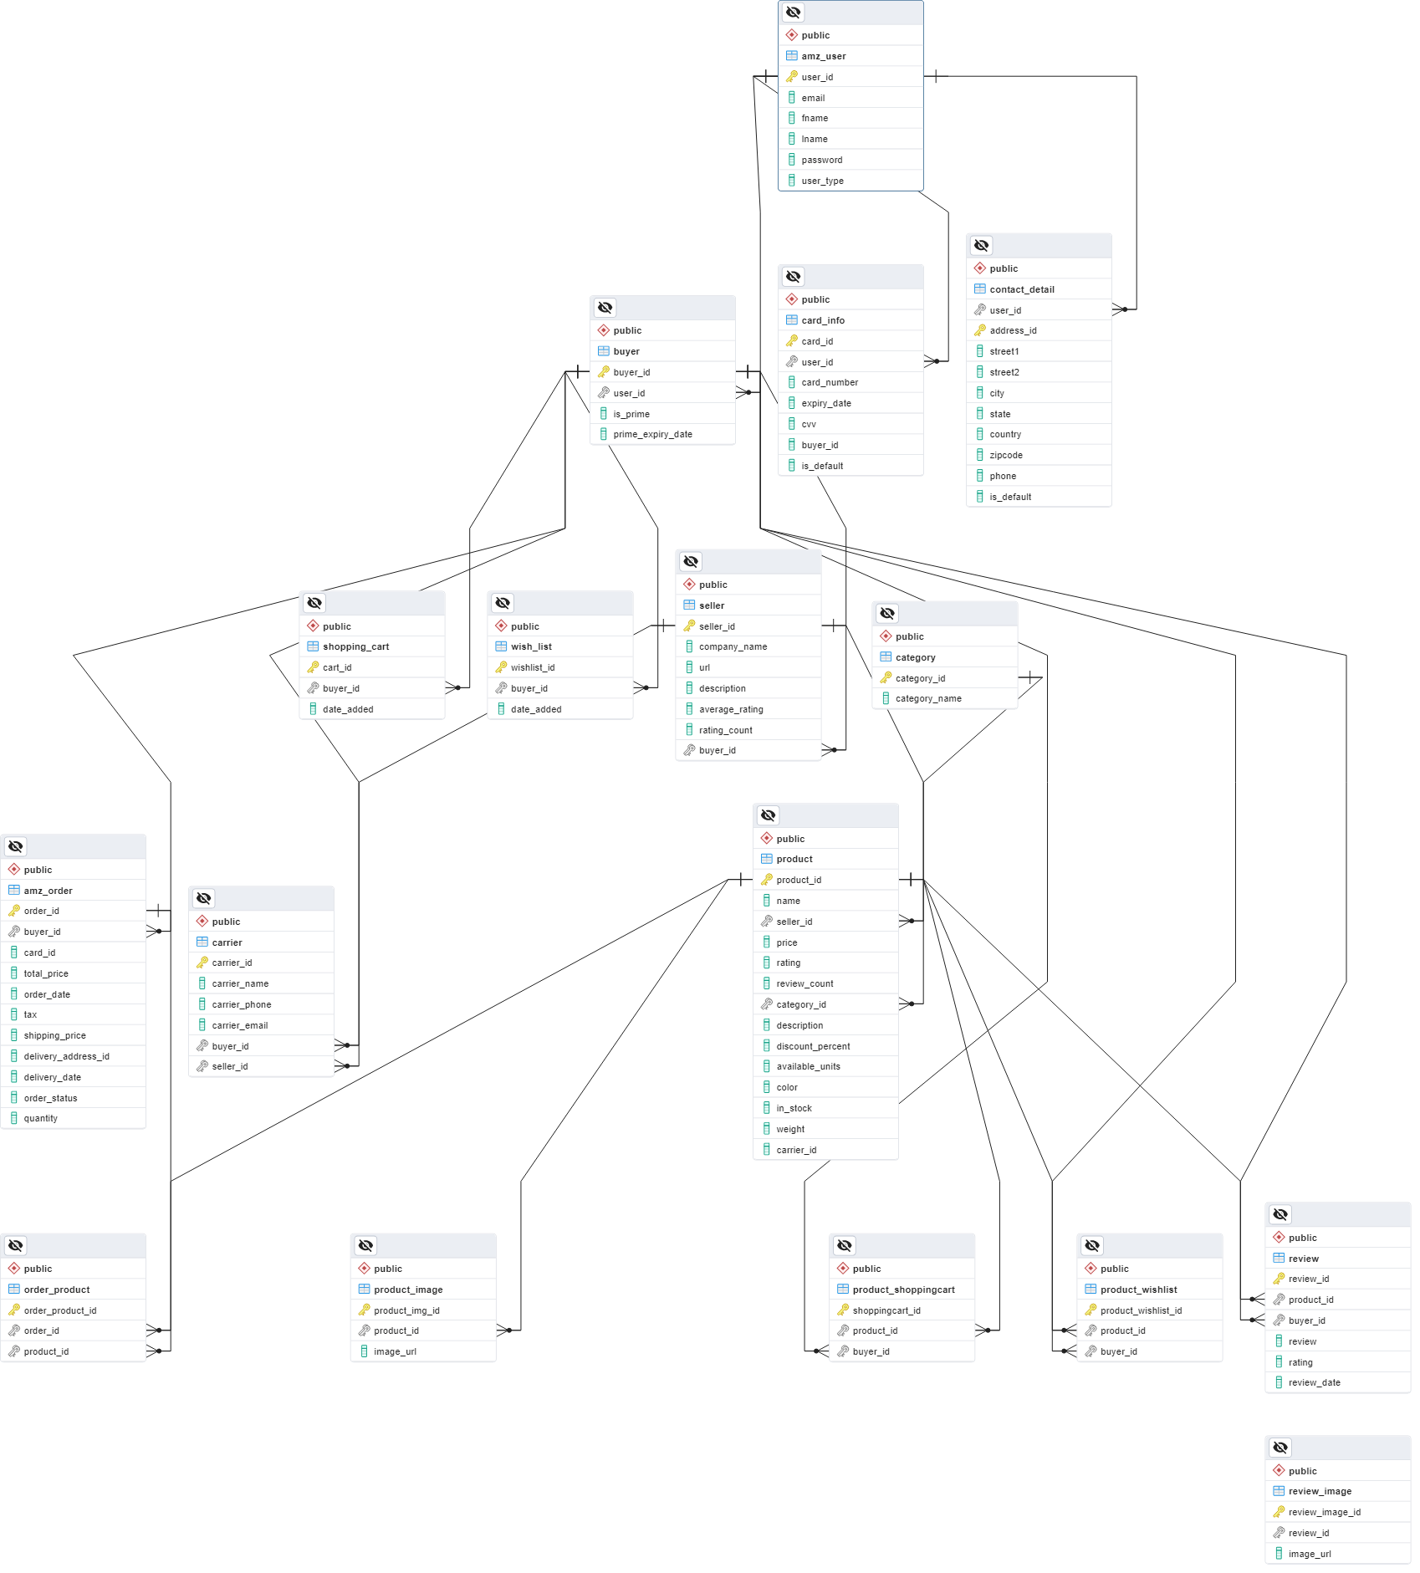

The relationship between the entities is either 1 to many or many to 1. This enlists the definition of the base attributes of a database and the schema helps develop an effective portal where the users can select and order their required products and also sort the results with filter options.

# Conclusion

Conclusively, the assessment describes the basic schema design. This design reflects the connections between the different entities in the database. It helps develop the company database and the users of the portal can effectively be implied. In order to determine a suitable measure for the company, the base database must be effectively implemented. This is subject to determining a well-established database and it reflects the Amazon orders and the products are to be connected. This is to determine an effective database where the users can see the products and also the order based on reviews.

**Video Link**:

[M3_CapstoneProject_RD.mp4](https://drive.google.com/file/d/1NknquJVunWVcPFRBJXtoj7wQBwHLSKyH/view?usp=sharing)