UAT Evidence Pack
Reference | CHG0012399
Environment | Non-Prod
Prepared by | J. Tan
Date | 2026-08-25

Item 1 — Config flag rollout check
Verified the new checkout-v2 feature flag is enabled in the non-prod config service and reflects correctly in the app settings page.
Screenshot
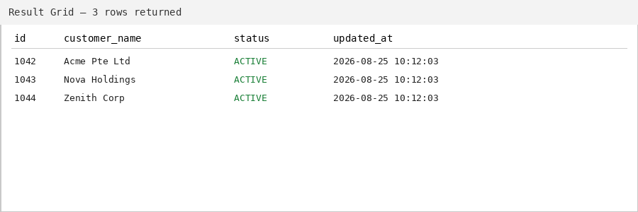

Item 2 — Backfill NULL customer_status to ACTIVE
UPDATE customers
SET status = 'ACTIVE'
WHERE status IS NULL;
Screenshot
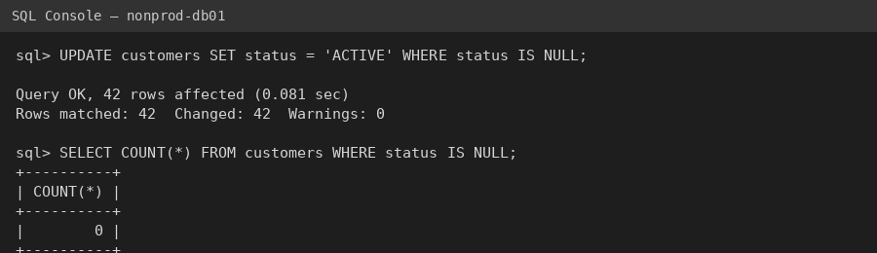

Item 3 — Access review — removed stale service account
Removed the deprecated svc-batch-old service account from the IAM group after confirming no active jobs reference it. Cross-checked against the last 30 days of audit logs.
Screenshot

