**ONLINE QUIZ PORTAL**

*Privileged and Proprietary information may be contained in this document and may be subject to legal privilege.*

*You may not use, copy and distribute to anyone this document (or any part of its contents) or take any action in reliance on it.*

*The originator and users of this document are personally responsible for using official version*

**Revision History:**

|  |  |  |  |  |  |
| --- | --- | --- | --- | --- | --- |
| ***Revision Number*** | ***Date*** | ***Author*** | ***Comments*** | ***Reviewed by*** | ***Approved by*** |
| 1 | 21-03-2021 | Shivani Maski |  |  |  |
|  |  |  |  |  |  |

**Contents**

1. OverView 4

1.1 How to start the quiz?.................................... ……………………………………..………………………………4

### 1. over View

It is an Online Quiz portal single page application developed using Angular. It has a set of 5 java puzzles and user can participate in the quiz portal and corresponding results for the user will be displayed.

### <https://github.com/sm35937/Onlinequizportal>

### 1.1 How to Start the Quiz

* User can start the quiz by clicking the start button, which is placed at the middle of the screen.

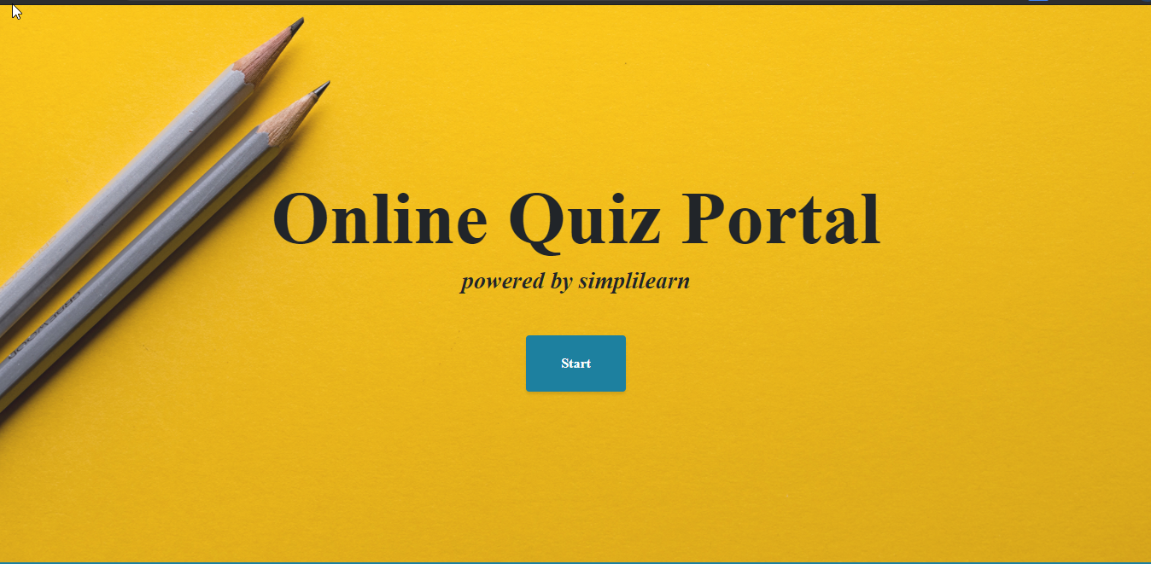

* Once the start button is clicked means, The MCQ questions will be displayed in the screens.

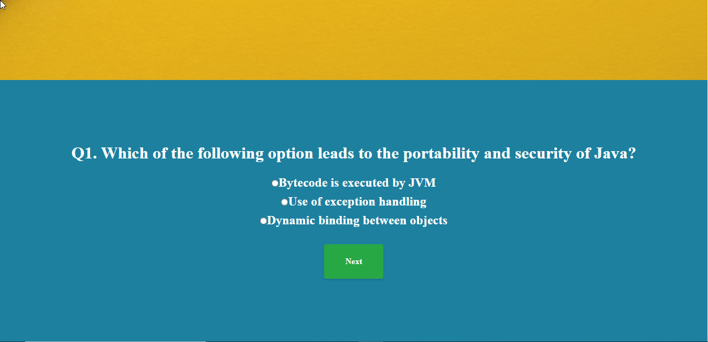

* Without entering the answer of the current question, user can’t traverse to the next question. It will show the error message like shown in the below image.

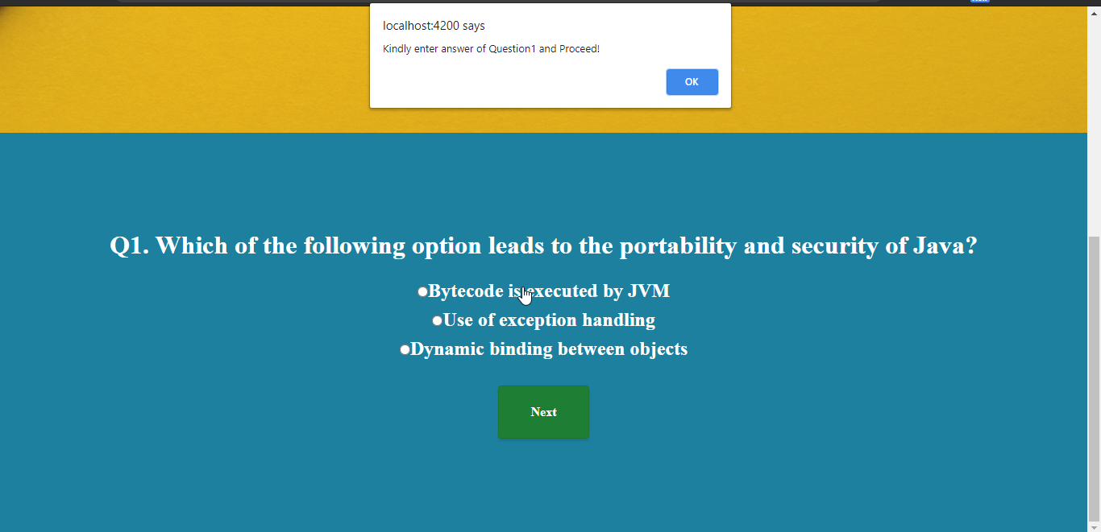

* User can able to traverse between the previous and the next questions.

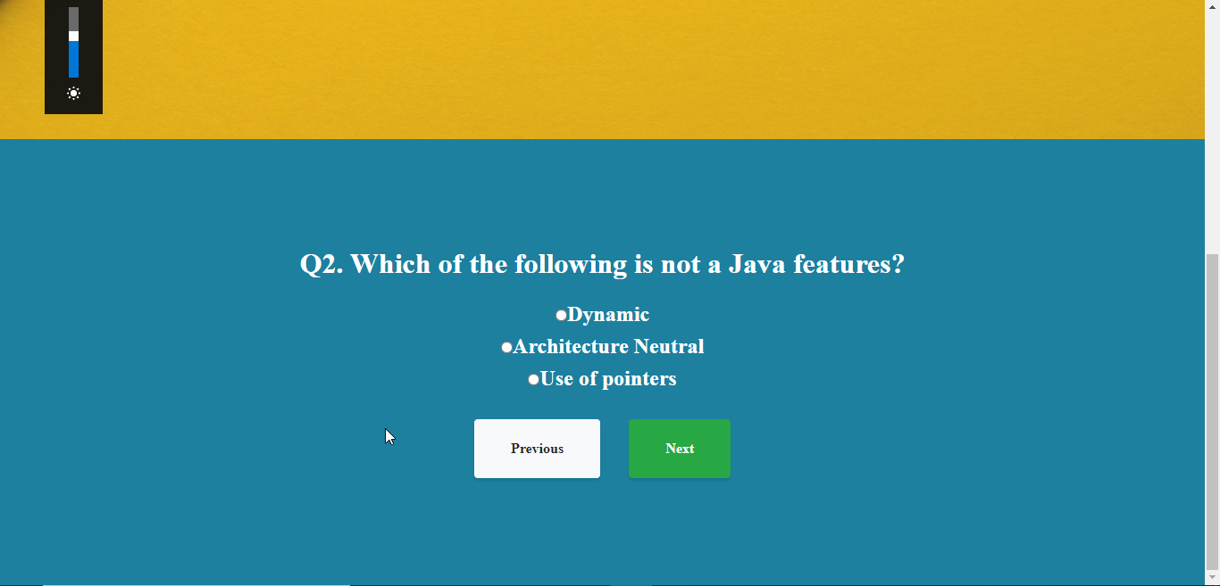

* Once all the questions were answered means, User can get the results by clicking the submit button.
* And results is shown in the new window as shown below.



