Automated Outreach Pipeline
Production Project Handoff Report
Prepared on 2026-06-06
This report summarizes the software project built for the SDE assignment: a complete backend pipeline that discovers lookalike companies, finds decision makers, resolves verified emails, generates AI-personalized cold emails, sends approved campaigns, and records lifecycle status.
Area | Status
Source code | Built in outreach-pipeline/
API | FastAPI endpoints implemented
CLI | Typer CLI implemented with approval prompt
Database | SQLAlchemy models and Alembic migration implemented
Queue/cache | Redis and Celery implemented
Docker | Dockerfile and docker-compose.yml implemented
Tests | 19 tests passed with 86.20% coverage
GitHub push | Prepared locally; waiting for repository URL or token
Vercel deployment | Requires deployment strategy; see Remaining Work

1. Project Overview
The user enters a company domain, for example openai.com. The pipeline then discovers similar companies using Ocean.io, finds senior technical and executive decision makers through Prospeo, verifies email addresses through Eazyreach, generates concise personalized sales emails with OpenAI, and sends approved emails with Brevo.
- The application exposes both REST API and CLI access.
- Campaign, company, contact, and email records are stored in PostgreSQL.
- External API calls use retries, exponential backoff, rate-limit handling, circuit breaking, and JSON logging.
- Docker Compose starts the API, Celery worker, PostgreSQL, and Redis.

2. Architecture
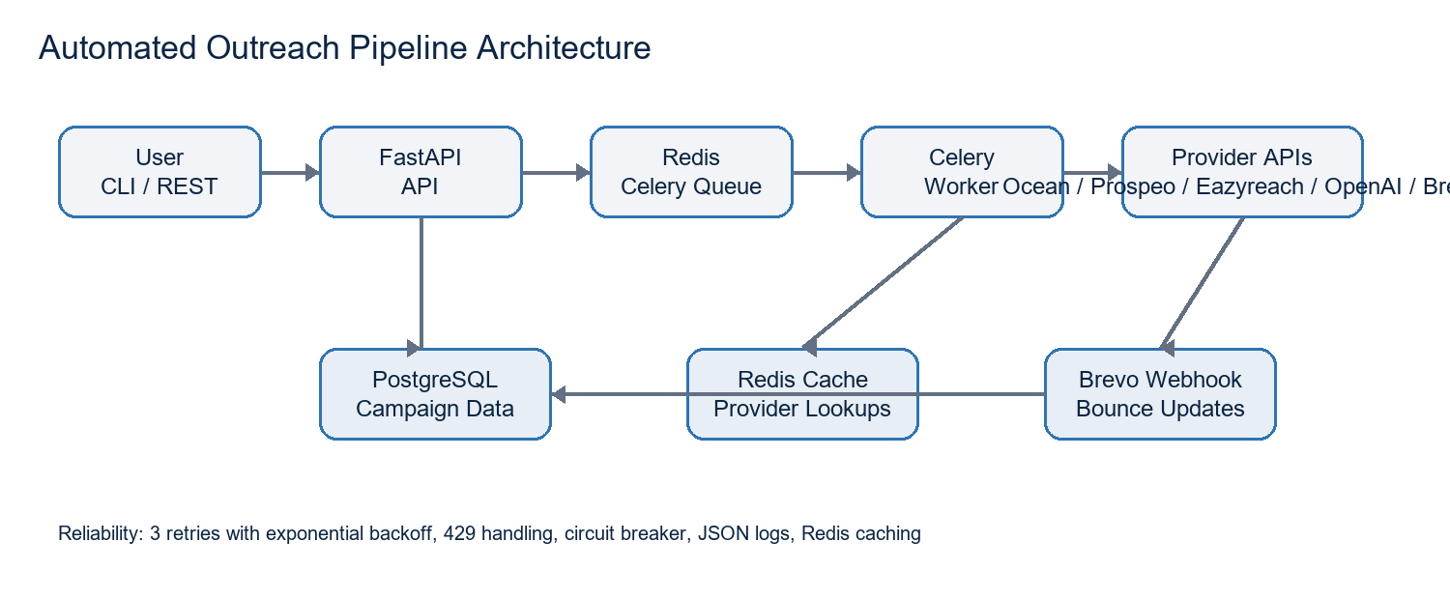

3. End-to-End Workflow
- User submits a source domain through POST /api/v1/pipeline/start or the outreach CLI.
- Ocean.io returns similar companies and domains.
- Prospeo searches each company and keeps only Founder, CEO, CTO, VP Engineering, Head of Engineering, and Director of Engineering contacts.
- Eazyreach resolves emails from LinkedIn profiles; only verified emails are saved.
- OpenAI generates a personalized subject and short outreach body for each verified contact.
- The system shows a campaign summary before sending. The CLI prompts Proceed? Y/N, while the REST API exposes POST /pipeline/{id}/send.
- Brevo sends approved emails and the database tracks PENDING, SENT, FAILED, and BOUNCED statuses.

4. Technical Stack
Layer | Technology
Backend | Python 3.12, FastAPI
CLI | Typer
Database | PostgreSQL, SQLAlchemy, Alembic
Queue | Redis, Celery
Caching | Redis
AI | OpenAI Responses API
Email delivery | Brevo SMTP API
Quality | Pytest, Black, Ruff, Mypy
Containerization | Docker, Docker Compose
Configuration | Pydantic Settings and .env

5. Database Schema
Table | Key Fields | Purpose
companies | id, name, domain, industry, created_at | Stores lookalike companies.
contacts | id, company_id, name, title, linkedin_url, email, verified | Stores decision makers and verified email status.
campaigns | id, source_domain, status, summary, error_message, created_at | Tracks each pipeline run.
emails | id, campaign_id, contact_id, subject, body, status, sent_at | Tracks generated and sent emails.

6. REST API
Endpoint | Purpose
POST /api/v1/pipeline/start | Create a campaign and queue discovery.
GET /api/v1/pipeline/{id} | Read campaign status, summary, and generated emails.
POST /api/v1/pipeline/{id}/send | Approve sending for generated pending emails.
GET /api/v1/companies | List stored companies.
GET /api/v1/contacts | List stored contacts.
GET /api/v1/campaigns | List campaigns.
GET /api/v1/emails | List generated emails.
POST /api/v1/webhooks/brevo | Receive bounce events from Brevo.

7. Reliability, Security, and Observability
- Retry policy: 3 retries with exponential backoff of 1s, 2s, and 4s.
- Rate-limit handling: HTTP 429 retries automatically and respects Retry-After when present.
- Circuit breaker: repeated provider failures open a provider-specific breaker and recover after cooldown.
- Secrets: API keys are read from environment variables and are never hardcoded.
- Validation: domains are normalized and validated before pipeline execution.
- Logs: structured JSON logs are emitted to stdout and logs/app.log.
- Caching: Ocean, Prospeo, and Eazyreach lookups use Redis cache to reduce provider cost and rate-limit pressure.

8. Running the Project
Local setup:
- python -m venv .venv
- .\.venv\Scripts\Activate.ps1
- pip install -r requirements.txt
- Copy-Item .env.example .env
- alembic upgrade head
- uvicorn app.main:app --reload
- celery -A app.tasks.celery_app worker --loglevel=info
Docker setup:
- Copy-Item .env.example .env
- docker compose up --build

9. Verification Completed
Check | Result
pytest | 19 passed
Coverage | 86.20%, above the 80% requirement
Ruff | All checks passed
Black | All files formatted
Mypy | No issues found in application code

10. GitHub and Vercel Status
Destination | Current Status | Needed From User
GitHub | Not pushed yet. The local folder is ready to initialize/commit/push. | Provide a GitHub repository URL with write access, or a GitHub personal access token / GitHub CLI login.
Vercel | Vercel CLI is logged in as sm5963397-9665. No production deploy was attempted because this backend requires Postgres, Redis, and a Celery worker. | Choose deployment shape: Vercel API-only plus external DB/Redis/separate worker, or deploy full Docker stack to Render/Railway/Fly/AWS instead.
Provider live run | Not executed against live providers. | Provide Ocean, Prospeo, Eazyreach, OpenAI, and Brevo API keys plus sender domain configuration.

11. Remaining Work / Not Done Yet
- GitHub push is not done because no remote repository or GitHub credential is available in the project folder.
- Vercel production deployment is not done because the complete backend is Docker/Postgres/Redis/Celery-based; Vercel alone cannot run the full worker and infrastructure stack.
- Live provider validation is not done because real API keys were not provided.
- Brevo sender-domain production readiness is not confirmed; SPF, DKIM, DMARC, and warm-up should be configured before real outreach.
- Eazyreach lookup path is configurable because account/version-specific endpoint paths may differ; confirm the exact path from your Eazyreach account if needed.

12. What I Need From You
- GitHub repository URL, for example https://github.com/<username>/automated-outreach-pipeline.git, or GitHub token/CLI login with repo write access.
- Decision on deployment target: Vercel API-only with external services and separate worker, or full Docker deployment on a platform that supports long-running services.
- Production environment variables: Ocean, Prospeo, Eazyreach, OpenAI, Brevo, PostgreSQL, Redis, and sender email settings.
- Brevo verified sender/domain details before enabling real email sends.

13. Project File Structure
Major source areas:
- app/api: FastAPI routes, middleware, and dependencies
- app/core: settings, security, logging, and application errors
- app/database: SQLAlchemy base and session factory
- app/models: company, contact, campaign, and email ORM models
- app/repositories: persistence access layer
- app/services: external provider clients and shared HTTP reliability utilities
- app/workflows: pipeline orchestration
- app/tasks: Celery application and background tasks
- app/cli: Typer commands
- app/tests: repository, service, API, and workflow tests
- migrations: Alembic environment and initial schema migration

14. Final Build Assessment
The software project itself is built and locally verified. The remaining items are deployment/account tasks, not missing source-code files. Once GitHub and production infrastructure details are provided, the project can be pushed and deployed with environment-specific configuration.

