**CS560**

**LAB-4 Assignment**

**NAME: M.sainadh**

**ID:** 16170273

1. **Implement a Mahout application (e.g., Classification/Recommedation/Association Rule Mining) using your own data and store your output to Solr.**

**Recommendation Mining:**

1. Create a maven Java project:

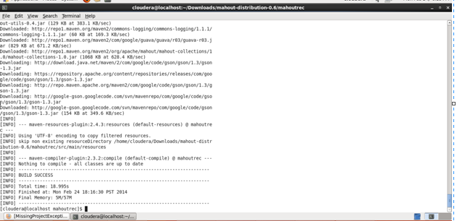

1. Edit the Pom.xml file and write the dependencies given. The mahout version has to be changed to fit to it.
2. Compile the project as

$ mvn compile

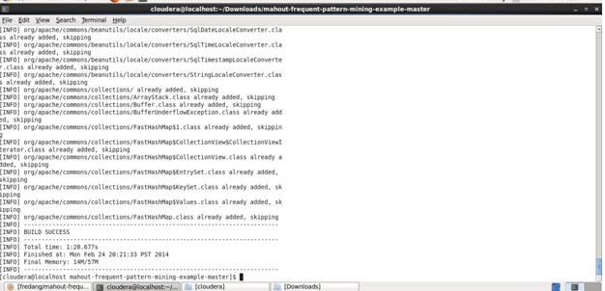

1. Execute the project with the dataset we have and the result is displayed with the recommended items for the users.

$ mvn exec: java -Dexec.mainClass = "com.unresyst.UnresystBoolRecommend

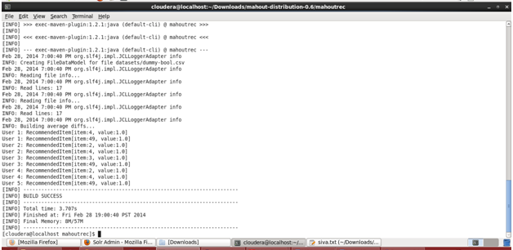

**Connection to SOLR:**

1. Goto hosts->parcels in cloudera and download the solr

Now login to : Localhost:8983/solr

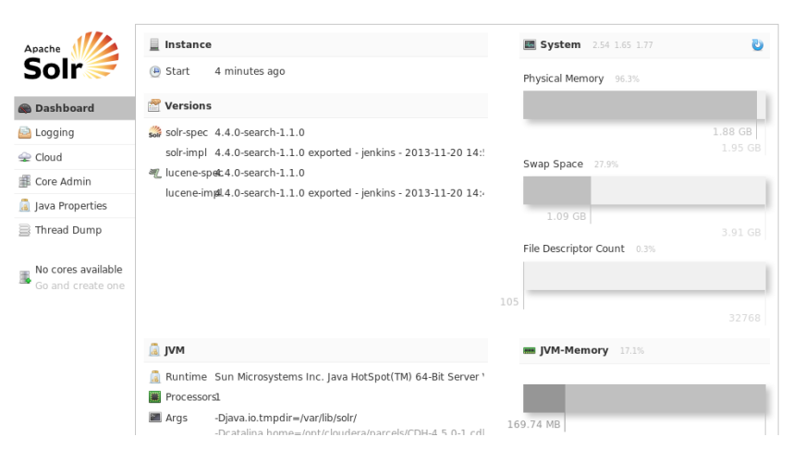

1. Now we need to configure the Collection for solr

$ solrctl instancedir --create collection1 $HOME/solr_configs

After creating the collection, now we can add the output data which we got from mahout to the SOLR as follows

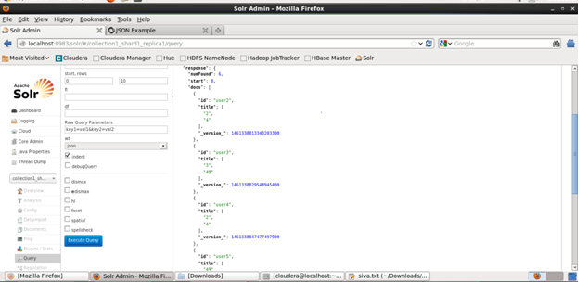

It returns success command once the data is submitted.

1. We can see the output by executing the query

[http://localhost.localdomain:8983/solr/collection1_shard1_replica1/select?q=*4*&wt=json&indent=true](http://localhost.localdomain:8983/solr/collection1_shard1_replica1/select?q=*4*&wt=json&indent=true)

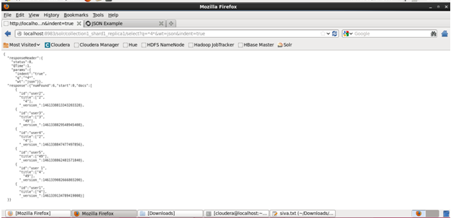

1. **Implement a mobile application to use the information through Solr REST Web Services**

Here, we need to a GUI to update the item value so that it display the Users to whom that item is recommended.

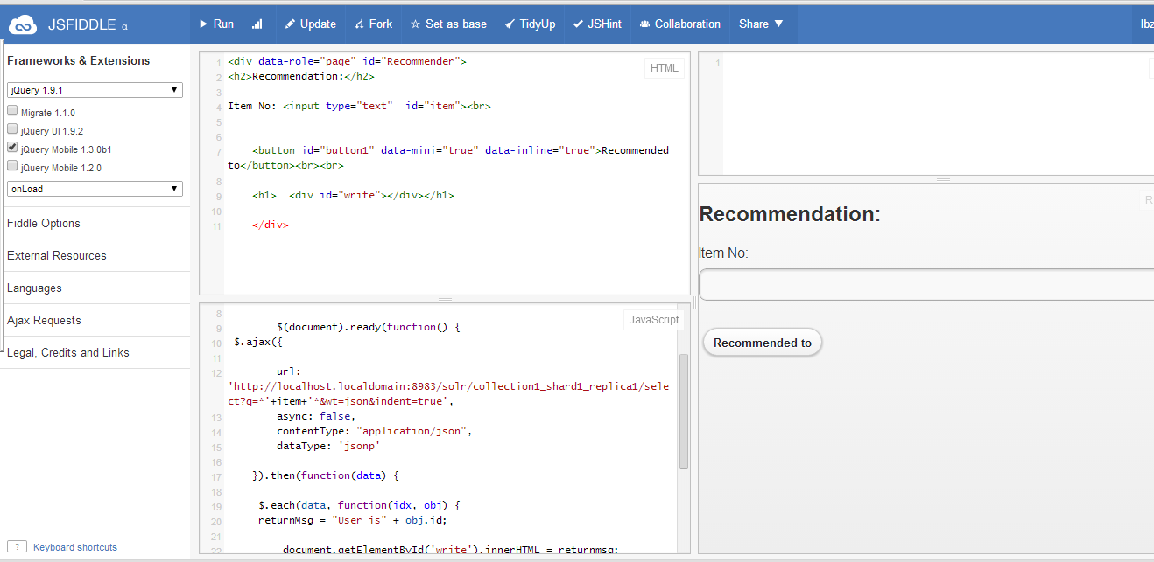

**The output will get displayed in JSON format for the item given in the field.**