**CS560**

**LAB-4 Assignment**

**NAME: M.sainadh**

**ID:** 16170273

**1.Mavan java project**

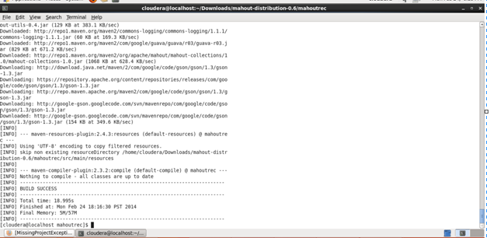

2.Compile the project

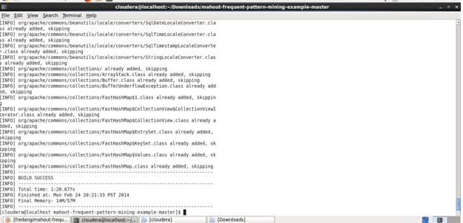

3. Recommendations

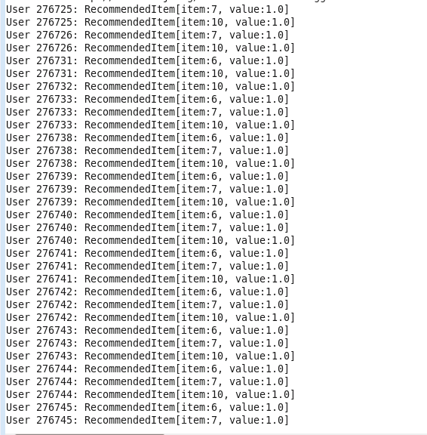

**4.jsfiddle**

