**Label Tracks – An Alternative To Map Series Annotation**

Carl Beyerhelm – Circle-5 GeoServices LLC – Rev 7July 2020

**Background** - The Event GDB’s **LabelPoint** feature class is effective in situations where a single-page map includes all of the Division and Branch breaks, as well as their corresponding label points. In a map series, however, static label points may not be positioned shrewdly enough to appear in each map frame that displays a portion of the label’s feature. A common solution is to create many Branch and Division labels as annotation, and then apply a page query that displays only the annotation that has been assigned to each map series frame. A shortcoming of this technique can be that the annotation’s content, position, and page assignment must be updated as the fire grows, as Divisions and Branches are relocated, and as map series frames are rearranged.

An alternative is to create linear “tracks” at a distance from Break and Perimeter features that labels can travel along as map extents change. When label tracks are in use, Division and Branch labels will appear wherever the track traverses a map frame. It’s a clean and clever technique I’m unable to claim any credit for.

Of course, tracks can be digitized and attributed manually, but the widget described here effectively automates the process for most situations by:

1. Creating a Division label track and a Branch label track at user-specified distances from generalized Break and Perimeter features,
2. Splitting each track at its intersections with a user-specified “splitter” line feature class (optional), and
3. Copying label attributes to the split track segments from the nearest **LabelPoint** feature (optional).

If users don’t elect to specify a “splitter” line feature class, the label tracks can be split and attributed manually.

**Prepare** – Complete these tasks prior to running the widget.

1. Copy the **MakeLabelTracks** toolbox to the incident’s **tools** folder.
2. The widget queries feature attributes during geoprocessing, so it is critical to ensure that attribution of **IncidentName**, **Label**, **LabelType**, and **FeatureCategory** fields in **LabelPoint**, **EventPoint**, and **EventPolygon** feature classes is complete and correct (below), and that **LabelPoint** positions clearly identify their Divisions and Branches.
3. Digitize a series of “splitter” lines that will divide tracks into Branch and Division segments. Division splitter lines should be long enough to intersect only the Division label track, but not long enough to reach the Branch label track (below right). One technique when digitizing is to use the right-click **Distance** tool to set line lengths. Or, it may be easier to just make all of the lines extra-long, run the widget, shorten the Division split lines as guided by the interim label tracks, and then rerun the widget. The widget runs in a matter of seconds and cleans up after itself, so no worries about running it twice.

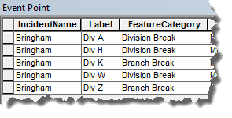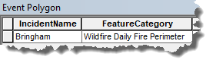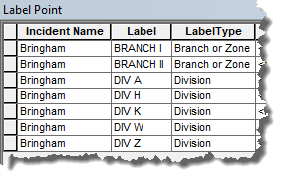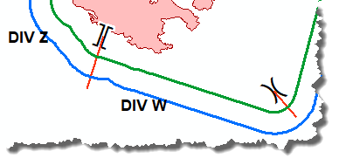

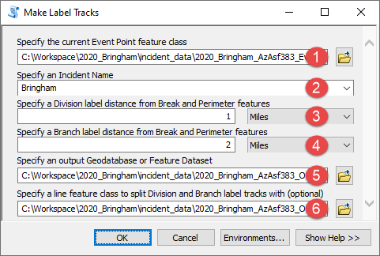**Use** – Expand the **MakeLabelTracks** toolbox, double-click the script tool icon, and complete the dialog as described and illustrated here. The widget works in both **ArcMap** and **ArcPro**.

1. Specify the current **EventPoint** feature class.
2. Select the current incident’s name from the dropdown list.
3. Specify the distance that Division labels should be from Break and Perimeter features.
4. Specify the distance that Branch labels should be from Break and Perimeter features.
5. Specify a location where the label tracks will be created. A **LabelTrack** feature dataset within the **OtherIncidentData** GDB is recommended.
6. Optional – Specify a line feature class that will split Division and Branch label tracks.

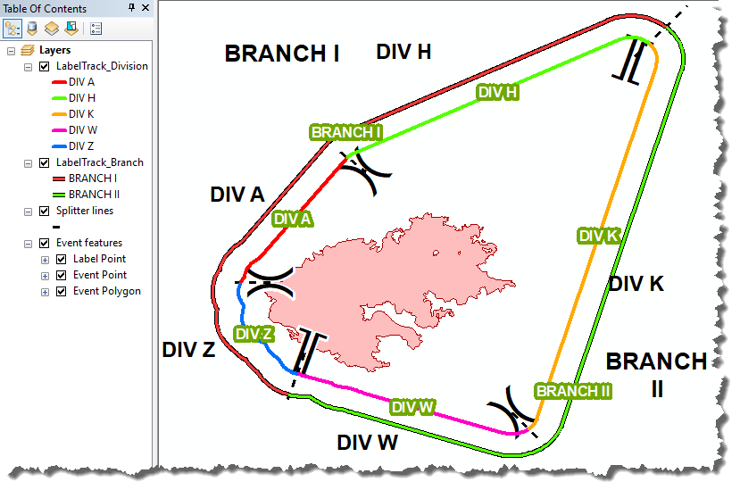

**Results and tips** – Branch and Division label tracks will be created in the specified location and, if a splitter was specified, label tracks will be split and attributes will be copied to each label track segment from the nearest **LabelPoint** feature. The widget typically completes in less than 20 seconds.

The example at right illustrates a fire perimeter, a series of Division and Branch breaks with corresponding static **LabelPoint** labels in black text, and black dashed lines that are used to split Division and Branch label tracks.

Widget-created Branch and Division label track segments are labelled with green-halo text that can traverse anywhere along their segment in response to shifting map frames.

For operational use, symbolize label tracks with no color to make them invisible, format labels as desired, and save the final configuration to LYR or LYRX files for use in map series.

Arrange map series frames to include enough label track to label features effectively.

Reshape label tracks and splitter lines as the incident progresses, or rerun the speedy widget with new splitter lines.

This technique may break down if Division or Branch breaks occur within deep or narrow concavities of a fire’s perimeter.

Automated processes may produce unexpected results, so occasional post-widget tweaking may be needed.

Create label tracks manually for complicated situations.