**Set Feature-Level Metadata Default Values In A Local Event Geodatabase**

Carl Beyerhelm - Circle-5 GeoServices LLC - Rev 4 June 2020

**Background** – Populating and maintaining feature-level metadata in an Event geodatabase is an important performance element for the GISS.

This widget sets incident-specific metadata values into the **Default Value** property of nine fields in each feature class of an Event geodatabase. The nine fields are **IncidentName**, **ContactName**, **ContactEmail**, **ContactPhone**, **GACC**, **IMTName**, **UnitID**, **LocalIncidentID**, and **IRWINID**.

Those default metadata values will be inherited by any new features created using on-screen digitizing, replace sketch, trace, and absolute XY methods. Features resulting from copy/paste will also inherit default metadata values in situations where Event field names do not match source field names, as is often the case with GPX or KML features. As such, this widget is an alternative to using feature templates as a source of metadata values. If feature templates are in use, their values will override the default values set by this widget.

The widget also records the user-supplied incident-specific metadata values for use in future sessions so that metadata re-entry is not required, and it updates those values if users revise them during subsequent sessions. This feature facilitates simultaneous metadata management for multiple incidents.

Additional widget functionality gives users two options for dealing with missing values in the attribute table's metadata fields.

1. If the **None** option is selected, no metadata feature attributes will be updated.
2. If the **Missing** option is selected, only the NULL or empty metadata attributes of features belonging to the specified target incident will be updated with new values.

The **Missing** option depends on **IncidentName** field values being complete and correct prior to use, so that missing metadata updates can be applied to features of the specified target incident.

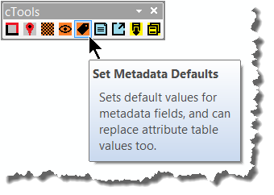**Install and use** – Follow these steps to install and use the widget.

1. Download the **cTools** toolbar add-in from this [**link**](https://drive.google.com/file/d/13tYWH5feHFKldbYaPMrzKQSwc8mkpAfP/view?usp=sharing), and double-click the **.esriaddin** file to install it for use in ArcMap.
2. Open ArcMap and, if it is not already visible, click **Customize – Toolbars** to activate the **cTools** toolbar. Dock the toolbar in any convenient location.
3. Add the **Event_GISSEdit** feature service to ArcMap, zoom to the incident’s AOI, and create a local copy for editing.
4. If the **Missing** option will be used, populate the **IncidentName** attribute of each feature belonging to the specified target incident from each of the target GDB's feature classes prior to use.
5. On the **cTools** toolbar, click the **Set Metadata Defaults** button (above right), and complete the dialog as illustrated and described on the next page.
6. A stand-alone version of this widget is available for use in ArcPro at this [**link**](https://drive.google.com/file/d/1gTx6kG2Rm9uCevLSj6ajceyy-xN-rkHp/view?usp=sharing). See page 4 for guidance and notes on use in ArcPro.

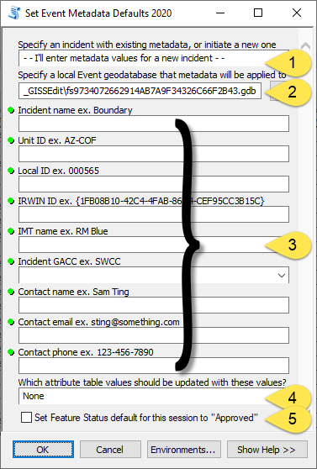**On first use at an incident:**

1. Select the **I'll enter metadata values for a new incident** option from the dropdown list.
2. Specify the local Event geodatabase that the metadata will be applied to. Typically, this will be the **Local Copy** of the National Incident Feature Service for the incident's extents.
3. Manually enter all nine incident-specific metadata values.
4. Elect an option for updating missing metadata feature attributes with new values from the widget's dialog. The options are **None** or **Missing**.

The **Missing** option will only be applied to features whose **IncidentName** attribute value matches the **Incident Name** entry in the widget's dialog.

1. Click **OK**, when entries are as desired.

**On subsequent uses:**

1. 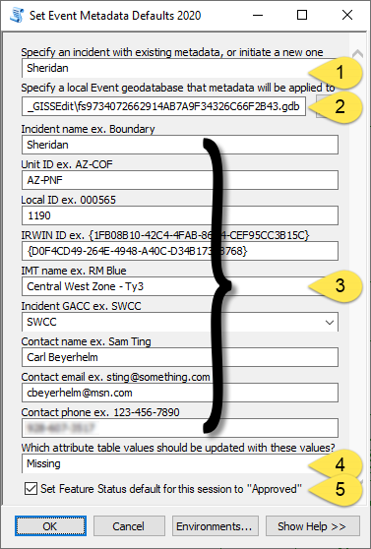Select an incident from the dropdown list.
2. Specify the local Event geodatabase that the metadata will be applied to. Typically, this will be the **Local Copy** of the National Incident Feature Service for the incident's extents.
3. All nine of the metadata values entered during the previous session will auto-fill, and users may revise metadata elements if their values have changed since the prior session.
4. Elect an option for updating missing metadata feature attributes with new values from the widget's dialog. The options are **None** or **Missing**.

The **Missing** option will only be applied to features whose **IncidentName** attribute value matches the **Incident Name** entry in the widget's dialog.

1. If desired, set “**Approved**” as the **Feature Status** default for this edit session.
2. Click **OK**, when entries are as desired.

The widget produces a brief log of its progress, as shown below.

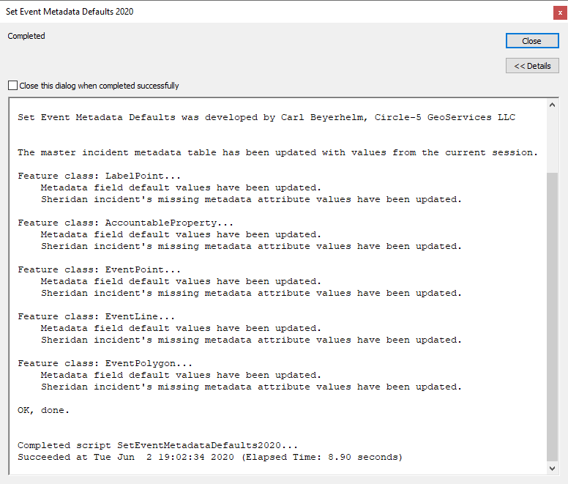

**Results** – The widget sets default metadata values for new features into nine fields in each feature class of an Event geodatabase (example below left) and, if the **Missing** option was selected, updates missing metadata feature attributes with new values (example below right).

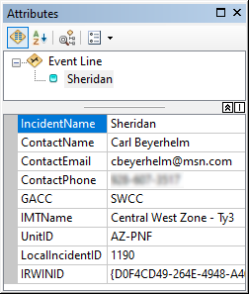

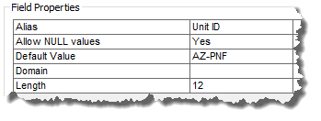

**Notes** - This widget has several characteristics to be aware of.

* The widget must be re-applied during each edit session because the value it assigns to the **Default Value** property of metadata fields is a property of the geodatabase, which is temporary.
* The approach described here permits new feature construction by any means, including copy/paste from a non-matching schema.
* Selecting the **Missing** option will, for better or worse, reset the **EditName** and **DateCurrent** field values of updated records to the editor's name and current time.
* The geodatabase may contain features from other incidents, but use of the **Missing** option will only update metadata attributes in features belonging to the specified target incident. Therefore, it is important that the **IncidentName** attribute of each feature belonging to the specified target incident, from each of the target GDB's feature classes, be populated prior to use.
* The widget records user-supplied incident-specific metadata values for use in future sessions so that metadata re-entry is not required, and it updates those values if users revise them during subsequent sessions. This feature facilitates simultaneous metadata management for multiple incidents. Each incident's metadata values are stored in a behind-the-scenes table (example below) embedded within the **cTools** toolbar.



**ArcPro limitations** - Widget functionality is limited in ArcPro because the **AssignDefaultToField** method is not supported in offline mobile geodatabases.

**Widget functionality matrix**

|  |  |  |
| --- | --- | --- |
| **Functionality** | **ArcMap** | **ArcPro** |
| Update missing attribute table values in nine metadata fields**\*** with incident-specific values for each feature class of a local edit Event geodatabase (file GDB and runtime GDB). | **✓** | **✓** |
| Set incident-specific values into the default value property of nine metadata fields**\*** for each feature class of a local edit Event geodatabase (fGDB in ArcMap only). **NOTE**: Values set in a feature template will override field default values. | **✓** | **🗶** |
| Set the **FeatureStatus** field's default value to "**Approved**". **NOTE**: Values set in a feature template will override field default values. | **✓** | **🗶** |

**\*** The nine metadata fields are IncidentName, ContactName, ContactEmail, ContactPhone, GACC, IMTName, UnitID, LocalIncidentID, and IRWINID.