**Create A USGS Topographic Vector Dataset For An Area Of Interest**

Carl Beyerhelm - Circle-5 GeoServices LLC - Revised 8 Jul 2019

**Background** - USGS topographic vector datasets have these advantages over their raster equivalents.

* All features are rendered as vectors, so there is no pixilation as users zoom in.
* Features can be turned off, filtered with a definition query, or replaced with other vector data.
* Features can be re-symbolized, and symbol weights scaled, to suit a user’s cartographic needs.
* Users can employ trace, copy, or replace sketch techniques to create new features from existing USGS topo vector features.
* Maps with USGS topo vectors in the background instead of DRGs, or other raster content, may export and print more rapidly, and have a crisper appearance, because they don't contain any elements that must be rasterized during export to PDF.
* USGS vector data are available nationwide. FSTopo vector data, while more feature-rich and better organized, are available only on National Forest System (NFS) and adjacent lands.

A comparison view of raster and vector topographic data are illustrated at left and right below.

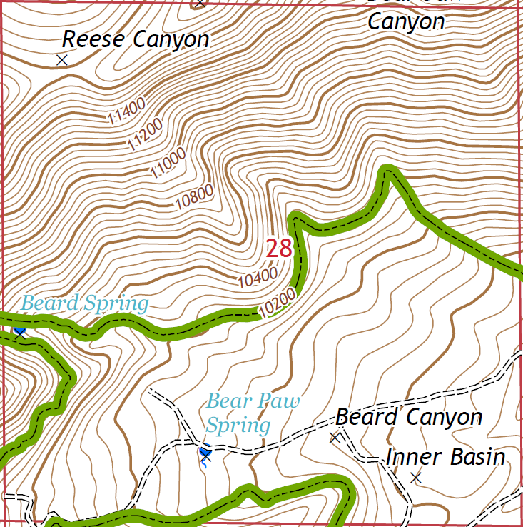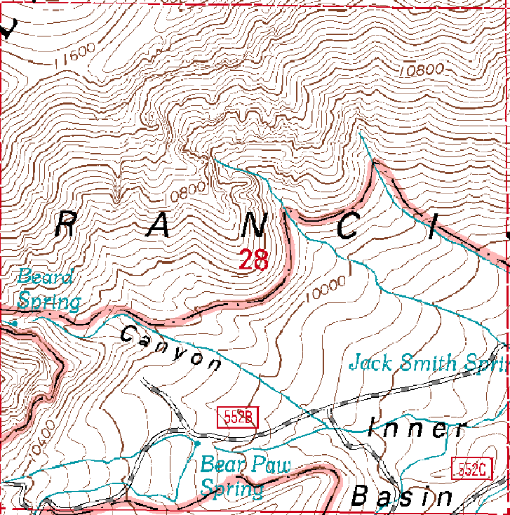

**Distribution elements** - All elements necessary to support use of the **USGS Topo Vector Prep** add-in are bundled within the **UsgsTopoVectorPrep_2019.esriaddin** file. These elements include:

* A toolbox and Python script
* A nation-wide 7.5-minute quad index
* A pre-symbolized LYR file
* A guidance document that describes installation, functionality, and use of the add-in

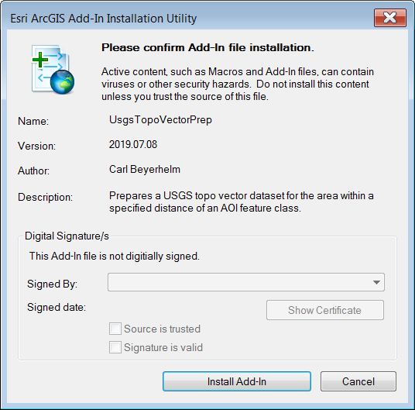**To install the add-in** – Double-click on the **UsgsTopoVectorPrep_2019.esriaddin** file in Windows Explorer, and then click the **Install Add-In** button, as illustrated at right. This add-in takes the form of an ArcMap toolbar, as seen below.

Toolbar.png

Installing add-ins does not require administrative privileges, and nothing is written to the system registry. An installed add-in exists as an "assembly cache" in the user’s personal **AddIns** folder.

**To delete the add-in** - In ArcMap, click **Customize – Add-In Manager…**, select **UsgsTopoVectorPrep**, and then click **Delete this Add-In**, as illustrated below. The add-in’s assembly cache will be removed from the user’s personal **AddIns** folder.

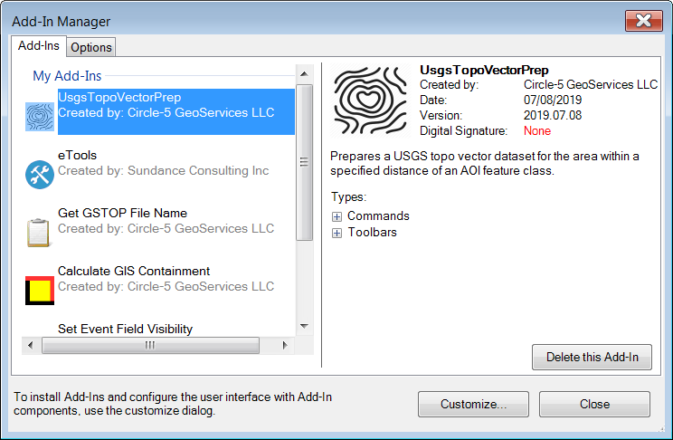

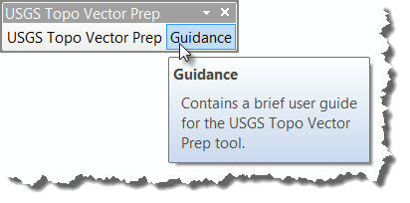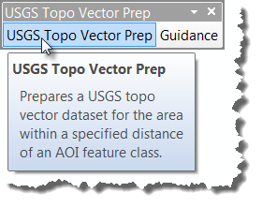**The toolbar** - The toolbar includes two buttons. The **USGS Topo Vector Prep** button (left) activates the USGS Topo Vector Prep tool. The **Guidance** button (right) opens this guidance doc.

**Tool functionality** - USGS topo vector data are distributed in zipped GDB format having 7.5-minute quad map extents. In order to be useful and efficient as background reference data, these separate GDBs must be combined into a single GDB, and their features dissolved across quad lines, symbolized, and labeled. An ArcGIS tool has been developed to do this, and its functionality includes these elements.

* Downloads (or copies) zipped USGS topo vector GDBs to a local folder.
* Unzips the GDB data.
* Clips all GDB features to their respective quad frame.
* 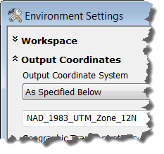Combines feature classes from each GDB into a single GDB.
* Attempts to DISSOLVE like-attributed polygon and line features that may have been split across quad frames.
* Re-sources and symbolizes all layers, and saves the result as a LYR file.
* Optionally, projects the **GCS_North_American_1983** feature classes into a user-specified spatial reference using the tool's built-in **Output Coordinates** environment setting, as illustrated at right.

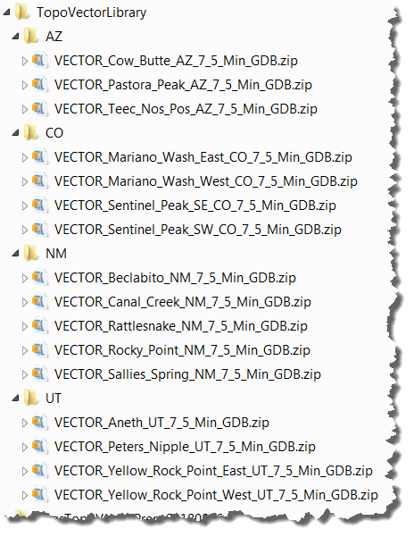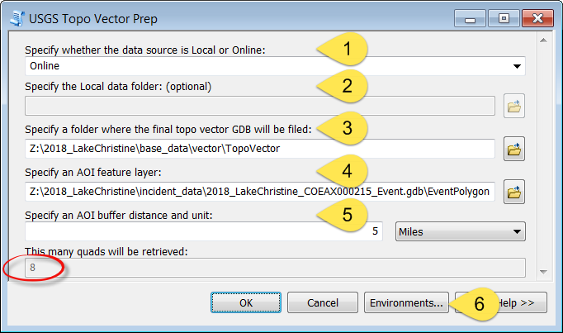

**Run the tool** - Click **USGS Topo Vector Prep** on the toolbar, and supply dialog inputs, as shown above.

1. Specify **Online** if data will be downloaded from USGS FTP servers, or **Local** if users have a local library of zipped USGS topo vector GDBs that can be copied directly.
2. Specify the root folder of a user's USGS topo vector data library if **Local** was specified as the first input. The data library must be structured as a series of two-character state abbreviation folders, with each folder containing that state's zipped topo vector GDBs. See the example above right.
3. Specify a folder where the final USGS topo vector GDB and LYR file will be created.
4. Specify a point, line, or polygon feature layer that encompasses the user's area of interest (AOI).
5. Specify a distance and linear unit, like **5 miles**, to define a desired buffer beyond the AOI's extents. The number of quads that will be retrieved is shown in the dialog's lower-left corner.
6. If desired, use the **Environments...** button to project results into a preferred spatial reference.

Click **OK**, and a process log informs users of tool progress. The end result is a USGS topo vector GDB and symbolizing LYR file. Of course, users may apply their own symbology or labeling as they see fit.

During testing, a 24-quad dataset was cooked in 9 minutes, 25 seconds from an online data source, less than 25 seconds per quad, so it is pretty fast.

**Results** - The resulting GDB and LYR are represented in the Table of Contents (TOC) seen at rig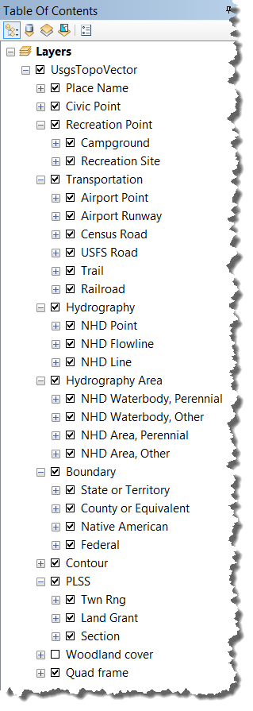ht. The **Quad frame** and **Boundary** layers are visible at all scales, polygon and line layers appear at 1:100,000 scale, and point layers and labels appear at 1:50,000 scale. The LYR's features are configured to scale up and down if the user elects to apply a reference scale to the data frame.

**Issues** - USGS topo vector datasets have many advantages, but they also present some challenges.

* Labeling vector topo features, like roads or contour lines, may become difficult due to high feature density and competition for label space. Users may need to spend some time fiddling with label **Priority** and **Weight** rankings in Maplex.
* Many entries are added to ArcMap's TOC, and these can be aggravatingly numerous when setting selectable layers, arranging draw order, identifying features, managing legends, and so on.
* Draw performance may lag due to feature and label density, as well as the many definition queries, label class definitions, and label expression that have to be re-evaluated whenever the screen is panned or refreshed.
* Many features are unable to be dissolved because they are not edge-matched closely enough at quad boundaries (like contour lines), or because of inaccurate or inconsistent attribution of edge-matched features (like roads). Both situations can lead to labeling annoyances.
* There are two road layers. The **Census Road** layer occurs primarily on non-NFS lands, while the **USFS Road** layer, predictably, occurs on NFS lands. However, there are areas of overlap where geometry, attribution and feature density of the two layers are frequently in disagreement. With any luck, the incident's hosting agency will be able to provide a decent road layer that can be substituted for the USGS topo vector roads.
* Labeling of the **LakePond**, **Reservoir**, **Spring**, and **Well** feature types in the **Place Name** (GNIS name) layer was turned off to avoid double-labeling corresponding features represented and labeled in the NHD layers.