**Neural Networks**

According to IBM Neural networks describes Neural Network in the following words:

Neural networks, also known as artificial neural networks (ANNs) or simulated neural networks (SNNs), are a subset of machine learning and are at the heart of deep learning algorithms. Their name and structure are inspired by the human brain, mimicking the way that biological neurons signal to one another.

Artificial neural networks (ANNs) are comprised of node layers, containing an input layer, one or more hidden layers, and an output layer. Each node, or artificial neuron, connects to another and has an associated weight and threshold. If the output of any individual node is above the specified threshold value, that node is activated, sending data to the next layer of the network. Otherwise, no data is passed along to the next layer of the network.

**Pedometers**

Pedometers are computers that use sensors to count steps, and the way the sensors do this is by taking the angular velocities and accelerations and inputting these to a neural network.

We use MATLAB to calculate the weights, i.e., the coefficients added to the variable to see their relevance to the model these weights are then stored in the architecture.

**Our Architecture**

We use a variance of RISC V architecture to build the architecture to count the steps.

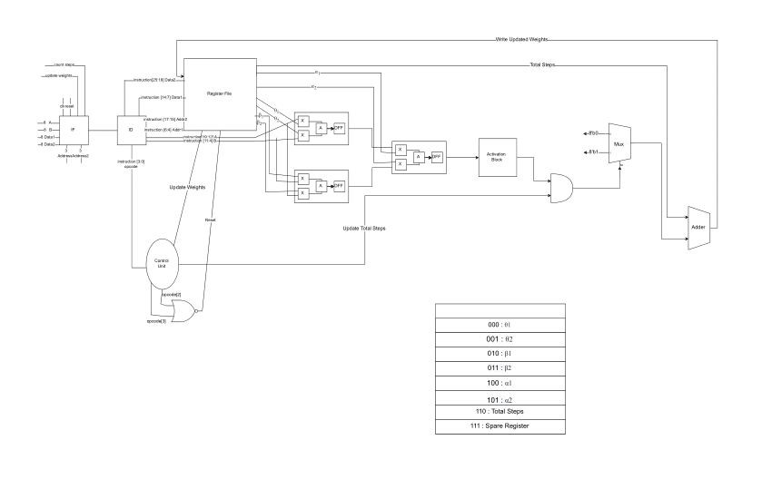

The architecture has a few buttons namely reset, count steps and update weights where the Instruction Fetch will be fetching Instructions accordingly. The instructions are 32 bits and have the following configuration:

|  |  |
| --- | --- |
| Calculate Steps | Update Weights / Reset |
| Opcode [0] | Opcode [0] |
| Opcode [1] | Opcode [1] |
| Opcode [2] | Opcode [2] |
| Opcode [3] | Opcode [3] |
| X[0] | RW_addr[0] |
| X[1] | RW_addr[1] |
| X[2] | RW_addr[2] |
| X[3] | R_Weight[0] |
| X[4] | R_Weight[1] |
| X[5] | R_Weight[2] |
| X[6] | R_Weight[3] |
| X[7] | R_Weight[4] |
| Y[0] | R_Weight[5] |
| Y[1] | R_Weight[6] |
| Y[2] | R_Weight[7] |
| Y[3] | RW_addr[0] |
| Y[4] | RW_addr[1] |
| Y[5] | RW_addr[2] |
| Y[6] | R_Weight[0] |
| Y[7] | R_Weight[1] |
|  | R_Weight[2] |
|  | R_Weight[3] |
|  | R_Weight[4] |
|  | R_Weight[5] |
|  | R_Weight[6] |
|  | R_Weight[7] |
|  |  |
|  |  |
|  |  |
|  |  |
|  |  |
|  |  |

This configuration allows for the same architecture to be used for different weights if the system is made more. Efficient by simply using update weights.

Sources:

Education, Ibm Cloud. “Neural Networks.” IBM, 3 Aug. 2021, www.ibm.com/cloud/learn/neural-networks.

“Single Layer Neural Network|Part-2| Solved Example|Artificial Neural Network|Data Mining Series.” YouTube, uploaded by Easy Computing Lectures, 18 Apr. 2020, www.youtube.com/watch?v=dpXDkSKIBOc.