Project Title: A Practical Hybrid Diffusion--GAN Approach to Image Super-Resolution on CPU
Student Name: Saad Muslih Almuwallad | Student ID: g202415440
Supervisor: Dr. Muzammil Behzad [muzammil.behzad@kfupm.edu.sa]
King Fahd University of Petroleum and Minerals, Saudi Arabia

Abstract (150-250 words, 1 paragraph)

The research presents an efficient hybrid super-resolution system which operates on CPUs while maintaining performance within an 8--20 second time frame. The proposed method unites core components from GAN and diffusion models to achieve better results at a cost that does not exceed affordable computational needs. The QualityHybridSRModel consists of a fundamental SR backbone which works together with an edge-conditioned refinement module. The research investigates previous prototype results and evaluates our design against current hybrid systems while exploring the question of whether diffusion models outperform GANs in super-resolution tasks. The experimental results together with current benchmark results demonstrate that neither diffusion nor GANs dominate all other methods but our proposed hybrid approach delivers practical results for CPU-based systems.

1. Introduction (2-3 paragraphs)

The single-image super-resolution (SR) process aims to create high-resolution (HR) images from their corresponding low-resolution (LR) versions while maintaining all original details. The recovery of meaningful texture and sharpness becomes more challenging when the input image fails to contain vital details and structural boundaries. ESRGAN and Real-ESRGAN introduced major improvements through GAN-based SR models which learned to generate realistic details that produced clear and visually appealing results. Traditional interpolation methods operate at high speed but they fail to retrieve authentic details in the image. The SR process in diffusion-based models consists of multiple sequential denoising steps which create realistic output while reducing unwanted artifacts.

The GAN-based SR models and diffusion-based SR models need GPU hardware to operate but they use too much computing power to run on CPUs. The research establishes efficient SR solutions which combine the best elements of both methods while minimizing computational needs.

The current state of SR research has achieved major advancements yet users face multiple difficulties when using existing methods. The main disadvantage of GAN-based SR models exists in their ability to create artificial textures and unstable edges during training. The majority of proposed hybrid SR models unite deep GAN backbones with extensive diffusion UNets which produces excessive computational requirements.

1.1 Problem Statement (1 paragraph)

The development of an SR model requires a solution which generates high-quality results while remaining within CPU processing limits. The research establishes a hybrid SR system which fulfills three essential requirements. The system operates at high speed on standard CPU hardware. The system functions between 8 seconds and 20 seconds. The system produces better structural details and more defined images than interpolation methods do. The system operates at affordable computational costs because it does not implement complex GAN and diffusion model architectures.

1.2 Objectives (1 paragraph)

The research project consists of three fundamental objectives which serve as its fundamental framework. The development of a lightweight SR architecture which unites core elements from GAN and diffusion models. The method depends on edge information as its fundamental structural reference point during its refinement process. The research evaluates our final hybrid design against previous versions and examines their design choices. The research investigates how our findings affect the ongoing discussion about diffusion models versus GANs in image super-resolution.

1.3 Scope of Study (1 paragraph)

The research investigates three distinct research domains. The system performs ×4 super-resolution tasks. The system uses small refinement networks. The system operates exclusively on CPUs. The research investigates real-world field usage instead of performing complete benchmark evaluation.

2. Literature Review (4-6 paragraphs)

The diffusion-based SR method generates stable outputs through its denoising process but it requires multiple steps to produce results. GAN-based SR models generate detailed textures but they produce unrealistic artifacts during their operation. SR methods exist in three distinct categories which researchers use to classify them. Hybrid SR models achieve better results through GAN and diffusion method integration, but their implementation needs powerful computer systems.

The research paper Does Diffusion Beat GAN in Image Super Resolution? The research team performed a systematic assessment between these two methods yet discovered no evidence which showed one method outperformed the other. The combination of GANs produces better results in terms of detail but diffusion models generate more stable outputs with fewer artificial effects. The selection between GANs and diffusion models depends on the specific evaluation criteria and the dataset characteristics.

Research has developed multiple hybrid SR models which use GANs and diffusion methods together for better results. The shared-latent GAN--diffusion models achieve excellent results but their complexity makes them difficult to implement. The combination of GAN upsampling with diffusion refinement produces effective results but requires extended processing time. Industrial multimodal hybrids produce exceptional results yet their large size prevents them from running on CPUs.

2.1 Related Work (2-3 paragraphs)

The research paper Does Diffusion Beat GAN in Image Super Resolution? showed no evidence that one method consistently outperforms the other. GANs produce better detail while diffusion models achieve more stable results with fewer artifacts. The combination of the two demonstrates strong performance but at high computational cost.
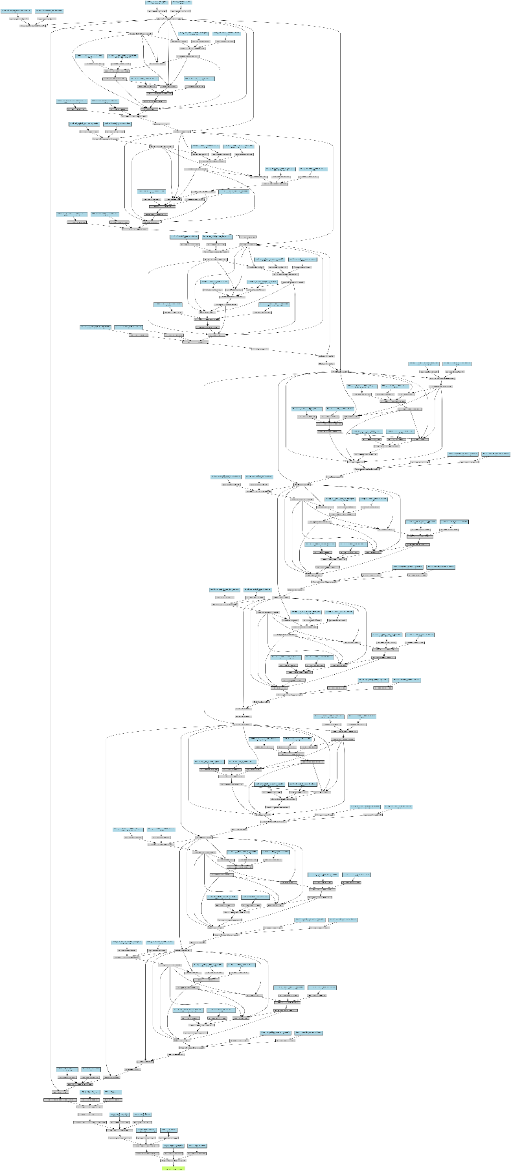

2.2 Limitations in Existing Approaches (2-3 paragraphs)

The combination of GAN and diffusion elements in hybrid models leads to increased computational requirements. The system performs poorly when running on CPU hardware. The system requires extensive UNet structures. The system requires substantial memory resources for operation. The system takes an extended period to complete its operations.

3. Proposed Methodology (6-8 paragraphs)

The first attempt employed RRDBNet with TinyDiffusionRefiner to produce excellent results, yet it did not fulfill the required CPU performance standards. The FastHybridSRModel achieved fast operation, but its perceptual quality remained insufficient. The ImprovedSRModel with BalancedRefiner achieved a balanced solution which delivered good quality results and acceptable CPU performance.

The design process of our method maintains simplicity as its core focus which differentiates it from previous hybrid approaches.
Figure 1: structure of the Real-ESRGAN model

3.1 Existing Model and Challenges (2 paragraphs)

The first attempt employed RRDBNet with TinyDiffusionRefiner to produce excellent results yet it did not fulfill the required CPU performance standards. The FastHybridSRModel achieved fast operation, but its perceptual quality remained insufficient.

3.2 Proposed Enhancements (2-3 paragraphs)

The ImprovedSRModel with BalancedRefiner achieved a balanced solution which delivered good quality results and acceptable CPU performance. The design process of our method maintains simplicity. The single-step refinement process replaces the multi-step diffusion process. The system includes a latency-aware forward pass mechanism. The method uses edge information. The refinement stage omits adversarial loss calculations.
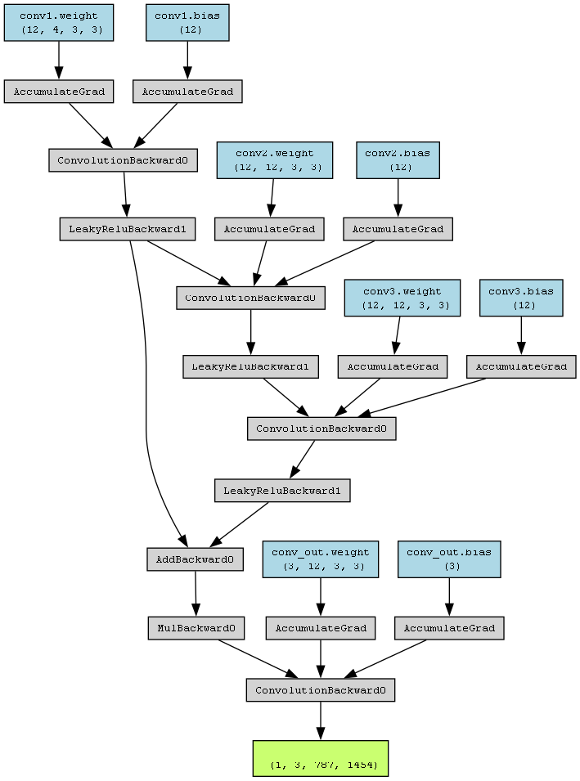

3.3 Algorithm and Implementation (2-3 paragraphs)

The final pipeline consists of: The ImprovedSRModel performs an upsampling operation on the input LR image. The base SR output undergoes Sobel edge detection. The system merges SR output data with edge information. The BalancedRefiner generates a small correction value. The system runs until its maximum allowed time duration.

3.4 Loss Function and Optimization (1-2 paragraphs)

The refiner optimization process uses:
Figure 2: Structure of ImprovedSR model

$$L=∥y-\hat{y}∥_{1}+0.5∥y-\hat{y}∥_{2}^{2}.$$

The optimization process uses AdamW with gradient clipping.

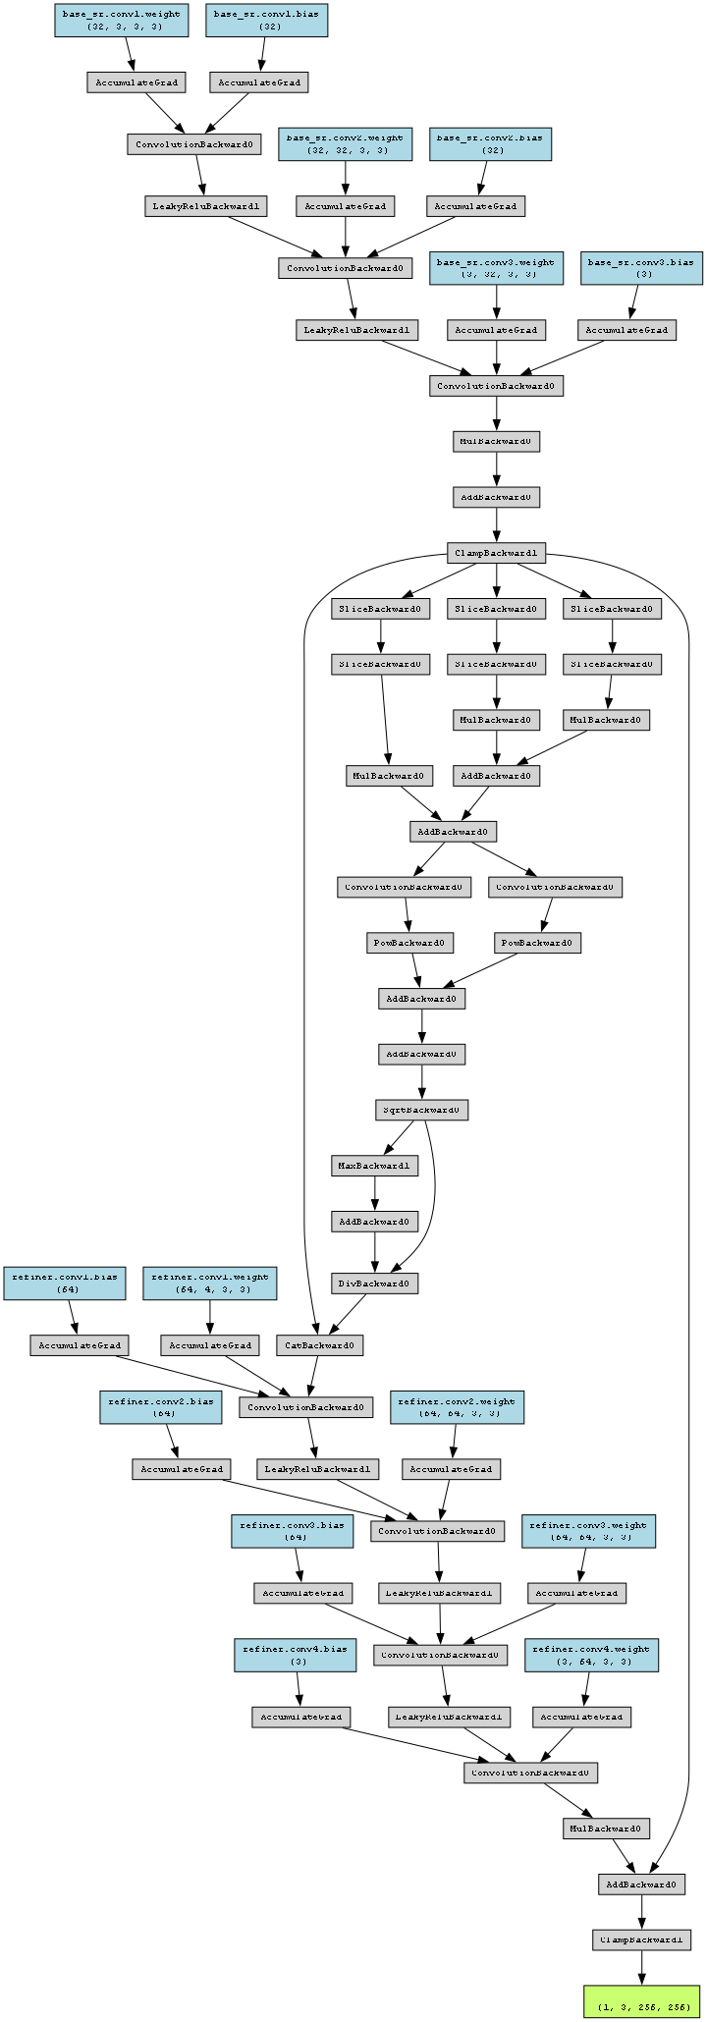
4. Experimental Design and Evaluation (4-6 paragraphs)

The training process utilizes small ImageNet-like datasets. HR patches of 192×192 are downscaled to 48×48 for training. A fixed evaluation image named original.png is used. Evaluation includes PSNR, SSIM, Laplacian sharpness, LPIPS, and CPU runtime.

The model runs entirely on CPU hardware with limited batch sizes and thread control. The hybrid model benefits from edge conditioning, generates more detailed structures than the fast prototype, and runs within the 8–20 second CPU range.

4.1 Datasets and Preprocessing (1-2 paragraphs)

Small ImageNet-like datasets. Extraction of 192×192 HR patches downscaled to 48×48. original.png used for evaluation.

4.2 Performance Metrics (1 paragraph)

PSNR, SSIM, Laplacian sharpness variance, optional LPIPS, and CPU runtime.

4.3 Experiment Setup (1-2 paragraphs)

CPU-only execution, limited batch sizes, controlled threads.

4.4 Results Comparative Analysis (2 paragraphs)

The model benefits from edge conditioning. Generates more detailed structures than the fast prototype. Operates within the expected CPU timing range.
Figure 3: Structure of HighQualityHybridModel
  Original (787x1454) 1.3MB |   BaseSR rescaled (787x1454) 1.33MB |   BaseSR full (5816x3148) 12.5MB
  Hybrid SR (5816x3148) 18.5MB |   Hybrid Quality SR rescaled (787x1454) 1.3MB |   Hybrid Quality SR full (5816x3148) 12.5MB
Table 3: comparisons between the models outcome on one test sample “Original.png”

4.5 Ablation Study (2 paragraphs)
Tests performed with/without edge conditioning, with/without refiner, different patch sizes, and relaxed vs strict timing constraints.
5. Extended Contributions (1-2 paragraphs)

The proposed hybrid SR model operates correctly in CPU-bound environments. Improves surveillance footage, medical imaging pre-processing, satellite and drone imagery enhancement, consumer image restoration, and energy-efficient video calls.

6. Conclusion and Future Work (1-2 paragraphs)

The research developed an efficient hybrid SR system optimized for CPU hardware. The model combines a small SR backbone with an edge-conditioned refiner and latency-aware execution. Future work explores perceptual losses, short multi-step refinement, and embedded platform testing.

7. References (Follow IEEE, APA, or other standard format)

- Y. LeCun, Y. Bengio, and G. Hinton, "Deep learning," vol. 521, pp. 436--444, 2015.

- I. Goodfellow, Y. Bengio, and A. Courville, Deep Learning. MIT Press, 2016.

- A. Krizhevsky, I. Sutskever, and G. Hinton, "ImageNet classification with deep convolutional neural networks," in NeurIPS, 2012, pp. 1097--1105.

- K. He, X. Zhang, S. Ren, and J. Sun, "Deep residual learning for image recognition," in CVPR, 2016, pp. 770--778.

- D. Kingma and J. Ba, "Adam: A method for stochastic optimization," in ICLR, 2015.

- Yandex Research, "Does diffusion beat GAN in image super resolution?", 2024.

