

dRinkzly booze

“A moment of Chilling”



Llena, John Rafael A.

Ubay-ubay, Bayani BJ

Lina-ac, Mark Bernard

Abuzo, Lorlyn A.

Estrada, Camille Glenn M.

May 22, 2020

1. **Executive summary**

The Drinkzly Booze app provides essential accommodation of the consumers to deliver such drinks and food they had purchase within the application for the people or areas affected by the pandemic. This application is used to facilitate the secure purchase and legal receiving of beverages such as beer and side dish while drinking the beer. These are the common contents of our application related to business and to suffice the needs of the consumers as well. However, our products will be purchased directly from the factory and not relying to the store unlike food panda.

1. **Objectives**

To develop assistance of consumers in terms of product delivery during pandemic and consumers preferences in terms of using our application in choosing their desired products to be bought within CDO area.

* 1. **Key to success**

What crews and technical groups should keep in mind and carry out is to be active in pending orders. This is to ensure that consumers will not get devastated on how we delivery their orders. We will also be presenting our products clearly with our application so that the price shown will be the real price expected by the consumer.

* 1. **Mission**

To provide good assistance to our consumers, and to be wary of the products sold that appear in our application. To provide good assistance to our consumers and to garner better feedback that would uplift our business to the fullest.

* 1. **Vision**

Creating unique, memorable and delightful experiences for every order they purchased.

**1.2.**

**1.2.1 Company overview**

**1.2.2 Trademarks**

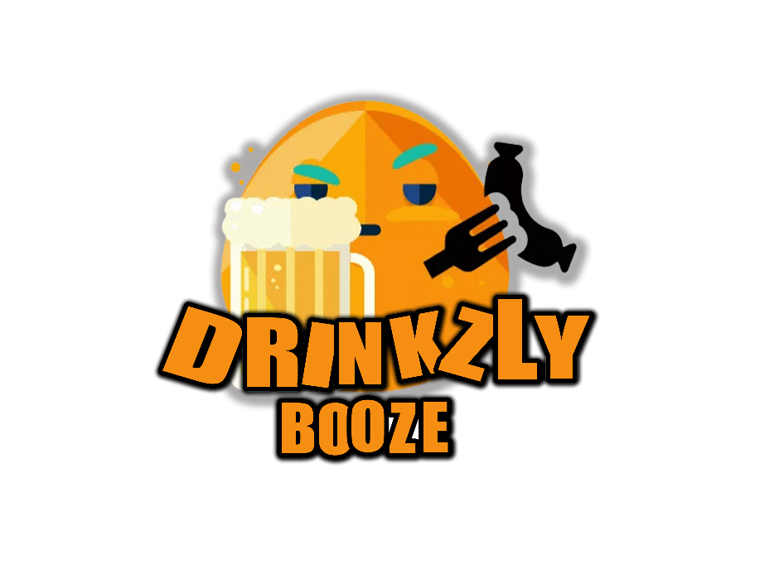 **2.2.1 Logo**

**2.2.2 Tagline**

“A moment of chilling”

**2.2.3 Target description**

Drinkzly Booze covers Cagayan de Oro city places only, due to pandemic we are also limiting our boundaries and also equipping our delivery crews with proper health protocol.

**II. MARKETING STRATEGY**

**2.1 Market Analysis**

Drinkzly Booze app provides different drinks and side dishes to give a customer’s a moment of chilling. Personal survey of the entrepreneur helps the business to enhance the way they market inside the market place. The researcher also conduct interview to the business-related areas which also give the entrepreneurs a hint to make the business more captivated by many of the consumers.

**2.2 Market Plan**

Categories of Beverages/foods

Register/Sign in

Drinkzly Booze App

Received and payments

Select/Purchase products button

Start delivery

**2.1.1 Equipment**

For the Delivery crews or shipper, we have their driver’s license and equipment’s for sudden undeniable cases for further delays of the product and other equipment that shows proper health protocols for the pandemic.

**2.2 Competitive Analysis**

Upon having the result of the interviews, online research and reading business articles. The entrepreneur can now identify their competitors in the business. There are some businesses related companies that has higher rate on the consumer minds.

**2.2.1 Food Panda**

The foodpanda group is the leading global online food delivery marketplace. Headquartered in Berlin, Germany. It operates in more than 40 countries across 5 continents. foodpanda allows users to conveniently discover food around their neighbourhood and directly order their favourite meals online or via mobile.

**Strength**

Food panda did not only include single food cuisine, but they include Asian, American and European cuisine in addition to that they also include Vegetarian delights.

**Weaknesses**

“Foodpanda didn’t even know (about the problems)," says the owner of the retail chain, who requested not to be identified. “We monitored all the transactions. But on the company’s side, there was lack of process, lack of ownership. Look, I don’t think its tech is the best, but there was nobody who owned up to this piece and we couldn’t even connect."

**2.2.2 Grab Food**

GrabFood is a food delivery service that connects local food businesses to people. When you place an order with GrabFood, we receive it and assign a GrabFood delivery partner to pick up the order from the restaurant to bring it to you.

**Strength**

You can now place multiple orders from different restaurants at once on GrabFood to satisfy your every craving

**Weakness**

With online deliverable, there is a big advantage of variety for choosing the channel for ordering for example, almost all food chains in NYC offers online delivery options with so much in their menus which includes Veggie Delights, fast food, Slashed and more you can just make your order by tapping and selecting from your mobile screen and wait for your order to arrive.

**Chart for competitive sale statistics**

**2.3**

Strength

Drinkzly Booze App provides exact details of the current location and expected time (tracker), of the shipper by the use of real time GPS. In addition to that, the Drinkzly Booze app has real time admin, whom will accommodate negative feedbacks, suggestions and recommendation for better future services.

Weakness

The app and also this business only caters Cagayan de Oro area only. Therefore, any costumers who will be using the app for a purpose of buying the products will be acknowledged depending on their locations.

Opportunities

Since we are experiencing pandemic, this particular business will be served as a tool to lessen the number of people who will be going outside. In addition to that, this business will make our shipper free from bogus buying, because their salary has been directly centered from the business head, and not depending on their number of deliveries.

Threats

Because of the new normal set by COVID-19, our means of delivery of our product is so important for us, material shortage might be the problem if we can’t deliver right away to the customer’s destination and the computer system might hacked by the hackers during a crucial selling period.

**III.ORGANIZATIONAL CHART**

3.1 Organizational Chart Description

It is a chart that will help the employees to understand the chain of command, with clear information on which people report to which manager. With an accurate chart, employees will be able to develop growth strategies and assign new projects. Employees even be able to assess if the chart makes sense: some businesses find that they have multitalented employees who could be put to work on other projects or answering to multiple apartments.

3.2 Chart

John Rafael A. Llena

**General Manager**

Mark Bernard A. Lina-ac

**Stock Manager**

Bayani BJ P. Ubay-Ubay

**Finance Manager**

Lorlyn A. Abuzo

**Assistant**

Camille Glenn M. Estrada

**Assistant**

**3.3. Promotional Activities**

* First 10 customers will get COMBO
* SUMMER PROMO
* CHRISTMAS GIVEAWAYS
* Online Marketing

**IV. LOCATION PLAN**

Drinkzly Booze has two Branches, in Branch A is located in Carmen, Cagayan de Oro City while the Branch B is located in Pabayo St., Cagayan de Oro City.

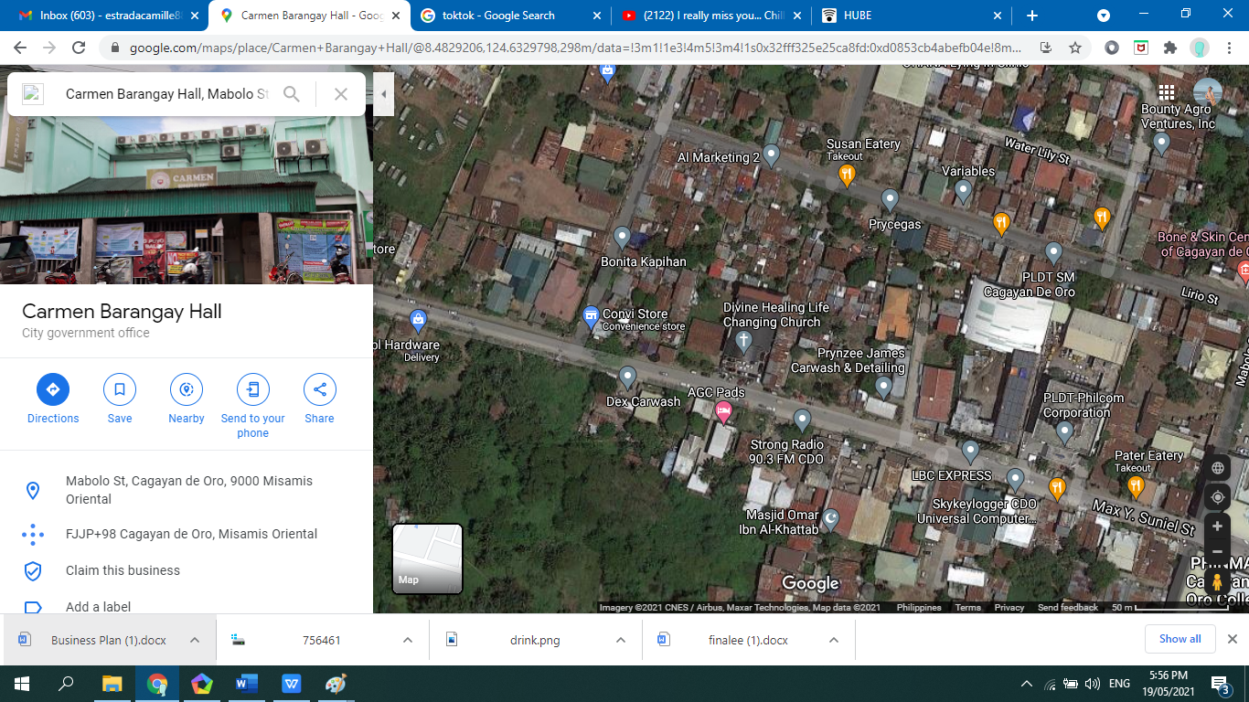**BRANCH A CARMEN**

Drinkzly booze

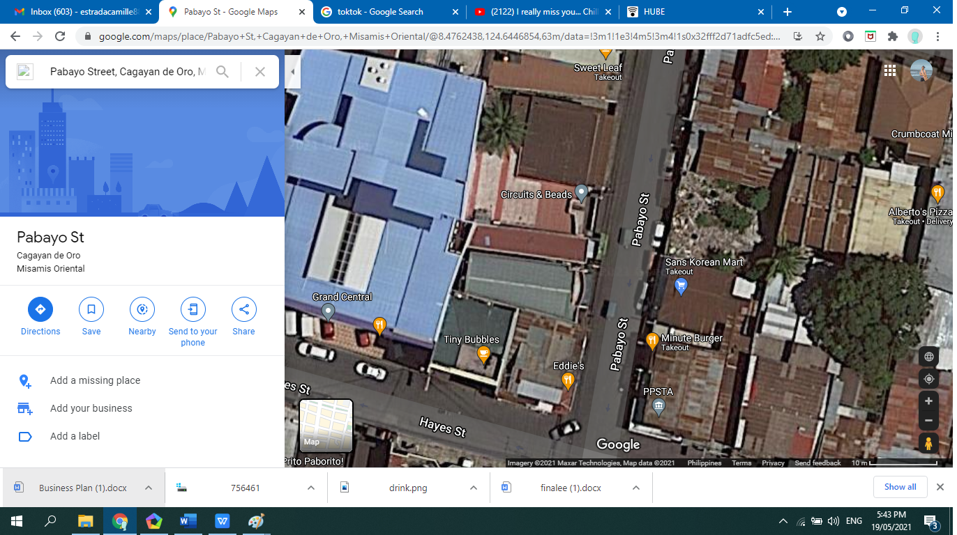**BRANCH B PABAYO**

Drinkzly booze

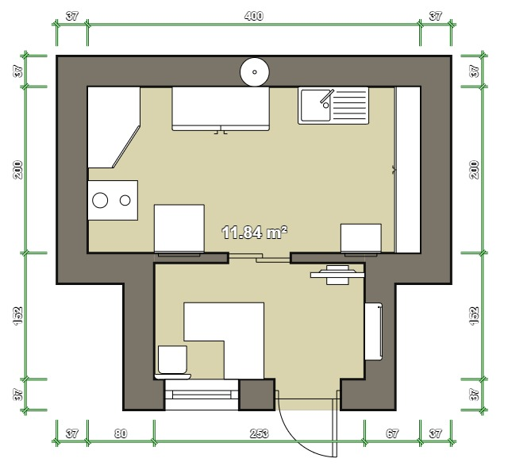**Floor Plan**

*(both Branch A*

*& Branch B*

*setup)*

**Strength of the location**

Due to the large number of populations, these areas we have chosen are better known or people can see that this business does exist.

**Weakness of the location**

Due to highest number of positive cases of COVID-19, the customer might choose other ordering app that is not located in the said location**.**

**V. FINANCIAL STATEMENT**

|  |  |  |  |  |
| --- | --- | --- | --- | --- |
| **Name of the Product** | **Category** | **Price** | **Quantity** | **Total** |
| **Red Horse** | **Beer** | **523.00** | **12** | **1,046.00** |
| **San Miguel Pale**  **Pilsen** | **Beer** | **966.00** | **24** | **11,592.00** |
| **Heinken** | **Beer** | **75.00** | **12** | **900** |
| **San Mig Light** | **Beer** | **78.00** | **12** | **936.00** |
| **Tanduay Ice** | **Beer** | **34.00** | **12** | **408** |
| **Beer na Beer** | **Beer** | **87.85** | **12** | **1,054** |
| **Tiger Crystal** | **Beer** | **999.00** | **24** | **23,976** |
| **Lambanog (Coconut Wine)** | **Local Wine** | **299.00** | **12** | **3,588** |
| **Basi (Sugar Coconut Wine** | **Local Wine** | **450.00** | **12** | **5,400** |
| **Bignay/Bugnay**  **(Wild Berry Wine)** | **Local Wine** | **380.00** | **12** | **4,560** |
| **Laksoy(Palm Liquor)** | **Local Wine** | **400.00** | **12** | **4,800** |
| **Tapuy(Rice Wine)** | **Local Wine** | **380.00** | **12** | **4,560** |
| **El Hombre** | **Tequila** | **231.00** | **12** | **2,772** |
| **Cuervo Silver** | **Tequila** | **845.00** | **12** | **10,140** |
| **Joven** | **Tequila** | **1,775.00** | **12** | **21,330** |
| **Reposado** | **Tequila** | **1,550.00** | **12** | **18,600** |
| **Anejo** | **Tequila** | **2,390.00** | **12** | **2,390** |
| **Extra Anejo** | **Tequila** | **78,000** | **12** | **936,000** |
| **Tanduay Gold Rum** | **Rum** | **900.00** | **12** | **10,800** |
| **Cruzan Aged Light Rum** | **Rum** | **495.00** | **12** | **5,940** |
| **Captain Morgan**  **Spiced Gold** | **Rum** | **495.00** | **12** | **5,940** |
| **Bacardi Black** | **Rum** | **649.00** | **12** | **7,788** |
| **Don Papa** | **Rum** | **1,390.00** | **12** | **16,680** |
| **Tanduay Superior 12 yrs. old** | **Rum** | **495.00** | **12** | **5,940** |
| **Ginebra San Miguel** | **Gin** | **106.00** | **12** | **1,218** |
| **Gilbey’s Gin** | **Gin** | **399.00** | **12** | **4,788** |
| **Zafiro Strawberry** | **Gin** | **249.00** | **12** | **2,988** |
| **Zafiro Classic** | **Gin** | **249.00** | **12** | **2,988** |
| **Tanqueray** | **Gin** | **799.00** | **12** | **9,588** |
| **G.S.M. Blue** | **Gin** | **104.00** | **12** | **1,248** |
| **The Bar** | **Gin** | **175.00** | **12** | **2,100** |
| **Smirnoff** | **Vodka** | **299.00** | **12** | **3,588** |
| **Red Square** | **Vodka** | **449.00** | **12** | **5,388** |
| **Gilbey’s Vodka** | **Vodka** | **339.00** | **12** | **4,788** |
| **Antonov** | **Vodka** | **206.00** | **12** | **2,472** |
| **Burnett’s Oranged|American Flavored** | **Vodka** | **336.00** | **12** | **4,032** |
| **Burnett’s Cranberry|American Flavored** | **Vodka** | **336.00** | **12** | **4,032** |
| **Burnett’s Limeade|American Flavored** | **Vodka** | **336.00** | **12** | **4,032** |
| **Tang Orange Juice** | **CHASER(Juice)** | **20.00** | **48** | **960** |
| **Nestlea Lemon Blend** | **CHASER(Juice)** | **20.00** | **48** | **960** |
| **Tang Calamansi** | **CHASER(Juice)** | **20.00** | **48** | **960** |
| **Tang Orange Mango** | **CHASER(Juice)** | **20.00** | **48** | **960** |
| **Tang Dalandan** | **CHASER(Juice)** | **20.00** | **48** | **960** |
| **Tang Four Seasons** | **CHASER(Juice)** | **20.00** | **48** | **960** |
| **JAMAICA** | **CHASER(Lime Juice)** | **50.00** | **12** | **600** |
| **CLUB MIX** | **CHASER(Lime Juice)** | **55.00** | **12** | **660** |
| **ISLAND MIXERS** | **CHASER(Lime Juice)** | **46.00** | **12** | **552** |
| **Other expenses** | **Materials** | **---------** | **-------** | **200,000** |
|  |  |  | **Grand Total** | **1,408,425** |