Example (screenshot):
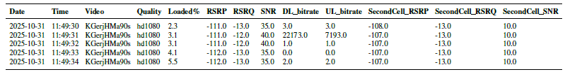
Short (from S13_V1_50_ST_KGerjHMa90s_example_tables.csv):
Timestamp | Video Position  (mm:ss) | Battery Level  (%) | Charge Counter  (µAh) | Temp  (C) | Voltage  (mV) | Calc. Current  (mA) | Calc. Power  (mW) | Energy  (mWh) | Volume  (%) | Brightness  (%)
10/18/2026 3:15:59 PM | 0:13 | 50 | 2493495 | 41 | 3771 | 2062.31 | 7776.97 | 80.846 | 26.7 | 255
10/18/2026 3:16:00 PM | 0:14 | 50 | 2493495 | 41 | 3771 | 2062.31 | 7776.97 | 82.855 | 26.7 | 255
10/18/2026 3:16:01 PM | 0:15 | 50 | 2493495 | 41 | 3771 | 2062.31 | 7776.97 | 85.274 | 26.7 | 255
10/18/2026 3:16:02 PM | 0:16 | 50 | 2493495 | 41 | 3771 | 2062.31 | 7776.97 | 87.478 | 26.7 | 255
10/18/2026 3:16:04 PM | 0:17 | 50 | 2493495 | 41 | 3771 | 2062.31 | 7776.97 | 89.509 | 26.7 | 255

Long (from S13_V1_50_ST_KGerjHMa90s_example_tables.csv):
Timestamp | Video Position  (mm:ss) | Battery Level  (%) | Voltage  (mV) | Calc. Current  (mA) | Calc. Power  (mW) | Energy  (mWh)
10/18/2026 3:15:59 PM | 0:13 | 50 | 3771 | 2062.31 | 7776.97 | 80.846
10/18/2026 3:16:00 PM | 0:14 | 50 | 3771 | 2062.31 | 7776.97 | 82.855
10/18/2026 3:16:01 PM | 0:15 | 50 | 3771 | 2062.31 | 7776.97 | 85.274
10/18/2026 3:16:02 PM | 0:16 | 50 | 3771 | 2062.31 | 7776.97 | 87.478
10/18/2026 3:16:04 PM | 0:17 | 50 | 3771 | 2062.31 | 7776.97 | 89.509

