Connecting Meta Quest 3 to my laptop:
- Connecting USB to Laptop
- Starting Meta Quest Developer Hub
- Device manager Devices: [Connected]
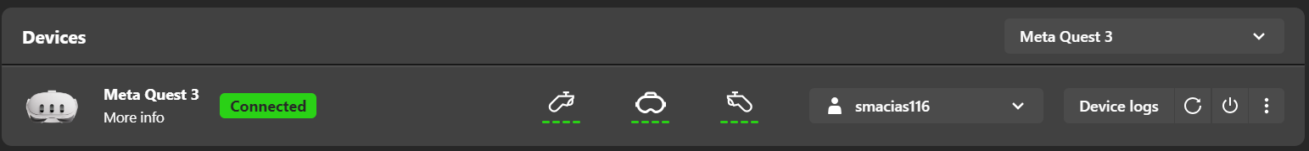
- Device manager Device actions ADV over Wi-Fi: [Off]
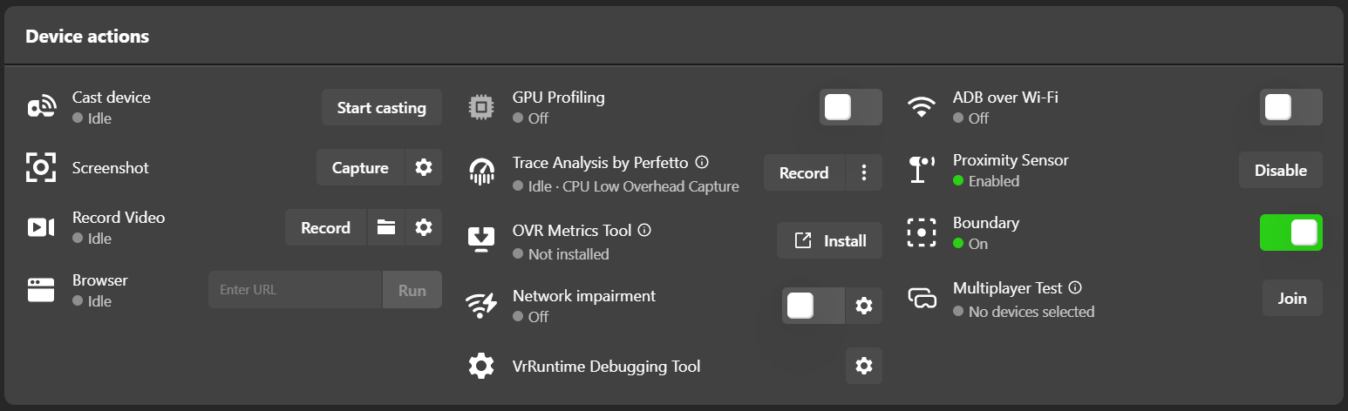
Enabling:
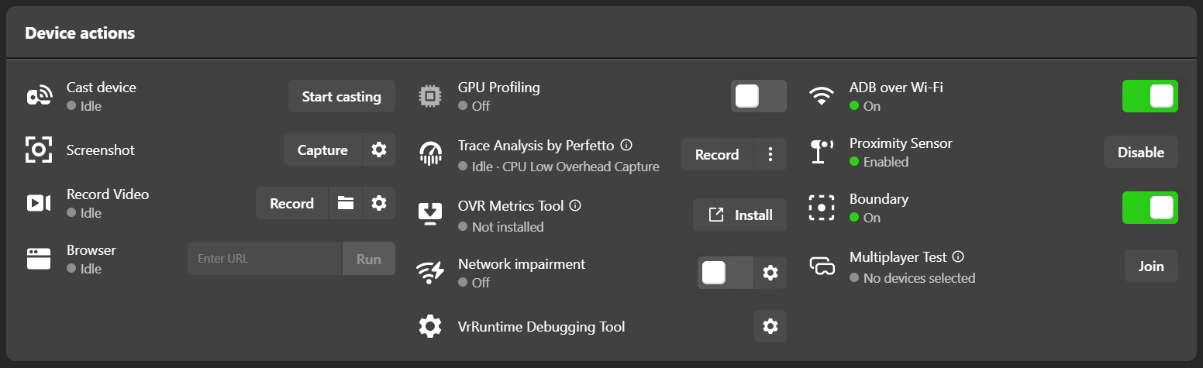

Checking ADB over Wi-Fi connection:
- Disconnecting USB from Laptop
- Checking connection:
cd "C:\Users\user\OneDrive - Loyola University New Orleans\FALL_2026\_MQ3_Research\Metrics"
.\adb.exe devices
- NOTE:
When not wearing the device, it turns to sleep mode and appears ‘offline’.
Once you wear it again, connection restarts and it’s shown as ‘device’.
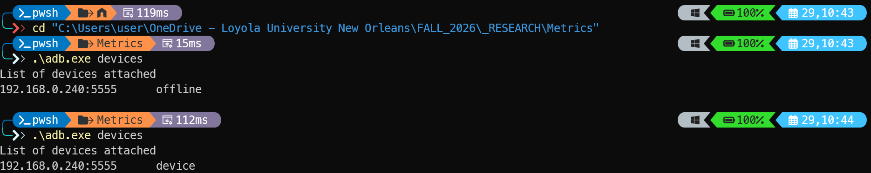

Other notes:
ADB package copies in
C:\Users\user\OneDrive - Loyola University New Orleans\FALL_2026\_MQ3_Research\Metrics
C:\platform-tools\platform-tools

BEFORE STARTING
--> got to the folder:
cd C:\Users\user\OneDrive - Loyola University New Orleans\FALL_2026\_MQ3_Research\Metrics

--> to check connectivity
.\adb.exe devices

--> see what raw battery data your Quest 3 is returning to ADB right now,
.\adb.exe -s 192.168.0.240:5555 shell dumpsys battery

--> Steps to Run the script (from PS)
1-Folder: cd "C:\Users\user\OneDrive - Loyola University New Orleans\FALL_2026\_RESEARCH\Metrics"
2-Run the script: python power_logger.py
3-If want to check .csv file while running Open with VSC or notepad (NOT Excel --> will cause error)
4-Stop recording: py Stop process (PS)--> Ctrl + C

Mock Test (Set 1 – V1):
100 % / STATIC
Brightness: 100
Volume: 25 approx.
Battery: 95
Network strength (Screenshot): Screenshot 2026-09-29 145728_v1_100.png
python power_logger.py
Ctrl + C
Metrics file name: quest3_power_1790712508.csv
Personal experience: All good, no glitches, buffering.

BEFORE STARTING SESSION
- Check connectivity
cd "C:\Users\user\OneDrive - Loyola University New Orleans\FALL_2026
./adb devices
- Charge Battery Level to the session set condition (100%, 50%...)
- Check Network Speed and capture screenshot to record values (https://www.speedtest.net/)
- Prepare the Video and check other if needed:
  - Close other apps,
  - Bright level,
  - Volume level,
  - Room conditions
- Prepare the Script (power shell execution, ready to execute)
- (Press the execution) As soon as ‘Play’ YouTube video, execute the Script in PS
- During the experiment respect the user_state condition (static, dynamic, etc).
- During the experiment take personal experience notes (dizziness, or other personal sensation / experience, buffering, quality of the video, etc),
- (Stop the script) As soon as the YouTube video finish, stop the Script in PS (Ctrl + C)
- Check the results before resuming to the next session:
  - .csv has been generated,
  - Note Personal experience on the sessions_list file (also on text file?),
  - Note Volume, Bright, etc…on the sessions_list file,
  - Note the .csv filename on the sessions_list file,
  - Note the Network metrics (screenshot) on the sessions_list file,

SET 1: 100% Battery Level + Static (beta) 09/29/2026

Suggestions/Improvement (_V1.py):
- Include id count visible in Power Shell
- Recording the video:
  - START VIDEO after 30 records (Manually, “press any key”)
  - STOP VIDEO (Manually, “press any key”)…the logging continues
  - STOP SCRIPT 30 seconds after the video has finished (to record last Charge Counter)
- Is it possible to record Brightness / Volume?
- Possible to extract video playing in YouTube?

Issues:
- Battery decreases to fast…. 2 videos sessions from 99% to 92%

Set 1 – V1:
Battery Level (%) | 98
Brightness: | 100
Volume (approx.): | 25
Network strength: | Screenshot 2026-09-30 082410_V1.png
MQ3_power_logger_beta.py
Ctrl + C
Metrics file name: | metrics_log_power_1790774700.csv
Personal experience: | All good

Set 1 – V2:
Battery Level (%) | 97
Brightness: | 100
Volume (approx.): | 25
Network strength: | Screenshot 2026-09-30 084537_V2.png
MQ3_power_logger_beta.py
Ctrl + C
Metrics file name: | metrics_log_power_1790776139.csv
Personal experience: | All good

Set 1 – V3:
Battery Level (%) | 95
Brightness: | 100
Volume (approx.): | 25
Network strength: | Screenshot 2026-09-30 092922_V3.png
MQ3_power_logger_beta.py
Ctrl + C
Metrics file name: | metrics_log_power_1790779149.csv
Personal experience:

SET 1: 100% Battery Level + Static 10/01/2026

Set 1 – V1: London Travel
Network strength: | Screenshot 2026-10-01 103722.png
RUN SCRIPT  VIDEO START  VIDEO STOP  STOP SCRIPT | MQ3_power_logger_V1.py  Press any key  Press any key  Ctrl + C
Metrics file name: | metrics_log_power_1790869094.csv
Personal experience:  & Notes: | All good  Video manual tracking didn’t stop correctly (‘1’ don’t finish) but it can be fixed (Check columns for video playing and audio)

Set 1 – V2: Spotlight Story: Help
Network strength: | Screenshot 2026-10-01 112618.png
RUN SCRIPT  VIDEO START  VIDEO STOP  STOP SCRIPT | MQ3_power_logger_V1.py  Press any key  Press any key  Ctrl + C
Metrics file name: | metrics_log_power_1790872009.csv
Personal experience:  & Notes: | All good

Set 1 – V3: Wild Cats (Safari in Russia)
Network strength: | Screenshot 2026-10-01 113712.png
RUN SCRIPT  VIDEO START  VIDEO STOP  STOP SCRIPT | MQ3_power_logger_V1.py  Press any key  Press any key  Ctrl + C
Metrics file name: | metrics_log_power_1790872706.csv
Personal experience:  & Notes: | All good  Audio was off for the first 60second approx. of this session (you can check ‘Volume’ column). Also, from this Set1-V3 onwards, the Volume level will deviate.

Set 1 – V4: Tiger (Elusive experience)
Network strength: | Screenshot 2026-10-01 115533.png
RUN SCRIPT  VIDEO START  VIDEO STOP  STOP SCRIPT | MQ3_power_logger_V1.py  Press any key  Press any key  Ctrl + C
Metrics file name: | metrics_log_power_1790873777.csv
Personal experience:  & Notes: | All good

Set 1 – V5: Elephant
Network strength: | Screenshot 2026-10-01 120911.png
RUN SCRIPT  VIDEO START  VIDEO STOP  STOP SCRIPT | MQ3_power_logger_V1.py  Press any key  Press any key  Ctrl + C
Metrics file name: | metrics_log_power_1790874683.csv
Personal experience:  & Notes: | All good

Set 1 – V6: First 3D VR
Network strength: | Screenshot 2026-10-01 122442.png
RUN SCRIPT  VIDEO START  VIDEO STOP  STOP SCRIPT | MQ3_power_logger_V1.py  Press any key  Press any key  Ctrl + C
Metrics file name: | metrics_log_power_1790875526.csv
Personal experience:  & Notes: | All good  This video is really dizzying, especially the first few minutes.

SET 2: 50% Battery Level + Static 10/01/2026

Set 2– V1: London Travel
Network strength: | Screenshot 2026-10-01 162941.png
RUN SCRIPT  VIDEO START  VIDEO STOP  STOP SCRIPT | MQ3_power_logger_V1.py  Press any key  Press any key  Ctrl + C
Metrics file name: | metrics_log_power_1790890260.csv
Personal experience:
& Notes:

Set 2– V2: Spotlight Story: Help
Network strength: | Screenshot 2026-10-01 164101.png
RUN SCRIPT  VIDEO START  VIDEO STOP  STOP SCRIPT | MQ3_power_logger_V1.py  Press any key  Press any key  Ctrl + C
Metrics file name: | metrics_log_power_1790890900.csv
Personal experience:
& Notes:

Set 2– V3: Wild Cats (Safari in Russia)
Network strength: | Screenshot 2026-10-01 165537.png
RUN SCRIPT  VIDEO START  VIDEO STOP  STOP SCRIPT | MQ3_power_logger_V1.py  Press any key  Press any key  Ctrl + C
Metrics file name: | metrics_log_power_1790891790.csv
Personal experience:
& Notes:

Set 2– V4: Tiger (Elusive experience)
Network strength: | Screenshot 2026-10-01 211303.png
RUN SCRIPT  VIDEO START  VIDEO STOP  STOP SCRIPT | MQ3_power_logger_V1.py  Press any key  Press any key  Ctrl + C
Metrics file name: | metrics_log_power_1790907264.csv
Personal experience:
& Notes:

Set 2– V5: Elephant
Network strength: | Screenshot 2026-10-01 212023.png
RUN SCRIPT  VIDEO START  VIDEO STOP  STOP SCRIPT | MQ3_power_logger_V1.py  Press any key  Press any key  Ctrl + C
Metrics file name: | metrics_log_power_1790907652.csv
Personal experience:
& Notes:

Set 2– V6: First 3D VR
Network strength: | Screenshot 2026-10-01 212914.png
RUN SCRIPT  VIDEO START  VIDEO STOP  STOP SCRIPT | MQ3_power_logger_V1.py  Press any key  Press any key  Ctrl + C
Metrics file name: | metrics_log_power_1790908190.csv
Personal experience:
& Notes:

SET 3: 100% Battery Level + Dynamic 10/04/2026

Set 3– V1: London Travel
Network strength: | Screenshot 2026-10-04 204144.png
RUN SCRIPT  VIDEO START  VIDEO STOP  STOP SCRIPT | MQ3_power_logger_V1.py  Press any key  Press any key  Ctrl + C
Metrics file name: | metrics_log_power_1791164708.csv
Personal experience:
& Notes:

Set 3– V2: Spotlight Story: Help
Network strength: | Screenshot 2026-10-04 210902.png
RUN SCRIPT  VIDEO START  VIDEO STOP  STOP SCRIPT | MQ3_power_logger_V1.py  Press any key  Press any key  Ctrl + C
Metrics file name: | metrics_log_power_1791166165.csv
Personal experience:
& Notes:

Set 3– V3: Wild Cats (Safari in Russia)
Network strength: | Screenshot 2026-10-04 211905.png
RUN SCRIPT  VIDEO START  VIDEO STOP  STOP SCRIPT | MQ3_power_logger_V1.py  Press any key  Press any key  Ctrl + C
Metrics file name: | metrics_log_power_1791166796.csv
Personal experience:
& Notes:

Set 3– V4: Tiger (Elusive experience)
Network strength: | Screenshot 2026-10-04 221734.png
RUN SCRIPT  VIDEO START  VIDEO STOP  STOP SCRIPT | MQ3_power_logger_V1.py  Press any key  Press any key  Ctrl + C
Metrics file name: | metrics_log_power_1791170285.csv
Personal experience:
& Notes:

Set 3– V5: Elephant
Network strength: | Screenshot 2026-10-04 222402.png
RUN SCRIPT  VIDEO START  VIDEO STOP  STOP SCRIPT | MQ3_power_logger_V1.py  Press any key  Press any key  Ctrl + C
Metrics file name: | metrics_log_power_1791170673.csv
Personal experience:
& Notes:

Set 3– V6: First 3D VR
Network strength: | Screenshot 2026-10-04 223300.png
RUN SCRIPT  VIDEO START  VIDEO STOP  STOP SCRIPT | MQ3_power_logger_V1.py  Press any key  Press any key  Ctrl + C
Metrics file name: | metrics_log_power_1791171208.csv
Personal experience:  & Notes: | At some point, for a 2 second, the device only reproduces a square screen the rest was black

SET 4: 50% Battery Level + Dynamic 10/05/2026

Set 4– V1: London Travel
Network strength: | Screenshot 2026-10-05 072959.png
RUN SCRIPT  VIDEO START  VIDEO STOP  STOP SCRIPT | MQ3_power_logger_V1.py  Press any key  Press any key  Ctrl + C
Metrics file name: | metrics_log_power_1791203547.csv
Personal experience:
& Notes:

Set 4– V2: Spotlight Story: Help
Network strength: | Screenshot 2026-10-05 074327.png
RUN SCRIPT  VIDEO START  VIDEO STOP  STOP SCRIPT | MQ3_power_logger_V1.py  Press any key  Press any key  Ctrl + C
Metrics file name: | metrics_log_power_1791204245.csv
Personal experience:
& Notes:

Set 4– V3: Wild Cats (Safari in Russia)
Network strength: | Screenshot 2026-10-05 081933.png
RUN SCRIPT  VIDEO START  VIDEO STOP  STOP SCRIPT | MQ3_power_logger_V1.py  Press any key  Press any key  Ctrl + C
Metrics file name: | metrics_log_power_1791206419.csv
Personal experience:
& Notes:

Set 4– V4: Tiger (Elusive experience)
Network strength: | Screenshot 2026-10-05 082910.png
RUN SCRIPT  VIDEO START  VIDEO STOP  STOP SCRIPT | MQ3_power_logger_V1.py  Press any key  Press any key  Ctrl + C
Metrics file name: | metrics_log_power_1791206981.csv
Personal experience:
& Notes:

Set 4– V5: Elephant
Network strength: | Screenshot 2026-10-05 100042.png
RUN SCRIPT  VIDEO START  VIDEO STOP  STOP SCRIPT | MQ3_power_logger_V1.py  Press any key  Press any key  Ctrl + C
Metrics file name: | metrics_log_power_1791212493.csv
Personal experience:
& Notes:

Set 4– V6: First 3D VR
Network strength: | Screenshot 2026-10-05 100954.png
RUN SCRIPT  VIDEO START  VIDEO STOP  STOP SCRIPT | MQ3_power_logger_V1.py  Press any key  Press any key  Ctrl + C
Metrics file name: | metrics_log_power_1791213029.csv
Personal experience:
& Notes:

SET 5: Sequence 1 (static) 10/06/2026

Set 5– V4+V2+V6 / V4
Network strength: | Screenshot 2026-10-06 094312.png
RUN SCRIPT  VIDEO START  VIDEO STOP  STOP SCRIPT | MQ3_power_logger_V1.py  Press any key  Press any key  Ctrl + C
Metrics file name: | metrics_log_power_1791297890.csv
Personal experience:
& Notes:

SET 6: Sequence 2 (static) 10/06/2026

Set 5– V6+V1+V4 / V6
Network strength: | Screenshot 2026-10-06 111539.png
RUN SCRIPT  VIDEO START  VIDEO STOP  STOP SCRIPT | MQ3_power_logger_V1.py  Press any key  Press any key  Ctrl + C
Metrics file name: | metrics_log_power_1791303420.csv
Personal experience:
& Notes:

SET 7: 100% Battery Level + Dynamic 10/12/2026

Set 7– V1: London Travel
Network strength: | Screenshot 2026-10-12 082535.png
RUN SCRIPT  VIDEO START  VIDEO STOP  STOP SCRIPT | MQ3_power_logger_V1.py  Press any key  Press any key  Ctrl + C
Metrics file name: | metrics_log_power_1791811805.csv
Personal experience:
& Notes:

Set 7– V2: Spotlight Story: Help
Network strength: | Screenshot 2026-10-12 090923.png
RUN SCRIPT  VIDEO START  VIDEO STOP  STOP SCRIPT | MQ3_power_logger_V1.py  Press any key  Press any key  Ctrl + C
Metrics file name: | metrics_log_power_1791814203.csv
Personal experience:
& Notes:

Set 7– V3: Wild Cats (Safari in Russia)
Network strength: | Screenshot 2026-10-12 092354.png
RUN SCRIPT  VIDEO START  VIDEO STOP  STOP SCRIPT | MQ3_power_logger_V1.py  Press any key  Press any key  Ctrl + C
Metrics file name: | metrics_log_power_1791815114.csv
Personal experience:
& Notes:

Set 7– V4: Tiger (Elusive experience)
Network strength: | Screenshot 2026-10-12 095948.png
RUN SCRIPT  VIDEO START  VIDEO STOP  STOP SCRIPT | MQ3_power_logger_V1.py  Press any key  Press any key  Ctrl + C
Metrics file name: | metrics_log_power_1791817218.csv
Personal experience:
& Notes:

Set 7– V5: Elephant
Network strength: | Screenshot 2026-10-12 101643.png
RUN SCRIPT  VIDEO START  VIDEO STOP  STOP SCRIPT | MQ3_power_logger_V1.py  Press any key  Press any key  Ctrl + C
Metrics file name: | metrics_log_power_1791818332.csv
Personal experience:
& Notes:

Set 7– V6: First 3D VR
Network strength: | Screenshot 2026-10-12 103913.png
RUN SCRIPT  VIDEO START  VIDEO STOP  STOP SCRIPT | MQ3_power_logger_V1.py  Press any key  Press any key  Ctrl + C
Metrics file name: | metrics_log_power_1791819601.csv
Personal experience:
& Notes:

SET 8: Sequence 1 (dynamic) 10/12/2026

Set 8– V4+V2+V6 / V4
Network strength: | Screenshot 2026-10-12 170724.png
RUN SCRIPT  VIDEO START  VIDEO STOP  STOP SCRIPT | MQ3_power_logger_V1.py  Press any key  Press any key  Ctrl + C
Metrics file name: | metrics_log_power_1791843036.csv
Personal experience:
& Notes:

SET 9: Sequence 2 (dynamic) 10/12/2026

Set 9– V6+V1+V4 / V6
Network strength: | Screenshot 2026-10-12 190604.png
RUN SCRIPT  VIDEO START  VIDEO STOP  STOP SCRIPT | MQ3_power_logger_V1.py  Press any key  Press any key  Ctrl + C
Metrics file name: | metrics_log_power_1791850071.csv
Personal experience:
& Notes:

SET 10: 100% Battery Level + Static 10/13/2026

Set 10– V1: London Travel
Network strength: | Screenshot 2026-10-13 183025.png
RUN SCRIPT  VIDEO START  VIDEO STOP  STOP SCRIPT | MQ3_power_logger_V1.py  Press any key  Press any key  Ctrl + C
Metrics file name: | metrics_log_power_1791934273.csv
Personal experience:
& Notes:

Set 10– V2: Spotlight Story: Help
Network strength: | Screenshot 2026-10-13 183908.png
RUN SCRIPT  VIDEO START  VIDEO STOP  STOP SCRIPT | MQ3_power_logger_V1.py  Press any key  Press any key  Ctrl + C
Metrics file name: | metrics_log_power_1791934772.csv
Personal experience:
& Notes:

Set 10– V3: Wild Cats (Safari in Russia)
Network strength: | Screenshot 2026-10-13 184553.png
RUN SCRIPT  VIDEO START  VIDEO STOP  STOP SCRIPT | MQ3_power_logger_V1.py  Press any key  Press any key  Ctrl + C
Metrics file name: | metrics_log_power_1791935186.csv
Personal experience:
& Notes:

Set 10– V4: Tiger (Elusive experience)
Network strength: | Screenshot 2026-10-13 185451.png
RUN SCRIPT  VIDEO START  VIDEO STOP  STOP SCRIPT | MQ3_power_logger_V1.py  Press any key  Press any key  Ctrl + C
Metrics file name: | metrics_log_power_1791935714.csv
Personal experience:
& Notes:

Set 10– V5: Elephant
Network strength: | Screenshot 2026-10-13 190056.png
RUN SCRIPT  VIDEO START  VIDEO STOP  STOP SCRIPT | MQ3_power_logger_V1.py  Press any key  Press any key  Ctrl + C
Metrics file name: | metrics_log_power_1791936100.csv
Personal experience:
& Notes:

Set 10– V6: First 3D VR
Network strength: | Screenshot 2026-10-13 190934.png
RUN SCRIPT  VIDEO START  VIDEO STOP  STOP SCRIPT | MQ3_power_logger_V1.py  Press any key  Press any key  Ctrl + C
Metrics file name: | metrics_log_power_1791936607.csv
Personal experience:
& Notes:

SET 11: 100% Battery Level + Static 10/18/2026

Set 11– V1: London Travel
Network strength: | Screenshot 2026-10-18 104356.png
Metrics file name: | metrics_log_power_1792338517.csv

Set 11– V2: Spotlight Story: Help
Network strength: | Screenshot 2026-10-18 110852.png
Metrics file name: | metrics_log_power_1792339794.csv

Set 11– V3: Wild Cats (Safari in Russia)
Network strength: | Screenshot 2026-10-18 113246.png
Metrics file name: | metrics_log_power_1792341201.csv

Set 11– V4: Tiger (Elusive experience)
Network strength: | Screenshot 2026-10-18 120543.png
Metrics file name: | metrics_log_power_1792343183.csv

Set 11– V5: Elephant
Network strength: | Screenshot 2026-10-18 122224.png
Metrics file name: | metrics_log_power_1792344344.csv

Set 11– V6: First 3D VR
Network strength: | Screenshot 2026-10-18 125519.png
Metrics file name: | metrics_log_power_1792346144.csv

SET 12: 100% Sequence2 (dynamic) 10/18/2026

Set 12– V1+V2+V3+V4+V5+V6
Network strength: | Screenshot 2026-10-18 132357.png
Metrics file name: | metrics_log_power_1792347863.csv

SET 13: 50% Battery Level + Static 10/18/2026

Set 13– V1: London Travel
Network strength: | Screenshot 2026-10-18 151329.png
Metrics file name: | metrics_log_power_1792354523.csv

Set 13– V2: Spotlight Story: Help
Network strength: | Screenshot 2026-10-18 152943.png
Metrics file name: | metrics_log_power_1792355420.csv

Set 13– V3: Wild Cats (Safari in Russia)
Network strength: | Screenshot 2026-10-18 154253.png
Metrics file name: | metrics_log_power_1792356308.csv

Set 13– V4: Tiger (Elusive experience)
Network strength: | Screenshot 2026-10-18 160105.png
Metrics file name: | metrics_log_power_1792357290.csv

Set 13– V5: Elephant
Network strength: | Screenshot 2026-10-18 160900.png
Metrics file name: | metrics_log_power_1792357765.csv

Set 13– V6: First 3D VR
Network strength: | Screenshot 2026-10-18 162240.png
Metrics file name: | metrics_log_power_1792358590.csv

IMPROVE:
- Improvements in MQ3_power_logger_V1.py:
  - Automate to minimize manual steps (avoiding copy/paste or editing code). If possible, I would also like to include a network speed check.
  - In post processing storing only rows where Video Session = 1 (to automatically delete non valuable rows) NOT to do this for Sets with Sequences.
  - Start-Stop sometimes fails (check this)

- Double-check the python script to see all the data is as expected: where the power metrics comes from? Re-check Calculated Power / Calculated Current.

- Why OVR Metric Tools record instant current:
  - It’s an internal app…the device security rules (SELinux) block the shell user, which is what ADB runs as, from reading the battery driver files directly.
  - Meta says that OVR Tool distorts results (the app itself consumes resource/battery, so it’s not a valuable tool to calculate the total headset consumption related to video streaming)

