DriftingDroids - yet another Ricochet Robots solver program
- Version 1.1 (2012-02-05)
- Written by Michael Henke <smack42@googlemail.com>
- Homepage https://github.com/smack42/DriftingDroids/wiki

Welcome
Ricochet Robots is a board game designed by Alex Randolph. If you don't know the game yet then you can start to read about it here:
Wikipedia (en) https://en.wikipedia.org/wiki/Ricochet_Robot
Wikipedia (de) https://de.wikipedia.org/wiki/Rasende_Roboter
BoardGameGeek http://boardgamegeek.com/boardgame/51/ricochet-robots
DriftingDroids is a computer version of the Ricochet Robots board game. It includes a solver algorithm that finds the optimal solutions to every game problem. You can use it as your trainer for solo playing or as a referee during real board gaming sessions.

How to install and run
Just unpack the Zip archive you've downloaded to a directory of your choice.
Double-click the file start.jar to run DriftingDroids.

Java SE (JRE version 6 or newer) is required to run DriftingDroids.
Windows users can download the latest version of Java here:
http://www.oracle.com/technetwork/java/javase/downloads/index.html
On other systems, such as Mac OS X or Linux, use a Java Runtime Environment that is already installed or that can be installed easily, such as Java for Mac OS X or IcedTea / OpenJDK.

Play the game
The program starts with the control area on the right side in play game mode. You can start another round by setting the positions of robots and goal using these controls:
- random robots The program places all robots on random board positions.
- place robot First choose a robot color from the list and then click on the new board position where you want to put this robot. Repeat this for all robots you want to place.
- random goal The program selects one of the available goals at random.
- select goal First click this button and then select one of the available goals on the board by clicking on it.
- game ID The program generates a unique Game ID for each game configuration, which includes the layout of the 4 board tiles and the positions of robots and goal. You can select a Game ID from the list or you can enter (or copy&paste) a Game ID into this text box. You can copy the Game ID of an interesting game problem and save it in a text file or send it to a friend who can run it in her copy of DriftingDroids.

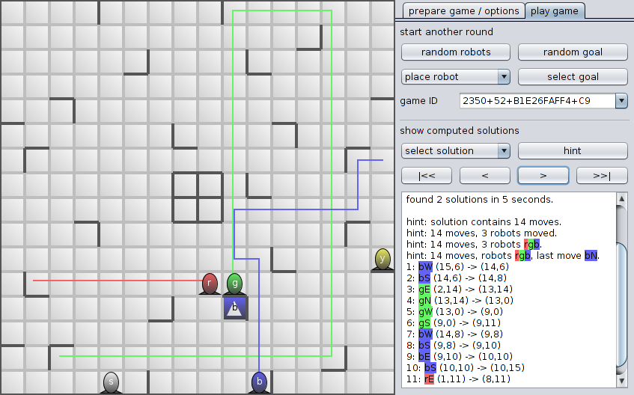
The solver runs in the background whenever you change the starting position (as described above) and presents its results in the lower part of the control area. Use these controls to examine the computed solutions:
- select solution For some game configurations the solver finds more than one optimal solution. This list of solutions is sorted according to the option prefer solution with minimum / maximum number of robots moved on the Options tab. The best solution is situated on top of the list and is selected automatically.
- hint Gives a hint: how many moves are in the solution. Click again for a second hint: how many moves and how many moved robots are involved in the solution. Click again for the third hint: how many moves and which robots are moved. Click again for the fourth hint: how many moves, which robots are moved and what's the last move of the solution.
- |<< Undo all shown moves.
- < Undo last shown move.
- > Show next move.
- >>| Show all moves.

Prepare game / Options
Here you can arrange the four board tiles and change some program options. The board view on the left side has all goals made visible so that you can recognize the Ricochet Robots board tiles more easily.

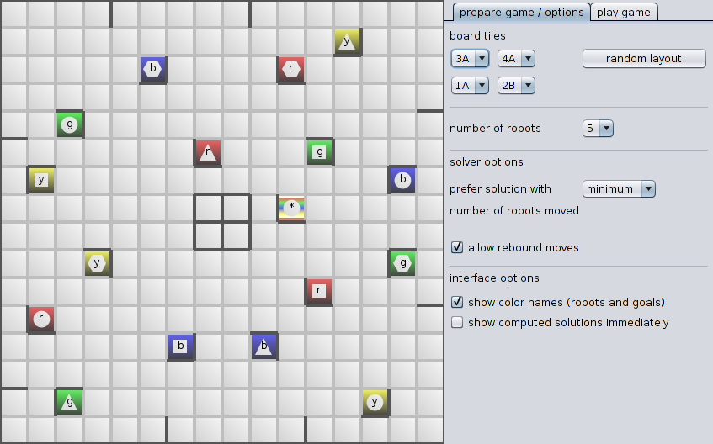
The board tiles in DriftingDroids are modeled after the tiles of the original Ricochet Robots board. They are simply named 1, 2, 3, 4 and the two sides front / back are named A / B. (see photos in directory doc)
Click on button random layout to let the program select a layout: all four different tiles will be used, they are placed at random positions with a random side (A or B) facing up.
You can arrange the board tiles manually by selecting any entry 1A … 4B in each of the four lists. The program imposes no restrictions on the possible combinations of tiles, e.g. you can build a board from four copies of tile 2B if you want to.
Select from the list the number of robots that will be present on the board. The first edition of the Ricochet Robot(s) board game had 4 robots (red, green, blue, yellow), while the current third edition of the game adds a 5th (silver) robot.
The solver algorithm currently offers two options:
- prefer solution with minimum / maximum number of robots moved Select minimum or maximum to let the solver finish the search for all optimal solutions and sort the list of solutions accordingly. (affects list select solution on tab play game)
- allow rebound moves Some people like to play Ricochet Robots by stricter rules that don't allow a robot to move back the way it came. Using DriftingDroids one can find that rebound moves make some solutions shorter. (example: game ID 0765+42+2E21BD0F+93 has 24-moves optimal solutions when rebound moves are allowed and 26-moves optimal solutions without rebounds) There have been some discussions about these rebound moves in online forums like this: http://boardgamegeek.com/forum/22741/ricochet-robots/rules
Currently there are two interface options you can set:
- show color names When active, the robots and goals on the board contain the initial letter of their respective color names. The tooltip text, which is shown when the mouse pointer hovers over a robot or goal, contains the full color name.
- show computed solutions immediately When active, the computed solutions will be shown automatically, as if you had clicked on button >>| (show all moves).

Acknowledgements
This program uses the following Java libraries:
- DesignGridLayout http://designgridlayout.java.net/
- AppStart http://code.google.com/p/appstart/
These tools are used to create this program:
- Eclipse http://www.eclipse.org/
- ProGuard http://proguard.sourceforge.net/
Thanks for ideas and inspiration go to:
- my sister who introduced the Ricochet Robots board game to me.
- all people who published review articles, scientific papers or computer programs about the Ricochet Robots game.
- special thanks to David Hansel for sending me the sources of his fast solver.

License
DriftingDroids - yet another Ricochet Robots solver program.
Copyright (C) 2011, 2012 Michael Henke <smack42@googlemail.com>
This program is free software: you can redistribute it and/or modify
it under the terms of the GNU General Public License as published by
the Free Software Foundation, either version 3 of the License, or
(at your option) any later version.
This program is distributed in the hope that it will be useful,
but WITHOUT ANY WARRANTY; without even the implied warranty of
MERCHANTABILITY or FITNESS FOR A PARTICULAR PURPOSE. See the
GNU General Public License for more details.
You should have received a copy of the GNU General Public License
along with this program. If not, see <http://www.gnu.org/licenses/>.

