Assignment

Mohamed Asimulla S

Prepared for

* Clients
* Linta Mathew

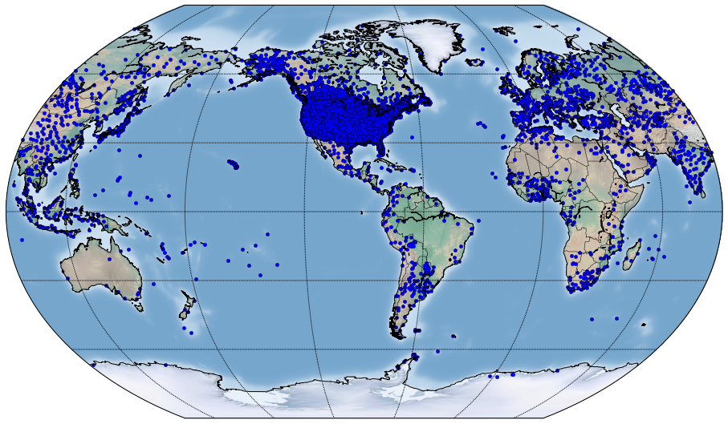

Table of Contents

Business Problem 2

Introduction 2

Assumptions/Limitations 2

System Process 2

Figure 1.System process 3

Languages 3

Software 3

User Requirment 3

File Details 3

Python Program Layout 4

Figure 2. Python program layout 4

Code location 4

How to run the program 5

References 5

Appendix 5

## Business Problem

Generate a pseudo weather data for a online game.

## Introduction

The objective of this task is to create a framework to generate pseudo weather data . This machine data will be then used as a input for a game.

## Assumptions/Limitations

Data is collected to generate pseudo weather data.

The program is depend on python API to get weather information.

## System Process

**Location.xml**

Python script

Shell script

Text file

GenerateWeatherData.sh GenerateWeather.py Output_Weather_Report.txt

## Figure 1.System process

The Unix shell script is wrapper script that will trigger the python script to generate data for a particular location as shown in figure 1.The location.xml is config file to load the location values into shell script . Python program will generate the resulting outfile file after gathering weather information .

## Languages

* Python
* Unix Shell Scripting

## Software

* Juypter notebook IDE/Atom IDE
* Unix Os /Mac OSX
* Python

## User Requirment

* Unix Os /Mac OSX
* Python
* python packages

## File Details

|  |  |  |
| --- | --- | --- |
| slno | File name | Pupose |
| 1 | readTagValue.sh | To Read XML tag value |
| 2 | Location.xml | Config value to store location details |
| 4 | GenerateWeatherData.sh | Wrapper to call python script |
| 5 | GenerateWeather.py | Main script to get weather informaion |
| 6 | Assignment.docx | Document with instrctions |
| 7 | Location.txt | Intermediate file to store geo location |
| 8 | Out_Weather_Report.txt | Outfile |

## Python Program Layout

## Figure 2. Python program layout

ThePython program layout is shown above in the figiure 2.

## Code location

The code is stored in Git hub and ASW cloud .The path is given below .

<https://s3-ap-southeast-2.amazonaws.com/smdasim/Assignment.docx>

https://s3-ap-southeast-2.amazonaws.com/smdasim/readTagValue.sh

<https://s3-ap-southeast-2.amazonaws.com/smdasim/GenerateWeather.py>

<https://s3-ap-southeast-2.amazonaws.com/smdasim/GenerateWeatherData.sh>

https://s3-ap-southeast-2.amazonaws.com/smdasim/Location.xml

<https://s3-ap-southeast-2.amazonaws.com/smdasim/Location.txt>

<https://s3-ap-southeast-2.amazonaws.com/smdasim/Out_Weather_Report.txt>

## How to run the program

Please submssion floder in a directory and run the script as shown below

./GenerateWeatherData.sh

## References

Gite, V. (2017). Bash Shell Script Function Examples. [online] Cyberciti.biz. Available at: https://www.cyberciti.biz/faq/bash-shell-script-function-examples/ [Accessed 22 Mar. 2017].

Pypi.python.org. (2017). PyPI - the Python Package Index : Python Package Index. [online] Available at: https://pypi.python.org/ [Accessed 22 Mar. 2017].

## Appendix

|  |
| --- |
| Password:  sh-3.2# pip install geopy  Collecting geopy  Downloading geopy-1.11.0-py2.py3-none-any.whl (66kB)  100% |████████████████████████████████| 71kB 660kB/s  Installing collected packages: geopy  Successfully installed geopy-1.11.0  sh-3.2# pw  sh: pw: command not found  sh-3.2# pwd  /Users/Yaqoob/Downloads/CBA/2  sh-3.2# python WeatherGenerator.py Melbourne  Traceback (most recent call last):  File "WeatherGenerator.py", line 17, in <module>  import geocoder  ImportError: No module named geocoder  sh-3.2# pip install geocoder  Collecting geocoder  Downloading geocoder-1.21.0-py2.py3-none-any.whl (69kB)  100% |████████████████████████████████| 71kB 494kB/s  Requirement already satisfied: click in /Applications/anaconda/lib/python2.7/site-packages (from geocoder)  Requirement already satisfied: six in /Applications/anaconda/lib/python2.7/site-packages (from geocoder)  Requirement already satisfied: requests in /Applications/anaconda/lib/python2.7/site-packages (from geocoder)  Collecting ratelim (from geocoder)  Downloading ratelim-0.1.6-py2.py3-none-any.whl  Requirement already satisfied: decorator in /Applications/anaconda/lib/python2.7/site-packages (from ratelim->geocoder)  Installing collected packages: ratelim, geocoder  Successfully installed geocoder-1.21.0 ratelim-0.1.6  sh-3.2# |

|  |
| --- |
| sh-3.2# ./GenerateWeatherData.sh  Adelaide  ...  Perth  ...  London  ...  Melbourne  ...  Moscow  ...  Ottawa  ...  Paris  ...  Seoul  ...  Shanghai  ...  Singapore  ...  Sydney  ...  Tokyo  ...  Toronto  ...  sh-3.2# |

|  |
| --- |
| sh-3.2# ls -plrt  total 1512  -rwxr-xr-x@ 1 Yaqoob staff 888 Mar 23 00:12 readTagValue.sh  -rwxr-xr-x@ 1 Yaqoob staff 318 Mar 23 13:12 Location.xml  -rwxr-xr-x@ 1 Yaqoob staff 702746 Mar 23 15:42 Assignment.docx  drwxr-xr-x 3 Yaqoob staff 102 Mar 23 18:35 .ipynb_checkpoints/  -rw-r--r-- 1 Yaqoob staff 20484 Mar 23 19:10 Untitled.ipynb  -rw-r--r--@ 1 Yaqoob staff 6148 Mar 23 22:35 .DS_Store  -rw-r--r-- 1 root staff 307 Mar 23 22:47 Location.txt  -rwxr-xr-x@ 1 Yaqoob staff 2078 Mar 23 22:48 GenerateWeatherData.sh  -rw-r--r--@ 1 Yaqoob staff 14412 Mar 23 22:49 GenerateWeather.py  -rw-r--r-- 1 root staff 834 Mar 23 22:49 Out_Weather_Report.txt  sh-3.2#  sh-3.2#  sh-3.2# |