1. Added another model GradientBoostingClassifier in train.py
2. 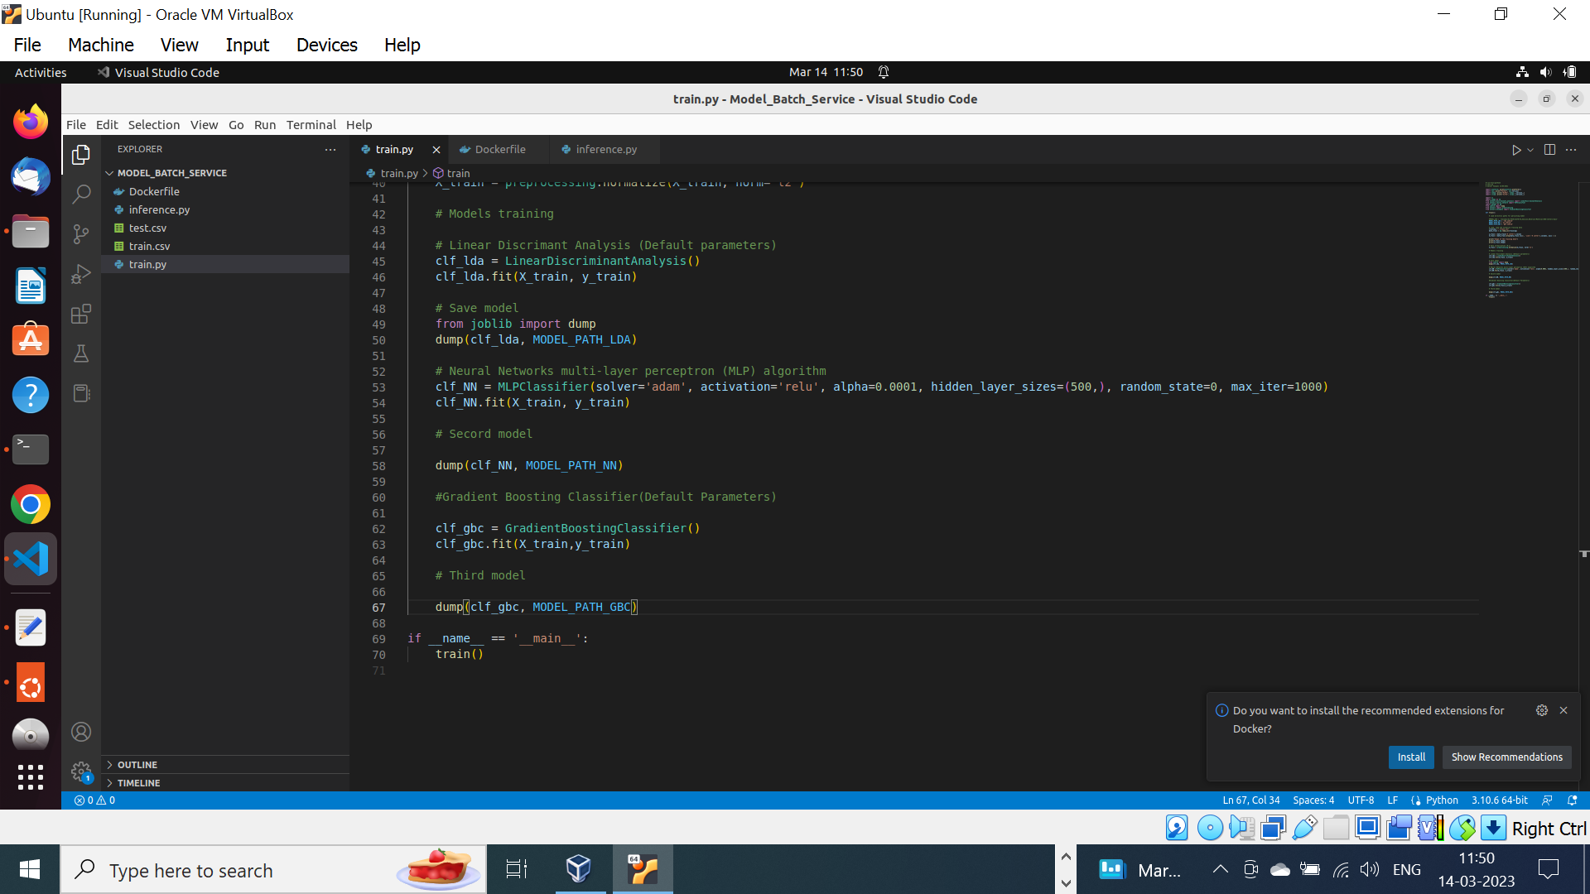
3. Added prediction and score results in inference.py for GradientBoostingClassifier.
4. 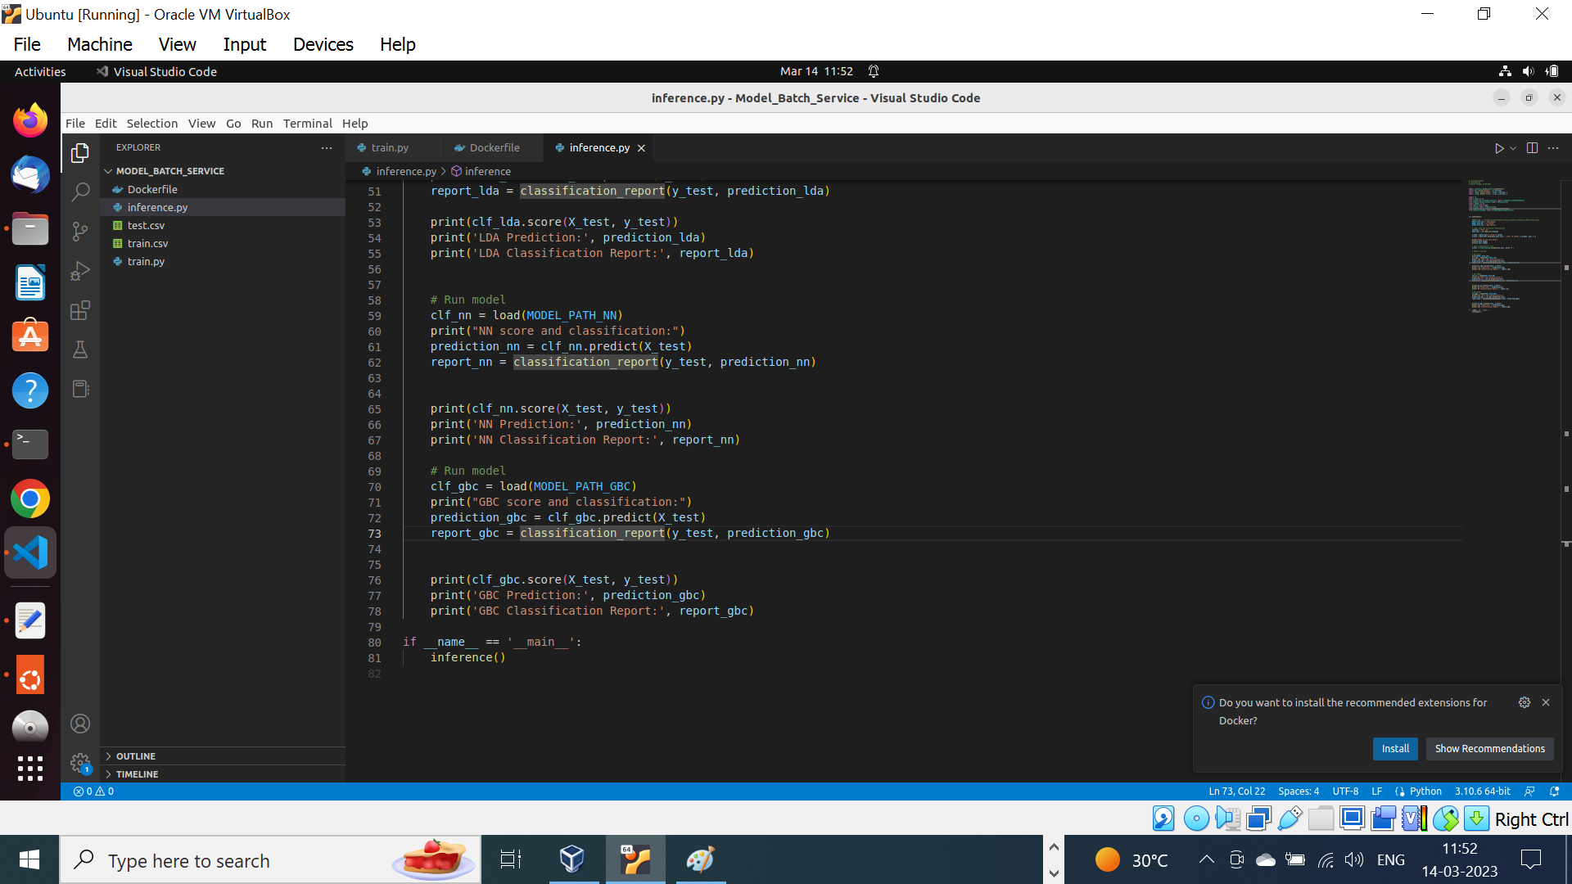
5. Created Docker image from Dockerfile. Used AWS EC2 instance as local ubuntu machine in virtual box is taking lot of time to create image.
6. 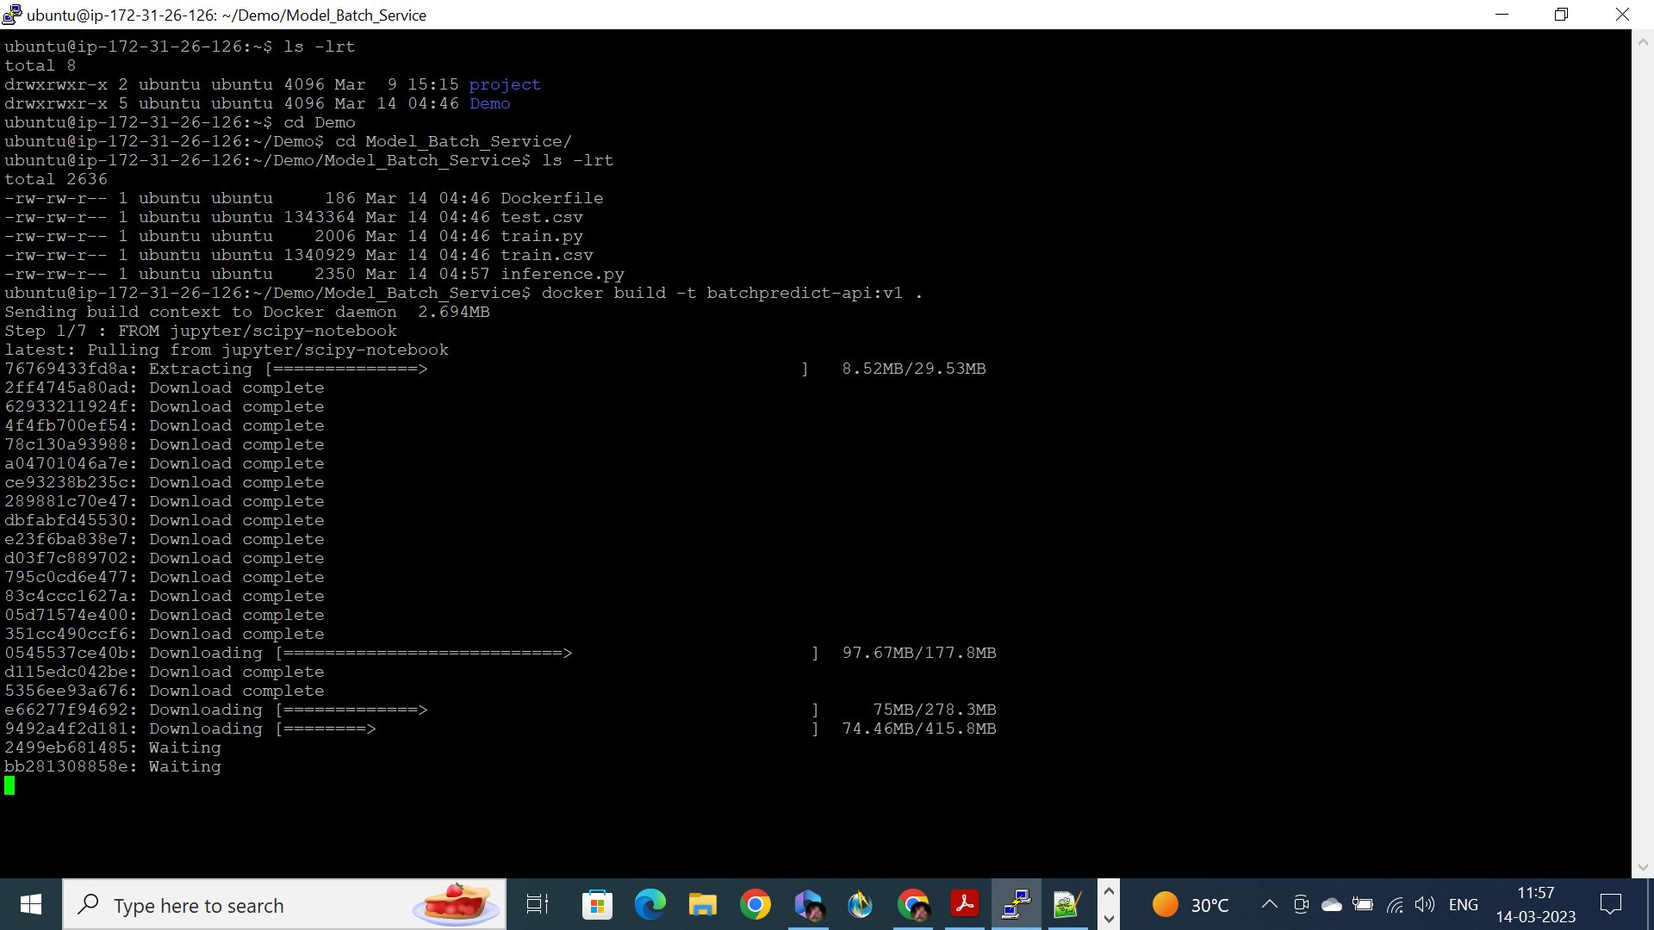
7. 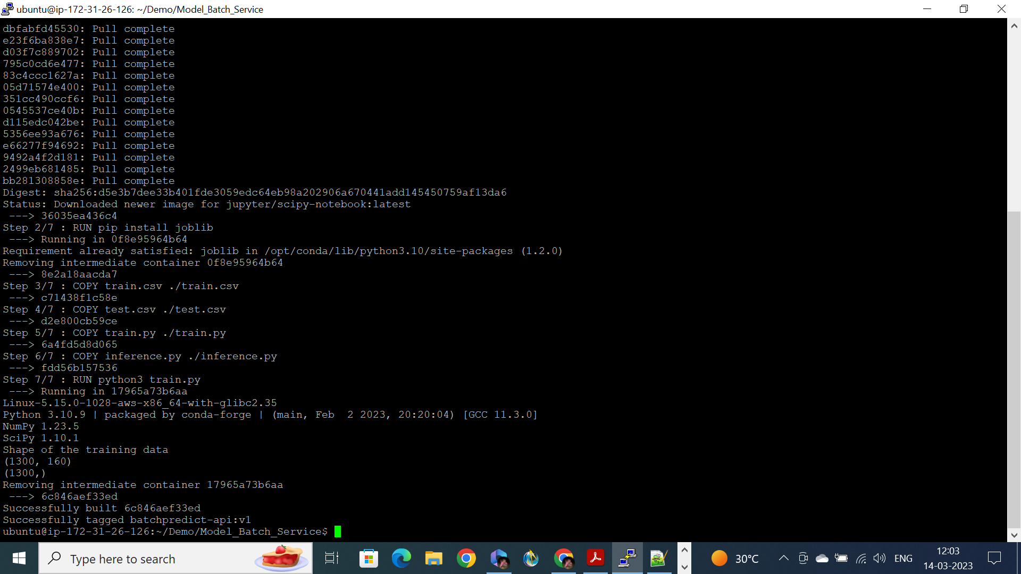
8. 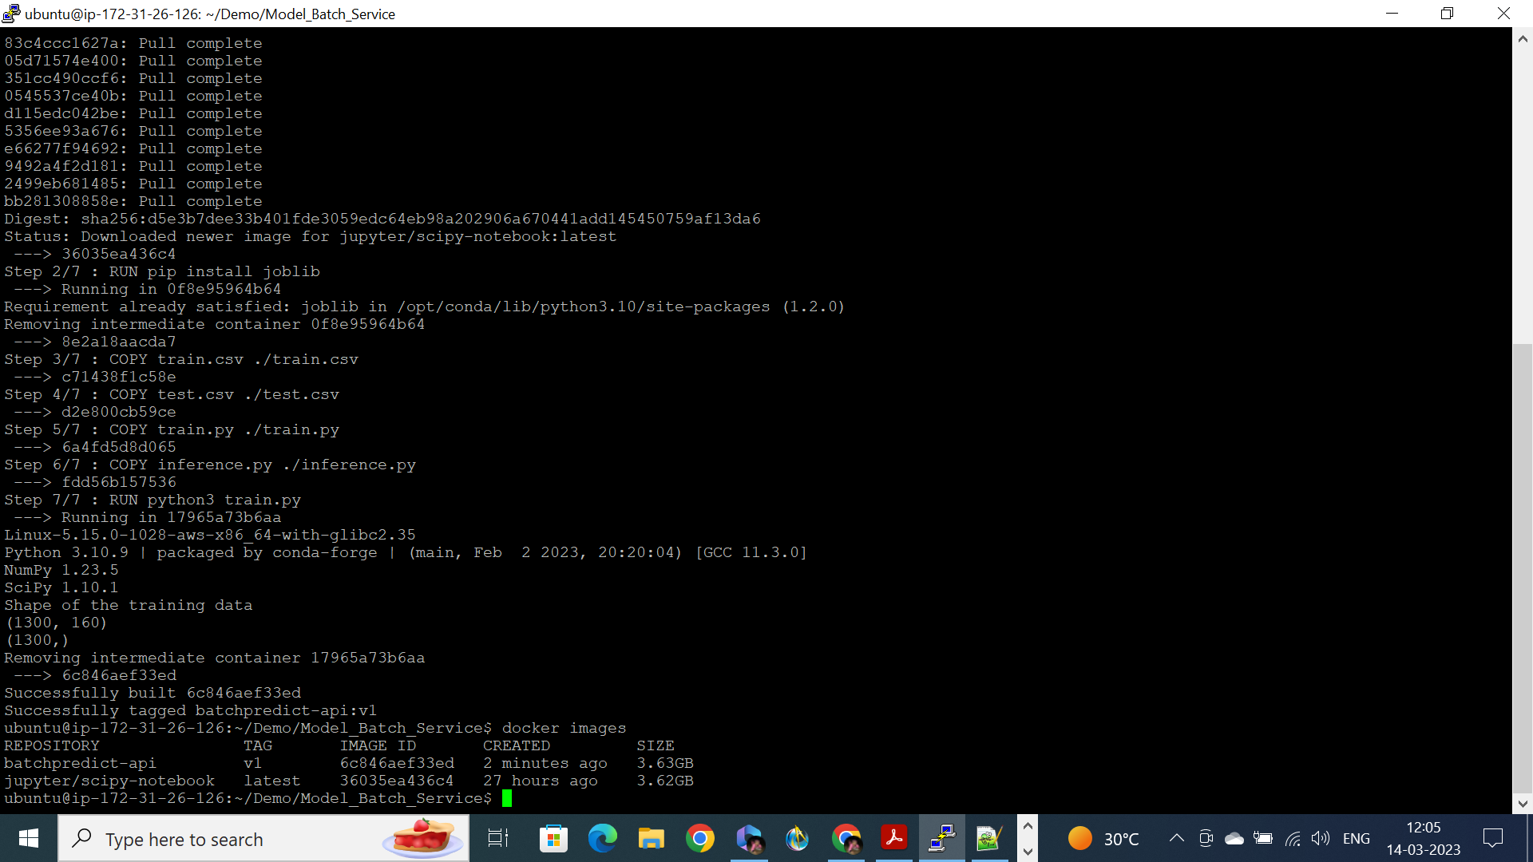
9. Running the container and inference.py for prediction using three models.
10. 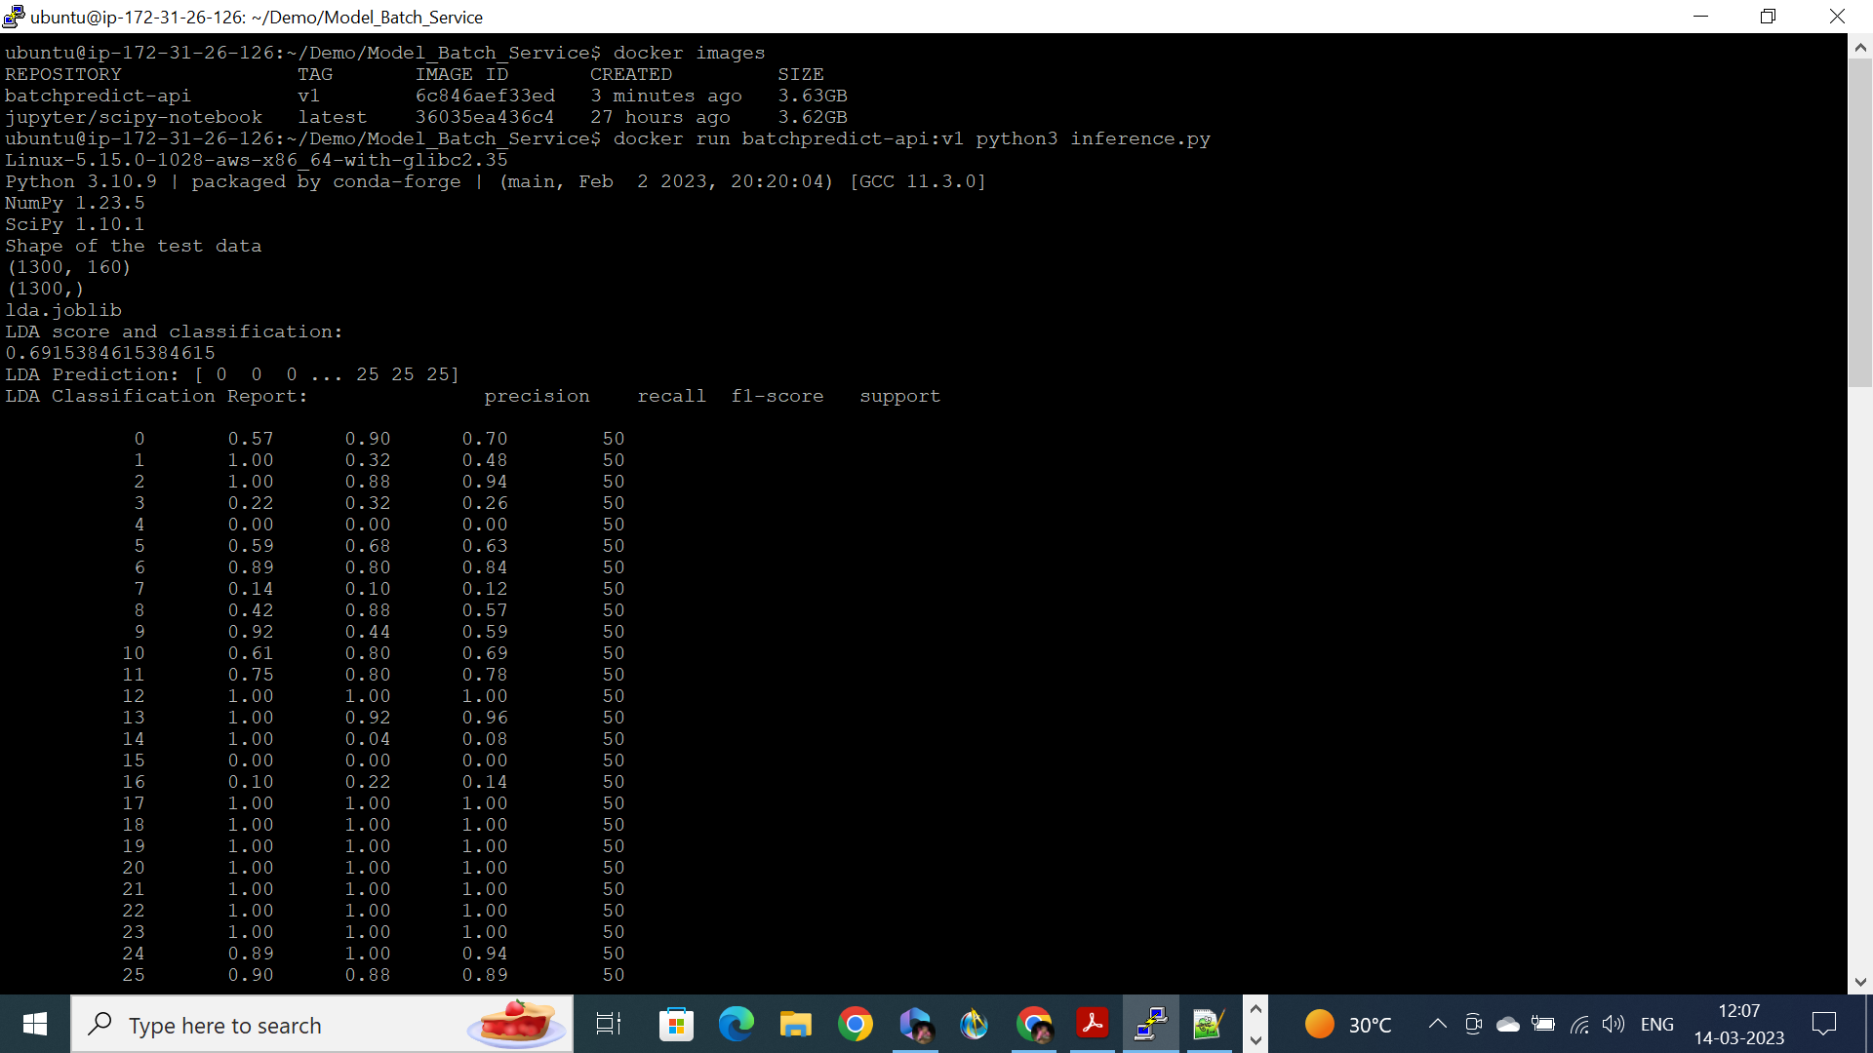
11. 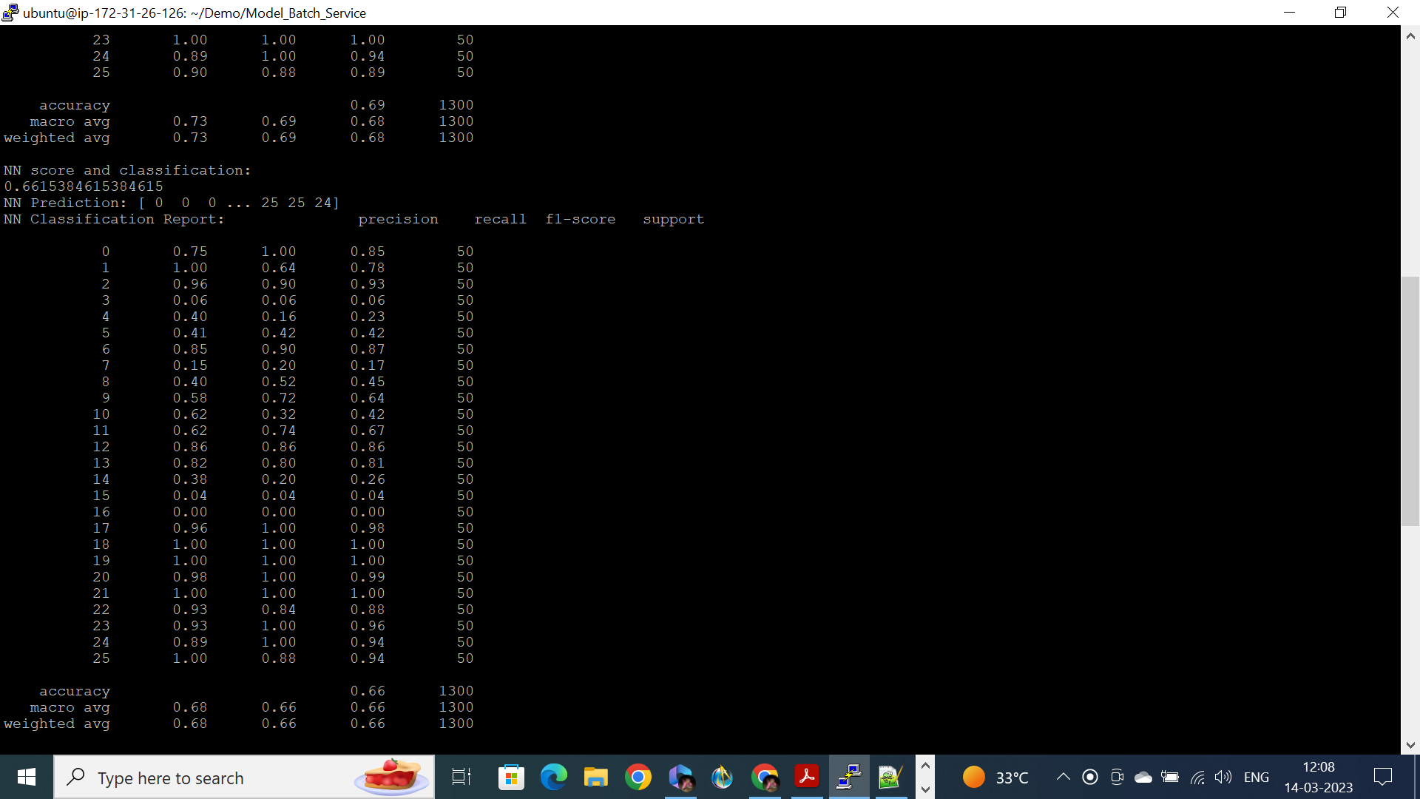
12. 